 

Test Summary Report

# Total Test Cases : 3 Passed : 2 Failed : 1

|  |  |  |  |  |
| --- | --- | --- | --- | --- |
| **Test Scenario Sr No** | **Test Case/Step Desc** | **Test Case/Step Status** | **StartTime** | **EndTime** |

|  |  |  |  |  |
| --- | --- | --- | --- | --- |
| **TC-25.01,25.09,25.10,25.11,25.12,25.13,30.01 create DynamicQRCode by clicking on the create new QR code button under group page** | **user able to create the DynamicQRCode by clicking on the create new QR code button under group page** | **Passed** | **2022/04/21 16:49:25** | **2022/04/21 16:49:50** |

|  |  |  |  |  |
| --- | --- | --- | --- | --- |
| **Test Step No** | **Step Desc** | **Expected Result** | **Actual Result** | **Step Status** |

|  |  |  |  |  |
| --- | --- | --- | --- | --- |
| 1 | Entering text 'madhukar.lakkam@globe.com.ph' in 'UserName' text field | Should able to enter data'madhukar.lakkam@globe.com.ph' into 'UserName' text field | Entered data'madhukar.lakkam@globe.com.ph' into 'UserName' text field successfully | Passed |

|  |  |  |  |  |
| --- | --- | --- | --- | --- |
| 2 | Entering text 'Lavi@1234' in 'Password' text field | Should able to enter data'Lavi@1234' into 'Password' text field | Entered data'Lavi@1234' into 'Password' text field successfully | Passed |

|  |  |  |  |  |
| --- | --- | --- | --- | --- |
| 3 | Click on 'LoginButton' | Able to click on 'LoginButton' button. | Clicked on 'LoginButton' button. | Passed |

|  |  |  |  |  |
| --- | --- | --- | --- | --- |
| 4 | Check visibility of locator 'WelcomeButton' in Page 'QRHooksHomePage' | 'WelcomeButton' should be visible on the Application | 'WelcomeButton' is visbile on the page 'QRHooksHomePage' | Passed |

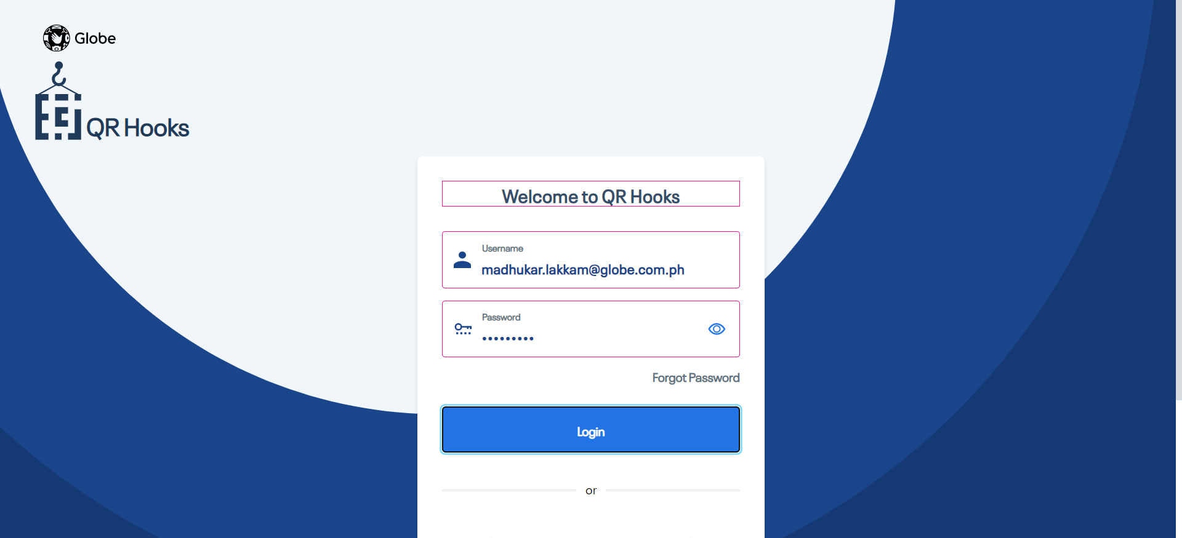

|  |  |  |  |  |
| --- | --- | --- | --- | --- |
| 5 | Check visibility of locator 'GroupText' in Page 'QRHooksHomePage' | 'GroupText' should be visible on the Application | 'GroupText' is visbile on the page 'QRHooksHomePage' | Passed |

|  |  |  |  |  |
| --- | --- | --- | --- | --- |
| 6 | Click on 'CreateNewGroupButton' | Able to click on 'CreateNewGroupButton' button. | Clicked on 'CreateNewGroupButton' button. | Passed |

|  |  |  |  |  |
| --- | --- | --- | --- | --- |
| 7 | Click on 'SaveButton' | Able to click on 'SaveButton' button. | Clicked on 'SaveButton' button. | Passed |

|  |  |  |  |  |
| --- | --- | --- | --- | --- |
| 8 | Check visibility of locator 'GrooupNameRequired' in Page 'CreateNewGroupPopUpWindow' | 'GrooupNameRequired' should be visible on the Application | 'GrooupNameRequired' is visbile on the page 'CreateNewGroupPopUpWindow' | Passed |

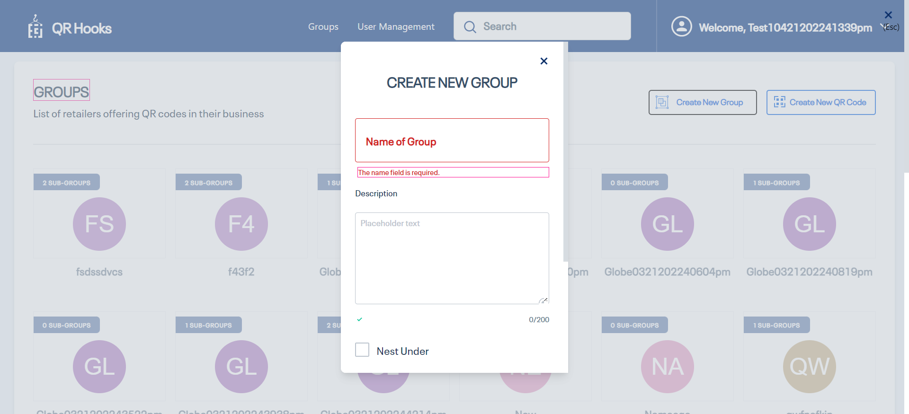

|  |  |  |  |  |
| --- | --- | --- | --- | --- |
| 9 | Click on 'CancelButton' | Able to click on 'CancelButton' button. | Clicked on 'CancelButton' button. | Passed |

|  |  |  |  |  |
| --- | --- | --- | --- | --- |
| 10 | Click on 'CreateNewGroupButton' | Able to click on 'CreateNewGroupButton' button. | Clicked on 'CreateNewGroupButton' button. | Passed |

|  |  |  |  |  |
| --- | --- | --- | --- | --- |
| 11 | Click on 'groupnameTextfield' | Able to click on 'groupnameTextfield' button. | Clicked on 'groupnameTextfield' button. | Passed |

|  |  |  |  |  |
| --- | --- | --- | --- | --- |
| 12 | Entering text 'Globe0421202244925pm' in 'groupnameTextfield' text field | Should able to enter data'Globe0421202244925pm' into 'groupnameTextfield' text field | Entered data'Globe0421202244925pm' into 'groupnameTextfield' text field successfully | Passed |

|  |  |  |  |  |
| --- | --- | --- | --- | --- |
| 13 | Check visibility of locator 'Desciption' in Page 'CreateNewGroupPopUpWindow' | 'Desciption' should be visible on the Application | 'Desciption' is visbile on the page 'CreateNewGroupPopUpWindow' | Passed |

|  |  |  |  |  |
| --- | --- | --- | --- | --- |
| 14 | Entering text 'User going to create the new group' in 'groupDescriptionField' text field | Should able to enter data'User going to create the new group' into 'groupDescriptionField' text field | Entered data'User going to create the new group' into 'groupDescriptionField' text field successfully | Passed |

|  |  |  |  |  |
| --- | --- | --- | --- | --- |
| 15 | Check visibility of locator 'Nest Under' in Page 'CreateNewGroupPopUpWindow' | 'Nest Under' should be visible on the Application | 'Nest Under' is visbile on the page 'CreateNewGroupPopUpWindow' | Passed |

|  |  |  |  |  |
| --- | --- | --- | --- | --- |
| 16 | Check visibility of locator 'DescriptionLegnth' in Page 'CreateNewGroupPopUpWindow' | 'DescriptionLegnth' should be visible on the Application | 'DescriptionLegnth' is visbile on the page 'CreateNewGroupPopUpWindow' | Passed |

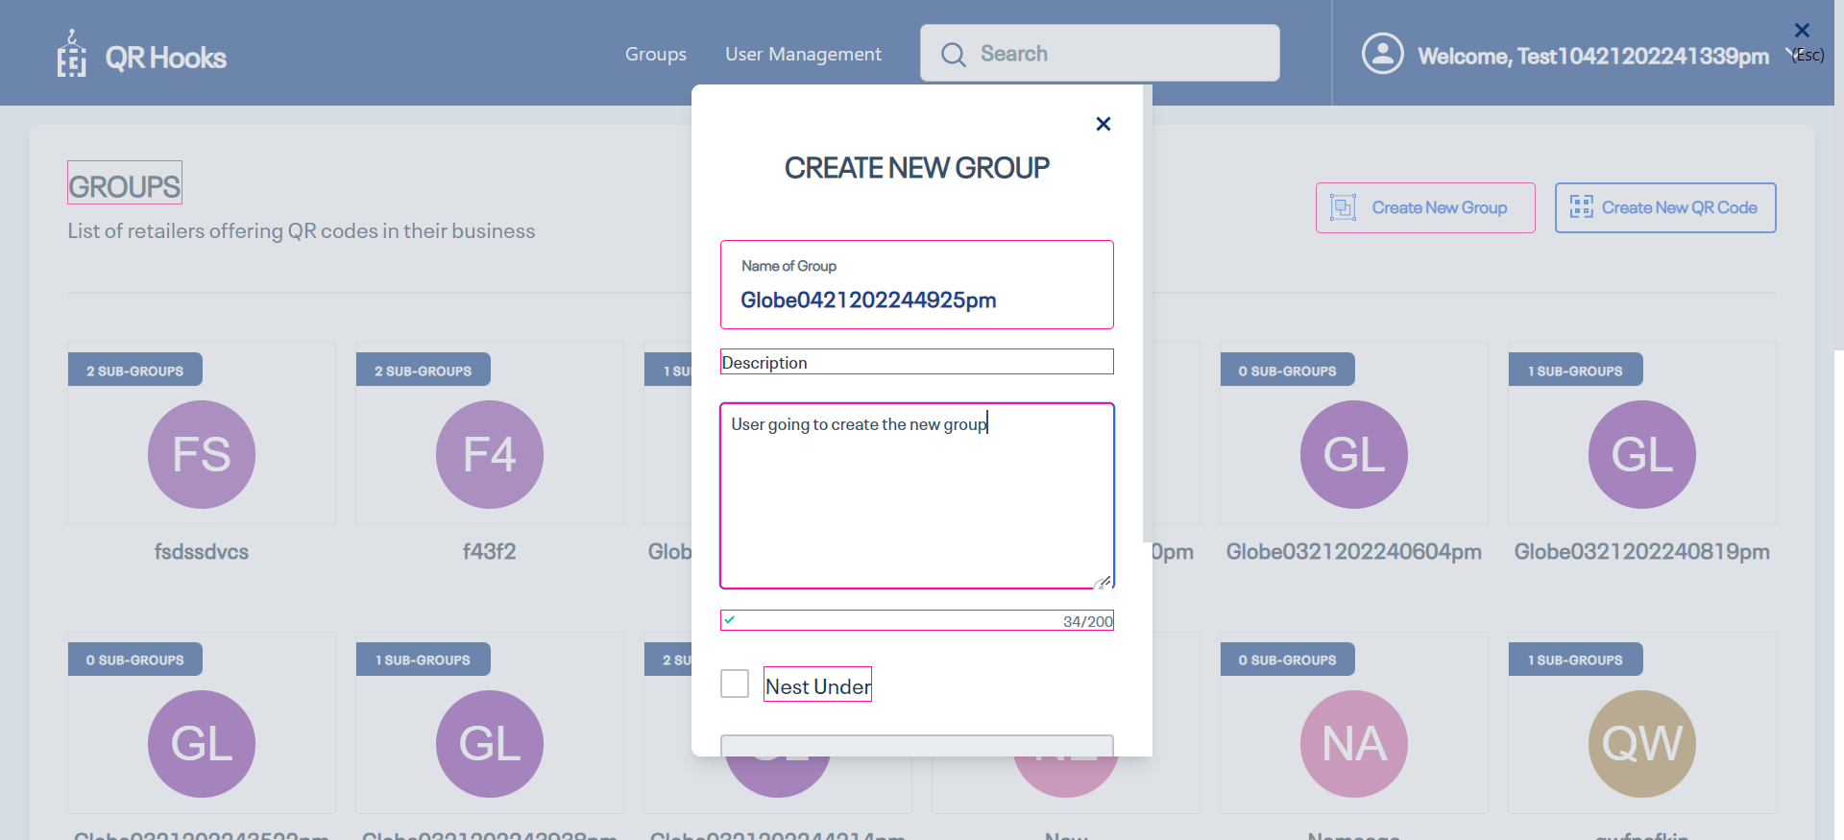

|  |  |  |  |  |
| --- | --- | --- | --- | --- |
| 17 | Check visibility of locator 'SaveButton' in Page 'CreateNewGroupPopUpWindow' | 'SaveButton' should be visible on the Application | 'SaveButton' is visbile on the page 'CreateNewGroupPopUpWindow' | Passed |

|  |  |  |  |  |
| --- | --- | --- | --- | --- |
| 18 | Click on 'SaveButton' | Able to click on 'SaveButton' button. | Clicked on 'SaveButton' button. | Passed |

|  |  |  |  |  |
| --- | --- | --- | --- | --- |
| 19 | Check visibility of locator 'GroupcreatedSuccessMessage' in Page 'QRHooksHomePage' | 'GroupcreatedSuccessMessage' should be visible on the Application | 'GroupcreatedSuccessMessage' is visbile on the page 'QRHooksHomePage' | Passed |

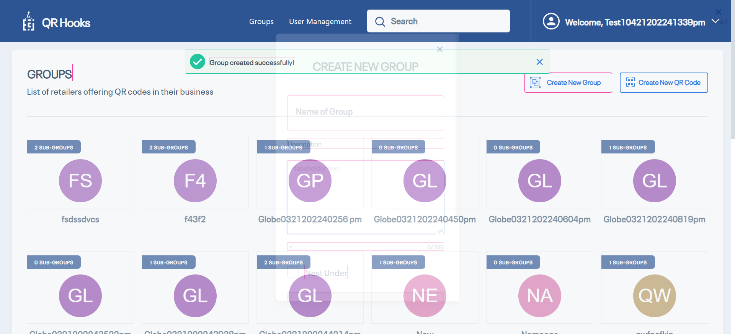

|  |  |  |  |  |
| --- | --- | --- | --- | --- |
| 20 | Entering text 'Globe0421202244925pm' in 'SearchBar' text field | Should able to enter data'Globe0421202244925pm' into 'SearchBar' text field | Entered data'Globe0421202244925pm' into 'SearchBar' text field successfully | Passed |

|  |  |  |  |  |
| --- | --- | --- | --- | --- |
| 21 | Check visibility of locator 'Globe0421202244925pm' in Page 'Edit Profile' | 'Globe0421202244925pm' should be visible on the Application | 'Globe0421202244925pm' is visbile on the page 'Edit Profile' | Passed |

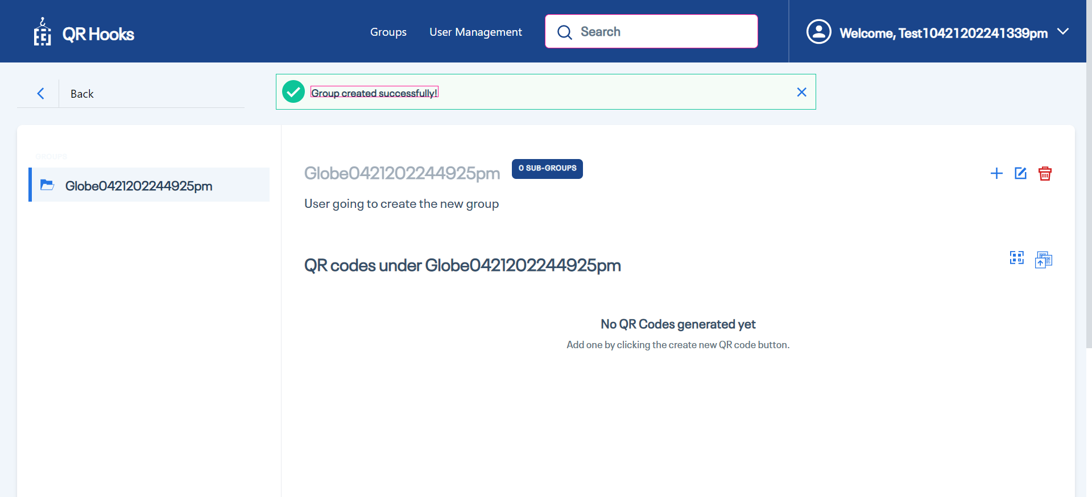

|  |  |  |  |  |
| --- | --- | --- | --- | --- |
| 22 | Entering text 'Globe0421202244925pm' in 'SearchBar' text field | Should able to enter data'Globe0421202244925pm' into 'SearchBar' text field | Entered data'Globe0421202244925pm' into 'SearchBar' text field successfully | Passed |

|  |  |  |  |  |
| --- | --- | --- | --- | --- |
| 23 | Click on 'ADDQRCOde' | Able to click on 'ADDQRCOde' button. | Clicked on 'ADDQRCOde' button. | Passed |

|  |  |  |  |  |
| --- | --- | --- | --- | --- |
| 24 | Entering text 'QRCodeName0421202244925pm' in 'Name' text field | Should able to enter data'QRCodeName0421202244925pm' into 'Name' text field | Entered data'QRCodeName0421202244925pm' into 'Name' text field successfully | Passed |

|  |  |  |  |  |
| --- | --- | --- | --- | --- |
| 25 | Entering text 'QRCodeDescriptio0421202244925pm' in 'description' text field | Should able to enter data'QRCodeDescriptio0421202244925pm' into 'description' text field | Entered data'QRCodeDescriptio0421202244925pm' into 'description' text field successfully | Passed |

|  |  |  |  |  |
| --- | --- | --- | --- | --- |
| 26 | Entering text 'QRCodeContent0421202244925pm' in 'Content' text field | Should able to enter data'QRCodeContent0421202244925pm' into 'Content' text field | Entered data'QRCodeContent0421202244925pm' into 'Content' text field successfully | Passed |

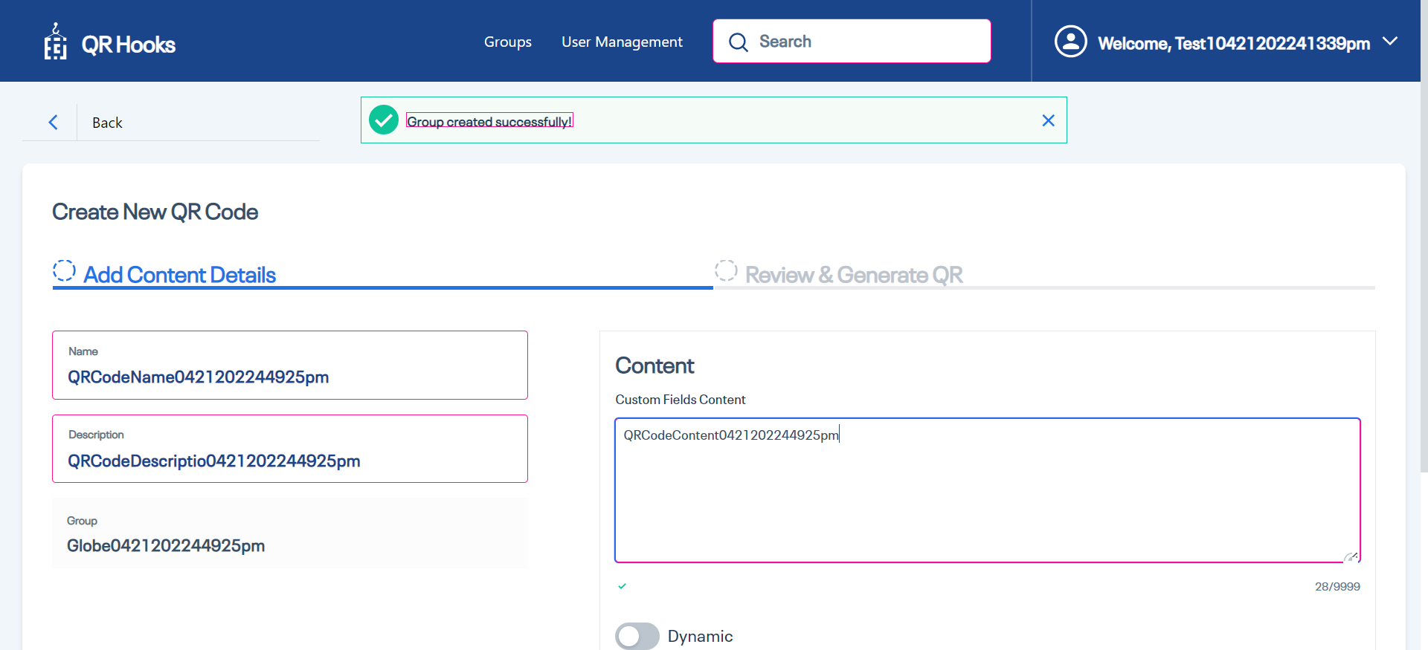

|  |  |  |  |  |
| --- | --- | --- | --- | --- |
| 27 | Check visibility of locator 'DynamicQRCodeButton' in Page 'QRCodeDetailsPage' | 'DynamicQRCodeButton' should be visible on the Application | 'DynamicQRCodeButton' is visbile on the page 'QRCodeDetailsPage' | Passed |

|  |  |  |  |  |
| --- | --- | --- | --- | --- |
| 28 | Click on 'DynamicQRCodeButton' | Able to click on 'DynamicQRCodeButton' button. | Clicked on 'DynamicQRCodeButton' button. | Passed |

|  |  |  |  |  |
| --- | --- | --- | --- | --- |
| 29 | Click on 'ADDFields' | Able to click on 'ADDFields' button. | Clicked on 'ADDFields' button. | Passed |

|  |  |  |  |  |
| --- | --- | --- | --- | --- |
| 30 | Entering text 'Fkey10421202244925pm' in 'ADDFieldsKey' text field | Should able to enter data'Fkey10421202244925pm' into 'ADDFieldsKey' text field | Entered data'Fkey10421202244925pm' into 'ADDFieldsKey' text field successfully | Passed |

|  |  |  |  |  |
| --- | --- | --- | --- | --- |
| 31 | Entering text 'FValue10421202244925pm' in 'ADDFieldsValue' text field | Should able to enter data'FValue10421202244925pm' into 'ADDFieldsValue' text field | Entered data'FValue10421202244925pm' into 'ADDFieldsValue' text field successfully | Passed |

|  |  |  |  |  |
| --- | --- | --- | --- | --- |
| 32 | Entering text 'http://qrhooks.solutions-chapters.click' in 'WebHookURL' text field | Should able to enter data'http://qrhooks.solutions-chapters.click' into 'WebHookURL' text field | Entered data'http://qrhooks.solutions-chapters.click' into 'WebHookURL' text field successfully | Passed |

|  |  |  |  |  |
| --- | --- | --- | --- | --- |
| 33 | Click on 'ADDParameters' | Able to click on 'ADDParameters' button. | Clicked on 'ADDParameters' button. | Passed |

|  |  |  |  |  |
| --- | --- | --- | --- | --- |
| 34 | Entering text 'ParameterName0421202244925pm' in 'ParameterText' text field | Should able to enter data'ParameterName0421202244925pm' into 'ParameterText' text field | Entered data'ParameterName0421202244925pm' into 'ParameterText' text field successfully | Passed |

|  |  |  |  |  |
| --- | --- | --- | --- | --- |
| 35 | Click on 'ADDQuery Parameter' | Able to click on 'ADDQuery Parameter' button. | Clicked on 'ADDQuery Parameter' button. | Passed |

|  |  |  |  |  |
| --- | --- | --- | --- | --- |
| 36 | Entering text 'UPKey10421202244925pm' in 'QueryParamKey' text field | Should able to enter data'UPKey10421202244925pm' into 'QueryParamKey' text field | Entered data'UPKey10421202244925pm' into 'QueryParamKey' text field successfully | Passed |

|  |  |  |  |  |
| --- | --- | --- | --- | --- |
| 37 | Entering text 'QPValue10421202244925pm' in 'QueryParamValue' text field | Should able to enter data'QPValue10421202244925pm' into 'QueryParamValue' text field | Entered data'QPValue10421202244925pm' into 'QueryParamValue' text field successfully | Passed |

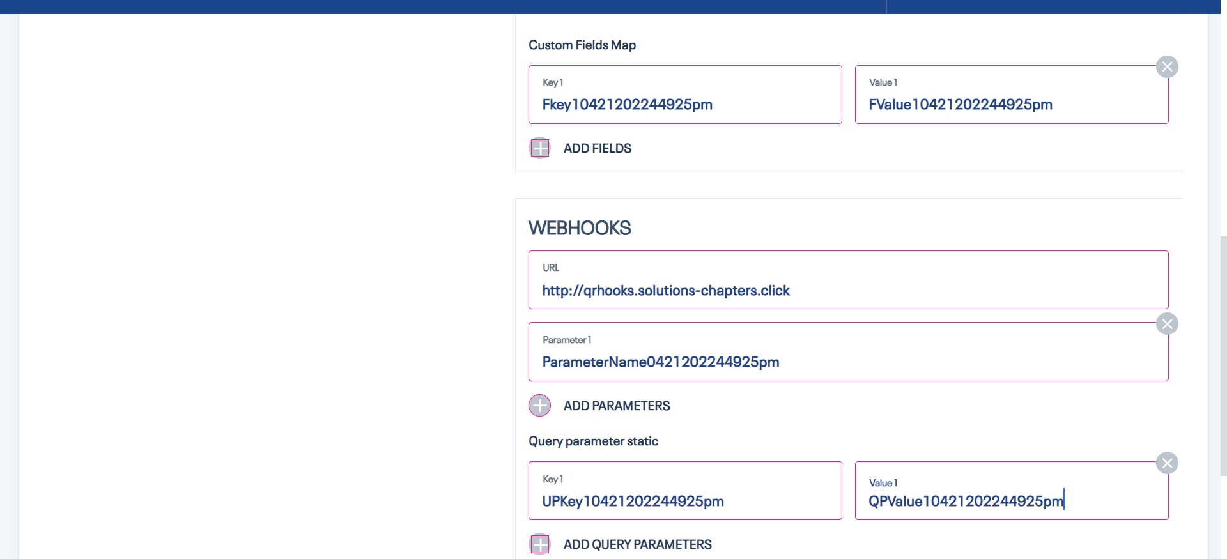

|  |  |  |  |  |
| --- | --- | --- | --- | --- |
| 38 | Click on 'NextButton' | Able to click on 'NextButton' button. | Clicked on 'NextButton' button. | Passed |

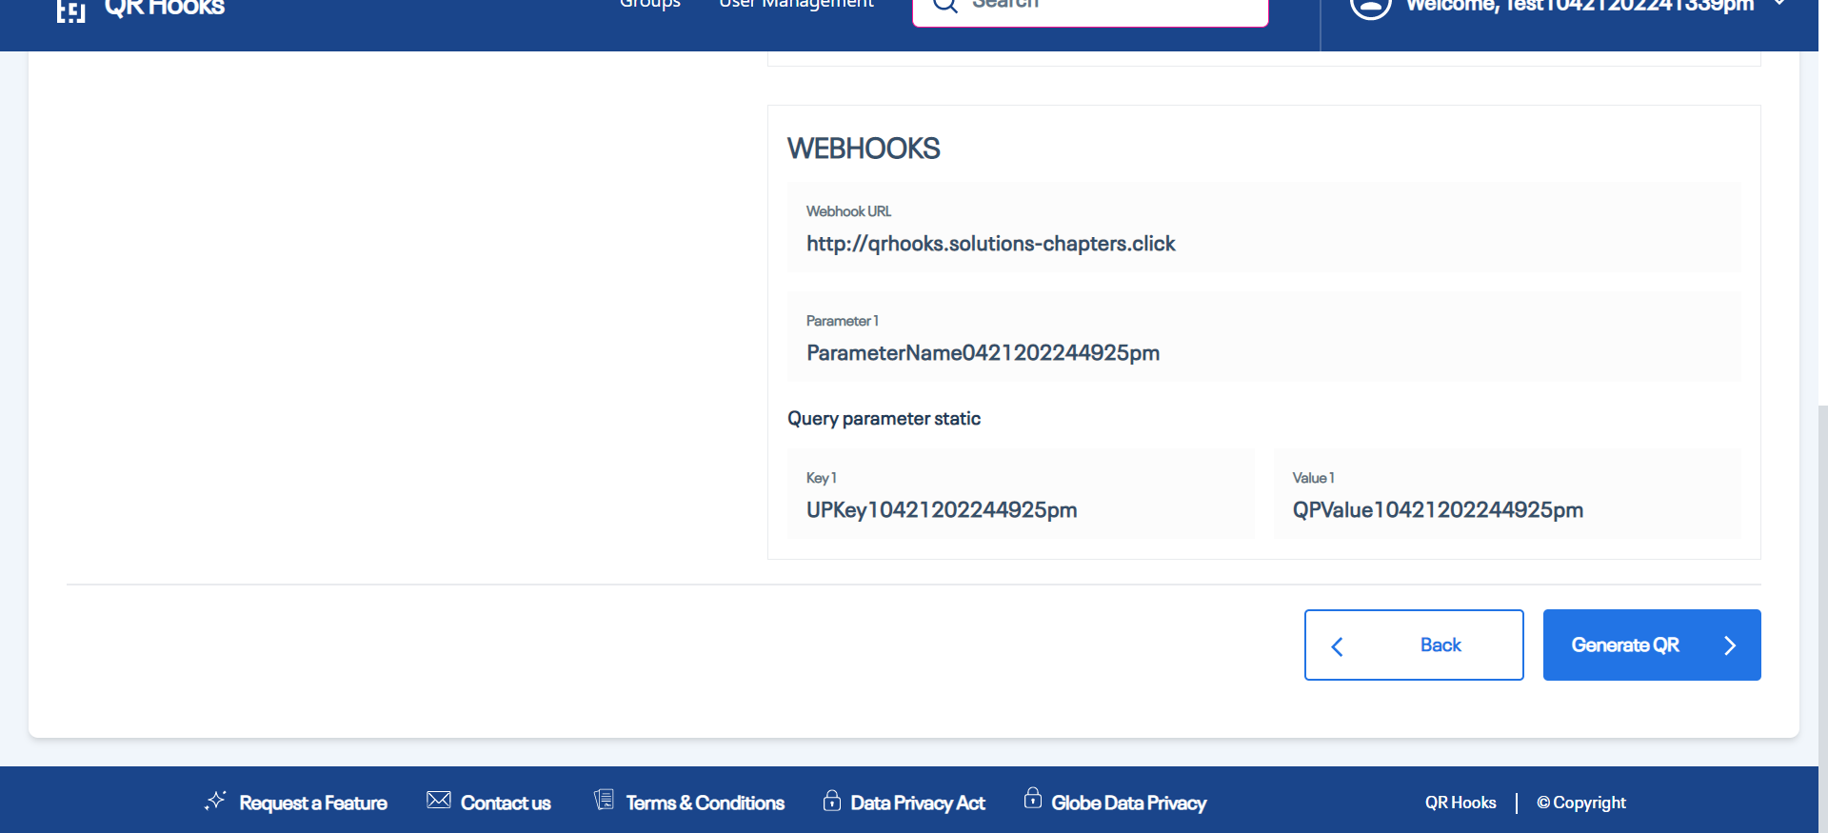

|  |  |  |  |  |
| --- | --- | --- | --- | --- |
| 39 | Comparing Actual vs Expected text | The Expected Text 'QRCodeName0421202244925pm' should be equal to Actual text from Application | The ExpectedText 'QRCodeName0421202244925pm' is same as the Actual Text 'QRCodeName0421202244925pm' | Passed |

|  |  |  |  |  |
| --- | --- | --- | --- | --- |
| 40 | Comparing Actual vs Expected text | The Expected Text 'QRCodeDescriptio0421202244925pm' should be equal to Actual text from Application | The ExpectedText 'QRCodeDescriptio0421202244925pm' is same as the Actual Text 'QRCodeDescriptio0421202244925pm' | Passed |

|  |  |  |  |  |
| --- | --- | --- | --- | --- |
| 41 | Comparing Actual vs Expected text | The Expected Text 'QRCodeContent0421202244925pm' should be equal to Actual text from Application | The ExpectedText 'QRCodeContent0421202244925pm' is same as the Actual Text 'QRCodeContent0421202244925pm' | Passed |

|  |  |  |  |  |
| --- | --- | --- | --- | --- |
| 42 | Comparing Actual vs Expected text | The Expected Text 'Fkey10421202244925pm' should be equal to Actual text from Application | The ExpectedText 'Fkey10421202244925pm' is same as the Actual Text 'Fkey10421202244925pm' | Passed |

|  |  |  |  |  |
| --- | --- | --- | --- | --- |
| 43 | Comparing Actual vs Expected text | The Expected Text 'FValue10421202244925pm' should be equal to Actual text from Application | The ExpectedText 'FValue10421202244925pm' is same as the Actual Text 'FValue10421202244925pm' | Passed |

|  |  |  |  |  |
| --- | --- | --- | --- | --- |
| 44 | Comparing Actual vs Expected text | The Expected Text 'http://qrhooks.solutions-chapters.click' should be equal to Actual text from Application | The ExpectedText 'http://qrhooks.solutions-chapters.click' is same as the Actual Text 'http://qrhooks.solutions-chapters.click' | Passed |

|  |  |  |  |  |
| --- | --- | --- | --- | --- |
| 45 | Comparing Actual vs Expected text | The Expected Text 'ParameterName0421202244925pm' should be equal to Actual text from Application | The ExpectedText 'ParameterName0421202244925pm' is same as the Actual Text 'ParameterName0421202244925pm' | Passed |

|  |  |  |  |  |
| --- | --- | --- | --- | --- |
| 46 | Comparing Actual vs Expected text | The Expected Text 'UPKey10421202244925pm' should be equal to Actual text from Application | The ExpectedText 'UPKey10421202244925pm' is same as the Actual Text 'UPKey10421202244925pm' | Passed |

|  |  |  |  |  |
| --- | --- | --- | --- | --- |
| 47 | Comparing Actual vs Expected text | The Expected Text 'QPValue10421202244925pm' should be equal to Actual text from Application | The ExpectedText 'QPValue10421202244925pm' is same as the Actual Text 'QPValue10421202244925pm' | Passed |

|  |  |  |  |  |
| --- | --- | --- | --- | --- |
| 48 | Click on 'GenerateQRCodeButton' | Able to click on 'GenerateQRCodeButton' button. | Clicked on 'GenerateQRCodeButton' button. | Passed |

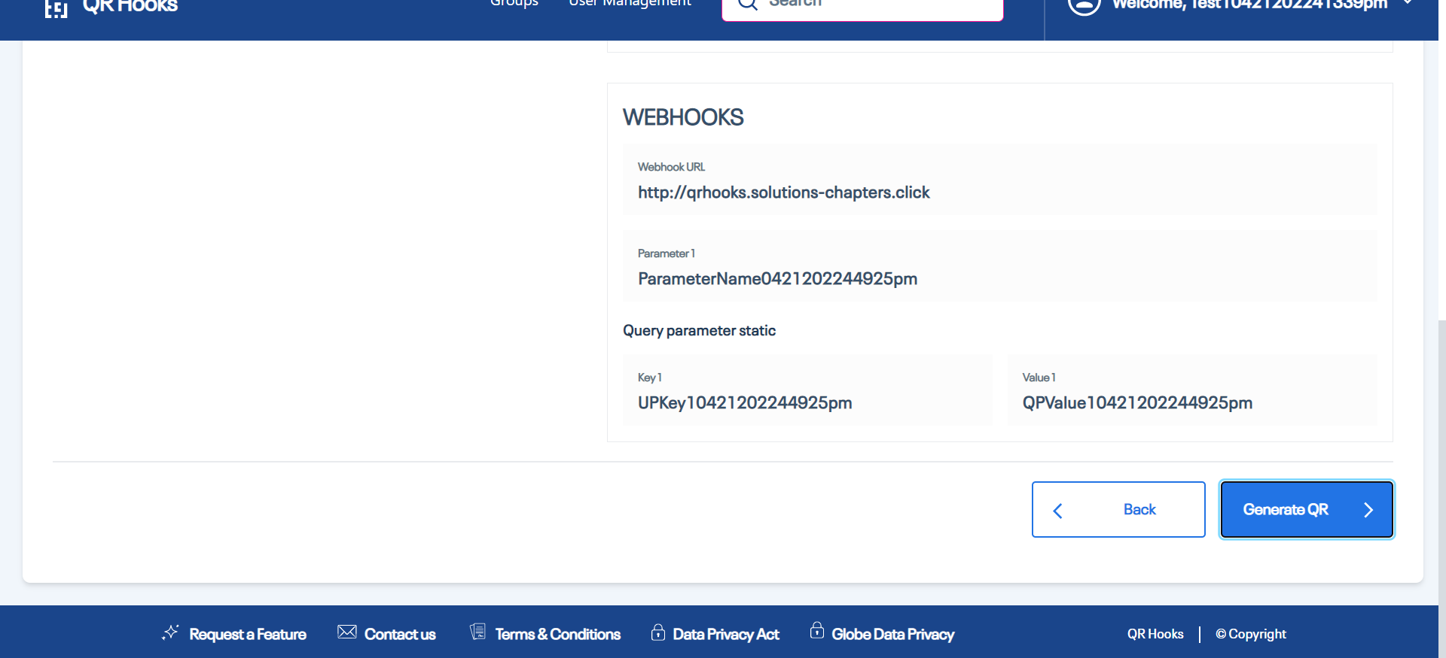

|  |  |  |  |  |
| --- | --- | --- | --- | --- |
| 49 | create the dynamic Qr code | User should be abe to create the dynamic QR Code | user is abe to create the dynamic Qr Code | Passed |

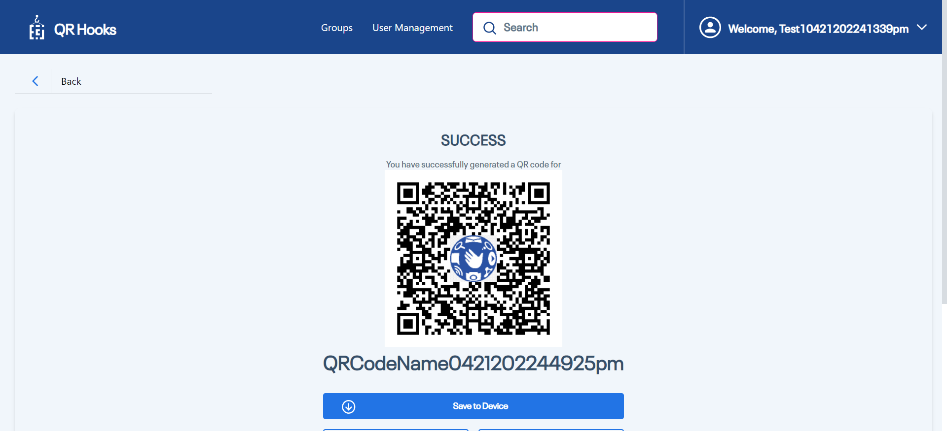

|  |  |  |  |  |
| --- | --- | --- | --- | --- |
| **Test Scenario Sr No** | **Test Case/Step Desc** | **Test Case/Step Status** | **StartTime** | **EndTime** |

|  |  |  |  |  |
| --- | --- | --- | --- | --- |
| **TC Edit the DynamicQRCode** | **User should be able to edit the dyanamic QRCode** | **Passed** | **2022/04/21 16:49:50** | **2022/04/21 16:50:06** |

|  |  |  |  |  |
| --- | --- | --- | --- | --- |
| **Test Step No** | **Step Desc** | **Expected Result** | **Actual Result** | **Step Status** |

|  |  |  |  |  |
| --- | --- | --- | --- | --- |
| 1 | Entering text 'Globe0421202244925pm' in 'SearchBar' text field | Should able to enter data'Globe0421202244925pm' into 'SearchBar' text field | Entered data'Globe0421202244925pm' into 'SearchBar' text field successfully | Passed |

|  |  |  |  |  |
| --- | --- | --- | --- | --- |
| 2 | Check visibility of locator 'Globe0421202244925pm' in Page 'Edit Profile' | 'Globe0421202244925pm' should be visible on the Application | 'Globe0421202244925pm' is visbile on the page 'Edit Profile' | Passed |

|  |  |  |  |  |
| --- | --- | --- | --- | --- |
| 3 | Click on 'EditButtonforQRCode' | Able to click on 'EditButtonforQRCode' button. | Clicked on 'EditButtonforQRCode' button. | Passed |

|  |  |  |  |  |
| --- | --- | --- | --- | --- |
| 4 | Click on 'EditName' | Able to click on 'EditName' button. | Clicked on 'EditName' button. | Passed |

|  |  |  |  |  |
| --- | --- | --- | --- | --- |
| 5 | Entering text 'EditName0421202244925pm' in 'EditName' text field | Should able to enter data'EditName0421202244925pm' into 'EditName' text field | Entered data'EditName0421202244925pm' into 'EditName' text field successfully | Passed |

|  |  |  |  |  |
| --- | --- | --- | --- | --- |
| 6 | Entering text 'EditDescription0421202244925pm' in 'Editdescription' text field | Should able to enter data'EditDescription0421202244925pm' into 'Editdescription' text field | Entered data'EditDescription0421202244925pm' into 'Editdescription' text field successfully | Passed |

|  |  |  |  |  |
| --- | --- | --- | --- | --- |
| 7 | Verify the group name | user should be able to See the Group Name | User is able to See the Group Name | Passed |

|  |  |  |  |  |
| --- | --- | --- | --- | --- |
| 8 | Entering text 'EditContent0421202244925pm' in 'Editcontent' text field | Should able to enter data'EditContent0421202244925pm' into 'Editcontent' text field | Entered data'EditContent0421202244925pm' into 'Editcontent' text field successfully | Passed |

|  |  |  |  |  |
| --- | --- | --- | --- | --- |
| 9 | Click on 'Save&Regenerate' | Able to click on 'Save&Regenerate' button. | Clicked on 'Save&Regenerate' button. | Passed |

|  |  |  |  |  |
| --- | --- | --- | --- | --- |
| 10 | Click on 'CancelButtonforEditQrCode PopUp' | Able to click on 'CancelButtonforEditQrCode PopUp' button. | Clicked on 'CancelButtonforEditQrCode PopUp' button. | Passed |

|  |  |  |  |  |
| --- | --- | --- | --- | --- |
| 11 | Click on 'Save&Regenerate' | Able to click on 'Save&Regenerate' button. | Clicked on 'Save&Regenerate' button. | Passed |

|  |  |  |  |  |
| --- | --- | --- | --- | --- |
| 12 | Check visibility of locator 'PopUpConfirmationMessage' in Page 'Edit QR Code Details' | 'PopUpConfirmationMessage' should be visible on the Application | 'PopUpConfirmationMessage' is visbile on the page 'Edit QR Code Details' | Passed |

|  |  |  |  |  |
| --- | --- | --- | --- | --- |
| 13 | Check visibility of locator 'CancelButtonforEditQrCode PopUp' in Page 'Edit QR Code Details' | 'CancelButtonforEditQrCode PopUp' should be visible on the Application | 'CancelButtonforEditQrCode PopUp' is visbile on the page 'Edit QR Code Details' | Passed |

|  |  |  |  |  |
| --- | --- | --- | --- | --- |
| 14 | Click on 'QRCodeSave' | Able to click on 'QRCodeSave' button. | Clicked on 'QRCodeSave' button. | Passed |

|  |  |  |  |  |
| --- | --- | --- | --- | --- |
| 15 | Comparing text of field 'QRName' in Page 'QRCodePage | The ExpectedText 'EditName0421202244925pm' should be equal to Actual text from Application | The ExpectedText 'EditName0421202244925pm' is same as the Actual Text 'EditName0421202244925pm' | Passed |

|  |  |  |  |  |
| --- | --- | --- | --- | --- |
| **Test Scenario Sr No** | **Test Case/Step Desc** | **Test Case/Step Status** | **StartTime** | **EndTime** |

|  |  |  |  |  |
| --- | --- | --- | --- | --- |
| **TC Delete the QR code for dynamic QR Code** | **User is able to delete The QRCode for dynamic QR Code** | **Failed** | **2022/04/21 16:50:06** | **2022/04/21 16:50:15** |

|  |  |  |  |  |
| --- | --- | --- | --- | --- |
| **Test Step No** | **Step Desc** | **Expected Result** | **Actual Result** | **Step Status** |

|  |  |  |  |  |
| --- | --- | --- | --- | --- |
| 1 | Click on 'GoToHomeButton' | Able to click on 'GoToHomeButton' button. | Clicked on 'GoToHomeButton' button. | Passed |

|  |  |  |  |  |
| --- | --- | --- | --- | --- |
| 2 | Entering text 'Globe0421202244925pm' in 'SearchBar' text field | Should able to enter data'Globe0421202244925pm' into 'SearchBar' text field | Entered data'Globe0421202244925pm' into 'SearchBar' text field successfully | Passed |

|  |  |  |  |  |
| --- | --- | --- | --- | --- |
| 3 | Click on 'DowloadQRCode' | Able to click on 'DowloadQRCode' button. | Clicked on 'DowloadQRCode' button. | Passed |

|  |  |  |  |  |
| --- | --- | --- | --- | --- |
| 4 | Dowload the QR Code | user should be able to dowload the QR Code | User is not able to dowload the qr code | Failed |

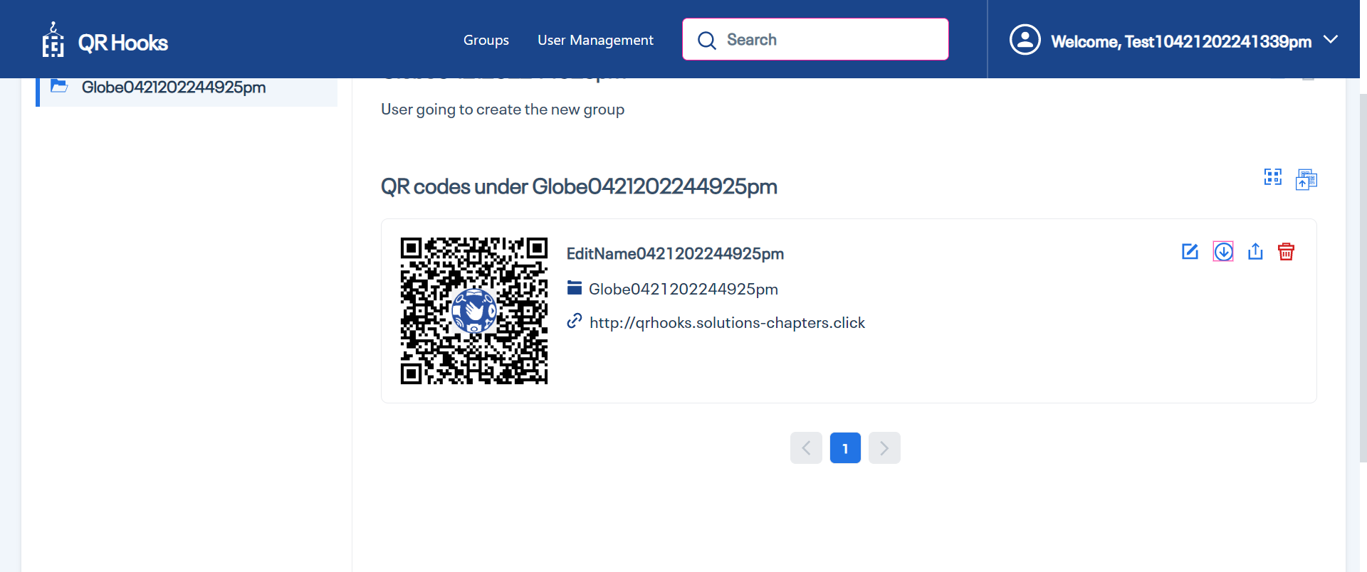

|  |  |  |  |  |
| --- | --- | --- | --- | --- |
| 5 | Comparing Actual vs Expected text | The Expected Text 'qr-hooks://qrhooks-api.solutions-chapters.click/scan/my3joio2v7x5' should be equal to Actual text from Application | The ExpectedText 'qr-hooks://qrhooks-api.solutions-chapters.click/scan/my3joio2v7x5' is same as the Actual Text 'qr-hooks://qrhooks-api.solutions-chapters.click/scan/my3joio2v7x5' | Passed |

|  |  |  |  |  |
| --- | --- | --- | --- | --- |
| 6 | Click on 'QrCodeDeleteButton' | Able to click on 'QrCodeDeleteButton' button. | Clicked on 'QrCodeDeleteButton' button. | Passed |

|  |  |  |  |  |
| --- | --- | --- | --- | --- |
| 7 | Click on 'QRCodePopUpDeleteButton' | Able to click on 'QRCodePopUpDeleteButton' button. | Clicked on 'QRCodePopUpDeleteButton' button. | Passed |

|  |  |  |  |  |
| --- | --- | --- | --- | --- |
| 8 | Check visibility of locator 'QRCOdeDeleteSuccesMessage' in Page 'GroupsPage' | 'QRCOdeDeleteSuccesMessage' should be visible on the Application | 'QRCOdeDeleteSuccesMessage' is visbile on the page 'GroupsPage' | Passed |