 

Test Summary Report

# Total Test Cases : 6 Passed : 3 Failed : 3

|  |  |  |  |  |
| --- | --- | --- | --- | --- |
| **Test Scenario Sr No** | **Test Case/Step Desc** | **Test Case/Step Status** | **StartTime** | **EndTime** |

|  |  |  |  |  |
| --- | --- | --- | --- | --- |
| **TC-20.02 create group** | **user able to create the group** | **Passed** | **2022/04/22 12:09:20** | **2022/04/22 12:09:35** |

|  |  |  |  |  |
| --- | --- | --- | --- | --- |
| **Test Step No** | **Step Desc** | **Expected Result** | **Actual Result** | **Step Status** |

|  |  |  |  |  |
| --- | --- | --- | --- | --- |
| 1 | Entering text 'madhukar.lakkam@globe.com.ph' in 'UserName' text field | Should able to enter data'madhukar.lakkam@globe.com.ph' into 'UserName' text field | Entered data'madhukar.lakkam@globe.com.ph' into 'UserName' text field successfully | Passed |

|  |  |  |  |  |
| --- | --- | --- | --- | --- |
| 2 | Entering text 'Lavi@1234' in 'Password' text field | Should able to enter data'Lavi@1234' into 'Password' text field | Entered data'Lavi@1234' into 'Password' text field successfully | Passed |

|  |  |  |  |  |
| --- | --- | --- | --- | --- |
| 3 | Click on 'LoginButton' | Able to click on 'LoginButton' button. | Clicked on 'LoginButton' button. | Passed |

|  |  |  |  |  |
| --- | --- | --- | --- | --- |
| 4 | Check visibility of locator 'WelcomeButton' in Page 'QRHooksHomePage' | 'WelcomeButton' should be visible on the Application | 'WelcomeButton' is visbile on the page 'QRHooksHomePage' | Passed |

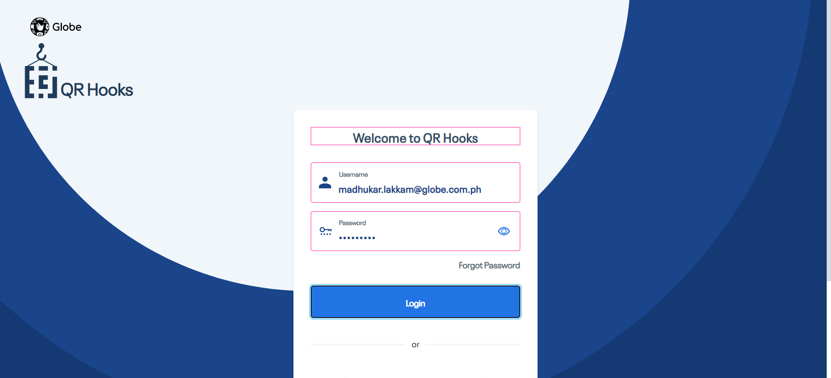

|  |  |  |  |  |
| --- | --- | --- | --- | --- |
| 5 | Check visibility of locator 'GroupText' in Page 'QRHooksHomePage' | 'GroupText' should be visible on the Application | 'GroupText' is visbile on the page 'QRHooksHomePage' | Passed |

|  |  |  |  |  |
| --- | --- | --- | --- | --- |
| 6 | Click on 'CreateNewGroupButton' | Able to click on 'CreateNewGroupButton' button. | Clicked on 'CreateNewGroupButton' button. | Passed |

|  |  |  |  |  |
| --- | --- | --- | --- | --- |
| 7 | Click on 'SaveButton' | Able to click on 'SaveButton' button. | Clicked on 'SaveButton' button. | Passed |

|  |  |  |  |  |
| --- | --- | --- | --- | --- |
| 8 | Check visibility of locator 'GrooupNameRequired' in Page 'CreateNewGroupPopUpWindow' | 'GrooupNameRequired' should be visible on the Application | 'GrooupNameRequired' is visbile on the page 'CreateNewGroupPopUpWindow' | Passed |

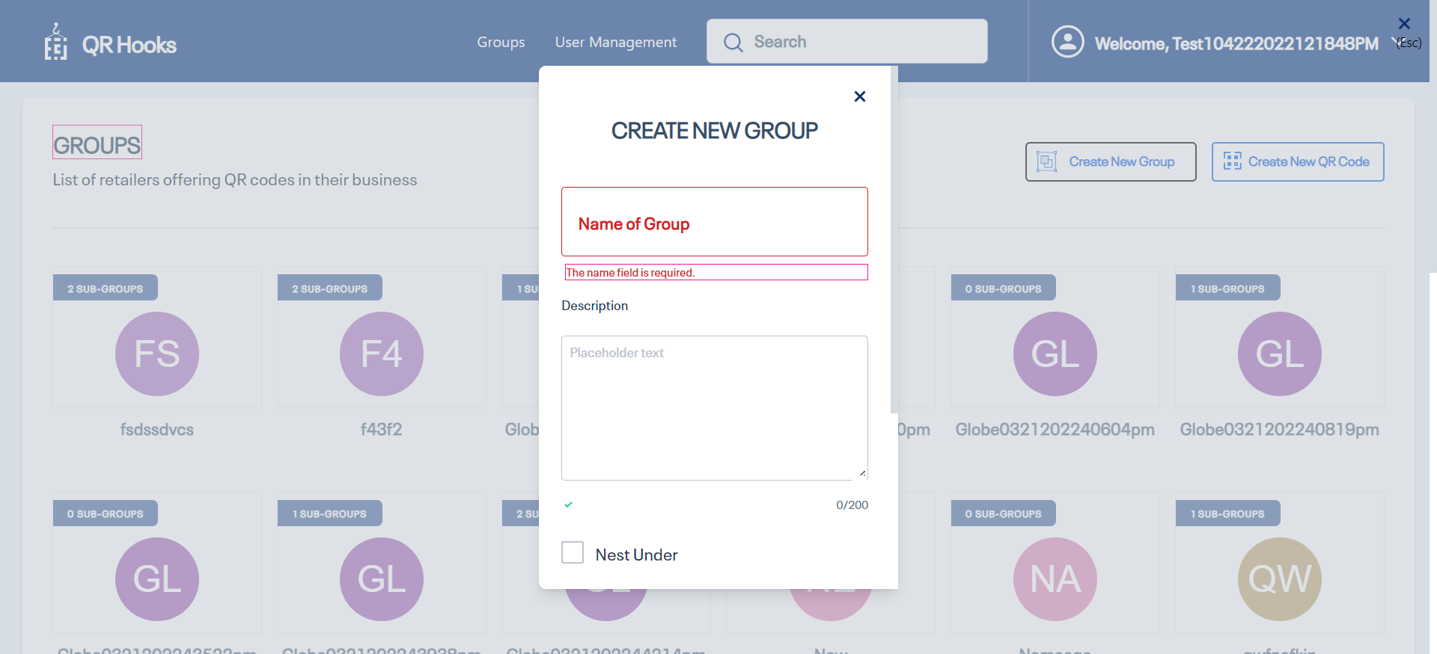

|  |  |  |  |  |
| --- | --- | --- | --- | --- |
| 9 | Click on 'CancelButton' | Able to click on 'CancelButton' button. | Clicked on 'CancelButton' button. | Passed |

|  |  |  |  |  |
| --- | --- | --- | --- | --- |
| 10 | Click on 'CreateNewGroupButton' | Able to click on 'CreateNewGroupButton' button. | Clicked on 'CreateNewGroupButton' button. | Passed |

|  |  |  |  |  |
| --- | --- | --- | --- | --- |
| 11 | Click on 'groupnameTextfield' | Able to click on 'groupnameTextfield' button. | Clicked on 'groupnameTextfield' button. | Passed |

|  |  |  |  |  |
| --- | --- | --- | --- | --- |
| 12 | Entering text 'Globe04222022120920pm' in 'groupnameTextfield' text field | Should able to enter data'Globe04222022120920pm' into 'groupnameTextfield' text field | Entered data'Globe04222022120920pm' into 'groupnameTextfield' text field successfully | Passed |

|  |  |  |  |  |
| --- | --- | --- | --- | --- |
| 13 | Check visibility of locator 'Desciption' in Page 'CreateNewGroupPopUpWindow' | 'Desciption' should be visible on the Application | 'Desciption' is visbile on the page 'CreateNewGroupPopUpWindow' | Passed |

|  |  |  |  |  |
| --- | --- | --- | --- | --- |
| 14 | Entering text 'User going to create the new group' in 'groupDescriptionField' text field | Should able to enter data'User going to create the new group' into 'groupDescriptionField' text field | Entered data'User going to create the new group' into 'groupDescriptionField' text field successfully | Passed |

|  |  |  |  |  |
| --- | --- | --- | --- | --- |
| 15 | Check visibility of locator 'Nest Under' in Page 'CreateNewGroupPopUpWindow' | 'Nest Under' should be visible on the Application | 'Nest Under' is visbile on the page 'CreateNewGroupPopUpWindow' | Passed |

|  |  |  |  |  |
| --- | --- | --- | --- | --- |
| 16 | Check visibility of locator 'DescriptionLegnth' in Page 'CreateNewGroupPopUpWindow' | 'DescriptionLegnth' should be visible on the Application | 'DescriptionLegnth' is visbile on the page 'CreateNewGroupPopUpWindow' | Passed |

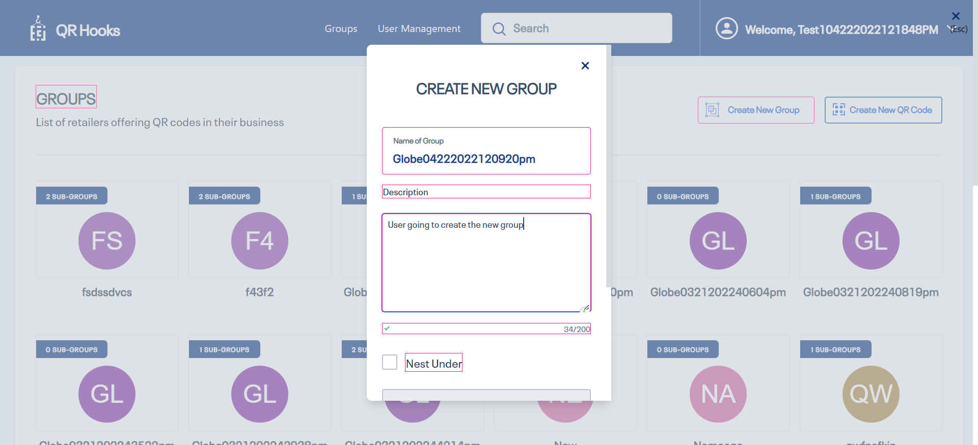

|  |  |  |  |  |
| --- | --- | --- | --- | --- |
| 17 | Check visibility of locator 'SaveButton' in Page 'CreateNewGroupPopUpWindow' | 'SaveButton' should be visible on the Application | 'SaveButton' is visbile on the page 'CreateNewGroupPopUpWindow' | Passed |

|  |  |  |  |  |
| --- | --- | --- | --- | --- |
| 18 | Click on 'SaveButton' | Able to click on 'SaveButton' button. | Clicked on 'SaveButton' button. | Passed |

|  |  |  |  |  |
| --- | --- | --- | --- | --- |
| 19 | Check visibility of locator 'GroupcreatedSuccessMessage' in Page 'QRHooksHomePage' | 'GroupcreatedSuccessMessage' should be visible on the Application | 'GroupcreatedSuccessMessage' is visbile on the page 'QRHooksHomePage' | Passed |

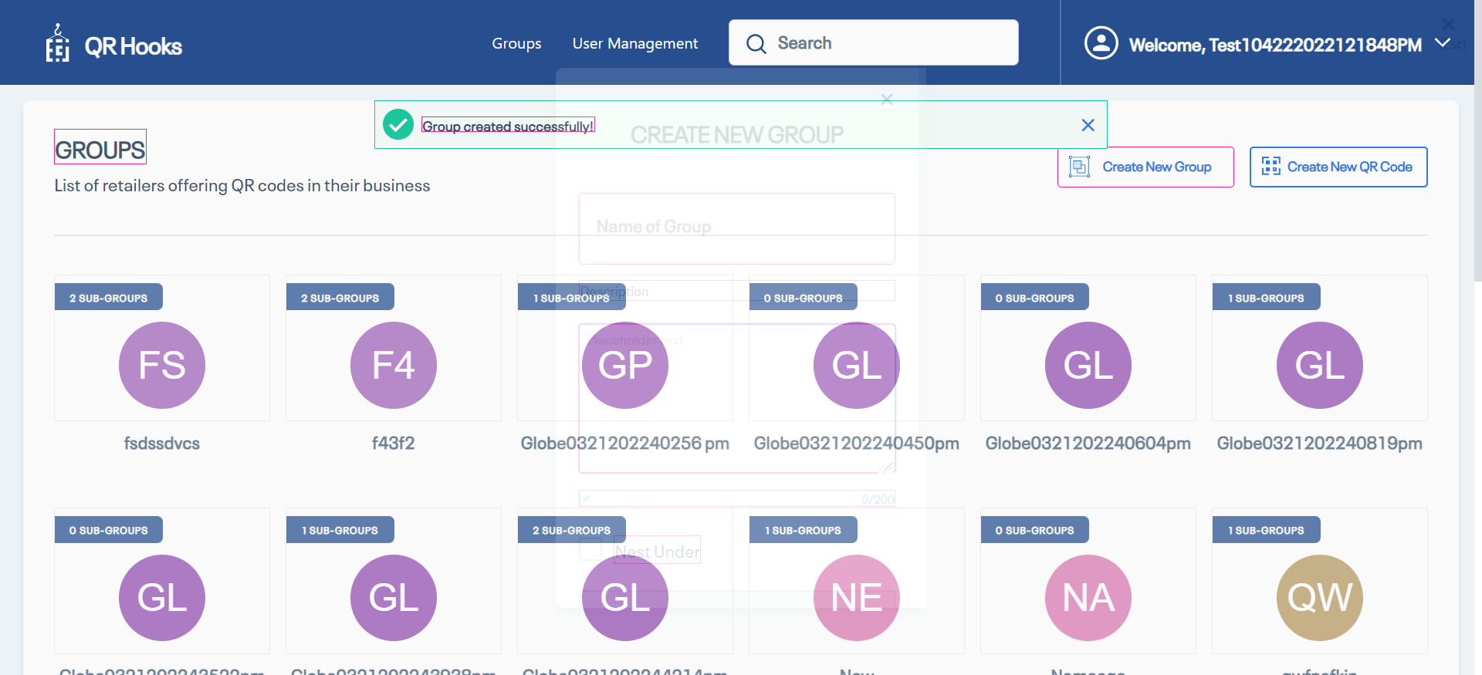

|  |  |  |  |  |
| --- | --- | --- | --- | --- |
| 20 | Entering text 'Globe04222022120920pm' in 'SearchBar' text field | Should able to enter data'Globe04222022120920pm' into 'SearchBar' text field | Entered data'Globe04222022120920pm' into 'SearchBar' text field successfully | Passed |

|  |  |  |  |  |
| --- | --- | --- | --- | --- |
| 21 | Check visibility of locator 'Globe04222022120920pm' in Page 'Edit Profile' | 'Globe04222022120920pm' should be visible on the Application | 'Globe04222022120920pm' is visbile on the page 'Edit Profile' | Passed |

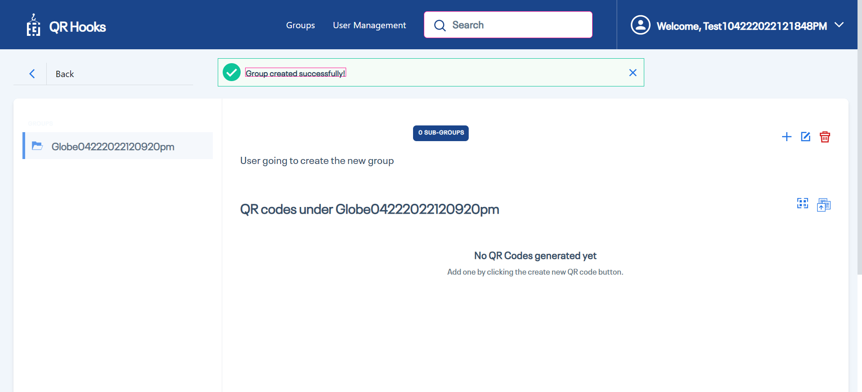

|  |  |  |  |  |
| --- | --- | --- | --- | --- |
| **Test Scenario Sr No** | **Test Case/Step Desc** | **Test Case/Step Status** | **StartTime** | **EndTime** |

|  |  |  |  |  |
| --- | --- | --- | --- | --- |
| **TC-25.03,25.04,25.06,25.07,25.08,25.14,25.15,25.16,25.17,29.01 createQRcode by clicking on create new QR Code button** | **User is able to create the QR Code by clicking on create new QR Code button** | **Failed** | **2022/04/22 12:09:35** | **2022/04/22 12:09:54** |

|  |  |  |  |  |
| --- | --- | --- | --- | --- |
| **Test Step No** | **Step Desc** | **Expected Result** | **Actual Result** | **Step Status** |

|  |  |  |  |  |
| --- | --- | --- | --- | --- |
| 1 | Click on 'GroupButton' | Able to click on 'GroupButton' button. | Clicked on 'GroupButton' button. | Passed |

|  |  |  |  |  |
| --- | --- | --- | --- | --- |
| 2 | Click on 'CreateNewQRCode' | Able to click on 'CreateNewQRCode' button. | Clicked on 'CreateNewQRCode' button. | Passed |

|  |  |  |  |  |
| --- | --- | --- | --- | --- |
| 3 | Check visibility of locator 'SelectagroupforSub-Group' in Page 'CreateNewQRCode' | 'SelectagroupforSub-Group' should be visible on the Application | 'SelectagroupforSub-Group' is visbile on the page 'CreateNewQRCode' | Passed |

|  |  |  |  |  |
| --- | --- | --- | --- | --- |
| 4 | Check visibility of locator 'ADDContentDetails' in Page 'CreateNewQRCode' | 'ADDContentDetails' should be visible on the Application | 'ADDContentDetails' is visbile on the page 'CreateNewQRCode' | Passed |

|  |  |  |  |  |
| --- | --- | --- | --- | --- |
| 5 | Check visibility of locator 'Review&Generate' in Page 'CreateNewQRCode' | 'Review&Generate' should be visible on the Application | 'Review&Generate' is visbile on the page 'CreateNewQRCode' | Passed |

|  |  |  |  |  |
| --- | --- | --- | --- | --- |
| 6 | Check visibility of locator 'CreateNewGroupButton' in Page 'CreateNewQRCode' | 'CreateNewGroupButton' should be visible on the Application | 'CreateNewGroupButton' is visbile on the page 'CreateNewQRCode' | Passed |

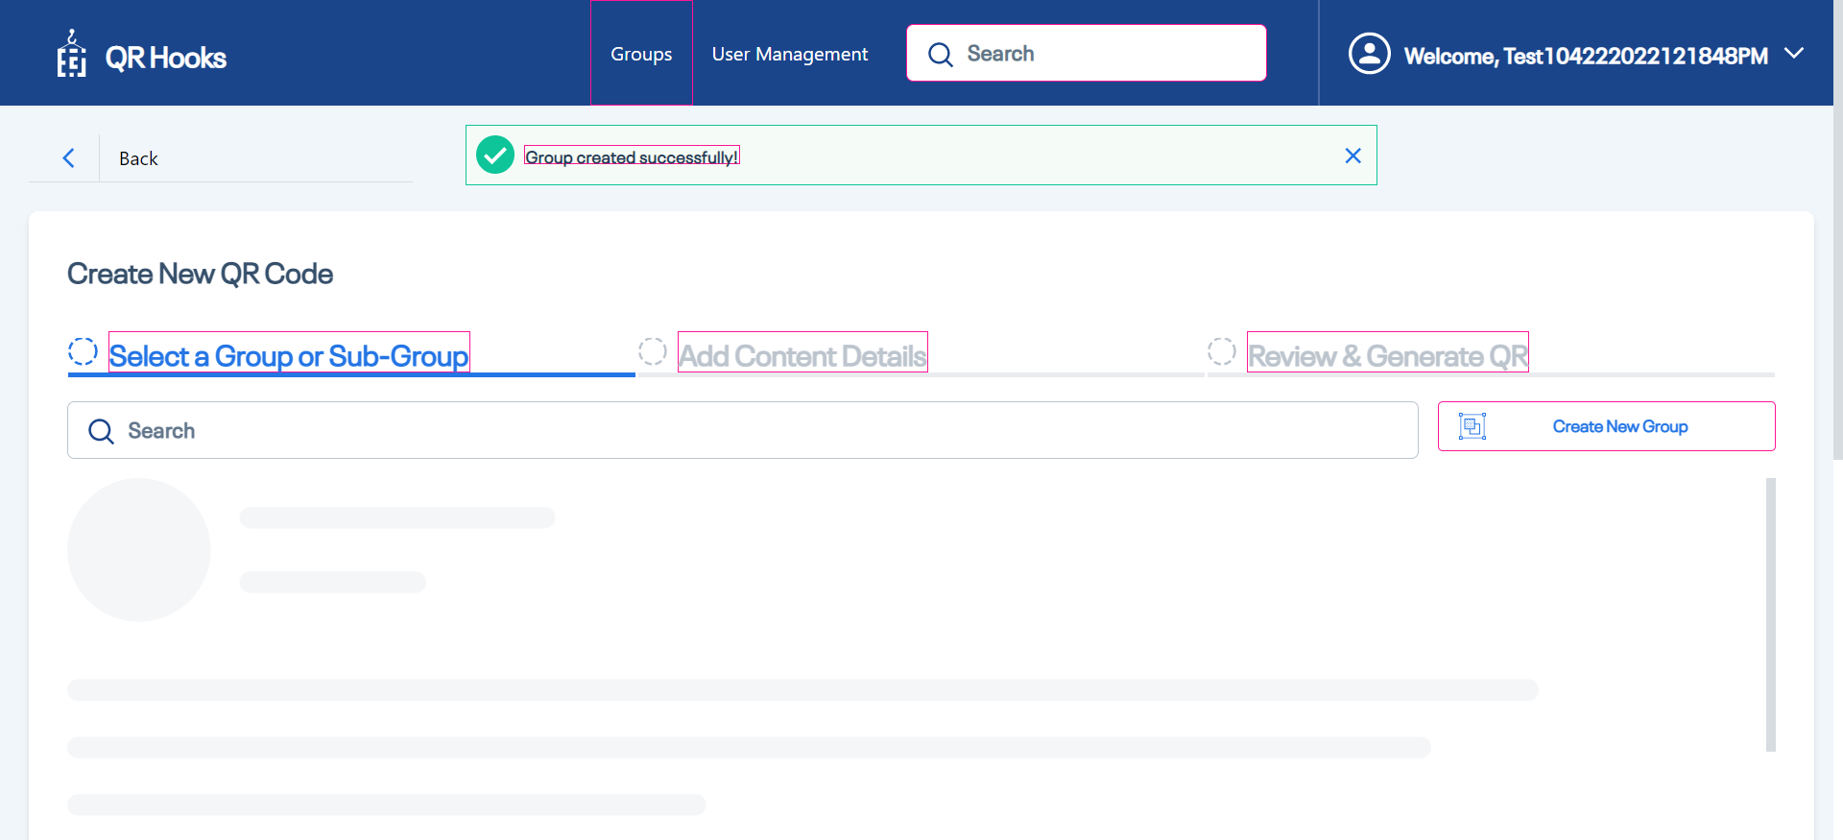

|  |  |  |  |  |
| --- | --- | --- | --- | --- |
| 7 | Entering text 'Globe04222022120920pm' in 'searchBar' text field | Should able to enter data'Globe04222022120920pm' into 'searchBar' text field | Entered data'Globe04222022120920pm' into 'searchBar' text field successfully | Passed |

|  |  |  |  |  |
| --- | --- | --- | --- | --- |
| 8 | Click on 'NextButton' | Able to click on 'NextButton' button. | Clicked on 'NextButton' button. | Passed |

|  |  |  |  |  |
| --- | --- | --- | --- | --- |
| 9 | Click on 'GoBack' | Able to click on 'GoBack' button. | Clicked on 'GoBack' button. | Passed |

|  |  |  |  |  |
| --- | --- | --- | --- | --- |
| 10 | Entering text 'Globe04222022120920pm' in 'searchBar' text field | Should able to enter data'Globe04222022120920pm' into 'searchBar' text field | Entered data'Globe04222022120920pm' into 'searchBar' text field successfully | Passed |

|  |  |  |  |  |
| --- | --- | --- | --- | --- |
| 11 | Click on 'NextButton' | Able to click on 'NextButton' button. | Clicked on 'NextButton' button. | Passed |

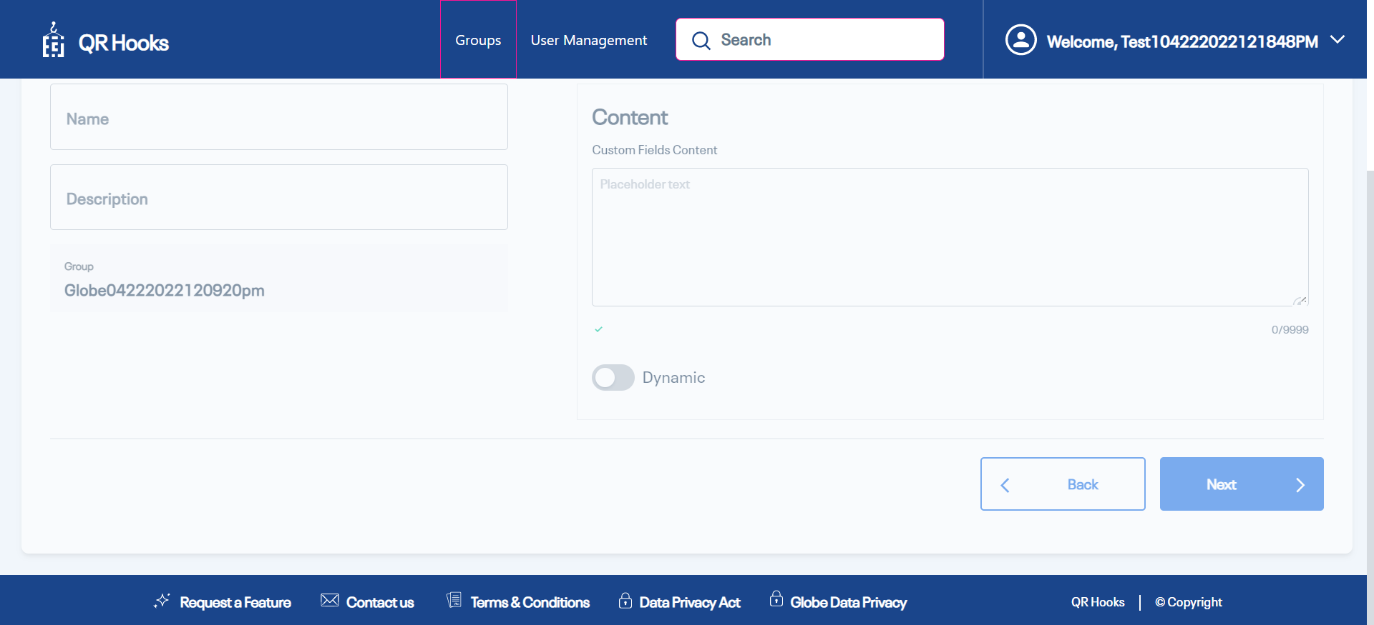

|  |  |  |  |  |
| --- | --- | --- | --- | --- |
| 12 | Click on 'NextButton' | Able to click on 'NextButton' button. | Clicked on 'NextButton' button. | Passed |

|  |  |  |  |  |
| --- | --- | --- | --- | --- |
| 13 | Check visibility of locator 'NameFiledRequired' in Page 'ADDContentDetails' | 'NameFiledRequired' should be visible on the Application | 'NameFiledRequired' is visbile on the page 'ADDContentDetails' | Passed |

|  |  |  |  |  |
| --- | --- | --- | --- | --- |
| 14 | Check visibility of locator 'contentfieldRequired' in Page 'ADDContentDetails' | 'contentfieldRequired' should be visible on the Application | 'contentfieldRequired' is visbile on the page 'ADDContentDetails' | Passed |

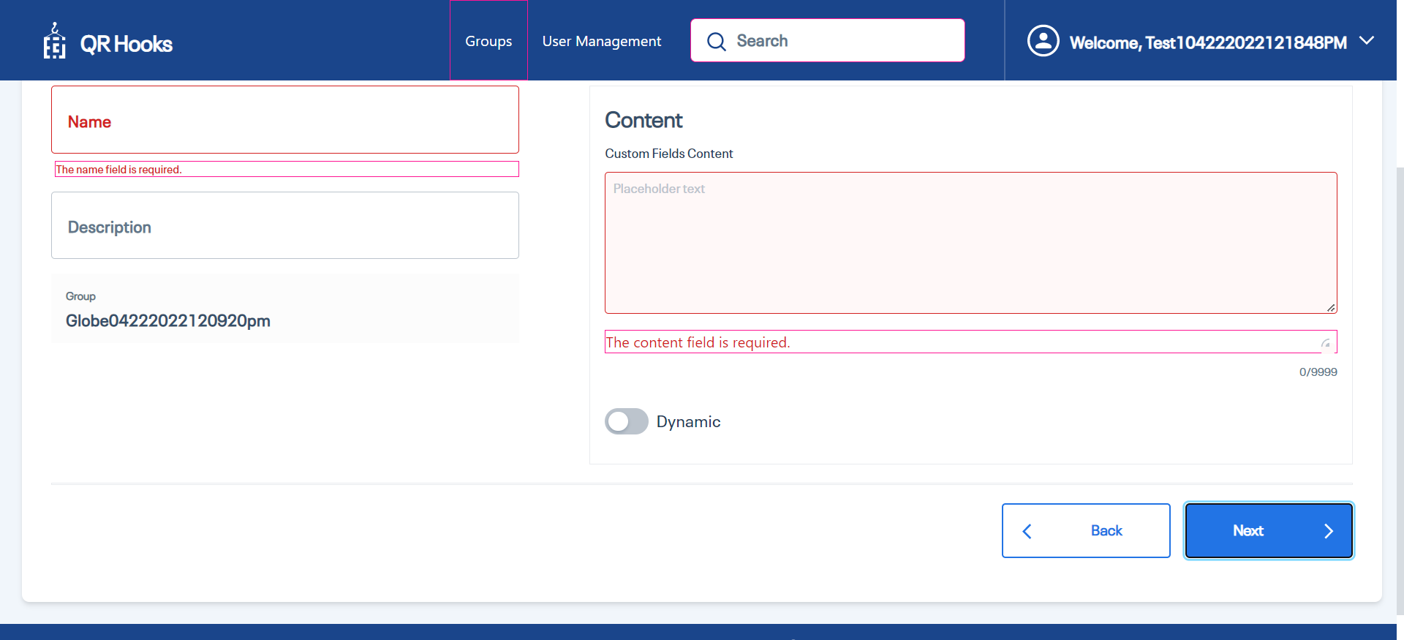

|  |  |  |  |  |
| --- | --- | --- | --- | --- |
| 15 | Entering text 'QRCodeName04222022120920pm' in 'Namefield' text field | Should able to enter data'QRCodeName04222022120920pm' into 'Namefield' text field | Entered data'QRCodeName04222022120920pm' into 'Namefield' text field successfully | Passed |

|  |  |  |  |  |
| --- | --- | --- | --- | --- |
| 16 | Entering text 'QRCodeDescriptio04222022120920pm' in 'descriptionField' text field | Should able to enter data'QRCodeDescriptio04222022120920pm' into 'descriptionField' text field | Entered data'QRCodeDescriptio04222022120920pm' into 'descriptionField' text field successfully | Passed |

|  |  |  |  |  |
| --- | --- | --- | --- | --- |
| 17 | Entering text 'QRCodeContent04222022120920pm' in 'Content' text field | Should able to enter data'QRCodeContent04222022120920pm' into 'Content' text field | Entered data'QRCodeContent04222022120920pm' into 'Content' text field successfully | Passed |

|  |  |  |  |  |
| --- | --- | --- | --- | --- |
| 18 | Check visibility of locator 'group' in Page 'ADDContentDetails' | 'group' should be visible on the Application | 'group' is visbile on the page 'ADDContentDetails' | Passed |

|  |  |  |  |  |
| --- | --- | --- | --- | --- |
| 19 | Verify the group name | user should be able to See the Group Name | User is able to See the Group Name | Passed |

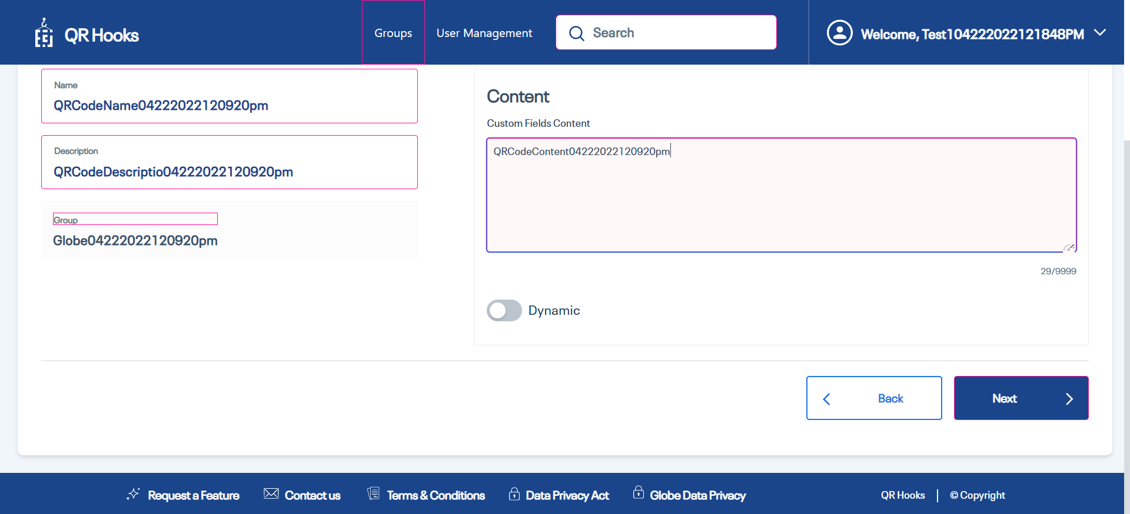

|  |  |  |  |  |
| --- | --- | --- | --- | --- |
| 20 | Click on 'NextButton' | Able to click on 'NextButton' button. | Clicked on 'NextButton' button. | Passed |

|  |  |  |  |  |
| --- | --- | --- | --- | --- |
| 21 | Click on 'GoBack' | Able to click on 'GoBack' button. | Clicked on 'GoBack' button. | Passed |

|  |  |  |  |  |
| --- | --- | --- | --- | --- |
| 22 | Click on 'NextButton' | Able to click on 'NextButton' button. | Clicked on 'NextButton' button. | Passed |

|  |  |  |  |  |
| --- | --- | --- | --- | --- |
| 23 | Verify the group name | user should be able to See the Group Name | User is able to See the Group Name | Passed |

|  |  |  |  |  |
| --- | --- | --- | --- | --- |
| 24 | Comparing Actual vs Expected text | The Expected Text 'QRCodeName04222022120920pm' should be equal to Actual text from Application | The ExpectedText 'QRCodeName04222022120920pm' is same as the Actual Text 'QRCodeName04222022120920pm' | Passed |

|  |  |  |  |  |
| --- | --- | --- | --- | --- |
| 25 | Comparing Actual vs Expected text | The Expected Text 'QRCodeDescriptio04222022120920pm' should be equal to Actual text from Application | The ExpectedText 'QRCodeDescriptio04222022120920pm' is same as the Actual Text 'QRCodeDescriptio04222022120920pm' | Passed |

|  |  |  |  |  |
| --- | --- | --- | --- | --- |
| 26 | Comparing Actual vs Expected text | The Expected Text 'QRCodeContent04222022120920pm' should be equal to Actual text from Application | The ExpectedText 'QRCodeContent04222022120920pm' is same as the Actual Text 'QRCodeContent04222022120920pm' | Passed |

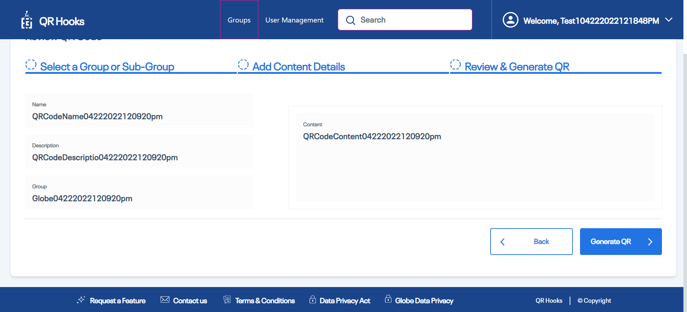

|  |  |  |  |  |
| --- | --- | --- | --- | --- |
| 27 | Click on 'GenerateQRCodeButton' | Able to click on 'GenerateQRCodeButton' button. | Clicked on 'GenerateQRCodeButton' button. | Passed |

|  |  |  |  |  |
| --- | --- | --- | --- | --- |
| 28 | Comparing text of field 'QRName' in Page 'QRCodePage | The ExpectedText 'QRCodeName04222022120920pm' should be equal to Actual text from Application | The ExpectedText 'QRCodeName04222022120920pm' is same as the Actual Text 'QRCodeName04222022120920pm' | Passed |

|  |  |  |  |  |
| --- | --- | --- | --- | --- |
| 29 | Comparing Actual vs Expected text | The Expected Text 'QRCodeContent04222022120920pm' should be equal to Actual text from Application | The ExpectedText 'QRCodeContent04222022120920pm' is same as the Actual Text 'QRCodeContent04222022120920pm' | Passed |

|  |  |  |  |  |
| --- | --- | --- | --- | --- |
| 30 | Click on 'SaveToDevice' | Able to click on 'SaveToDevice' button. | Clicked on 'SaveToDevice' button. | Passed |

|  |  |  |  |  |
| --- | --- | --- | --- | --- |
| 31 | Check visibility of locator 'ShareviaEmail' in Page 'QRCodePage' | 'ShareviaEmail' should be visible on the Application | 'ShareviaEmail' is visbile on the page 'QRCodePage' | Passed |

|  |  |  |  |  |
| --- | --- | --- | --- | --- |
| 32 | Check visibility of locator 'GoToHomeButton' in Page 'QRCodePage' | 'GoToHomeButton' should be visible on the Application | 'GoToHomeButton' is visbile on the page 'QRCodePage' | Passed |

|  |  |  |  |  |
| --- | --- | --- | --- | --- |
| 33 | Dowload the QR Code | user should be able to dowload the QR Code | User is not able to dowload the qr code | Failed |

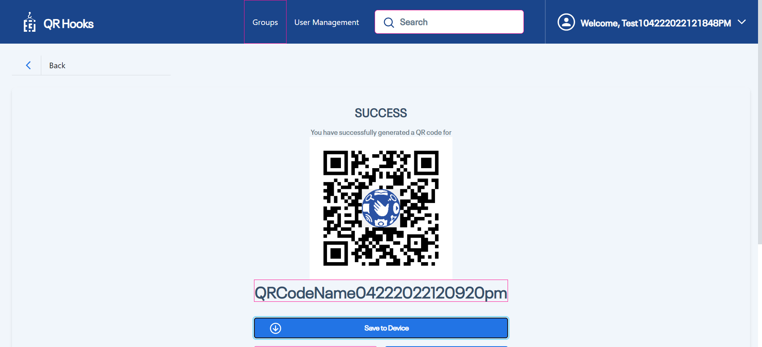

|  |  |  |  |  |
| --- | --- | --- | --- | --- |
| **Test Scenario Sr No** | **Test Case/Step Desc** | **Test Case/Step Status** | **StartTime** | **EndTime** |

|  |  |  |  |  |
| --- | --- | --- | --- | --- |
| **TC-20.02,20.04,20.08 EditQR code** | **User is able to Edit The QRCode** | **Passed** | **2022/04/22 12:09:54** | **2022/04/22 12:10:05** |

|  |  |  |  |  |
| --- | --- | --- | --- | --- |
| **Test Step No** | **Step Desc** | **Expected Result** | **Actual Result** | **Step Status** |

|  |  |  |  |  |
| --- | --- | --- | --- | --- |
| 1 | Click on 'QRCodeEditButton' | Able to click on 'QRCodeEditButton' button. | Clicked on 'QRCodeEditButton' button. | Passed |

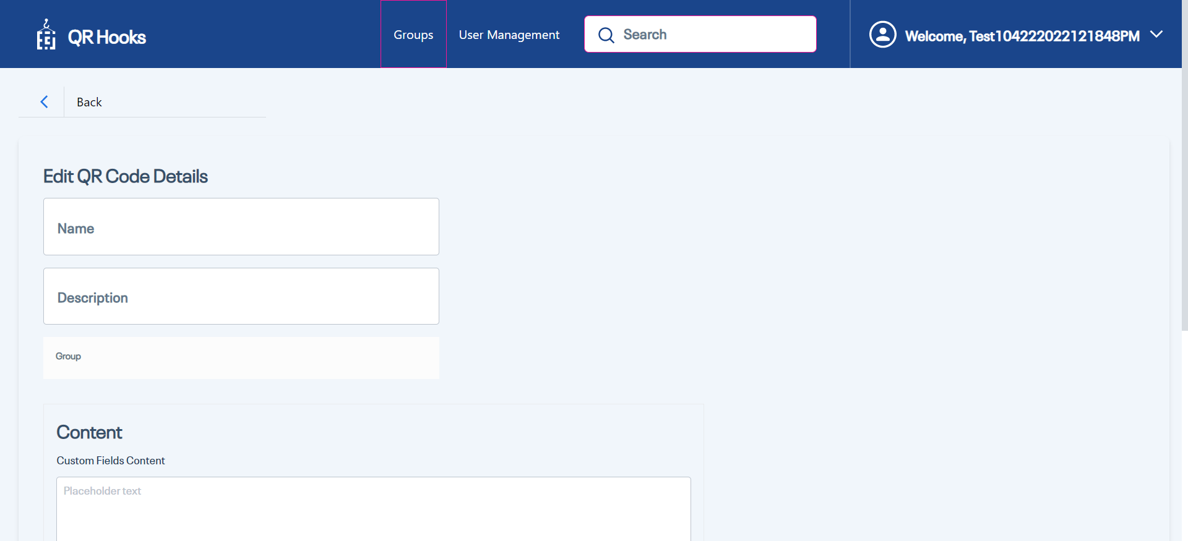

|  |  |  |  |  |
| --- | --- | --- | --- | --- |
| 2 | Click on 'EditName' | Able to click on 'EditName' button. | Clicked on 'EditName' button. | Passed |

|  |  |  |  |  |
| --- | --- | --- | --- | --- |
| 3 | Entering text 'EditName04222022120920pm' in 'EditName' text field | Should able to enter data'EditName04222022120920pm' into 'EditName' text field | Entered data'EditName04222022120920pm' into 'EditName' text field successfully | Passed |

|  |  |  |  |  |
| --- | --- | --- | --- | --- |
| 4 | Entering text 'EditDescription04222022120920pm' in 'Editdescription' text field | Should able to enter data'EditDescription04222022120920pm' into 'Editdescription' text field | Entered data'EditDescription04222022120920pm' into 'Editdescription' text field successfully | Passed |

|  |  |  |  |  |
| --- | --- | --- | --- | --- |
| 5 | Verify the group name | user should be able to See the Group Name | User is able to See the Group Name | Passed |

|  |  |  |  |  |
| --- | --- | --- | --- | --- |
| 6 | Entering text 'EditContent04222022120920pm' in 'Editcontent' text field | Should able to enter data'EditContent04222022120920pm' into 'Editcontent' text field | Entered data'EditContent04222022120920pm' into 'Editcontent' text field successfully | Passed |

|  |  |  |  |  |
| --- | --- | --- | --- | --- |
| 7 | Click on 'Save&Regenerate' | Able to click on 'Save&Regenerate' button. | Clicked on 'Save&Regenerate' button. | Passed |

|  |  |  |  |  |
| --- | --- | --- | --- | --- |
| 8 | Click on 'CancelButtonforEditQrCode PopUp' | Able to click on 'CancelButtonforEditQrCode PopUp' button. | Clicked on 'CancelButtonforEditQrCode PopUp' button. | Passed |

|  |  |  |  |  |
| --- | --- | --- | --- | --- |
| 9 | Click on 'Save&Regenerate' | Able to click on 'Save&Regenerate' button. | Clicked on 'Save&Regenerate' button. | Passed |

|  |  |  |  |  |
| --- | --- | --- | --- | --- |
| 10 | Check visibility of locator 'PopUpConfirmationMessage' in Page 'Edit QR Code Details' | 'PopUpConfirmationMessage' should be visible on the Application | 'PopUpConfirmationMessage' is visbile on the page 'Edit QR Code Details' | Passed |

|  |  |  |  |  |
| --- | --- | --- | --- | --- |
| 11 | Check visibility of locator 'CancelButtonforEditQrCode PopUp' in Page 'Edit QR Code Details' | 'CancelButtonforEditQrCode PopUp' should be visible on the Application | 'CancelButtonforEditQrCode PopUp' is visbile on the page 'Edit QR Code Details' | Passed |

|  |  |  |  |  |
| --- | --- | --- | --- | --- |
| 12 | Click on 'QRCodeSave' | Able to click on 'QRCodeSave' button. | Clicked on 'QRCodeSave' button. | Passed |

|  |  |  |  |  |
| --- | --- | --- | --- | --- |
| 13 | Comparing text of field 'QRName' in Page 'QRCodePage | The ExpectedText 'EditName04222022120920pm' should be equal to Actual text from Application | The ExpectedText 'EditName04222022120920pm' is same as the Actual Text 'EditName04222022120920pm' | Passed |

|  |  |  |  |  |
| --- | --- | --- | --- | --- |
| 14 | Comparing Actual vs Expected text | The Expected Text 'EditContent04222022120920pm' should be equal to Actual text from Application | The ExpectedText 'EditContent04222022120920pm' is same as the Actual Text 'EditContent04222022120920pm' | Passed |

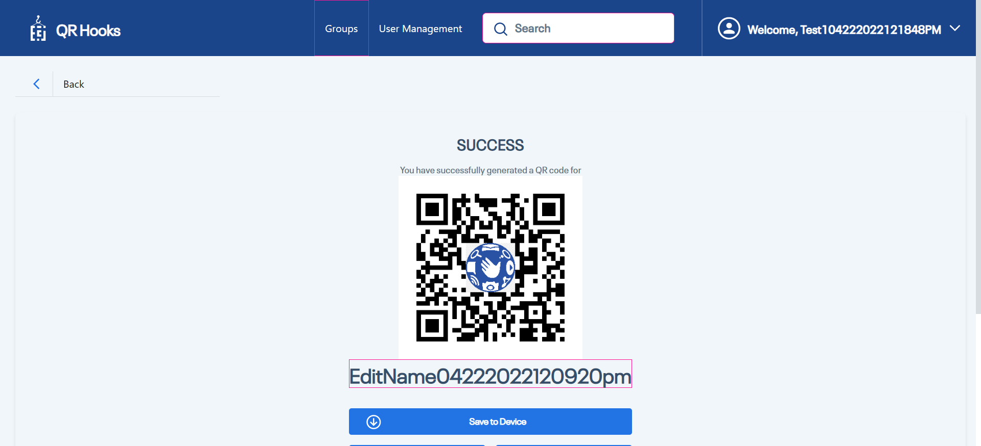

|  |  |  |  |  |
| --- | --- | --- | --- | --- |
| **Test Scenario Sr No** | **Test Case/Step Desc** | **Test Case/Step Status** | **StartTime** | **EndTime** |

|  |  |  |  |  |
| --- | --- | --- | --- | --- |
| **TC-20.09,25.17,25.18,25.19,25.21,25.22,25.23 Validate Under QR Code options(Download QR Code, Share via Email, Go to Home Button)** | **User should be able to Validate the under QR Code Options(Download QR Code,Share via Email, Go To Home Button)** | **Failed** | **2022/04/22 12:10:05** | **2022/04/22 12:10:09** |

|  |  |  |  |  |
| --- | --- | --- | --- | --- |
| **Test Step No** | **Step Desc** | **Expected Result** | **Actual Result** | **Step Status** |

|  |  |  |  |  |
| --- | --- | --- | --- | --- |
| 1 | Check visibility of locator 'QRCodeEditButton' in Page 'QRCodePage' | 'QRCodeEditButton' should be visible on the Application | 'QRCodeEditButton' is visbile on the page 'QRCodePage' | Passed |

|  |  |  |  |  |
| --- | --- | --- | --- | --- |
| 2 | Check visibility of locator 'ShareviaEmail' in Page 'QRCodePage' | 'ShareviaEmail' should be visible on the Application | 'ShareviaEmail' is visbile on the page 'QRCodePage' | Passed |

|  |  |  |  |  |
| --- | --- | --- | --- | --- |
| 3 | Check visibility of locator 'GoToHomeButton' in Page 'QRCodePage' | 'GoToHomeButton' should be visible on the Application | 'GoToHomeButton' is visbile on the page 'QRCodePage' | Passed |

|  |  |  |  |  |
| --- | --- | --- | --- | --- |
| 4 | Click on 'SaveToDevice' | Able to click on 'SaveToDevice' button. | Clicked on 'SaveToDevice' button. | Passed |

|  |  |  |  |  |
| --- | --- | --- | --- | --- |
| 5 | Dowload the QR Code | user should be able to dowload the QR Code | User is not able to dowload the qr code | Failed |

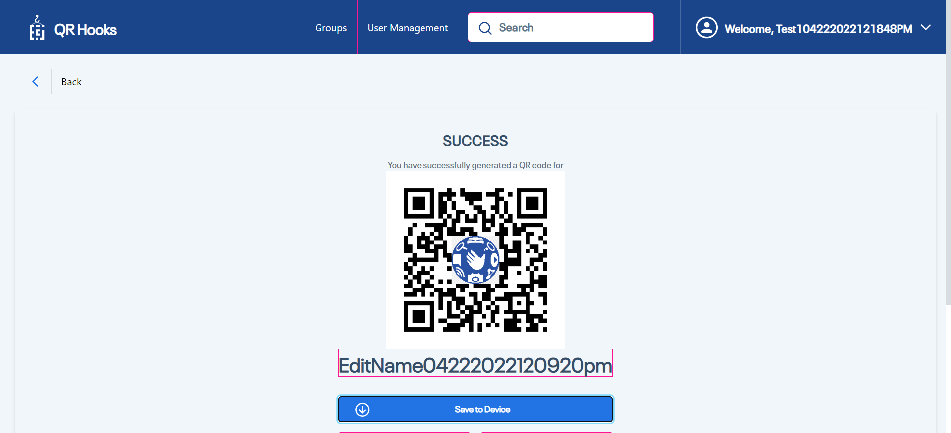

|  |  |  |  |  |
| --- | --- | --- | --- | --- |
| 6 | Click on 'GoToHomeButton' | Able to click on 'GoToHomeButton' button. | Clicked on 'GoToHomeButton' button. | Passed |

|  |  |  |  |  |
| --- | --- | --- | --- | --- |
| 7 | Check visibility of locator 'GroupText' in Page 'QRHooksHomePage' | 'GroupText' should be visible on the Application | 'GroupText' is visbile on the page 'QRHooksHomePage' | Passed |

|  |  |  |  |  |
| --- | --- | --- | --- | --- |
| **Test Scenario Sr No** | **Test Case/Step Desc** | **Test Case/Step Status** | **StartTime** | **EndTime** |

|  |  |  |  |  |
| --- | --- | --- | --- | --- |
| **TC-12.06,12.07,12.08,12.09,14.03,19.01,21.01 Delete the QR code and also validate the share via Email button for QR Code, download button for QR Code and QR code delete under group page** | **User should be able to delete the Qr Code and also user should be able to validate the share via Email button for QR Code, download button for QR Code and QR code delete under group page** | **Failed** | **2022/04/22 12:10:09** | **2022/04/22 12:10:17** |

|  |  |  |  |  |
| --- | --- | --- | --- | --- |
| **Test Step No** | **Step Desc** | **Expected Result** | **Actual Result** | **Step Status** |

|  |  |  |  |  |
| --- | --- | --- | --- | --- |
| 1 | Entering text 'Globe04222022120920pm' in 'SearchBar' text field | Should able to enter data'Globe04222022120920pm' into 'SearchBar' text field | Entered data'Globe04222022120920pm' into 'SearchBar' text field successfully | Passed |

|  |  |  |  |  |
| --- | --- | --- | --- | --- |
| 2 | Disabled 'DeleteButtonforgroup' | 'DeleteButtonforgroup should be disabled' button. | 'DeleteButtonforgroup' is disabled. | Passed |

|  |  |  |  |  |
| --- | --- | --- | --- | --- |
| 3 | Click on 'DowloadQRCode' | Able to click on 'DowloadQRCode' button. | Clicked on 'DowloadQRCode' button. | Passed |

|  |  |  |  |  |
| --- | --- | --- | --- | --- |
| 4 | Dowload the QR Code | user should be able to dowload the QR Code | User is not able to dowload the qr code | Failed |

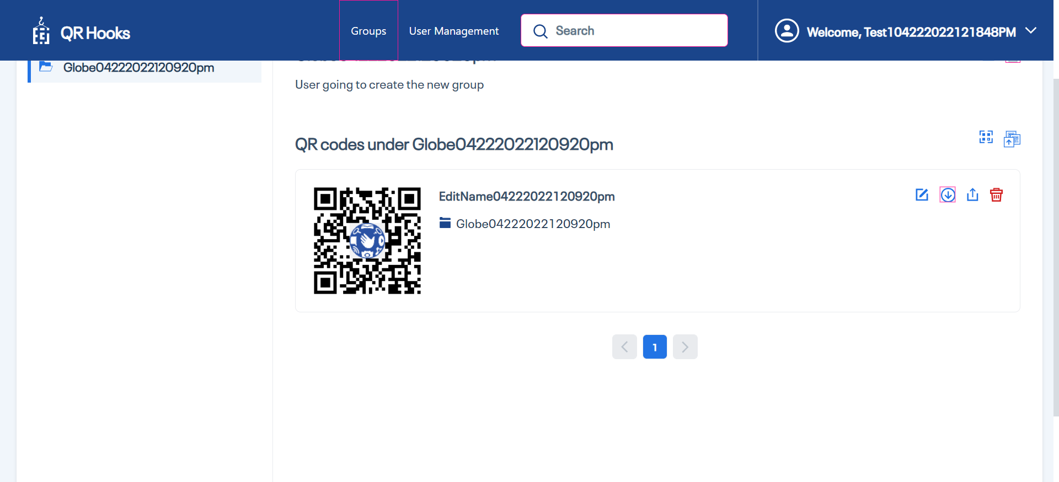

|  |  |  |  |  |
| --- | --- | --- | --- | --- |
| 5 | Comparing Actual vs Expected text | The Expected Text 'EditContent04222022120920pm' should be equal to Actual text from Application | The ExpectedText 'EditContent04222022120920pm' is same as the Actual Text 'EditContent04222022120920pm' | Passed |

|  |  |  |  |  |
| --- | --- | --- | --- | --- |
| 6 | Check visibility of locator 'ShareviaEmailQRCOdeButton' in Page 'GroupsPage' | 'ShareviaEmailQRCOdeButton' should be visible on the Application | 'ShareviaEmailQRCOdeButton' is visbile on the page 'GroupsPage' | Passed |

|  |  |  |  |  |
| --- | --- | --- | --- | --- |
| 7 | Check visibility of locator 'EditButtonforQRCode' in Page 'GroupsPage' | 'EditButtonforQRCode' should be visible on the Application | 'EditButtonforQRCode' is visbile on the page 'GroupsPage' | Passed |

|  |  |  |  |  |
| --- | --- | --- | --- | --- |
| 8 | Click on 'QrCodeDeleteButton' | Able to click on 'QrCodeDeleteButton' button. | Clicked on 'QrCodeDeleteButton' button. | Passed |

|  |  |  |  |  |
| --- | --- | --- | --- | --- |
| 9 | Click on 'QRCodePopUpCancelButton' | Able to click on 'QRCodePopUpCancelButton' button. | Clicked on 'QRCodePopUpCancelButton' button. | Passed |

|  |  |  |  |  |
| --- | --- | --- | --- | --- |
| 10 | Click on 'QrCodeDeleteButton' | Able to click on 'QrCodeDeleteButton' button. | Clicked on 'QrCodeDeleteButton' button. | Passed |

|  |  |  |  |  |
| --- | --- | --- | --- | --- |
| 11 | Check visibility of locator 'QRCodeDeletePopUpTitle' in Page 'GroupsPage' | 'QRCodeDeletePopUpTitle' should be visible on the Application | 'QRCodeDeletePopUpTitle' is visbile on the page 'GroupsPage' | Passed |

|  |  |  |  |  |
| --- | --- | --- | --- | --- |
| 12 | Check visibility of locator 'QRCodePopConfirmation' in Page 'GroupsPage' | 'QRCodePopConfirmation' should be visible on the Application | 'QRCodePopConfirmation' is visbile on the page 'GroupsPage' | Passed |

|  |  |  |  |  |
| --- | --- | --- | --- | --- |
| 13 | Click on 'QRCodePopUpDeleteButton' | Able to click on 'QRCodePopUpDeleteButton' button. | Clicked on 'QRCodePopUpDeleteButton' button. | Passed |

|  |  |  |  |  |
| --- | --- | --- | --- | --- |
| 14 | Check visibility of locator 'QRCOdeDeleteSuccesMessage' in Page 'GroupsPage' | 'QRCOdeDeleteSuccesMessage' should be visible on the Application | 'QRCOdeDeleteSuccesMessage' is visbile on the page 'GroupsPage' | Passed |

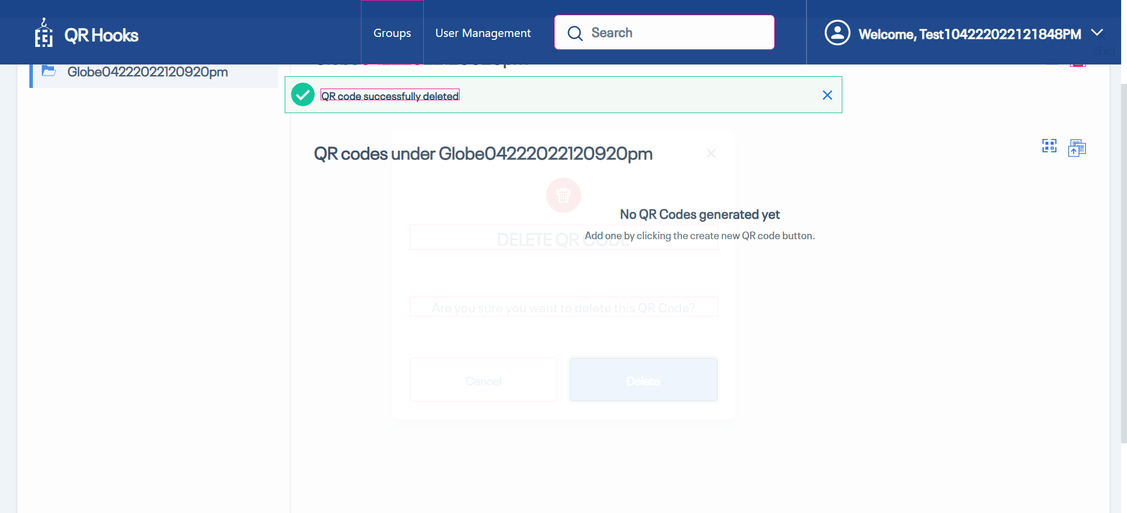

|  |  |  |  |  |
| --- | --- | --- | --- | --- |
| **Test Scenario Sr No** | **Test Case/Step Desc** | **Test Case/Step Status** | **StartTime** | **EndTime** |

|  |  |  |  |  |
| --- | --- | --- | --- | --- |
| **TC-14.01 Delete the group** | **user should be able to delete the group** | **Passed** | **2022/04/22 12:10:17** | **2022/04/22 12:10:18** |

|  |  |  |  |  |
| --- | --- | --- | --- | --- |
| **Test Step No** | **Step Desc** | **Expected Result** | **Actual Result** | **Step Status** |

|  |  |  |  |  |
| --- | --- | --- | --- | --- |
| 1 | Click on 'DeleteGroup' | Able to click on 'DeleteGroup' button. | Clicked on 'DeleteGroup' button. | Passed |

|  |  |  |  |  |
| --- | --- | --- | --- | --- |
| 2 | Check visibility of locator 'DeleteGroupPopUpConformationText' in Page 'DeleteGroupPopUp' | 'DeleteGroupPopUpConformationText' should be visible on the Application | 'DeleteGroupPopUpConformationText' is visbile on the page 'DeleteGroupPopUp' | Passed |

|  |  |  |  |  |
| --- | --- | --- | --- | --- |
| 3 | Click on 'CancelButton' | Able to click on 'CancelButton' button. | Clicked on 'CancelButton' button. | Passed |

|  |  |  |  |  |
| --- | --- | --- | --- | --- |
| 4 | Click on 'DeleteGroup' | Able to click on 'DeleteGroup' button. | Clicked on 'DeleteGroup' button. | Passed |

|  |  |  |  |  |
| --- | --- | --- | --- | --- |
| 5 | Click on 'DeleteButton' | Able to click on 'DeleteButton' button. | Clicked on 'DeleteButton' button. | Passed |

|  |  |  |  |  |
| --- | --- | --- | --- | --- |
| 6 | Check visibility of locator 'GroupDeletedSuccessMessage' in Page 'DeleteGroupPopUp' | 'GroupDeletedSuccessMessage' should be visible on the Application | 'GroupDeletedSuccessMessage' is visbile on the page 'DeleteGroupPopUp' | Passed |

