Adaptive BaseRTT Relearning for TCP Vegas
over Dynamic LEO Satellite Paths
Team 8
Wong Zhao Yuen, Jamyandorj Ugtakhbayar, Lavanya manivannan
CS30401 Introduction to Computer Networks, KAIST, Fall 2026

Abstract
Route changes in a low-Earth-orbit (LEO) network can raise propagation delay without reducing link capacity. TCP Vegas can mistake this change for queueing when its lifetime-minimum BaseRTT becomes stale. We reproduce the mechanism in the course ns-3/Hypatia environment and investigate two sender-side mitigations: a sliding recent RTT minimum and conditional adaptive relearning. The refresh study covers 500, 1,584 and 2,160 satellites and exposes a throughput–queueing trade-off. The selected adaptive prototype requires a persistent RTT shift and a cooldown. Development results report higher throughput in both tested adaptive layouts, while oracle timing and a five-flow control provide supporting, limited evidence. Persistent queueing remains an ambiguity, and a matched adaptive-versus-refresh delay and fairness comparison is still required.

I. Introduction
Low-Earth-orbit networks differ from terrestrial paths because satellites move and the end-to-end route can change while a transport connection remains active [1, 2, 3]. In the provided Hypatia/ns-3 environment, shortest-distance routes are recomputed every 100 ms [4]. The propagation component of round-trip time (RTT) can change without a link-capacity reduction. This matters for delay-based congestion control, which uses RTT inflation as evidence of queued packets.
We study TCP Vegas [5] because its explicit historical baseline lets us observe how route changes affect congestion control. An upward propagation shift can make that baseline unattainable. Vegas is a historical delay-based design; the modern loss-based CUBIC implementation provides a capacity control for our experiments.
Our contribution is a concrete reproduction and mechanism trace in the course LEO setting, comparison of two sender-side baseline-relearning approaches, and evaluation using constellation variation, oracle interventions and a congestion-safety control. The general rerouting and persistent-congestion issues of Vegas are already known [6]; we do not claim to discover them. Our investigation adds the measured LEO cases and the implementation-specific trade-offs described below.

II. Problem Statement

Research question and failure mechanism
Our research question is: How can TCP Vegas distinguish a persistent route-induced increase in propagation delay from actual queueing congestion in dynamic LEO satellite networks, so that stale BaseRTT estimates do not unnecessarily reduce throughput?
In the tested ns-3 implementation, BaseRTT is the minimum valid Vegas RTT measurement observed over the connection. Let $B$ be BaseRTT, $R$ the current-cycle minimum RTT, and $W$ the congestion window in segments. Vegas computes

The difference $D$, logged as diff, estimates excess packets in flight. In congestion avoidance, $D>β=4$ decreases the window, $D<α=2$ increases it, and values in between hold it. Slow start and recovery also affect the window; $γ=1$ remains unchanged.
This logic assumes that the baseline is still attainable on the current route. After a longer-propagation route is selected, $R$ can rise while $B$ stays low. Vegas then interprets propagation delay as queueing and repeatedly reduces $W$. Because rate is approximately $W⋅MSS⋅8/R$, reducing the window can leave the path substantially underutilized even when no capacity has been removed.
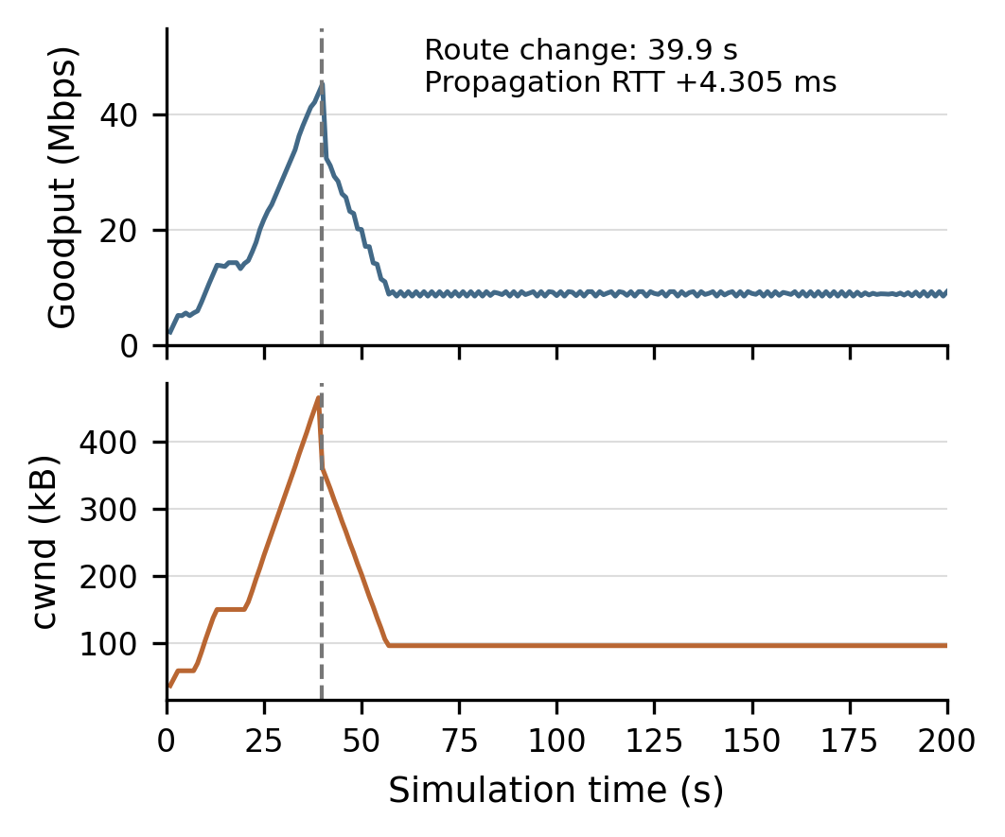
Figure 1. Standard Vegas with 2,160 satellites. One-second acknowledged goodput and sampled cwnd show the sustained collapse after the 39.9 s route change. A kilobyte is 1,000 bytes.

Reproduced evidence
The strongest case occurs in the 2,160-satellite controlled constellation. At 39.9 s, propagation RTT rises from 81.143 to 85.448 ms, an increase of 4.305 ms. The cycle RTT floor rises to around 87 ms, while BaseRTT stays near 82.452 ms. The internal trace records $D>4$ and repeated DECREASE decisions. The congestion window falls from roughly 470 kB near the event to about 95 kB by 60 s; goodput settles near 9 Mbps (Figs. 1–2).
The 0–200 s raw flow summaries give standard Vegas 41.51 Mbps with 1,584 satellites and 12.12 Mbps with 2,160. CUBIC reaches 95.86 and 95.91 Mbps on the same configured 100 Mbps links. Thus the low Vegas rate is not simply the usable capacity of the route. The earlier instrumented dense original-Vegas run also has only 0.081 mean total queued packets over 20–200 s, supporting a stale-baseline interpretation rather than sustained queue growth.
RTT alone nevertheless does not uniquely identify the cause of a delay increase. A standing queue can raise its observed minimum too. The goal is to improve the distinction under tested conditions, not to infer propagation delay perfectly from arbitrary RTT observations.
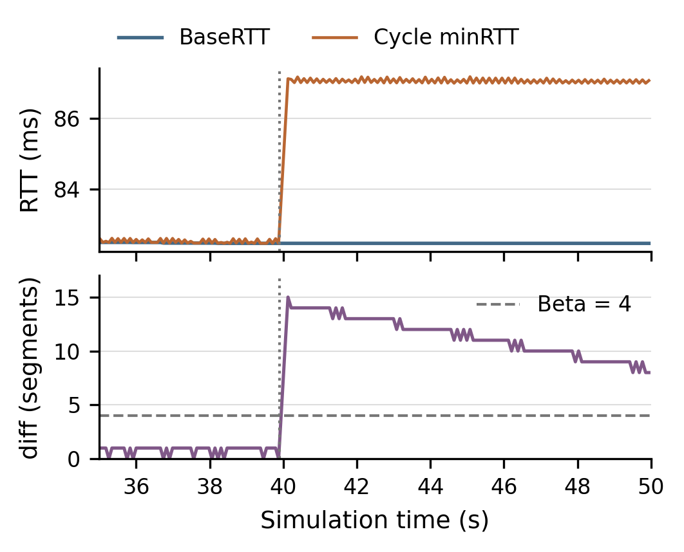
Figure 2. Dense-case internal controller trace. Cycle minRTT moves to a new floor while BaseRTT remains low; diff exceeds the congestion-avoidance threshold. The vertical line marks 39.9 s.

III. Proposed Ideas

Recurring BaseRTT refresh
Our first approach lets old RTT observations expire. We test original lifetime-minimum Vegas against recent-minimum histories of $T=1,5,10$ s. Although we refer to this informally as periodic refresh, the implemented rule is a sliding minimum: at each valid RTT sample, expired observations are removed and the baseline becomes the minimum remaining observation. It is not an unconditional reset at fixed timer ticks. $T=0$ selects original Vegas as a control.
This method assumes that recent history contains a sufficiently unqueued sample of the current route. It forgets an obsolete shorter route without receiving route information. However, a queue persisting throughout the history window can become part of the baseline, allowing additional queued traffic. A shorter history may react faster but learn queueing more readily. The implementation retains recent candidate samples in a deque, with amortized constant work per RTT sample and variable memory that can grow with the number of samples in the history window.

Adaptive BaseRTT relearning
The final group prototype changes only the sender’s Vegas implementation. At an eligible Vegas calculation, with more than two RTT samples in the cycle, it applies the following rule:
- Check $R>B+3$ ms and whether more than 10 s have elapsed since the previous adaptive reset.
- If both conditions hold, increment a persistence counter; otherwise clear it.
- After five consecutive qualifying calculations, set $B←R$, clear the counter, record the reset time, and continue normal Vegas control.
The initial reset timestamp is set far in the past, so the first reset need not wait ten seconds from connection start. Ordinary minimum-RTT updates remain enabled and can decrease BaseRTT later. Five qualifying updates are not five seconds; the 10 s cooldown limits resets rather than scheduling them. The code uses strict greater-than comparisons for both the 3 ms margin and the 10 s cooldown.
The shift margin filters small fluctuations, persistence rejects short spikes, and the cooldown limits repeated relearning. These are engineering thresholds for the first prototype, not optimized or universally valid values. The adaptive modification adds constant-size sender state, a counter and timestamp, and constant work per eligible calculation. It adds no packets or signaling.

Assumptions and final design choice
Both ideas deploy at the sender and use ordinary RTT samples. They require no receiver change, orbital data, route-change notification or in-network support. Deployment outside the simulator would require a corresponding TCP stack change and validation. The adaptive rule assumes that a relevant baseline increase persists across several updates while many transient spikes do not. Sufficiently persistent congestion can still satisfy the rule.
We selected adaptive relearning as the final prototype because it makes baseline increases conditional on a persistent shift and explicitly limits repeated updates. Oracle timing tests and the tested five-flow case support this direction. We retain the recurring-refresh branch as a measured alternative and evidence of the queue-learning trade-off. Selection reflects this trigger design, not a claim that adaptive Vegas gives the highest throughput or has proven lower queueing than sliding history.

IV. Experiment Setup

Platform and controlled parameters
We use the course ns-3.48 environment with the TA-ported Hypatia LEO modules; the reference Docker image is ghcr.io/yeonjong21/cs30401-lab1:2026f-v1 [4]. The Seoul–London path contains only ground–satellite links (GSLs) and inter-satellite links (ISLs), with no terrestrial segments. Table I states the parameter basis. Unless stated otherwise, one flow requests 100 GB from time zero and remains backlogged for 200 simulated seconds. The fixed seed is 123456789. Each configuration is one deterministic run, not a set of statistical repetitions.
Table I. Controlled settings and parameter basis.
Parameter | Value and basis
Constellations | 1,584 = $72×22$, course default; 2,160 = $72×30$, density perturbation; 500 = $25×20$, refresh extension.
Orbit | 550 km altitude, ${53}^{∘}$ inclination, ${25}^{∘}$ minimum elevation; retained shell parameters.
Routing | +Grid ISLs, shortest path by distance, updated every 100 ms; course defaults.
Endpoints | Seoul–London; fixed to compare controllers on the same endpoint pair.
Links | ISLs and GSLs at 100 Mbps; fixed capacity, checked using CUBIC.
Buffers | 1,000-packet drop-tail device queues; fixed large-buffer condition exposes queue/delay costs.
TCP | MSS 1,380 bytes; initial cwnd 10 segments; Vegas $α=2$, $β=4$, $γ=1$; pacing disabled for Vegas/CUBIC.
Duration | 200 s primary cases; 60 s pilots and safety case; captures dense and later default-layout events.
At 100 Mbps and 90 ms RTT, the bandwidth–delay product is approximately 1.125 MB, or 815 segments of 1,380 bytes. The 1,000-packet buffer is a deliberate large-buffer test, not a claim about deployed satellite equipment. Smaller buffers and other rates remain useful follow-up controls. Changing constellation size also changes geometry and route history; the layouts are not independent repetitions of one topology, and satellite count alone is not isolated. The 500 and 2,160 layouts are experimental constructions, not claims to model deployed shells.
The environment does not add random loss, weather, capacity variation or a separate handover interruption. Our conclusions concern route dynamics under these assumptions. Early 60 s Vegas/CUBIC pilots motivated the primary investigation, but their averages are not pooled with the 200 s results.

Experiment progression
Table II retains the group’s T1–T10 identifiers and adds the earlier refresh branch. Baselines reproduce the failure and check capacity; internal tracing tests the mechanism; oracle resets test intervention timing; adaptive runs test sender-only relearning in two layouts; cross-traffic probes false resets.
Table II. Experiment matrix and the question addressed by each configuration.
Test | Configuration | Purpose
T1–T4 | Standard Vegas and CUBIC; 1,584 and 2,160 satellites; one flow; 200 s. | Reproduce Vegas underutilization and separate it from the path’s usable capacity.
T5 | Instrumented original Vegas; 2,160 satellites; 200 s. | Connect BaseRTT, cycle minRTT, diff and decisions to cwnd collapse; not an independent statistical repeat.
Refresh | Original and 1/5/10 s histories; 500/1,584/2,160 satellites; one flow; 200 s. | Twelve measured cases test baseline forgetting and its goodput, queue, RTT, drop and retransmission costs.
T6–T7 | Dense oracle resets at 39.9355 and 40.5002 s; one flow; 200 s. | Compare an immediate intervention with waiting for the new RTT floor. Uses external event knowledge.
T8–T9 | Adaptive Vegas; 2,160 and 1,584 satellites; one flow; 200 s. | Test the 3 ms / 5-update / 10 s sender rule and whether recovery extends beyond the dense case.
T10 | Adaptive Vegas; 1,584 satellites; five flows; 60 s. Flow 0 starts at 0 s, others at 35 s. | Test whether added same-direction shared-path contention triggers an adaptive reset.
The safety workload holds the endpoint pair, link rates, buffers and TCP type fixed, then adds four flows, each requesting 100 GB, at 35 s. Oracle tests use externally chosen reset times and are diagnostic controls, not deployable versions of the sender-only detector. No adaptive 500-satellite case has been evaluated in the available results.

V. Evaluation

Metrics and measurement intervals
We report acknowledged application goodput: newly acknowledged bytes multiplied by eight, divided by elapsed time and ${10}^{6}$, in Mbps. It measures useful delivery rather than all transmitted bits, which can include retransmissions. Whole-run averages use 0–200 s, including startup. One-second goodput and cwnd traces identify when degradation begins and whether it persists.
BaseRTT, cycle minRTT, diff and decision actions expose the control mechanism. Route propagation RTT is the geometric path component; it is distinct from measured RTT and from TCP’s smoothed RTT (SRTT). Reset times/counts evaluate relearning timing and possible false triggers.
The refresh investigation also measures time-weighted total monitored device-queue occupancy, p95 SRTT from 100 ms samples, device/traffic-control drops, and data retransmissions. Queue totals sum monitored devices, not just one bottleneck. The original refresh headlines exclude startup and use 20–200 s; Table III recomputes those cases over 0–200 s to match the adaptive comparison. The separate queue-cost comparison uses 20–200 s consistently.

Throughput recovery in the main group study
Table III and Fig. 3 summarize the outcomes. Baseline Vegas and CUBIC values are recomputed from raw flow summaries. Adaptive and oracle rates are the group’s reported development-run averages; their console traces confirm reset events and completed runs, but raw progress/flow summaries for independently recomputing those rates were not retained in the attached evidence. We mark these values with an asterisk in tables and figures.
Table III. Average goodput over 0–200 s, in Mbps. An asterisk marks a group-reported development average.
Method | 500 | 1,584 | 2,160
Original Vegas | 8.93 | 41.51 | 12.12
1 s history | 82.15 | 72.17 | 75.43
5 s history | 79.12 | 68.37 | 73.03
10 s history | 75.01 | 64.60 | 67.13
Adaptive Vegas | — | 64.7* | 71.0*
CUBIC control | — | 95.86 | 95.91
The reported adaptive rate rises from 41.51 to 64.7 Mbps in the 1,584-satellite case and from 12.12 to 71.0 Mbps in the 2,160-satellite case. Relative to the unrounded baseline totals, these represent approximately 55.9% and 485.8% improvement. They reach about 67.5% and 74.0% of the corresponding CUBIC rates. The result targets a specific false-congestion failure; it does not establish adaptive Vegas as the best congestion controller.
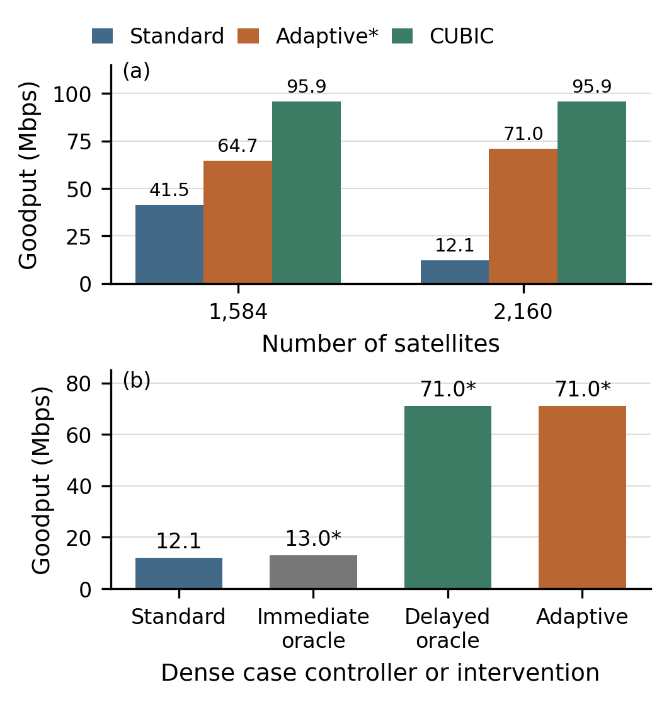
Figure 3. Whole-run goodput over 0–200 s. (a) Adaptive development results improve on standard Vegas in both layouts. (b) Dense-case timing controls: immediate resetting gives little recovery; delayed and adaptive resetting have higher reported rates. Asterisks identify group-reported averages.

What the recurring-refresh experiments add
Every tested recent-history setting improves whole-run rate over original Vegas in each of the three layouts (Table III). This supports the diagnosis that an obsolete minimum is important across more than the single dense case. However, the improvement is not monotonic in satellite count: different route histories matter. The adaptive method was not tested at 500 satellites, so the refresh extension does not demonstrate adaptive generality there.
The history length also changes the cost of recovery. In the dense case over 20–200 s, original Vegas gives 12.41 Mbps; 1, 5 and 10 s histories give 82.17, 79.82 and 73.54 Mbps. The corresponding mean total queues are 0.081, 76.29, 15.65 and 4.82 packets, while p95 SRTT is 87.15, 111.19, 92.00 and 88.55 ms (Fig. 4). A 5 s history sacrifices some of the 1 s history’s rate while reducing its queue and delay cost substantially. These observations motivate investigating a more selective trigger.
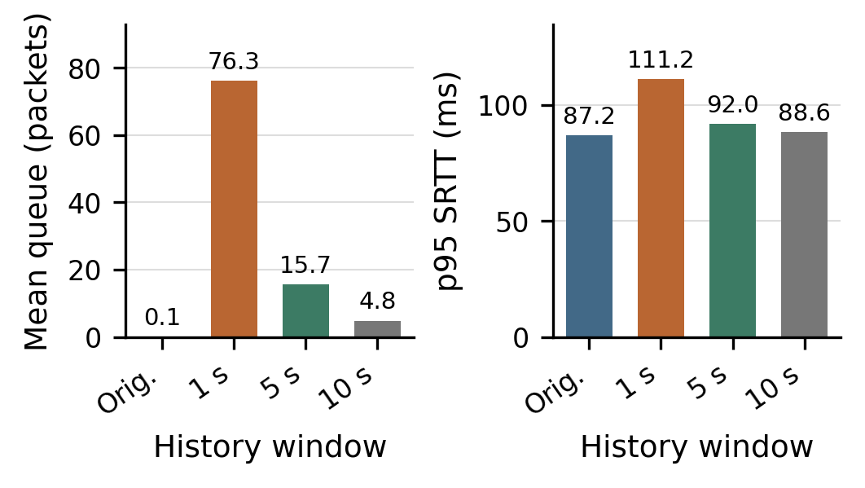
Figure 4. Dense refresh trade-off over 20–200 s. Short history increases queue occupancy and p95 smoothed RTT. Queue occupancy is summed across monitored devices. These are refresh measurements, not adaptive queue results.
All twelve refresh cases record zero observed device/traffic-control buffer drops over 20–200 s, but this does not imply an absence of retransmissions. For example, the 500-satellite 5 s case has 179 data retransmissions in that interval versus zero in its original control. The traces do not by themselves establish the cause of each retransmission. Recovery therefore should not be assessed from goodput alone.
The 1 s and 5 s histories exceed adaptive’s reported rate in both overlapping layouts over the common 0–200 s interval. We therefore do not justify the final choice as a throughput win over refresh. Equivalent adaptive queue, delay and fairness measurements are missing; a direct cost comparison remains open.

Causal and timing controls
The dense immediate oracle resets at 39.9355 s, changing BaseRTT from 82.4517 to 88.2292 ms, yet its reported rate is only 13.0 Mbps. The next logged control cycle at 40.1284 s already has BaseRTT 83.0451 ms, so the newly learned baseline was not durable. This trace establishes the timing problem without identifying the precise cause of every intervening sample.
The delayed oracle resets at 40.5002 s to 87.2921 ms and reports 71.0 Mbps. Adaptive Vegas independently resets at 40.4762 s to 87.0198 ms and also reports 71.0 Mbps. These interventions support a causal role for baseline relearning and show that its timing matters. The adaptive reset is generated by RTT persistence, not by a route-event notification. Equal rounded whole-run averages do not imply identical transient behavior.

Behavior in the default topology
Adaptive resets also occur with 1,584 satellites, at 122.213 s (88.5564 to 91.7887 ms) and 188.059 s (91.4341 to 99.4510 ms). The group reports an average increase from 41.51 to 64.7 Mbps. This extends the observed recovery beyond the dense layout, while leaving broader endpoint, orbit and threshold coverage as future work. The baseline may decrease between adaptive resets through the ordinary minimum update, explaining why the second reset’s starting value differs from the first reset’s ending value.

Congestion-safety control
The five-flow, 60 s adaptive test records no ADAPTIVE_RESET event, including after the four competitors start at 35 s. Its reported per-flow averages are shown in Table IV. The detector therefore does not automatically classify this particular episode of shared-path competition as a baseline shift.
Table IV. Reported per-flow averages in the 1,584-satellite safety test. Active intervals differ; these rates are not a fairness or simultaneous aggregate-throughput comparison.
Flow | Averaging interval (s) | Rate (Mbps)
0 | 0–60 | 20.6*
1 | 35–60 | 10.0*
2 | 35–60 | 10.2*
3 | 35–60 | 12.9*
4 | 35–60 | 13.0*
This is one limited safety case, not a proof against false resets from arbitrary standing queues. Flow 0 is active for 60 s while the other flows are active for only 25 s. Their averages cannot be summed into concurrent aggregate throughput or used directly for Jain’s fairness index. Fairness requires rates measured over a common interval, such as 35–60 s. The current multi-flow decision log also lacks a flow/socket identifier, limiting per-flow attribution of internal decisions.

Conditions and remaining limitations
Adaptive relearning helps when a relevant upward shift exceeds 3 ms, persists across five eligible calculations and passes the cooldown gate. Smaller or shorter shifts do not trigger this mechanism; shifts during cooldown must wait before persistence counting can qualify. A downward baseline change is handled by ordinary minimum updates rather than by the adaptive reset. Persistent queueing can satisfy the same tests, which is the central unresolved ambiguity.
The evidence covers one city pair, fixed 100 Mbps links and 1,000-packet buffers, short simulated intervals, and deterministic scenarios without random loss or outages. We have not tested threshold sensitivity, mixed-controller competition, other endpoints or longer orbital intervals. A matched adaptive/refresh study must compare goodput, queue occupancy, SRTT, drops, retransmissions and fairness under the same workload and measurement window.
Reproducibility is also incomplete for the final adaptive branch. Its clean runner covers primary baseline, adaptive and safety cases, but not the oracle variants; the group records a fresh-environment reproduction as unfinished. The adaptive/oracle raw progress summaries and a complete oracle rerun path must be retained before those reported performance totals can be independently regenerated from the submission. The figures here replot existing evidence; no new full simulations were executed for this report revision.

VI. Conclusion
We reproduced a specific Vegas failure in which a route-induced increase in propagation delay makes the historical BaseRTT stale. The dense case falls to 12.12 Mbps over 200 s despite a 95.91 Mbps CUBIC capacity control. Both recent-history refresh and conditional adaptive relearning address the obsolete baseline in the measured settings. The refresh branch improves rate across 500, 1,584 and 2,160 satellites, but shorter history can increase queueing and delay. The group’s selected adaptive prototype reports 64.7 Mbps with 1,584 satellites and 71.0 Mbps with 2,160, supported by observed reset events, timing controls and zero resets in one congestion-safety case.
Our conclusion is that cautious baseline relearning is a useful mitigation in these tested LEO scenarios. The adaptive rule is a heuristic, not a universal propagation-versus-congestion classifier. Its final selection favors conditional timing and constant state; comparative delay/fairness benefits over sliding history and complete fresh-environment reproduction remain to be demonstrated.

References
[1] S. Kassing, D. Bhattacherjee, A. Baptista Águas, J. E. Saethre, and A. Singla, “Exploring the ‘Internet from space’ with Hypatia,” in Proc. ACM Internet Measurement Conference (IMC), 2020.
[2] M. Handley, “Delay is Not an Option: Low Latency Routing in Space,” in Proc. ACM Workshop on Hot Topics in Networks (HotNets), 2018.
[3] D. Bhattacherjee and A. Singla, “Network Topology Design at 27,000 km/hour,” in Proc. ACM Conference on Emerging Networking Experiments and Technologies (CoNEXT), 2019.
[4] KAIST, “CS30401 Network Lab 1: Improving TCP for LEO Satellite Networks” and “Lab Environment Guide,” Fall 2026.
[5] L. S. Brakmo and L. L. Peterson, “TCP Vegas: End to End Congestion Avoidance on a Global Internet,” IEEE Journal on Selected Areas in Communications, vol. 13, no. 8, pp. 1465–1480, 1995.
[6] R. J. La, J. Walrand, and V. Anantharam, “Issues in TCP Vegas,” University of California, Berkeley, Tech. Rep. UCB/ERL M99/3, 1999.

