Adaptive BaseRTT Relearning for TCP Vegas over Dynamic LEO Satellite Paths
CS30401 Introduction to Computer Networks — Network Lab 1
Team ID: [INSERT TEAM ID] Members: [INSERT ALL MEMBER NAMES]

1. Introduction
Low-Earth-orbit (LEO) networks differ from terrestrial paths because satellites move and the end-to-end route can change while a transport connection remains active [1]–[3]. In the provided Hypatia/ns-3 environment, shortest-path routes are recomputed every 100 ms, so the propagation component of RTT can change even when there is no congestion, loss, or capacity reduction. This is especially important for delay-based congestion control, whose decisions depend on interpreting RTT inflation as evidence of queued packets.
We study TCP Vegas [4] because its congestion-avoidance rule explicitly compares a historical BaseRTT against the current-cycle minimum RTT. This makes the mechanism easy to isolate and directly exposes a mobility-specific failure mode: after a persistent route-induced propagation increase, the historical minimum may no longer be attainable. Our contribution is (i) a concrete reproduction and causal trace of this failure, (ii) a sender-only BaseRTT relearning rule that requires no satellite metadata, and (iii) evaluation across two constellation sizes, an oracle control, a CUBIC capacity control, and a five-flow congestion-safety test.
2. Problem Statement
2.1 Precise failure mechanism
In ns-3 TCP Vegas, BaseRTT is the minimum Vegas RTT measurement observed over the connection. For each Vegas update, the implementation computes a target congestion window from the ratio BaseRTT/minRTT and then computes diff = cwnd − targetCwnd. With the default thresholds α = 2 and β = 4 packets, diff > β causes the congestion window to decrease. This logic is appropriate when minRTT − BaseRTT mainly represents queuing, but a LEO route change can permanently raise the propagation floor itself.
Our concrete problem is therefore: after the path changes to a longer-propagation route, Vegas retains the older smaller BaseRTT, interprets the persistent propagation increase as persistent queueing, repeatedly reduces cwnd, and can settle at a throughput far below the available path capacity.
2.2 Reproduced evidence
The strongest case occurs in the 2,160-satellite controlled constellation. At 39.9 s, the route changes and the propagation RTT rises from 81.143 ms to 85.448 ms (+4.305 ms). The current-cycle RTT floor rises accordingly, but BaseRTT remains near 82.45 ms. Vegas diff jumps above β = 4 and remains high, causing repeated DECREASE decisions. The congestion window falls from roughly 470 kB near the route change to about 95 kB by 60 s, while throughput falls to about 9 Mbit/s and remains low for most of the run.

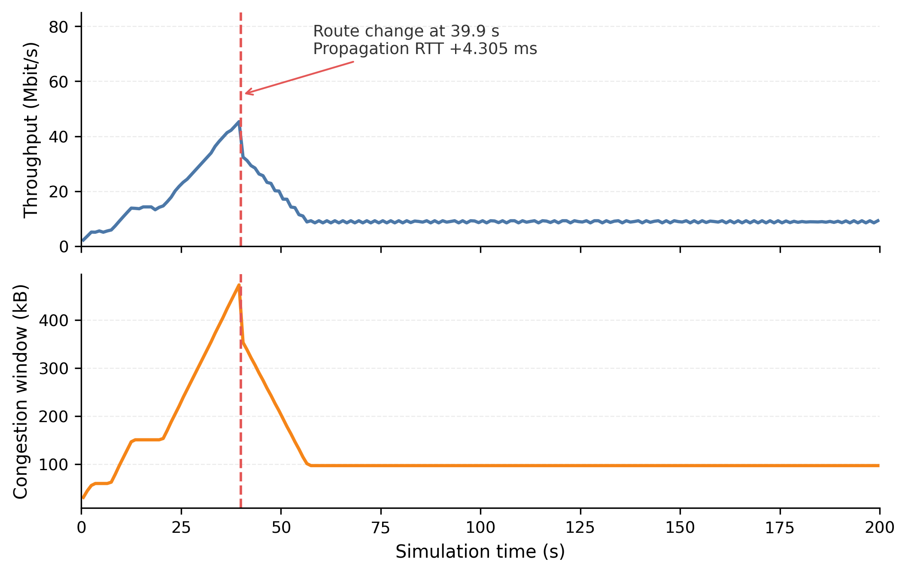
Fig. 1. Dense-case collapse. The route change at 39.9 s raises the propagation RTT floor; standard Vegas then reduces cwnd and settles at low throughput.
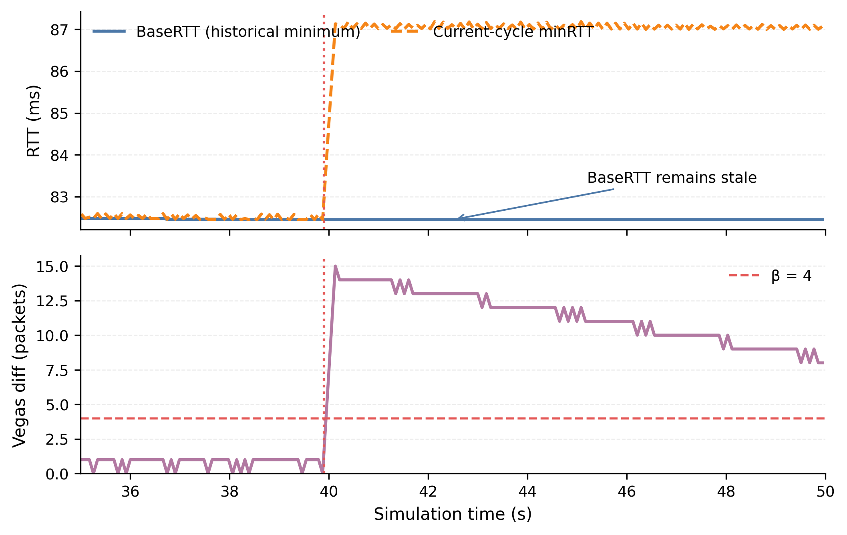
Fig. 2. Mechanism trace around the 39.9 s event. minRTT moves to a new floor while BaseRTT stays stale; Vegas diff rises above β = 4.

A CUBIC control separates path capacity from the Vegas-specific failure. Under the same 100 Mbit/s links, CUBIC reaches 95.9 Mbit/s in both constellations. Standard Vegas reaches 41.5 Mbit/s in the 1,584-satellite case and only 12.1 Mbit/s in the 2,160-satellite case. Thus, the dense-case 12.1 Mbit/s result is not explained by a low-capacity route.
3. Proposed Idea
3.1 Adaptive BaseRTT relearning
We modify only the sender-side Vegas implementation. When the minimum RTT observed in a Vegas cycle is persistently above the stored BaseRTT, the sender treats the old baseline as potentially stale. The implemented rule is:
• Shift threshold: minRTT > BaseRTT + 3 ms.
• Persistence: the condition must hold for 5 consecutive Vegas RTT-update cycles.
• Cooldown: at least 10 s must have elapsed since the previous relearning event.
• Action: set BaseRTT = current-cycle minRTT, reset the persistence counter, and continue normal Vegas control.
These values are engineering thresholds for this first prototype, not claimed to be globally optimal. The 3 ms margin avoids reacting to very small fluctuations, the persistence requirement rejects short spikes, and the cooldown limits repeated resets. The rule adds constant-size sender state (a counter and last-reset time), no extra packets, and no changes to the receiver or satellite network.
3.2 Assumptions and deployment
• Assumption: a true path-baseline increase persists across several Vegas update cycles, whereas many transient RTT spikes do not.
• Deployment: sender-side TCP only. No route-change notification, orbit data, receiver modification, or in-network support is required.
• Cost: O(1) state and a few comparisons per Vegas window update; no signaling overhead.
• Risk: sufficiently persistent real congestion may also elevate RTT for multiple cycles and could be mistaken for a baseline shift. We therefore evaluate one explicit cross-traffic safety case and treat the result as limited evidence, not a proof of general safety.
4. Experiment Setup
All experiments use the course Docker image ghcr.io/yeonjong21/cs30401-lab1:2026f-v1 with ns-3.48 and the TA-ported Hypatia LEO modules [1]. The path contains only GSLs and ISLs between Seoul and London. Unless stated otherwise, each run contains one long-lived TCP flow for 200 s. The simulator is deterministic for these inputs; the configured seed is 123456789.

Parameter | Value and basis
Constellation A | 72 × 22 = 1,584 satellites; provided Starlink-shell default. 550 km, 53° inclination, 25° minimum elevation.
Constellation B | 72 × 30 = 2,160 satellites. Controlled density perturbation used to create a second route-dynamics condition; not claimed to model a deployed Starlink shell.
Topology/routing | +Grid ISLs; shortest path by distance; routing recomputed every 100 ms. These are provided Hypatia defaults.
Endpoints | Seoul to London ground stations; fixed across all comparisons.
Links | ISL and GSL = 100 Mbit/s. Held constant to isolate the TCP/path-delay interaction; CUBIC near 95.9 Mbit/s verifies high usable capacity.
Queues | Drop-tail, 1,000 packets on ISL and GSL. Held fixed across all runs to avoid changing queueing conditions between baseline and treatment.
TCP | TcpVegas, pacing disabled; default Vegas α=2, β=4, γ=1. TcpCubic used as capacity control.
Duration | 200 s for primary single-flow runs; 60 s for the five-flow congestion-safety test.

5. Evaluation
5.1 Metrics
• Average throughput (Mbit/s): primary application-level outcome and direct measure of the observed underutilization.
• 1 s throughput and cwnd over time: show when the collapse begins and whether recovery is sustained.
• BaseRTT, current-cycle minRTT, Vegas diff, and route propagation RTT: identify the control-loop mechanism rather than only the symptom.
• Reset timestamps and reset count: verify that relearning occurs near persistent path-delay increases and check for false resets in the cross-traffic test.

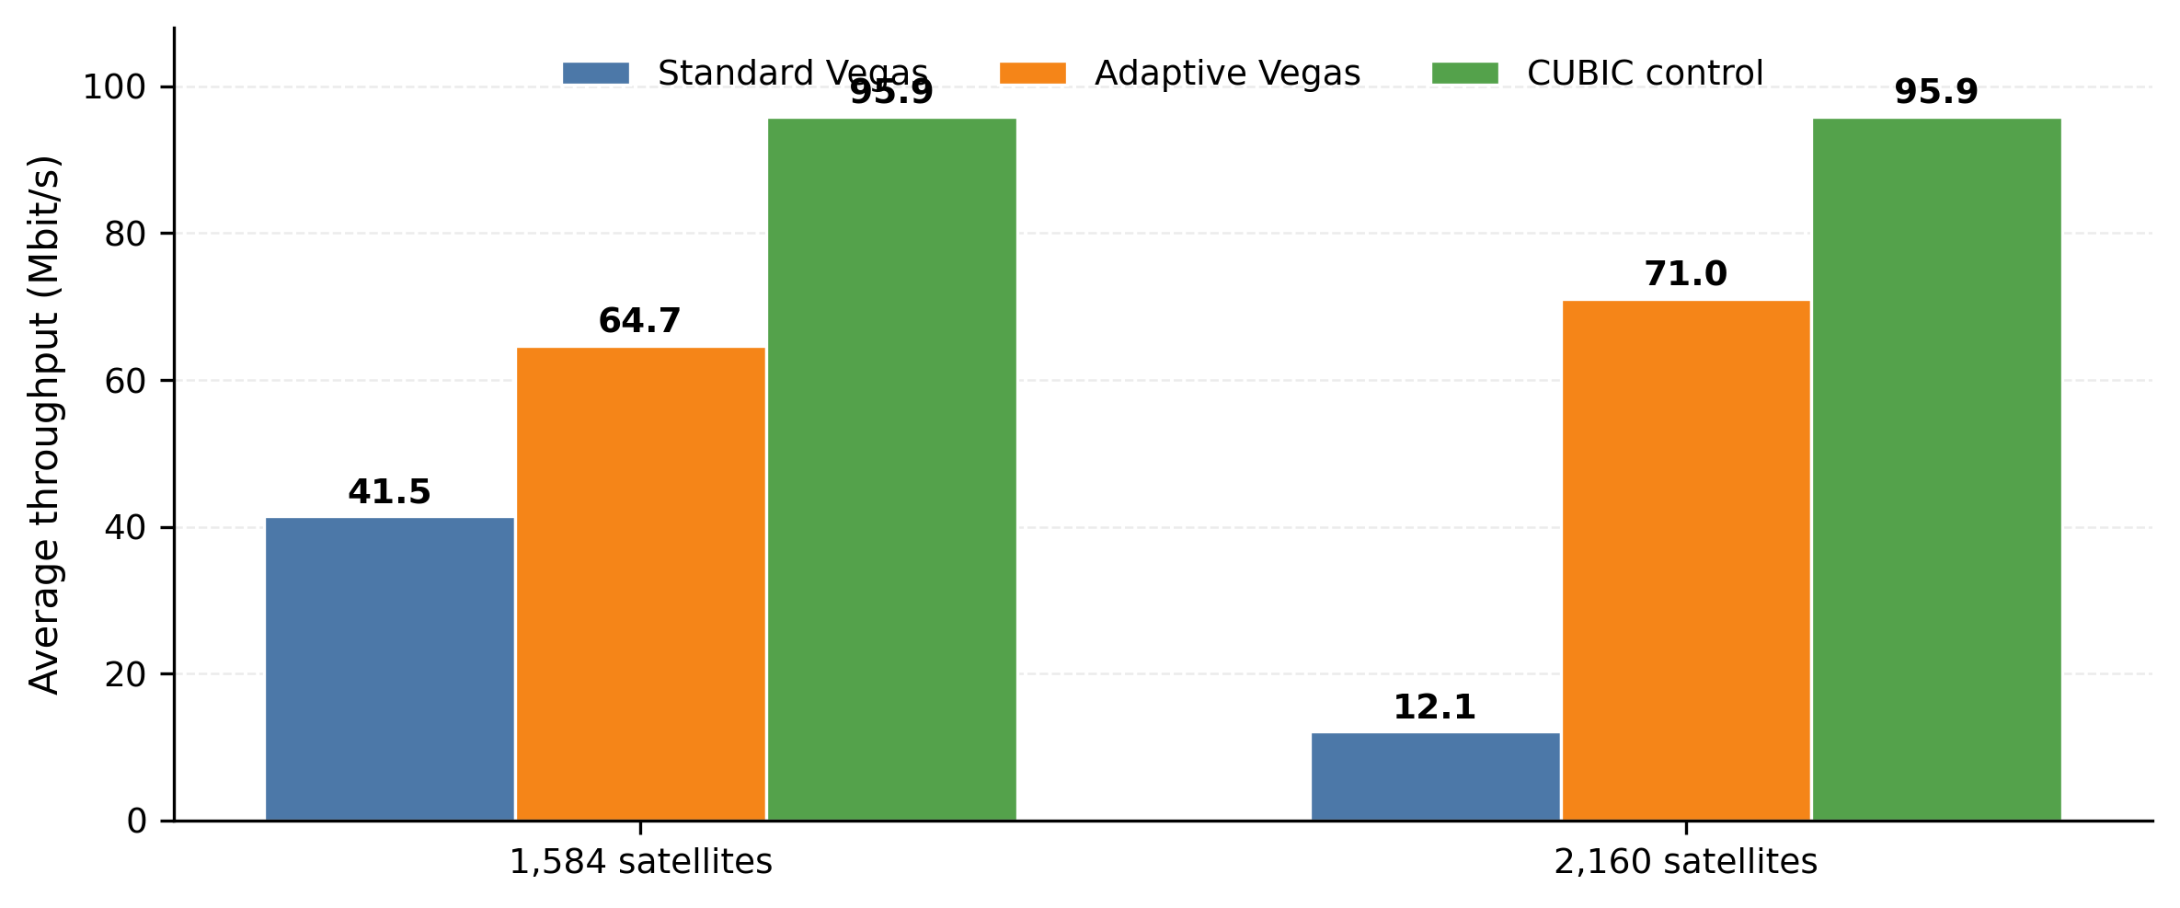
Fig. 3. Primary quantitative comparison. Adaptive Vegas improves average throughput in both tested constellations, while CUBIC confirms that the paths retain near-link-rate capacity.

5.2 Quantitative improvement
Adaptive BaseRTT relearning raises average Vegas throughput from 41.5 to 64.7 Mbit/s in the 1,584-satellite case, a 55.9% increase. In the 2,160-satellite case, it raises throughput from 12.1 to 71.0 Mbit/s, a 486.8% increase. The adaptive result reaches 67.5% and 74.0% of the 95.9 Mbit/s CUBIC control in the two cases, respectively. The goal is not to outperform CUBIC, but to remove a specific false-congestion failure in Vegas.
5.3 Causal and timing controls
An oracle experiment tests whether changing BaseRTT can causally recover the dense case. A one-time reset almost immediately after the route change (39.9355 s) does not recover performance: average throughput is 13.0 Mbit/s. A delayed reset at 40.5002 s, after the post-change RTT floor has stabilized, reaches 71.0 Mbit/s. The adaptive detector resets automatically at 40.4762 s and also reaches 71.0 Mbit/s. This shows both that BaseRTT relearning addresses the identified cause and that reset timing matters; simply resetting at the first sign of a route change is insufficient.
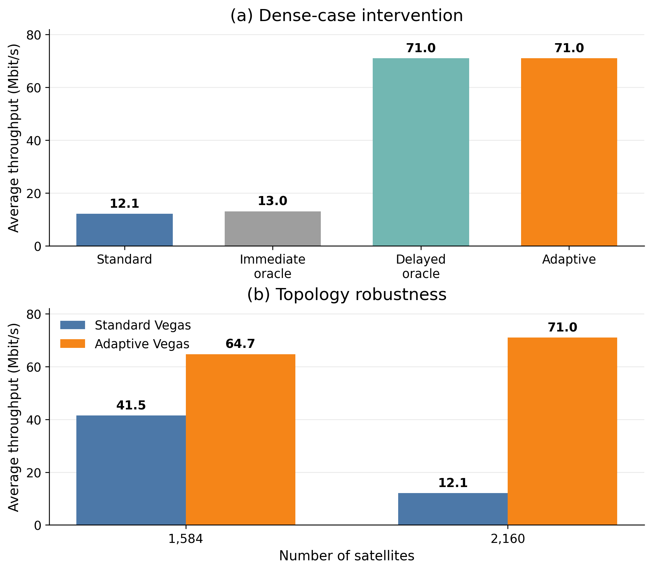
Fig. 4. Dense-case causal control. Immediate resetting fails, while a delayed oracle reset and the automatic persistent-shift detector both recover throughput.
5.4 Behaviour in the default topology
The mechanism also activates in the 1,584-satellite topology. Adaptive resets occur at 122.213 s (BaseRTT 88.5564→91.7887 ms) and 188.059 s (91.4341→99.451 ms). These follow observed upward path-delay changes and the 200 s average throughput improves from 41.5 to 64.7 Mbit/s. This reduces the risk that the dense result is a single-topology artifact, while still leaving broader topology coverage as future work.
5.5 Congestion-safety control
A separate 60 s test uses five Vegas flows on the 1,584-satellite path. Flow 0 starts at 0 s; four additional flows start at 35 s, creating persistent shared-path competition. No ADAPTIVE_RESET event occurs after the added traffic begins. The measured per-flow run averages are 20.6, 10.0, 10.2, 12.9, and 13.0 Mbit/s, with the different averaging intervals noted in Fig. 5. This test provides evidence that the detector does not automatically treat this particular congestion episode as a route-baseline shift. It is not a general proof of congestion safety or fairness.
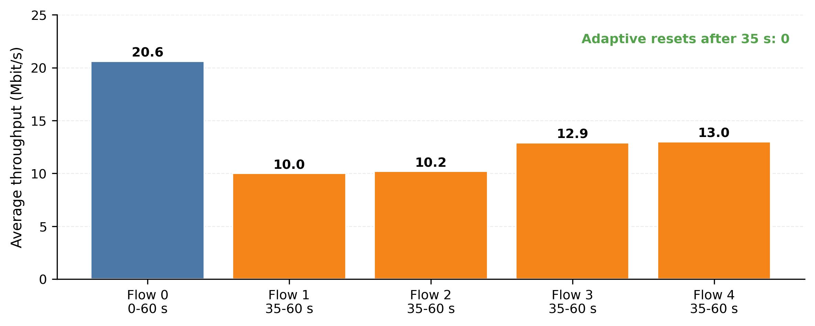
Fig. 5. Five-flow congestion-safety control. Four flows begin at 35 s; the adaptive detector produces zero resets after cross-traffic begins.
5.6 Conditions, costs, and limitations
• Helps when: route mobility causes a persistent upward change in the no-queue RTT floor and the new floor remains stable long enough for the persistence test.
• Does not help automatically when: the path baseline decreases, the increase is below 3 ms, or the increase does not persist for five Vegas cycles.
• Timing sensitivity: the failed immediate oracle reset shows that relearning from an unstable post-change RTT sample can be ineffective.
• Congestion ambiguity: long-lived queueing can also persist. We tested one five-flow case with zero false resets, but more traffic patterns are needed before claiming general robustness.
• Scope: results cover one source–destination pair, two constellation sizes, fixed 100 Mbit/s link rates, fixed queues, and the provided no-random-loss model. Weather, outages, capacity variation, and random loss were not evaluated.
• Parameter generality: 3 ms / 5 cycles / 10 s are prototype thresholds. Sensitivity analysis is future work; they should not be presented as universally optimal.
• Deployment cost: sender TCP implementation change only; no network signaling or receiver change. Operational deployment would still require kernel/stack modification and validation.
6. Conclusion
We reproduced a specific TCP Vegas failure caused by LEO route dynamics rather than by low path capacity. In the 2,160-satellite case, a 4.305 ms route-induced propagation RTT increase makes the connection’s historical BaseRTT stale, pushes Vegas diff above β, shrinks cwnd, and leaves standard Vegas at 12.1 Mbit/s despite a 95.9 Mbit/s CUBIC control. A sender-only persistent-shift detector that relearns BaseRTT raises dense-case throughput to 71.0 Mbit/s and improves the 1,584-satellite case from 41.5 to 64.7 Mbit/s. The oracle experiments confirm that relearning the baseline is causal and that timing matters. A five-flow test produces no false reset after cross-traffic begins, but broader congestion, path, and threshold testing remains necessary. The result therefore supports the narrower claim that stale delay baselines are a real failure mode for Vegas on dynamic LEO paths and that cautious BaseRTT relearning is an effective mitigation in the tested conditions.

7. References
[1] S. Kassing, D. Bhattacherjee, A. B. Aguas, J. E. Saethre, and A. Singla, “Exploring the ‘Internet from space’ with Hypatia,” Proceedings of the ACM Internet Measurement Conference (IMC), 2020.
[2] M. Handley, “Delay is Not an Option: Low Latency Routing in Space,” Proceedings of the ACM Workshop on Hot Topics in Networks (HotNets), 2018.
[3] D. Bhattacherjee and A. Singla, “Network Topology Design at 27,000 km/hour,” Proceedings of the ACM Conference on Emerging Networking Experiments and Technologies (CoNEXT), 2019.
[4] L. S. Brakmo and L. L. Peterson, “TCP Vegas: End to End Congestion Avoidance on a Global Internet,” IEEE Journal on Selected Areas in Communications, vol. 13, no. 8, 1995.

