CSA-1702 ARTIFICIAL INTELLIGENCE

Program-1:

1. Write a python program to implement Simple Calculator program.

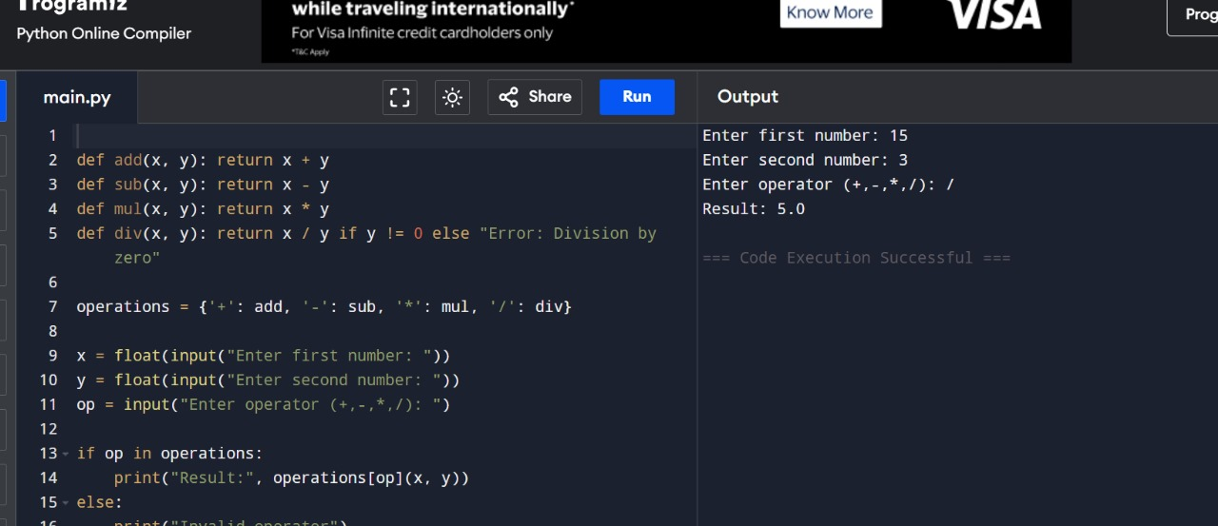

1. Write a python program to Add Two Matrices.

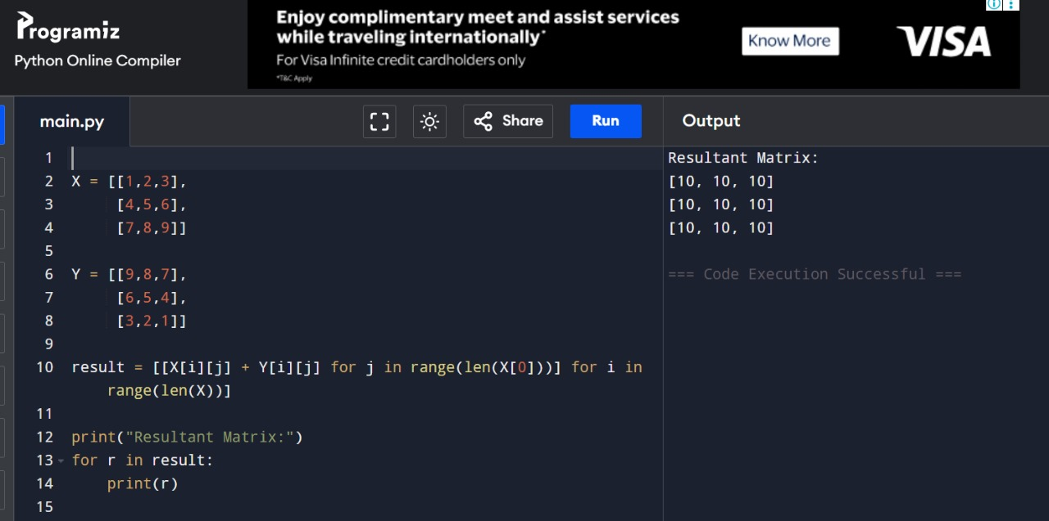

1. Write a python program to Transpose a Matrix.

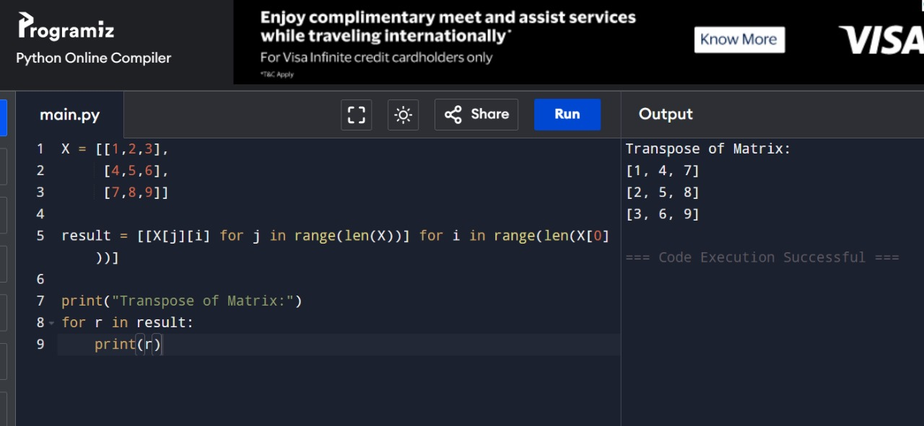

1. Write a python program to sort the sentence in alphabetical order?

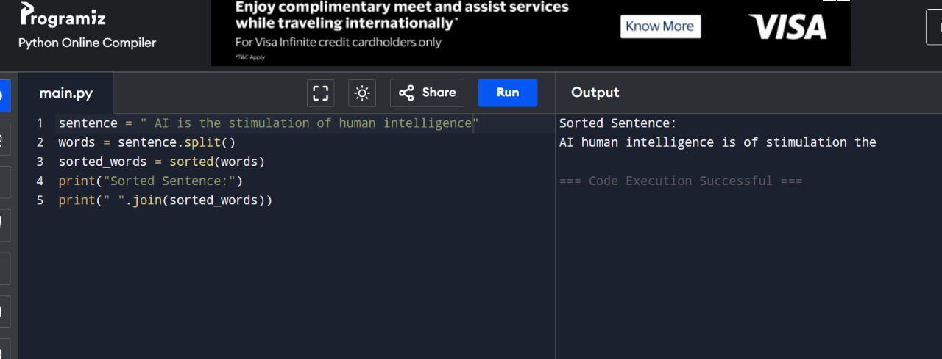

1. Write a python program to implement List operations (Nested List, Length, Concatenation, Membership, Iteration, Indexing and Slicing)?

