**EXPERIMENT-14 VM**

VMWARE-HARDDISK

(Allocating the Storage using VMware)

STEP -1: Create a new Virtual Machine

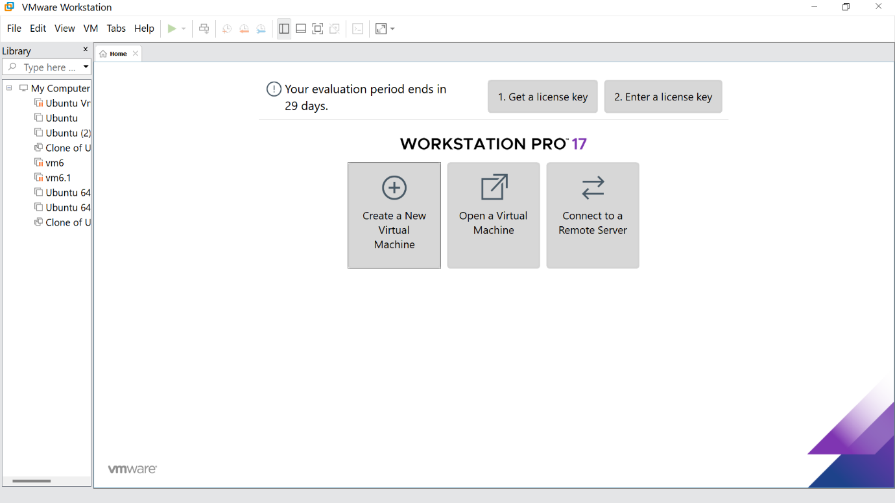

STEP -2: Click on Typical option and click Next

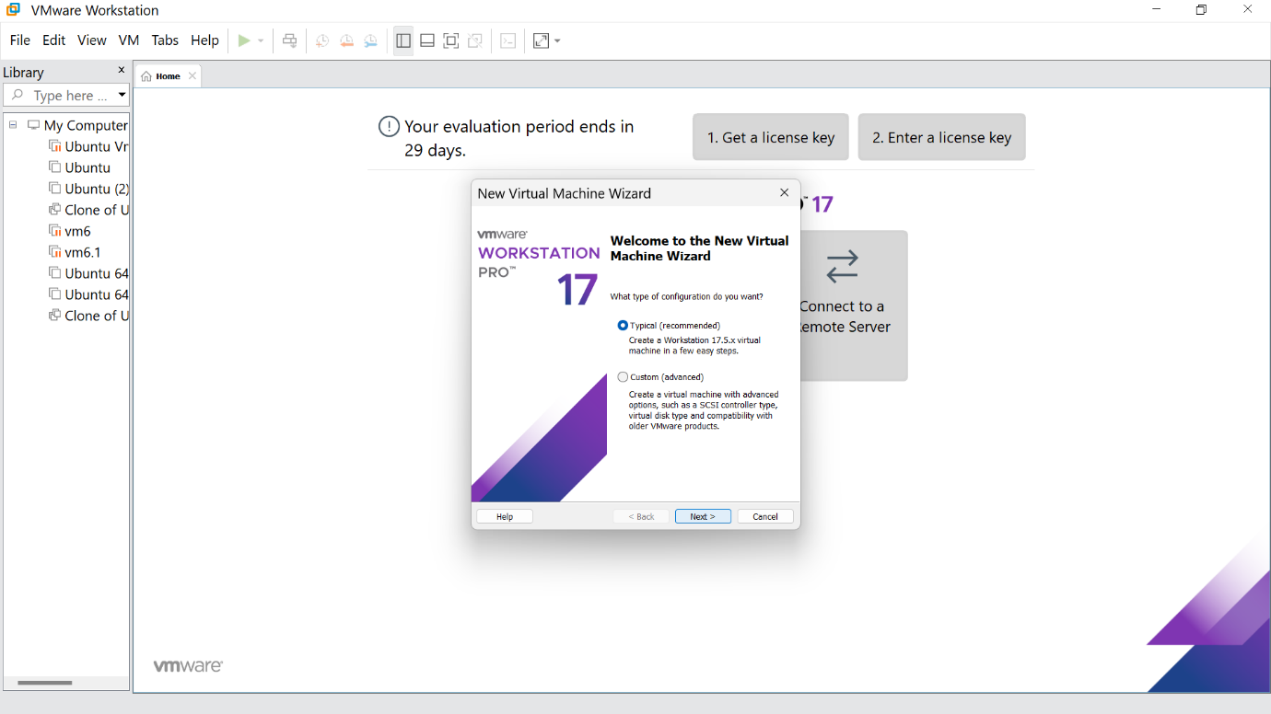

STEP -3: Click the install option and proceed to next step

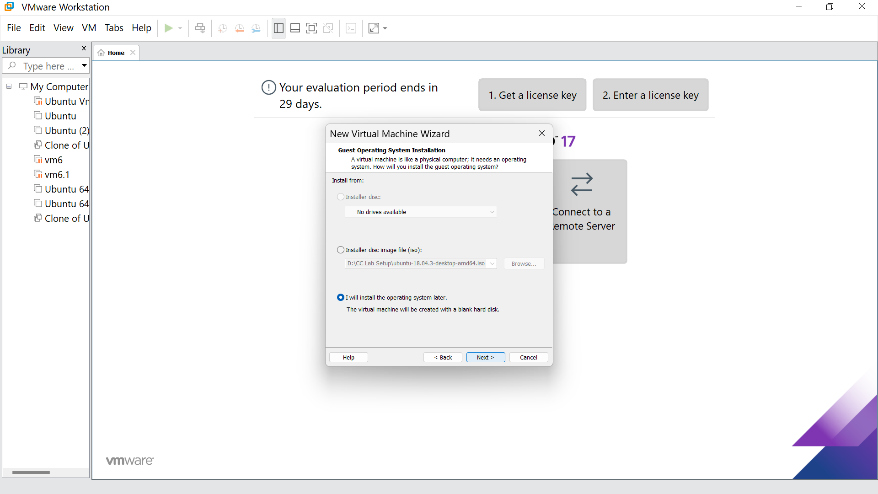

STEP -4: Select Linux option and click Next

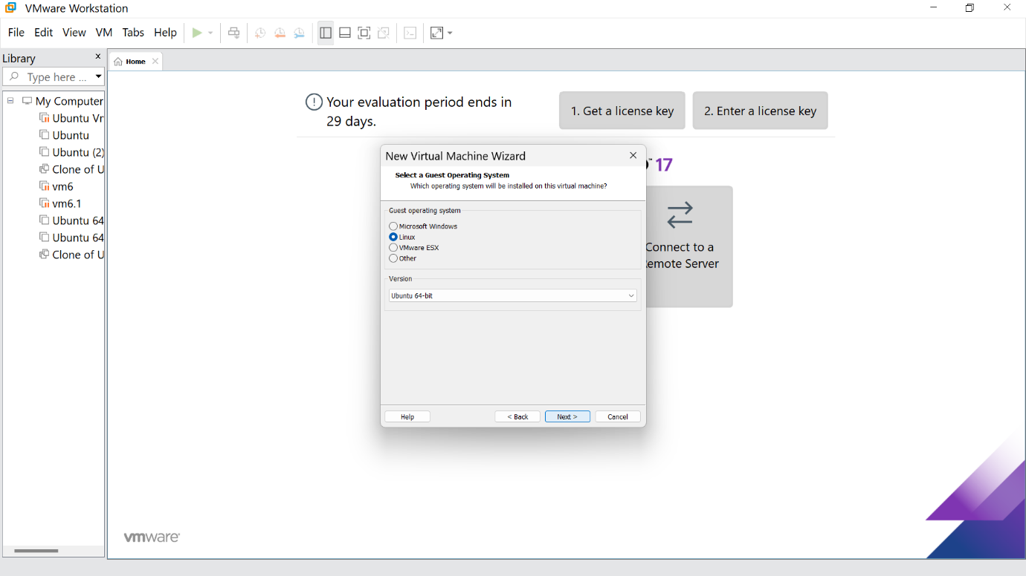

STEP -5: Give the name for the virtual machine(optional) and click next

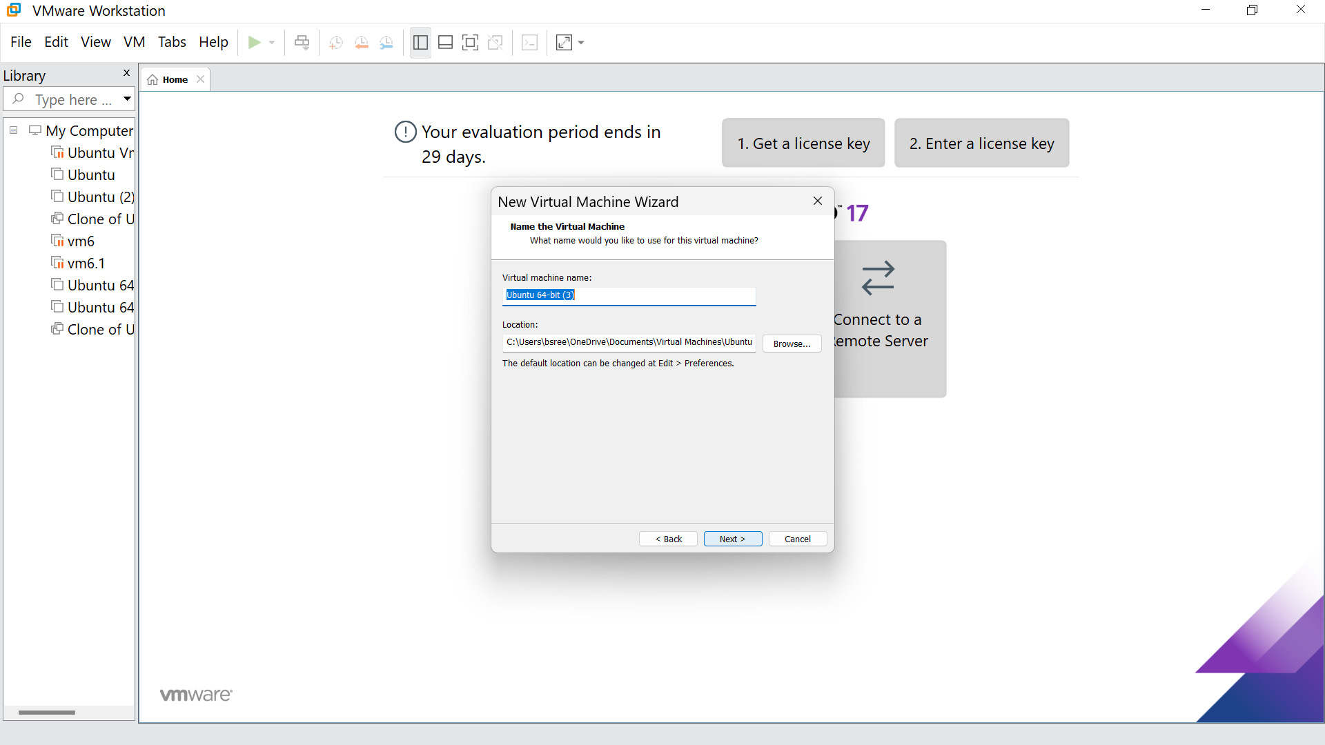

STEP -6: Select the option to store the disk in single file and click next

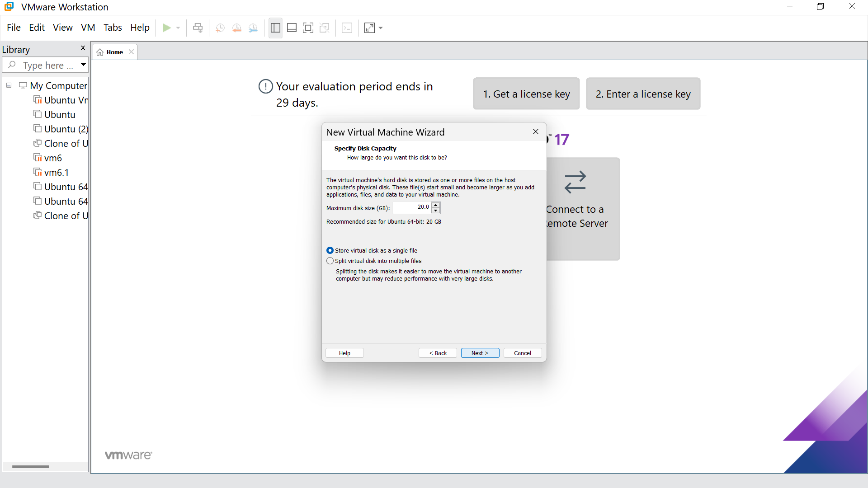

STEP -7: Our new VM is ready ,click finish

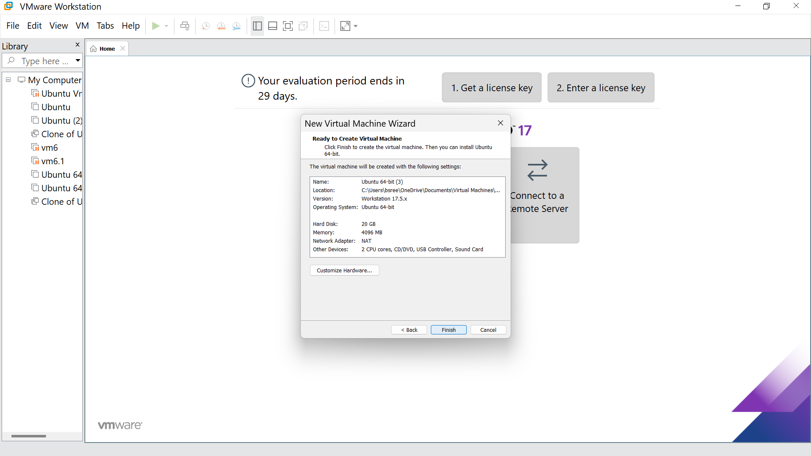

STEP -8: This is the creation of VM

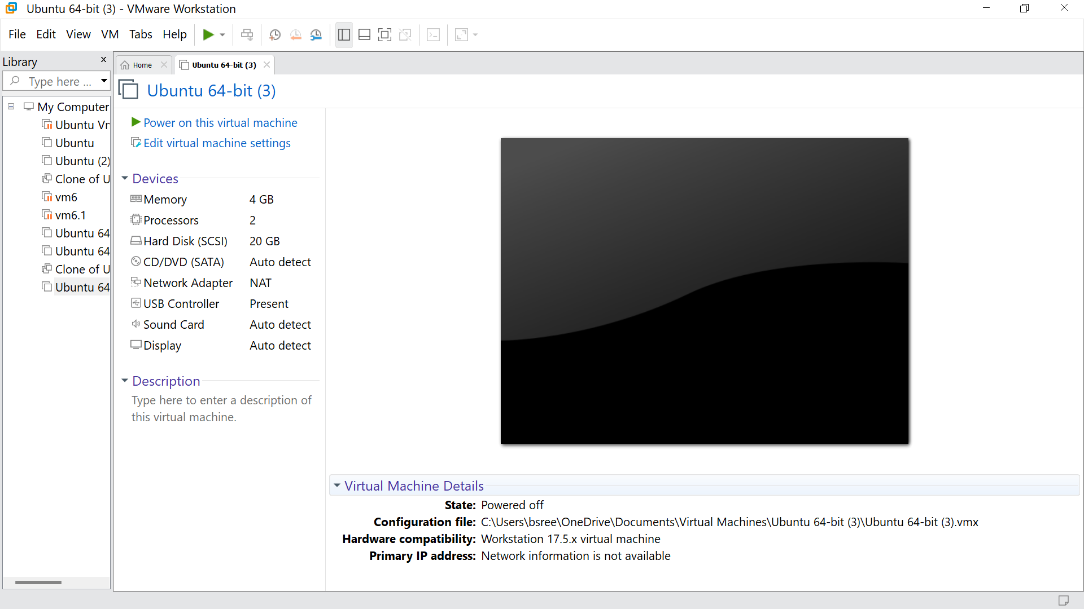

STEP -9: Go to hard disk ,click on add

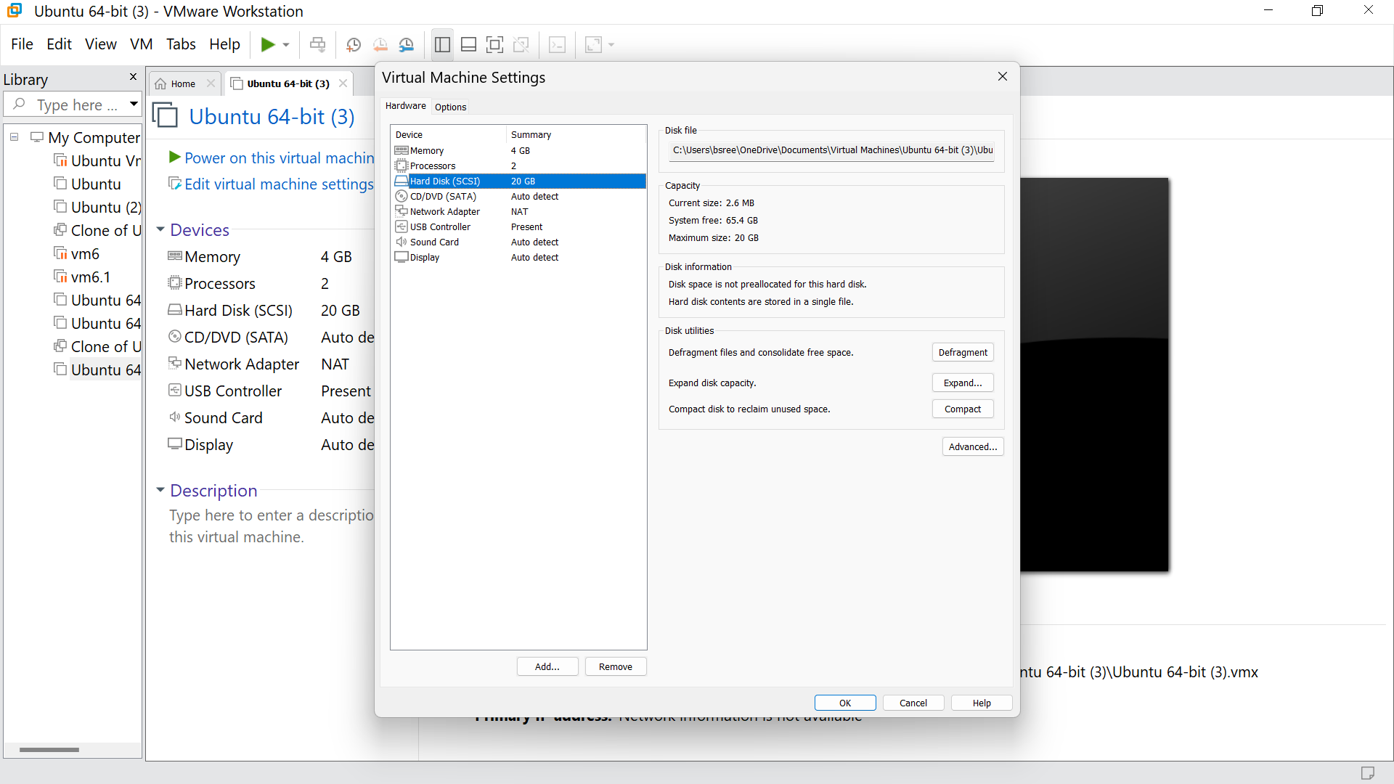

STEP -10: click on next

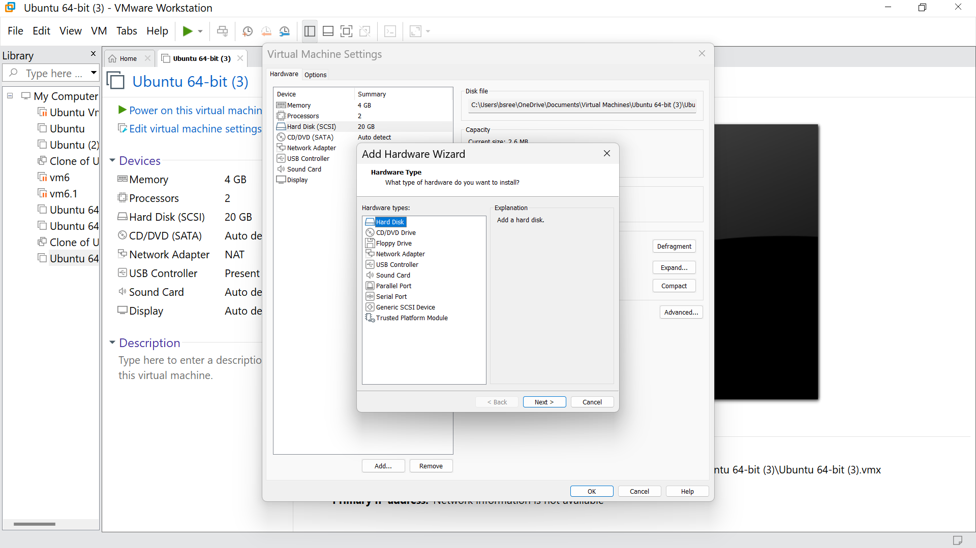

STEP -11: Choose SCSI option and click next

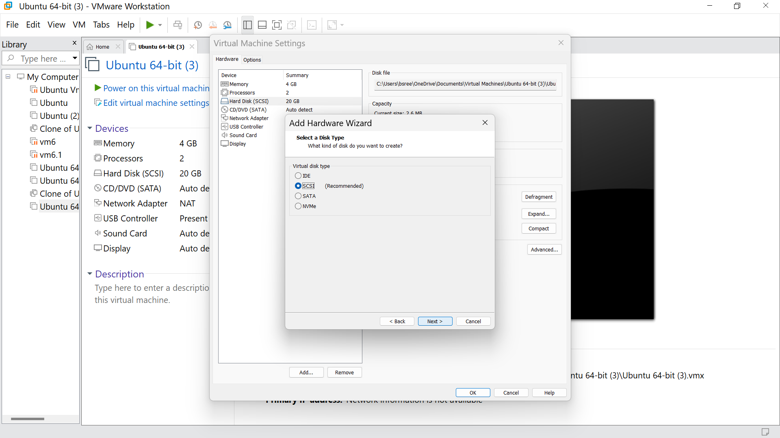

STEP -12: Click on ‘create a new virtual disk option’, and click next

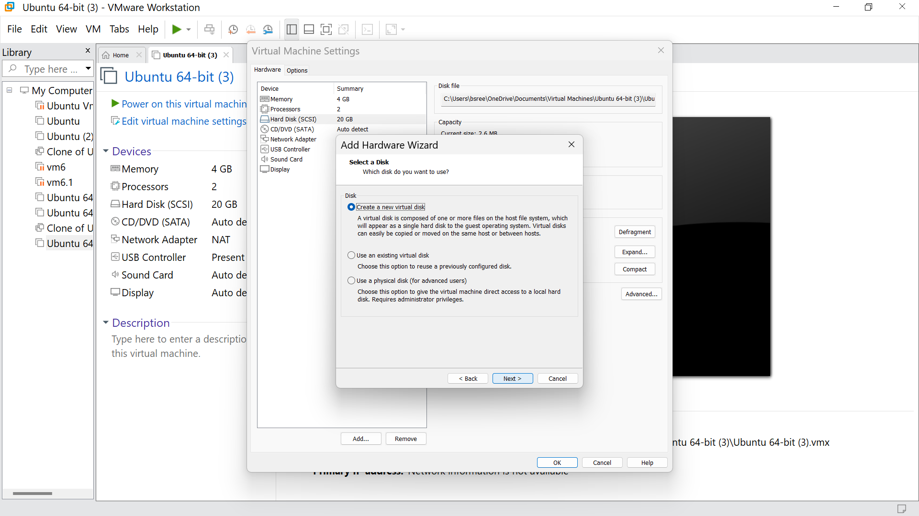

STEP -13: Set the required GB for the HardDisk. And click next

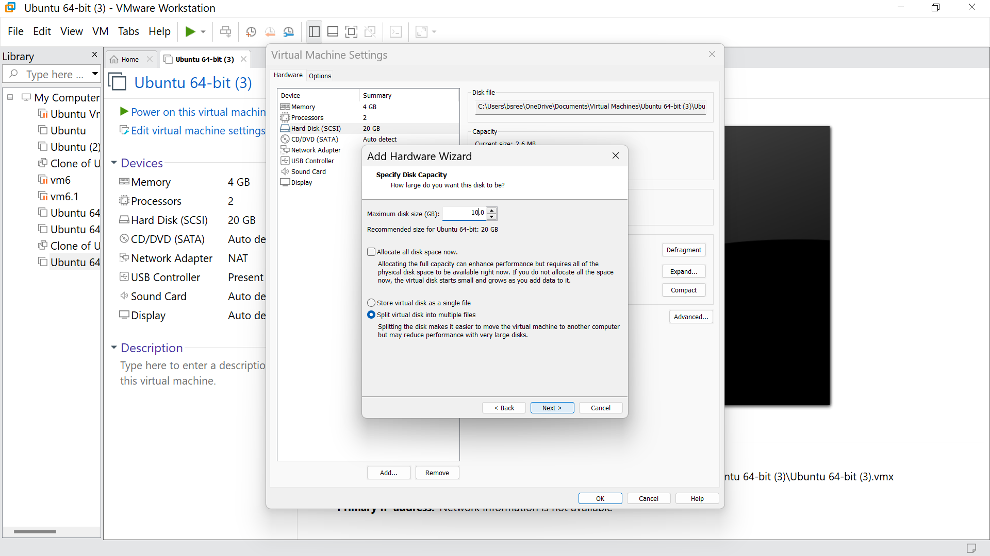

STEP -14: To add the HardWare click finish

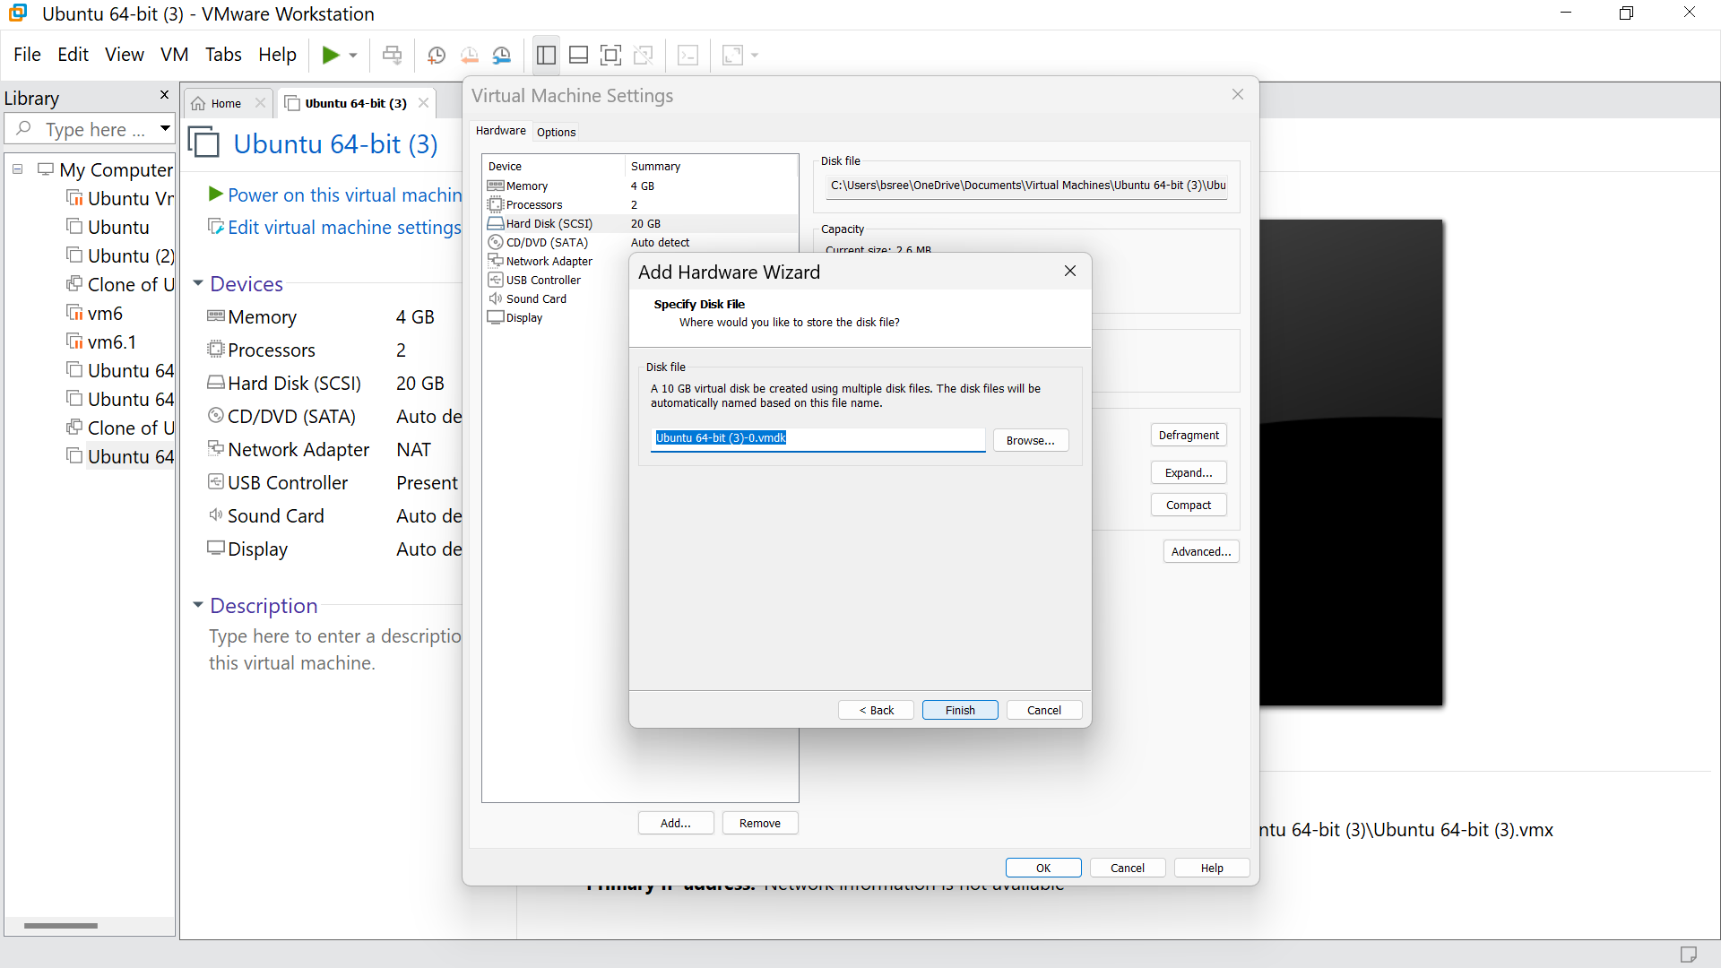

STEP -15: Click ok

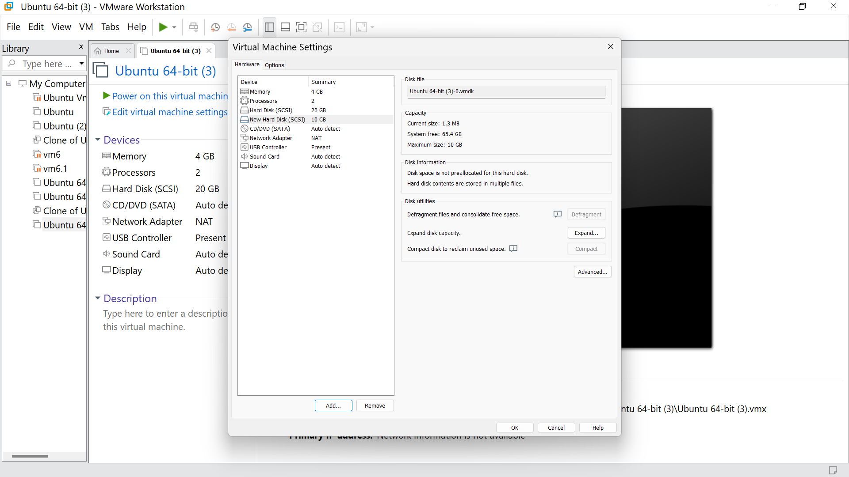

STEP -16: Hence we got the output

