CHAOSPILOT AI
Project Documentation
AI-driven chaos engineering for cloud-native resilience
Built for the Bosch hackathon problem statement “AI-Driven Chaos Engineering for Cloud-Native Resilience”.
Repository: https://github.com/LaveUI/ChaosPilotAI
Team No: 25
Team members
Annu Marry Mahesh
Vaibhav Gupta
Ishita Sharma
Nirav Parmar
Samhit Reddy
Manipal Institute of Technology, Bengaluru

Contents
1. Overview 3
2. Sample application 3
3. Architecture 4
4. The five agents 5
5. AI versus code 6
6. Framework 6
7. Failure scenarios 7
8. Safety design 8
9. Measurement and scoring 8
10. Setup and usage 9
11. Configuration 11
12. Project layout 11
13. Results 12
14. Testing 12
15. Troubleshooting 12
16. Limitations and future work 13

1. Overview
ChaosPilot AI finds the weak points of a cloud-native application by breaking it on purpose, safely. Five AI agents observe the application, decide what to break, inject the failure, roll it back, explain what happened, recommend fixes and rank the weaknesses. Plain code, not the AI, enforces every safety limit and calculates the resilience score. The result is a self-contained HTML report and a results file for each run.

Problem statement
Chaos engineering tests resilience by injecting failures into a running system, but it is usually manual: an engineer must choose what to break, judge when to stop, and interpret the outcome, and a badly chosen experiment can cause a real outage. The hackathon problem, “AI-Driven Chaos Engineering for Cloud-Native Resilience”, asks for a system where AI helps with these decisions. ChaosPilot AI answers it by letting AI agents plan, run and explain experiments inside hard limits that code enforces.

2. Sample application
The system under test is Google Online Boutique, an open-source web shop built from 12 microservices that talk to each other over gRPC. It runs in a local Kubernetes cluster created with kind.
Application | Google Online Boutique (GoogleCloudPlatform/microservices-demo)
Services | 12 microservices (frontend, loadgenerator, adservice, cartservice, checkoutservice, currencyservice, emailservice, paymentservice, productcatalogservice, recommendationservice, shippingservice, redis-cart)
Dependencies | 16 dependencies, extracted automatically from the Kubernetes manifests
Licence | Apache-2.0
Deployment | Local kind cluster; the repo ships the manifest in sample/ for use when the upstream repo is not cloned

Why it was chosen
- It is a realistic, multi-service shop: a request to the frontend fans out to many backends, so one failing service can have a visible effect on others.
- It is openly licensed (Apache-2.0) and runs on a laptop-sized kind cluster, so it is a safe sandbox.
- Its Kubernetes manifests describe the services and their addresses, which lets the mapper build the dependency map automatically.

Dependency map
The mapper builds the map from the manifests (python3 -m chaosai map writes graph.json and graph.mmd). The Planner uses it to decide which services matter most; the report shows it with the tested services highlighted.
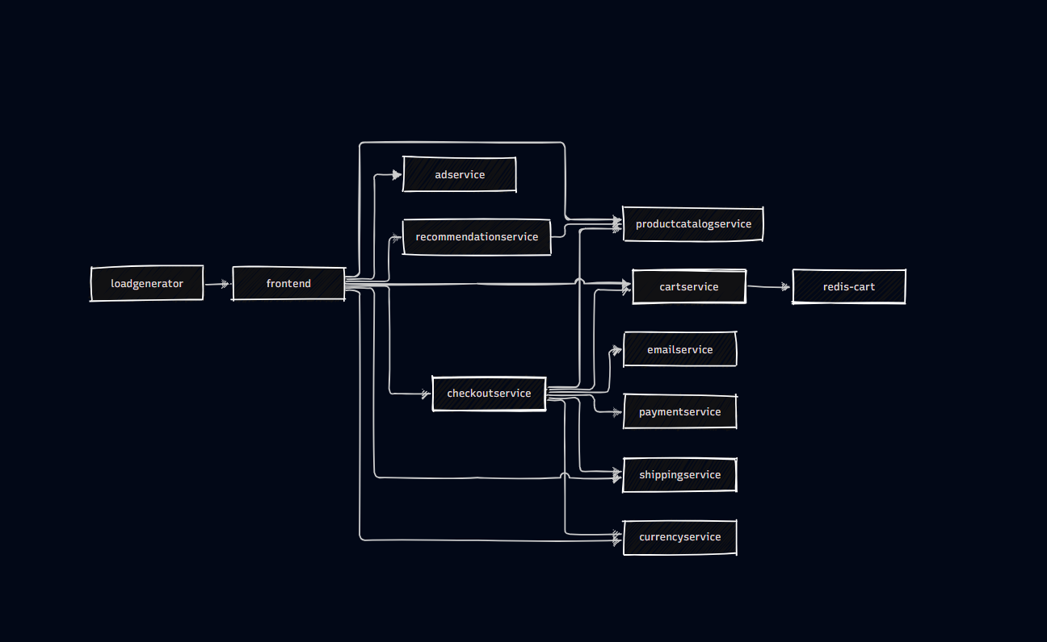
Figure 1: Online Boutique dependency map (12 services, 16 dependencies)

3. Architecture
The diagram below shows the whole system. The agents decide; trusted code enforces the limits, and only validated faults ever reach the cluster.
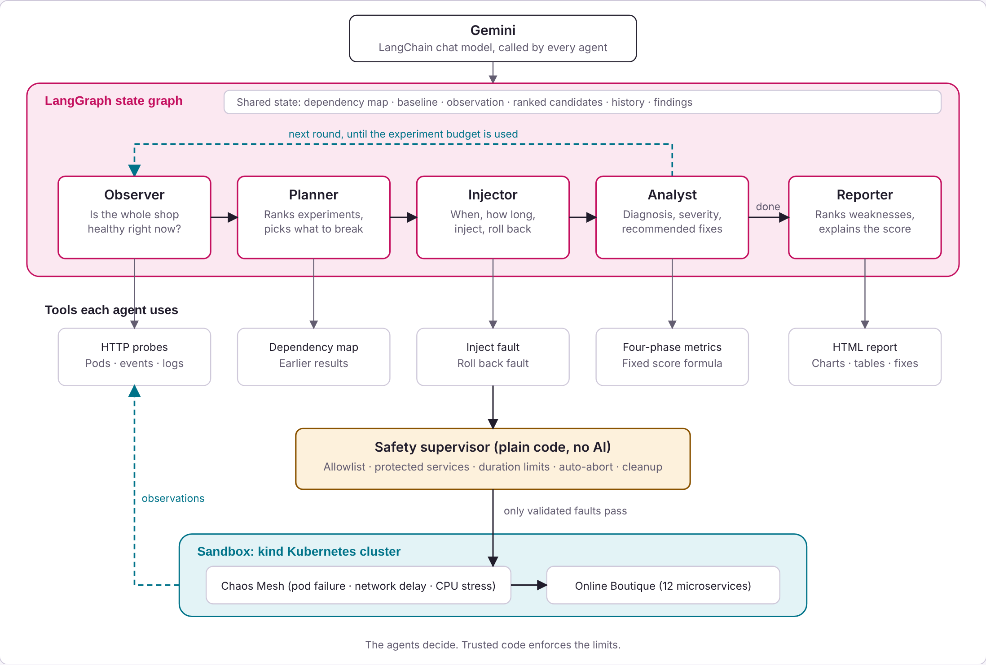
Figure 2: ChaosPilot AI architecture

The four layers
Layer | What it contains
Application | Online Boutique (12 microservices) in a kind Kubernetes cluster, with Chaos Mesh installed to inject faults. This is the sandbox where all experiments run.
Tools | What the agents act through: HTTP probes, pod/event/log reads, the dependency map and earlier results, fault injection and rollback, four-phase metrics with the fixed score formula, and the HTML report.
Safety supervisor | Plain code with no AI: the fault allowlist, protected services, duration limits, automatic abort and cleanup. Only validated faults pass through it to the cluster.
Agents | Five agents (Observer, Planner, Injector, Analyst, Reporter) run as a LangGraph state graph, all calling the selected model (Gemini or Ollama) through one client.

4. The five agents
All five agents are in chaosai/agents.py and are nodes of one LangGraph state graph built in run_agents. Each has a rule-based version of its decision, so the pipeline still runs without a model. The report states, per agent, whether a decision came from the selected model or from the rules.

4.1 Observer
Reads | The whole application: live HTTP probes, every deployment and pod, restarts, warning events and logs.
Decides | Whether the app is healthy enough to test, and which services already look unhealthy.
Tool | Kubernetes read access and HTTP probes.
Rule-based fallback | Checks the probe and cluster readings with fixed rules; for example, a deployment that is not ready is flagged as unhealthy.

4.2 Planner
Reads | The dependency map, the Observer’s report and the results of earlier experiments.
Decides | A ranked list of five candidate experiments, and which one runs next (the top one not yet tested).
Tool | The allowlist of faults (it can only choose from allowed faults and services).
Rule-based fallback | Scores every allowed service and fault pair: +3 per service relying on it, +4 for a single replica, +5 for a fault type not tried yet, −3 per earlier test on that service, −6 if the service is already confirmed weak.

4.3 Injector
Reads | Pre-flight probes before the fault, and live readings while the fault is active.
Decides | Whether to inject now, for how long, and whether to roll back early.
Tool | Chaos Mesh (creates the fault, watches it, removes it).
Rule-based fallback | Injects for the configured duration with no early rollback; only the safety guard can stop the fault. The pre-flight check and cleanup are code in every mode.

4.4 Analyst
Reads | The before, during, recovery and after measurements of the experiment.
Decides | Cause, severity and recommended fixes for each experiment.
Tool | The score formula (analyzer.py).
Rule-based fallback | Rule-based recommendations, for example: run at least 2 replicas after a pod failure on a single replica, add timeouts and a circuit breaker after a network delay, set CPU limits and an autoscaler after CPU stress, add readiness and liveness probes if recovery is slow.

4.5 Reporter
Reads | Every experiment’s result and diagnosis.
Decides | The order of all weaknesses by severity, and what the resilience score means.
Tool | The HTML report.
Rule-based fallback | Ranks the weaknesses by severity with a standard explanation of the score.

5. AI versus code
The model makes the judgement calls; code makes everything that must be exact or safe. Every answer from the model is validated against the allowlist, the dependency map and the protected services before anything runs.
Decided by the selected model | Always decided by code
What to observe and how to describe it | Probe measurements, error rates and latency
Which service to break, with which fault, in what order | Which faults exist (the allowlist) and which services are protected
Whether and how long to inject, and early rollback | Duration limits and the automatic abort
Diagnosis, severity and fixes | The resilience score formula
Ranking and summary | Deleting the fault on every exit path

6. Framework

LangGraph state graph
The agents are wired as a LangGraph StateGraph (built in _build_graph and run by run_agents). If LangGraph is not installed, the same agents run in a plain Python loop.
Nodes | observer, planner, injector, analyst, reporter
Shared state | AgentState: the current round, the observation, the chosen experiment (exp), its measured result, and an outcome string that the routing reads. The run also keeps the dependency map, baseline, history and findings.
Fixed edges | START → observer → planner; reporter → END
Conditional edges | planner → injector or reporter; injector → analyst, observer or reporter; analyst → observer or reporter
Loop | After the analyst, the graph returns to the observer for the next round until the experiment budget is used; then it goes to the reporter.

LangChain as the model connector
Agents call the model through one client in chaosai/llm.py, which asks for structured JSON output against a schema per agent and retries transient failures. With langchain-google-genai installed it connects to Gemini through the LangChain chat model (ChatGoogleGenerativeAI); otherwise it uses the Google Gen AI SDK (google-genai).

Gemini and Ollama options
--planner value | Behaviour
auto (default) | Gemini when a key is set, otherwise the rules
llm | Gemini; the run stops at the start if no key or client library is found
local | Local Ollama model configured under local_agent (default qwen2.5:3b); no API key required
rule-based | Rules only, no model calls

Gemini needs the GEMINI_API_KEY environment variable (never stored in a file) and uses llm.model, which can be overridden with CHAOSAI_MODEL. For local mode, the Ollama server must be on a loopback address and the model is set by local_agent.model.

7. Failure scenarios
Failure | Chaos Mesh kind | Effect | Settings
pod-failure | PodChaos | One pod of the service is unavailable | mode: one pod
network-delay | NetworkChaos | 500 ms latency (50 ms jitter) on the service | mode: all pods of the service; correlation 50
cpu-stress | StressChaos | 2 CPU workers at 90% load in one pod | mode: one pod

Each experiment targets one service for at most 60 seconds. The Injector may choose a shorter duration, never below 15 seconds.

Why these three
They cover three different ways a service fails in practice: it disappears (pod failure), it becomes slow (network delay), and it is starved of resources (CPU stress). Each is supported by Chaos Mesh, is time-limited so Chaos Mesh also expires it, and can be removed cleanly, which keeps the blast radius small.

8. Safety design
Control | How it works
Allowlist | Only pod-failure, network-delay and cpu-stress exist in chaos.py. Any other action raises an error. The model proposes, the code checks: every suggestion is validated against the allowlist, the dependency map and the protected services.
Protected services | frontend and loadgenerator are never targeted (exclude_services in config.yaml).
Limits (blast radius) | One service per experiment, one pod for pod and CPU faults, and a fixed duration (60 s maximum, 15 s minimum for the Injector’s choice).
Pre-flight check | The Injector refuses to start if the app is unhealthy, and the Planner never targets a service the Observer reported as unhealthy.
Stop conditions (automatic abort) | The experiment is stopped if the rolling error rate exceeds 50%, if p95 latency exceeds the larger of 1500 ms and 5× the baseline p95, if more than 3 extra pods become unhealthy, or if a stop file exists. The time taken to remove the fault is measured.
Agent rollback | While a fault is active the Injector reviews the readings and can remove it early. The automatic abort is checked first and cannot be overridden by the agent.
Chaos Mesh expiry | Each fault is created with a fixed duration, so Chaos Mesh also removes it on its own even if ChaosPilot AI stops.
Manual kill switch | Ctrl+C, python3 -m chaosai kill, or creating the file runs/STOP. The fault is always deleted in a finally block.

To rehearse the abort, run with the strict limits in config-safety-test.yaml:
python3 -m chaosai --config config-safety-test.yaml agent --rounds 1

9. Measurement and scoring

Four phases
Phase | What is measured
Before | Normal error rate and latency before the fault is injected (compared against the baseline).
During | Error rate and latency while the fault is active.
Recovery | How long the application takes to return to normal after the fault is removed (timeout 120 s).
After | Readings once recovery is complete, to confirm the application is back to normal.

Resilience score
Each experiment scores 100 minus penalties; the overall score is the mean across experiments. Experiments scoring below 90 are listed as weaknesses. The score always comes from the formula in chaosai/analyzer.py; the Reporter explains it but cannot change it.
Penalty | Max | Full penalty when | Calculation
Errors | 40 | Mean error rate during the fault is 50% or more | 40 × min(1, error rate / 0.5)
Latency | 25 | p95 is 10× the baseline p95 or more | 25 × min(1, (p95 ratio − 1) / 9)
Recovery | 25 | Recovery takes 60 s or more, or never happens | 25 × min(1, recovery seconds / 60)
Safety abort | 10 | The guard had to stop the experiment | Flat 10 points

10. Setup and usage

Prerequisites
- Docker, kind, kubectl and helm
- Python 3.10 or later
- About 8 GB of free memory for Docker
- For the model agents: a Gemini API key, or Ollama with a pulled model for local mode
On Windows, use python in place of python3.

Step 1: try it without a cluster (offline simulator)
pip install -r requirements.txt
python3 -m unittest discover -s tests
python3 -m chaosai --sim map
python3 -m chaosai --sim baseline --seconds 15
python3 -m chaosai --sim agent --rounds 3 --planner rule-based
Open the newest runs/<id>/report.html. The simulator is a toy model for development; its numbers are not real results.

Step 2: set up the real cluster
On Linux or macOS, run ./setup.sh. On Windows, or by hand:
pip install -r requirements.txt
kind create cluster --name chaos
kubectl apply -f sample/kubernetes-manifests.yaml
kubectl get pods # repeat until all 12 are Running 1/1
helm repo add chaos-mesh https://charts.chaos-mesh.org
helm repo update
helm install chaos-mesh chaos-mesh/chaos-mesh -n chaos-mesh --create-namespace \
--set chaosDaemon.runtime=containerd \
--set chaosDaemon.socketPath=/run/containerd/containerd.sock
Then, in a separate terminal that stays open, forward the shop to your machine and check that http://localhost:8080 shows the shop:
kubectl port-forward deployment/frontend 8080:8080

Step 3: run the agents on the cluster
Set the Gemini key as an environment variable (PowerShell: $env:GEMINI_API_KEY = "your-key"). Never put it in a file in the repository.
export GEMINI_API_KEY=your-key
python3 -m chaosai map
python3 -m chaosai baseline --seconds 60
python3 -m chaosai agent --rounds 3 --planner llm
For local mode, start Ollama, pull the model and run:
ollama pull qwen2.5:3b
python3 -u -m chaosai agent --rounds 1 --planner local

Step 4: apply a fix and verify it
python3 -m chaosai fix # applies the safe automatic fixes from the last run
python3 -m chaosai rerun # repeats the same experiments and compares the scores

Commands
Command | What it does
map | Parses the manifests into graph.json and graph.mmd
baseline | Measures the normal error rate and latency
agent --rounds N | Runs the five agents for N rounds and writes the report
fix | Applies the safe automatic fixes (scale a stateless service to 2 replicas) from the last run
rerun | Repeats the last experiments and compares scores with the previous run
report | Regenerates the HTML report of a run
kill | Panic button: stops the session and deletes all chaosai faults
plan --n N, run | Without the agent loop: save a fixed list of experiments, then run it
monitor | Separate watcher: diagnoses faults you inject yourself, using a local Ollama model

Add --sim before the command to use the offline simulator.

The report
Each run writes runs/<id>/report.html (self-contained, works offline) and results.json. The report shows the overall resilience score, a score bar and the points lost for every experiment, which agents ran and whether each decision came from the model or the rules, the Observer’s findings and the Planner’s ranked candidates per round, the Reporter’s ranked weaknesses, the recommended fixes and before/after comparison, the dependency map with tested services highlighted, the safety audit, and for each experiment the Injector’s decision, the Analyst’s diagnosis and a latency and error timeline across the four phases.

11. Configuration
Settings are in config.yaml; every key is optional and defaults live in chaosai/config.py.
Key | Meaning
target_urls | Pages the prober requests
experiment_duration_s, cooldown_s | Longest fault duration, and the pause between rounds
allowlist, exclude_services | Faults the agents may use, and services they may never target
safety | Abort thresholds (max_error_rate, p95_factor, min_p95_ms, max_extra_unhealthy_pods, window, min_samples)
agent_review_every_samples | How often the Injector reviews a running fault (in probes)
llm.model | Gemini model name
local_agent.model, local_agent.ollama_url | Local Ollama model and loopback server URL
graph_overrides | Manual corrections to the dependency map (add_edges, remove_edges)

12. Project layout
File | Job
chaosai/mapper.py | Manifests → dependency map
chaosai/agents.py | The five agents and the LangGraph state graph that runs them
chaosai/planner.py | Candidate ranking (selected model and rules) and validation
chaosai/llm.py | Gemini and Ollama clients with structured JSON output
chaosai/runner.py | Inject, measure in four phases, recover
chaosai/guard.py | Abort rules
chaosai/chaos.py | Allowlisted Chaos Mesh manifests
chaosai/analyzer.py | Score formula and rule-based recommendations
chaosai/report.py | Self-contained HTML report
chaosai/env.py | KubeEnv (real cluster) and SimEnv (offline simulator)
chaosai/local_agent.py | The separate monitor command (local Ollama)
chaosai/config.py | Defaults, merged with config.yaml
chaosai/cli.py | Commands
tests/ | Unit tests (test_core.py)
sample/ | Online Boutique manifest used when the upstream repo is not cloned
docs/ | Architecture diagram and dependency map
setup.sh, demo.sh, Makefile | Cluster setup, full-loop demo, and shortcuts (test, sim, kill, clean)

13. Results

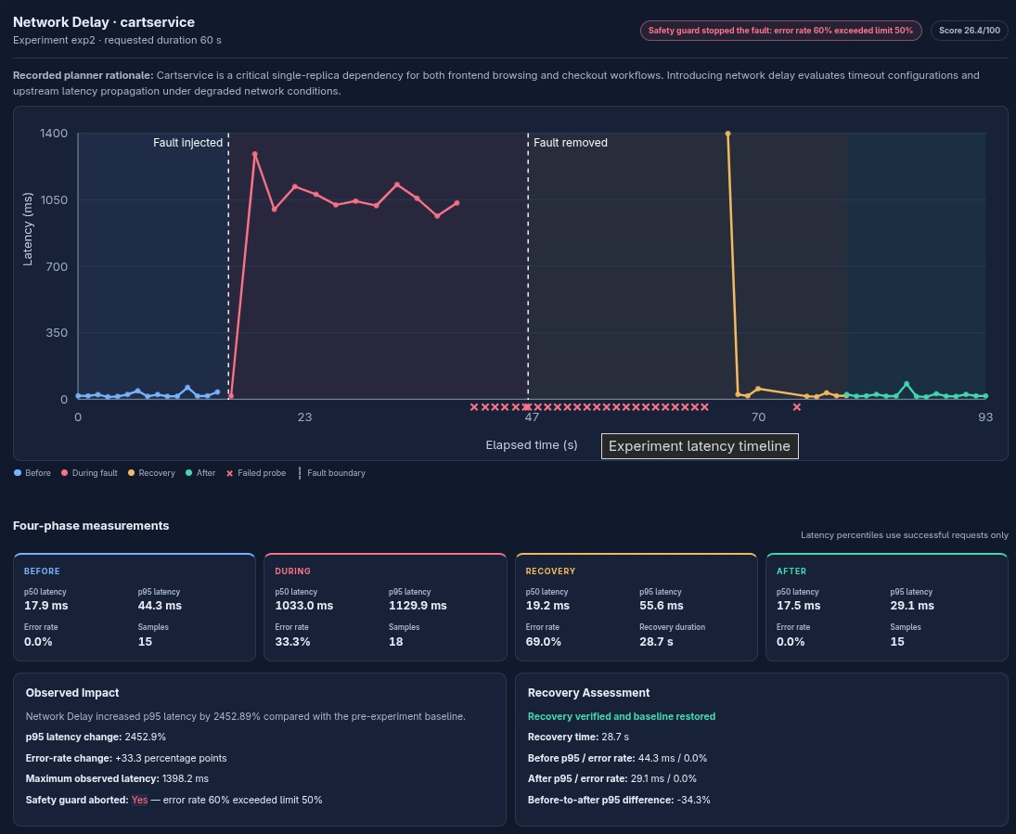

14. Testing

Unit tests
The tests in tests/test_core.py run without a cluster or an API key (python3 -m unittest discover -s tests, or make test). They cover:
- Mapper: services, edges, transitive dependents and overrides
- Chaos manifests: each allowed action renders; unknown actions are rejected
- Safety guard limits and the score formula (perfect, worst and monotonic cases)
- Planner rules, validation of model output, and explicit modes (llm requires Gemini; rule-based never calls it)
- Agent loop with a stubbed model: all five agents use the model; the Injector can decline or roll back early; the guard still aborts when the agent says continue; the model cannot target a protected service; bad answers fall back to the rules
- Model client: JSON parsing, retries of transient failures, local Ollama settings and loopback-only URL
- Report rendering and the local monitor

Offline simulator
The --sim flag swaps the real cluster (KubeEnv) for a simulated one (SimEnv), so the full pipeline of map, baseline, agents, fix and rerun can run in seconds with no Docker, Kubernetes or API key. The ./demo.sh --sim script runs this whole loop. The simulator is only for development and demonstration; its numbers are not real results.

15. Troubleshooting
Problem | What to do
Baseline shows errors | The port-forward is not running, or pods are not ready. Check kubectl get pods.
Chaos Mesh pods crash on kind | Check the containerd settings in setup.sh.
Network delay has no effect | Check that the chaos-daemon pods are running in the chaos-mesh namespace.
A fault will not go away | Run python3 -m chaosai kill.
First line says rule-based although a key is set | Check GEMINI_API_KEY is set in the same terminal and the requirements are installed.
First line says Python loop | LangGraph is not installed. Run pip install -r requirements.txt.
A manifest is rejected | kubectl apply --dry-run=server -f runs/<id>/<file>.yaml shows why.

16. Limitations and future work

Limitations
- Only three fault types (pod failure, network delay, CPU stress), one service per experiment and at most 60 seconds each; compound or multi-service failures are not tested.
- The sandbox is a local kind cluster, so the findings describe the sample app in that environment, not a production system.
- The dependency map comes from the Kubernetes manifests, so calls that are not visible there need manual graph_overrides.
- Health is measured through HTTP probes on the frontend pages via a port-forward, so problems that do not affect those pages may go unnoticed.
- Automatic fixes are limited to scaling a stateless service to 2 replicas; other recommendations are advice for a person to apply.
- Model quality and API rate limits affect the agents; a small local model (default qwen2.5:3b) will reason less well than Gemini. The rule-based fallback keeps runs going but is less adaptive.

Future work
- Add more fault types, such as packet loss, HTTP errors and memory or disk stress.
- Support multi-service and compound experiments, and run on a cloud cluster.
- Extend automatic fixes beyond replica scaling, for example resource limits, autoscalers and probes.
- Run experiments in CI so resilience is checked on every change, and test other applications.

