Buck-Converter (DC-DC)
Theory, Working Results & Applications
NATIONAL UNIVERSITY OF SCIENCES & TECHNOLOGY

Lab Project
Due Date: May 13, 2025
Electrical Network Analysis (EE - 211)

Group
Ayesha Mohsin | Laveeza Fatima | Fatima Habib | Ramisa Irum | Hafsa Sultan
SEECS | SEECS | SEECS | SEECS | SEECS
National University of Sciences and Technology | National University of Sciences and Technology | National University of Sciences and Technology | National University of Sciences and Technology | National University  Of Science and technology
CMS: 517660 | CMS: 515521 | CMS: 509029 | CMS: 504703 | CMS: 500779

Abstract

This project addresses the design and implementation of a buck converter (step-down DC-DC converter), which efficiently converts input voltage to lower level voltages. The buck converter is based on the concept of Pulse Width Modulation (PWM) to control output voltage through adjusting the duty cycle of a switching MOSFET. The main elements are an LM7809 voltage regulator, a 555 timer IC for generating PWM, an IRFZ44N MOSFET as the switch, an SB340 Schottky diode for freewheeling, and an inductor-capacitor (LC) filter to smooth the output.

The converter effectively steps down input voltages from 9V to 25V to a regulated output of 1V to 24V. The system was verified by driving a DC motor and LED lights, showing stable operation under different loads. Simulations and hardware implementation confirmed the design, showing that it can provide a smooth and adjustable DC output. The project shows the benefits of buck converters over linear regulators, such as increased efficiency, less heat dissipation, and improved power handling.

Buck Converter & Working Principle

A buck converter (step-down converter) is a DC-to-DC power converter which steps down voltage (while drawing less average current) from its input (supply) to its output (load). It is a class of switched-mode power supply (SMPS) typically containing at least two semiconductors (a diode and a transistor, although modern buck converters frequently replace the diode with a second transistor used for synchronous rectification) and at least one energy storage element, a capacitor, inductor, or the two in combination. To reduce voltage ripple, filters made of capacitors (sometimes in combination with inductors) are normally added to such a converter's output (load-side filter) and input (supply-side filter). It is called a buck converter because the voltage across the inductor “bucks” or opposes the supply voltage.
Switching converters (such as buck converters) provide much greater power efficiency as DC-to-DC converters than linear regulators, which are simpler circuits that lower voltages by dissipating power as heat, but do not step up output current
Buck converter usually works on the higher frequency on and off state continuously and the in doing so the current that passes through the inductor creates the magnetic field around the coil of inductor. The most basic phenomenon is as follows:
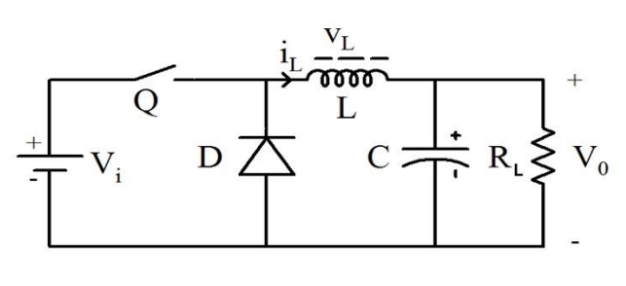
ON State of Buck Converter:
A buck converter is employed to decrease DC voltage. When the switch (Q) is in the closed position, current passes from the power supply via the inductor to the load. The inductor begins to charge and develops a magnetic field. This field stores energy. The capacitor also charges in this process. It smoothes the output voltage. The diode is reverse-biased, and hence it prevents current from flowing in the backward direction. The voltage across the load (Vo) rises as the current through the inductor rises. The power is regulated by employing PWM (Pulse Width Modulation), which switches on and off very quickly. The diagram for the on state can be seen below.
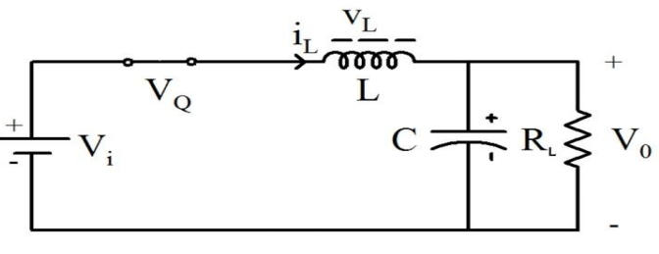

OFF State of Buck Converter:
When the switch (Q) is in the open state, the power supply is interrupted. The inductor behaves now like a source of power. It supplies its stored energy to maintain current flowing through the load. The current reduces slowly. The diode gets forward-biased and provides a path for current flow. The capacitor assists in maintaining voltage also. The inductor drains its energy during this interval. Before the inductor has discharged completely, the switch again comes on. This maintains the output voltage constant and greater than zero.

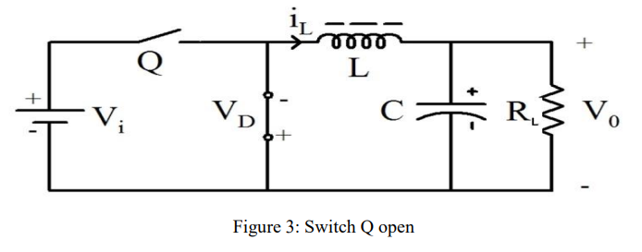
Duty Cycle:
Duty cycle is the time the switch remains ON in relation to the duration of one entire ON-OFF cycle. The switch remains ON for longer when the duty cycle is high, providing more output voltage. When the inductor never falls to zero current, the converter operates in Continuous Conduction Mode (CCM). When the current goes to zero, it's in Discontinuous Conduction Mode (DCM). The buck converter continues to switch ON and OFF at high rate, leveraging the inductor's magnetic field to regulate the voltage and current. The technique is efficient and provides smooth and stable DC output. The concept of the duty cycle can be best explained by the diagram below.
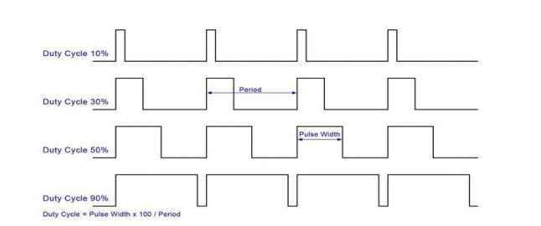

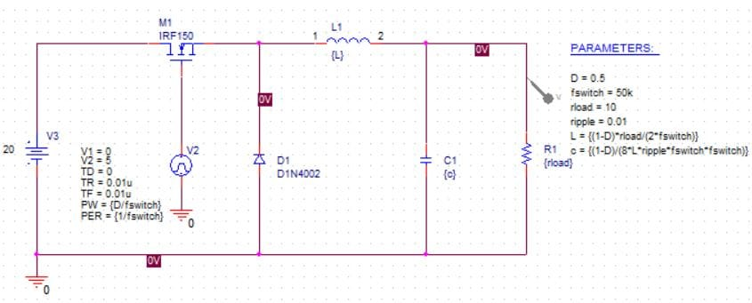
Simulations For A Basic Buck Converter

Circuit Diagram:

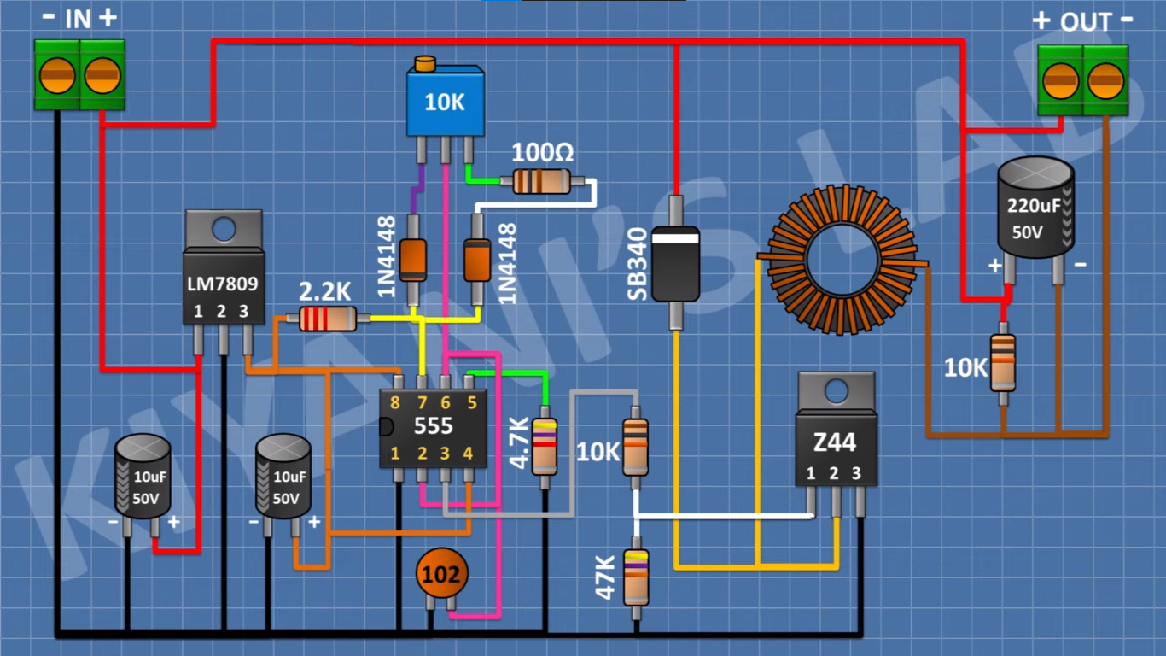

Components
• LM7809
- Type: Voltage Regulator
- Function: Provides 9V regulated supply for the 555 timer and other control circuitry.
• 555 Timer IC
- Type: PWM Generator
- Function: Generates a square wave signal (PWM) to control the switching of the MOSFET, thereby regulating output voltage.
• IRFZ44N (Z44)
- Type: Power MOSFET
- Function: Acts as a switch; turns ON and OFF according to PWM signal to control current flow through the inductor.
• SB340
- Type: Schottky Diode
- Function: Provides a freewheeling path for the inductor’s current when the MOSFET is OFF, ensuring continuous current flow to the load.
• Inductor
- Type: Energy Storage Element
- Function: Stores energy in its magnetic field when the MOSFET is ON and releases it when OFF to maintain output current.
• 220μF 50V Capacitor
- Type: Output Filter
- Function: Smooths the pulsating DC from the inductor into a stable DC output voltage.
• 2 × 10μF 50V Capacitors
- Type: Power Supply Filtering
- Function: Reduces voltage ripple and noise in the input and across the 555 timer power lines.
• 10kΩ Potentiometer
- Type: PWM Duty Cycle Adjuster
- Function: Allows manual control of the 555 timer's duty cycle, affecting the average output voltage.
• 47kΩ Resistors
- Type: Timing and Gate Biasing
- Function: Used in the 555 timer configuration and to pull down the gate of the MOSFET.
• 2.2kΩ Resistor
- Type: Timing Resistor
- Function: Sets timing interval in the 555 timer's astable mode.
• 100Ω Resistor
- Type: Gate Resistor
- Function: Limits inrush current to the MOSFET gate to prevent damage and reduce ringing.
• 2 × 1N4148 Diodes
- Type: Fast Switching Diodes (Protection)
- Function: Protects the 555 timer circuit by blocking reverse currents and voltage spikes.
• 102 Capacitor (1nF)
- Type: Timing Capacitor
- Function: Works with resistors to define the PWM frequency for the 555 timer.
• 10kΩ Resistor (across output)
- Type: Bleeder Resistor
- Function: Discharges the output capacitor slowly after power-off and helps stabilize output voltage under no-load condition.

Working

REGULATOR:
The regulator used in the project was LM7809. LM7809 is a fixed-voltage integrated-circuit voltage regulator designed for a wide range of applications. The L7809 voltage regulator provides 9V Positive voltage as output and can provide local on-card regulation, eliminating the distribution problems associated with single-point regulation. Although designed primarily as a fixed voltage regulator, but it can be used with external components to obtain adjustable voltage.
MOSFETS:
In general, MOSFETS are voltage dependent devices while traditional transistors are current dependent. What this means is that a standard transistor current output is directly proportional to current input. There will always be a base current and anything which guarantees current flow also guarantees heat dissipation which directly converts to energy loss and inefficiency.
MOSFETS use voltage to control a gate and thereby the channel that controls output current. This potentially eliminates the base current which can represent a significant percentage of the total device current and power. There are also benefits regarding switching speed in MOSFETS.

TRIMPOTS:
A trimmer, or preset, is a miniature adjustable electrical component. It is meant to be set correctly when installed in some device, and never seen or adjusted by the device's user. Trimmers can be variable resistors (potentiometers), variable capacitors, or trimmable inductors. They are common in precision circuitry like A/V components, and may need to be adjusted when the equipment is serviced. Trimpots are often used to initially calibrate equipment after manufacturing. Unlike many other variable controls, trimmers are mounted directly on circuit boards, turned with a small screwdriver and rated for many fewer adjustments over their lifetime. Trimmers like trimmable inductors and trimmable capacitors are usually found in superhet radio and television receivers, in the intermediate frequency (IF), oscillator and radio frequency (RF) circuits. They are adjusted into the right position during the alignment procedure of the receiver.

555 TIMER IC:
555 Timer IC is used to generate high frequency as in terms of that it is used to create continuous ON and OFF state in the circuit that is responsible for the step down of DC voltage and increment in current of the circuit.
The name 555 is due to the fact that the internal circuit of the timer is connected to the three 5k ohm resistors. The 555 timer chip is extremely robust and stable 8-pin device that can be operated either as a very accurate Monostable, Bistable or Astable Multivibrator to produce a variety of applications such as one-shot or delay timers, pulse generation, LED and lamp flashers, alarms and tone generation, logic clocks, frequency division, power supplies and converters etc, in fact any circuit that requires some form of time control as the list is endless.

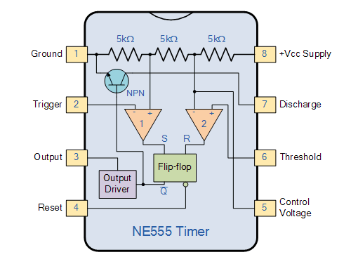

PINS OF 555 TIMER IC
- Pin 1. – Ground, The ground pin connects the 555 timer to the negative (0v) supply rail.
- Pin 2. – Trigger, The negative input to comparator No 1. A negative pulse on this pin “sets” the internal Flip-flop when the voltage drops below 1/3Vcc causing the output to switch from a “LOW” to a “HIGH” state.
- Pin 3. – Output, The output pin can drive any TTL circuit and is capable of sourcing or sinking up to 200mA of current at an output voltage equal to approximately Vcc – 1.5V so small speakers, LEDs or motors can be connected directly to the output.
- Pin 4. – Reset, This pin is used to “reset” the internal Flip-flop controlling the state of the output, pin 3. This is an active-low input and is generally connected to a logic “1” level when not used to prevent any unwanted resetting of the output.
- Pin 5. – Control Voltage, This pin controls the timing of the 555 by overriding the 2/3Vcc level of the voltage divider network. By applying a voltage to this pin the width of the output signal can be varied independently of the RC timing network. When not used it is connected to ground via a 10nF capacitor to eliminate any noise.
- Pin 6. – Threshold, The positive input to comparator No 2. This pin is used to reset the Flip-flop when the voltage applied to it exceeds 2/3Vcc causing the output to switch from “HIGH” to “LOW” state. This pin connects directly to the RC timing circuit.
- Pin 7. – Discharge, The discharge pin is connected directly to the Collector of an internal NPN transistor which is used to “discharge” the timing capacitor to ground when the output at pin 3 switches “LOW”.
- Pin 8. – Supply +Vcc, This is the power supply pin and for general purpose TTL 555 timers is between 4.5V and 15V.

SB340 SCHOTTKY DIODE:
Schottky diodes are used for their low turn-on voltage, fast recovery time and low-loss energy at higher frequencies. These characteristics make Schottky diodes capable of rectifying a current by facilitating a quick transition from conducting to blocking state. Therefore, Schottky diodes are often an ideal choice for semiconductor devices in many applications.

Hardware:

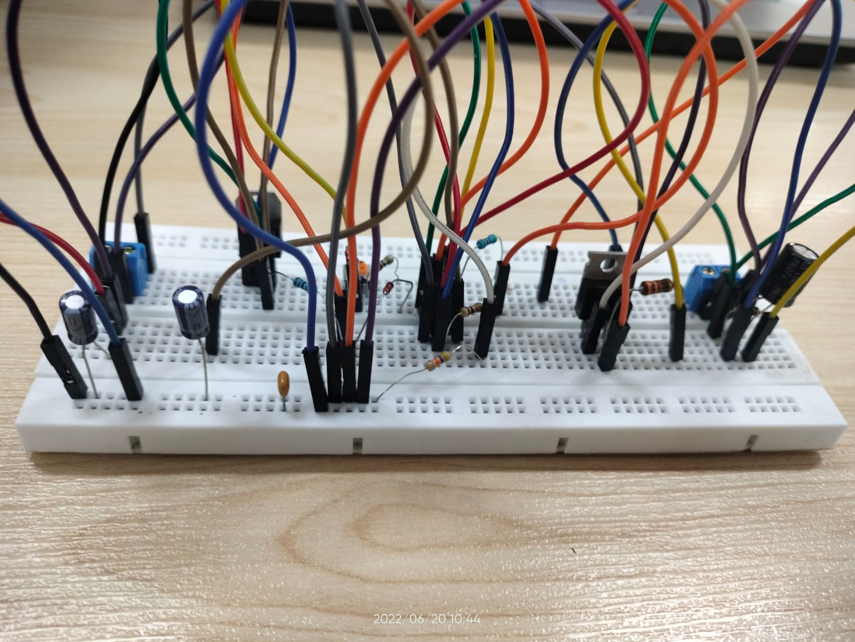

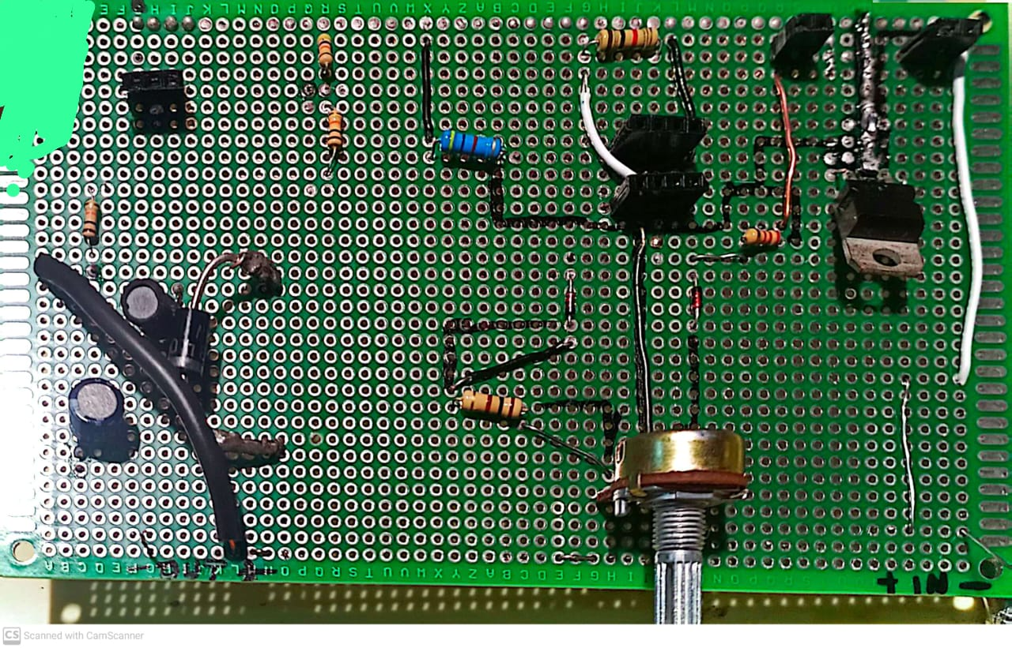

Simulations:

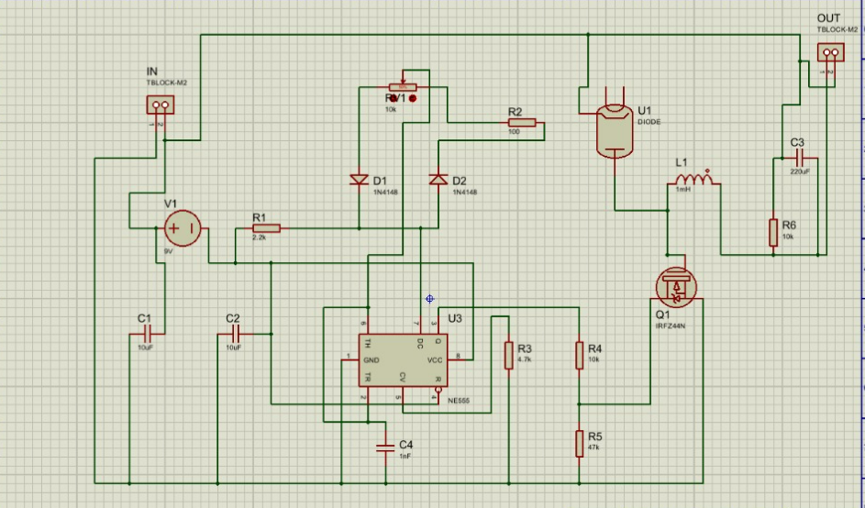

EFFICIENCY FACTORS
Conduction losses that depend on load:
- Resistance when the transistor or MOSFET switch is conducting.
- Diode forward voltage drop (usually 0.7 V or 0.4 V for schottky diode)
- Inductor winding resistance
- Capacitor equivalent series resistance
Switching losses:
- Voltage-Ampere overlap loss
- Frequency switch *CV² loss
- Reverse latence loss
- Losses due driving MOSFET gate and controller consumption.
- Transistor leakage current losses, and controller standby consumption.

Application:
It steps down DC voltage (while drawing less average current) from its input (supply) to its output (LOAD)
Efficiency of buck converters can be very high, often over 90%, making them useful for tasks such as converting a computer's main supply voltage. However we have used the the ouput to run a motor and the 3 led lights. The motor was runnable on the minimum of 3.3V.

Output:
The output voltage Vout​ of a buck converter is ideally given by:
Vout=D⋅Vin
Where:
- D = Duty cycle of the PWM signal (from 0 to 1)
- Vin​ = Input voltage
For example, if:
- Vin=12 V
- Duty cycle D=0.5 (i.e., 50%)
Then,
Vout=0.5×12=6 V
Power = (Vin - Vout) * Iout
We take mean of all the values of voltage and then power in order to find the efficiency. The regulator we used LM7806 can provide 1 to 1.5 A, so our converter provided an output current of 1.5A.
Mean voltage(input) = (5 + 10 + 15 + 18 + 20 + 25) / 6 = 15.5 V
Mean voltage(output) = (1.66 + 3.1 + 5.1 + 13.2 + 15 + 20.1) / 6 = 9.72 V
Power = (Vin - Vout) * Iout
Vin(avg)= 15.5 V
Vout(avg)= 9.72 V
Power = 8.67W
EFFICIENCY:
η = [VOUT × IOUT / (VOUT × IOUT + POUT)] × 100
η = 62.71%
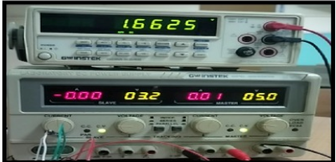
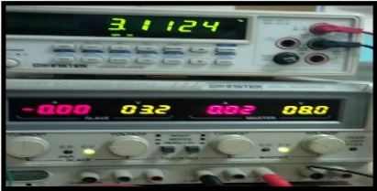
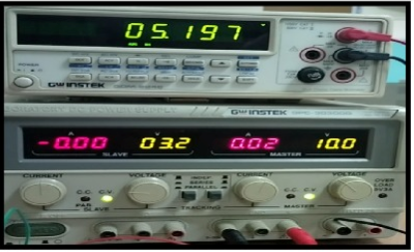
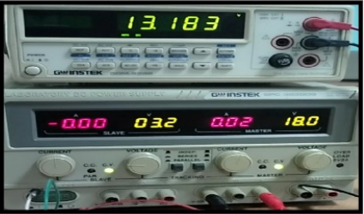

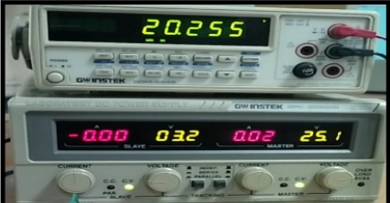

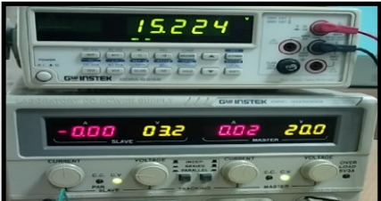

Deliverables:
- Hardware for the project
- Simulations of the project
- Vin(9V-25V) , expected Vout(1V-24V)
- Application( working motor and LEDs with the output voltage)

