Qn22. Provide and explain on the Continue statement in Java
The continue statement in Java is used to skip the current iteration of a loop and move directly to the next iteration.
Unlike break, which terminates the loop completely, continue only skips the remaining code in the current iteration.
🔹 Syntax
continue;

🔹 Example 1 – Using continue in a for loop
package JavaLearning02;
public class Qn22a_ContinueInForLoop {
public static void main(String[] args) {
for(int i=1; i<=5; i++) {
if(i == 3) {
continue;
}
System.out.println("i = " + i);
}
}
}

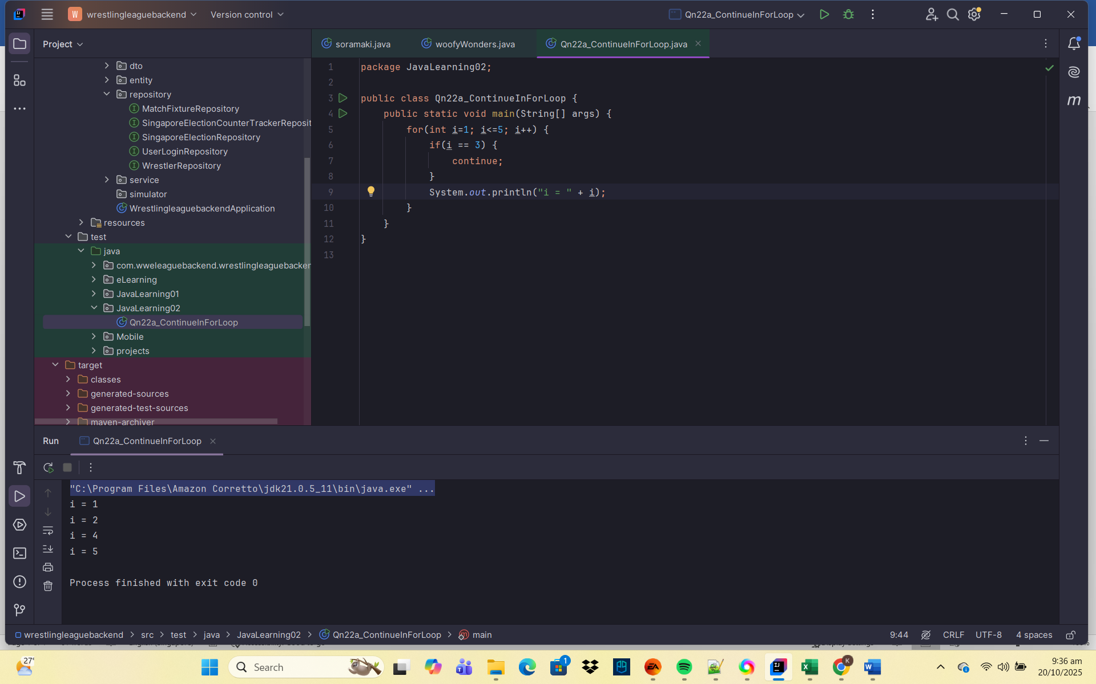
🧠 Explanation:
- When i == 3, the continue statement executes.
- The remaining code in that loop iteration is skipped.
- Control jumps to the next iteration (i = 4).

🔹 Example 2 – Using continue in a while loop
package JavaLearning02;
public class Qn22b_ContinueWhileLoop {
public static void main(String[] args) {
int num = 0;
while (num < 5) {
num++;
if(num == 3) {
continue; // Skip number 3
}
System.out.println("num = " + num);
}
}
}

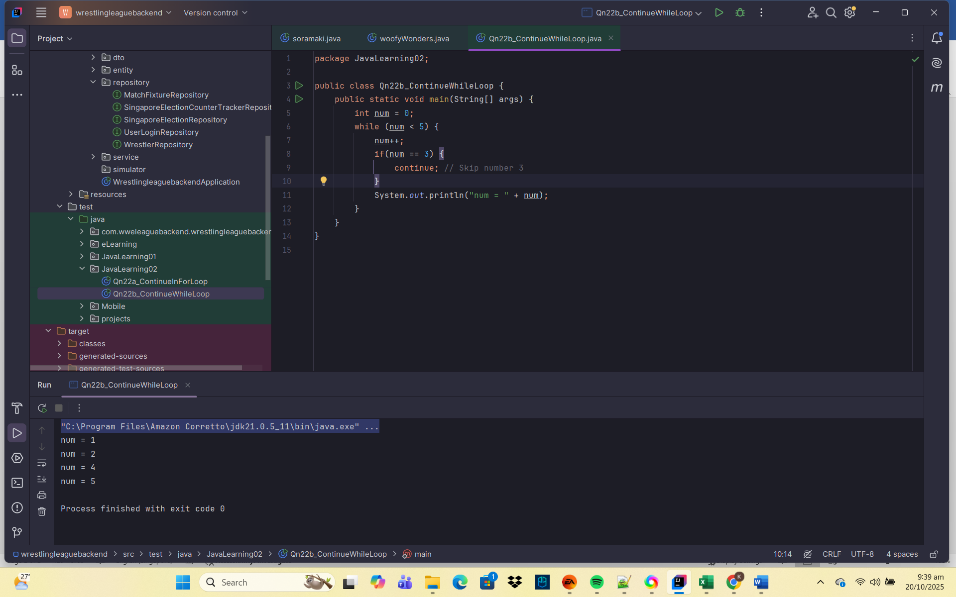

🧩 Explanation:
- When num equals 3, the continue statement skips the println line.
- The loop doesn’t stop — it simply jumps back to check the condition again.
🔹 Example 3 – Using continue in a do-while loop
package JavaLearning02;
public class Qn22c_ContinueDoWhile {
public static void main(String[] args) {
int i = 0;
do{
i++;
if(i==2) {
continue; // skip 2
}
System.out.println("i = " + i);
} while (i<4);
}
}

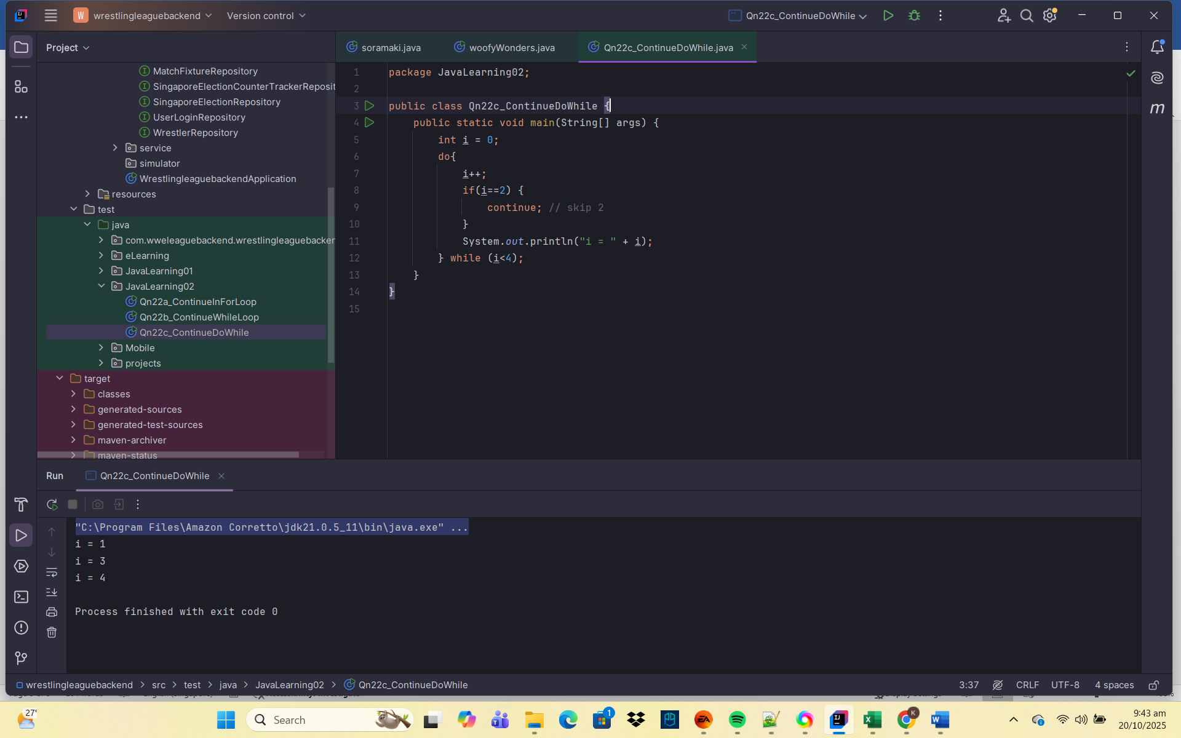

🧠 Explanation:
- When i == 2, the continue skips printing.
- The loop condition is rechecked immediately, continuing the iteration process.

🔹 Example 4 – Using continue in Nested Loops
package JavaLearning02;
public class Qn22d_ContinueNestedLoop {
public static void main(String[] args) {
for(int i =1; i<=3; i++) {
for(int j=1; j<=3; j++) {
if(j==2) {
continue; // Skip j = 2
}
System.out.println("i = " + i + ", j = " + j);
}
}
}
}

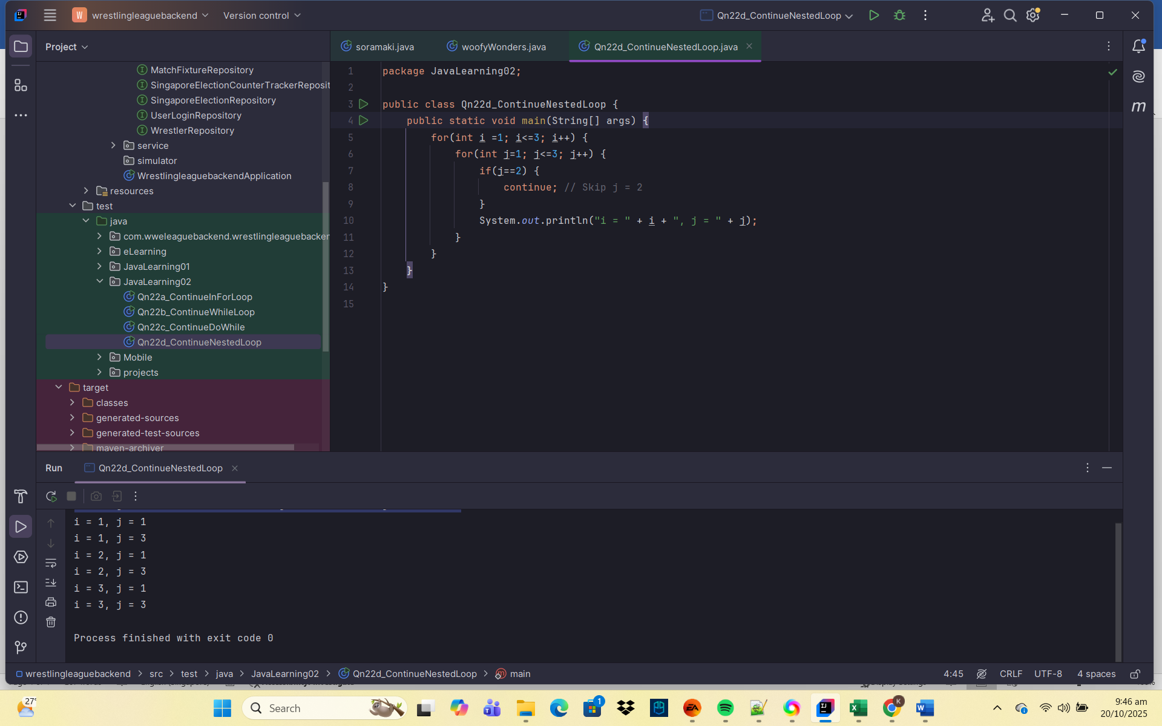
🧩 Explanation:
- The inner loop skips any time j == 2.
- The outer loop still continues normally.

🔹 Labeled continue (Advanced Concept)
A labeled continue lets you skip the current iteration of an outer loop directly.
package JavaLearning02;
public class Qn22e_LabeledContinueAdvancedConcept {
public static void main(String[] args) {
outerloop:
for(int i = 1; i <= 3; i++) {
for(int j = 1; j <=3; j++) {
if(j==2) {
continue outerloop; // Skip outer loop iteration
}
System.out.println("i = " + i + ", j = " + j);
}
}
}
}

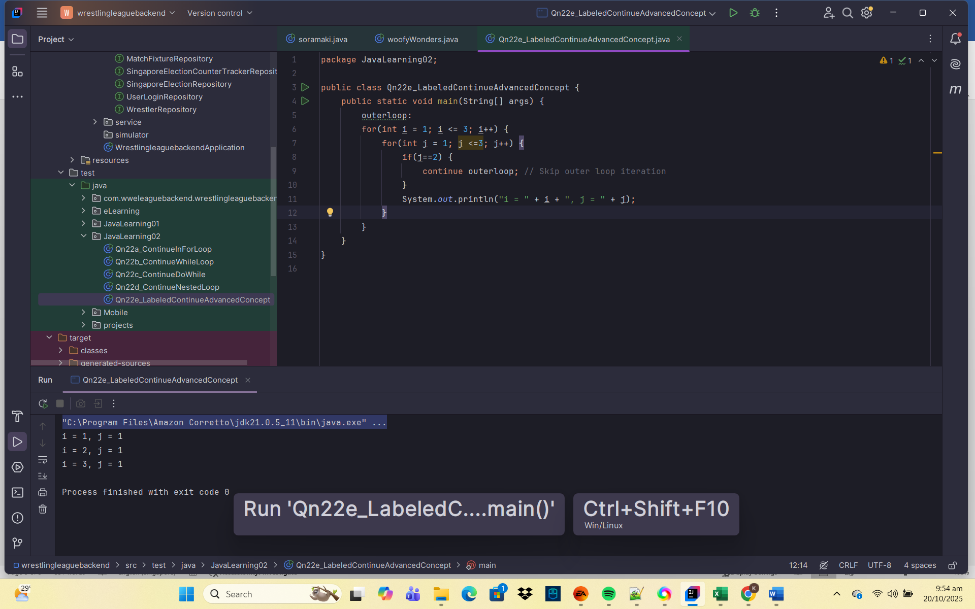
🧠 Explanation:
- Normally, continue affects only the inner loop.
- With a label, it jumps straight to the next iteration of the outer loop instead.

🧩 Key Points Summary
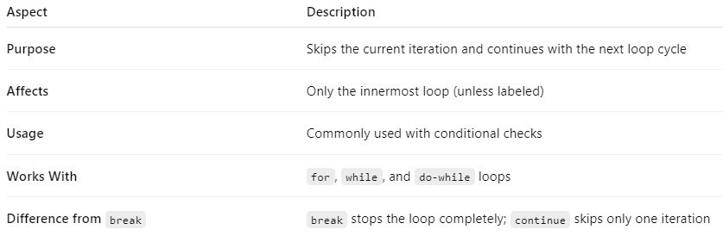
🔹 Example Comparison
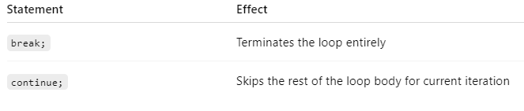
✅ Summary
- The continue statement is used to skip certain iterations of a loop when a condition is met.
- It helps make code cleaner by avoiding unnecessary nested if-else blocks.
- Use it carefully in nested loops to avoid confusion — labeled continue can control outer loops.

Qn23. Provide and explain on the Return statement in Java
The return statement in Java is used to exit from a method and optionally send a value back to the caller.
It marks the end of a method’s execution — once a return executes, no other code in that method runs.

🔹 Syntax
return; // used in void methods (no value returned)
return value; // used in methods that return a value

🔹 Example 1 – return in a void method
package JavaLearning02;
public class Qn23a_ReturnVoidMethod {
public static void main(String[] args) {
greetUser("Lavenzo");
greetUser("");
}
public static void greetUser(String name) {
if(name == null || name.isEmpty()) {
System.out.println("Invalid name.");
return; // Exit early, nothing else will execute
}
System.out.println("Hello, " + name);
}
}

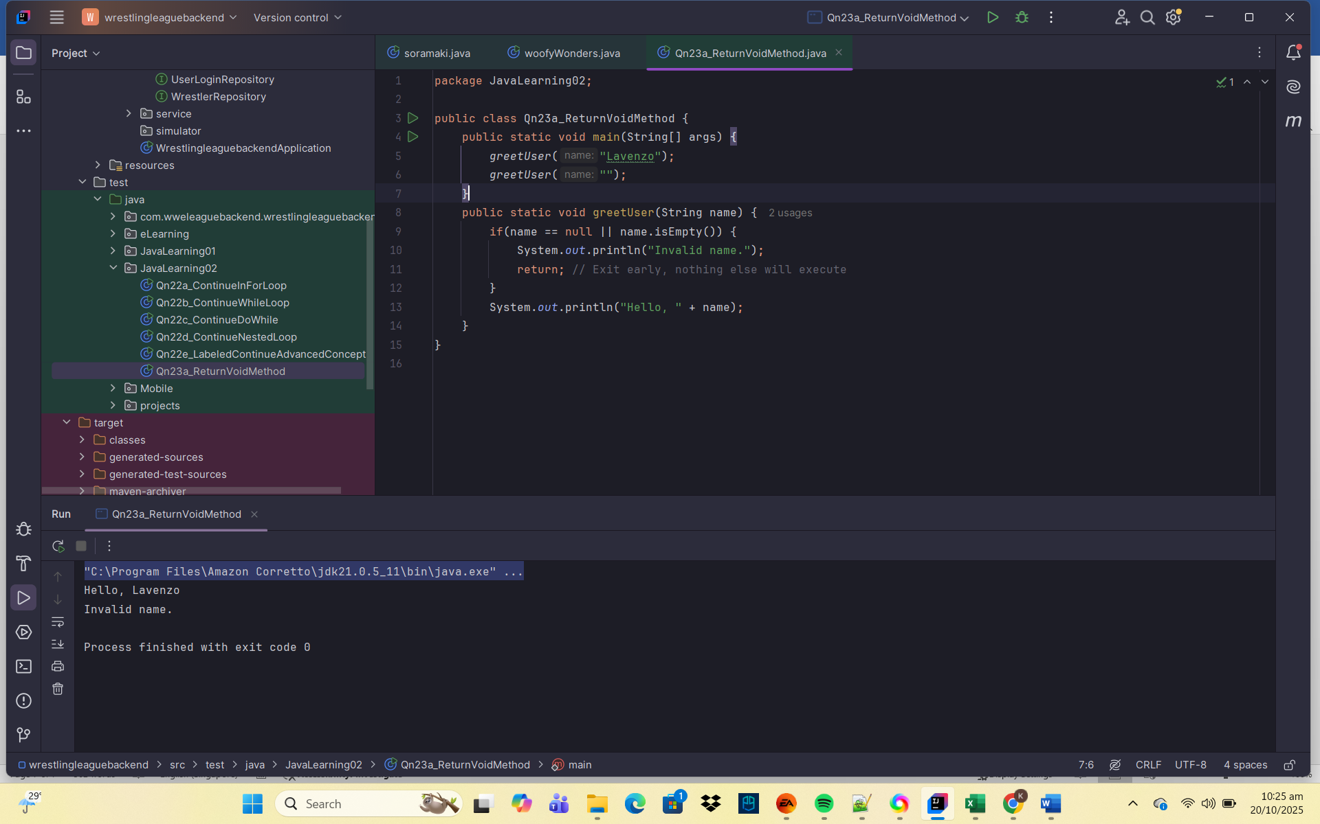
🧠 Explanation:
- The method greetUser() does not return a value because it’s void.
- When the name is invalid, return; exits the method immediately — the remaining statements are skipped.

🔹 Example 2 – return in a method that returns a value
package JavaLearning02;
public class Qn23b_ReturnValueMethod {
public static void main(String[] args) {
int result = square(5);
System.out.println("Square is: " + result);
}
public static int square(int num) {
return num * num; // Returns the result to the caller
}
}

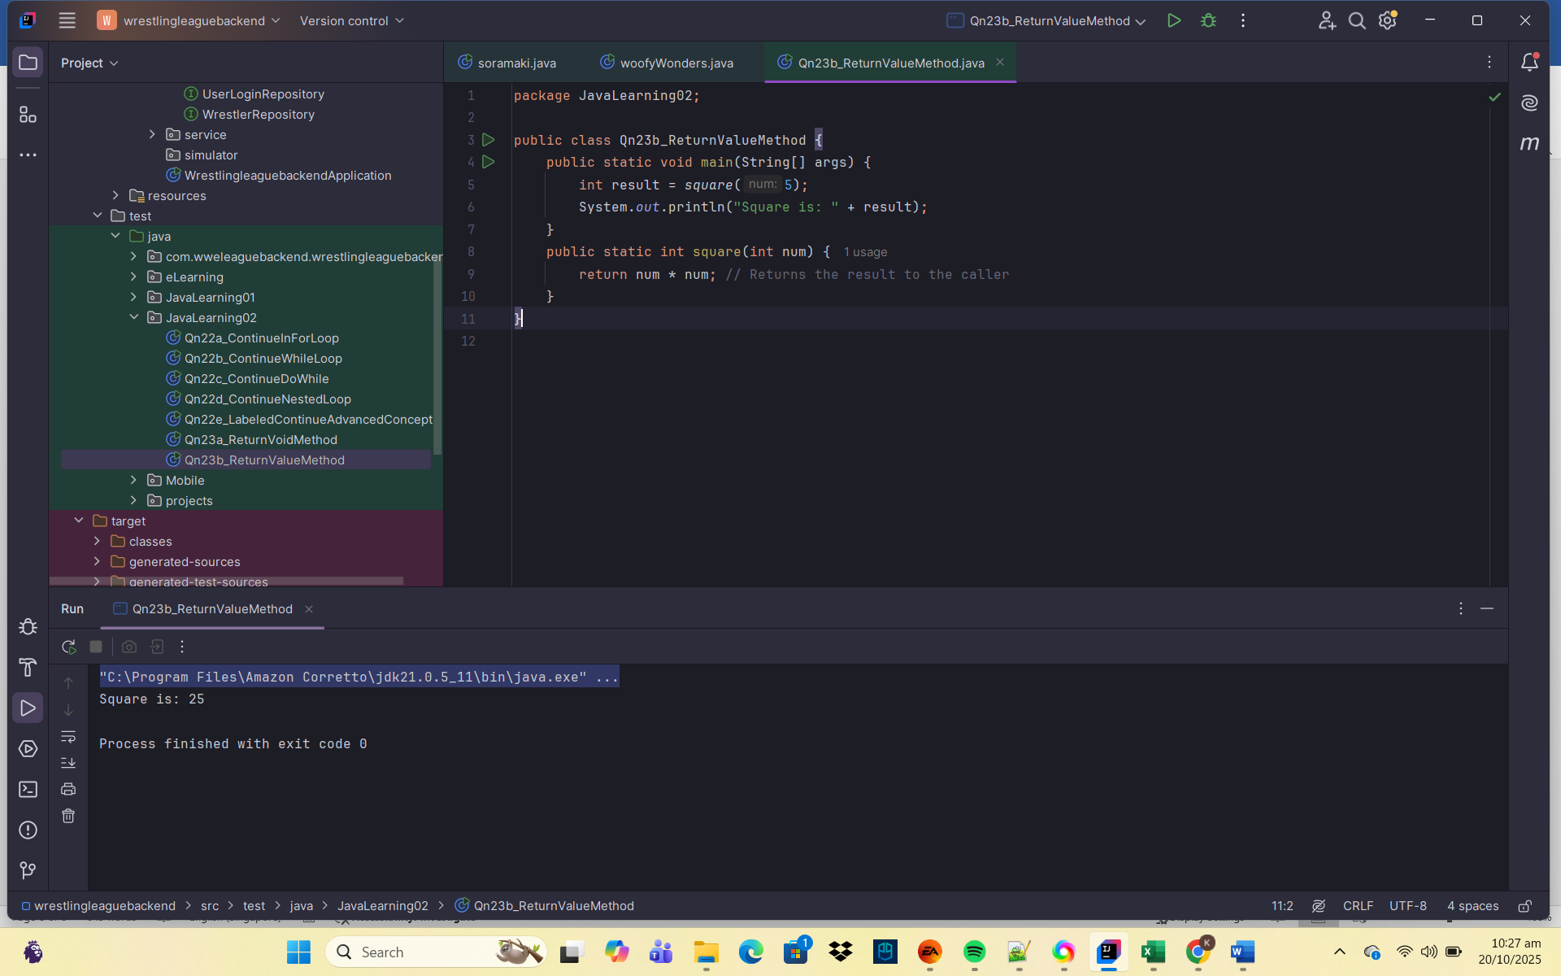
🧩 Explanation:
- The method square() returns an int value to its caller.
- The expression num * num is calculated, and its result is sent back using return.

🔹 Example 3 – Conditional return
package JavaLearning02;
public class Qn23c_ConditionReturnMethod {
public static void main(String[] args) {
System.out.println(checkNumber(5));
System.out.println(checkNumber(-3));
System.out.println(checkNumber(0));
}
private static String checkNumber(int num) {
if(num > 0) {
return "Positive";
} else if (num < 0) {
return "Negative";
} else {
return "Zero";
}
}
}

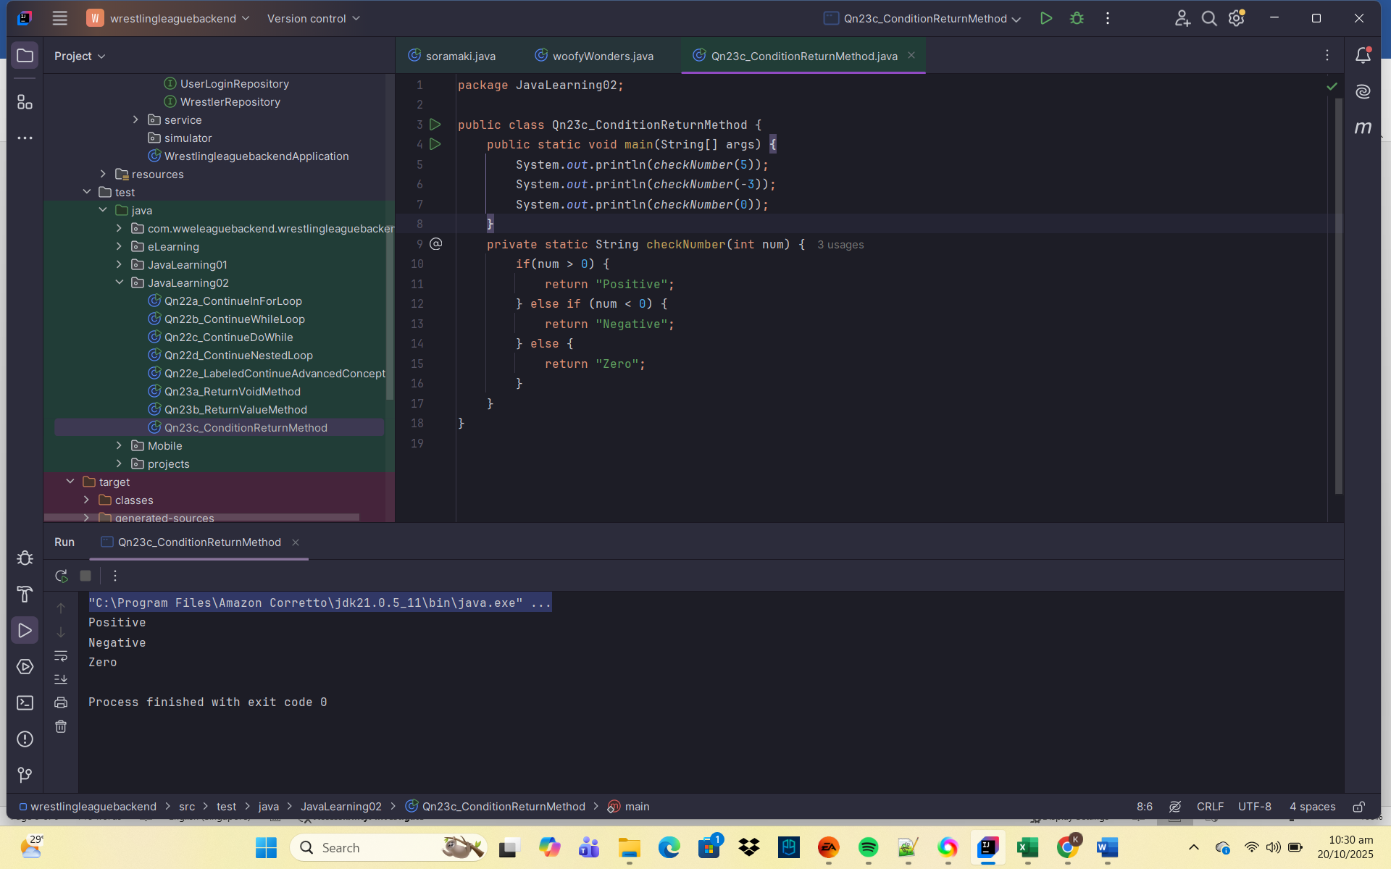
🧠 Explanation:
- The method checkNumber() decides which string to return based on the input.
- Each return exits the method immediately, ensuring only one result is sent back.

🔹 Example 4 – Returning from a loop
package JavaLearning02;
public class Qn23d_ReturningFromLoop {
public static void main(String[] args) {
int[] arr = {1,3,7,8,11};
System.out.println("First even number: " + findFirstEven(arr));
}
private static int findFirstEven(int[] nums) {
for(int num: nums) {
if(num%2 == 0) {
return num; // Immediately return the first even number
}
}
return -1; // Return -1 if no even number found
}
}

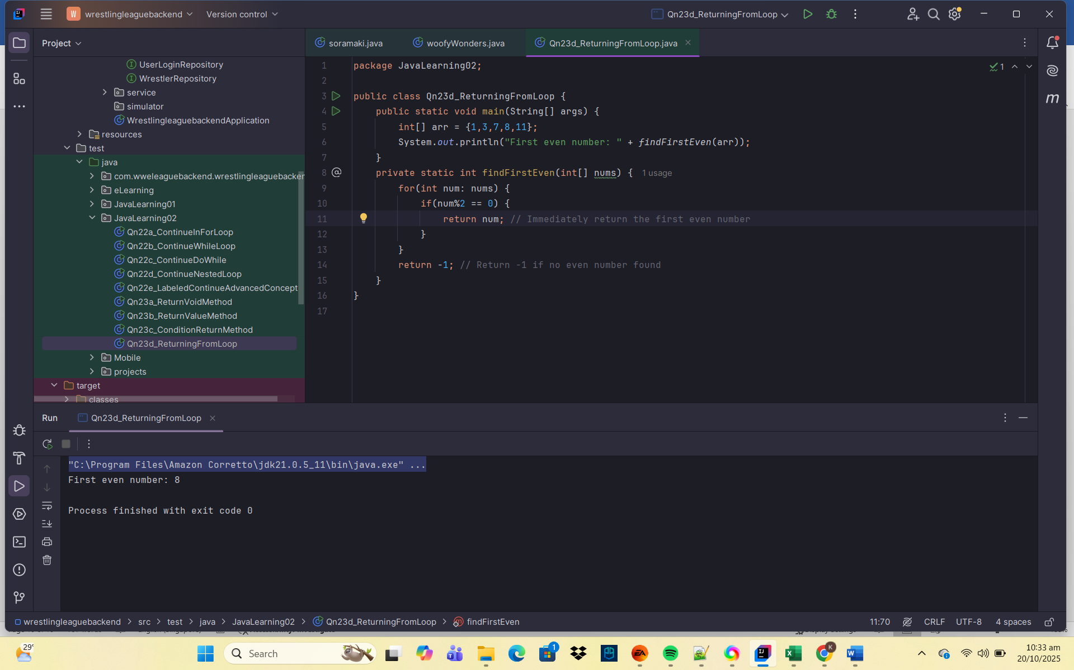
Explanation:
- The loop scans each number until it finds one that’s even.
- Once found, it uses return to exit immediately — no need to check the rest.

🔹 Example 5 – Returning an Object
package JavaLearning02;
public class Qn23e_ReturningObject {
public static void main(String[] args) {
String msg = getMessage(true);
System.out.println(msg);
}
private static String getMessage(boolean isMorning) {
if(isMorning) {
return "Good morning!";
}
return "Good evening";
}
}

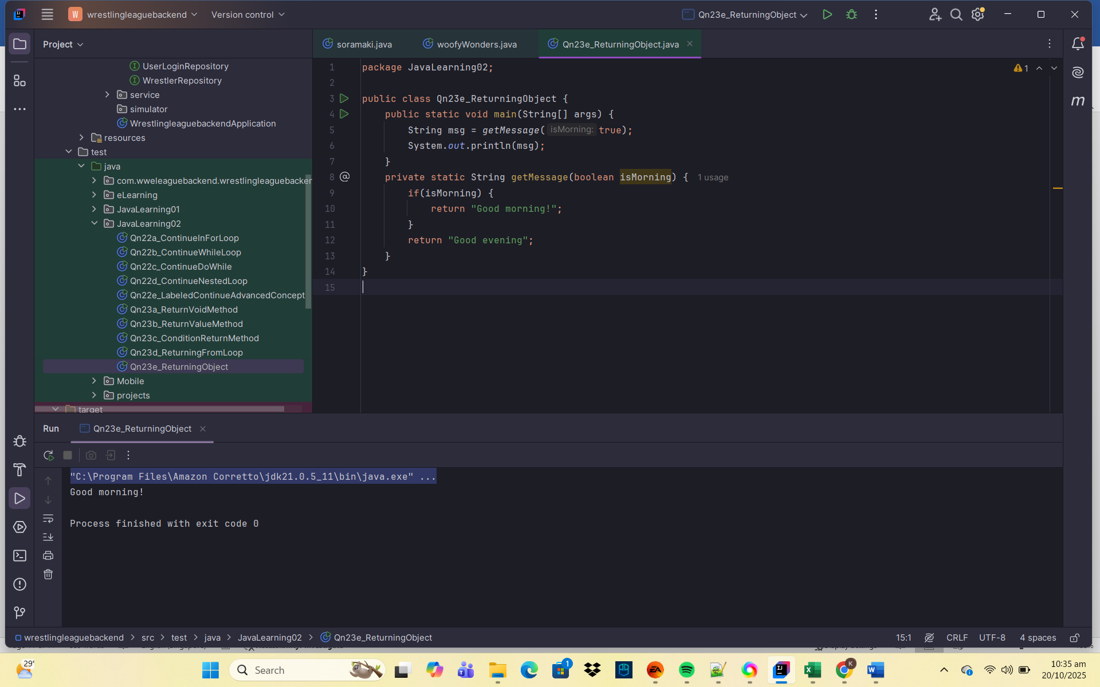
🧠 Explanation:
- A String (object) is returned based on the condition.
- The return statement can send any object, not just primitive data types.

🔹 Example 6 – Multiple return statements
package JavaLearning02;
public class Qn23f_MultipleReturnStatements {
public static void main(String[] args) {
System.out.println("Discount: " + getDiscount(8) + "%") ;
System.out.println("Discount: " + getDiscount(65) + "%");
System.out.println("Discount: " + getDiscount(25) + "%");
}
private static int getDiscount(int age) {
if(age < 12) {
return 50;
} else if(age >= 60){
return 30;
}
return 10;
}
}

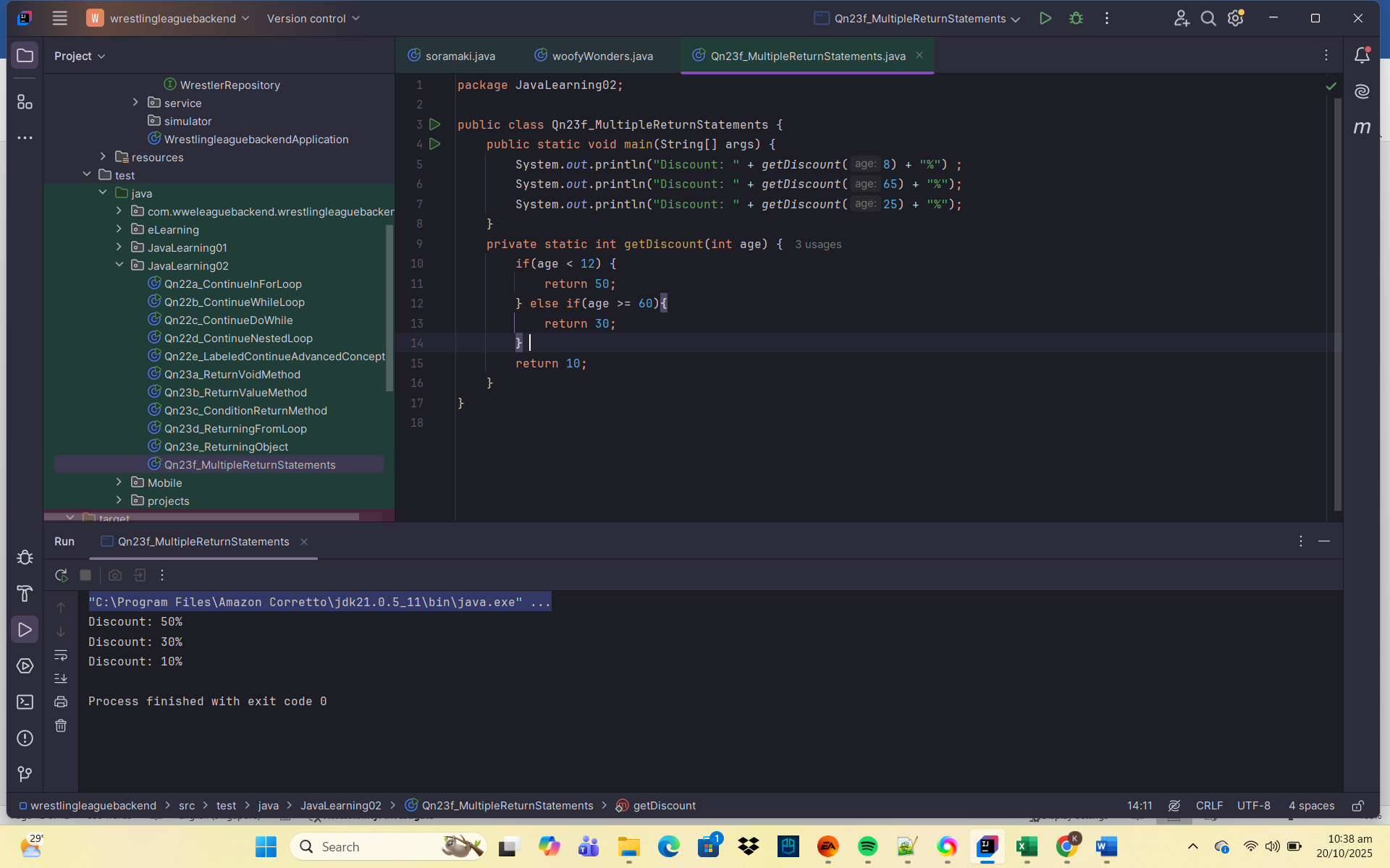
🧠 Explanation:
- You can have multiple return statements in a method.
- Each return corresponds to a specific condition and ends method execution immediately.

🔹 Example 7 – Returning from main()
package JavaLearning02;
public class Qn23g_ReturningFromMain {
public static void main(String[] args) {
System.out.println("Start of program");
if(args.length == 0) {
System.out.println("No arguments passed, existing...");
return; // Exit main early
}
System.out.println("Arguments provided!");
}
}

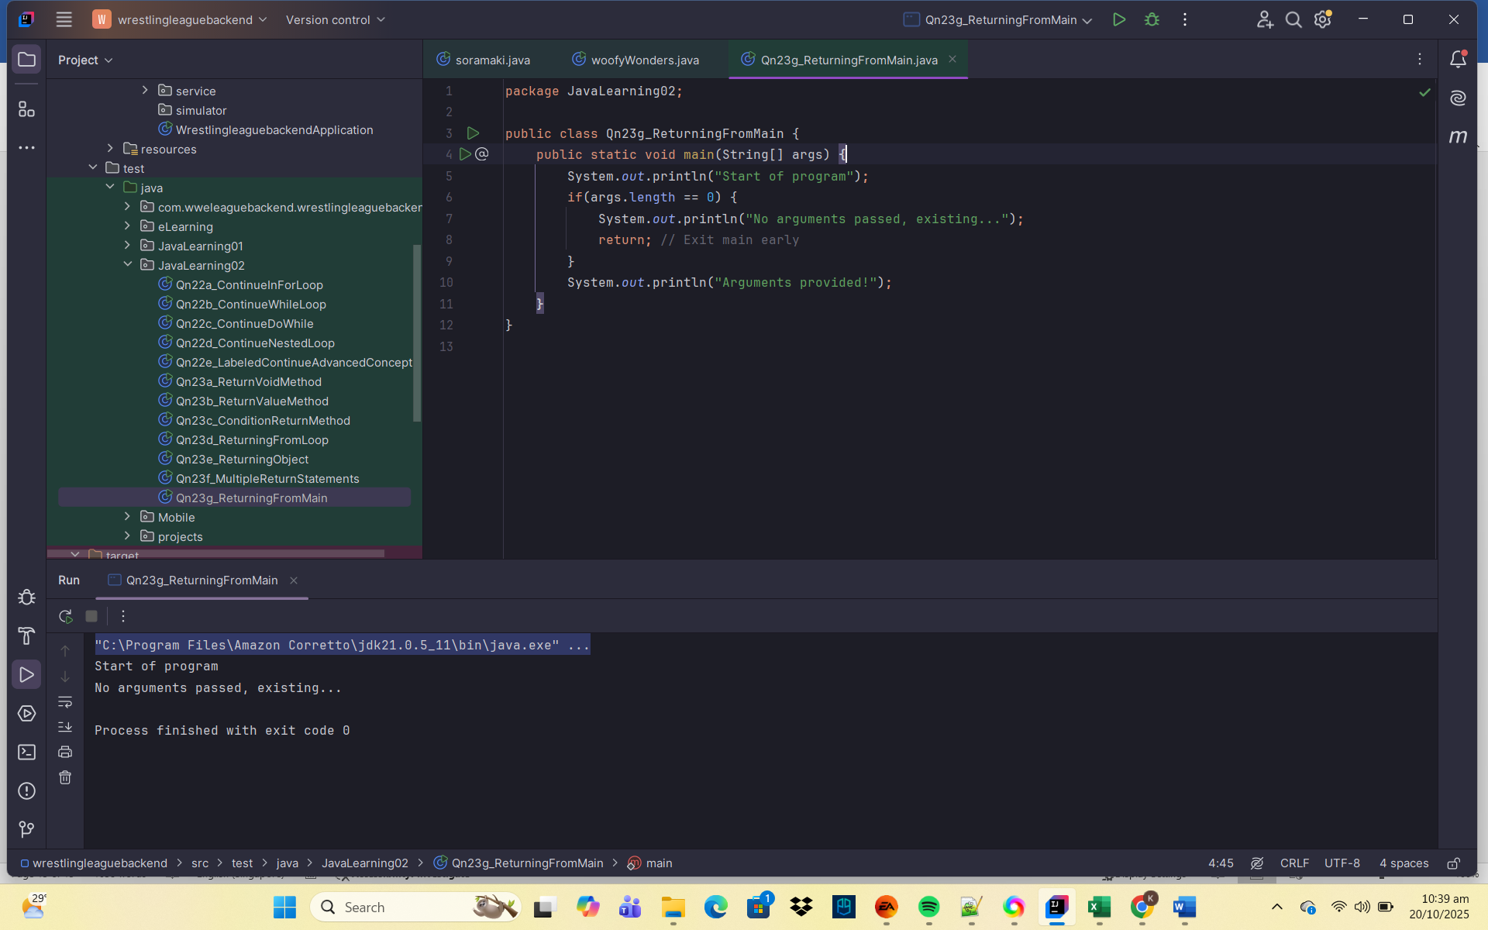
🧠 Explanation:
- The main() method can also use return; to end the program early.
🧩 Key Points Summary
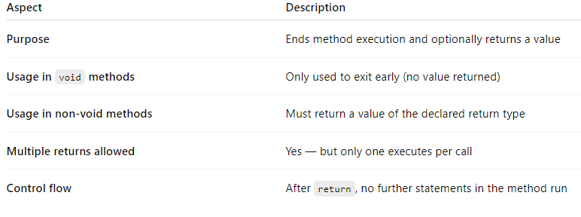
🔹 Common Mistakes
❌ Returning wrong data type
public static int getValue() {
return "Hello"; // Error: incompatible types
}

✅ Fix:
public static String getValue() {
return "Hello";
}
✅ Summary
- The return statement is a key control flow tool that exits a method.
- In void methods → it exits early.
- In methods with return type → it must return a matching value.
- Execution stops immediately once return is hit.
- Helps simplify logic and make code cleaner.

