Qn59. Provide and explain on Java Wrapper Classes Used in Java
1️⃣ What Are Algorithms in Java?
In Java, algorithms refer to step-by-step procedures used to solve problems such as:
- searching
- sorting
- iterating
- manipulating data in Collections
- performing computations
Java provides many built-in algorithms as part of the Collections Framework, mainly through the java.util.Collections and java.util.Arrays utility classes.
These built-in algorithms are optimized and widely used in real software development.
2️⃣ Types of Algorithms Commonly Used in Java
Java supports many fundamental algorithms, grouped into categories:
A. Searching Algorithms
1. Linear Search
Used on unsorted arrays/lists.
public static int linearSearch(int[] arr, int target) {
for (int i = 0; i < arr.length; i++) {
if (arr[i] == target) return i;
}
return -1;
}

2. Binary Search
Used on sorted arrays/lists.
Java provides built-in support:
int index = Arrays.binarySearch(arr, target);

B. Sorting Algorithms
Java's built-in sorting uses TimSort (highly efficient hybrid of merge sort + insertion sort).
Built-in methods:
Collections.sort(list); // sorts List
Arrays.sort(array); // sorts array

Sorting can be:
- Natural order (e.g., alphabetical, numerical)
- Custom order using Comparator
Example (custom sorting):
Collections.sort(list, (a, b) -> b - a); // descending
C. Shuffling Algorithm
Randomly rearranges list elements.
Collections.shuffle(list);
Used for:
- card games
- simulations
- random sampling
D. Reversing Algorithm
Reverses order of elements in a list.
Collections.reverse(list);

E. Minimum and Maximum
int min = Collections.min(list);
int max = Collections.max(list);

F. Frequency Count
Counts how often an element appears.
int count = Collections.frequency(list, "Apple");

G. Copy Algorithm
Collections.copy(destList, srcList);

H. Fill Algorithm
Collections.fill(list, 0);
Fills list entirely with a value.

3️⃣ Algorithm Examples
Example 1 – Sorting and Searching
package JavaW3School04;
import java.util.Arrays;
public class Qn59a_SortingAndSearching {
public static void main(String[] args) {
int[] numbers = {50, 20, 40, 10, 30};
Arrays.sort(numbers); // sort ascending
System.out.println(Arrays.toString(numbers));
int index = Arrays.binarySearch(numbers, 30);
System.out.println("Found 30 at index: " + index);
}
}

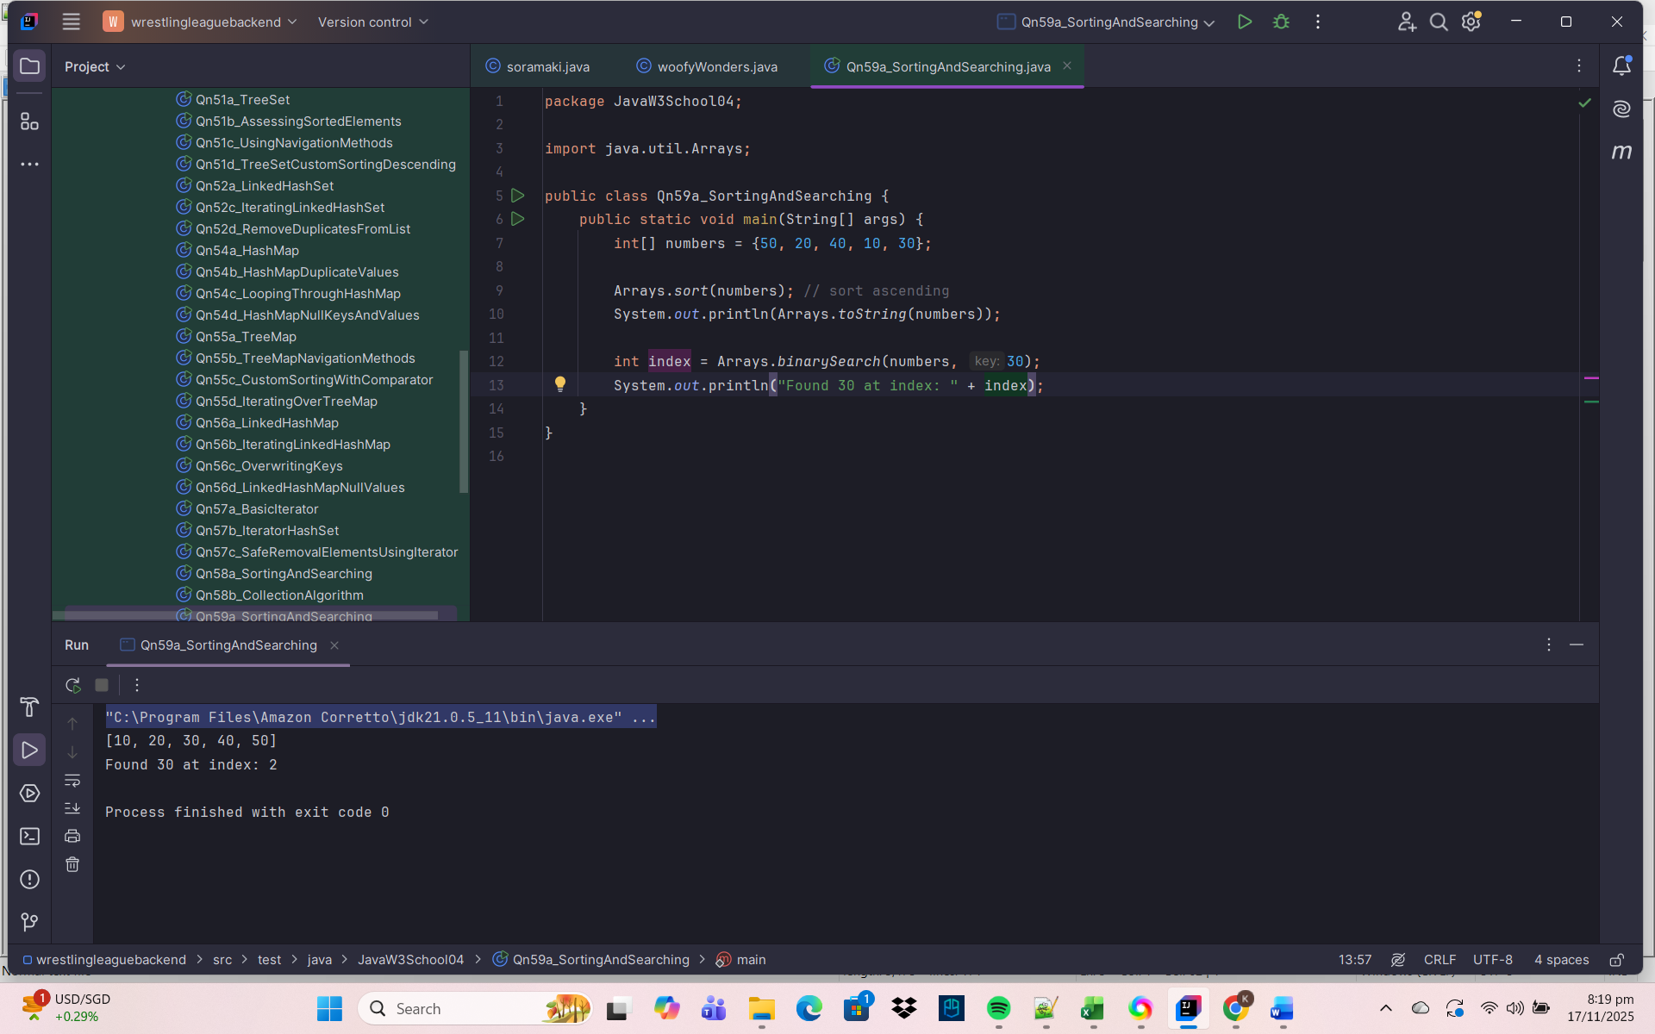
Example 2 – Using Collections Algorithms
package JavaW3School04;
import java.util.ArrayList;
import java.util.Collections;
import java.util.List;
public class Qn59b_CollectionsAlgorithms {
public static void main(String[] args) {
List<String> names = new ArrayList<>();
names.add("Kevin");
names.add("Yumi");
names.add("Alice");
Collections.sort(names);
System.out.println("Sorted Name Order: " + names);
Collections.reverse(names);
System.out.println("Reverse Name Order: " + names);
Collections.shuffle(names);
System.out.println("Shuffled Name Order: " + names);
}
}

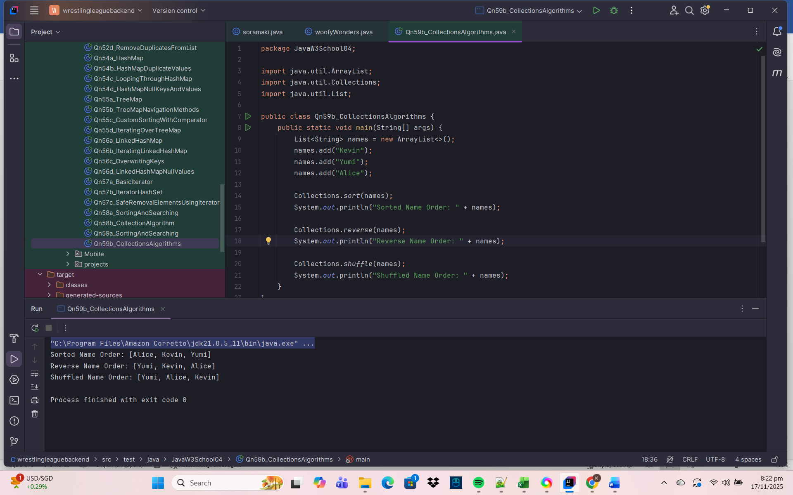
4️⃣ Where Are These Algorithms Located in Java?
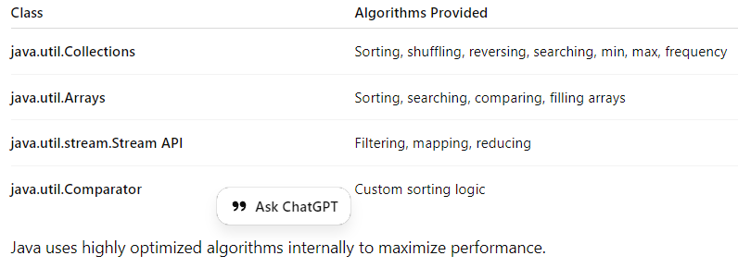
5️⃣ Why Are Algorithms Important in Java?
- Improve program efficiency
- Help manipulate and analyze data
- Provide reusable, reliable mechanisms
- Backbone of complex applications (sorting, searching, analytics)
6️⃣ Summary Table
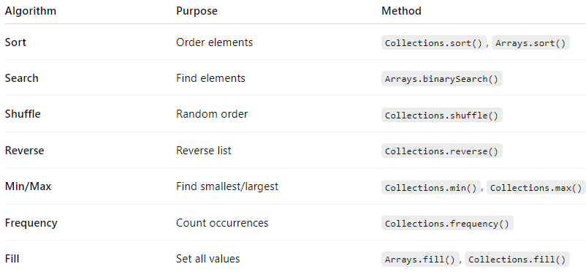
✅ Final Summary
Java provides many built-in algorithms (sorting, searching, reversing, shuffling, min/max, frequency, fill, copy) through:
- java.util.Collections (for Lists)
- java.util.Arrays (for arrays)
These algorithms are efficient, easy to use, and essential for handling data structures in real-world applications.

Qn60. Provide and explain on Java Generics used to write classes, interfaces, and methods in Java
1️⃣ What Are Generics in Java?
Generics in Java allow you to write classes, interfaces, and methods that can operate on any data type while maintaining type safety.
They were introduced in Java 5 to reduce:
- Casting
- Runtime errors
- Code duplication
Generics ensure compile-time type checking.
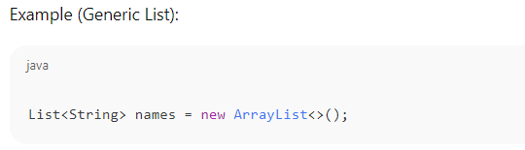
2️⃣ Why Use Generics? (Benefits)
✔ 1. Type Safety
You specify what type the collection holds:
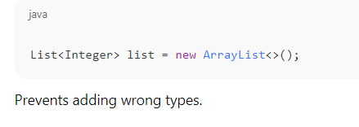
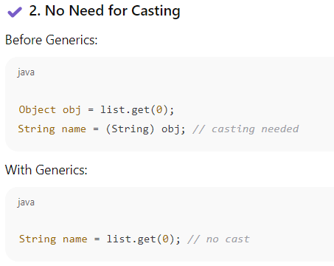
✔ 3. Reusability
Write once, use with any type.
✔ 4. Compile-Time Error Checking
Errors detected early, not at runtime.
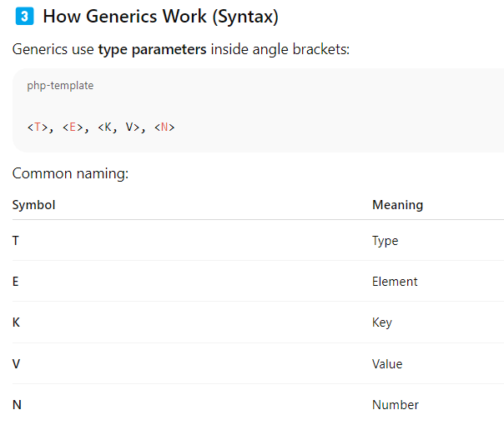
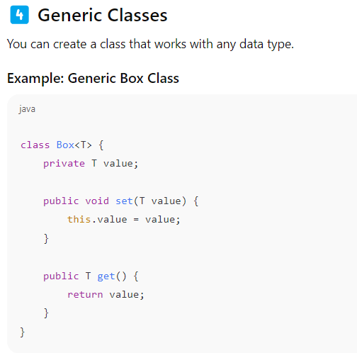
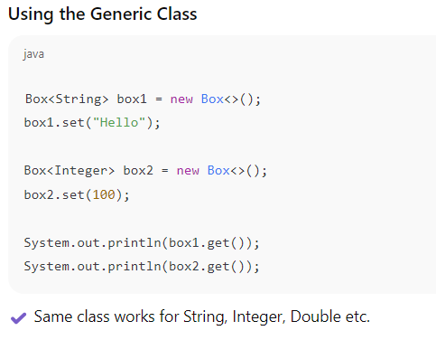
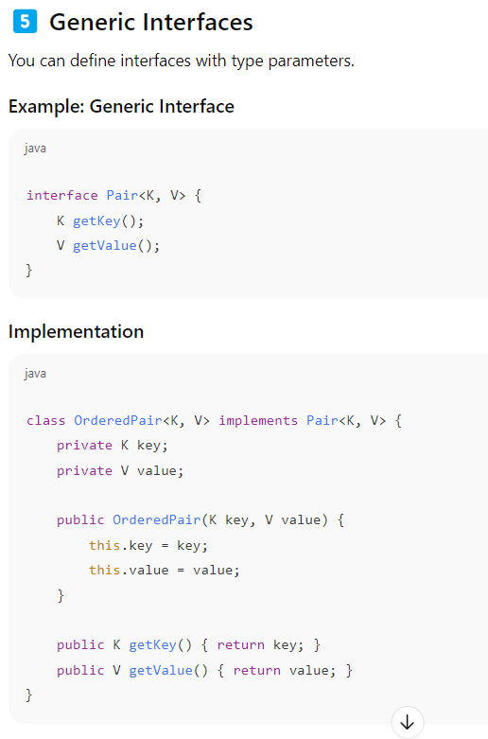
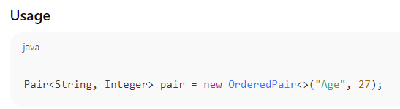
6️⃣ Generic Methods
A method that accepts any data type.
Example: Generic Method
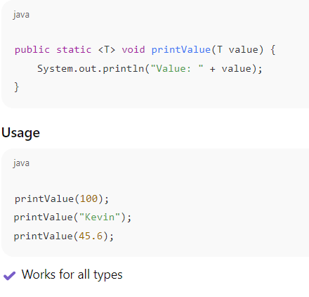
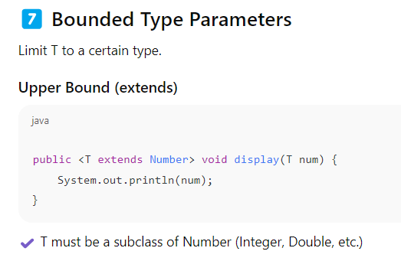
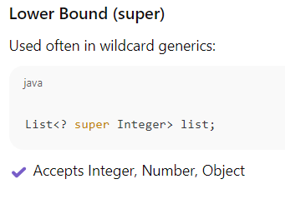
8️⃣ Wildcards in Generics
Wildcards give flexibility.

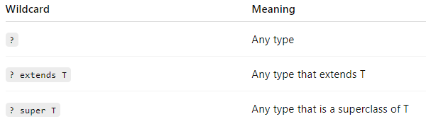

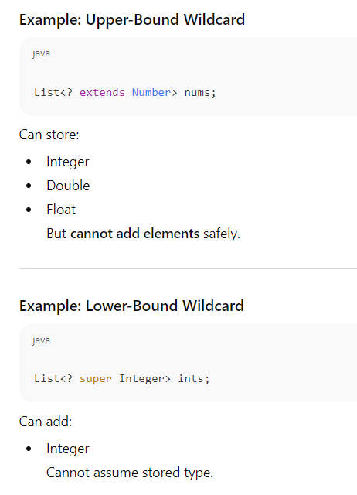
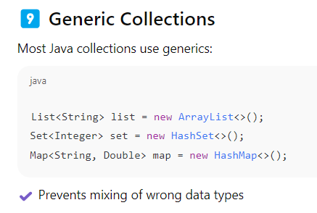
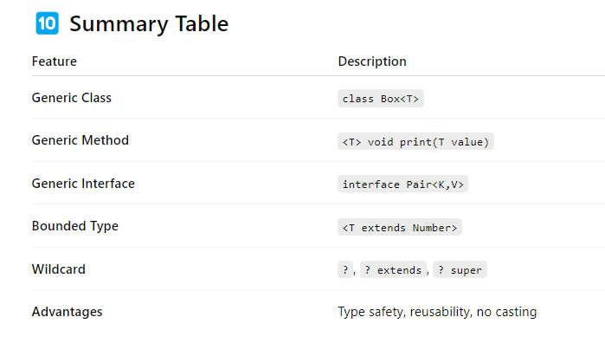
✅ Final Summary
Generics in Java allow writing flexible, reusable, and type-safe code for:
- Classes (class Box<T>)
- Interfaces (interface Pair<K,V>)
- Methods (<T> void show(T value))
They ensure:
- Compile-time type safety
- No need for casting
- Reusable logic for multiple data types
Generics are one of the most powerful features in Java and are heavily used in the Collections Framework.

Generic Class Example
package JavaW3School04;
class Box<T> {
T value; // T is a placeholder for any data type
void set(T value) {
this.value = value;
}
T get() {
return value;
}
}
public class Qn60_JavaGeneric {
public static void main(String[] args) {
// Create a Box to hold a String
Box<String> stringBox = new Box<>();
stringBox.set("Hello");
System.out.println("Value: " + stringBox.get());
// Create a Box to hold an Integer
Box<Integer> intBox = new Box<>();
intBox.set(50);
System.out.println("Value: " + intBox.get());
}
}

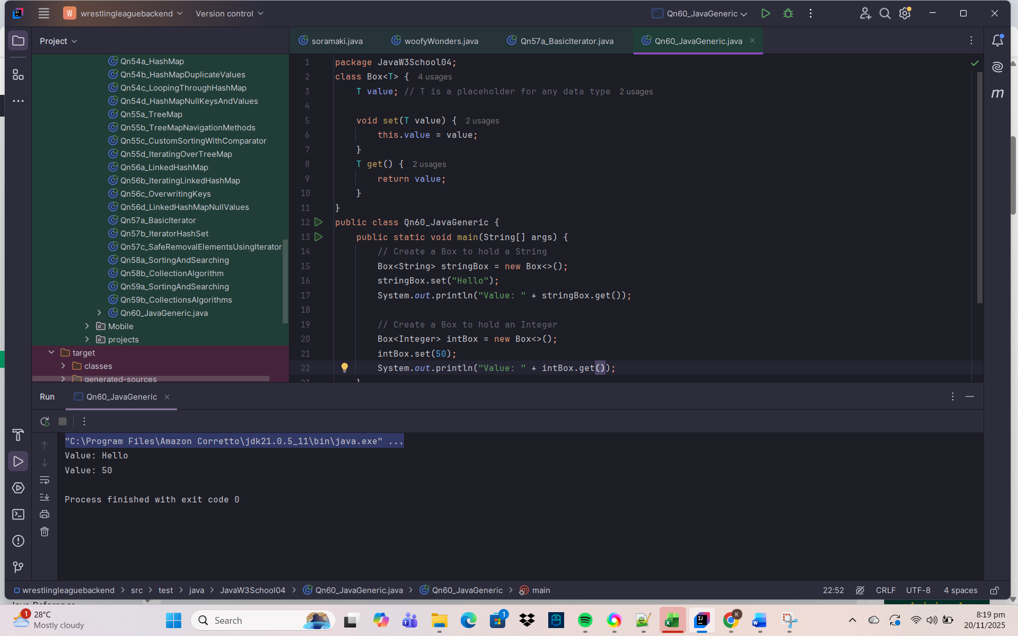

Qn61. Provide and explain on Java Annotations used in Java
1️⃣ What Are Annotations in Java?
Annotations in Java are metadata — special markers that provide additional information to:
- the compiler
- the JVM
- frameworks (like Spring)
- tools (like IDEs, Lombok)
Annotations do not affect program logic directly, but they influence how code is interpreted, validated, or processed.
They were introduced in Java 5.
2️⃣ Purpose of Annotations
✔ 1. Provide instructions to the compiler
Examples:
- @Override
- @Deprecated
- @SuppressWarnings

✔ 2. Provide metadata for frameworks
Examples:
- @Entity, @Autowired in Spring
- @Test in JUnit

✔ 3. Provide instructions at runtime
Examples:
- @Retention(RetentionPolicy.RUNTIME)
- Reflection processing

✔ 4. Reduce boilerplate code
Examples using Lombok:
- @Getter
- @Setter
- @Data
3️⃣ Built-in Annotations in Java (Most Common)
A. @Override
Indicates a method is overriding a superclass method.
@Override
public void run() {
System.out.println("Running...");
}

✔ Helps the compiler catch mistakes
✔ If method name is wrong → compiler error
B. @Deprecated
Marks code as outdated and should not be used.
@Deprecated
public void oldMethod() {
System.out.println("Old method.");
}

✔ IDE shows warning
✔ Still works but discouraged
C. @SuppressWarnings
Suppresses compiler warnings.
@SuppressWarnings("unchecked")
List list = new ArrayList();
✔ Not a best practice but useful for legacy code
4️⃣ Meta-Annotations (Annotations for Annotations)
These are used to define how custom annotations behave.
A. @Retention
Specifies how long annotation is kept.
@Retention(RetentionPolicy.RUNTIME)
Types:
- SOURCE → removed by compiler
- CLASS → stored in .class file (default)
- RUNTIME → available during runtime via reflection

B. @Target
Specifies where annotation can be used.
@Target(ElementType.METHOD)
Types include:
- METHOD
- CLASS
- FIELD
- PARAMETER
- CONSTRUCTOR
- TYPE
C. @Documented
Included in generated Javadoc.
D. @Inherited
Subclass inherits annotation from superclass.
5️⃣ Creating Custom Annotations
You can define your own annotation.
import java.lang.annotation.*;

@Retention(RetentionPolicy.RUNTIME)
@Target(ElementType.METHOD)
public @interface MyAnnotation {
String value();
}

Using the annotation:
@MyAnnotation(value = "Test method")
public void show() {
System.out.println("Hello");
}

6️⃣ Annotations in Popular Frameworks
✔ Spring Framework
@Autowired
@Service
@RestController
@GetMapping
✔ Junit
@Test
@BeforeEach
@AfterEach
✔ Hibernate/JPA
@Test
@BeforeEach
@AfterEach
Annotations drive behaviors like:
- Dependency injection
- REST endpoints
- Database mapping
- Test execution
7️⃣ Example Summary Program
package JavaW3School04;
class Parent {
@Deprecated
public void oldMethod() {
System.out.println("Old");
}
}
class Child extends Parent {
@Override
public void oldMethod() {
System.out.println("Overridden");
}
}
public class Qn61_JavaAnnotationExample {
@SuppressWarnings("unchecked")
public static void main(String[] args) {
Child child = new Child();
child.oldMethod();
}
}

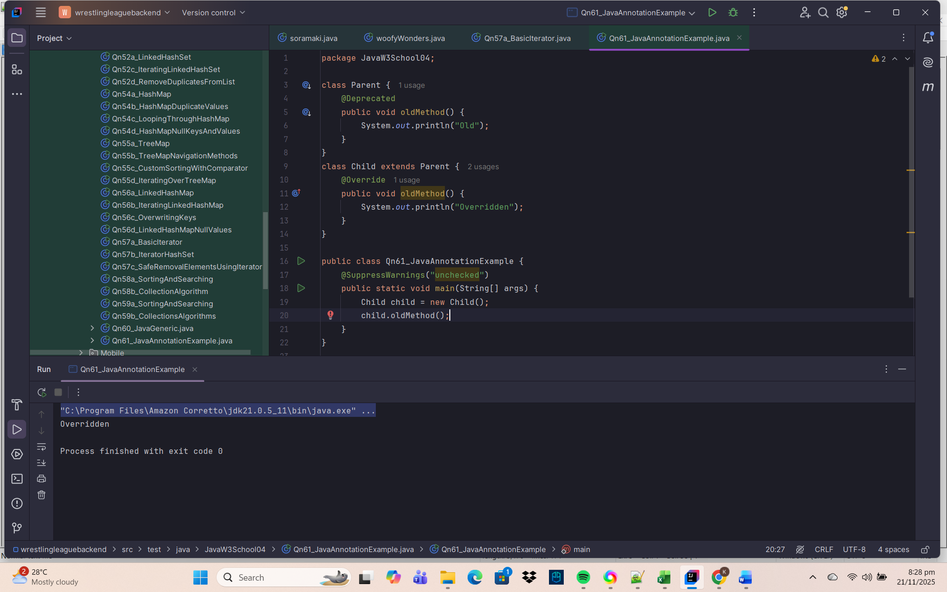
✔ Demonstrates usage of 3 built-in annotations
8️⃣ Why Are Annotations Important?
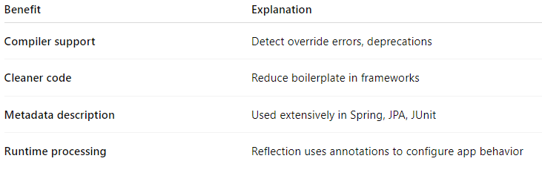
9️⃣ Summary Table
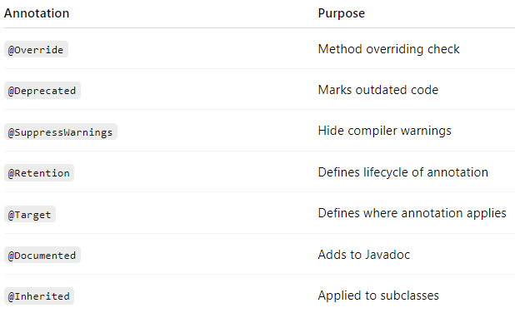
✅ Final Summary
Java Annotations are metadata that:
- help compilers
- guide frameworks
- simplify coding
- provide runtime information
- allow creation of custom annotations
They are essential in modern Java development (Spring, JPA, JUnit).

Qn62. Provide and Explain on Java Regular Expressions Used in Java
1️⃣ What Are Regular Expressions (Regex) in Java?
Regular Expressions (Regex) in Java are patterns used to search, match, and manipulate text.
Java provides regex support through two main classes in the java.util.regex package:
import java.util.regex.Pattern;
import java.util.regex.Matcher;
Regex is widely used for:
- Validating user input (email, phone number, password)
- Searching text
- Replacing substrings
- Splitting strings
- Data filtering
2️⃣ Key Classes Used in Java Regex
A. Pattern
Represents the compiled regex.
Example:
Pattern pattern = Pattern.compile("[a-z]+");
B. Matcher
Matches the pattern against input text.
Example:
Matcher matcher = pattern.matcher("hello");

C. String Class Methods (Built-in Regex Support)
You can also use regex with:
- matches()
- replaceAll()
- split()
Example:
"hello".matches("[a-z]+");

3️⃣ Basic Regex Example
package JavaW3School04;
import java.util.regex.Matcher;
import java.util.regex.Pattern;
public class Qn62a_BasicRegexExample {
public static void main(String[] args) {
Pattern pattern = Pattern.compile("Java");
Matcher matcher = pattern.matcher("I love Java progranning");
if(matcher.find()) {
System.out.println("Match found!");
}
}
}

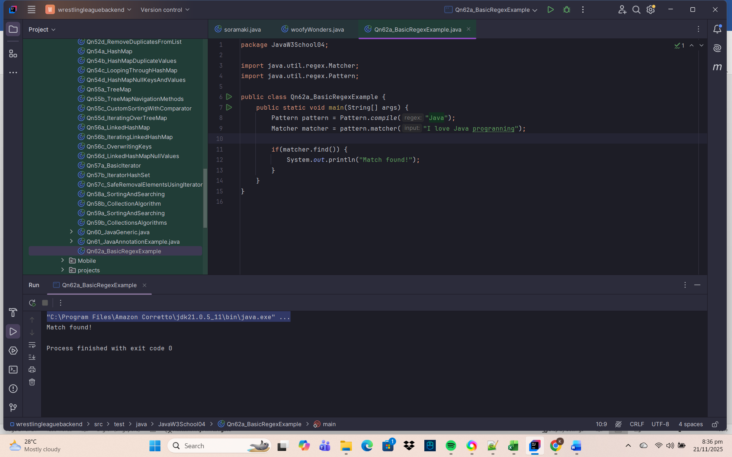
✔ matcher.find() checks if the pattern exists

4️⃣ Common Regex Symbols (Cheat Sheet)
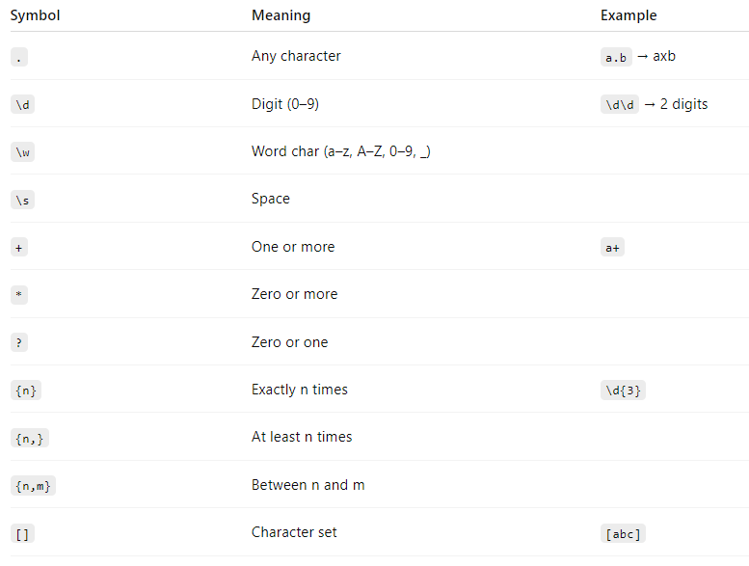
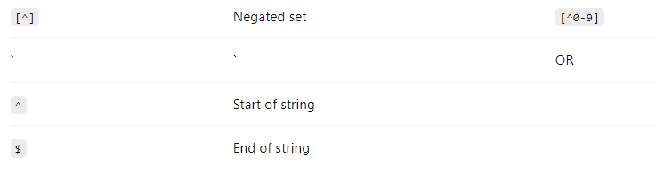
5️⃣ Example: Email Validation
String emailRegex = "^[A-Za-z0-9+_.-]+@[A-Za-z0-9.-]+$";

System.out.println("kevin@gmail.com".matches(emailRegex));

✔ Checks if the given string is a valid email

6️⃣ Example: Phone Number Validation
String phoneRegex = "\\d{8}";
System.out.println("91234567".matches(phoneRegex));
✔ 8-digit phone number
7️⃣ Example: Password Validation
At least:
- 8 characters
- 1 digit
- 1 uppercase
- String passRegex = "^(?=.*[A-Z])(?=.*\\d).{8,}$";
- System.out.println("Password1".matches(passRegex));

8️⃣ Using Pattern & Matcher for Full Matching
Pattern pattern = Pattern.compile("\\d{3}");
Matcher matcher = pattern.matcher("123");

if (matcher.matches()) {
System.out.println("Matched exactly 3 digits");
}

9️⃣ Using find() for Partial Matching
Pattern pattern = Pattern.compile("\\d+");
Matcher matcher = pattern.matcher("Age: 25 years old");

while (matcher.find()) {
System.out.println("Number found: " + matcher.group());
}
25

🔟 Using replaceAll()
String result = "Java is fun".replaceAll("fun", "awesome");
System.out.println(result);

1️⃣1️⃣ Using split()
String[] words = "A,B,C".split(",");

1️⃣2️⃣ Practical Use Cases
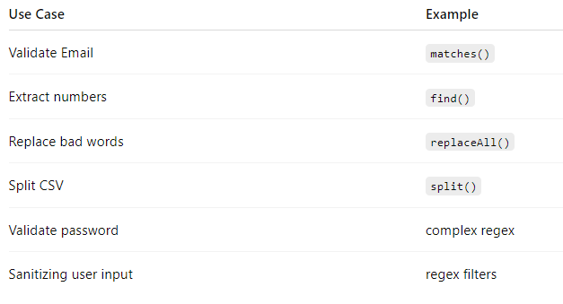
1️⃣3️⃣ Summary Table
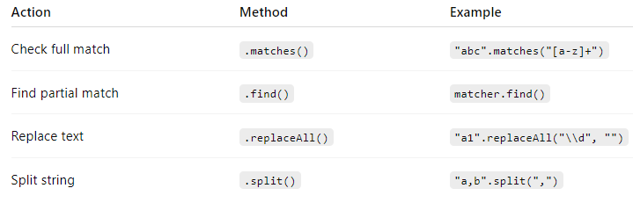
✅ Final Summary
Java Regular Expressions are used for pattern matching and text processing.
They are implemented using:
- Pattern (compile regex)
- Matcher (match regex)
- String methods (matches, replaceAll, split)
Regex is powerful for validation, searching, replacing, text extraction, and data cleaning.

Qn63. Provide and Explain on Java Threads Used in Java
1️⃣ What Are Threads in Java?
A Thread in Java is a lightweight unit of execution within a program.
Java programs can run multiple tasks simultaneously by using multithreading.
A thread allows your program to:
- Perform tasks in parallel
- Handle background work
- Improve performance on multi-core processors

2️⃣ Why Use Threads?
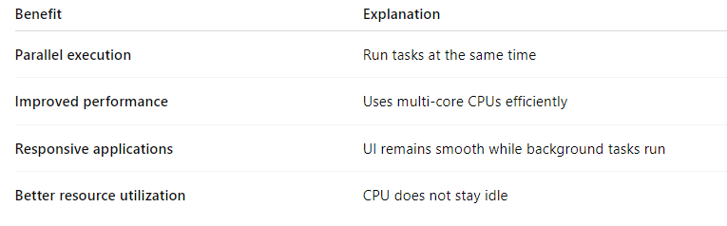
3️⃣ Two Ways to Create Threads in Java
A. Extending the Thread Class
package JavaW3School04;
class MyThread extends Thread {
@Override
public void run() {
System.out.println("Thread is running...");
}
}
public class Qn63a_ExtendingThreadClass {
public static void main(String[] args) {
MyThread t = new MyThread();
t.start(); // starts new thread
}
}

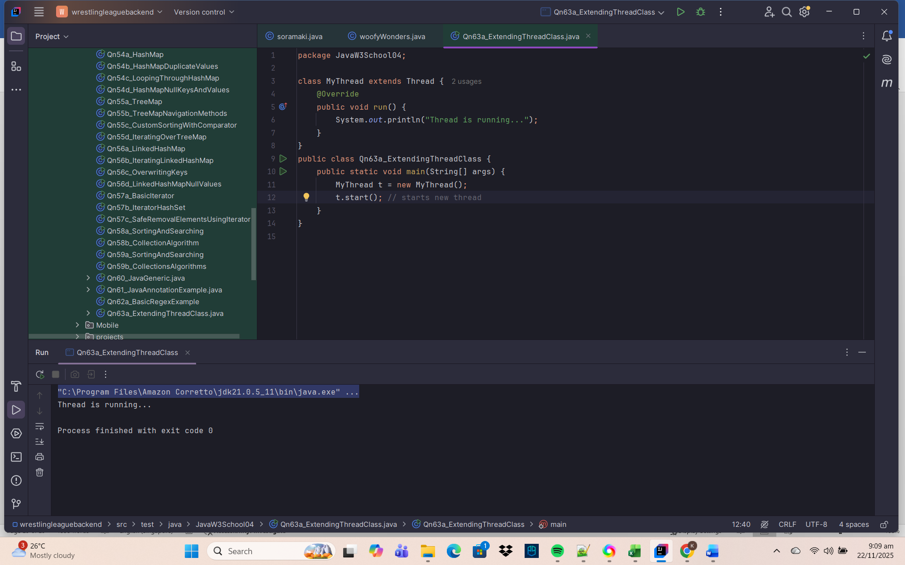
✔ Key Points
- Override the run() method
- Call start() → creates a new thread and runs run()
- Calling run() directly does not create a new thread
B. Implementing Runnable Interface
package JavaW3School04;
class MyRunnable implements Runnable {
@Override
public void run() {
System.out.println("Runnable is running...");
}
}
public class Qn63b_ImplementRunnableInterface {
public static void main(String[] args) {
Thread t = new Thread(new MyRunnable());
t.start();
}
}

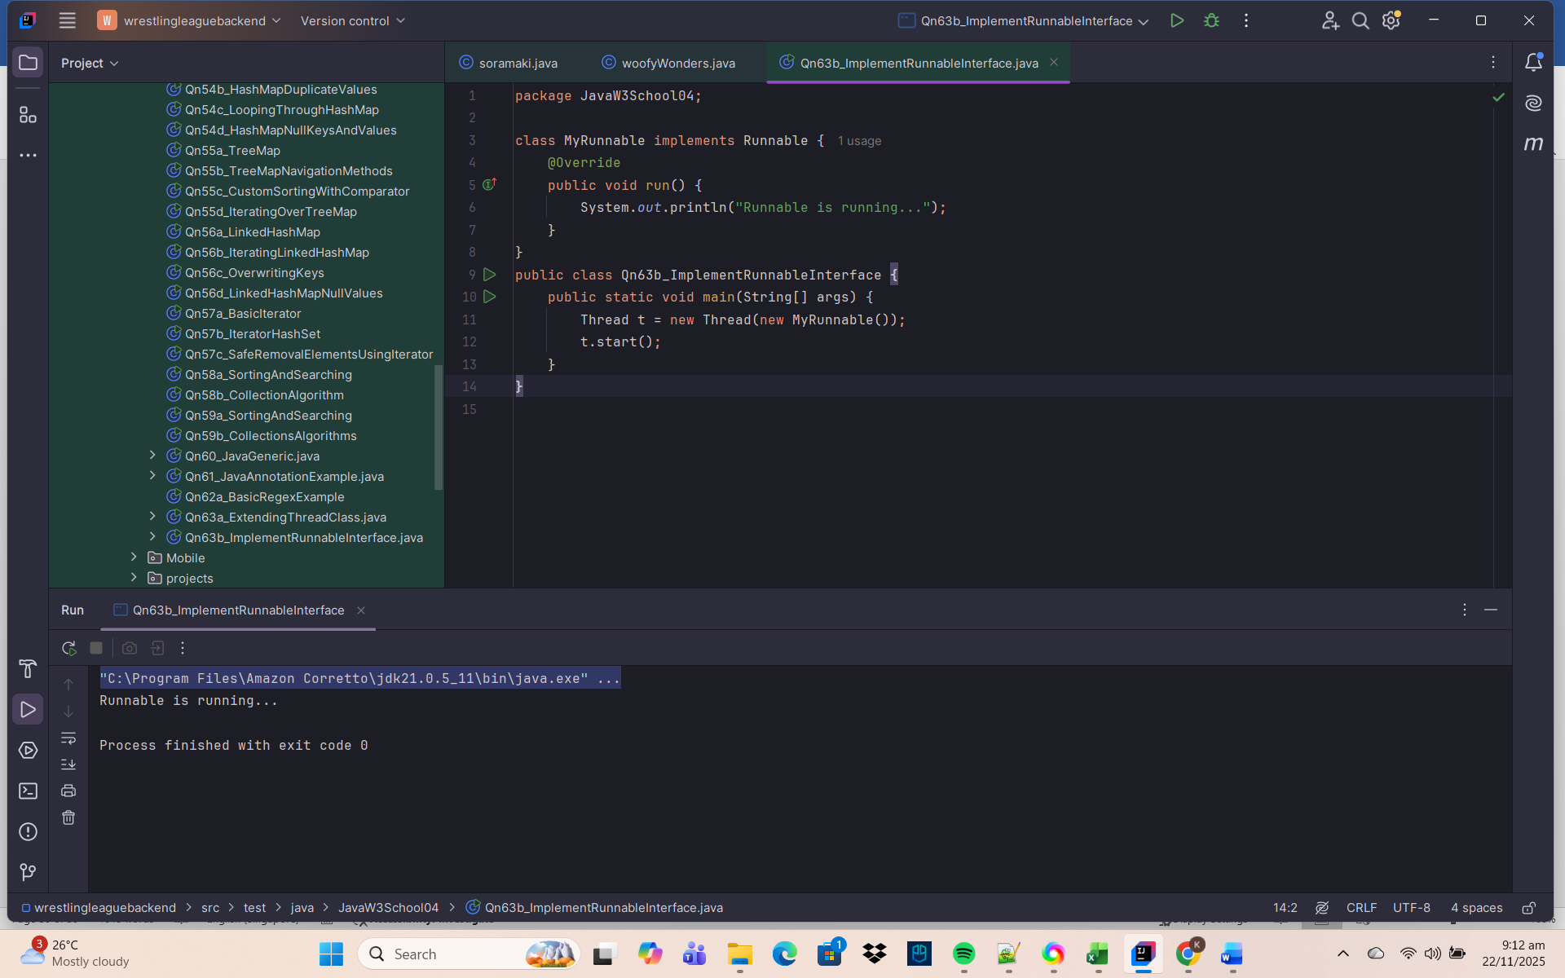
✔ Why Runnable is Better?
- Can extend another class
- Used widely in real projects
- Cleaner separation between task and thread

4️⃣ Thread Lifecycle (States)
A thread goes through these states:
NEW → RUNNABLE → RUNNING → BLOCKED/WAITING → TERMINATED

Explanation:
- NEW → Thread object created
- RUNNABLE → Ready to run
- RUNNING → Currently executing
- BLOCKED/WAITING → Waiting for resource or sleep
- TERMINATED → Task completed
5️⃣ Important Thread Methods
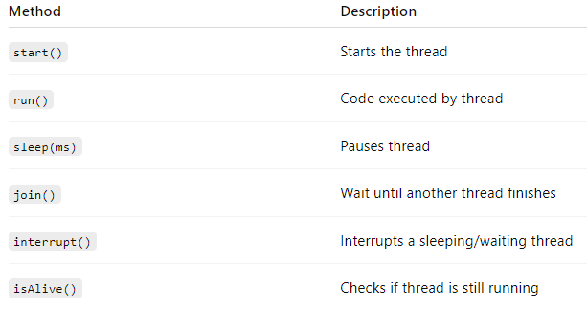
6️⃣ Example: Using sleep()
package JavaW3School04;
public class Qn63e_SleepMethod extends Thread{
public void run() {
for(int i = 1; i <= 3; i++) {
System.out.println("Count: " + i);
try {
Thread.sleep(1000); // pause for 1 sec
} catch (Exception e) {
}
}
}
public static void main(String[] args) {
new Qn63e_SleepMethod().start();
}
}

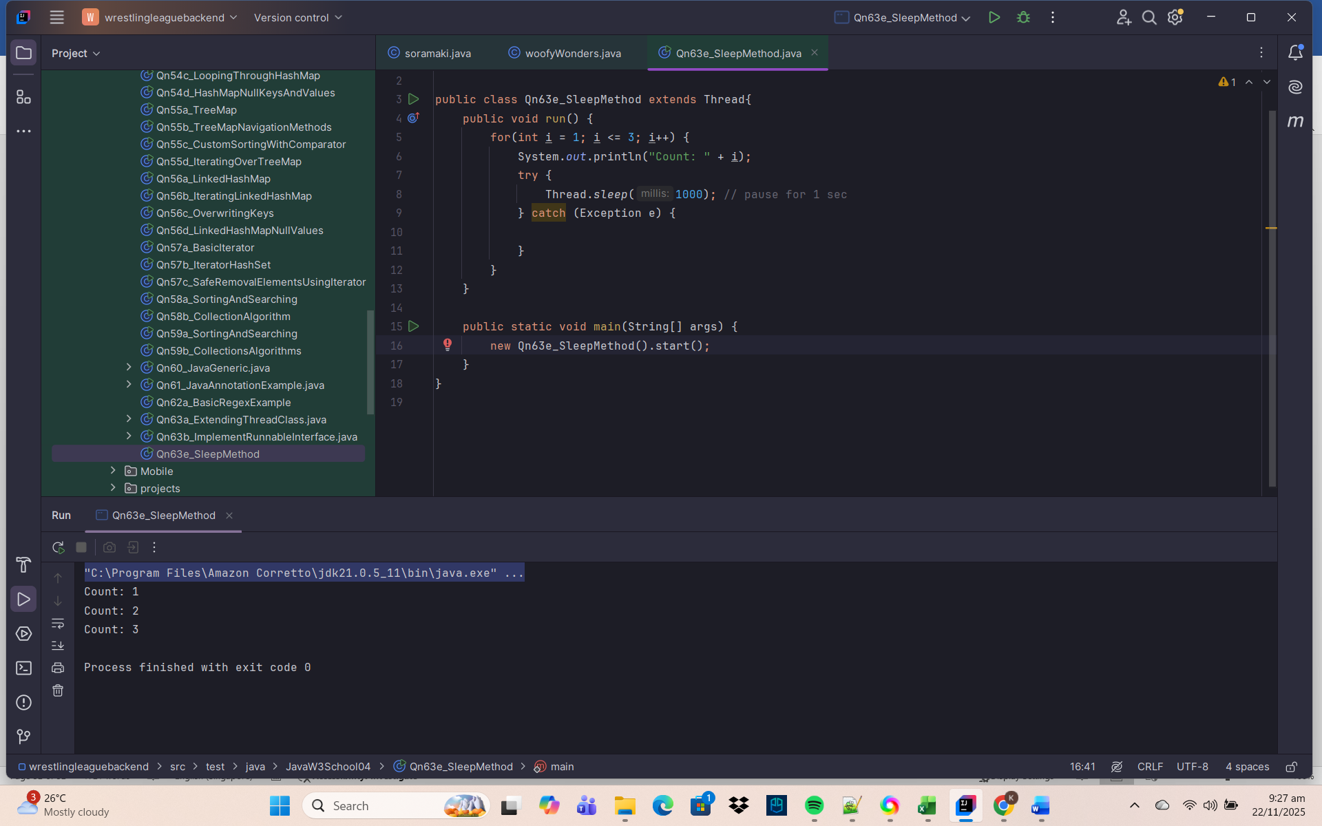
7️⃣ Example: join() (Waiting for Another Thread)
Thread t1 = new Thread(() -> {
try { Thread.sleep(1000); } catch (Exception e) {}
System.out.println("Task 1 done");
});

Thread t2 = new Thread(() -> {
System.out.println("Task 2 waiting...");
try { t1.join(); } catch (Exception e) {}
System.out.println("Task 2 done after Task 1");
});

t1.start();
t2.start();

✔ t2 waits until t1 finishes
8️⃣ Thread Priority
t.setPriority(Thread.MAX_PRIORITY);
Priorities:
- 1 → MIN
- 5 → NORM (default)
- 10 → MAX
CPU may consider priority but not guaranteed.
9️⃣ Synchronization (Avoiding Race Conditions)
When two threads modify shared data → inconsistent results happen.
Use synchronized keyword.
public synchronized void increment() {
counter++;
}
Prevents multiple threads from entering method at same time.

🔟 Daemon Threads
These are background threads used for tasks like garbage collection.
t.setDaemon(true);
Daemon threads stop automatically when main program ends.
1️⃣1️⃣ Multithreading Example
package JavaW3School04;
public class Qn63f_MultiThreading {
public static void main(String[] args) {
Thread t1 = new Thread(() -> System.out.println("Task 1"));
Thread t2 = new Thread(() -> System.out.println("Task 2"));
t1.start();
t2.start();
}
}

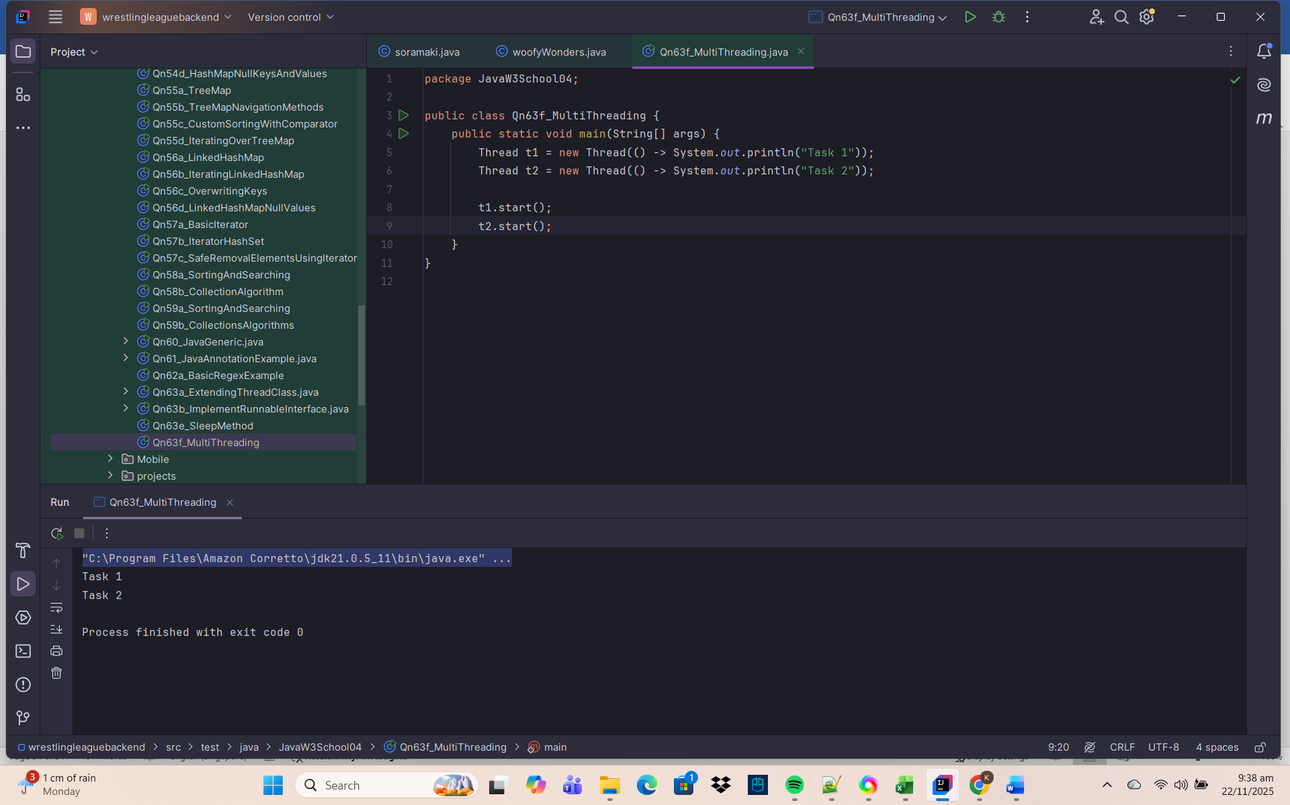
✔ Both tasks run parallel.
1️⃣2️⃣ Executor Framework (Modern Threading)
Instead of manually creating threads, Java provides:
ExecutorService service = Executors.newFixedThreadPool(3);
service.submit(() -> System.out.println("Task running"));
service.shutdown();

Better for:
- Thread pools
- Large applications
- Web servers
1️⃣3️⃣ Summary Table
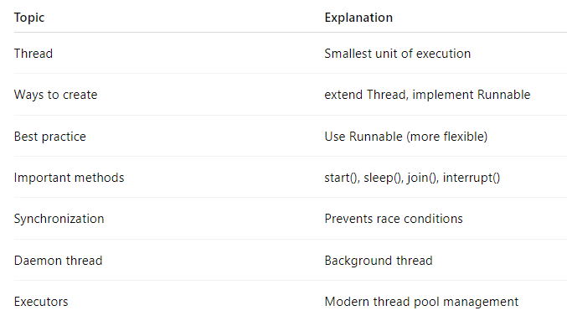
✅ Final Summary
Java Threads allow parallel execution of tasks using multithreading.
Threads can be created by:
- extending Thread
- implementing Runnable
- using ExecutorService
Threads improve performance, efficiency, and responsiveness of Java applications.

Qn64. Provide and explain on Java Lamda used in Java
1️⃣ What Are Lambda Expressions in Java?
A Lambda Expression is a short block of code that behaves like a method, but without a name.
It is used to provide an implementation of a functional interface.
Lambdas were introduced in Java 8 to make code:
- Shorter
- Cleaner
- More readable
- Suitable for functional-style programming
2️⃣ What Is a Functional Interface?
A Functional Interface is an interface with only one abstract method.
Example:
@FunctionalInterface
interface MyFunction {
void show();
}
3️⃣ Lambda Expression Syntax
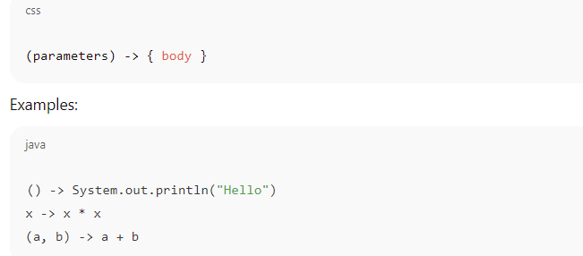

4️⃣ Lambda Expressions – Basic Example
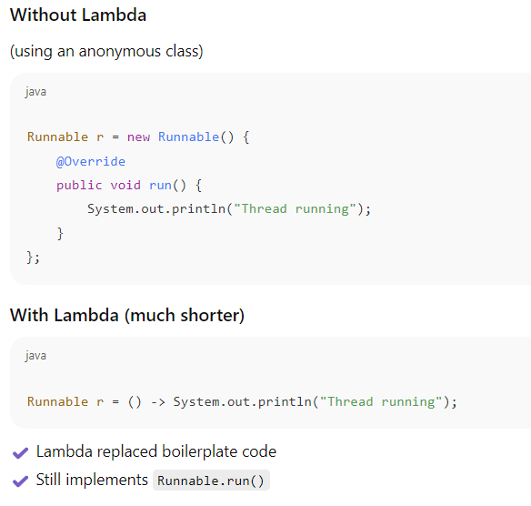
5️⃣ Types of Lambda Expressions
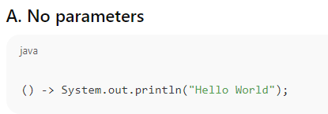
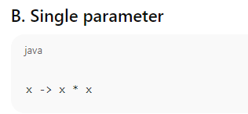
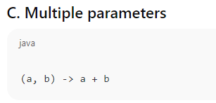
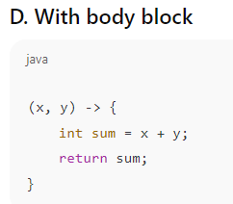
6️⃣ Lambda with Functional Interface Example
package JavaW3School04;
interface Greeting {
void sayHello(String name);
}
public class Qn64_LambdaFunctionalInterface {
public static void main(String[] args) {
Greeting g = (name -> System.out.println("Hello " + name));
g.sayHello("Kevin");
}
}

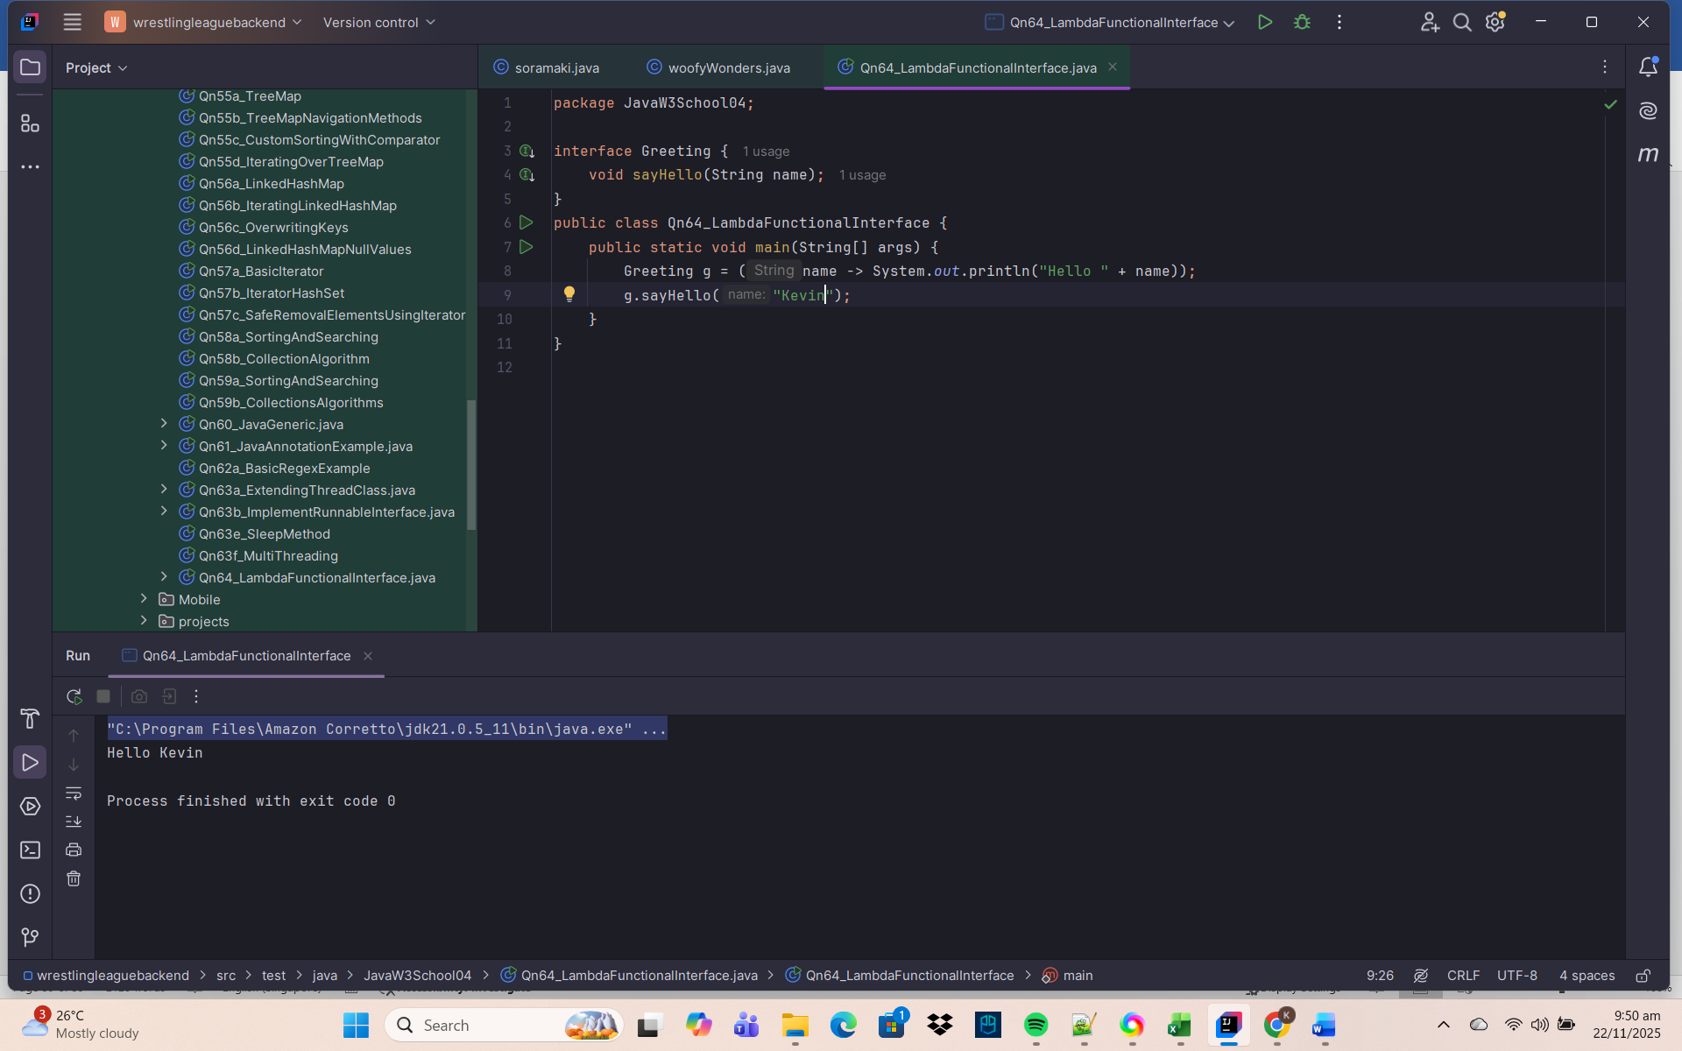
✔ Functional interface
✔ Lambda implements the method
✔ No need for class or anonymous class
7️⃣ Built-in Functional Interfaces (java.util.function)
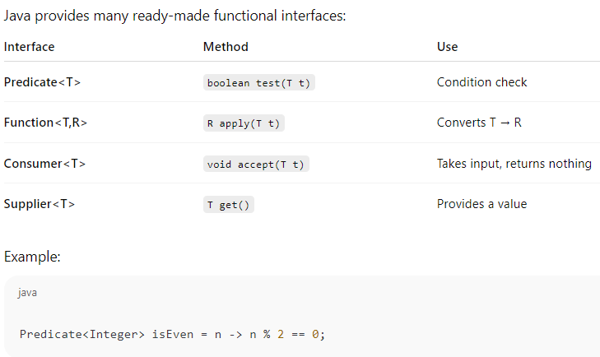

8️⃣ Lambda Expressions with Collections
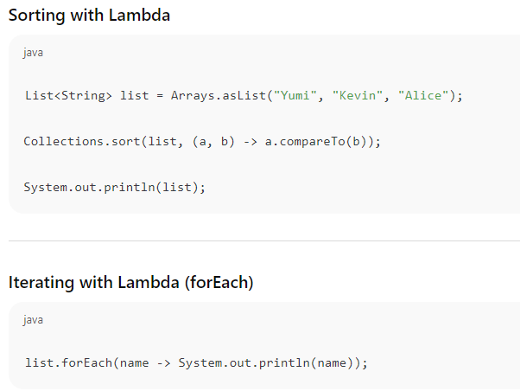
9️⃣ Stream API Uses Lambdas
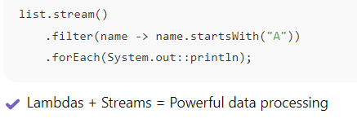
🔟 Lambda Expression with Thread Example
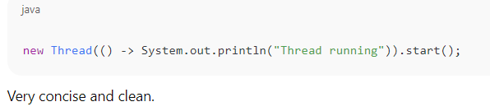
1️⃣1️⃣ Why Use Lambda Expressions?
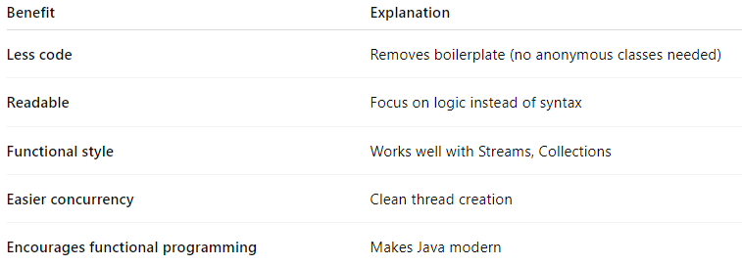
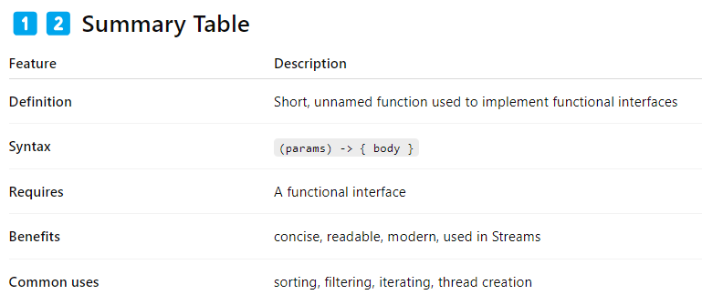
✅ Final Summary
Java Lambda Expressions provide a clean, compact way to implement functional interfaces.
They simplify code, especially when working with:
- Threads
- Collections
- Stream API
- Event handling
- Functional-style programming
Lambdas make Java more expressive and reduce unnecessary boilerplate.

Qn65. Provide and explain on Java Advanced Sorting used in Java
1️⃣ What is “Advanced Sorting” in Java?
“Advanced sorting” in Java usually means going beyond simple ascending sort of numbers or strings, and includes:
- Sorting user-defined objects
- Sorting with custom rules (e.g. by name then age)
- Sorting using Comparable and Comparator
- Using lambda expressions and Streams
- Sorting in descending order, multi-level sorting, case-insensitive sorting, etc.
Java’s advanced sorting is built mainly on:
Arrays.sort(...)
Collections.sort(...)
List.sort(...)
Stream.sorted(...)

All of them rely internally on TimSort (efficient O(n log n) algorithm).
2️⃣ Using Comparable – Natural Ordering
To define a default (natural) sort order for your custom class, implement Comparable<T> and override compareTo().
Example: Sort Students by name (natural order)
package JavaW3School04;
import java.util.ArrayList;
import java.util.Collections;
import java.util.List;
class Student1 implements Comparable<Student1> {
String name;
int age;
Student1(String name, int age) {
this.name = name;
this.age = age;
}
@Override
public int compareTo(Student1 other) {
return this.name.compareTo(other.name); // natural order by name
}
public String toString() {
return name + " (" + age + ")";
}
}
public class Qn65_ComparableNaturalOrder {
public static void main(String[] args) {
List<Student1> list = new ArrayList<>();
list.add(new Student1("Kevin", 27));
list.add(new Student1("Alice", 22));
list.add(new Student1("Yumi", 24));
Collections.sort(list); // uses compareTo()
System.out.println(list);
}
}

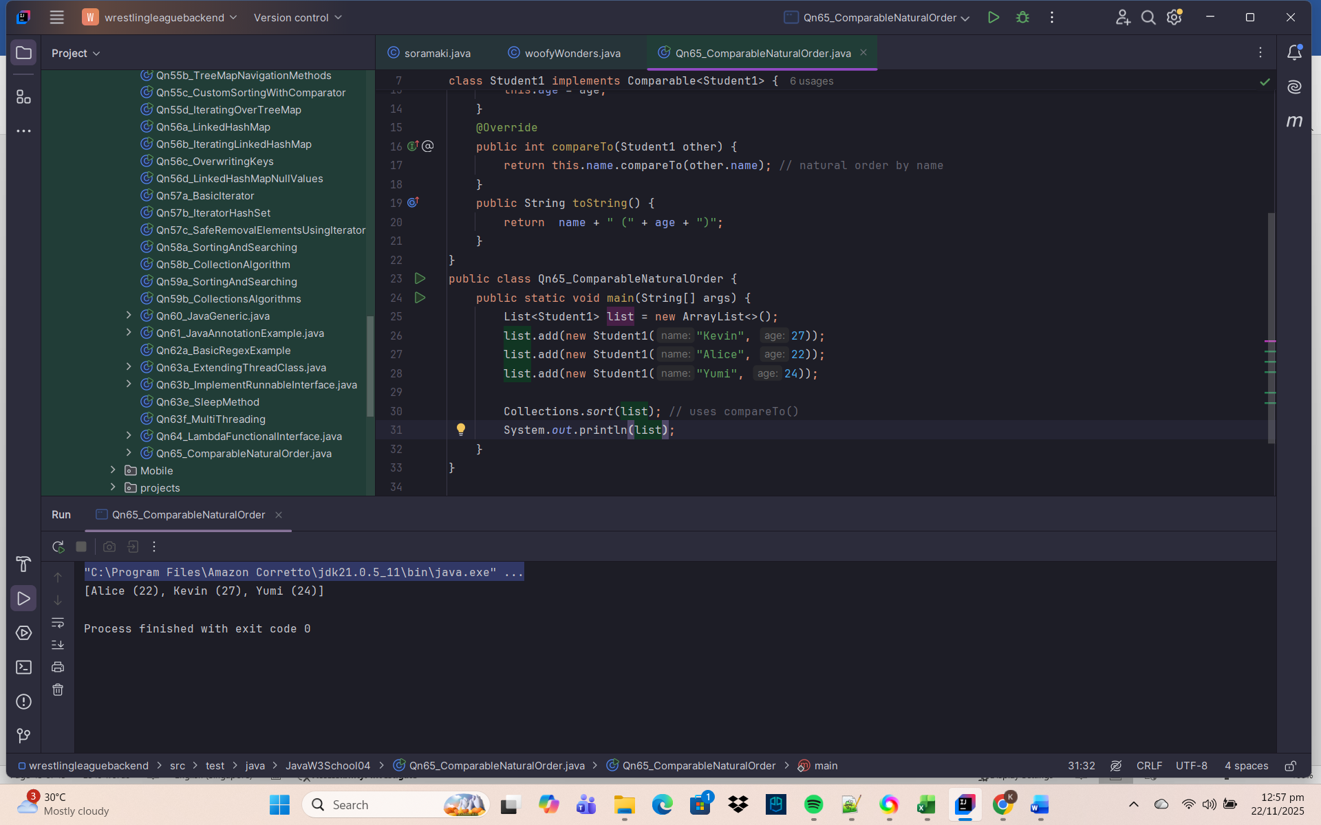

✅ Key point:
Comparable gives a single default sorting rule.
3️⃣ Using Comparator – Custom Sorting Rules
Comparator lets you define different sorting strategies without changing the class code.
Example: Sort Students by age instead of name

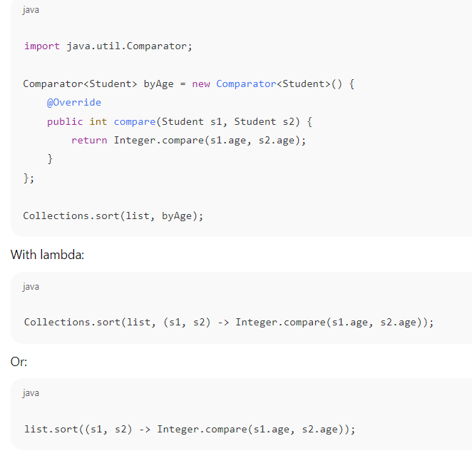
✅ Key point:
You can have many different comparators for the same class.
4️⃣ Java 8+ Advanced Comparator Helpers
Java 8 introduced fluent methods in Comparator:
- Comparator.comparing(...)
- thenComparing(...)
- reversed()
- comparingInt, comparingDouble, etc.
🔹 Sort by age (ascending)
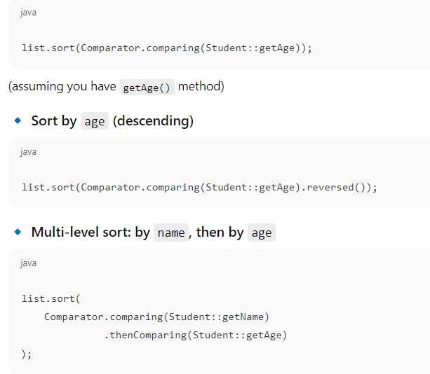
✅ Advanced sorting pattern:
- First sort key → comparing(...)
- Tie-breaker keys → thenComparing(...)
- Reverse → reversed()

5️⃣ Case-Insensitive & Custom String Sorting
Case-insensitive sort:
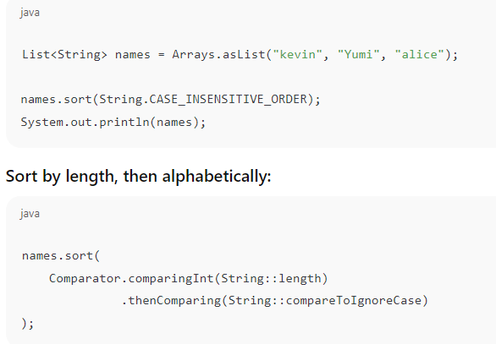
6️⃣ Sorting Maps (by Keys / Values)
Map cannot be sorted directly, but you can:
🔹 Sort by key using TreeMap:
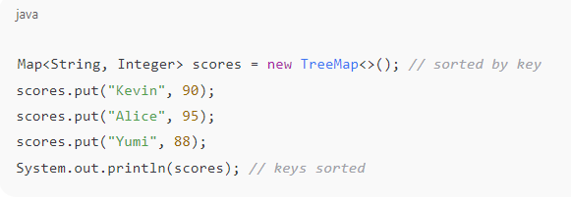
🔹 Sort by value using entrySet() + List
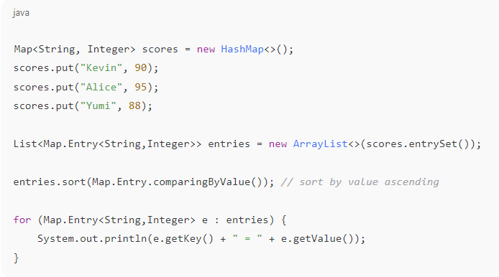
7️⃣ Advanced Sorting with Streams API
Stream.sorted() allows inline sorting in pipelines.
Example: Sort then filter
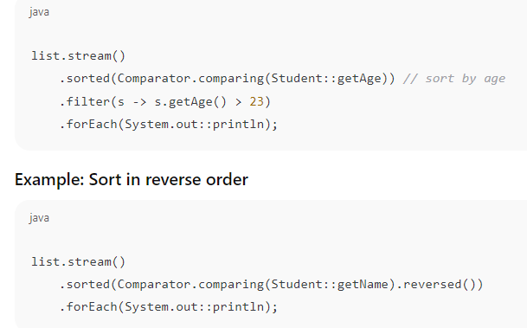

8️⃣ Summary Table – Advanced Sorting Tools
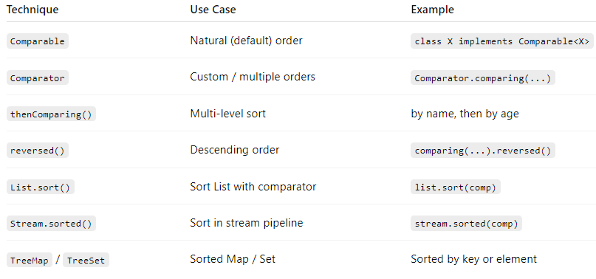

✅ Final Summary
Advanced sorting in Java means using:
- Comparable for natural order
- Comparator (with lambdas) for custom, multi-level, and reverse sorting
- Collections / List / Arrays sort methods
- Streams (sorted()) for functional-style sorting
- TreeMap / TreeSet for automatically sorted collections
This allows you to sort any type of data in any way you want – by one field, multiple fields, ascending/descending, case-insensitive, etc.

