Landing page

1. The register and login button are not visible enough for the user to quickly navigate the page, I suggest u make it bigger and put in on the top Conner rather than the buttom
2. As I am logging in realized that the number filed is an updown counter which I don’t think it appropriate.

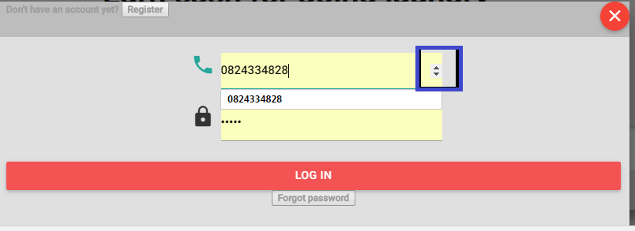

Receiving Page

1. I can’t logging from Receiving page.

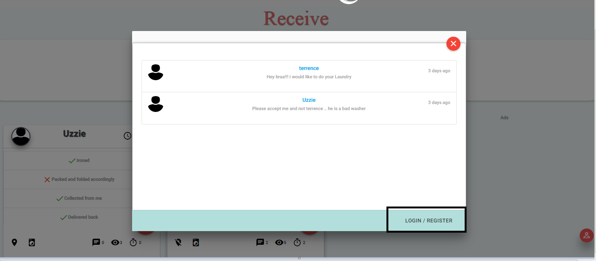

1. When I want to add a comment on my laundry, the enter button does not work which is supposed to work for user friendly purposes.

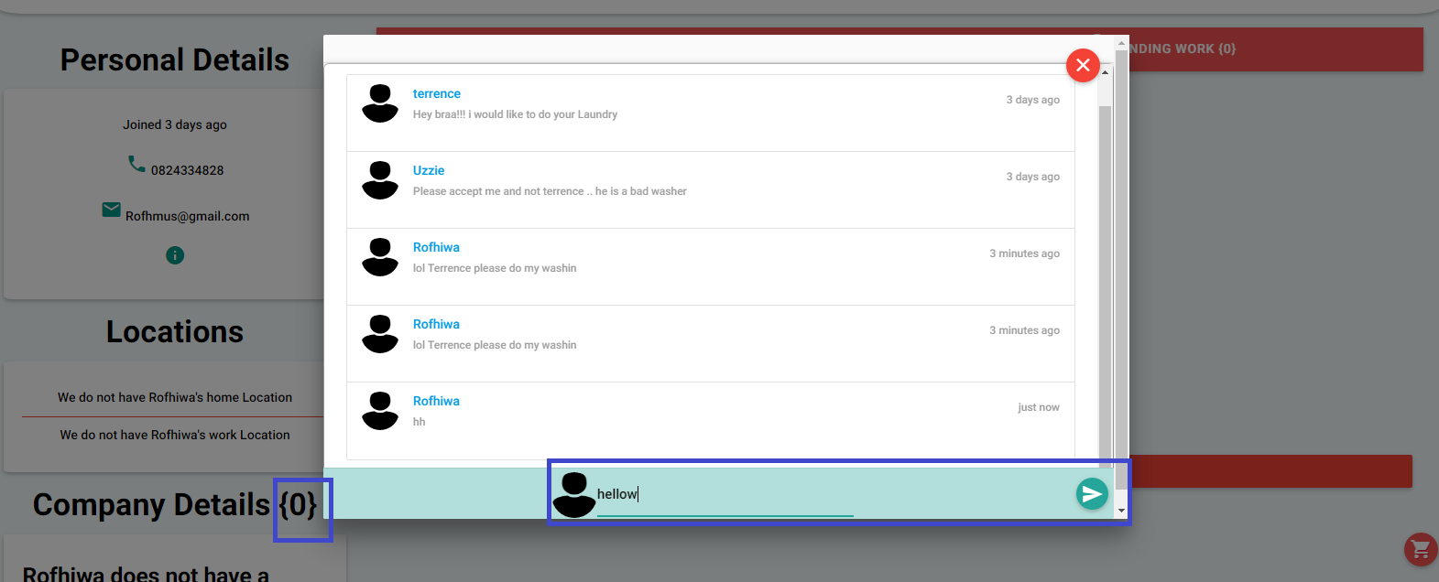

1. It would be nice if when I hover over the highlighted symbols I get I message of what they are for just as you did in the (notifications, receive, send & profile)

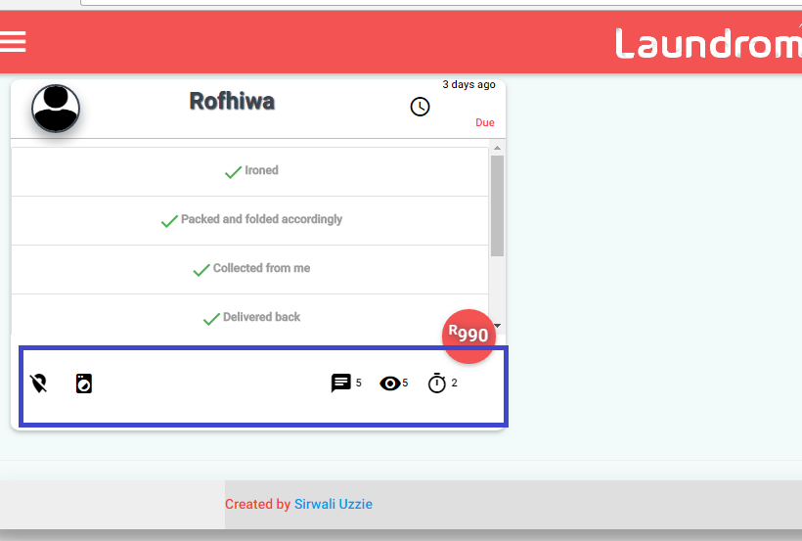

1. I can’t accept the person I want to do laundry 4 me and I also cant view their profile, perhaps

Give me a clear indication that I have selected a specific individual

