Visoka skola strukovnih studija za informacione i komunikacione tehnologije

Dokumentacija

<https://lavic33.github.io/leotravel/>

Predmet:Web programiranje 2 Student:Lav Bjelogrlic Nikolov 126/18

# SADRŽAJ

SADRŽAJ 2

1. UVOD 3
   1. Korišćeni programski jezici i okruženja 3
   2. Opis funkcionalnosti 3
   3. Template 3
   4. Organizaciona šema 5

Mapa sajta 5

* 1. Slike stranica i opisi funkcionalnosti 5
     1. index.html-Home 6
     2. index.html-Destinacije 7
     3. index.html-Why Us? 7
     4. index.html-Author 8
     5. index.html-Forma za book 8
     6. index.html-Footer 9

1. Kodovi 10
   1. HTML 10
      1. index.html 10
   2. CSS 17
      1. main.scss 17
   3. JavaScriptijQuery 18
      1. main.js 18
   4. JSON 24
      1. destinations.json 24
      2. countries.json 27
      3. promos.json 28

# UVOD

## Korišćen iprogramski jezici I okruženja

#### HTML5

#### CSS3

#### Boostrap 4

#### JavaScript

#### AJAX

#### JSON

#### JQuery

#### Visual StudioCode

## Opis funkcionalnosti

-Dinamicko ispisavanje zemalja za filter iz json fajla

-Dinamicko ispisvanje svih turistckih destinacija iz json fajla

-Filtriranje destinacija po prevoz I zemlji,sortitanje po ceni

-Dinamicko ispisvanje blok “WhyUs” iz json fajla

-Dinamicko popunjavanje padajuce liste destinacija iz json fajla

-Racunanje cene na osnovu cene odabrane destinacije I broja osoba

-Popunjavanje datuma kraja aranzmana na osnovu datuma pocetka I broja trajanja odabranog aranzmana

-Sinhronizovana 2 filtera putem local storage

*Napomena cuva u local storage I cita iz njega ali ima bag u ispisvanju destinacija uz zadate filtere

## Template

Koriscen je template sa <http://markups.io/> .

# Organizacija

## 1.4)Organizaciona šema

Index.html

## Mapa sajta

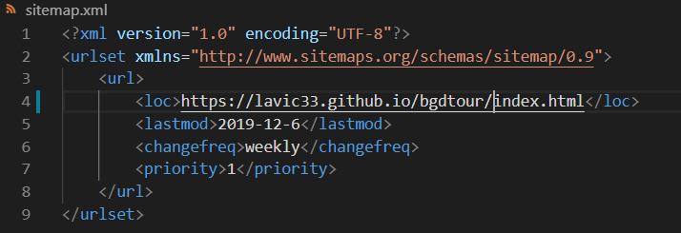

### 

## 1.5)Slike stranica i opisi funkcionalnosti

Print screenovi stranica sajta:

### 1.5.1)index.html-Home

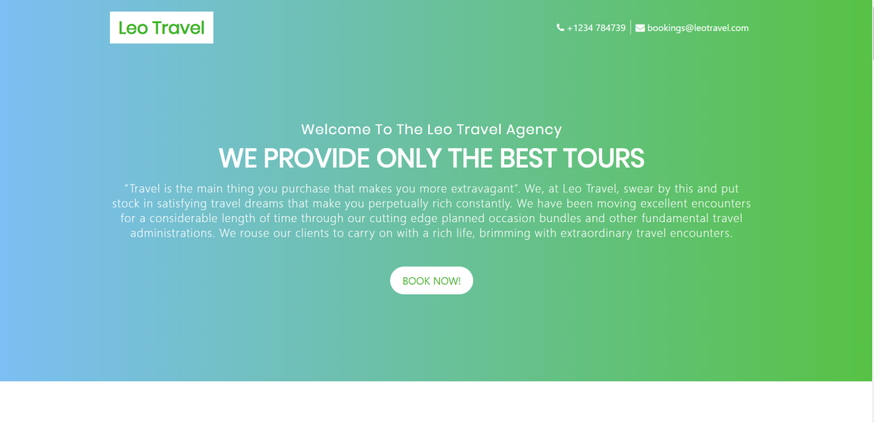

-Klikom na dugme “Book now” automatski se skroluje do diva sa prikazanim destinacijama

### 1.5.2)index.html-Destinacije

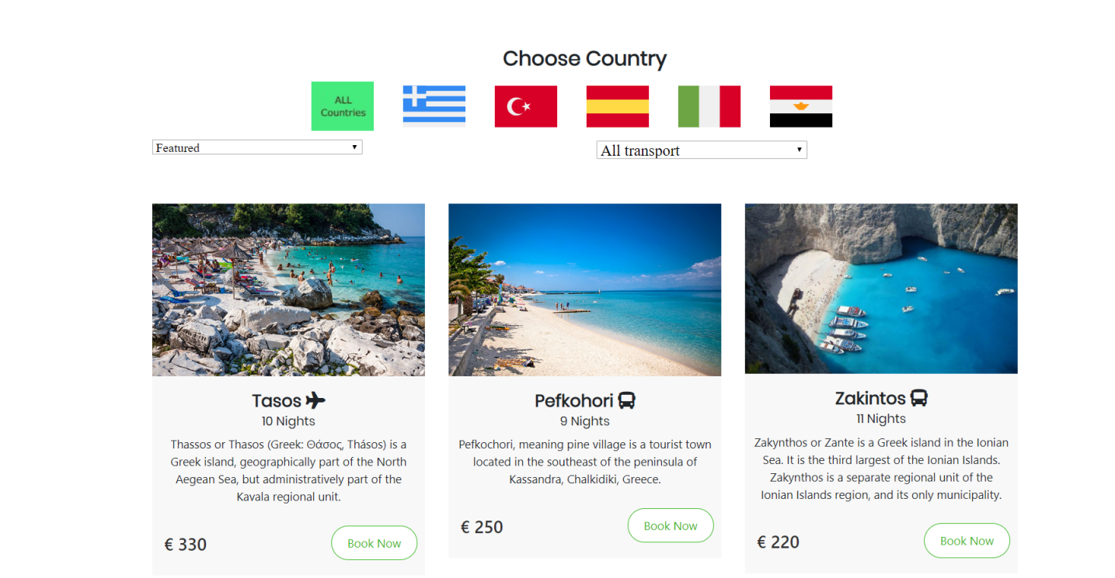

Ovde se nalaze dinamicki ispisane destinacije koje su u ponudi kao I zastave za filter po zemlji I padajuce liste za sort I filter,po ceni I po vrsti prevoza

### 1.5.3)index.html-Why us?

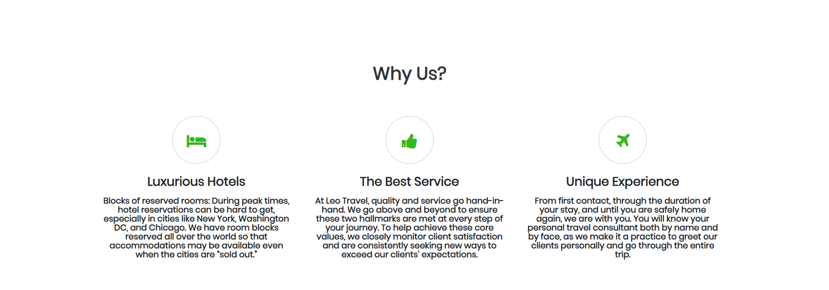

Ovde se nalaze dinamicki ispisani razlozi za odabir agencije dinamicki ucitani iz JSON fajla.

### 1.5.4)index.html-Author

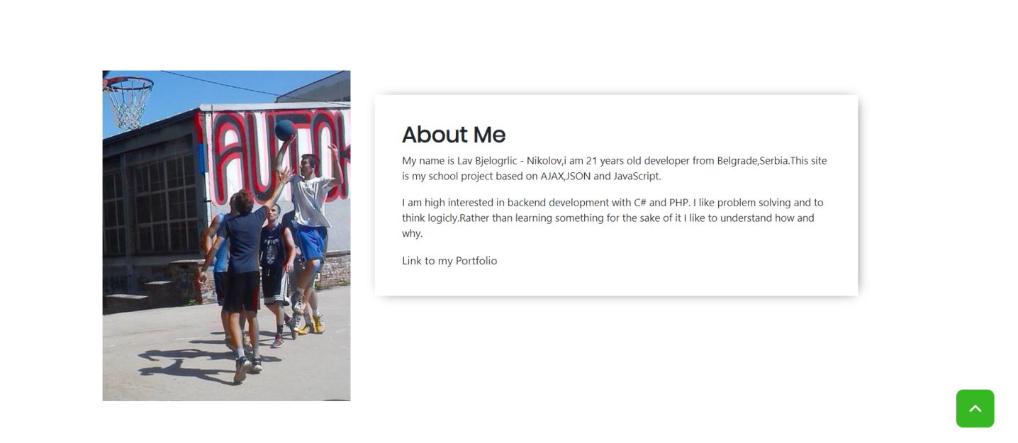

Jednostavan deo u autoru sajta.

1.5.5)index.html-Forma za book

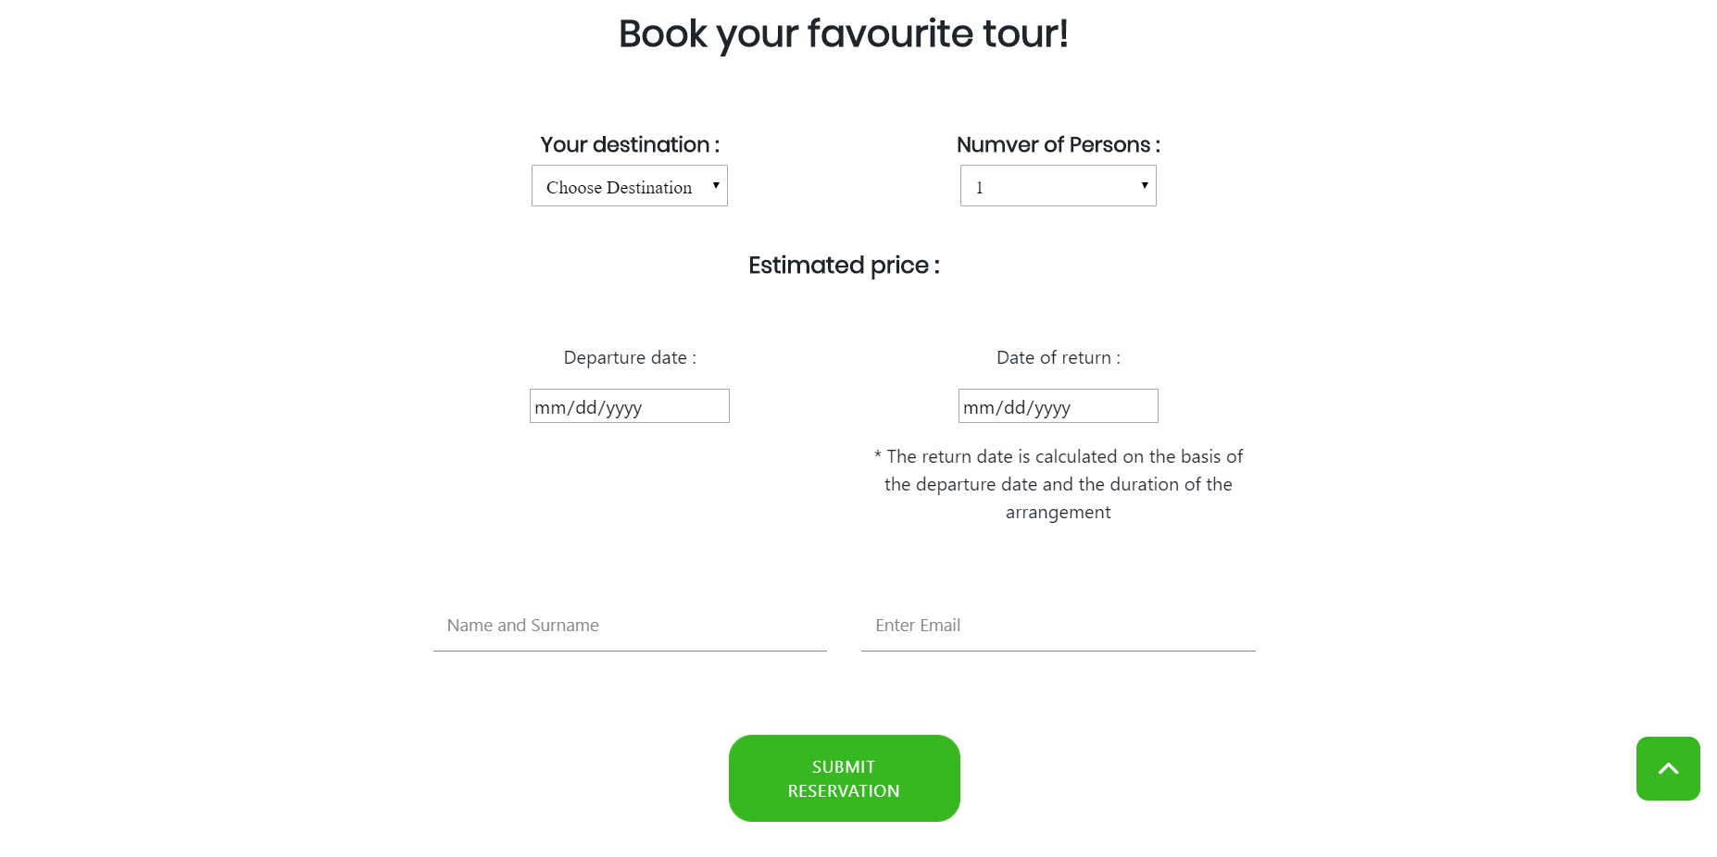

Ovde se nalazi forma za book,odabirom destinacije I broja osoba dinamicki se racuna cena.

Odabirom destinacije I datuma pocetka aranzmana dinamicki se racuna kraj aranzmana.

Vrsi se provera forme regularnim izrazima.

### 1.5.6)index.html-Footer

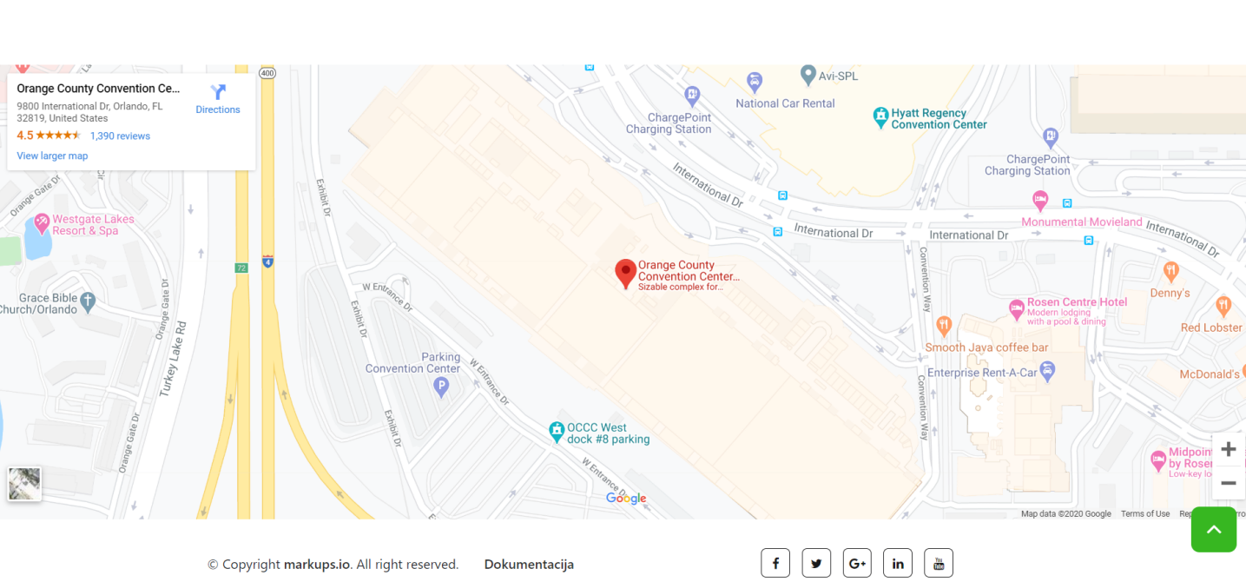

Footer sa google maps API-jem,linkovima do socijalnih mreza I copyrightom.

# Kodovi

## 2.1)HTML

### 2.1.1)index.html

<!DOCTYPE html>

<html lang="en">

  <head>

    <!-- Required meta tags -->

    <meta charset="utf-8">

    <meta name="viewport" content="width=device-width, initial-scale=1, shrink-to-fit=no">

    <meta name="description" content="Travel agency with best offers and hotels all over the World"/>

    <meta name="keywords" content="Travel,agency,Spain,Greece,Pefkohori,Beaches,Cheap"/>

    <meta name="author" content="Lav BjelogrliÄ‡-Nikolov"/>

    <title>Belgrade Tourist Tour</title>

    <link rel="stylesheet" href="css/main.css"/>

    <link rel="shortcut icon" href="img/ikonica.ico"/>

    <title>Leo Travel</title>

    <!-- Favicon -->

    <link rel="shortcut icon" type="image/icon" href="assets/images/favicon.ico"/>

    <!-- Font Awesome -->

    <link href="https://maxcdn.bootstrapcdn.com/font-awesome/4.6.3/css/font-awesome.min.css" rel="stylesheet"/>

     <!-- Bootstrap CSS -->

    <link rel="stylesheet" href="https://maxcdn.bootstrapcdn.com/bootstrap/4.0.0-beta/css/bootstrap.min.css" integrity="sha384-/Y6pD6FV/Vv2HJnA6t+vslU6fwYXjCFtcEpHbNJ0lyAFsXTsjBbfaDjzALeQsN6M" crossorigin="anonymous">

    <!-- Slick slider -->

    <link href="assets/css/slick.css" rel="stylesheet">

    <!-- Theme color -->

    <link id="switcher" href="assets/css/theme-color/default-theme.css" rel="stylesheet">

    <!-- Main Style -->

    <link href="style.css" rel="stylesheet">

    <!-- Fonts -->

    <!-- Poppins For Title -->

    <link href="https://fonts.googleapis.com/css?family=Poppins" rel="stylesheet">

    <link rel="stylesheet" href="https://use.fontawesome.com/releases/v5.8.1/css/all.css" integrity="sha384-50oBUHEmvpQ+1lW4y57PTFmhCaXp0ML5d60M1M7uH2+nqUivzIebhndOJK28anvf" crossorigin="anonymous">

    <link href="https://maxcdn.bootstrapcdn.com/font-awesome/4.6.1/css/font-awesome.min.css" rel="stylesheet"/>

    </head>

  <body>

   <!--START SCROLL TOP BUTTON -->

    <a class="scrollToTop" href="#">

      <i class="fa fa-angle-up"></i>

    </a>

  <!-- END SCROLL TOP BUTTON -->

    <!-- Start Header -->

    <header id="mu-hero">

        <div class="container">

            <div class="mu-hero-area">

                <div class="mu-hero-top">

                    <!-- Start center Logo -->

                    <div class="mu-logo-area">

                        <!-- text based logo -->

                        <a class="mu-logo" href="index.html"><span>Leo Travel</span></a>

                        <!-- Image based logo -->

                        <!-- <a class="mu-logo" href="index.html"><img src="assets/images/logo.jpg" alt="logo img"></a> -->

                    </div>

                    <!-- End center Logo -->

                    <div class="mu-hero-top-info">

                        <ul>

                            <li>

                                <i class="fa fa-envelope" aria-hidden="true"></i>

                                <span>bookings@leotravel.com</span>

                            </li>

                            <li>

                                <div class="mu-telephone">

                                    <i class="fa fa-phone" aria-hidden="true"></i>

                                    <span>+1234 784739</span>

                                </div>

                            </li>

                        </ul>

                    </div>

                </div>

                <!-- Start hero featured area -->

                <div class="mu-hero-featured-area">

                    <div class="mu-hero-featured-content">

                        <h2>Welcome To The Leo Travel Agency </h2>

                        <h1>WE PROVIDE ONLY THE BEST TOURS</h1>

                        <p>Lorem ipsum dolor sit amet, consectetur adipisicing elit. Atque ut omnis beatae quam quibusdam facere expedita explicabo eaque non sit. Amet vitae exercitationem ad rerum consequuntur numquam magni nemo dolorem, itaque eius perferendis praesentium consequatur. Dolores, nihil, molestiae sunt tenetur aut similique nostrum deleniti amet minima. Esse magnam inventore, ea.</p>

                        <a href="#mu-featured-tours" class="mu-book-now-btn">Book Now!</a>

                    </div>

                </div>

                <!-- End hero featured area -->

            </div>

        </div>

    </header>

    <!-- End Header -->

    <!-- Start main content -->

    <main>

        <!-- Start Featured Tours -->

        <section id="mu-featured-tours">

            <div class="container">

                <div class="row" id="filters">

                    <div class="col-md-12">

                        <div id="countries" class="mu-scrolldown-area">

                            <h3>Choose Country</h3>

                        </div>

                    </div>

                    <div class="col-md-6">

                        <select id="sort">

                            <option value="0">Featured</option>

                            <option value="PriceLtoH">Price - Low to High</option>

                            <option value="PriceHtoL">Price - High to Low</option>

                        </select>

                    </div>

                    <div class="col-6" id="transport">

                        <select id="prevoz">

                            <option value="-1">All transport</option>

                            <option value="Avion"><i class=icon-foo>&#xf072;</i>  Airplane transport</option>

                            <option value="Autobus"> <i class=icon-foo>&#xf207;</i>  Autobus transport</option>

                            </select>

                    </div>

                </div>

                <div class="row">

                    <div class="col-md-12">

                        <div class="mu-featured-tours-area">

                            <!-- Start Featured Tours content -->

                            <div class="mu-featured-tours-content" id="destinacije">

                            </div>

                            <!-- End Featured Tours content -->

                        </div>

                    </div>

                </div>

            </div>

        </section>

        <!-- End Featured Tours -->

        <!-- Start Why Us -->

        <section id="mu-why-us">

            <div class="container">

                <div class="row">

                    <div class="col-md-12">

                        <div class="mu-why-us-area">

                            <h2>Why Us?</h2>

                            <div class="mu-why-us-content">

                                <div class="row" id="promo">

                                    </div>

                                </div>

                            </div>

                        </div>

                    </div>

                </div>

            </div>

        </section>

        <!-- End Why Us -->

        <section id="mu-about">

            <div class="container">

                <div class="row">

                    <div class="col-md-12">

                        <div class="mu-about-area">

                            <!-- Start Feature Content -->

                            <div class="row">

                                <div class="col-md-6">

                                    <div class="mu-about-left">

                                        <img class="" src="assets/images/ja.jpeg" alt="slika mene">

                                    </div>

                                </div>

                                <div class="col-md-6">

                                    <div class="mu-about-right">

                                        <h2>About Me</h2>

                                        <p>My name is Lav Bjelogrlic - Nikolov,i am 21 years old developer from Belgrade,Serbia.This site is my school project based on AJAX,JSON and JavaScript.</p>

                                        <p>I am high interested in backend development with C# and PHP. I like problem solving and to think logicly.Rather than learning something for the sake of it I like to understand how and why. </p>

                                        <a href="https://lavic33.github.io/LavBjelogrlic/" target="blank">Link to my Portfolio</a>

                                    </div>

                                </div>

                            </div>

                            <!-- End Feature Content -->

                        </div>

                    </div>

                </div>

            </div>

        </section>

        <!-- Start Call to Action -->

        <!-- Start Call to Action -->

        <!-- Start Contact -->

        <section id="mu-contact">

            <div class="container">

                <div class="row">

                    <div class="col-md-12">

                        <div class="mu-contact-area">

                            <h2>Book your favourite tour!</h2>

                            <!-- Start Contact Content -->

                            <div class="mu-contact-content">

                                <div class="row">

                                    <div class="col-md-12">

                                        <div class="mu-contact-form-area">

                                            <div id="form-messages"></div>

                                            <form id="ajax-contact" method="post" class="mu-contact-form">

                                                <div class="row mb-5">

                                                    <div class="col-md-6">

                                                        <h6>Your destination :</h6>

                                                        <select name="destinacija" id="destinacija" class="p-2">

                                                        </select>

                                                        <p id="greskaDest" class="red"></p>

                                                    </div>

                                                    <div class="col-md-6 ">

                                                        <h6>Number of Persons :</h6>

                                                        <select name="brOsoba" id="brOsoba" class="p-2">

                                                        </select>

                                                    </div>

                                                    <div class="col-md-12">

                                                        <h5 class="mt-4">Estimated price : <span id="cena"></span></h5>

                                                    </div>

                                                </div>

                                                <div class="row mb-5">

                                                    <div class="col-md-6">

                                                        <p>Departure date :</p>

                                                        <input class="mb-3" type="date" name="datumOd" id="datumOd">

                                                        <span id="greskaDate"></span>

                                                    </div>

                                                    <div class="col-md-6 ">

                                                        <p>Date of return :</p>

                                                        <input class="mb-3" type="date" name="datumDo" id="datumDo" readonly>

                                                        <p>*

                                                            The return date is calculated on the basis of the departure date and the duration of the arrangement</p>

                                                    </div>

                                                </div>

                                                <div class="row">

                                                    <div class="col-md-6">

                                                        <div class="form-group">

                                                            <input type="text" class="form-control" placeholder="Name and Surname" id="name" name="name" required>

                                                            <p id="greskaName" class="red"></p>

                                                        </div>

                                                    </div>

                                                    <div class="col-md-6">

                                                        <div class="form-group">

                                                            <input type="email" class="form-control" placeholder="Enter Email" id="email" name="email" required>

                                                            <p id="greskaMail" class="red"></p>

                                                        </div>

                                                    </div>

                                                </div>

                                                <button id="posalji" type="button" class="mu-send-msg-btn mt-5"><span>Submit Reservation</span></button>

                                            </form>

                                        </div>

                                    </div>

                                </div>

                            </div>

                            <!-- End Contact Content -->

                        </div>

                    </div>

                </div>

            </div>

        </section>

        <!-- End Contact -->

        <!-- Start Google Map -->

        <div id="mu-google-map">

            <iframe src="https://www.google.com/maps/embed?pb=!1m18!1m12!1m3!1d3508.8176744277202!2d-81.47150788457147!3d28.424757900613237!2m3!1f0!2f0!3f0!3m2!1i1024!2i768!4f13.1!3m3!1m2!1s0x88e77e378ec5a9a9%3A0x2feec9271ed22c5b!2sOrange+County+Convention+Center!5e0!3m2!1sen!2sbd!4v1503833952781" width="850" height="450" allowfullscreen></iframe>

        </div>

        <!-- End Google Map -->

    </main>

    <!-- End main content -->

    <!-- Start footer -->

    <footer id="mu-footer">

        <div class="container">

            <div class="mu-footer-area">

                <div class="row">

                    <div class="col-md-6">

                        <div class="mu-footer-left">

                            <p class="mu-copy-right">&copy; Copyright <a rel="nofollow" href="http://markups.io">markups.io</a>. All right reserved.&nbsp;&nbsp;&nbsp;&nbsp;&nbsp;&nbsp; <a href="doc.pdf" target="blank">Dokumentacija</a></p>

                        </div>

                    </div>

                    <div class="col-md-6">

                        <div class="mu-footer-right">

                            <div class="mu-social-media">

                                <a href="#"><i class="fa fa-facebook"></i></a>

                                <a href="#"><i class="fa fa-twitter"></i></a>

                                <a href="#"><i class="fa fa-google-plus"></i></a>

                                <a href="#"><i class="fa fa-linkedin"></i></a>

                                <a href="#"><i class="fa fa-youtube"></i></a>

                            </div>

                        </div>

                    </div>

                </div>

            </div>

        </div>

    </footer>

    <!-- End footer -->

    <!-- JavaScript -->

    <!-- jQuery first, then Popper.js, then Bootstrap JS -->

    <script src="https://ajax.googleapis.com/ajax/libs/jquery/3.2.1/jquery.min.js"></script>

    <script src="https://cdnjs.cloudflare.com/ajax/libs/popper.js/1.11.0/umd/popper.min.js" integrity="sha384-b/U6ypiBEHpOf/4+1nzFpr53nxSS+GLCkfwBdFNTxtclqqenISfwAzpKaMNFNmj4" crossorigin="anonymous"></script>

    <script src="https://maxcdn.bootstrapcdn.com/bootstrap/4.0.0-beta/js/bootstrap.min.js" integrity="sha384-h0AbiXch4ZDo7tp9hKZ4TsHbi047NrKGLO3SEJAg45jXxnGIfYzk4Si90RDIqNm1" crossorigin="anonymous"></script>

    <!-- Slick slider -->

    <script type="text/javascript" src="assets/js/slick.min.js"></script>

    <!-- Ajax contact form  -->

    <!-- Custom js -->

    <script type="text/javascript" src="assets/js/custom.js"></script>

    <script type="text/javascript" src="assets/js/main.js"></script>

  </body>

</html>

## 2.2)CSS

### 2.2.1)main.css

/* Moj css */

.drzava{

    width:80px;

    margin-right: 3%;

}

@import url("https://maxcdn.bootstrapcdn.com/font-awesome/4.6.1/css/font-awesome.min.css");

select {

    font-family: 'FontAwesome', 'Second Font name' ;

    width:50%;

  }

.red{

    color:red;

}

## 2.3)Javascript/Jquery

### 2.3.1)main.js

window.onload = function(){

    getCountries();

    getDestinations();

    dohvatiPromo();

    proveriLs();

    document.querySelector("#sort").addEventListener("change",prepSort);

    document.querySelector("#prevoz").addEventListener("change",filterPrevoz);

    document.querySelector("#posalji").addEventListener("click",forma);

    document.querySelector("#destinacija").addEventListener("change",forma);

    document.querySelector("#brOsoba").addEventListener("change",forma);

    document.querySelector("#datumOd").addEventListener("change",forma);

    document.querySelector("#name").addEventListener("blur",forma);

    document.querySelector("#email").addEventListener("blur",forma);

}

function getCountries(){

    $.ajax({

        url:"assets/data/countries.json",

        method:"get",

        type:"json",

        success:function(countries){

            setCountries(countries);

        }

    })

}

var nizDest = [];

function getDestinations(){

    $.ajax({

        url:"assets/data/destinations.json",

        method:"get",

        type:"json",

        success:function(destinations){

            setDestinations(destinations);

            nizDest = destinations;

            fillOptionDest(nizDest);

        }

    })

}

function prepSort(){

    let krit= document.querySelector("#sort").value;

    addLocalS("cena",krit);

    sortitaj(krit,nizDest);

}

function setCountries(countries){

    let html=`<a href="#" class="country" data-countryId="0"><img class="drzava" src="assets/images/all.jpg"/></a>

    `;

    for(c of countries){

        html+=`

        <a href="#" class="country" data-countryId="${c.id}"><img class="drzava" src="${c.image}"/></a>

        `

    }

    document.querySelector("#countries").innerHTML+=html;

    var zemlje = document.getElementsByClassName("country");

    for(let j=0;j<zemlje.length;j++){

    zemlje[j].addEventListener("click",filterZemljePrep);

}

}

function filterZemljePrep(e){

    e.preventDefault();

    let selectedId=this.dataset.countryid;

    addLocalS("zemlja",selectedId);

    filtriraj(selectedId);

}

function setDestinations(destinations){

    let html=`<div class="row">`;

    for(d of destinations){

        let i=0;

        html+=`

        <div class="col-md-4">

        <div class="mu-featured-tours-single">

            <img src="assets/images/${d.coverImg}" alt="img">

            <div class="mu-featured-tours-single-info">

                <h3>${d.name} ${prevozIkonica(d.prevoz)}</h3>

                <h4> ${d.noNights} Nights</h4>

                <span class="mu-price-tag">&euro; ${d.price} </span>

                <p>${d.desc}</p>

                <a href="#mu-contact" data-id="${d.id}"  class="mu-book-now-btn bookDest">Book Now</a>

            </div>

        </div>

    </div>

        `

    }

    function prevozIkonica(prevoz){

        if(prevoz == "Avion"){

            return  `<i class="fas fa-plane"></i>`

        }

        else{

            return ` <i class="fas fa-bus"></i>`

        }

    }

    html+=`</div>`;

    document.querySelector("#destinacije").innerHTML=html;

}

function filterPrevoz(destinations){

    let prevoz=document.querySelector("#prevoz").value;

    addLocalS("prevoz",prevoz);

    $.ajax({

        url:"assets/data/destinations.json",

        method:"get",

        type:"json",

        success:function(destinations){

           prevoz != -1 ? destinations = destinations.filter(d => d.prevoz == prevoz) : setDestinations(destinations);

            setDestinations(destinations);

        }

    })

}

function sortitaj(krit,destinations){

   console.log(destinations);

           if(krit == "PriceLtoH"){

               destinations.sort(function(a,b){

                    if(a.price<b.price){

                        return -1;

                    }

                    if(a.price>b.price){

                        return 1;

                    }

                    if(a.price == b.price){

                        return 0;

                    }

                })

                setDestinations(destinations);

           }

           if(krit == "PriceHtoL"){

            destinations.sort(function(a,b){

                 if(a.price>b.price){

                     return -1;

                 }

                 if(a.price<b.price){

                     return 1;

                 }

                 if(a.price == b.price){

                     return 0;

                 }

             })

             setDestinations(destinations);

        }

        else{

            setDestinations(destinations);

        }

        }

function dohvatiPromo () {

    $.ajax({

        url:"assets/data/promos.json",

        method:"get",

        type:"json",

        success:function(promo){

            ispisPromo(promo);

        }

    })

    function ispisPromo(promo){

        let html="";

        for(p of promo){

            html+=`

            <div class="col-md-4">

            <div class="mu-why-us-single">

                <div class="my-why-us-single-icon">

                    <i class="fa fa-${p.icon}" aria-hidden="true"></i>

                </div>

                <h3>${p.name}<h3>

                <p>${p.desc}</p>

            </div>

             </div>

            `

        }

        document.querySelector("#promo").innerHTML= html;

    }

  }

function filtriraj(idZemlje){

    $.ajax({

        url:"assets/data/destinations.json",

        method:"get",

        type:"json",

        success:function(destinations){

            if(idZemlje != "0"){

                destinations = destinations.filter(d => d.country.id == idZemlje);

            }

            setDestinations(destinations);

        }

    })

}

function fillOptionDest(nizDest){

    let html=`<option value="0">Choose Destination</option>`;

    for(d of nizDest){

        html+= `

        <option value="${d.id}">${d.name}</option>

        `

    }

    document.querySelector("#destinacija").innerHTML = html;

}

var OsobeMax = 8;

function brOsoba(maxBrOsoba){

    let html="";

    for(let i=1 ; i< maxBrOsoba+1; i++){

         html+=`

         <option value="${i}">${i}</option>

         `

    }

    document.querySelector("#brOsoba").innerHTML= html;

}

brOsoba(OsobeMax);

//regexp za formu

//fja za racunanje cene na osovnu desinacije i broja osoba

//fja za dodavanje datuma u polje datum vracanja

function forma(){

    let ime = document.querySelector("#name").value;

    let email = document.querySelector("#email").value;

    let dest = document.querySelector("#destinacija").value;

    let brOsoba = document.querySelector("#brOsoba").value;

    let datumPolazak = document.querySelector("#datumOd").value;

    if(dest != "0"){

        document.querySelector("#greskaDest").innerHTML = "";

    }

    else{

        document.querySelector("#greskaDest").innerHTML = "* You must choose destination ";

    }

    regName=/(^[A-Z][A-z\s]*)$/;

    regMail = /^[A-z\.\_\-\d]{4,20}@[A-z\.\_\-]{4,20}$/;

    if(regName.test(ime) && ime != ""){

        document.querySelector("#greskaName").innerHTML = "";

    }

    else{

        document.querySelector("#greskaName").innerHTML = "* Name and surname are required</br>(exp : John Smith)";

    }

    if(regMail.test(email) && email != ""){

        document.querySelector("#greskaMail").innerHTML = "";

    }

    else{

        document.querySelector("#greskaMail").innerHTML = "* Email is required </br>(exp : john@gmail.com)";

    }

    function findDestPrice(dest){

        let cena = nizDest.filter(x => x.id == dest).map(x => x.price);

        return cena;

    }

    function findDestDuration(dest){

        let brDana = nizDest.filter(x => x.id == dest).map(x => x.noNights);

        return brDana;

    }

    function racunajCenu(cena,brOsoba){

        return cena*brOsoba;

    }

    function popniDatum(datumOd,brDana){

        if(dest == 0){

            return false;

        }

        let trenutniDatum = new Date();

        let trenutniTimeStamp = new Date(trenutniDatum);

        let timestamp = new Date(datumOd).getTime();

        if(timestamp < trenutniDatum){

            document.querySelector("#greskaDate").innerHTML =" <p class='red'>*You must choose date in future !</p>";

        }

        else{

            document.querySelector("#greskaDate").innerHTML ="";

        }

        let endTimestamp = timestamp +(brDana*86400*1000);

        let datumVracanja = new Date(endTimestamp);

        let dateForInput = `${datumVracanja.getFullYear() }-${('0' + (datumVracanja.getMonth() + 1)).slice(-2)}-${('0' + datumVracanja.getDate()).slice(-2)}`;

        document.querySelector("#datumDo").value=dateForInput;

    }

    popniDatum(datumPolazak,findDestDuration(dest));

    findDestPrice(dest); // ovo ide kad prodje provera za dest

    function ispisCene(){

    let ispisCena=racunajCenu(findDestPrice(dest),brOsoba);

    document.querySelector("#cena").innerHTML = `${ispisCena}&euro;`;

    }

    ispisCene();

}

function addLocalS(name,vrednost){

    localStorage.setItem(name, vrednost);

}

function proveriLs(){

    if(localStorage){

        let zemlja = localStorage.getItem("zemlja");

        let cena = localStorage.getItem("cena");

        let prevoz = localStorage.getItem("prevoz");

       let pomocniNiz=[];

       if(zemlja != null){

           pomocniNiz = nizDest.filter(x=> x.country.id == zemlja);

           nizDest = pomocniNiz;

           if(prevoz != null){

               pomocniNiz = nizDest.filter(x=> x.prevoz == prevoz);

               nizDest = pomocniNiz;

           }

           setDestinations(nizDest);

       }

    }

}

## 2.4)JSON

### 2.3.1)destinations.json

[

    {

        "id":1,

        "name":"Tasos",

        "country":{

            "id":1,

            "name":"Greece"

        },

        "price":330,

        "coverImg":"tasos.jpg",

        "noNights":10,

        "desc":"Thassos or Thasos (Greek: Θάσος, Thásos) is a Greek island, geographically part of the North Aegean Sea, but administratively part of the Kavala regional unit.",

        "prevoz" :"Avion"

    },

    {

        "id":2,

        "name":"Pefkohori",

        "country":{

            "id":1,

            "name":"Greece"

        },

        "price":250,

        "coverImg":"pefki.jpg",

        "noNights":9,

        "desc":"Pefkochori, meaning pine village is a tourist town located in the southeast of the peninsula of Kassandra, Chalkidiki, Greece. ",

        "prevoz" :"Autobus"

    },

    {

        "id":3,

        "name":"Zakintos",

        "country":{

            "id":1,

            "name":"Greece"

        },

        "price":220,

        "coverImg":"zante.jfif",

        "noNights":11,

        "desc":"Zakynthos or Zante  is a Greek island in the Ionian Sea. It is the third largest of the Ionian Islands. Zakynthos is a separate regional unit of the Ionian Islands region, and its only municipality.",

        "prevoz":"Autobus"

    },

    {

        "id":4,

        "name":"Sicilija",

        "country":{

            "id":4,

            "name":"Italy"

        },

        "price":420,

        "coverImg":"Sicilia.jpg",

        "noNights":8,

        "desc":"Sicily  is the largest island in the Mediterranean Sea and one of the 20 regions of Italy. It is one of the five Italian autonomous regions and is officially referred to as Regione Siciliana. It has 5 million inhabitants.",

        "prevoz":"Avion"

    },

    {

        "id":5,

        "name":"Kalabrija",

        "country":{

            "id":4,

            "name":"Italy"

        },

        "price":390,

        "coverImg":"Calabria.jpg",

        "noNights":7,

        "desc":"Calabria  is a region in Southern Italy.The capital city of Calabria is Catanzaro. The Regional Council of Calabria is based at the Palazzo Campanella in the city of Reggio Calabria. ",

        "prevoz":"Avion"

    },

    {

        "id":6,

        "name":"Kusadasi",

        "country":{

            "id":2,

            "name":"Turkey"

        },

        "price":230,

        "coverImg":"kusadasi.jpg",

        "noNights":10,

        "desc":"Kuşadası  is a resort town on Turkey's Aegean coast, and the center of the seaside district of the same name within Aydın Province. Kuşadası is 95 km  south of İzmir, and 71 km  from Aydın. The municipality's primary industry is tourism.",

        "prevoz":"Autobus"

    },

    {

        "id":7,

        "name":"Antalija",

        "country":{

            "id":2,

            "name":"Turkey"

        },

        "price":250,

        "coverImg":"antalija.jpg",

        "noNights":10,

        "desc":"Antalya is the fifth-most populous city in Turkey and the capital of Antalya Province. Located on Anatolia's southwest coast bordered by the Taurus Mountains, Antalya is the largest Turkish city on the Mediterranean coast outside the Aegean region with over one million people in its metropolitan area.",

        "prevoz":"Autobus"

    },

    {

        "id":8,

        "name":"Majorka",

        "country":{

            "id":3,

            "name":"Spain"

        },

        "price":500,

        "coverImg":"majorka.jpg",

        "noNights":9,

        "desc":"Mallorca  is the largest island in the Balearic Islands, which are part of Spain and located in the Mediterranean. The native language, as on the rest of the Balearic Islands, is Catalan, which is co-official with Spanish.",

        "prevoz":"Avion"

    },

    {

        "id":9,

        "name":"Kosta Brava",

        "country":{

            "id":3,

            "name":"Spain"

        },

        "price":460,

        "coverImg":"costabrava.jpg",

        "noNights":10,

        "desc":"The Costa Brava is a coastal region of Catalonia in northeastern Spain, consisting of the comarques (counties) of Alt Empordà, Baix Empordà and Selva in the province of Girona. Costa Brava stretches from the town of Blanes, 60 km northeast of Barcelona, to the French border.",

        "prevoz":"Avion"

    },

    {

        "id":10,

        "name":"Hurgada",

        "country":{

            "id":5,

            "name":"Egypt"

        },

        "price":600,

        "coverImg":"hurgada.jfif",

        "noNights":12,

        "desc":"Hurghada  is a city in the Red Sea Governorate of Egypt. It is one of the country's main tourist centres located on the Red Sea coast.",

        "prevoz":"Avion"

    },

    {

        "id":11,

        "name":"Sarm El Seik",

        "country":{

            "id":5,

            "name":"Egypt"

        },

        "price":530,

        "coverImg":"sarmelsaik.jpg",

        "noNights":11,

        "desc":"Sharm El Sheikh  is an Egyptian city on the southern tip of the Sinai Peninsula, in South Sinai Governorate, on the coastal strip along the Red Sea.",

        "prevoz":"Avion"

    }

]

### 2.4.2)countries.json

[

    {

        "id":1,

        "name" : "Greece",

        "image":"assets/images/greece.svg"

    },

    {

        "id":2,

        "name" : "Turkey",

        "image":"assets/images/turkey.svg"

    },

    {

        "id":3,

        "name" : "Spain",

        "image":"assets/images/spain.svg"

    },

    {

        "id":4,

        "name" : "Italy",

        "image":"assets/images/italy.svg"

    },

    {

        "id":5,

        "name":"Egypt",

        "image":"assets/images/egypt.svg"

    }

]

### 2.4.3)promos.json

[

    {

        "id":1,

       "name":"Luxurious Hotels",

       "desc" : "Blocks of reserved rooms: During peak times, hotel reservations can be hard to get, especially in cities like New York, Washington DC, and Chicago. We have room blocks reserved all over the world so that accommodations may be available even when the cities are “sold out.” ",

       "icon":"bed"

    },

    {

        "id":2,

       "name":"The Best Service",

       "desc" : "At Leo Travel, quality and service go hand-in-hand. We go above and beyond to ensure these two hallmarks are met at every step of your journey. To help achieve these core values, we closely monitor client satisfaction and are consistently seeking new ways to exceed our clients’ expectations. ",

       "icon":"thumbs-up"

    },

    {

        "id":3,

       "name":"Unique Experience",

       "desc" : "From first contact, through the duration of your stay, and until you are safely home again, we are with you. You will know your personal travel consultant both by name and by face, as we make it a practice to greet our clients personally and go through the entire trip. ",

       "icon":"plane"

    }

]