StudyBridge – A Collaborative Learning Platform
by
Lavi Choudhary

A PROJECT SYNOPSIS
Submitted to the
HIMACHAL PRADESH TECHNICAL UNIVERSITY (H.P.T.U.) HAMIRPUR, H.P.
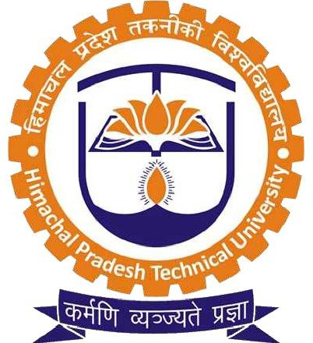
In partial fulfilment of the requirements for the award of the degree
of
MASTER OF COMPUTER APPLICATIONS (M.C.A.)
in
3rd Semester
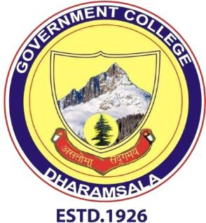

December, 2025 Department Of M.C.A.
Government College Dharamshala

PROJECT SYNOPSIS

ON

StudyBridge – A Collaborative Learning Platform
SUBMITTED IN PARTIAL FULFILMENT FOR AWARD OF THE DEGREE
Master of Computer Applications (MCA)

SESSIONS 2024-26 Lavi Choudhary 240630010031
UNDER THE GUIDANCE OF

DR. SATISH SOOD

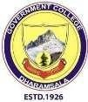

DEPARTMENT OF MCA (MASTER OF COMPUTER APPLICATION) GOVERNMENT DEGREE COLLEGES DHARAMSHAL
HIMACHAL PRADESH TECHNICAL UNIVERSITY
HAMIRPUR (H.P)

