  - Introduction
Today education is no longer limited to classrooms, printed books, or handwritten notes. Students now use digital resources, online videos, and shared study materials to prepare for exams and develop new skills. But the digital world also creates several problems. Study materials are spread across many websites, some notes are not verified, and students often find it difficult to locate accurate information or communicate with classmates. Because of these challenges, there is a need for one simple and organized platform where students can find everything, they require for studying.
StudyBridge – A Collaborative Learning Platform is created to solve these problems. It works like a bridge that connects students to important study resources, learning tools, and communication features. Students can upload and share notes, watch subject-wise educational videos, take mock tests, and chat with other students in real time. The platform is designed to be simple, modern, and easy to use so that every student can navigate it without difficulty.
One major issue with other online platforms is the lack of quality control. Many study materials available on the internet are incorrect or outdated. To fix this, StudyBridge includes an Admin Approval System. When students upload notes or videos, an admin checks and verifies the content before making it public. This ensures that students always get clean, useful, and authentic study material.
StudyBridge also includes a Profile Management System. Each student has to complete their profile with basic details such as name, phone number, institution, and profile photo. New users are sent to the profile page during their first login so that the platform always has accurate user information.
Motivation plays an important role in a student’s learning journey. For this reason, StudyBridge has a modern and interactive dashboard that shows motivational quotes, shortcuts to subjects, upload statistics, and important announcements. This keeps students focused, encourages regular study, and makes the platform more engaging.
Overall, StudyBridge aims to provide a complete, safe, and collaborative digital learning environment where students can learn, share, communicate, and grow together. It brings all essential study features—notes, videos, mock tests, chat, announcements, and profile management—into one simple and organized platform designed to support effective learning.
  - Objectives
The primary objective of StudyBridge – A Collaborative Learning Platform is to create a unified digital space that supports students throughout their academic journey. The platform has been designed to address common learning challenges such as scattered study materials, lack of verified content, limited academic interaction, and unstructured study habits. StudyBridge brings all essential learning tools—notes, videos, mock tests, communication, and announcements—together in one easy-to-use system. The objectives focus on improving accessibility, increasing engagement, and ensuring a smooth learning experience for all users.
- To provide a central hub for study materials
One of the biggest problems that students face is the need to search across different websites, apps, and social media platforms to gather study materials. StudyBridge aims to eliminate this issue by providing a dedicated space where students can upload and download notes in PDF or DOC format. The centralized collection of materials reduces time wastage, increases convenience, and ensures that students always have quick access to the resources they need. The inclusion of an admin approval mechanism further ensures that only relevant and high-quality academic materials become available for students.
- To offer subject-wise educational videos
StudyBridge provides organized and categorized study videos for various subjects, including Mathematics, Reasoning, General Knowledge, and English. Instead of spending time filtering through unrelated content on YouTube or other platforms, students can directly access videos that have been selected based on academic value. Categorization not only saves time but also encourages students to follow a structured approach to learning.
- To conduct mock tests for exam readiness
Mock tests help students understand real exam patterns and evaluate their preparation level. StudyBridge includes an easy-to-use mock test module where students can take practice tests, receive instant results, and analyze their performance. This encourages self-learning, improves problem-solving skills, and builds confidence before actual examinations. The mock test module helps students identify weak areas that need more attention.
- To enable real-time academic communication
Academic discussions and doubt-clearing sessions are an important part of learning. StudyBridge includes a one-to-one chat system where students can privately communicate, share questions, and help each other in real time. This feature helps recreate a collaborative classroom environment in a digital format. It strengthens peer learning and enables quick sharing of important ideas or doubts.
- To maintain a verified and reliable academic environment
Academic discussions and doubt-clearing sessions are an important part of learning. StudyBridge includes a one-to-one chat system where students can privately communicate, share questions, and help each other in real time. This feature helps recreate a collaborative classroom environment in a digital format. It strengthens peer learning and enables quick sharing of important ideas or doubts.
- To deliver a modern, interactive, and user-friendly experience
Engagement plays a key role in student motivation. Therefore, StudyBridge uses a modern UI built with Bootstrap 5, attractive color themes, responsive layouts, and smooth AOS animations. The dashboard contains motivational quotes, shortcut cards, announcements, and activity summaries which keep students constantly engaged. The interface is designed so that even students with basic computer knowledge can use the system comfortably.
- To maintain structured, secure, and updated user information
The Profile Management Module ensures that every student maintains essential personal and academic information, including name, phone number, institution, qualification, and profile photo. This improves user authenticity, makes communication easier, and helps the admin maintain a well-organized community of learners. The system also ensures data privacy with secure password hashing and controlled access.
- To ensure modularity and future scalability
StudyBridge is built using a modular approach so that new features can be added without modifying the entire system. Future enhancements such as online classroom modules, AI-based study recommendations, group chat, or detailed user analytics can be integrated smoothly. This scalability ensures that the platform can continue to grow and support students for many years.
- To support collaborative and self-paced learning
The system encourages students to learn at their own speed while also giving them the tools to collaborate with peers. Notes, videos, chat, and mock tests are available 24/7, allowing students to use the platform whenever they want. The combination of self-learning and peer learning helps improve academic performance.

  - About Organization
The development of StudyBridge – A Collaborative Learning Platform was carried out within the academic environment of the MCA (Master of Computer Applications) Department. The institution strongly supports innovation, creativity, and technical skill development. As part of the MCA curriculum, students are encouraged to work on real-life software projects that help them apply theoretical concepts in practical situations. StudyBridge was developed under this guidance and reflects the institution’s commitment to modern learning methods.
The organization provides students with essential facilities that support technical development, including fully equipped computer laboratories, updated software tools, stable internet connectivity, and access to digital and physical learning resources. These facilities allow students to experiment, design, and implement their ideas in a professional environment. During the course, students receive training in several important areas of software development such as:
- System analysis and system design
- Database management and database modelling
- Software engineering concepts
- Web technologies (HTML, CSS, JavaScript, PHP, MySQL)
- Application development and deployment
- Testing techniques and documentation practices
The MCA program emphasizes a practical and problem-solving approach. Students learn how to convert user requirements into working software, design user-friendly interfaces, test systems for errors, and prepare technical documentation. The development of StudyBridge reflects these skills, as the platform combines strong backend logic with a clean and interactive user interface.
Faculty members play a major role in guiding students throughout the entire development process. Instructors provide continuous support during every stage, including requirement gathering, planning, system design, coding, testing, and final deployment. Their feedback helps refine the project and improve its quality. This supportive academic environment ensures that the final project is not only suitable for academic evaluation but also capable of being used as a practical, real-world solution.
Overall, the organization promotes a learning culture that blends theory with practical implementation. StudyBridge is a direct outcome of this culture, demonstrating how students can design meaningful digital solutions when provided with the right resources, guidance, and academic environment.
2.1 Identification of Need
Problem Specification
In today’s academic environment, students depend heavily on digital resources for preparing for exams, competitive tests, assignments, and classroom learning. Although many online platforms exist, students still face several challenges because the information is not properly organized or verified. The following problems are commonly experienced:
- Scattered Resources
Study materials such as notes, videos, mock tests, and announcements are spread across many different platforms. A student may watch videos on YouTube, receive notes on WhatsApp, search for PDFs on Google, and check college announcements separately. This constant switching between apps wastes time and reduces learning efficiency.
- Unverified Content
A major issue with online learning is that a lot of the content is outdated, incomplete, or incorrect. Students cannot rely on random notes or videos found online because the accuracy cannot be guaranteed. This affects learning quality and exam performance.
- Lack of Academic Community
There is no simple, dedicated platform where students can discuss doubts privately with other students. Social media apps are not ideal for academic communication, and group chats often become cluttered, making it difficult to focus on studies.
- No Personalization
Most existing platforms do not allow users to maintain personal profiles or academic identities. Without personalization, the learning experience becomes scattered and unstructured, and it becomes harder for students to track their own academic progress.
- Lack of Admin Control
Open online platforms allow anyone to upload anything, which often leads to low-quality or irrelevant study material being shared. Without proper moderation, there is no way to maintain the quality of academic resources.

- Limited Motivation
Many students struggle to maintain consistency while studying. Existing systems do not provide motivational tools, dashboards, or simple progress indicators that help students stay engaged.
Existing System
Before the development of StudyBridge, students relied on multiple separate tools and platforms for their academic needs:
Common Platforms Used
- YouTube → For watching educational videos
- Google Drive / WhatsApp → For sharing and receiving notes
- Mock test mobile apps → For practicing MCQs
- Social media apps → For communicating with classmates
- College notice boards / PDFs → For receiving announcements
Problems in the Existing System
- No central hub: Students must depend on multiple platforms instead of a single organized system.
- No structured categories: Materials are not sorted properly (e.g., by subject or topic).
- No admin verification: Anyone can upload anything; quality is not monitored.
- No personal dashboards: Students cannot view all updates or resources in one place.
- No academic-focused chat: General apps mix personal and academic chats, causing distraction.
- Difficult to track new materials: Updates are often missed because there is no centralized notification system.
Proposed System
StudyBridge – A Collaborative Learning Platform provides a complete solution to the problems identified above. It brings all academic features into one secure and easy-to-use platform.
- Centralized Resource Hub
Students can access notes, videos, mock tests, and announcements all in one place, making studying more organized and efficient.
- Admin Moderation
All student-uploaded content is reviewed by the admin. Only approved material becomes available to others. This ensures accuracy, quality, and reliability.
- One-to-One Chat System
Students can directly message peers for doubt clarification, topic discussion, and academic help. This promotes collaborative learning.
- Dashboard Analytics
The dashboard shows motivational quotes, upload statistics, quick links, and announcements, helping students stay updated and focused.
- Profile Management System
Every user has a personalized profile with name, institution, qualification, and contact details. This creates a professional academic environment.
- Secure Login & Authentication
Session-based login, encrypted passwords, and restricted access ensure that the platform remains safe and protected.
- Responsive and Animated User Interface
The platform works smoothly on mobile, tablet, and desktop devices. Modern animations make the interface visually appealing and user-friendly.
Feasibility Analysis
A feasibility study determines whether the project is practical, achievable, and worth implementing. StudyBridge is analysed based on three types of feasibility:
- Technical Feasibility
- The system uses widely available and easy-to-learn technologies like PHP, MySQL, and Apache.
- It runs on any device that has a modern browser (Chrome, Firefox, Edge, etc.).
- Hardware requirements are minimal, making the system accessible to all.
- The platform can be deployed on local servers (XAMPP) or cloud servers (AWS, DigitalOcean).
- The MySQL database can manage thousands of records smoothly.
- Operational Feasibility
- The user interface is simple and intuitive, so students do not need technical knowledge to use it.
- Admin tasks such as approval and content monitoring are easy to perform.
- File uploading and downloading are fast and smooth.
- The responsive design ensures the system works well on both mobile and desktops.
- Economic Feasibility
- The entire system is developed using open-source tools with no licensing costs.
- Maintenance and upgrades are inexpensive.
- Suitable for students and educational institutions with limited budgets.
- Hosting can be managed with low-cost servers.
2.2 Project Planning and Project Scheduling
Project planning is a critical step in software development because it ensures that the entire system is built in an organized, structured, and time-bound manner. StudyBridge was developed using a clear plan so that every phase—right from requirement gathering to deployment—was completed efficiently. Proper planning also reduces errors, saves time, and ensures that all modules work smoothly when integrated.
StudyBridge follows a 10-week development timeline, where each activity was scheduled carefully to avoid overlap and confusion. The project was divided into multiple phases, and each phase had specific goals, resources, and deliverables.
PERT Chart
A PERT (Program Evaluation and Review Technique) chart is used to identify tasks, their order, and the time required to complete each one. It helps in planning the flow of the project and ensures that every task is completed within the given deadline.
Below is an easy and expanded explanation of each activity:
- Requirement Gathering – 2 Weeks
This phase involved:
- Meeting students and teachers
- Understanding academic needs
- Identifying problems in the existing system
- Listing all features (notes, videos, chat, admin verification, mock tests, profile management)
This phase is crucial because correct requirements ensure a correct final project.
- System Design – 2 Weeks
This includes creating:
- Data Flow Diagrams (DFDs)
- ER Diagram
- Use-case diagrams
- Basic screen layout design (UI flow)
- Internal structure of modules
This step ensures that the development team knows exactly how the system will function.
- Database Design – 1 Week
In this stage:
- Database tables were created
- Primary key and foreign key relationships were decided
- Data constraints were applied
- Sample data was tested
This ensures that the database supports all modules like notes, videos, announcements, chat, and profiles.
- Student Module Development – 2 Weeks
This includes developing:
- Registration and login
- Profile update page
- Notes upload/download
- Videos page
- Mock tests
- Chat system for students
This is one of the most important parts of the system.
- Admin Module Development – 2 Weeks
The admin features include:
- Notes approval/rejection
- Managing videos
- Posting announcements
- Managing users
- Monitoring system activity
This phase ensures quality control and smooth management.
- Integration – 1 Week
All modules are combined:
- Student modules
- Admin modules
- Database connections
- UI components
- Validation and authentication systems
This step ensures that the system works as one complete application.
- Testing – 1 Week
Testing involves checking:
- Functional testing
- Security testing (password hashing, SQL injection prevention)
- Responsive testing (mobile + desktop)
- Performance testing
- Error handling
This ensures that the system is stable and error-free.
- Deployment & Documentation – 1 Week
This is the final stage:
- Hosting the project on a server (XAMPP for local)
- Creating reports (synopsis, SRS, design documents)
- Preparing for project submission and demonstration

Gantt Chart
A Gantt Chart visually represents the project timeline. It shows which tasks are done in which week and helps identify overlaps or delays.
Below is a clear explanation of the timeline:
Week 1–2: Requirement Gathering
- Identify system needs
- Discuss features
- Prepare initial requirement document
- Finalize scope of the project
This is the foundation of the entire development process.
Week 3–4: System & Database Design
- Prepare DFDs, ER diagrams, data models
- Design UI flow
- Build database structure
- Confirm design with project guide
This stage ensures that the project has a solid blueprint.
Week 5–6: Student Module Development
- Build login, registration, profile
- Create notes upload/download
- Develop videos page
- Implement chat system
- Add mock test module
This is the biggest part of the system and takes the most time.
Week 7–8: Admin Module Development
- Implement approval/rejection system
- Add video management
- Add announcement system
- Add user control options
- Improve dashboard for admin
This ensures proper management and quality control.
Week 9: Integration & Testing
- Combine admin + student modules
- Fix bugs
- Test all features
- Test UI and responsiveness
This ensures a smooth and error-free system.
Week 10: Deployment & Documentation
- Host project locally
- Prepare screenshots
- Finalize project report
- Final testing before submission
2.3 Software Requirement Specifications (SRS)
The Software Requirement Specification (SRS) describes what the system must do, how it should behave, and the conditions under which it must operate. It acts as a formal agreement between developers, users, and stakeholders. For StudyBridge – A Collaborative Learning Platform, the SRS serves as the foundation for designing, developing, and testing the entire system.
Functional Requirements
Functional requirements explain the specific actions, operations, and behaviors that the system must perform.
- User Registration & Login
- Users must be able to create an account using a valid email and password.
- Passwords are stored securely using hashing techniques.
- Only registered users can log in and access personalized features.
- Profile Update System
- After first-time login, users are redirected to complete their profile (name, phone, institution, qualification, photo).
- Users can update their profile anytime from their dashboard.
- Notes Upload/Download
- Students can upload notes in PDF or DOC format.
- Uploaded notes remain Pending until the admin reviews them.
- After approval, notes become available for download to all users.
- Video Module
- Students can access categorized educational videos.
- Videos are provided through YouTube links for better performance.
- Subject categories help students quickly find relevant content.
- Mock Test Module
- Users can attempt subject-wise mock tests.
- The system displays scores and performance feedback.
- Helps students in exam practice and self-evaluation.
- One-to-One Chat Module
- Students can send and receive private messages with other users.
- Useful for doubt-solving and collaborative learning.
- Chat history is securely stored in the database.
- Announcements Module
- Admin can post important updates and notifications.
- Students can view announcements directly on their dashboard.
- Admin Approval System
- Admin verifies all uploaded notes and videos.
- Admin can approve, reject, or remove inappropriate content.
- Ensures only reliable and academic material is displayed.
Non-Functional Requirements
Non-functional requirements describe how the system should perform, rather than what it should do.
- Security
- User passwords are encrypted using PHP password hashing.
- Prepared statements are used to prevent SQL injection.
- Only authenticated users can access the dashboard.

- Reliability
- The system should work consistently without unexpected failures.
- Upload and download operations must function smoothly when the server is active.
- Usability
- Interface should be clean, simple, and easy to understand.
- Buttons, menus, and forms must be user-friendly and intuitive.
- Portability
- The platform should work on all modern browsers (Chrome, Firefox, Edge).
- Must run smoothly on mobile, tablet, laptop, and desktop devices.
- Performance
- Pages should load quickly with minimal delay.
- File uploads should handle large academic materials without crashing.
- Chat messages should appear instantly.
- Maintainability
- Code structure should allow easy updates and improvements.
- Database design must support future growth and scalability.
User Characteristics
- Students
- Primary users of the platform.
- Require only basic web-browsing knowledge.
- Can upload notes, download study material, watch videos, take tests, and use chat.
- Admin
- Manages content, users, and platform activities.
- Should understand quality standards for uploaded study material.
- Can approve, reject, or delete notes and videos.
Constraints
Constraints represent limitations that the system must operate within.
- File Upload Limit
- Notes must follow the maximum file size allowed by the server (e.g., 40 MB unless modified).

- Security Restrictions
- Only logged-in users can upload files.
- Admin approval is required before content becomes public.
- Mandatory Admin Verification
- Notes and videos cannot be displayed until approved.
- Ensures quality control and content authenticity.
System Interfaces
Interfaces describe how the system interacts with users and other components.
- Browser Interface
- The system is accessed through modern web browsers.
- Built with HTML, CSS, JavaScript, and Bootstrap for a responsive UI.
- Database Interface
- MySQL database stores data such as user accounts, notes, videos, messages, and announcements.
- Backend connects using MySQL or PDO.
- Server Interface
- Apache server handles incoming HTTP requests.
- PHP processes authentication, file uploads, and data handling…………………….
2.4 Software Engineering
The development of StudyBridge – A Collaborative Learning Platform follows a structured and well-organized software engineering approach. To ensure flexibility, efficiency, and smooth improvements throughout the entire development process, the Agile + Incremental Model was chosen. This hybrid approach brings together the strengths of both Agile methodology and the Incremental development model.
The goal was to create a system that could grow step-by-step while still allowing continuous feedback, testing, and refinement. Since StudyBridge contains many modules—such as notes, videos, chat, profile, mock tests, and admin tools—the model needed to support modular development. Agile + Incremental is ideal for such systems.

Why Agile + Incremental Model Was Used
Flexible and Easy to Modify
Agile development allows changes to be made at any stage. During StudyBridge development, new requirements such as:
Profile completion redirection
- Better dashboard UI
- Stronger admin approval flow
- Improved chat logic
Step-by-Step (Incremental) Development
The system was built module by module, with each part fully developed and tested before moving to the next:
- Login & Registration
- Profile Management
- Notes Upload/Download
- Video Module
- Mock Tests
- Chat System
- Announcements
- Admin Panel
Continuous Feedback
Feedback was taken regularly from:
- Students (end users)
- Project guide
- Test users
Better Testing
Testing happened after each module:
- Unit Testing
- Integration Testing
- UI Testing
- Security Testing
Strong Risk Management
Incremental development allows risks to be identified early.
For example:
- File upload issues
- Chat synchronization
- Database constraints
Ideal for Academic Projects
Agile + Incremental is suitable for student projects because:
- It is simple to follow
- Easy to explain in reports and presentations
- Produces results quickly
- Allows flexible development schedule
Phases Used in StudyBridge Development
Requirement Analysis
Understanding the needs of:
- Students
- Admin
- Academic systems
System Design
Includes:
- Data Flow Diagrams (DFDs)
- ER Diagram
- Use-case diagrams
- UI wireframes
- Database schema
Module Development
Each module is developed separately:
- Backend (PHP)
- Frontend (HTML, CSS, Bootstrap, JS)
- Database operations (MySQL)
Testing
Testing involved:
- Validating login
- Checking file uploads
- Verifying admin approval
- Chat message delivery
- Profile updating
Deployment
StudyBridge was deployed on:
- Local server (XAMPP) for development
- Ready for future cloud deployment (AWS/Google Cloud)
Maintenance
After deployment:
- UI polishing
- Bug fixes
- Performance tuning
- Preparing for additional features
2.5 Data Models
Data models describe how information is stored, processed, and transferred inside the system. They help in understanding how different components of StudyBridge interact with each other and how data moves between users, the system, and the database.
In simple terms, data models give a visual and logical representation of:
- how data enters the system,
- how it is processed,
- where it is stored, and
- how it is retrieved.
Data models also ensure that the system is well-structured, efficient, and easy to maintain. For StudyBridge, data models were extremely important because the platform deals with multiple interconnected features like notes, videos, chat, announcements, profiles, and mock tests. By using data models, the entire system becomes easier to design and understand.
Data Flow Diagram (DFD) – Level 1
The DFD Level 1 breaks the StudyBridge system into its major functional subsystems.
Each subsystem represents an independent module that interacts with users and data stores.
User/Student
Processes:
- Register Account
- Login to system
- Update profile
- View Notes
- Attempt Mock test
- View Dashboard
Admin Panel
Processes:
- Approve Notes
- Reject Inappropriate Content
- Post Announcements
- Manage Users

Data Flow Diagram (DFD) – Level 2
DFD Level 2 provides a deeper breakdown of the internal operations of each subsystem.
Notes Module
Internal Operations:
- Validate file type (PDF/DOC/DOCX/TXT)
- Validate file size
- Save file to server/cloud storage
- Store metadata in database
- Change status (Pending → Approved/Rejected)
Videos Module
Internal Operations:
- Validate YouTube link
- Check selected category
- Save video entry in database
- Fetch playlist for viewing
Chat Module
Internal Operations:
- Validate sender and receiver IDs
- Save message to database
- Fetch previous conversations
- Display real-time chat
Mock Test Module
Internal Operations:
- Fetch questions from question bank
- Submit user-selected answers
- Evaluate responses
- Calculate score
- Store result in database
- Display result to user
Profile Module
Internal Operations:
- Validate user input fields
- Upload and save profile picture
- Update profile details in database
- Fetch profile information for display
Admin Panel
Internal Operations:
- Retrieve pending notes
- Approve or reject user uploads
- Manage announcements
- Manage user accounts
- Remove inappropriate content
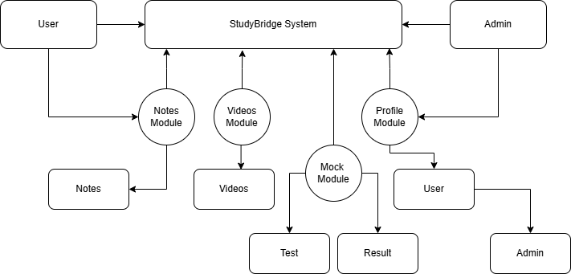
ER Diagram Model
The Entity–Relationship (ER) Diagram represents the logical structure of the StudyBridge database. It shows how the main entities are connected and how data flows between them.
The primary entities in the system include:
Users
Attributes:
- id (PK)
- name
- email
- password
- role (student/admin)
- phone
- institution
- avatar
Notes
Attributes:
- id (PK)
- title
- category
- file_path
- status (Pending / Approved / Rejected)
- user_id (FK → Users.id)
Videos
Attributes:
- id (PK)
- title
- category
- link (YouTube URL)
- uploaded_by (FK → Users.id OR admin)
Messages
Attributes:
- id (PK)
- sender_id (FK → Users.id)
- receiver_id (FK → Users.id)
- message
- timestamp
Announcements
Attributes:
- id (PK)
- title
- content
- admin_id (FK → Users.id)
- created_at

Mock Tests
Attributes:
- id (PK)
- question
- options
- correct_answer
- created_at
Entity Relationships
The ER diagram represents the following relationships:
One-to-Many (Users → Notes)
- A single user can upload multiple notes.
One-to-Many (Admin → Announcements)
- A single admin can post multiple announcements.
Many-to-Many (Users ↔ Users through Messages)
- Users can send and receive messages to/from many other users.
One-to-Many (Users → Videos)
- Admin or users can upload multiple videos.
Notes belong to categories
- Categories define classification (Maths, Reasoning, GK, English).

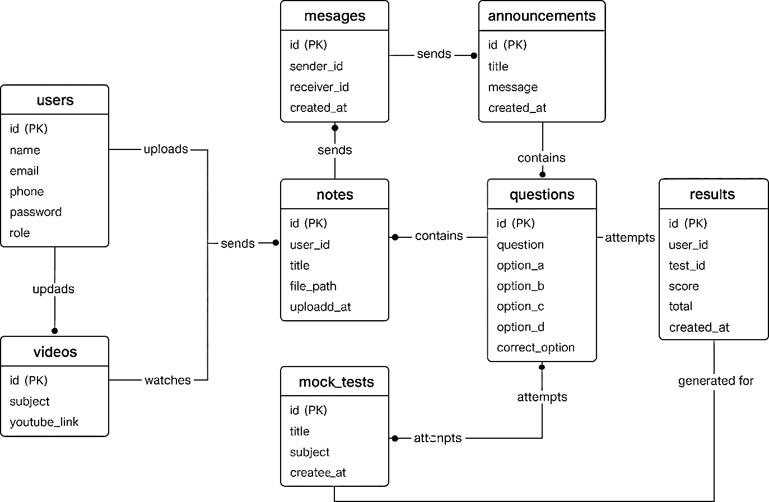
Use-Case Diagram Overview
The Use-Case Diagram explains how different actors interact with the StudyBridge system.
There are two primary actors:
Actors:
- Student
- Admin
Student Use-Cases
- Register
- Login
- Upload Notes
- View / Download Notes
- Watch Videos
- Attempt Mock Tests
- Chat with Peers
- Update Profile
Admin Use-Cases
- Approve Notes
- Delete Notes
- Post Announcements
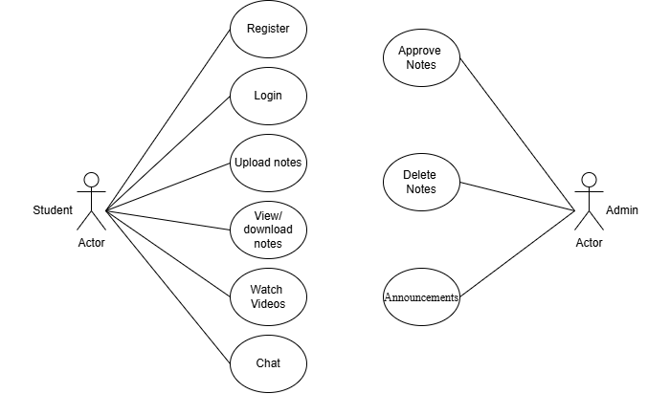
- View User List

Activity Diagram
Activity diagrams describe step-by-step actions performed by students and admins.
Below are two major workflows:
Login Activity (Student / Admin)
Steps:
- User enters credentials (email + password)
- System validates entered details
- If credentials incorrect → show error message
- If first login → redirect to profile completion page
- Else → open user dashboard
Notes Upload Activity (Student)
Steps:
- Student uploads a file (PDF / DOC / TXT)
- System validates:
- File type
- File size
- System saves file to server/cloud
- Sets status = “Pending”
- Admin reviews file
- Admin approves or rejects the note
- If approved → becomes visible to all students
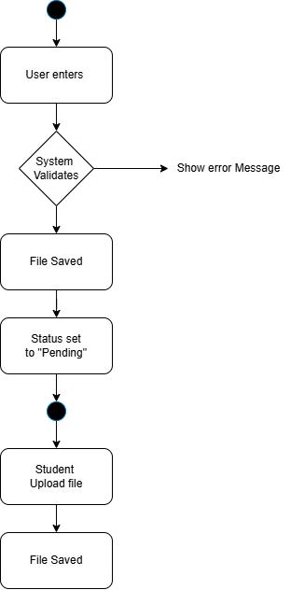
- If rejected → student gets notification
3.1 Modularization Details
Modularization means breaking the entire system into smaller, manageable, and independent units called modules. Each module performs a specific function and interacts with other modules only when required.
StudyBridge is divided into eight main modules, described below:
User Registration & Login Module
This module handles:
- Creating new student/admin accounts
- Secure login using hashed passwords
- Session creation and session validation
- Redirecting first-time users to complete their profile
This module ensures that only authenticated users can access the system.
Profile Management Module
This module allows users to:
- Update name, email, phone, and institution
- Upload a profile photograph
- Complete mandatory profile information
- View personal dashboard
If the profile is incomplete, the user cannot proceed further.
Notes Module
This module manages all note-related features:
- Upload notes in PDF/DOC format
- View notes uploaded by other users
- Download approved notes
- Status control: Pending → Approved/Rejected
Metadata and file path are stored in the database.
Videos Module
This module handles categorized educational videos:
- Subject-wise playlists (Maths, Reasoning, GK, English)
- Embedding YouTube links
- Admin can upload and manage video links
Students can easily find videos based on subjects.
Mock Test Module
This module allows students to:
- Attempt multiple-choice questions
- Submit their answers
- View their scores and correct answers
- Practice for competitive exams
All test questions are stored in the database.
Chat System Module
A simple communication module where users can:
- Send messages
- Receive messages
- View chat history
This module supports collaborative learning and discussion.
Announcements Module
Admin can post important updates such as:
- System notices
- Exam alerts
- New notes availability
Announcements appear on the student dashboard.
Admin Module
Admin has full control over the system:
- Approve or reject notes
- Upload video links
- Manage announcements
- Monitor all users and activities
This module ensures the platform remains well-managed and secure.
3.2 Data Integrity and Constraints
Data integrity ensures that all information stored in the StudyBridge database remains accurate, consistent, valid, and protected from unauthorized modification. The system uses several techniques to maintain high data quality and security.
Validation Rules
These rules ensure that only correct and acceptable data enters the system:
- Only PDF/DOC/DOCX/TXT files are allowed for notes upload
- Only image files (JPG/PNG) are allowed for profile photo
- Users must choose a strong password
- Profile completion is mandatory before accessing the dashboard
These validations prevent invalid or harmful data from entering the database.
Primary Keys
Every database table contains a unique primary key to identify each record:
- user_id
- note_id
- video_id
- message_id
- announcement_id
Primary keys prevent duplication and ensure each entry is uniquely identifiable.
Foreign Keys
Foreign keys maintain relationships between tables and ensure referential integrity:
- notes.user_id → users.id
- messages.sender_id → users.id
- announcements.admin_id → users.id
- videos.uploaded_by → users.id
These constraints ensure that related data remains properly linked, and no orphan records exist.
Database Constraints
Additional constraints enforce the validity of stored data:
- NOT NULL applied to required fields
- UNIQUE constraint for the email field
- CHECK constraints for valid file types, note categories, and video categories
- DEFAULT values used for timestamps such as created_at
These constraints ensure that data remains well-structured and consistent.
Security Constraints
Security rules protect the system from unauthorized access and attacks:
- Password hashing using password_hash()
- Session management for user authentication
- SQL Injection prevention using prepared statements and input sanitization
These mechanisms ensure that sensitive information remains secure and that the system is protected from malicious users.
3.3 Database Design
Database Design defines how data is stored, organized, and linked inside the StudyBridge system. The database is implemented in MySQL and consists of several related tables. Each table stores specific information and connects to others using primary keys and foreign keys to maintain data integrity.
Users Table
Purpose: Stores all student and admin information
Fields:
- id (Primary Key)
- name
- email (Unique)
- password
- phone
- institution
- avatar
- role (student/admin)
- created_at (timestamp)
Notes Table
Purpose: Stores uploaded study notes
Fields:
- id (Primary Key)
- title
- category (Maths/Reasoning/GK/English)
- file_path
- status (Pending/Approved/Rejected)
- uploaded_at
- user_id (Foreign Key → users.id)
Videos Table
Purpose: Stores educational YouTube video links
Fields:
- id (Primary Key)
- title
- category
- link (YouTube URL)
- uploaded_by (Foreign Key → users.id)
Messages Table
Purpose: Stores all chat messages exchanged between usersFields:
- id (Primary Key)
- sender_id (Foreign Key → users.id)
- receiver_id (Foreign Key → users.id)
- message
- sent_at (timestamp)
Announcements Table
Purpose: Stores admin-generated updates and alerts
Fields:
- id (Primary Key)
- title
- message
- admin_id (Foreign Key → users.id)
- created_at
Mock Tests Table
Purpose: Stores questions for mock test module
Fields:
- id (Primary Key)
- question
- optionA
- optionB
- optionC
- optionD
- correct_option
3.4 User Interface Design
StudyBridge provides a clean, modern, and user-friendly interface designed using HTML, CSS, Bootstrap 5, and enhanced with AOS (Animate On Scroll) animations. The UI is optimized for both mobile and desktop screens, ensuring a smooth experience for all users.
Design Principles Used
Simplicity
- Easy navigation for students
- Clear layout with minimal clutter
- Icons and buttons placed logically
Consistency
- Fixed theme colors:
- #1e3c72 (Primary)
- #2a5298 (Gradient / Secondary)
- Uniform font style and button shapes across all pages
Responsiveness
- Fully responsive design
- Works seamlessly on mobile, tablet, and desktop
- Bootstrap grid ensures flexible layouts
Accessibility
- Readable fonts
- Proper contrast for visually clear text
- Clean icons for quick understanding
- Keyboard-friendly navigation
Visual Appeal
- AOS animations for smooth transitions
- Animated quotes and UI elements
- Modern split-screen design on login/register

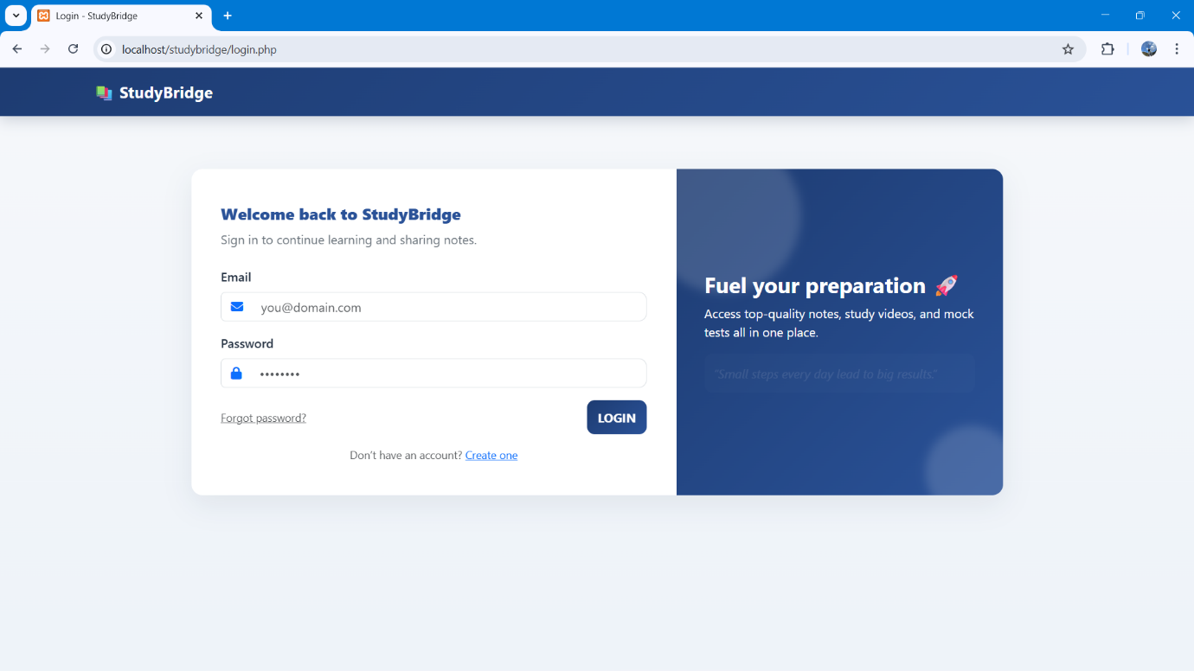
Major Screens

Login Page
- Split-screen layout
- Motivational animated quote
- Smooth fade-in animation
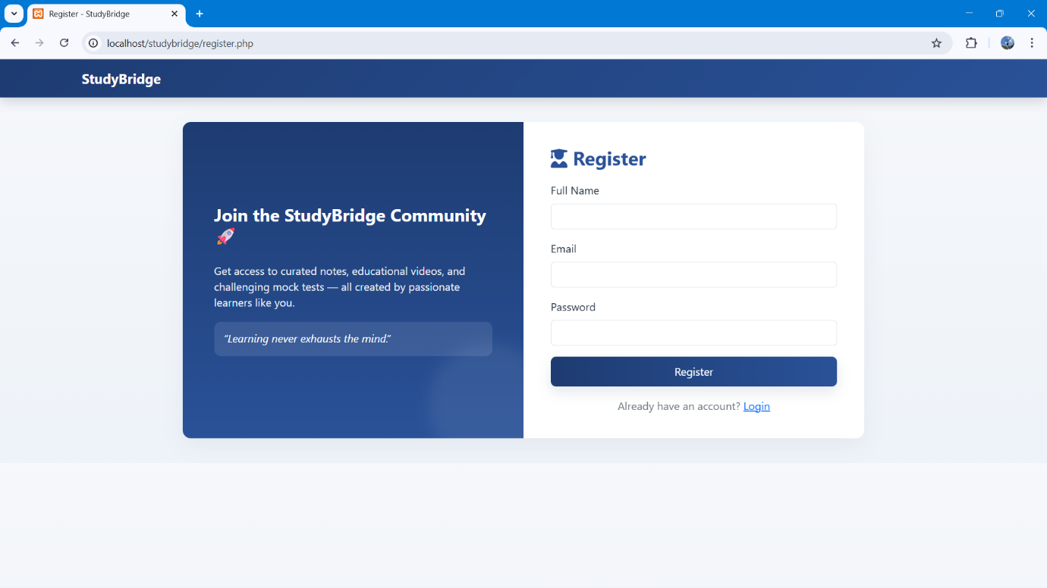

Register Page
- Mirrored version of login design
- Clean fields with validation

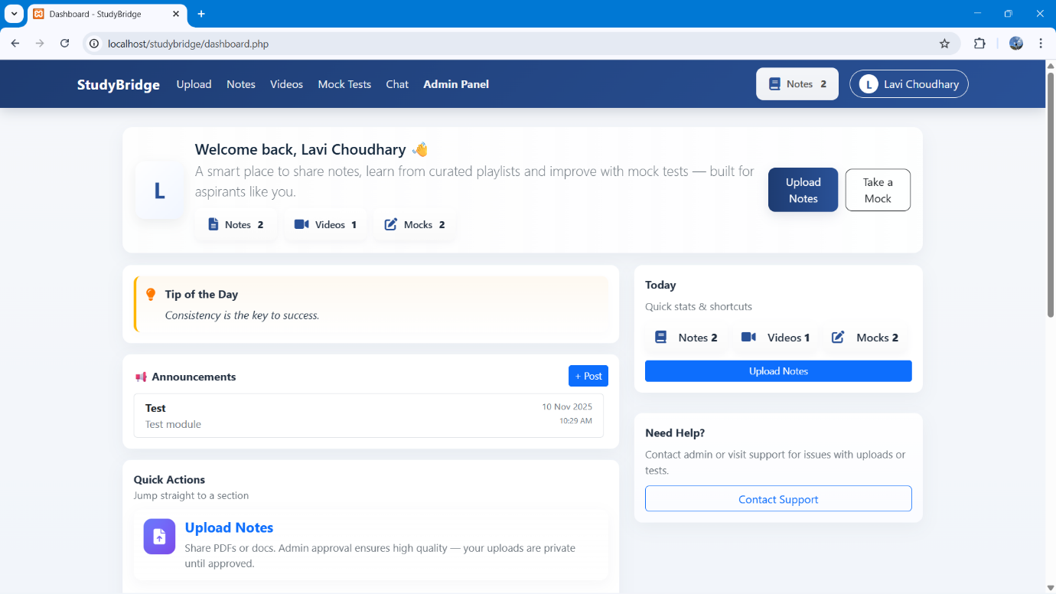
Dashboard
- Displays user statistics
- Latest announcements
- Personalized welcome message
- Motivational quote section
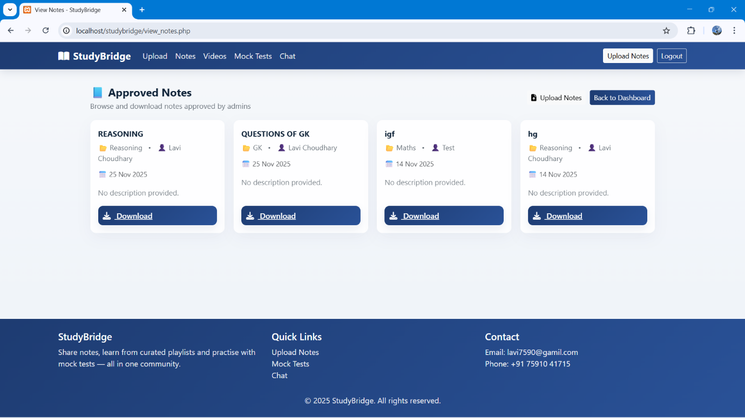
- Category-based filtering

Notes Page
- Upload notes section
- View/download approved notes
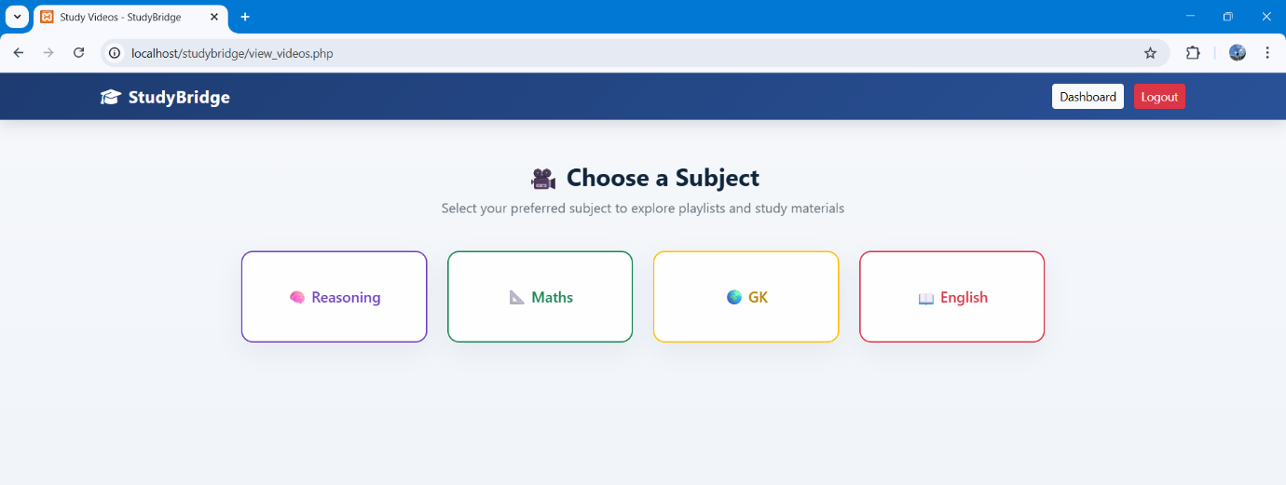
Videos Page
- Subject-based categorized YouTube playlists
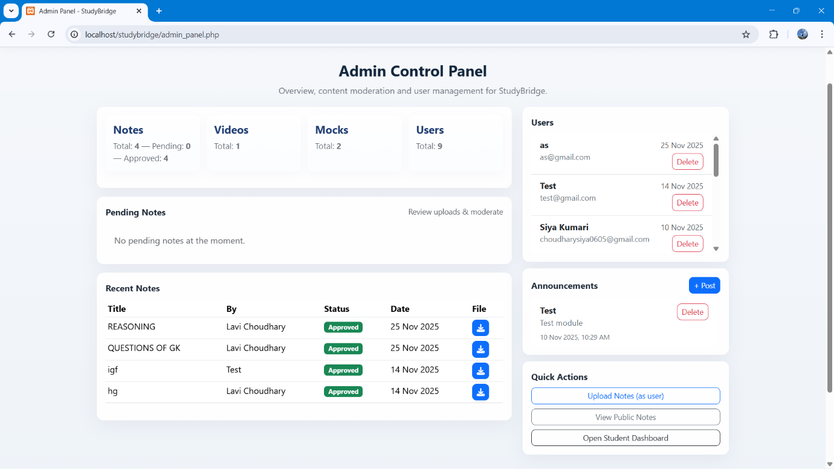
- Responsive embedded video cards

Admin Panel
- Notes approval interface
- User management
- Video uploads
- Announcements posting

3.5 Test Cases
Testing is performed to ensure that all features of StudyBridge work correctly, meet user expectations, and maintain system reliability.
Different levels of testing were conducted, including unit testing, system testing, and security testing.
Unit Test Cases
Unit testing was performed on individual modules to verify that each component works independently.
Modules Tested:
Registration Module
- Email validation
- Password hashing
- Duplicate email handling
Login Validation
- Correct/incorrect credentials
- Session creation
File Upload Testing
- Valid/invalid file types
- File size restrictions
- Upload success/failure
Chat Module
- Message sending
- Message receiving
- Chat history retrieval
Profile Update Module
- Updating details
- Changing avatar
- Validation of fields
System Test Cases
System testing ensures that all modules work together as a complete system.
System-Level Tests:
Correct redirection after login
- Notes approval workflow
- Student uploads → Admin reviews → Status updates
- Video loading and playback
- Mock test scoring
- Question loading
- Answer submission
- Result calculation
- Session timeout
- Auto logout after inactivity
- Responsive design test
- Mobile
- Tablet
- Desktop
Security Test Cases
Security testing ensures that user data is safe and the system is protected from attacks.
Security Checks Performed:
SQL Injection Attempts
- Tested inputs to ensure rejection of malicious SQL
Invalid File Upload
- Uploading EXE, ZIP, scripts to ensure they are blocked

Unauthorized Dashboard Access
- Trying to open dashboard without login
Password Mismatch Validation
- Proper error messages for wrong passwords
Testing Conclusion
All test cases were executed and the system passed successfully after minor debugging and optimizations.

4.1 SQL Commands / Database Creation
This section provides a brief overview of the SQL commands used to create the core database tables. These tables store user information, notes, and other system data
Example SQL Table (Users Table):
CREATE TABLE users (
id INT AUTO_INCREMENT PRIMARY KEY,
name VARCHAR(100),
email VARCHAR(100) UNIQUE,
password VARCHAR(255),
phone VARCHAR(20),
institution VARCHAR(100),
avatar VARCHAR(255),
role VARCHAR(20),
created_at TIMESTAMP DEFAULT CURRENT_TIMESTAMP
);
4.2 Sample Project Coding
This section shows a small portion of the backend PHP code used for validating user login. This demonstrates how system modules interact with the database.
Example: Login Validation Code (PHP):
<?php
session_start();
include("includes/db.php");
$message = "";
if ($_SERVER["REQUEST_METHOD"] == "POST") {
$email = trim($_POST['email']);
$password = $_POST['password'];
$stmt = $conn->prepare("SELECT id, name, role, password FROM users WHERE email=? LIMIT 1");
$stmt->bind_param("s", $email);
$stmt->execute();
$result = $stmt->get_result();
if ($result->num_rows === 1) {
$user = $result->fetch_assoc();
if (password_verify($password, $user['password'])) {
$_SESSION['user_id'] = $user['id'];
$_SESSION['name'] = $user['name'];
$_SESSION['role'] = $user['role'];
if ($user['role'] === "admin") {
header("Location: admin_panel.php");
exit;
}
$check = $conn->prepare("SELECT qualification, phone, dob, institution, avatar FROM users WHERE id = ? LIMIT 1");
$check->bind_param("i", $user['id']);
$check->execute();
$row = $check->get_result()->fetch_assoc();
$missing = false;
$fields = ['qualification', 'phone', 'dob', 'institution', 'avatar'];
foreach ($fields as $f) {
if (empty($row[$f])) {
$missing = true;
break;
}}
if ($missing) {
$_SESSION['must_complete_profile'] = true;
header("Location: profile_update.php");
} else {
header("Location: dashboard.php");
}
exit;
} else {
$message = "❌ Invalid password!";
}
} else {
$message = "⚠️ No account found with this email!";
}}
?>
4.3 Comments and Description of Coding Segments
This section explains the purpose of the above code snippet and highlights the important logic used.
- The code checks whether the login form was submitted
- Fetches user data from the database using the entered email
- Uses password_verify() to check if the password is correct
- If correct, a session is created for the user
- The user is redirected to the dashboard after successful login
5.1 Testing Techniques and Testing Strategies Used
Multiple testing techniques were applied to ensure complete verification of the system:
Unit Testing
- Tested individual modules such as login, registration, notes upload, and profile update
- Checked input validation, field handling, and function calling
Integration Testing
- Verified interaction between modules (e.g., notes upload → admin approval → notes display)
- Ensured smooth data flow between UI, backend, and database
System Testing
- Tested the entire StudyBridge platform as a whole
- Ensured correct redirection, access control, and response handling
Security Testing
- Checked password hashing, session handling, and access restrictions
- Verified protection against SQL injection using prepared statements
User Acceptance Testing (UAT)
- Conducted with sample users
- Ensured that interface, navigation, and performance met expectations

5.2 Testing Plan Used
The testing plan for StudyBridge included the following steps:
Identify Functional Requirements
- Login, notes upload, video viewing, mock tests, chat, and admin approval.
Prepare Test Inputs and Expected Outputs
- Valid and invalid data sets were created for each module.
Execute Test Cases
- Unit and system test cases were executed using manual testing.

Record Actual Results
- Outputs were compared against expected results.
Track and Fix Defects
- Errors were debugged and retested until resolved.
Final Validation
- System behavior was rechecked after fixes for stability.

5.3 Test Reports for Unit Test Cases and System Test Cases
Unit Test Case Results
Modules tested individually:
Registration Module
- Empty field handling
- Duplicate email prevention
- Password hashing stored successfully
Login Module
- Valid and invalid credentials
- Wrong password identification
- Session creation and redirection
Notes Upload
- File type validation (PDF/DOC only)
- File size restriction
- Status stored as “Pending”
Chat Module
- Message send/receive
- Chat history retrieval
System Test Case Results
Full platform tested end-to-end:
- Successful login → dashboard redirection
- Notes upload → admin approval → visibility to students
- Video loading and playback from embedded playlists
- Mock test submission → score calculation
- Unauthorized access blocked (e.g., dashboard without login)
- Responsive display on mobile, tablet, and desktop

5.4 Debugging and Code Improvement
During testing, certain issues were identified and resolved:
Debugging Performed
- Incorrect redirection after login (fixed with session checks)
- File upload failure due to invalid path (resolved by absolute directory usage)
- Missing validation for empty form fields (added server-side checks)
- Chat messages not updating instantly (database fetch logic corrected)
Code Improvements
- Implemented password_hash() and password_verify() for secure authentication
- Replaced raw SQL queries with prepared statements for security
- Added input sanitization and validation filters
- Improved UI responsiveness using optimized Bootstrap classes
- Implemented session timeout to prevent unauthorized access

These improvements enhanced security, performance, and reliability of StudyBridge.
6.1 Conclusion
The StudyBridge project has been successfully designed and implemented as a web-based learning platform to assist students in accessing academic resources in an organized and efficient manner. The system integrates multiple functionalities such as user registration and login, notes uploading and downloading, categorized video learning, mock test practice, announcements, and a simple chat module within a single platform.
Through structured system design techniques, including DFDs, ER Diagrams, Use Case and Activity Diagrams, the development process remained systematic, scalable, and easy to maintain. Proper validation, password hashing, prepared statements, and session handling ensured data security and reliable performance.
Comprehensive unit and system testing confirmed that all modules function correctly and meet the expected requirements. Overall, StudyBridge successfully achieves its objective of providing a centralized, user-friendly, and accessible learning environment that supports students in preparing for competitive examinations.
6.2 Further Scope and Enhancement
Although StudyBridge fulfills its current objectives, several enhancements can be introduced in future versions to improve functionality and user experience:
- Mobile Application Development
A dedicated Android/iOS app can increase accessibility and real-time usage.
- Real-time Chat with WebSockets
Implementing live messaging will replace the refresh-based system.
- Advanced Mock Test Features
- Timed exams
- Rank comparison
- Performance analytics
- Question explanations
- AI-Based Recommendation System
Suggest notes and videos based on user activity and weak areas.
- Push Notifications / Alerts
Instant updates for new notes, announcements, and upcoming tests.
- Discussion Forums
Group-based doubt clearing, rather than only one-to-one chat.
- Cloud Storage Integration
Use AWS S3 or Google Drive API for scalable file handling.
- Multi-language Support
Helps students from different regions access study content.

These enhancements will make StudyBridge more interactive, scalable, and beneficial for a larger user base in future versions.

