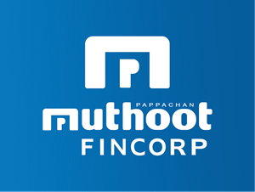

## TRAINING CERTIFICATE

Date :- 20/11/2024

To Whom So Ever It May Concern

This Is To Certify That Miss Lavina Jain Student Of Royal Institute Of Management And Advance Studies (MBA 3rd Semester) Session 2024-2025 Has Undergone Her Internship Training During (07/10/2024 To 16/11/2024) From Our Organization.

During this period, we found her sincere in acquiring practical Knowledge in HR/Marketing /Finance Field.

We found her sincere and hardworking and wishing best of luck in their future endeavor.

Signature and Seal