Table of contents

1. Introduction

1.1 Product scope

1.2 Product value

1.3 Intended audience

1.4 Intended use

1.5 General description

2. Functional requirements

3. External interface requirements

3.1 User interface requirements

3.2 Hardware interface requirements

3.3 Software interface requirements

3.4 Communication interface requirements

4. Non-functional requirements

4.1 Security

4.2 Capacity

4.3 Compatibility

4.4 Reliability

4.5 Scalability

4.6 Maintainability

4.7 Usability

1. **Introduction:** 
   1. Product scope:

Creating this website would give a broad connection to dog lovers community, where dog lovers would be capable of adopting dogs, finding their lost dog, or give a report about a found dog.

* 1. Product value:

People who are active on this website would have the ability to see all of the dog breeds and choose which type of dog they find more suitable. Search for their lost dog their or give a report about a missing dog found. In the same time, the description provided by the previous owners or owners generally will help people know more about the dog breed they have and how to handle some difficulties they face with their dogs. They can communicate with each other helping new adopters, sort the difficulties they have with their dog.

* 1. Intended audience:

The product is intended to serve the people who love dogs, or thinking about adopting dog, find the dog that suits their character. Learn about what they can tolerate and not tolerate before they have a dog in their house.

* 1. Intended use:

People will see the picture and description of the dog, request a meeting via email posted by each user, for them to agree on a meeting for adoption.

* 1. General description:

In the website you can upload a picture, description of the picture, the dogs are identified with their breeds. Meetings are set between the owner and the person who wants to adopt the dog.

1. **Functional Requirements:**

This is a new system for a company that take care of dogs, dog lovers are able to have an account in this website for them to choose any dog from the list of pictures with a brief description. After clicking on the picture, a full description will be given where you can mention your dog habits, the things hated or beloved by the dog. The dog’s manner, is the dog energetic, friendly, do you feel safe around the dog? Question might also be asked to the person who is offering the dog for adoption. People with dogs might agree to meet each other for their dogs to breed. Advices might be given and taken for people with dogs with different breeds, and they can recommend which veterinary they feel is better than others. How much care? Attention, and expenses the dog needs monthly.

The security privilege will be easily maintained using the email as a way for the community to communicate with each other. Information such as the home address, and sensitive information will not be presented or vulnerable to any person not working in the organization. The most important user classes are the administrators of the organization and the users who from the dog community lovers. The admins are allowed to use laptops only, for them to have a high level of functionality on the website. Meanwhile the dog lovers’ users can either use the website through a laptop or a phone. Other than normal phones or laptops no other specification must be mentioned except the fact that admins only can access the user database.

Due to the simplicity of the website program and the limited ability of the users where they can only post pictures and description, and the only way of communication is via email. Security precautions other than the organization database security is not required. The language used to build the website is python Django, a sample of user database to test the software is required and the approval of the system front end looks is needed from the owner of the organization. A help button will give ability for the users to reach the administrator if any issue happened that needs to be fixed.

The project will be made originally with no dependencies, in a simple user environment. Commercials on the right and left panels will be displayed in a way to not disturb the user and in the same time it will attract the user if the users have interest. Normally ads from vet hospitals, dog foods and needs will be posted, and admins will be the ones who are controlling the flow of ads.

1. External interface requirement:
   1. User interface:

As shown below when the user login, the pictures of the dogs are shown in the meetup section, to contact the owner or book an appointment. There is a button that will guide the user to the breed info for him/her to choose the dog depending on its breed. Contacting the organization is applicable using the button on the top or the bottom of the page.

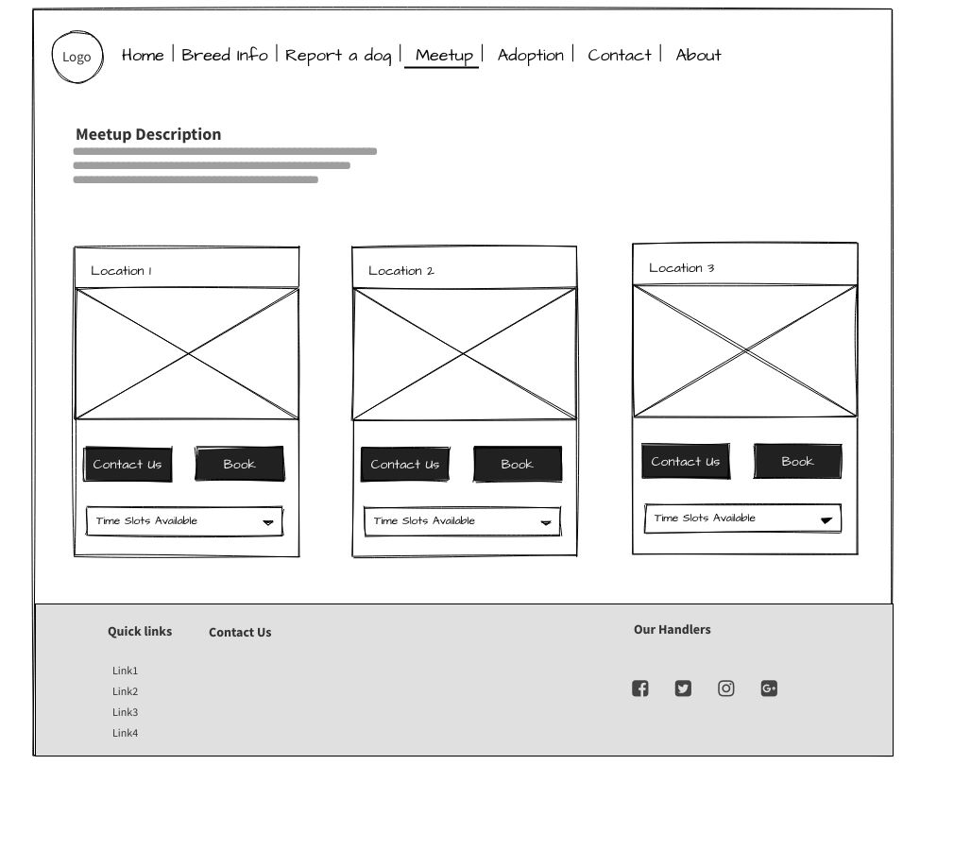

* 1. Hardware interface:

Hyper-Text Transfer Protocol (HTTP), since it is the most widely used web communication protocol.

* 1. Software interface:

The image below shows the relation between the tables, we have breed table, reports table, dogs table, events, event subscription, admin, user table. Entities are specified in addition to their attributes as shown in the screenshot.

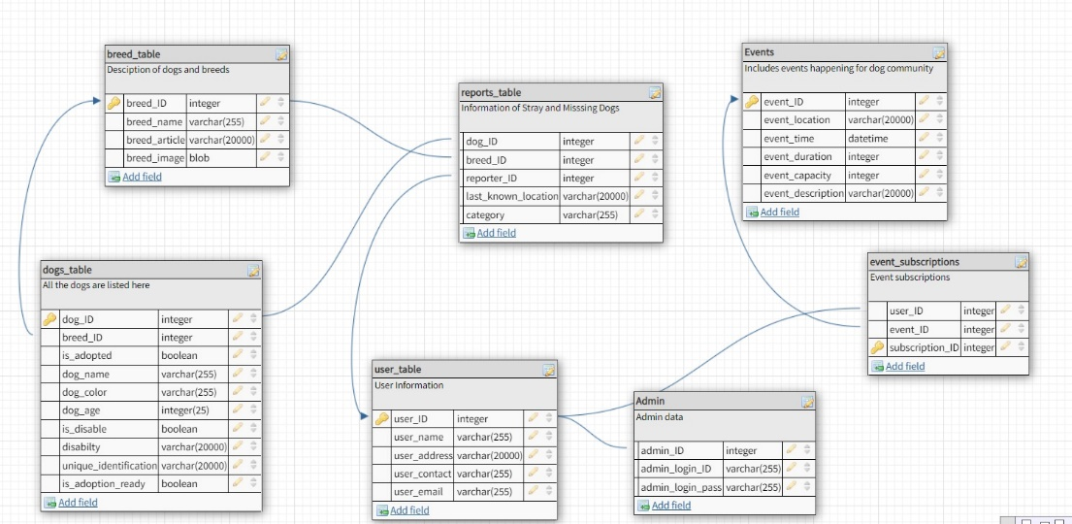

* 1. Communication interface:

Social media like Instagram Facebook and other web forms, are the secondary ways for the dog community lovers to contact each other. But the main way is through emails.

1. **Nonfunctional requirements:**
   1. Security:

Your infrastructure should then be hardened following the successful conclusion of the end-to-end tests, operating systems, application servers and database. After everything is finished, we advise you to harden your network.

* 1. Capacity:

A network server with four 1TB drives, has a storage capacity of 4 terabytes.

* 1. Performance:
* The landing page must have a response time of 6 seconds or less on our website, along with the display of text and images, and while using LTE connection. This website must support 100 users per hour.
  1. Compatibility:

The application must support being able to open on any android or IOS running system. Or any laptop that uses windows or IOS.

* 1. Reliability:
* FAILURE TOLERANCE: Lessens the possibility of data loss as a result of hardware failure. Every piece of software and hardware ought to be on fault tolerant systems.
* FILE RECOVERY: For any crucial data, the restoration of deleted or damaged files that date back at least 30 days is crucial.
  1. Scalability:

The system has to be scalable enough just to handle 1,000 simultaneous visits while still performing at its best.

* 1. Maintainability:
* Following a system failure, the mean time to restore the system (MTTRS) cannot be longer than ten minutes. MTTRS includes all delay time and corrective maintenance time.
* Maintains the long-term storage of documents required for eDiscovery and regulatory compliance. The most crucial stage is having a data protection policy for document archiving.
  1. Usability:

The error rate of new users who are posting the dog image and description in the right place is less than 1%.

Using the following criteria:

* Learnability. How quickly do people do the key tasks once they view the interface?
* Efficiency. How soon can users accomplish their objectives?
* Memorability. Can consumers return to the interface later and begin using it effectively straight away?
* Errors. How frequently do users make errors?
* Satisfaction. Is the layout comfortable to use?