**Wireframing and Mockups:**

Table of Contents

|  |  |
| --- | --- |
| Title | Page Number |
| 1. Sitemap – | 1 |
| 1. Pages – |  |
| * 1. Home | 2 |
| * 1. Breed Info | 3 |
| * 1. Report a dog | 4 |
| * 1. Meetup | 5 |
| * 1. Adoption | 6 |
| * 1. About Us | 7 |

**SiteMap**

**Pages**

1. **Home Page**

1. 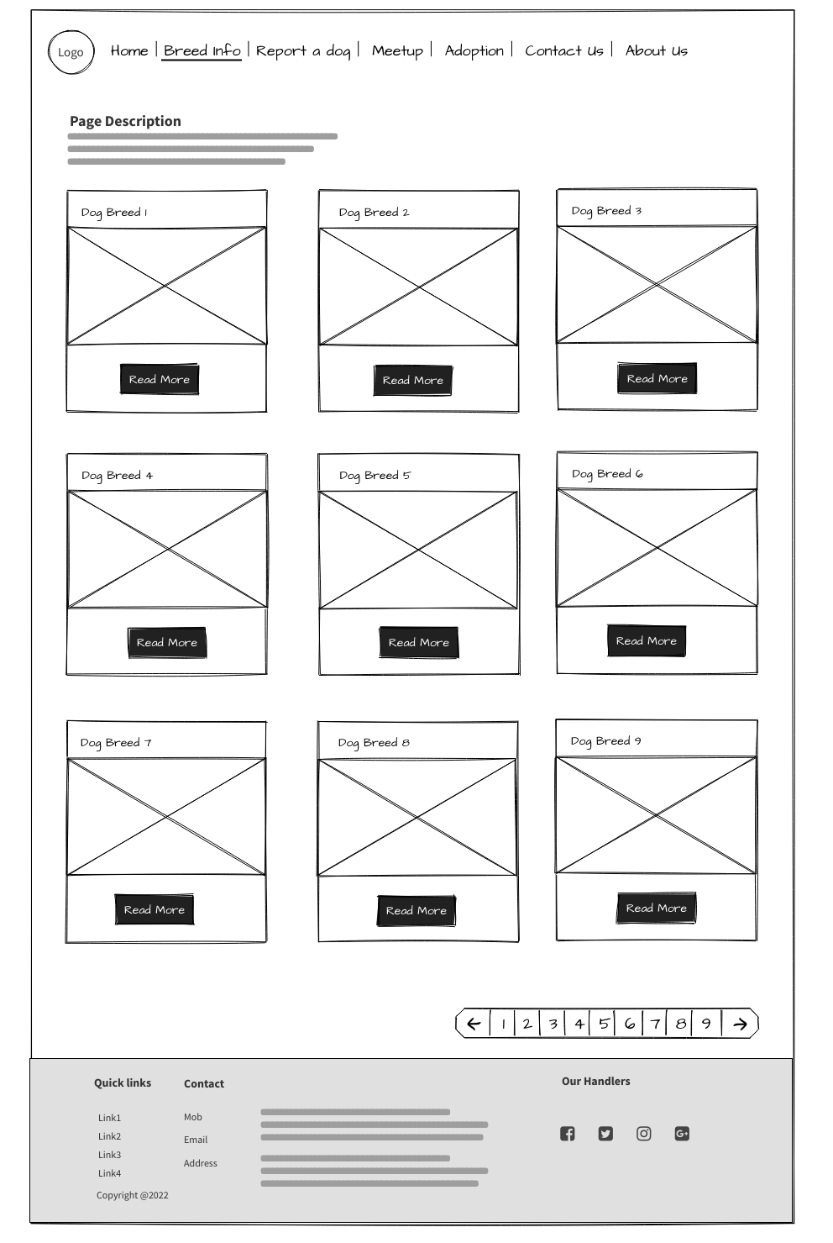**Breed Info**
2. **Report on a dog**
3. **Missing dog**
4. 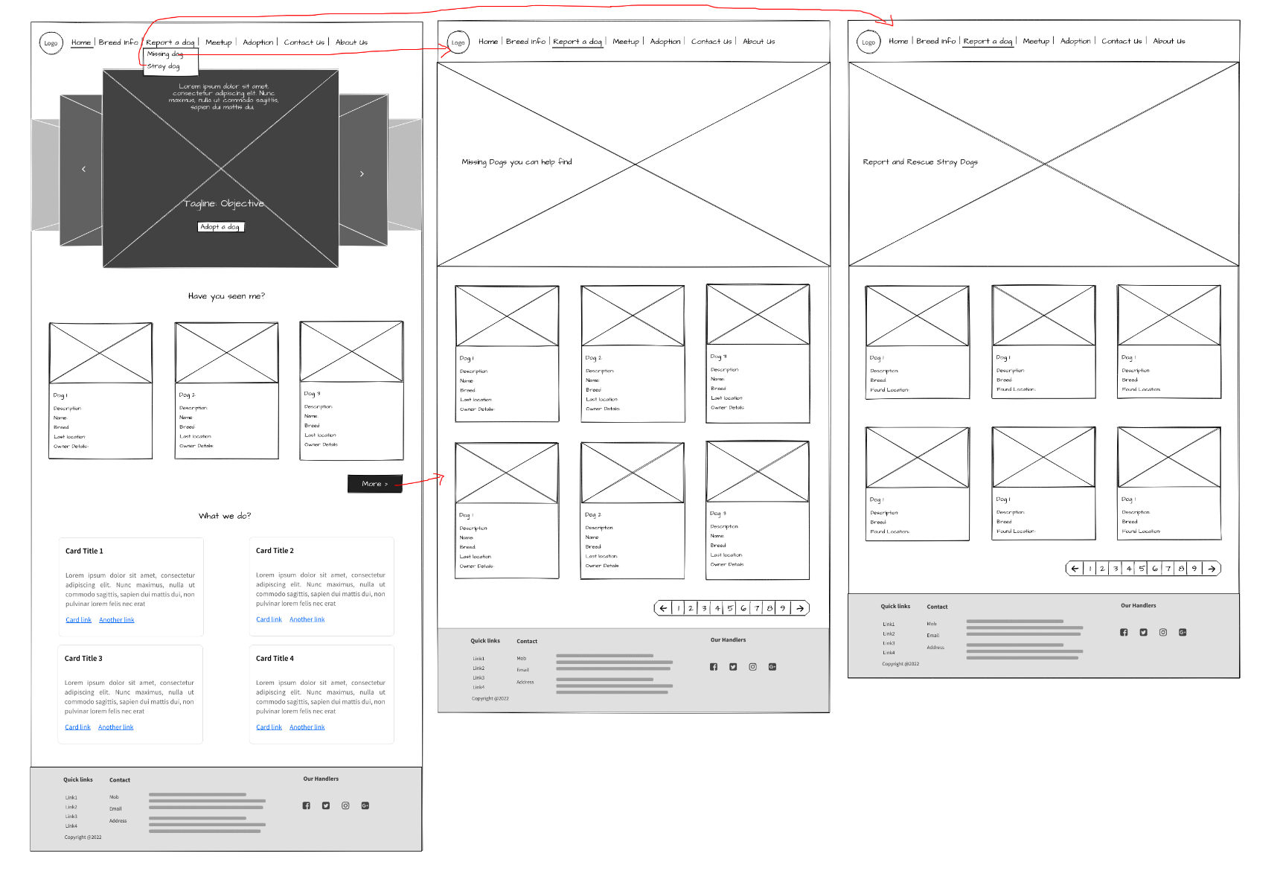 **Stray dogs**
5. 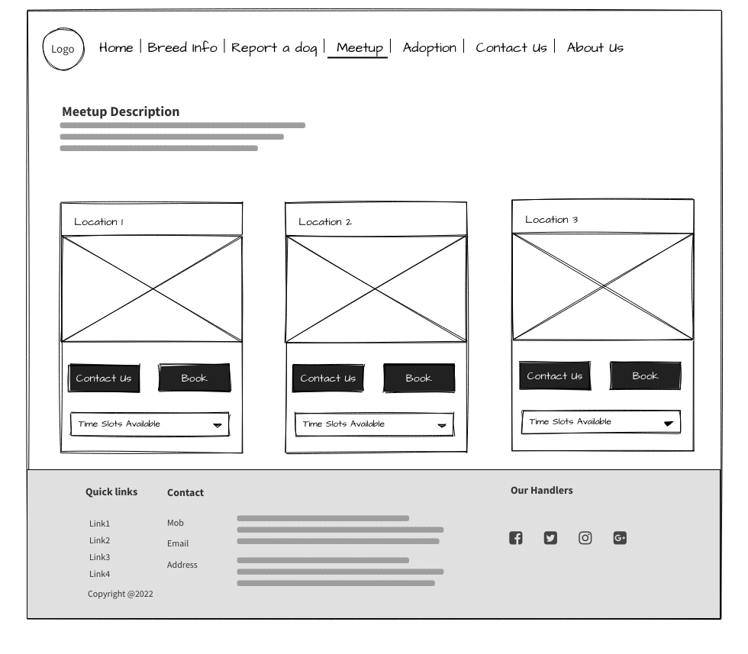**Meetup**
6. 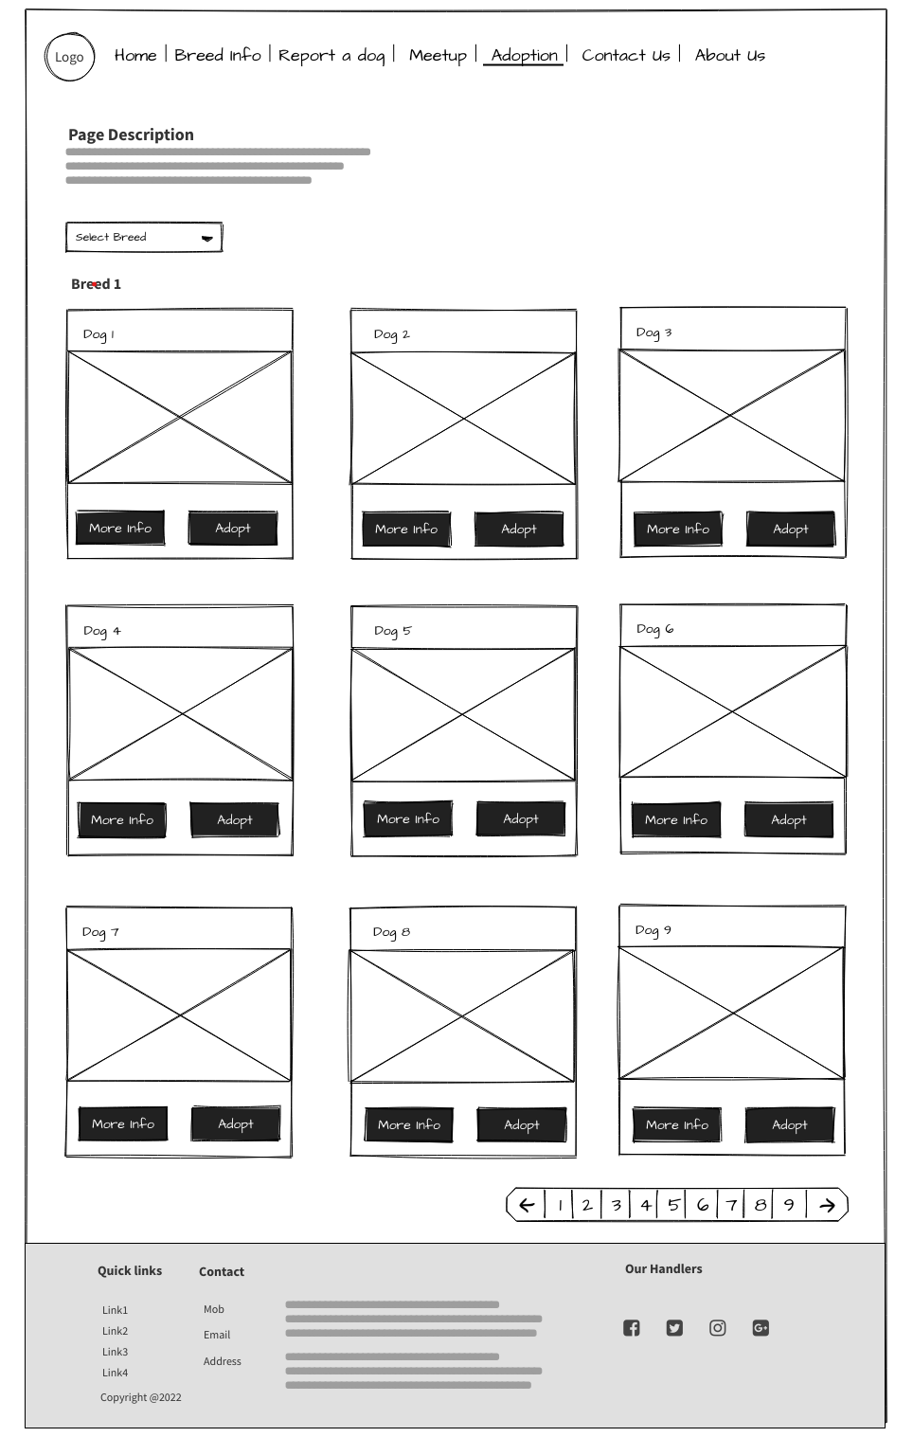**Adoption**
7. **About Us Page**

