create table customer(cid integer primary key, c_last_name varchar(20) not null, c_mid_name varchar(20), c_first_name varchar(20) not null, account_no integer unique not null, account_type varchar(10) not null, amount integer, bank char(10) not null, c_email varchar(25) unique);

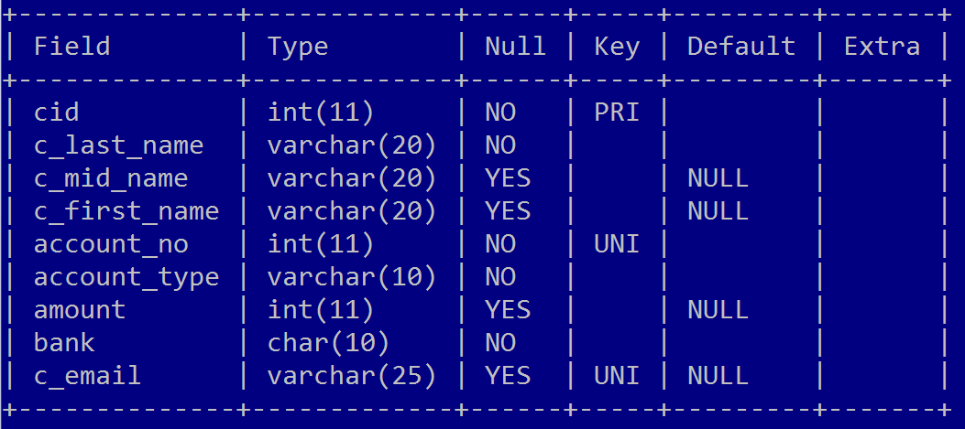

create table employee(e_id integer primary key, e_last_name char(25) not null, e_mid_name varchar(20), e_first_name varchar(20) not null, e_email_id varchar(30) unique, e_department varchar(10) not null, e_manager_id integer references employee(e_id));

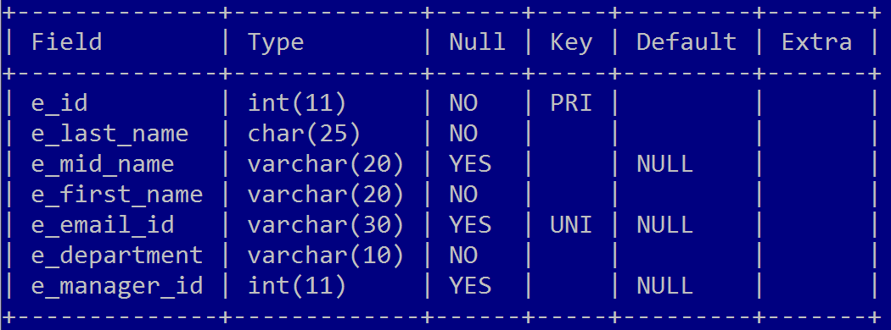

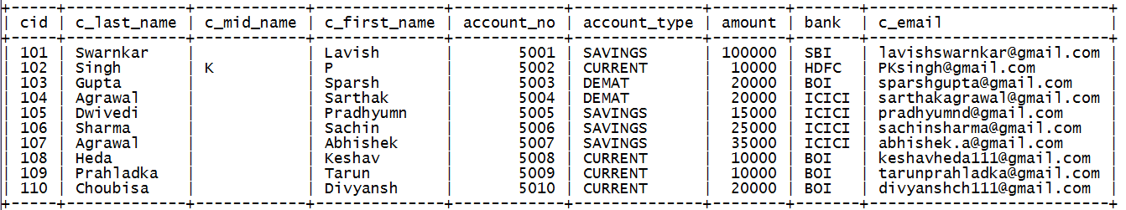

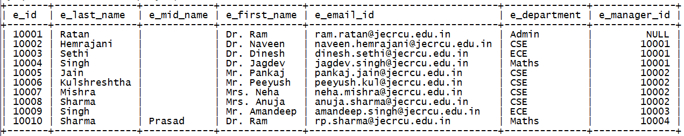

select c_first_name from customer where amount<20000;

select cid, c_first_name from customer where account_type="SAVINGS";

select cid, c_first_name,account_type from customer where account_type!="SAVINGS";

select c_first_name,amount from customer where amount>=20000 and amount<=50000;

select c_first_name,amount from customer where amount between 20000 and 50000;

select c_first_name,account_type,bank from customer where account_type="CURRENT" and bank="HDFC";

select c_first_name,account_type,bank from customer where account_type="CURRENT" or account_type="SAVINGS";

select c_first_name,account_type,bank from customer where account_type in ("CURRENT","SAVINGS");

select c_first_name,amount from customer where amount not between 20000 and 50000;

select c_first_name,account_type,bank from customer where bank in ("SBI”,”HDFC”,”ICICI”);

select c_first_name,account_type,bank from customer where bank not in ("SBI”,”HDFC”,”ICICI”);

select c_first_name from customer where c_first_name like "L%H";

select c_first_name from customer where c_first_name like "%VI%";

update customer set amount=amount+(amount*5/100);

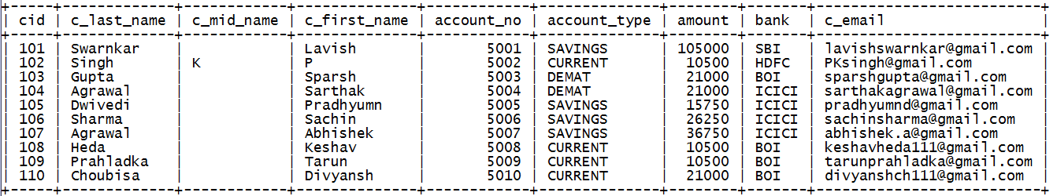

update customer set amount=amount+(amount*5/100) where cid=101;

delete from customer where cid=102;

select * from employee where e_manager_id = (select e_id from employee where e_first_name="Dr. Naveen");

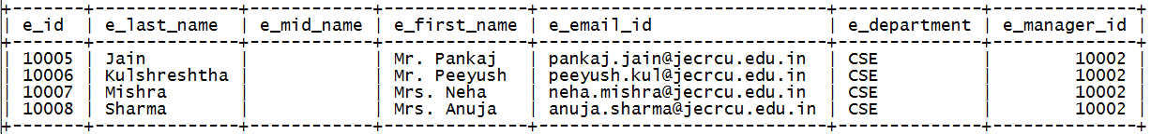

select max(amount) from customer;

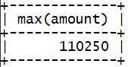

create table customer_loan(loan_id int primary key not null, loan_amount int not null, c_id int);

insert into customer_loan values(501, 20000, 101);

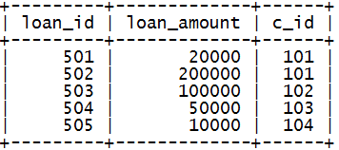

select e_department,count(*) from employee group by e_department;

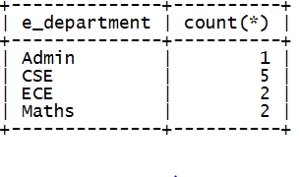

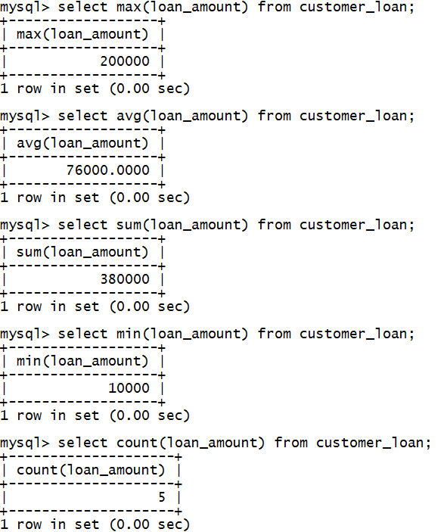

select c_id, sum(loan_amount) from customer_loan group by c_id having sum(loan_amount)>20000;

