**Transaction Server with Locking Mechanism**

**1.Project Structure**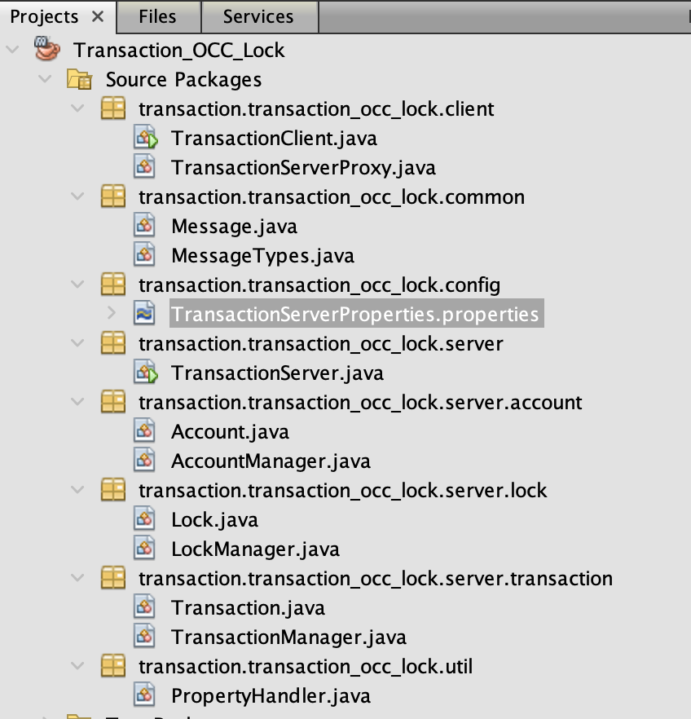

**Client** -

| - *TransactionClient.java* -

| - *TransactionServerProxy.java* -

**Common** -

| - *Message.java* -

| - *MessageTypes.java* -

**Config** -

| - *TransactionServerProperties.properties.properties* -

**Server** -

| - *TransactionServer.java* -

**Account** -

| - *Account.java*

| - *AccountManager.java*

***Transaction*** *-*

*| - Transaction.java -*

*| - TransactionManager.java -*

***Lock -***

***|*** - Lock.java

| - LockManager.java

**Util -**

| - PropertyHandler.java

**Executing Project -**

1. Make configuration changes in **TransactionServerProperties.properties**

HOST=localhost (*Hostname*)

PORT=9797 (*Port Number*)

LOCKING_ENABLED=true (*change it to false to disable locking mechanism*)

NUMBER_ACCOUNTS=100 (*Total number of accounts* )

INITIAL_BALANCE=10 (*Initial Balance in each Account*)

NUMBER_TRANSACTIONS=20 (*Number of transactions to be executed by client*)

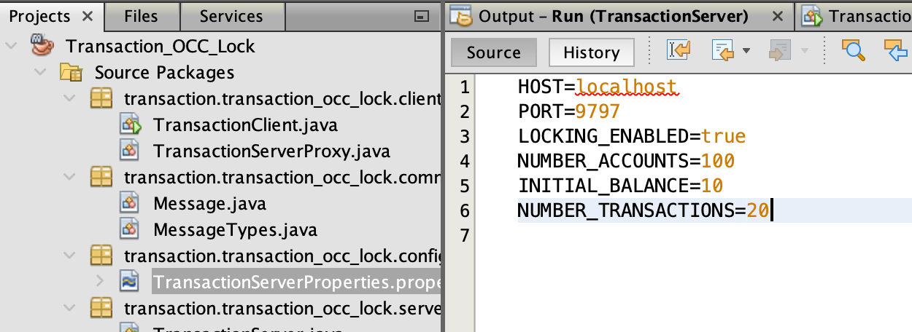

**2** . Run **TransactionServer.java**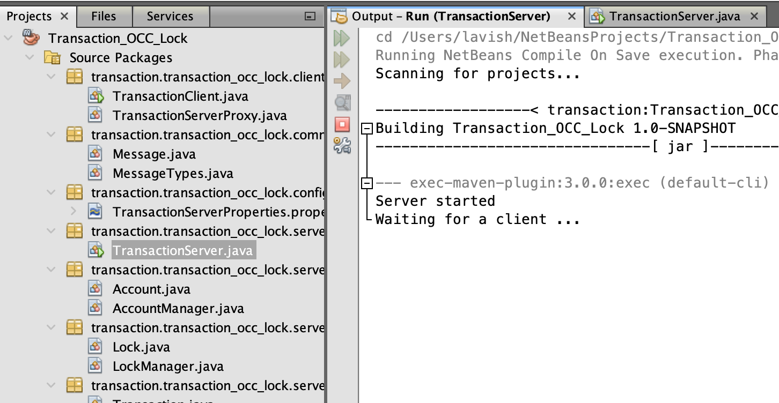

**3.** Run **TransactionClient.java**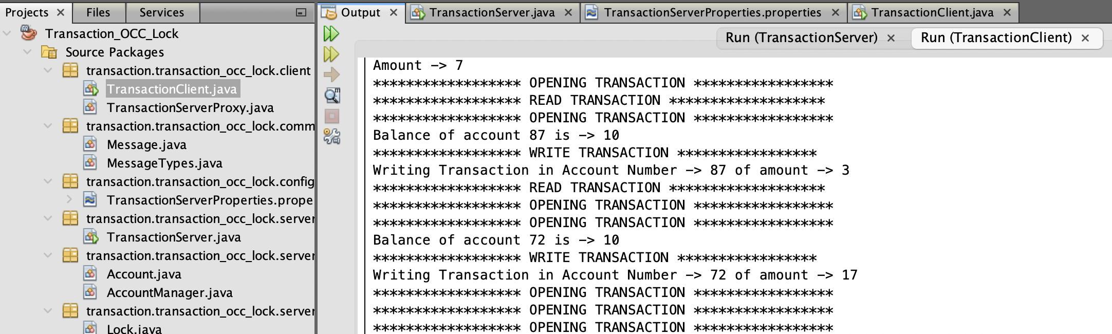

**Logs in console -**

**Client side Logs**

* Shows Total accounts (Value from Configuration file)
* Shows Initial Balance (Value from Configuration file)
* Shows Total Transactions (from Configuration file)
* Account FROM (Randomly chosen source account)
* Account TO (Randomly chosen destination account)
* Amount (Randomly chosen Amount to be withdraw/deposit)
* OPENING TRANSACTION (Initialisation of client thread)
* READ TRANSACTION (Reading of account balance of random account)
* WRITE TRANSACTION (Writing an amount in random account)
* CLOSE TRANSACTION (Closing of client thread )
* Closing Socket…. (Termination of all client threads)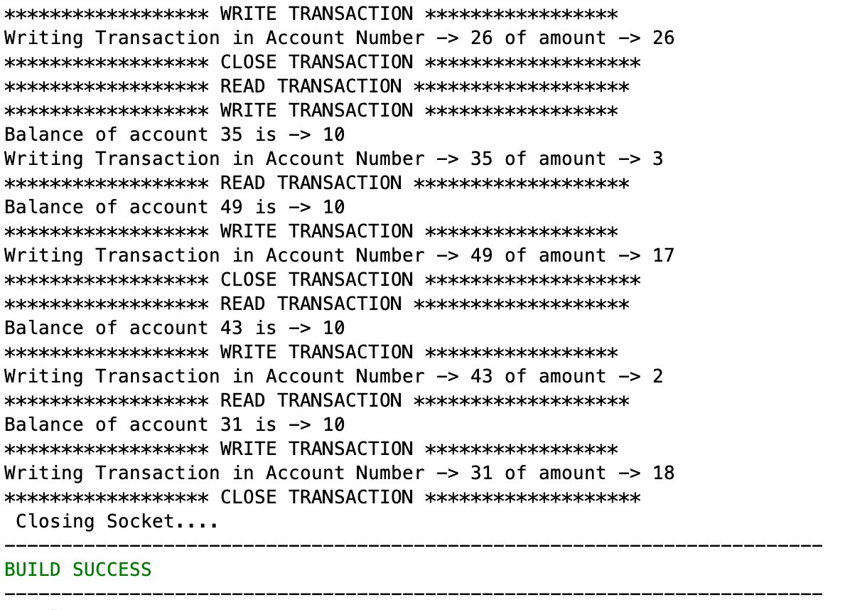

**Server side Logs**

* OPEN TRANSACTION (Initialisation of server thread)
* READ REQUEST (Reading Source account balance )
* WRITE REQUEST (Writing an amount in Source account)
* READ REQUEST (Reading Destination account balance )
* WRITE REQUEST (Writing an amount in Destination account)
* CLOSE TRANSACTION (Closing of server thread)
* SHUTTING IT DOWN (After all the server threads are done executing)
* PRINTOUT SUMMARY (Shows total balance in all Accounts and Account wise balance)