Assignment 1006

Renée Manigo

1. **Write a short note on IDENTITY in SQL with example**

Identity tells the system to automatically add a list of numbers in sequence. This way we can avoid manually adding the numbers manually to each script.

An example is if I want to start an Employee table listing the employess starting from 2000. That would be written as

Employee int Identify (2000,1) Primary Key ----- meaning start at 2000 and go up only 1 number for each additional script/employee added.

1. **Write SQL queries for**

* **Print highest salary**

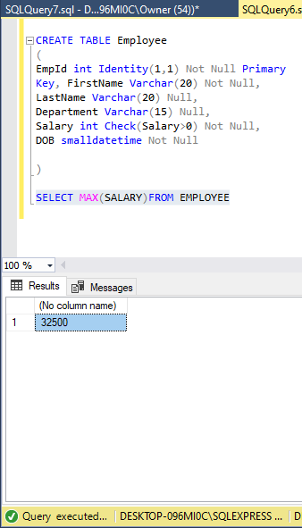

* **Print employee records with highest salary**

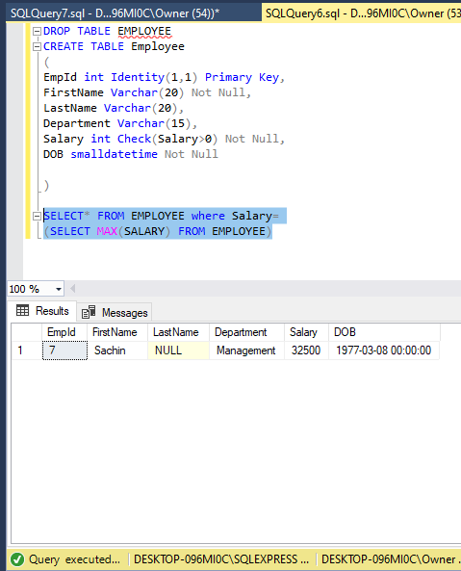

* **Print second highest salary**

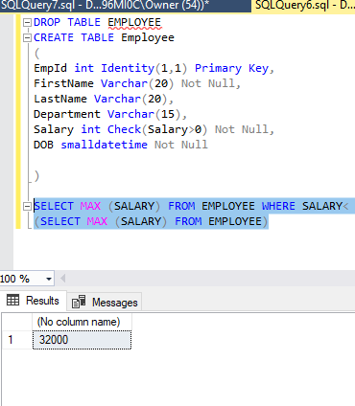

* **Print employee records with second highest salary**

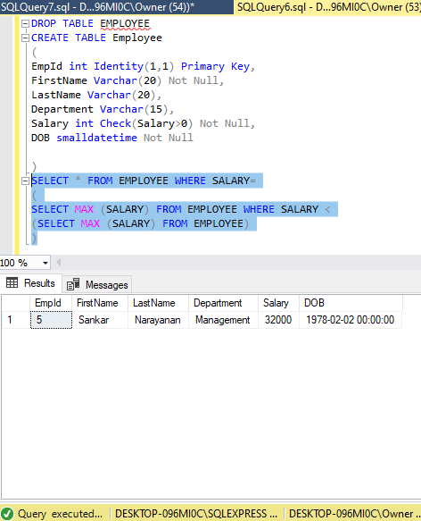

* **Print lowest salary**

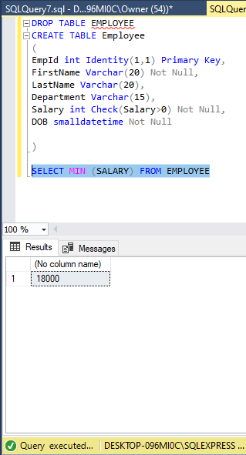

**Print employee records with lowest salary**

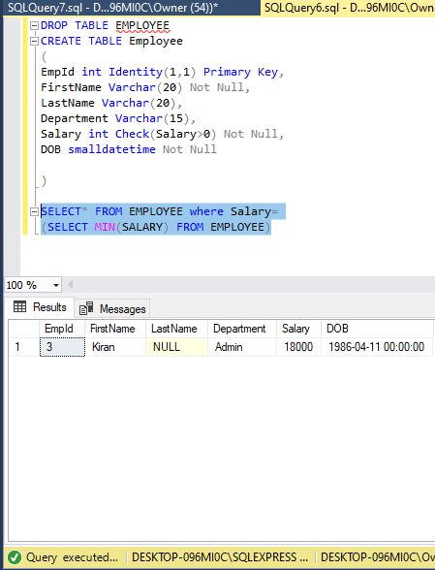

**Print second lowest salary**

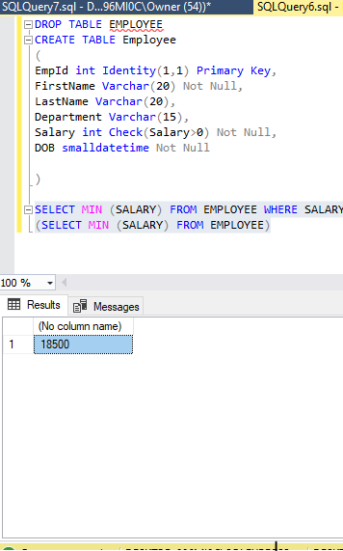

* **Print employee records with second lowest salary**

