Assignment 1009

Renée Manigo

1. **Print “Hello World” in Java**

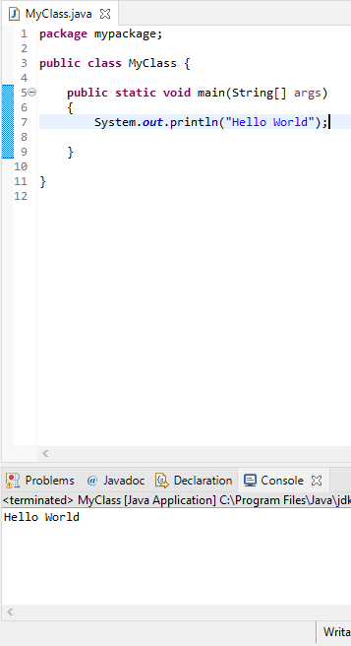

1. **Program to declare two integer variables and print product.**

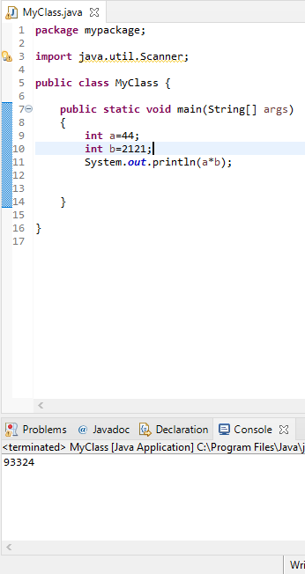

1. **Write the difference between int and float in Java.**

INT- will not take decimal values. Used only to declare integers

FLOAT- used for decimal values

1. **Read name from user and print.**

