Assignment 1011

Renée Manigo

**7. Read fn and ln from user and print full name**

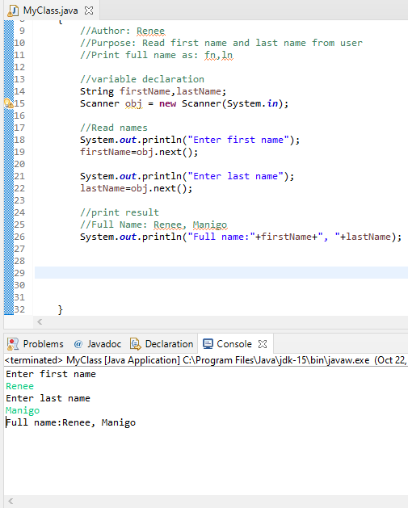

**8. Read a number from user and print it is even or odd.**

