Assignment 1012

Renée Manigo

1. **Read a number from user and check if it is even or odd.**

**Algorithm**

Read n

if n%2 is zero, print even

else print odd

**Code**

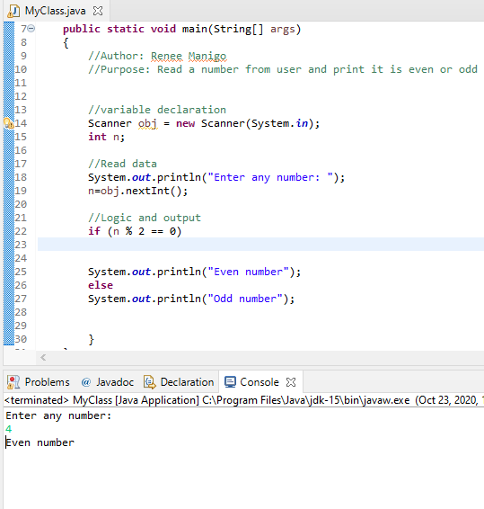

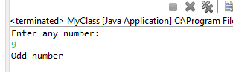

1. **Write java code to print the following comments:**

* **Trainer with 15 years exp.**
* **Trainer with exp 15**
* **Trainer having exp 15**

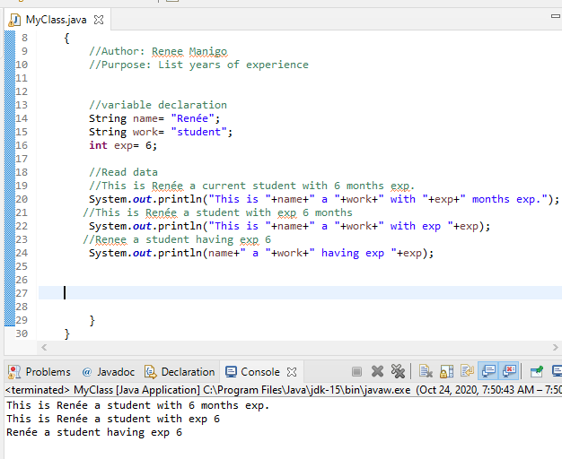

1. **Read a number from user and check if it is prime or not prime.**

**Algorithm**

**Read n**

**Count =0**

**For i=1 to n step 1**

**If n is % by 1**

**Increase count by 1**

**If count=2 print prime**

**Else print not prime**

**Code**

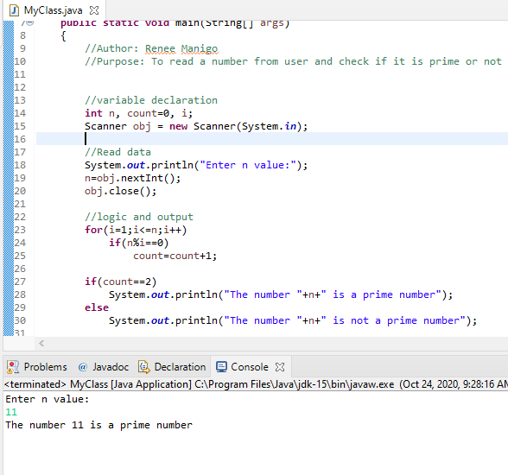

1. **Read a number from user and print the multiplication table of the given number.**

**Algorithm**

**Read n**

**For i=1 to 10 step 1**

**Print nxi=n*i**

**Code**

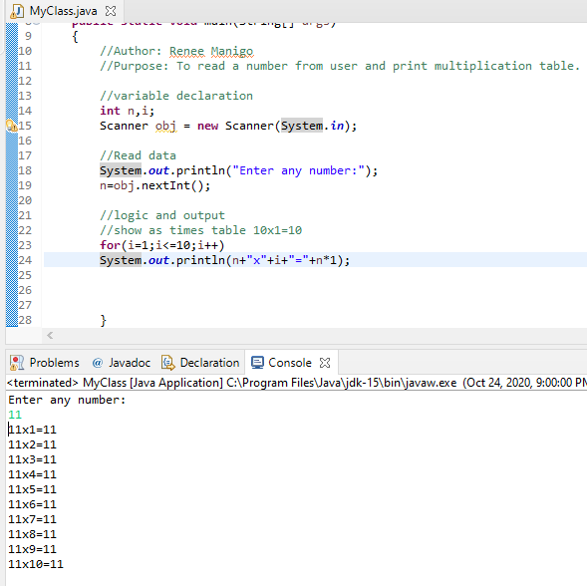

1. **Read a number from user and print the factors of the number.**

**Algorithm**

**Read n**

**For i=1 to n step 1**

**If n is divisible by 1**

**Print i**

**Code**

