HONG KONG INSTITUTE OF VOCATIONAL EDUCATION Name: Law Cheuk Hung

**Laboratory 6: Quality Assurance and Test Coverage** Class: 2A

**Module Intended Learning Outcome (#3):**

On completion of the module, students are expected to be able to:

* Develop the game software models for testing analysis.

**Lesson Intended Learning Outcome:**

On completion of this lab, students are expected to be able to:

* Apply the test coverage techniques in developing test cases.

**TASK:**

**1.** A Call Graph in testing shows the relationship between calling and called methods.

(a) Draw the Call Graph for the following program.

class StudentFactory {

public static Student createStudent( String kind ) { if ( kind.equals("FT") ) return new FullTimeStudent();

else

if ( kind.equals("PT") )

return new PartTimeStudent(); else

return null;

}

}

abstract class Student { public abstract void whoAmI(); }

class FullTimeStudent extends Student {

public void whoAmI() {

System.out.println("I am a full-time student!");

}

}

class PartTimeStudent extends Student {

public void whoAmI() {

System.out.println("I am a part-time student!"); } }

public class Test {

public static void main( String[] args ) {

Student s = StudentFactory.createStudent(args[0]); s.whoAmI();

}

}

Main(String[])

StudentFactory.

createStudent(String)

FullTimeStudent.

whoAmI()

PartTimeStudent.

whoAmI()

1. Explain why it is not possible to determine which *whoAmI( )* method (of *FullTimeStudent* or *PartTimeStudent*) is called during development stage.

Because there are two classes inheritance the Student abstract class. They both have the whoAmI function. So, for determine which class is calling the whoAmI function, it depends on the user input type of the parameter in the call function.

1. List all the possible scenarios when the test program Test.java runs.

Argument input “FT”, system calls FullTimeStudent class’s whoAmI function.

Argument input “PT”, system calls PartTimeStudent class’s whoAmI function.

Argument input “Who”, system occurs ArrayIndexOutOfBounds exception.

Argument input “”, system occurs NullPointer exception.

**2.** Given the following JAVA coding.

public int proc(int a, int b, int x)

{

**if** ((a>1) && (b==0))

{ x = x/a; }

**else** if ((a==2)||(x>1))

{ x = x+1; } return x;

}

1. Draw the control flow graph for the given coding;

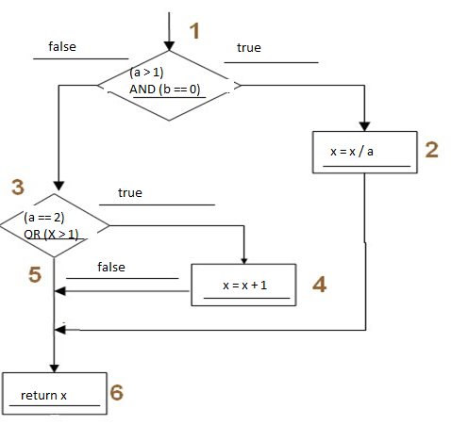

1. Find the required test cases and the cooresponding paths to satisfy ***Statement Coverage***. Give a set of possible input for each test case.

1 🡪 2 🡪 6, possible input: a = 3, b = 0, x = 3.

1 🡪 3 🡪 4 🡪 6, possible input: a = 2, b = 3, x = 2.

1. Find the required test cases and the cooresponding paths to satisfy ***Branch Coverage***. Give a set of possible input for each test case.

1 🡪 2 🡪 6, possible input: a = 3, b = 0, x = 3.

1 🡪 3 🡪 4 🡪 6, possible input: a = 2, b = 3, x = 2.

1 🡪 3 🡪 5 🡪 6, possible input: a = 3, b = 3, x = 0.

1. Do you agree that all statements covered imply branch coverage condition? Justify your answer with your answers to part (b) and (c)?

I disagree, because branch coverage should cover all the test case, and the branch coverage in this scenario, it can cover the test case that if two if-statements are false which statement coverage cannot.

1. Given the following JAVA program coding for the method ***findMethod*** in a Game program:

public int findMethod (int a) {

 int x = a; int y = 25;

while (x != y) {



if (x > y)



* + - 1. = x - y;

else



* + - 1. = x;

}

 return x;

}

Note: S1 through S4 are statement nodes and D1 through D2 are decision nodes in the program.

* 1. Draw the Data Dependency Graph for the given JAVA program.

public int findMethod (int a) {

int x = a;

int y = 25;

while (x != y) {

if (x > y)

* + - 1. = x - y;

else

* + - 1. = x;

}

return x;

}

* 1. Draw the Control Flow Graph for the given JAVA program. (Please use the symbols S1-S4 as statmement nodes and D1-D2 as decision nodes)

* 1. Identify **THREE** possible execution paths of the Control Flow Graph you answered in

(b).

_______________________________________________________________________

_______________________________________________________________________

_______________________________________________________________________

* 1. Provide the following details to test the sub-path D2-S3 identified in the Control Flow Graph you answered in (b)

* + - Extend sub-path D2-S3 to a complete path;

* + - Find the set of data conditions required to complete the full path;

* + - Prepare the Equivalence Classes from the data conditions;

* + - Select an input data from the Equivalence Classes and give the Predict

Output.

_______________________________________________________________________

_______________________________________________________________________

_______________________________________________________________________

_______________________________________________________________________

_______________________________________________________________________

1. Given the following Java method :-

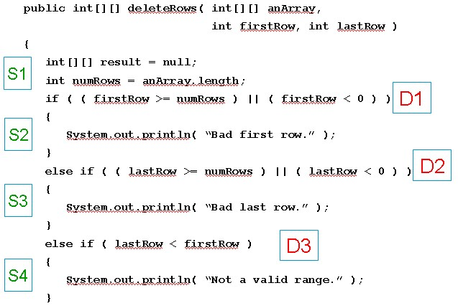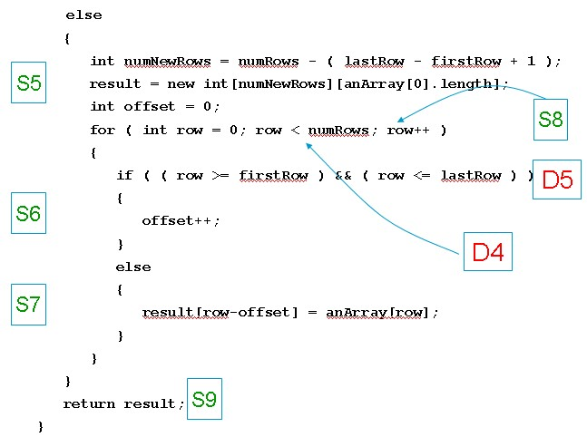

You are required to complete the following tasks :

1. Draw the Control Flow Graph for identifying all possible sub-paths and paths.

(Please use the symbols S1-S9 as statmement nodes and D1-D5 as decision nodes)

1. Choose the Data Condition and identify its equivalence classes for a path of S1 – D1 – D2 – D3 – S4 – S9.

1. Decide by yourself a set of possible Input Data and its corresponding Predict Output for the path specified in (b).