HONG KONG INSTITUTE OF VOCATIONAL EDUCATION Name : _Law Cheuk Hung_
Laboratory 5: Principles of Testing Analysis and Graph Models Class : 2A

Module Intended Learning Outcome (#3):
On completion of the module, students are expected to be able to:
- Develop the game software models for testing analysis.

Lesson Intended Learning Outcome:
On completion of this lab, students are expected to be able to:
- Compare structured and unstructured testing.
- Apply the models for testing and experience in developing test cases.

TASK:

- When talking about the quality of a game, state any 5 major quality factors that will determine whether you want to buy the game or not.

Quality of the story,
Quality of the game mechanics,
Quality of game audio and visual effects,
Beauty of the visual style,
Use of humor and exaggeration.

- What are the 2 major game quality appraisal activities?

Testing and peers’ review.

- Draw a V Model to align testing activities with the software development cycle.

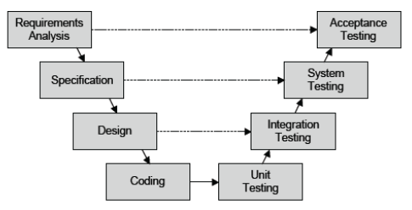

- What are the definitions of First Playable Version, Alpha Version, Beta Version and Gold Master Version of a game? Give an example to show why it is possible to have testing activities even after a game has been released to the market?

First Playable Version :- The first time all the major gameplay elements are functional and playable.

Alpha Version :- The point at which a game’s features are completed. (Alpha Testing)

Beta Version :- The point at which a game contains o known bugs, but that is yet shippable. (Beta Testing)

Gold Master Version :- The final version of the game that is sent to be manufactured.

Example to show why it is possible to have testing activities even after a game has been
released to the market :-

Some of the mobile game, after the player finish the tour mode, the game will pop out a dialog that let the player to give rating and leave comments in the app store. It can let the game developer to improve the game after the players have played the game.

- State 8 major items to be included in a typical test case.

Test case id,
Objective (the feature to be tested),
Brief description (including the steps involved),
Platform (for conducting the test case),
Test data (if data is required),
Expected result,
Actual result (as expected or not),
Remarks.

- Given a SoundApplet which intends to be used to play (or loop play) sound files of different formats. Try and test run SoundApplet.java with SoundApplet.htm.

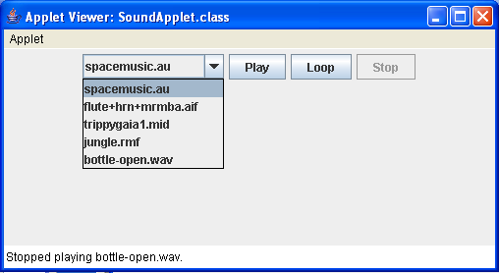

- Before you start testing the Sound Applet, identify the number of test cases required and specify each test case.

Total 10 test cases.
spacemusic.au → Play → Stop, spacemusic.au → Loop → Stop
flute+hrn+mrmba.aif → Play → Stop, flute+hrn+mrmba.aif → Loop → Stop
trippygaia1.mid → Play → Stop, trippygaia1.mid → Loop → Stop
jungle.rmf → Play → Stop, jungle.rmf → Loop → Stop
bottle-open.wav → Play → Stop, bottle-open.wav → Loop → Stop

- Perform the testing based on your test cases.

- Identify 4 POTENTIAL problems of this Sound Applet based on your testing.

Play other song while playing a song, the new song may not start from the begin.
After looping the song, it may not change to un-loop state.
After stop a song, it may not play or loop the song again.
After playing the song, it may not switch to loop state.

- What are you going to check and make sure that these 4 POTENTIAL problems are actually problems or not?

Change song while looping or playing the song.
Press Play button or Loop button after stop a song.

