
FACULTY OF INFORMATION SCIENCE AND TECHNOLOGY

TCC 4223
INTRODUCTION OF CLOUD COMPUTING

ASSIGNMENT

Trimester March/April 2026 (Term 2610)

No. | Student ID | Student Name | Set VM | Signature
 | 243DT245TU | Law Jie Po | VM 1 | Law
 | 243DT2460N | Cheong Chee Hou | VM 2 | Cheong
 | 243DT245KP | Teo Kok Chuan | VM 3 | Teo

Table of Contents
Introduction 3
VM Setup Details 4
Methodology 5
CPU Usage 5
Memory Usage 6
Disk Performance 7
Boot Time 7
Application Performance 8
Results & Analysis 9
Conclusion 10
Appendix 11

Introduction

Nowadays, cloud computing is a very common service that delivers computer resources on-demand, such as storages, databases and server with pay-as-you-go price. It’s a popular service thanks to its elasticity, scalability and accessibility across the internet. And on the back of its beneficial characteristic, virtualization plays a key role in enabling cloud computing service.
Virtualization is a process to create a software version of computing resources such as storage, mailbox and databases. It allows multiple virtual machines to run on single physical machine, where each VM operates independently with different CPU, OS and memory allocation. To ensure the VMs runs smoothly, hypervisor such as Oracle VirtualBox was introduced to ensures the smooth operation of the VMs.
Oracle VirtualBox is a widely adopted hypervisor that aims to provide accessible platform for creating and managing virtual machines. Oracle VirtualBox supports various guest OS include FreeBSD, Ubuntu and Fedora, making it an ideal platform for VM performance analysis as different configurations produces different performance outcomes, given the guest OS or applications, which greatly affects the decision making of administrator for allocating resources in cloud environments.
This project aims to analyse different virtual machines with different configurations, different guest OSs and different applications installed. The performance benchmarking will be primarily based on 2 Ubuntu and 1 Fedora VM with MySQL, MariaDB and Nginx installed respectively to analyze the performance metric of the different VMs

VM Setup Details

VM | OS | CPU | RAM | Storage
VM1 | Ubuntu | 2 Core | 6 GB | 20 GB
VM2 | Ubuntu | 2 Core | 4 GB | 30 GB
VM3 | Fedora | 1 Core | 2GB | 15 GB

Application Installed
VM1: MySQL & Nginx
VM2: MariaDB & Nginx
VM3: MariaDB & Nginx
MySQL: An open-source relational database management system that stores and manage data in structured table. It is widely used in web applications and enterprise system to store website data
MariaDB: An open-source relational database management system that stores and manage data in structured table. MariaDB often tends to operate better in terms of query execution given the same VM configuration
Nginx: An open web server and reverse proxy server that uses to execute proxy request. It uses an event-driven, non-blocking architecture that uses significantly less memory.

Methodology

CPU Usage
Code: sysbench cpu run
VM1
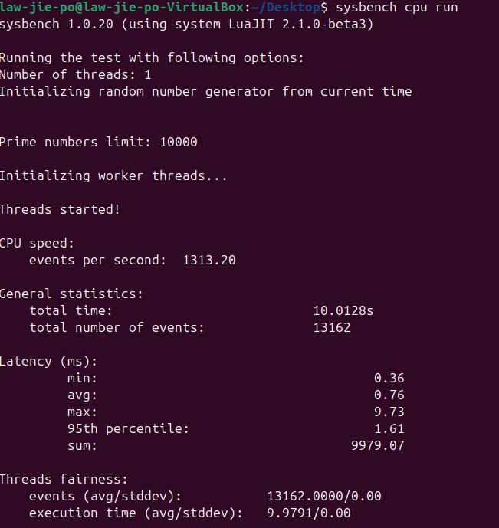

VM2
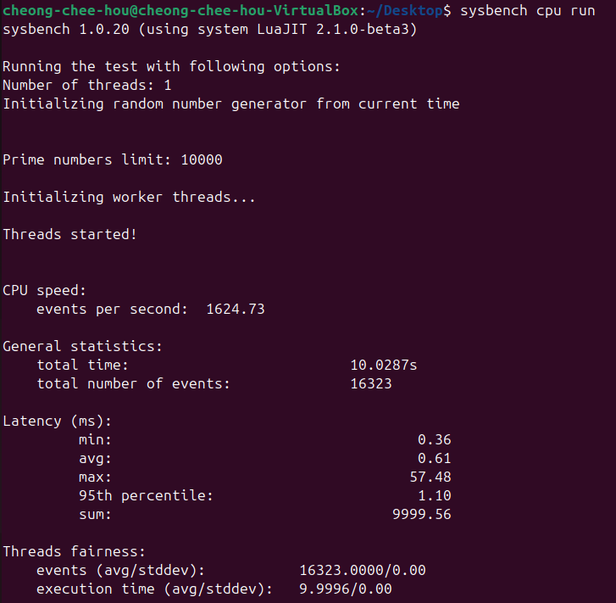

VM3

Memory Usage
Code: htop
VM1
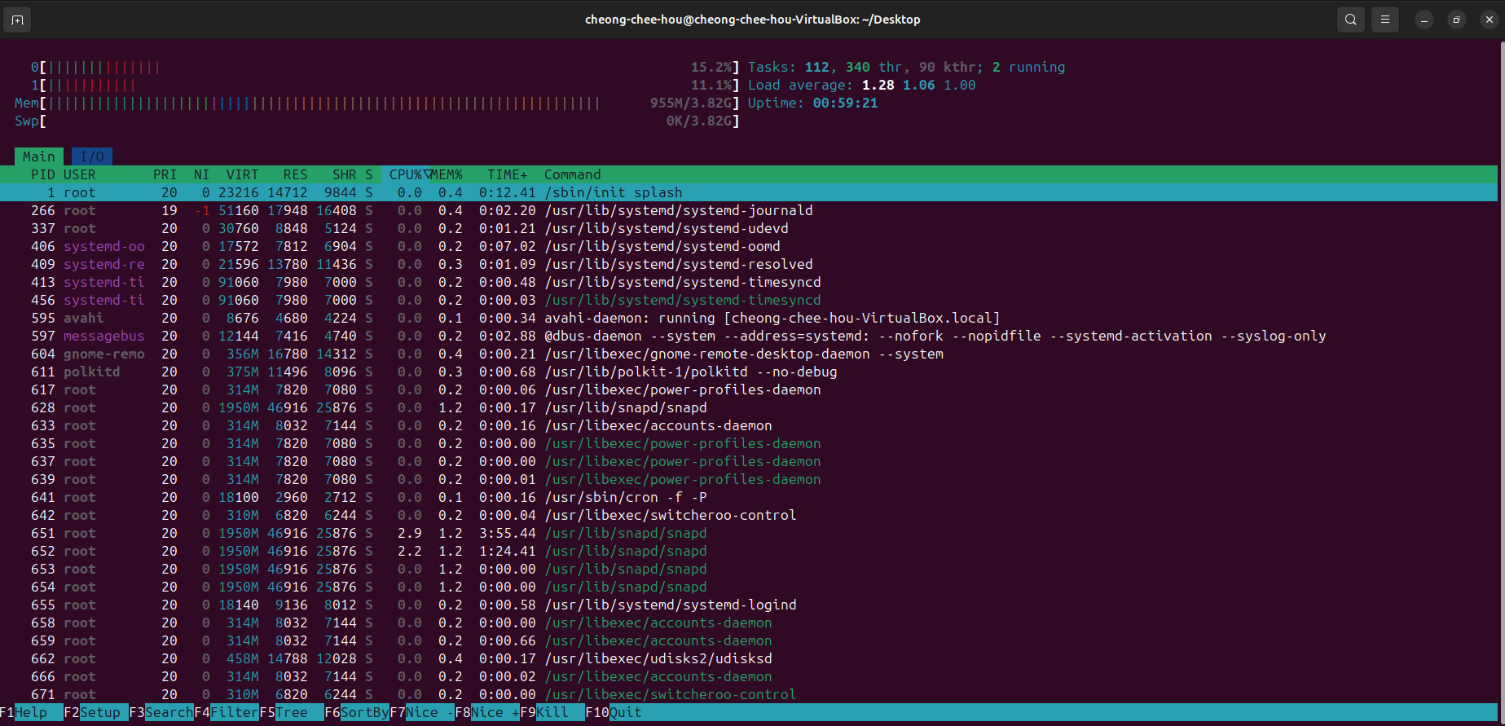
VM2
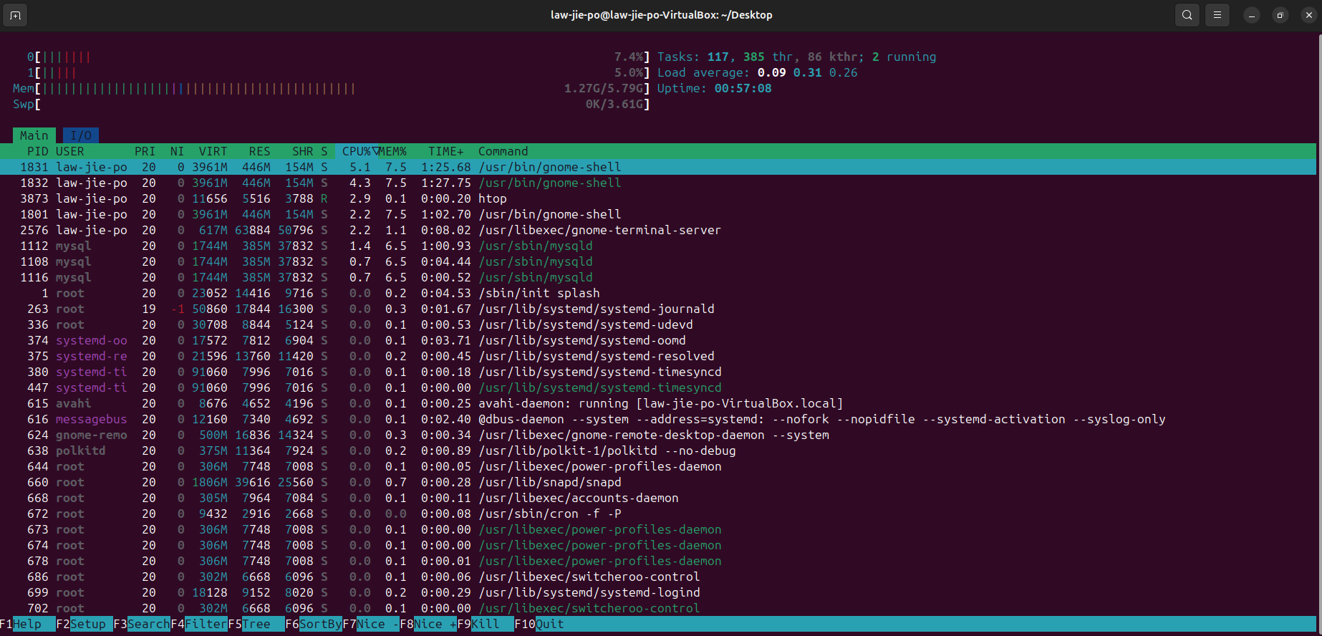
VM3
Code: free -h
VM1

VM2
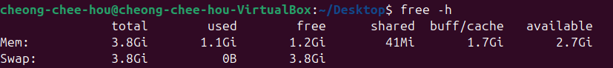

VM3

Disk Performance
VM1

VM2

VM3

Boot Time
Code: systemd-analyzed
VM1
VM2
VM3

Application Performance
Nginx
VM1
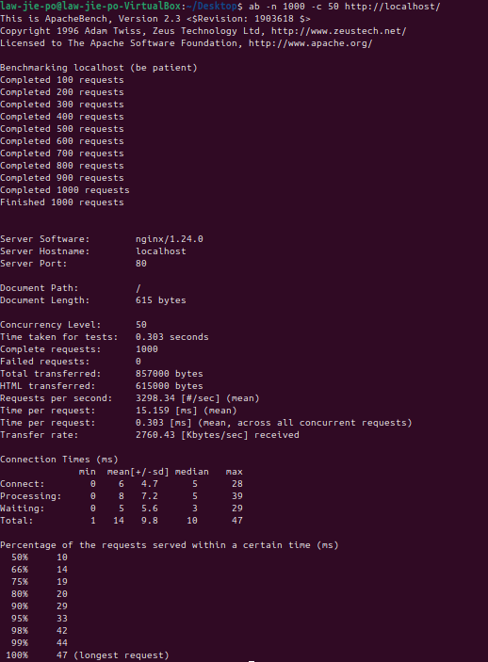

VM2
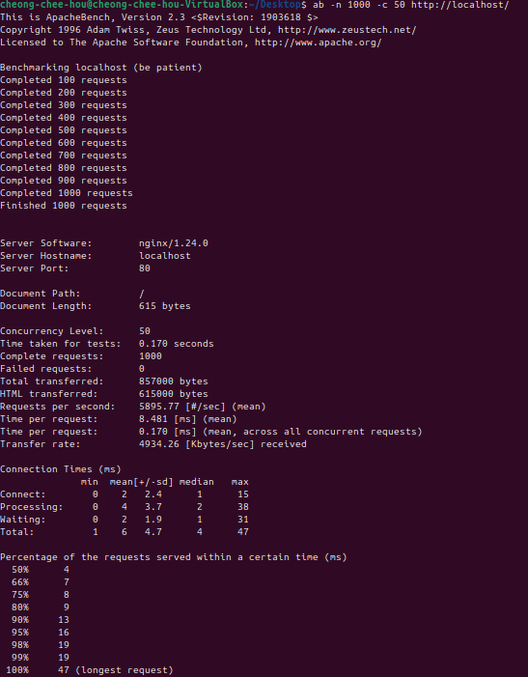
VM3
MySQL
VM1
MariaDB
VM2
VM3

Results & Analysis

CPU Usage
VM | OS | CPU | RAM | Storage | CPU Events/sec | Avg Latency (ms)
VM1 | Ubuntu | 2 Core | 6 GB | 20 GB | 1313.20 | 0.76
VM2 | Ubuntu | 2 Core | 4 GB | 30 GB | 1624.73 | 0.61
VM3 | Fedora | 1 Core | 2GB | 15 GB | 1974.31 | 0.51

Memory Usage
VM | OS | CPU | RAM | Storage | Used Memory | Free Memory | Available
VM1 | Ubuntu | 2 Core | 6 GB | 20 GB | 1.5GB | 2.9GB | 4.3GB
VM2 | Ubuntu | 2 Core | 4 GB | 30 GB | 1.1GB | 1.2GB | 2.7GB
VM3 | Fedora | 1 Core | 2GB | 15 GB | 461MB | 1.4GB | 1.5GB

Disk Performance
VM | OS | CPU | RAM | Storage | Read (MB/s) | Write (MB/s)
VM1 | Ubuntu | 2 Core | 6 GB | 20 GB | 5.09 | 3.39
VM2 | Ubuntu | 2 Core | 4 GB | 30 GB | 6.57 | 4.38
VM3 | Fedora | 1 Core | 2GB | 15 GB | 3.38 | 2.25

Boot Time
VM | OS | CPU | RAM | Storage | Kernel (s) | User space (s) | Total Boot Time (s)
VM1 | Ubuntu | 2 Core | 6 GB | 20 GB | 4.262 | 20.174 | 24.437
VM2 | Ubuntu | 2 Core | 4 GB | 30 GB | 17.151 | 31.983 | 49.134
VM3 | Fedora | 1 Core | 2GB | 15 GB | 5.463 | 20.686 | 44.591

Application Performance
Nginx
VM | OS | CPU | RAM | Storage | Requests/sec | Time per Request (ms) | Transfer Rate (KB/s)
VM1 | Ubuntu | 2 Core | 6 GB | 20 GB | 3298.34 | 15.159 | 2760.43
VM2 | Ubuntu | 2 Core | 4 GB | 30 GB | 5895.77 | 8.481 | 4934.26
VM3 | Fedora | 1 Core | 2GB | 15 GB | 3076.37 | 16.253 | 26194.24

MariaDB and MySQL
VM | OS | CPU | RAM | Storage | Database | Transactions/sec | Avg Latency (ms)
VM1 | Ubuntu | 2 Core | 6 GB | 20 GB | MySQL | 183.60 | 21.78
VM2 | Ubuntu | 2 Core | 4 GB | 30 GB | MariaDB | 449.20 | 8.90
VM3 | Fedora | 1 Core | 2GB | 15 GB | MariaDB | 148.60 | 6.71

Conclusion

Appendix

Tutorial for downloading and setup Nginx on Ubuntu
Nathan Wander. (2024, August 31). Setup NGinX on Ubuntu 24.04 | Beginners Tutorial [Video]. YouTube.
https://www.youtube.com/watch?v=0TmLhQgiF7o
Tutorial for Ubuntu
Sobell, M. G. (2009). A practical guide to Ubuntu Linux (Versions 8.10 and 8.04). In Prentice Hall PTR eBooks.
http://dl.acm.org/citation.cfm?id=1538448
Tutorial for setup MySQL and MariaDB on Ubuntu
Susan B. (2023, June 5). Install and configure MySQL / MariaDB (Ubuntu) [Video]. YouTube.
https://www.youtube.com/watch?v=sfJe5tWtsaA
Tutorial for setup MariaDB on Fedora
Open-Source Central. (2024, October 5). Master MariaDB/MySQL on Fedora: Step-by-Step Installation & Pro Setup Guide! [Video]. YouTube.
https://www.youtube.com/watch?v=Eb5umxkIkWM
Tutorial for setup Nginx on Fedora
IT techni. (2023, July 23). Nginx setup on fedora [Video]. YouTube.
https://www.youtube.com/watch?v=ENP3GlqUhXE
Analysis of cloud computing
Velte, T. J., Velte, A., & Elsenpeter, R. (2009). Cloud computing, a practical approach. In Medical Entomology and Zoology.
http://ci.nii.ac.jp/ncid/BB00385132
Benefit Analysis of Cloud Computing
10 Benefits of Virtualization in cloud Computing for 2026 | DigitalOcean. (2026, February 3).
https://www.digitalocean.com/resources/articles/benefits-of-virtualization

