STUDENT ID | 243DT245TU
NAME | Law Jie Po

Follow the instructions that from AWS Lab Academy: Lab 1: Introduction to AWS IAM

Answer the following questions.

Question No. | Snapshot/ Answer
- Screen shot your Console Home (show your Account ID & Federated user) – 1m
i. | 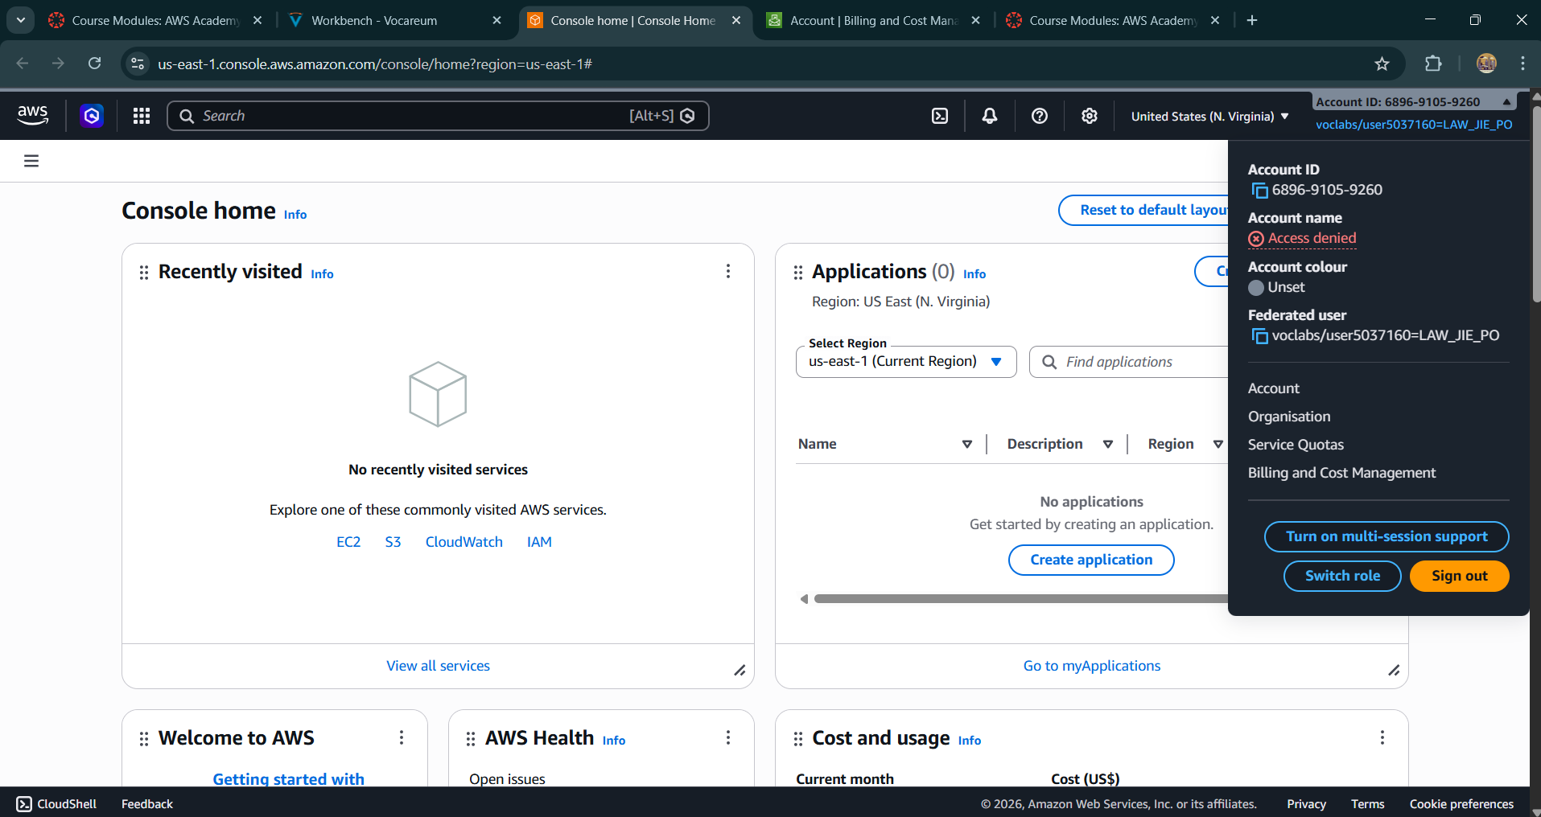
- AWS console URL – 1m
 | https://us-east-1.console.aws.amazon.com/console/home?region=us-east-1#
- Sign-in URL for IAM users in the account – 1m
i. | https://689691059260.signin.aws.amazon.com/console
- Screenshot IAM Dashboard – 1m
i. | 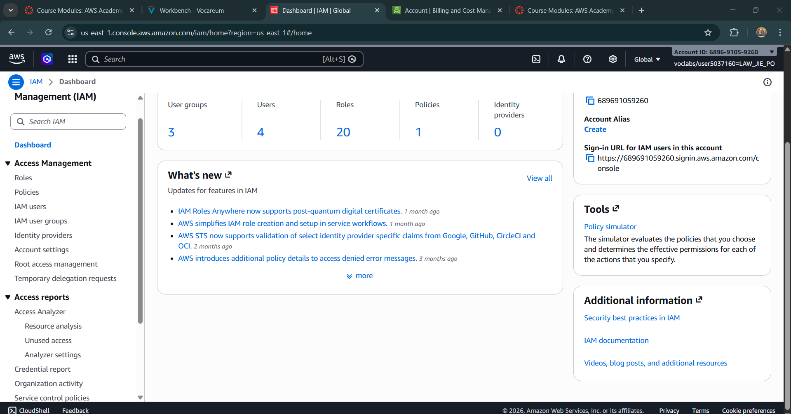
- Screenshot IAM user page showing 3 accounts. – 1m
i. | 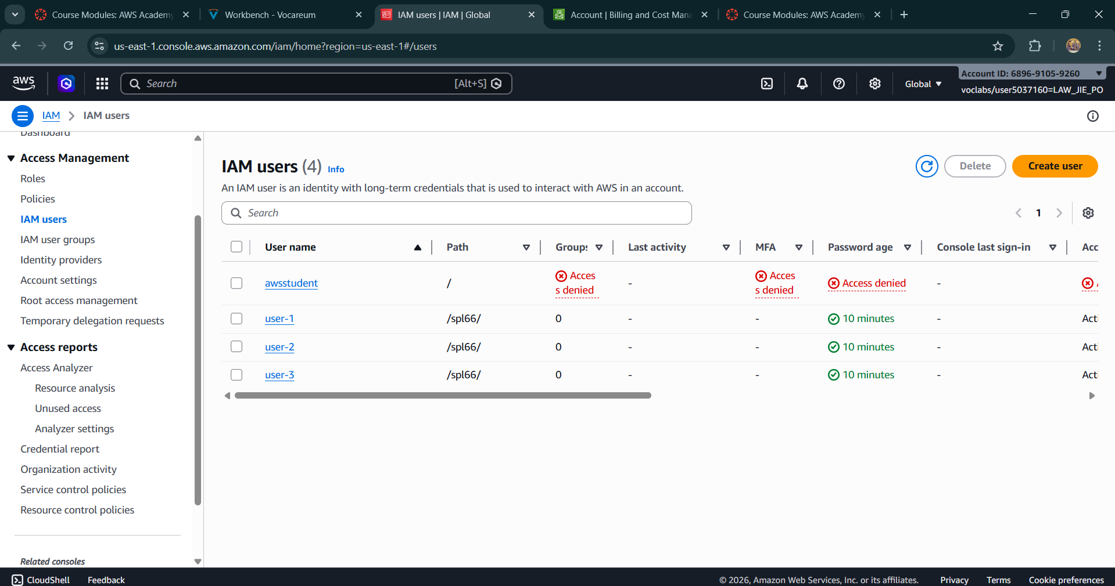
- Screenshot IAM user groups page showing 3 groups name. – 1m
i. | 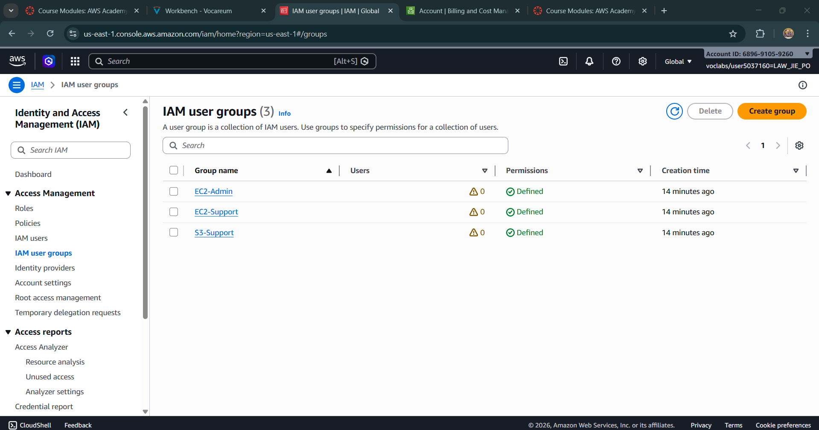
- Show user that been assigned to the S3-Support (After Task 2 done) – 1m
i. | 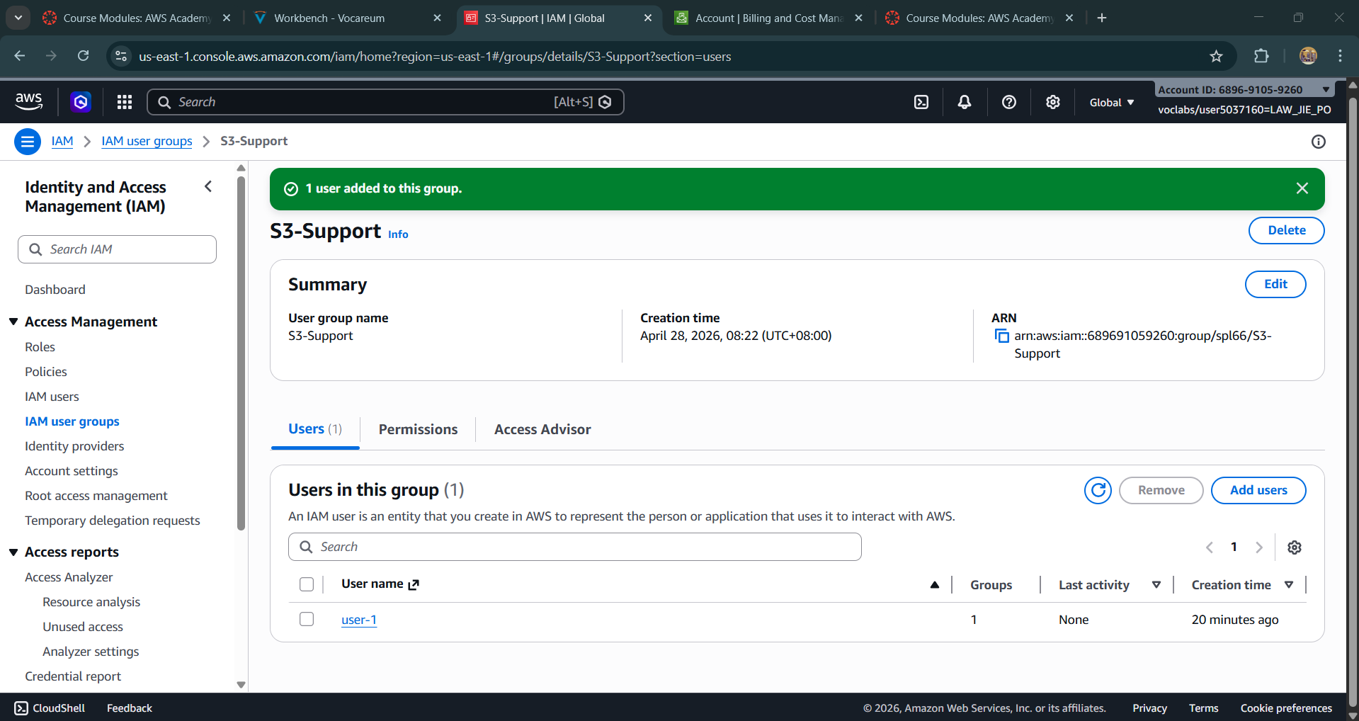
- Show user that been assigned to the EC2-Support (After Task 2 done) – 1m
i. | 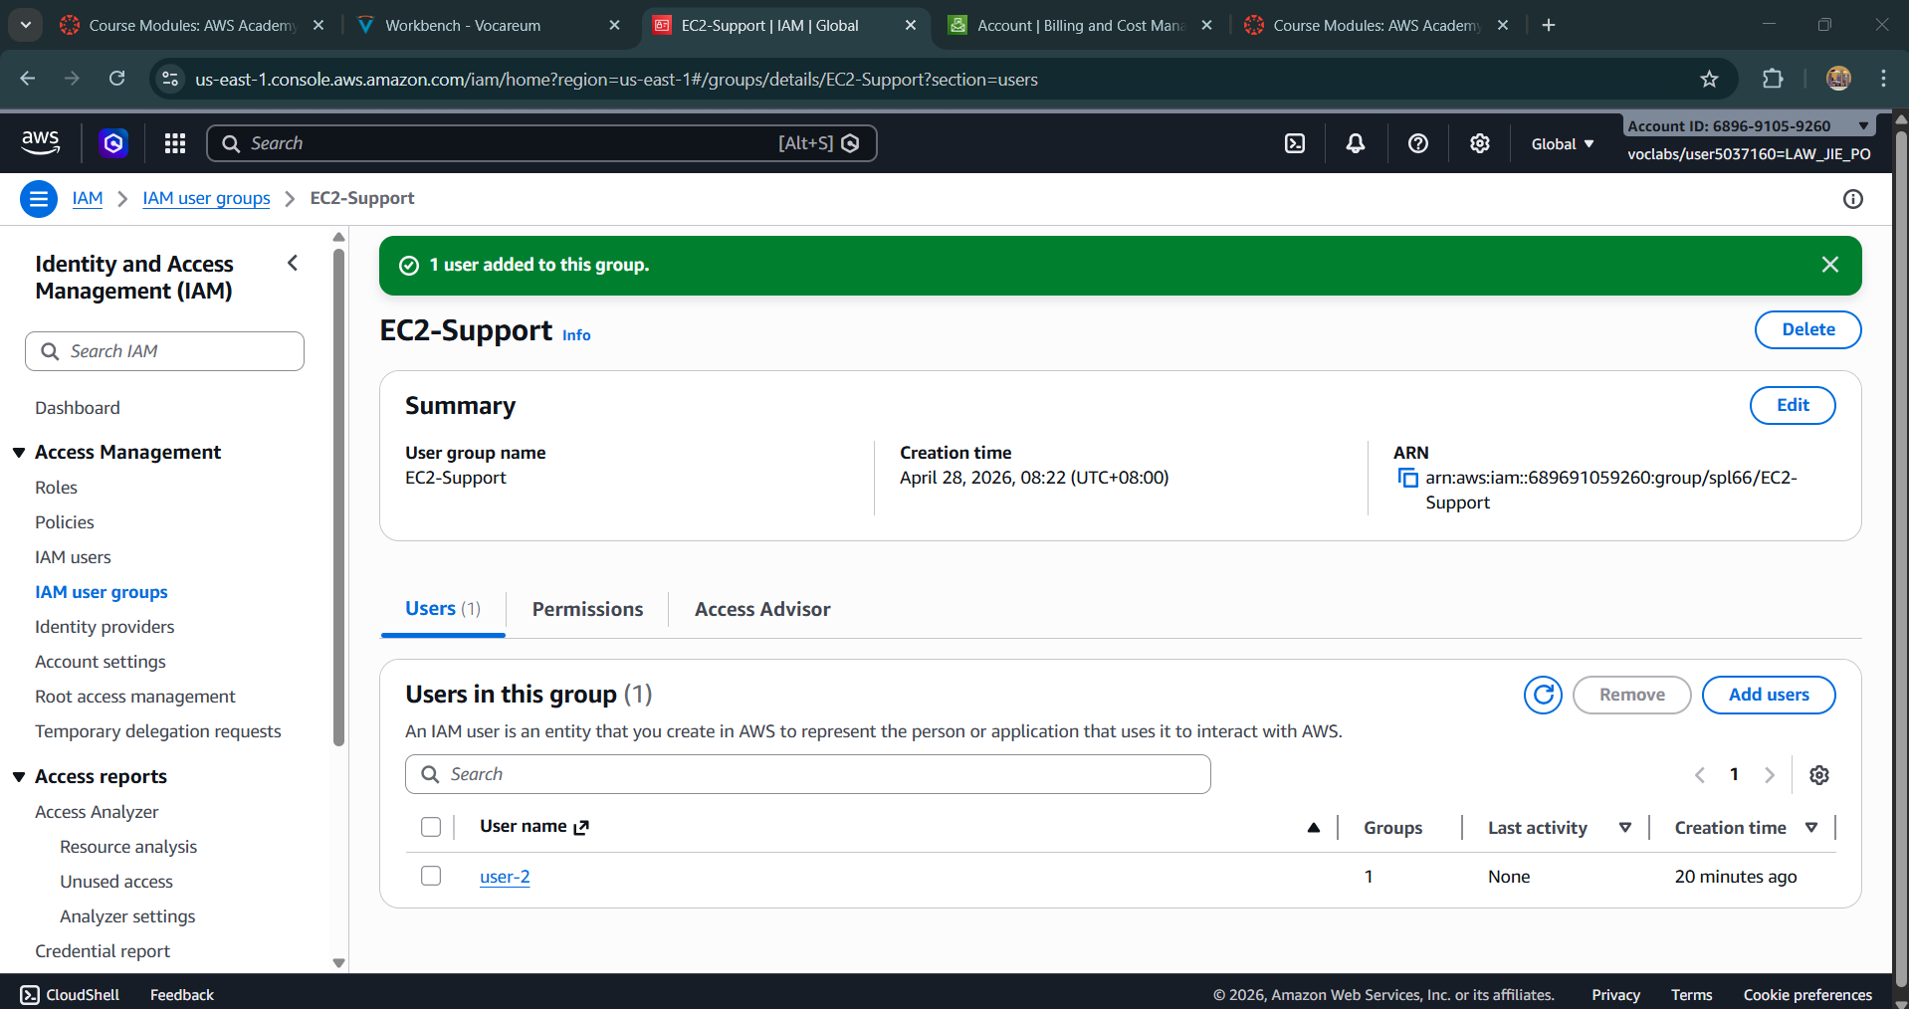
- Show user that has been assigned to the EC2-Admin (After Task 2 done) – 1m
i. | 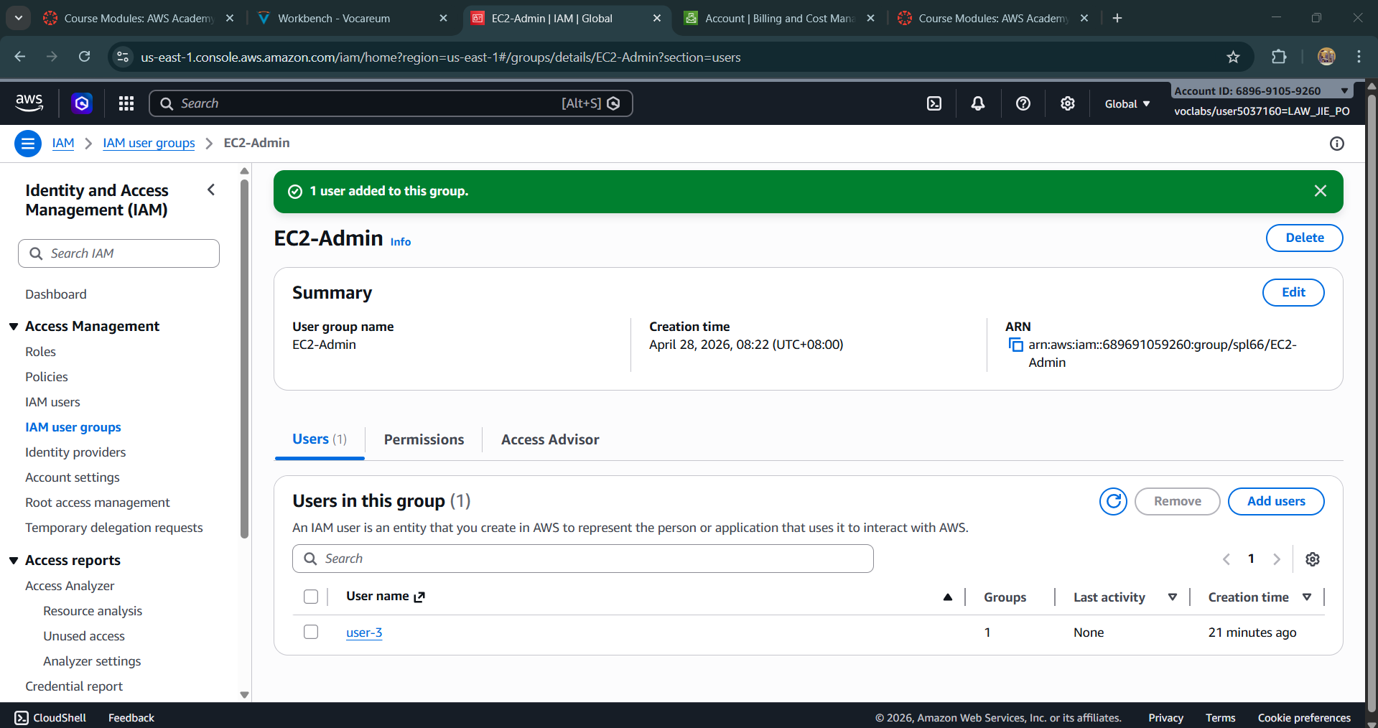
- Show Lab Host instance has been stopped when you login as user3 in IAM users sign-in link – 1m
i. | 