Diagnosing and Resolving Database Overload
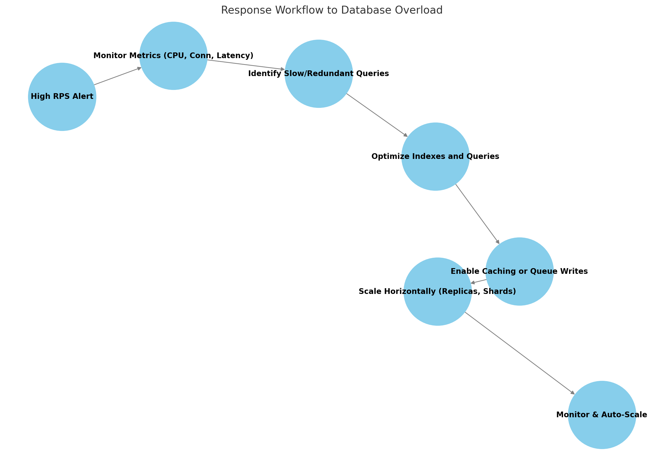
The chart above visually represents the end-to-end workflow from detecting high load to implementing strategic scaling and monitoring solutions.

1. Monitor System-Level Metrics
- - CPU & memory utilization
- - Disk IOPS and throughput
- - Open connections / connection pool saturation
- - Locking/deadlocks
- - Average query latency and throughput

2. Identify Slow or Problematic Queries
- - Analyze slow query logs and execution plans
- - Look for full table scans, Cartesian joins
- - Spot missing indexes and over-fetching
- - Prioritize the most frequent and slowest queries

3. Evaluate Connection Management
- - Check for short-lived or idle connections
- - Ensure connections are being properly released
- - Monitor usage vs. connection pool limits

4. Optimize Queries and Indexes
- - Add indexes on WHERE, JOIN, ORDER BY columns
- - Replace SELECT * with specific fields
- - Refactor inefficient joins or subqueries

5. Improve Connection Handling
- - Implement connection pooling
- - Use using blocks or Dispose()
- - Limit idle timeout durations

6. Enable Caching
- - Use Redis or MemoryCache for hot data
- - Cache HTTP GET responses where applicable
- - Leverage CDN edge caching for static queries

7. Scale Horizontally
- - Add read replicas to offload SELECT traffic
- - Partition (shard) large tables across databases
- - Route by tenant or geographic region

8. Queue Write Operations
- - Use RabbitMQ, Kafka, or Azure Service Bus
- - Decouple app from DB for write-heavy events

9. Apply CQRS (Optional)
- - Use separate write and read models
- - Optimize denormalized read projections

10. Implement Long-Term Solutions
- - Auto-scaling of cloud resources
- - TTL and archival policies
- - Load testing pre-release

