E-Commerce MVP Technical Design

1. Overview
This document outlines the technical design and workflow of a Minimum Viable Product (MVP) for an e-commerce platform. The MVP includes essential features to enable customers to browse products, add them to a shopping cart, and complete a purchase with a single payment method. Future extensibility is a key architectural consideration.

2. Goals of MVP
- Allow users to browse and purchase products
- Store order and user information
- Provide a lightweight admin panel
- Set a foundation for future growth

3. System Components

3.1 Frontend
- Developed in Vue.js, Angular or React
- Responsive design for desktop and mobile
- Communicates with backend via RESTful API

3.2 Backend
- .NET 8 Web API
- REST endpoints for authentication, product catalog, cart, checkout
- PostgreSQL or SQL Server for data storage

3.3 Third-Party Services
- Stripe or PayPal for payment processing
- SendGrid or Mailgun for order confirmations (optional)

4. Key Features

4.1 User Authentication
- Register, login, logout
- Password reset via email (optional)

4.2 Product Catalog
- Public listing of products
- Search and category filter support

4.3 Shopping Cart
- Add/remove/update quantity of items
- Stored in session or user profile (if logged in)

4.4 Checkout
- Simple contact/shipping address form
- Payment via Stripe/PayPal
- Confirmation page with order summary

4.5 Order Management
- Store order data in DB
- Allow users to view past orders

4.6 Admin Interface
- Secure login for admin
- Add/edit/delete products
- View basic order information

5. Workflow Diagram
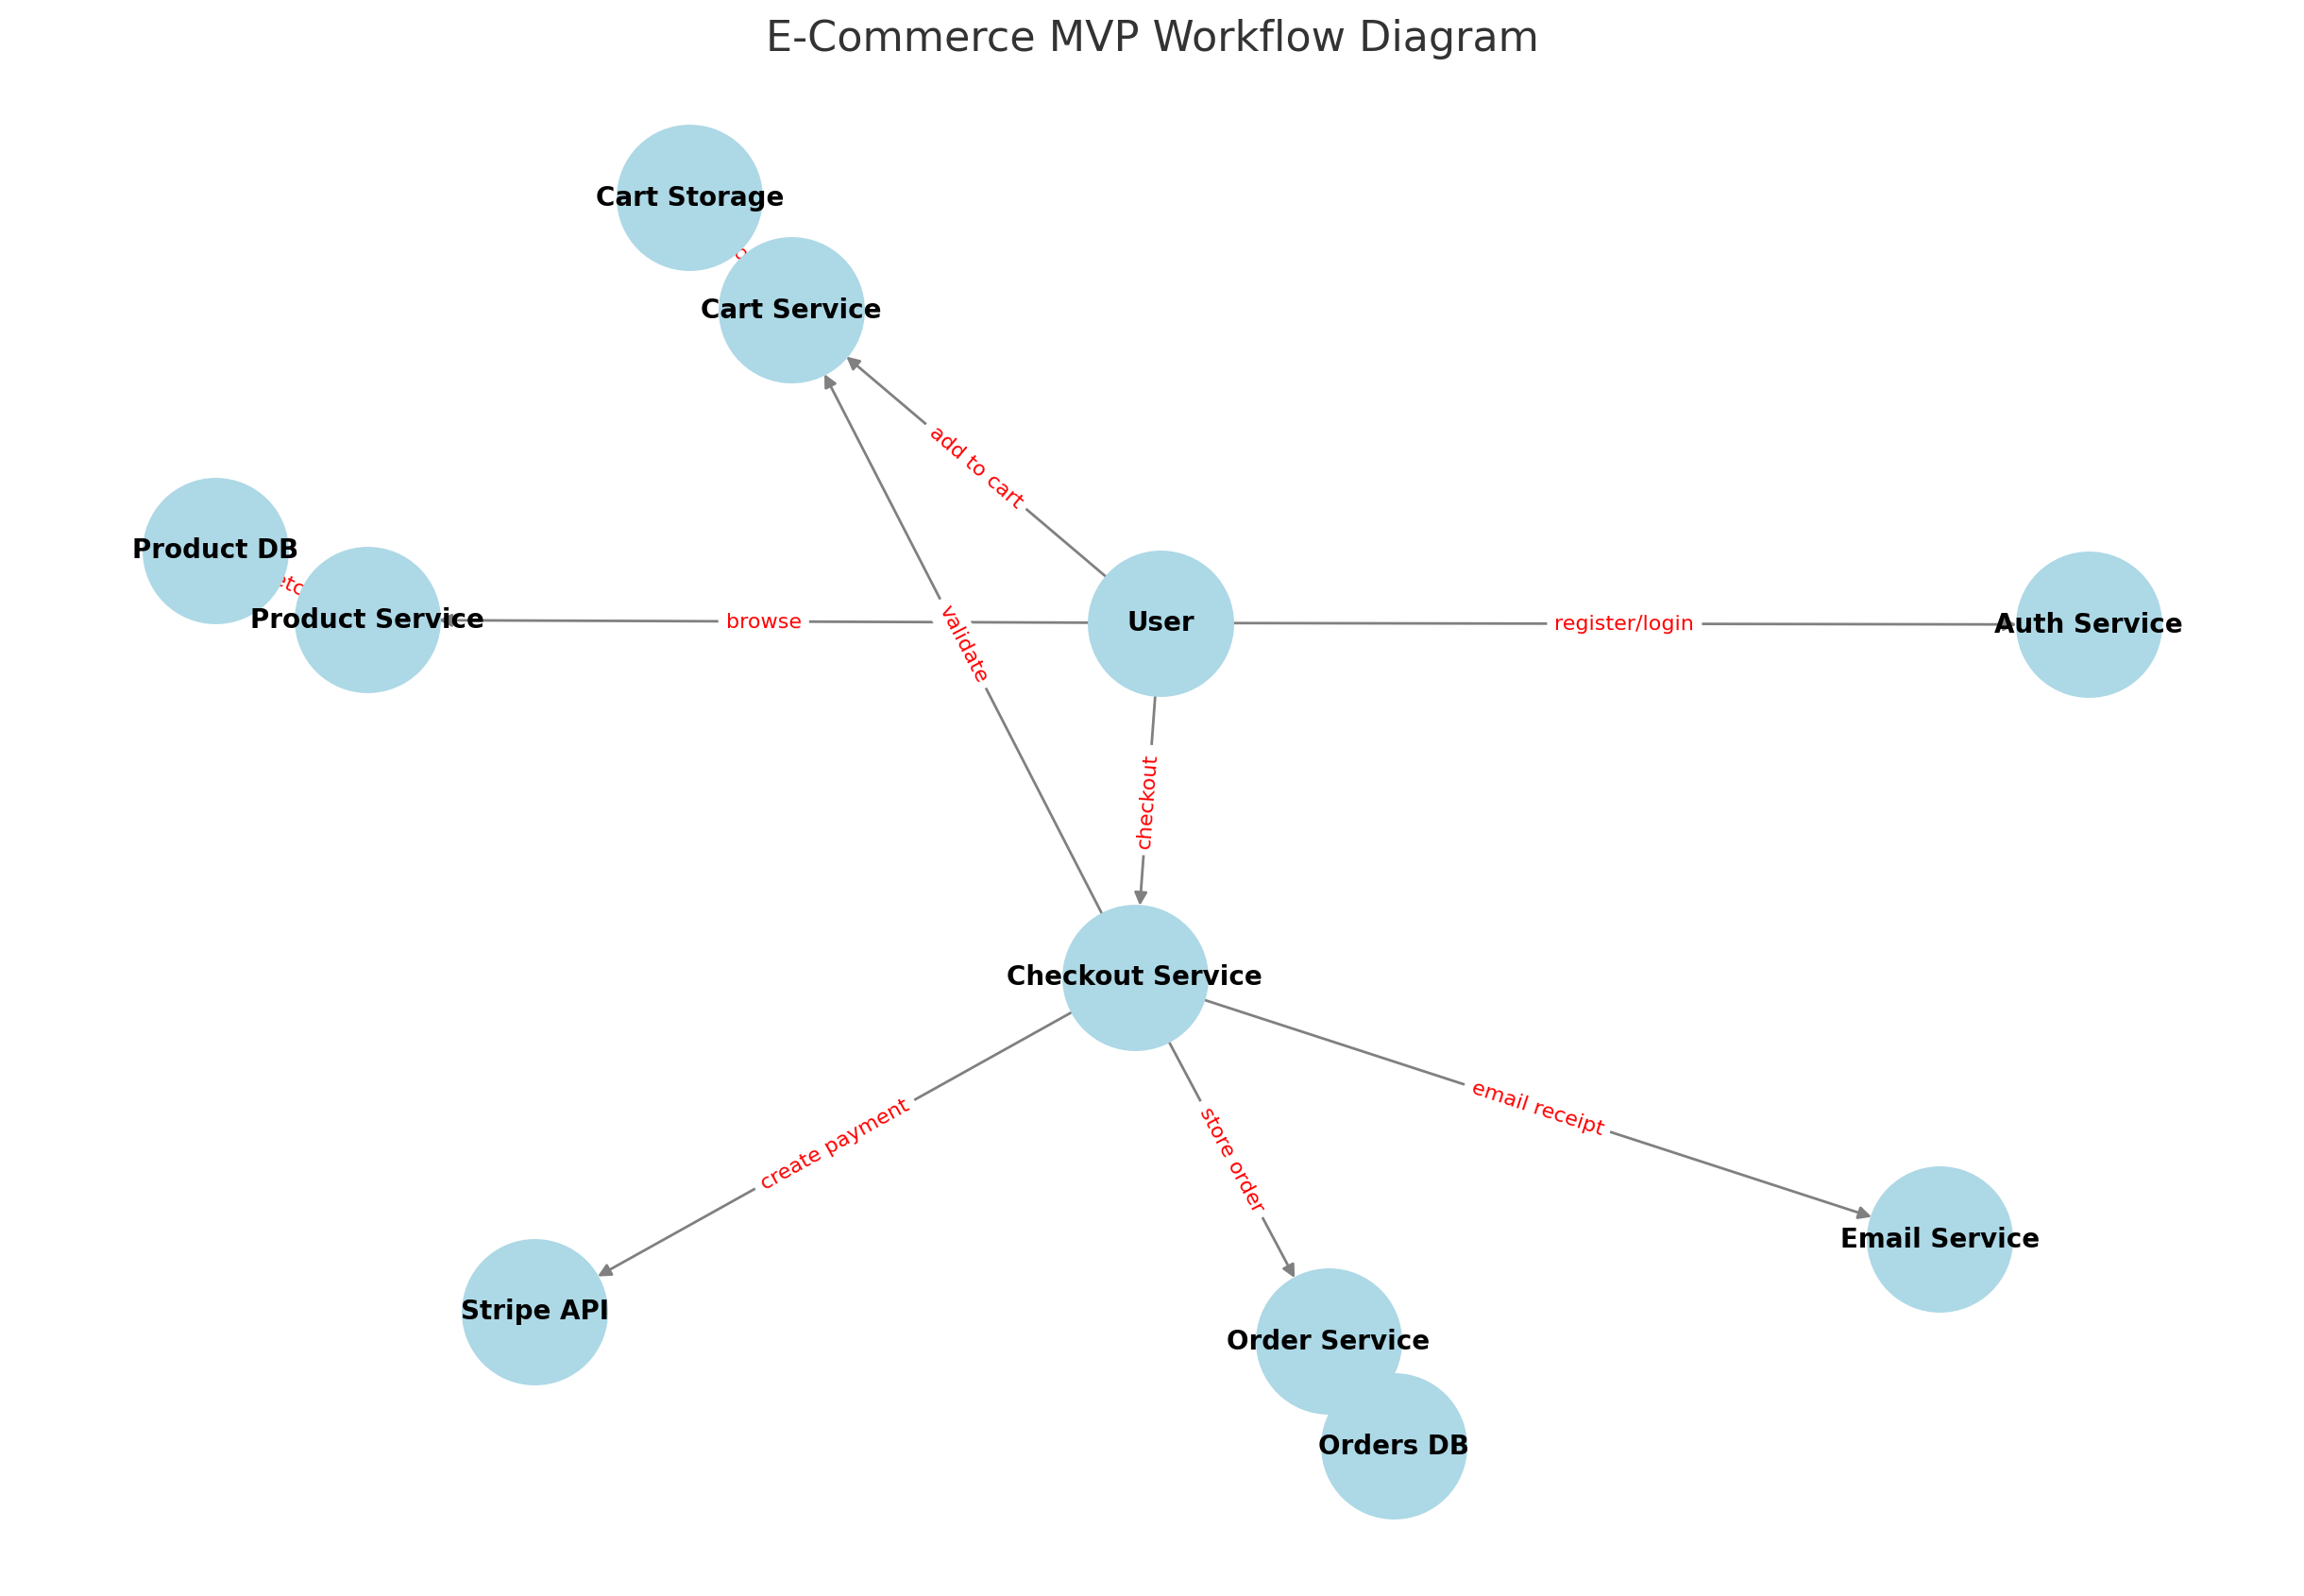

6. Database Design (Simplified)

Users
- Id (PK)
- Email
- PasswordHash

Products
- Id (PK)
- Name
- Description
- Price
- ImageUrl
- Category

Orders
- Id (PK)
- UserId (FK)
- OrderDate
- TotalAmount

OrderItems
- Id (PK)
- OrderId (FK)
- ProductId (FK)
- Quantity
- UnitPrice

7. REST API Endpoints

Authentication
- POST /api/auth/register
- POST /api/auth/login

Products
- GET /api/products
- GET /api/products/{id}

Cart
- POST /api/cart/add
- POST /api/cart/remove
- GET /api/cart

Checkout
- POST /api/checkout

Orders
- GET /api/orders

8. Security Considerations
- JWT-based authentication for secure sessions
- HTTPS for all requests
- Rate limiting on login endpoint
- Validation and sanitization of user input

9. Future Extensibility
- Discount codes via a separate Promotion Service
- Multi-payment support via plugin pattern
- Recommendation engine (targeted marketing)
- Inventory tracking per product

10. Conclusion
This MVP delivers essential e-commerce functionality while maintaining a clean, scalable architecture. It is designed to allow quick iteration and future enhancement based on real user feedback.

