Microservice Architecture for a Social Media Platform

Overview
This document outlines the design of a microservice architecture for a scalable social media platform.
The platform supports user account management, content posting (text, images, videos), social interactions
such as likes and follows, feed generation, and notification delivery.

Service Decomposition
The system is decomposed into the following services:
• UserService: Handles user registration, login, and profile management.
• AuthService: Issues and validates JWT tokens for secure authentication.
• FollowService: Manages the social graph for followers and following users.
• ContentService: Stores and retrieves user-generated content.
• MediaService: Handles media uploads and retrieval via cloud storage.
• InteractionService: Tracks user interactions like likes and shares.
• FeedService: Generates personalized content feeds.
• NotificationService: Sends real-time notifications to users.

Architecture Diagram
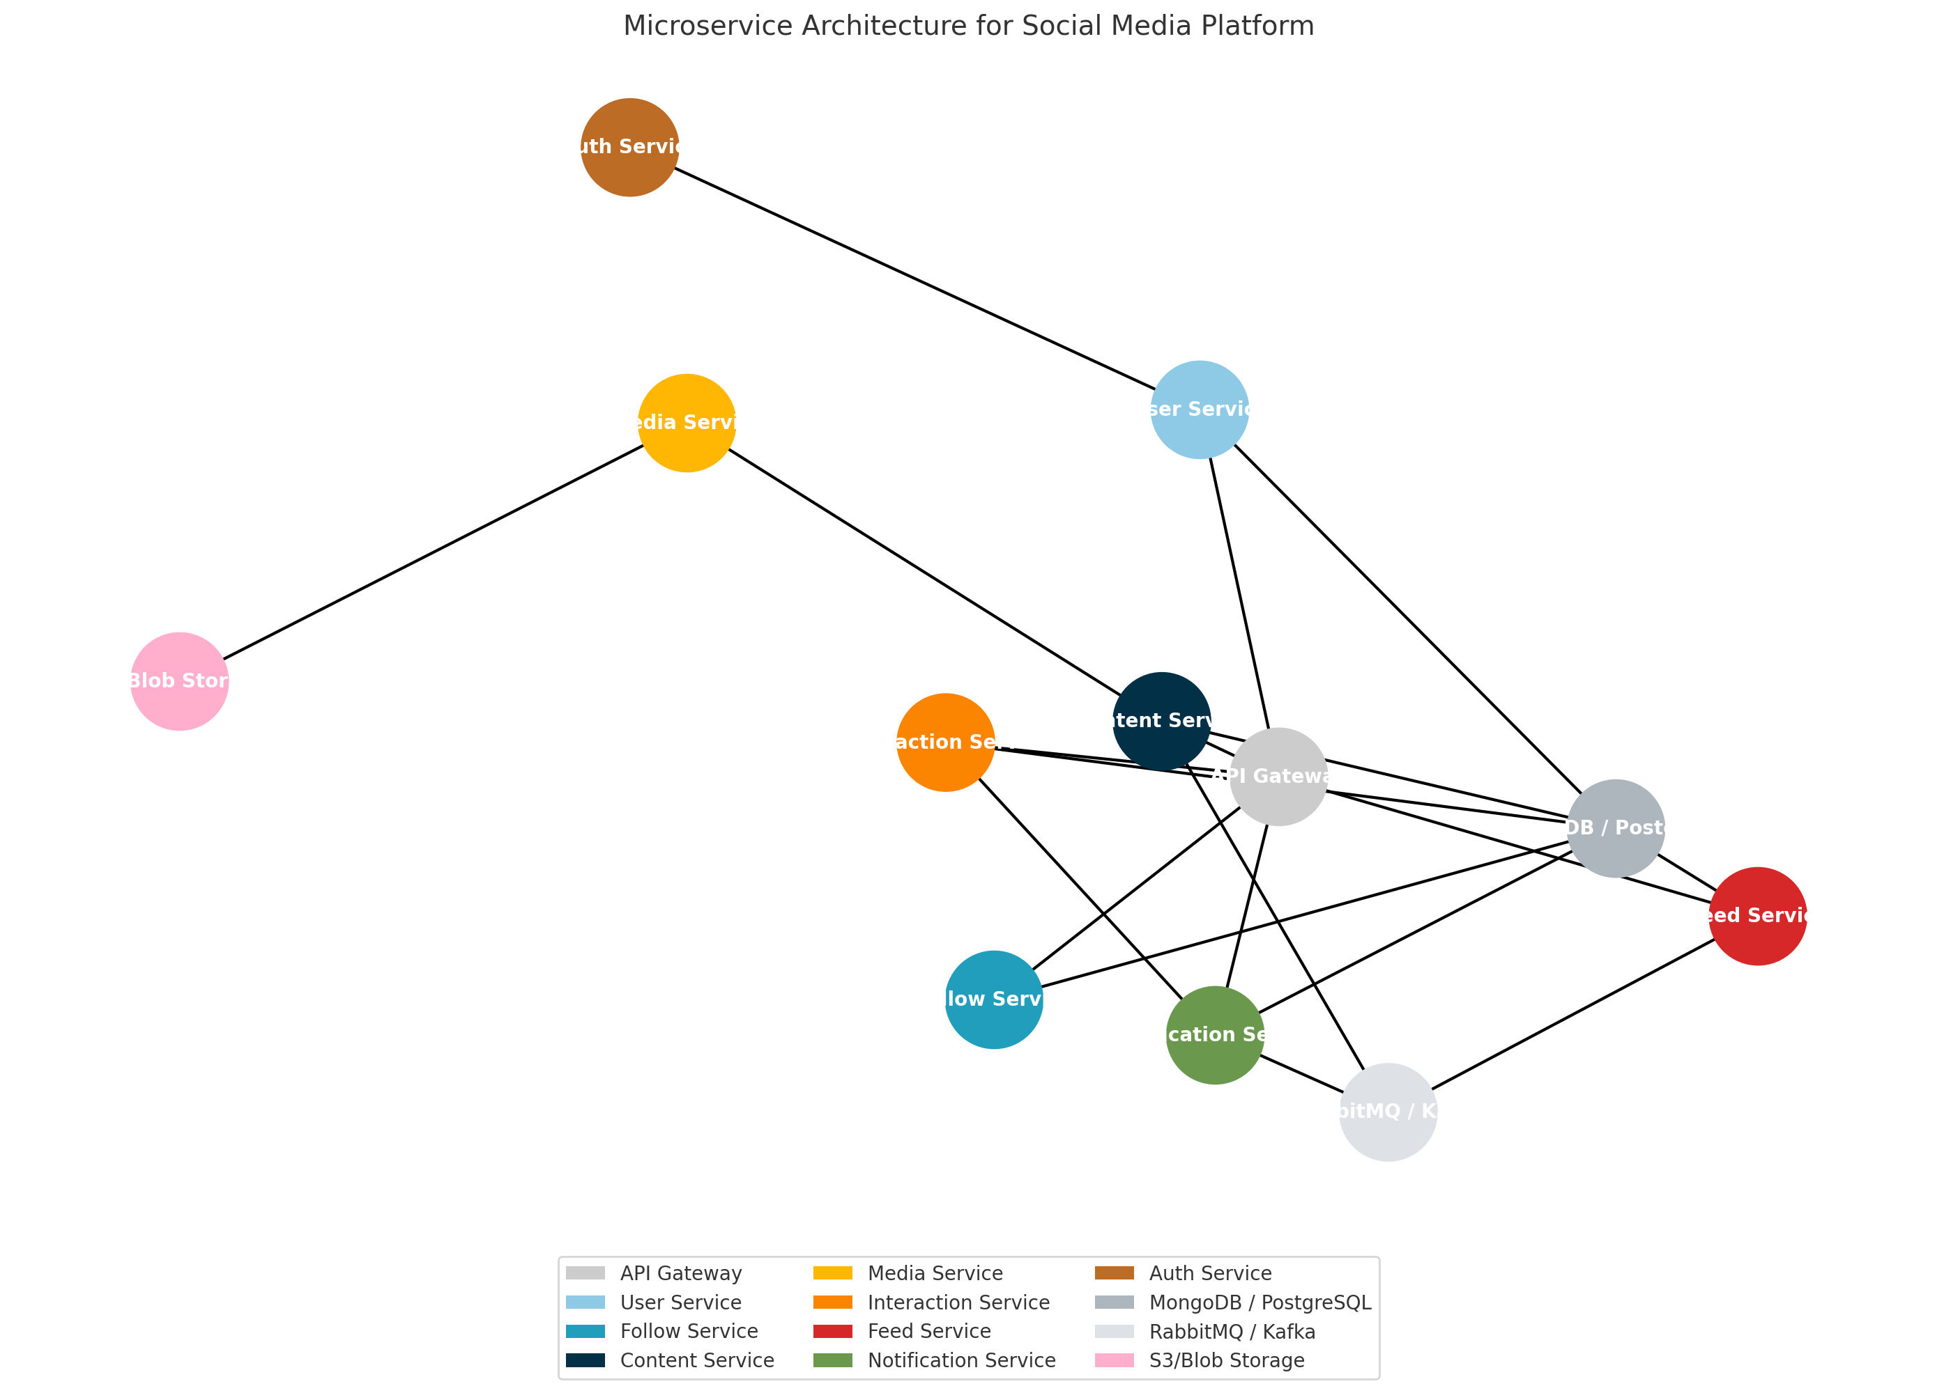

Interaction Flow Diagram
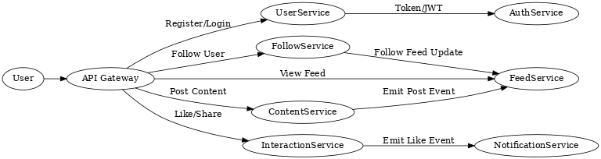

Data Management & Integration
Each service manages its own database to enforce data encapsulation and autonomy. This includes:
- PostgreSQL for User, Interaction, and Content services
- RedisGraph or Neo4j for FollowService
- MongoDB for FeedService and NotificationService
- S3 or Blob storage for MediaService
Inter-service communication is handled via REST or gRPC for direct requests, and RabbitMQ/Kafka for event-driven updates.

Scalability & Resilience
The platform is designed for scalability using:
- Stateless services to support horizontal scaling
- Asynchronous event queues for decoupled processing
- Service discovery and API Gateway routing
- Load balancing and circuit breakers to handle high traffic and failures

Conclusion
This microservice architecture offers modularity, scalability, and fault tolerance for a modern social media platform.
Each service has a single responsibility and communicates efficiently with others via standardized APIs or events.

