  - Test Observations
- The data we collect may be skewed towards pro-Palestinian/ anti-Israel posts
- Pro-Palestinian users seem to have significantly larger networks (based on number of followers)
- The most common words that are not hashtags are too general – will likely be inefficient using them as keywords for querying posts (maybe unless we use a very limited list with words that are specifically related to the times we’re interested in)
- There seem to be some tweets that are repeatedly posted (the one we noticed were a list of hashtags)
- Some hashtags are not clearly used by just one ‘community’ (#antisemitism seemed to be used in an anti-Israel post)
- The most common hashtags in the 1000-tweets sample (see image below):
  - Free Palestine
  - Hamas
  - Gaza
  - Israel
  - Never forget
  - Gaza genocide
  - Palestine
  - Antisemitism (#trump, #standwithukraine and #syria are the same as antisemitism)
- Sampling strategies
  - A strategy for expanding the hashtag list – identify common hashtags from a query using the initial list, add the ones not listed, and query again (do several iterations of this)
  - Network analysis - Identify influential users from the tweets that we sample by hashtags - by identifying users that posted the most. Trace the network from them.

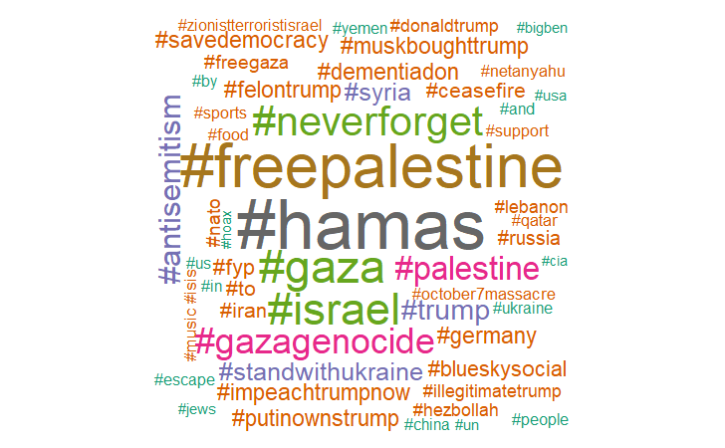
- e.g., Word cloud from 1000 tweets (using TF-IDF)

