/*

Name : Rohit Narayan Telgote

PRN : 1941054

Batch : B4

*/

// Aim : Design a Distributed Application using Message passing Interface for remote computation

**Server.java**

import java.sql.*;

import java.sql.Connection;

import java.rmi.*;

import java.rmi.Naming.*;

import java.rmi.server.*;

import java.rmi.registry.*;

import java.util.Vector;

interface DBInterface extends Remote {

public String input(String name1) throws RemoteException;

}

public class Server extends UnicastRemoteObject implements DBInterface {

int flag = 0, n, i, j;

String name3;

ResultSet r;

public String reverse_str(String s1) {

char ch[] = s1.toCharArray();

String rev = "";

for (int i = ch.length - 1; i >= 0; i--) {

rev += ch[i];

}

return rev;

}

public Server() throws RemoteException {

try {

System.out.println("InitializingServer\nServerReady");

} catch (Exception e) {

System.out.println("ERROR:" + e.getMessage());

}

}

public static void main(String[] args) {

try {

Server rs = new Server();

java.rmi.registry.LocateRegistry.createRegistry(1030).rebind("DBServ",

rs);

} catch (Exception e) {

System.out.println("ERROR:" + e.getMessage());

}

}

public String input(String name1) {

try {

name3 = reverse_str(name1);

// name3=name1.concat(name2);

} catch (Exception e) {

System.out.println("ERROR:" + e.getMessage());

}

return name3;

}

}

**Client.java**

import java.sql.*;

import java.rmi.*;

import java.io.*;

import java.util.*;

import java.util.Vector.*;

import java.lang.*;

import java.rmi.registry.*;

public class Client {

static String name1, name2, name3;

public static void main(String args[]) {

Client c = new Client();

BufferedReader b = new BufferedReader(new InputStreamReader(System.in));

int ch;

try {

Registry r1 = LocateRegistry.getRegistry("localhost", 1030);

DBInterface DI = (DBInterface) r1.lookup("DBServ");

do {

// System.out.println("\n:Menu:" + "\n1.Send Input Strings\n2.Display

// ConcatenatedString\n" + "\nEnteryourchoice:");

System.out.println("\n\t\t*** Menu ***");

System.out.println("\n 1.Send Input Strings");

System.out.println("\n 2.Display Reversed String ");

System.out.println("\n Enter your choice:");

ch = Integer.parseInt(b.readLine());

switch (ch) {

case 1: {

System.out.println("Enter String :");

name1 = b.readLine();

name3 = DI.input(name1);

break;

}

case 2: {

System.out.println("\nReversed String = " + name3);

// int i=0;

// System.out.println(""+name3+"");

break;

}

}

} while (ch > 0);

} catch (Exception e) {

System.out.println("ERROR:" + e.getMessage());

}

}

}

**Output :**

**Server.java**

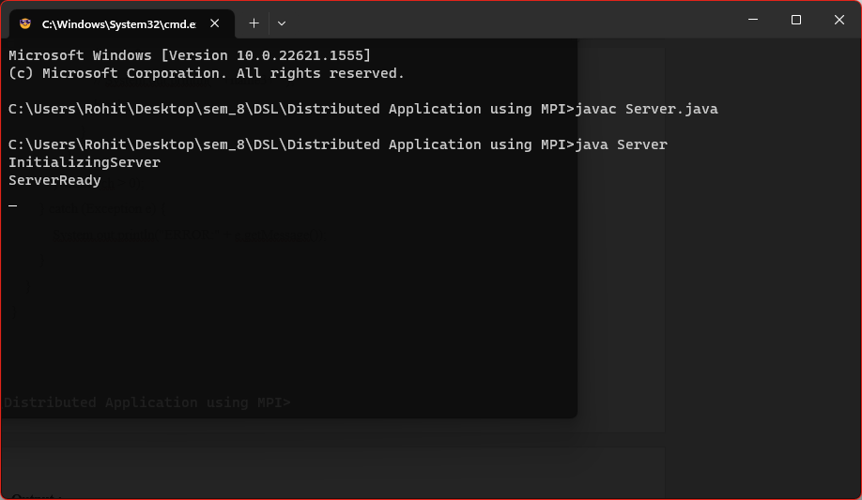

**Client.java**

