/*

Name : Rohit Narayan Telgote

PRN : 1941054

Batch : B4

*/

// Aim : Program for distributed application using RMI

**Server.java**

import java.sql.*;

// import java.sql.Connection;

import java.rmi.*;

import java.rmi.Naming.*;

import java.rmi.server.*;

import java.rmi.registry.*;

import java.util.Vector;

interface DBInterface extends Remote {

public String input(String name1, String name2) throws RemoteException;

}

public class Server extends UnicastRemoteObject implements DBInterface {

int flag = 0, n, i, j;

String name3;

ResultSet r;

public Server() throws RemoteException {

try {

System.out.println("Initializing Server\nServer Ready");

}

catch (Exception e) {

System.out.println("ERROR: " + e.getMessage());

}

}

public static void main(String[] args) {

try {

Server rs = new Server();

java.rmi.registry.LocateRegistry.createRegistry(1030).rebind(

"DBServ", rs);

}

catch (Exception e) {

System.out.println("ERROR: " + e.getMessage());

}

}

public String input(String name1, String name2){

try {

name3 = name1.concat(name2);

}

catch (Exception e) {

System.out.println("ERROR: " + e.getMessage());

}

return name3;

}

}

**Client.java**

import java.sql.*;

import java.rmi.*;

import java.io.*;

import java.util.*;

import java.util.Vector.*;

import java.lang.*;

import java.rmi.registry.*;

public class Client {

static String name1, name2, name3;

public static void main(String args[]) {

Client c = new Client();

BufferedReader b = new BufferedReader(new InputStreamReader(System.in));

int ch;

try {

Registry r1 = LocateRegistry.getRegistry("localhost", 1030);

DBInterface DI = (DBInterface) r1.lookup("DBServ");

do {

System.out.println("1.Send input strings\n2.Display Concatenated string\nEnter ur choice");

ch = Integer.parseInt(b.readLine());

switch (ch) {

case 1:

System.out.println(" \n Enter first string:");

name1 = b.readLine();

System.out.println(" \n Enter second string:");

name2 = b.readLine();

name3 = DI.input(name1, name2);

break;

case 2:

// display

System.out.println("\nConcatenated String is : ");

int i = 0;

System.out.println(" " + name3 + "");

break;

}

} while (ch > 0);

} catch (Exception e) {

// System.out.println("ERROR: " +e.getMessage());

}

}

}

**Output :**

**Server.java**

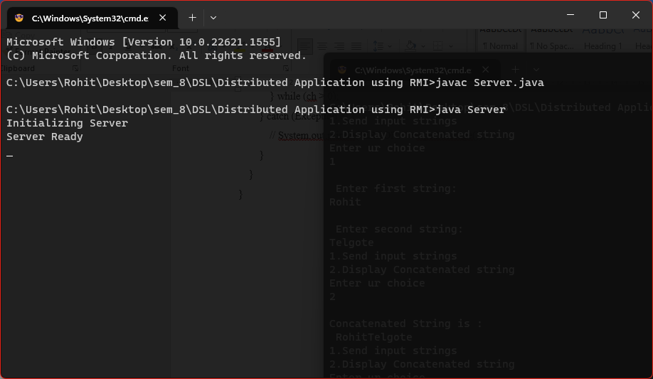

**Client.java**

