# Name : Rohit Narayan Telgote

# PRN : 1941054

# Batch : B4

# Aim : Program for distributed application using RPC

**rpsserver.py**

from xmlrpc.server import SimpleXMLRPCServer

import xmlrpc.client

def fact(n):

if n < 0:

return 0

elif n == 0 or n == 1:

return 1

else:

fact = 1

while(n > 1):

fact *= n

n -= 1

return fact

server = SimpleXMLRPCServer(("localhost",8000))

print("Server i litening on port 8000...")

server.register_function(fact,"fact")

server.serve_forever()

**rpcclient.py**

import xmlrpc.client

proxy = xmlrpc.client.ServerProxy("http://localhost:8000/")

n = int(input("Enter a number to calculate factorial: "))

factorial = proxy.fact(n)

print("Response from server..")

print("Factorial of number is :",factorial)

**Output :**

**Rpcserver.py**

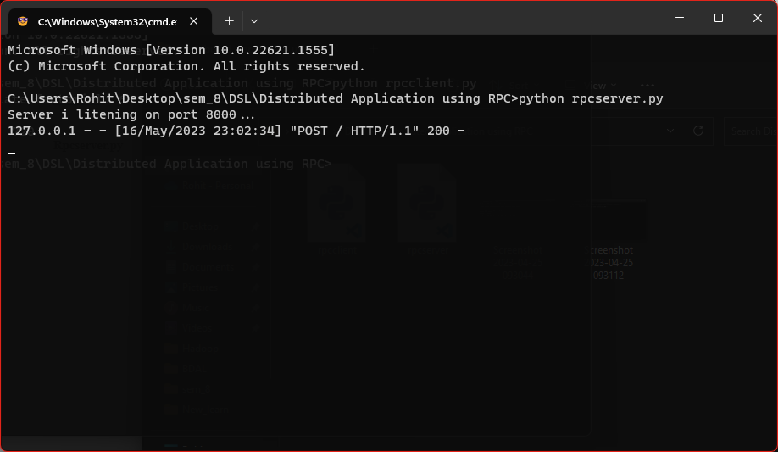

**Rpcclient.py**

