CASE STUDY – 3
Introduction
EcoRide Smart Electric Cycle is an innovative, next-generation commuter e-bike designed for sustainable, affordable, and intelligent urban mobility. The project focuses on combining functionality, smart technology, and ergonomic design into a modular platform suitable for students, professionals, and eco-conscious riders. The EcoRide series introduces six variants—Base, Solar, Swappable, Folding, Cargo, and Performance—each addressing specific user needs through differentiated features while maintaining a unified design language.
Problem Clarification and Breakdown
The EcoRide Smart Electric Cycle addresses several limitations in current e-bike designs:
• Lack of integrated solar or regenerative charging systems.
• Poor ergonomics and weight distribution for daily commuting.
• Absence of modular storage and connectivity features.
• High cost of premium models limiting accessibility.
EcoRide focuses on creating a flexible, user-friendly, and cost-effective smart e-bike platform combining tri-charging, smart connectivity, and ergonomic design.

Combining Sub-Solutions into Subsystems
EcoRide integrates multiple engineering solutions into distinct, efficient subsystems:
1. Structural Frame Subsystem –
Material Option | Key Features | Pros | Cons | Rank
Aluminium Alloy 6061-T6 | Lightweight, corrosion-resistant | Good strength–weight ratio, low cost | Moderate fatigue resistance | 1
Carbon Fiber Composite | Ultra-light, high stiffness | Excellent weight reduction | Expensive, complex manufacturing | 2
Chromoly Steel (Cr–Mo) | Strong and durable | Very tough and long-lasting | Heavier than aluminium | 3
Magnesium Alloy | Lighter than aluminium | High shock absorption | Corrosion-prone, costly | 4
Titanium Alloy | High-end, corrosion-free | Excellent durability | Very high cost | 5

Aluminium Alloy 6061-T6 → lightweight aluminium alloy frame ensuring durability ,stability & low cost.
2. Drive and Motor Subsystem – 350–500 W brushless DC motor for efficient power and regenerative braking.
Motor Type | Key Features | Pros | Cons | Rank
Brushless DC (Hub Motor) | Integrated wheel drive | Low maintenance, quiet | Moderate torque, less flexible | 1
Mid-Drive BLDC Motor | Center-mounted | High torque, natural feel | Higher cost, complex chain | 2
Geared Hub Motor | Internal gear reduction | Better hill climbing | Slight noise, more wear | 3
Brushed DC Motor | Simple & cheap | Easy to replace | High maintenance, low efficiency | 4

Brushless DC Hub Motor (350–500 W) → efficient, reliable, easy to integrate.
3. Battery and Power Subsystem – 36–48 V Li-ion battery (swappable in some models) supporting plug-in, solar, and pedal regeneration.
Battery Type | Voltage / Capacity | Pros | Cons | Rank
Lithium-Ion (18650 / 21700 cells) | 36–48 V, 10–15 Ah | High energy density, rechargeable | Needs BMS protection | 1
Lithium Iron Phosphate (LiFePO₄) | 36–48 V, 12 Ah | Long life, thermally stable | Slightly heavier | 2
Lead Acid (Sealed) | 24–36 V, 20 Ah | Very low cost | Heavy, low cycle life | 3
Solid-State Battery | 48 V, 10 Ah | Ultra safe, compact | Not yet affordable | 4

4. Control and Connectivity Subsystem – GPS, app-based control, Bluetooth connectivity, and digital display.
System Option | Features | Pros | Cons | Rank
Smart MCU + LCD Display + Bluetooth App | Real-time speed, battery, GPS | User-friendly, low cost | Limited advanced analytics | 1
IoT Cloud Module (4G/Wi-Fi) | Remote monitoring | Advanced data access | Expensive, needs SIM/internet | 2
Basic LED Panel Only | Battery + speed | Cheap, simple | Lacks connectivity | 3
Touchscreen Dashboard | Color display, GPS map | Premium appeal | High power draw | 4

MCU + LCD + Bluetooth App → reliable, cost-effective, modern.
5. Ergonomic and Safety Subsystem – adjustable handlebar, hydraulic brakes, seat comfort, LED lighting.
Component / Design | Pros | Cons | Rank
Hydraulic Disc Brakes (Front & Rear) | High braking power, safe | Slightly higher cost | 1
Mechanical Disc Brakes | Inexpensive, easy to service | Less efficient under load | 3
Drum Brakes | Low maintenance | Heavy, poor cooling | 4
V-Brakes | Cheap and simple | Poor wet performance | 5
Adjustable Seat + Handleba | Fits all riders | Slightly heavier | 2
Fixed Geometry | Lightweight | Not adaptable | 6

Hydraulic Disc + Adjustable Ergonomics → safe and user-comfortable.
6. Storage and Utility Subsystem – modular cargo attachments, detachable storage box, and solar panel integration.
Storage Option | Pros | Cons | Rank
Detachable Rear Box (Plastic/FRP) | Lightweight, waterproof | Limited volume | 1
Integrated Cargo Rack (Metal) | Strong, load-bearing | Adds weight | 2
Soft Side Panniers (Fabric) | Flexible, inexpensive | Not weatherproof | 3
Under-Seat Compartment | Compact | Small capacity | 4

Detachable Rear FRP Box + Metal Rack → good mix of utility, weight, and durability

Selection Matrix
Criteria | C1 | C2 | C3 | C4 | C5 | C6 | C7 | C8 | C9 | C10 | C11 | C12 | C13 | C14
Aluminium Alloy | + | + | + | + | - | - | - | - | - | - | - | - | + | -
Carbon Fiber | - | - | - | - | + | + | - | - | - | - | - | - | - | -
Chromoly Steel | - | - | - | - | - | - | - | - | - | + | + | - | - | -
MagnesiumAlloy | - | - | - | - | - | - | - | - | + | - | - | + | - | +
TitaniumAlloy | - | - | - | - | - | - | + | + | - | - | - | - | - | -
BrushlessDC | - | - | + | + | + | + |  | - | - | + | - | - | + | -
BLDCMotor | + | + | - | - | - | - |  | - | - | - | - | - | - | +
GearedHubMotor | - | - | - | - | - | - | + | - | + | - | - | + | - | -
BrushedDCMotor | - | - | - | - | - | - |  | + | - | - | + | - | + | -
Smart MCU | + | + | + | - | + | + |  | - | - | - | - | - | - | +
IoT Cloud | - | - | - | + | - | - | + | - | + | - | - | - | - | -
HydraulicDiscBrakes | + | - | + | - | + | + |  | + | - | + | + | - | + | -
MechanicalDiscBrakes | - | + | - | + | - | - | + | - | + | - | - | + | - | +
Detachable Rear Box | + | + | + | - | - | - | + | - | - | - | - | - | + | -
Integrated Cargo Rack | - | - | - | + | + | - | - | + | + | - | - | + | - | +
SELECTION | Y | Y | Y | Y | Y | Y | N | N | N | N | N | N | N | N

Concept Name and Selection criteria
Model Name | Reason for Selection/Rejection | Selection
EcoRide Lite 350 | Affordable & practical | YES
EcoRide Solar 350 S | Sustainable energy integration | YES
EcoRide X Swap | Modular & fleet-ready | YES
EcoRide Fold | Compact and ergonomic | YES
EcoRide Cargo | Utility and load handling | YES
EcoRide R Sport | Performance and innovation | YES
Ultra Ti 500 | Excessive cost | NO
Mag 300 | Material corrosion | NO
Metro Basic | Heavy, outdated | NO
Cloud X IoT | Overly complex, costly | NO
Urban 200 | Lacks smart features | NO
EcoMax | Fragile solar design | NO
Alpha Gear 350 | Weak braking, no regen | NO
City Com 250 | Poor tech integration | NO
Mini Fold+ | Structural overheating risk | NO

Concept Generation and Evaluation
Based on Case Studies 1 and 2, six design concepts for EcoRide were generated to serve various market segments.
Concept 1 – Base Model (EcoRide 350): Minimalistic commuter e-bike with tri-charging and GPS; focus on affordability.
Concept 2 – Solar Edition (EcoRide 350 S): Integrated solar panel for off-grid charging; eco-premium identity.
Concept 3 – Swappable Model (EcoRide 350 X): Removable battery for fleet and delivery use; modular and durable design.
Concept 4 – Folding Edition (EcoRide 350 F): Compact and portable; ideal for metro and apartment commuters.
Concept 5 – Cargo Model (EcoRide 350 C): Heavy-duty frame and extended rear carrier for load applications.
Concept 6 – Performance Edition (EcoRide 350 R): Sportier design, high-power motor, and smart dashboard for enthusiasts.

Concept Evaluation Matrix
Evaluation Criteria | Weight (%) | Concept 1 | Concept 2 | Concept 3 | Concept 4 | Concept 5 | Concept 6
Concept Name |  | EcoRide Lite | EcoRide Solar | EcoRide X Swap | EcoRide Fold | EcoRide Cargo | EcoRide R Sport
Lightweight, durable | 10 | 7 | 7 | 8 | 8 | 8 | 7
Pedal-to charge / regeneration | 22.7 | 8 | 0 | 8 | 7 | 8 | 7
Pedal assist + throttle | 13.3 | 7 | 6 | 9 | 9 | 8 | 8
Solar charging | 6 | 0 | 7 | 6 | 7 | 0 | 6
Replaceable battery | 10 | 7 | 8 | 8 | 6 | 8 | 8
GPS tracking | 6 | 6 | 6 | 7 | 5 | 6 | 8
Braking safety | 10 | 7 | 7 | 9 | 6 | 8 | 7
Puncture resistant tyres | 6 | 7 | 7 | 9 | 7 | 7 | 8
Storage | 6 | 4 | 4 | 6 | 8 | 0 | 0
Affordability | 10 | 9 | 7 | 8 | 7 | 9 | 7
Total | 100 | 68.6 | 51.38 | 79.93 | 71.06 | 69.6 | 71.73
Rank |  | 5th | 6th | 1st | 3rd | 4th | 2nd

CONCEPT DESIGN:
Concept 1 – EcoRide 350 Lite (Urban Basic Edition)
User focus: Budget commuters, students, short-range users
Key Features
- Lightweight aluminium frame (≤18 kg) for daily urban mobility
- Pedal-assist and throttle combo (350 W motor)
- Fixed battery (36 V 12 Ah) with plug-in charging only
- Basic GPS tracking and LED dashboard
- Puncture-resistant tyres and mechanical disc brakes
Rationale
Scores high in affordability (9) and lightweight design (7). No solar or regen keeps cost low.
Pros
- Cheapest model; easy to service
- Ideal for college or campus use
Cons
- No regenerative or solar capability
- Moderate range (~70 km)
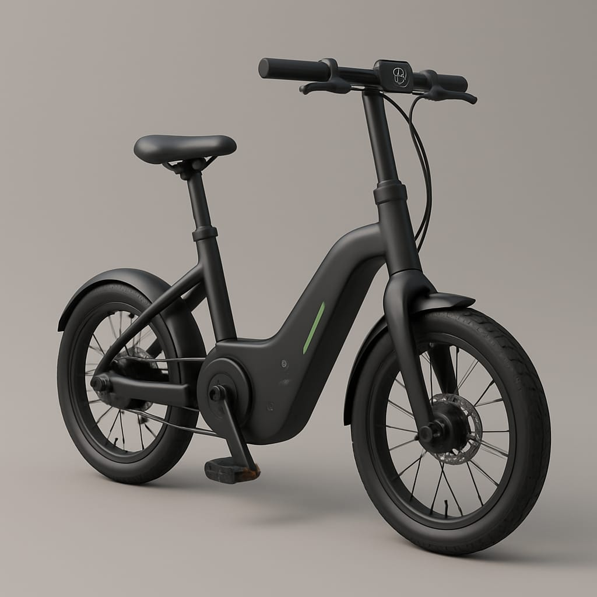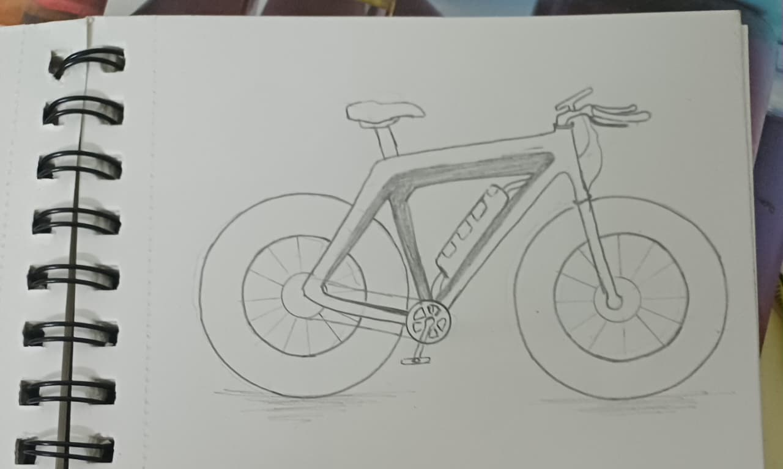

Concept 2 – EcoRide Solar 350 S (Eco-Premium Edition)
User focus: Environment-friendly riders, off-grid users
Key Features
- Flexible solar film integrated on rear box (≈30 W)
- Plug + solar dual charging system
- Standard 350 W BLDC motor with pedal-assist + throttle
- GPS + regenerative controller
- LED dashboard with solar status indicator
Rationale
High solar-charging score (7) and strong eco-identity.
Pros
- Solar recharge adds 10–15 km/day
- Lower running cost, ideal for eco-conscious buyers
Cons
- Slightly higher price (solar integration cost)
- Heavier by ~1.5 kg

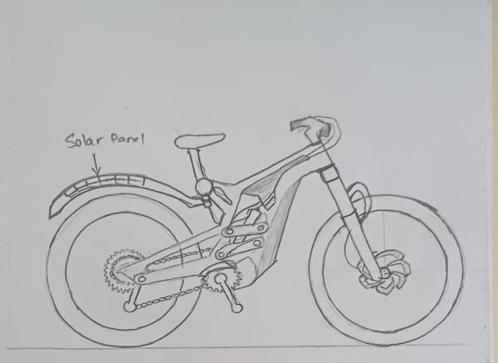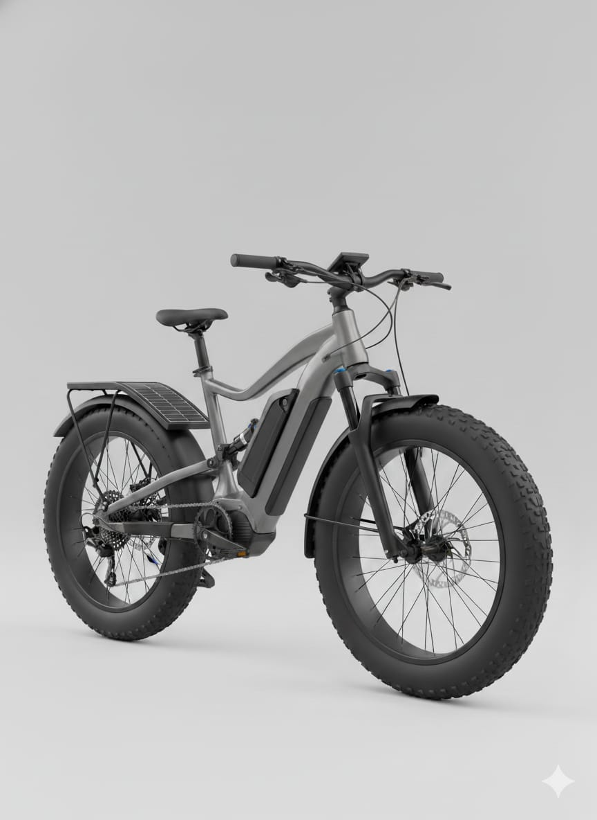
Concept 3 – EcoRide X Swap (Swappable-Battery Fleet Edition)
User focus: Delivery, rental, or heavy-use riders
Key Features
- Replaceable 48 V 15 Ah battery (slide-out drawer)
- Regenerative braking + throttle assist
- 500 W hub motor (higher torque for load)
- Dual-disc hydraulic brakes with brake-cut sensor
- GPS-enabled tracking for fleet management
Rationale
Top scores in replaceable battery (8), regen (8), and safety (9).
Pros
- Continuous use with battery swapping
- Best for delivery or rental applications
Cons
- Heavier frame (~22 kg)
- Complex battery mechanism increases cost
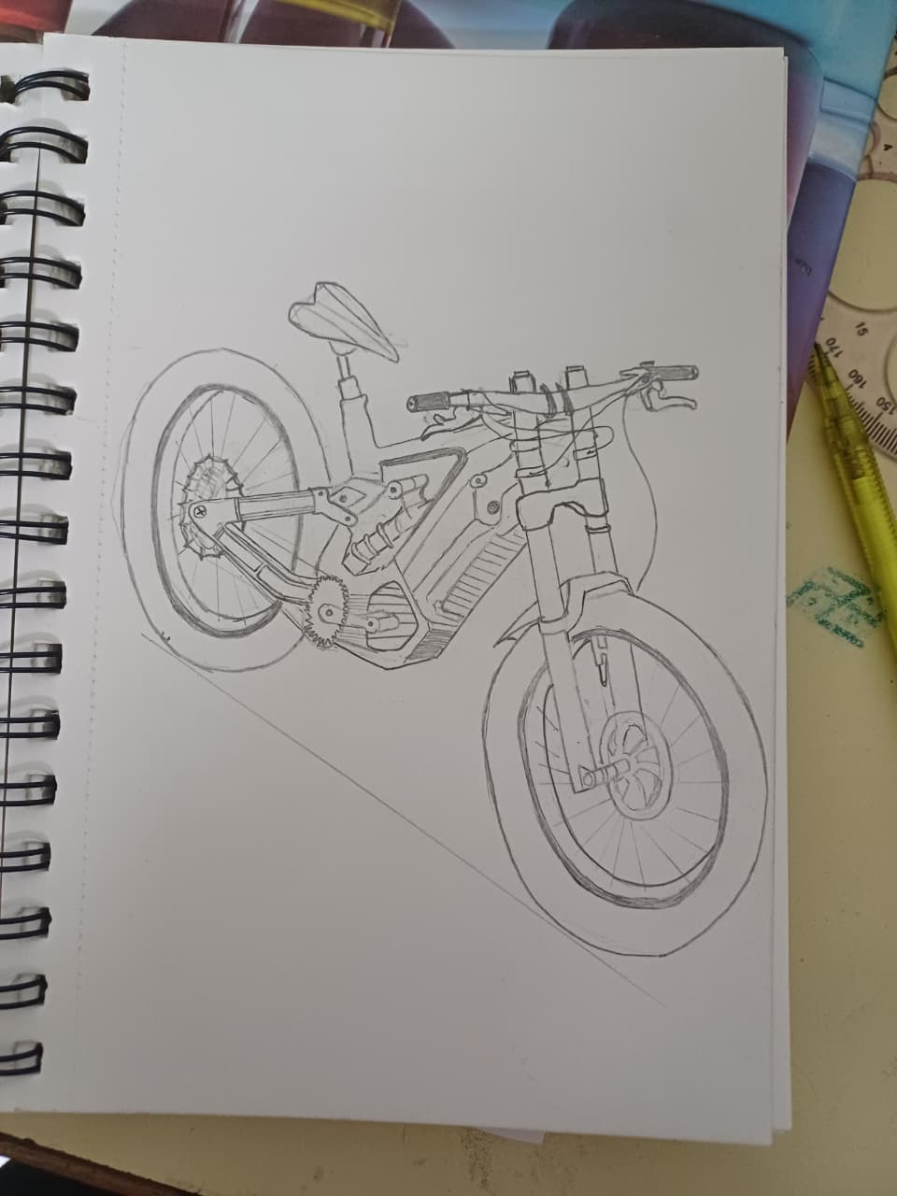
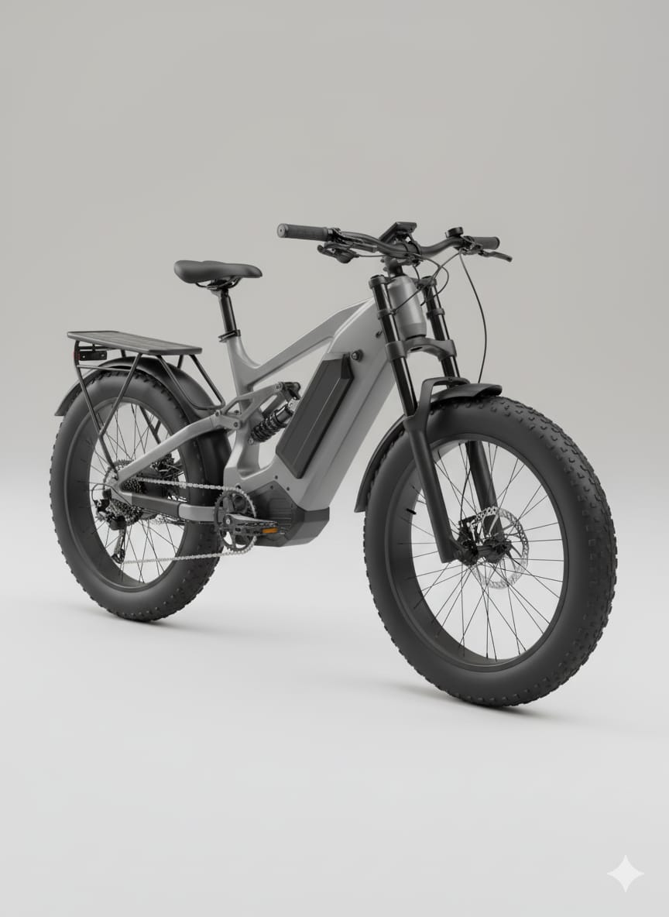
Concept 4 – EcoRide Fold 350 F (Compact Metro Edition)
User focus: Apartment dwellers, train/metro commuters
Key Features
- Quick-fold alloy frame (fold in 20 s)
- Pedal-assist + throttle; small 350 W motor
- Integrated storage box (8 L) under seat
- Optional solar lid for trickle charging
- Soft-grip ergonomics and adjustable seat
Rationale
Excels in storage (8) and compact design (8); balanced all-rounder.
Pros
- Portable, light (≤18 kg folded)
- Perfect for short mixed transport routes
Cons
- Moderate braking power (score 6)
- Limited range (~60–70 km)
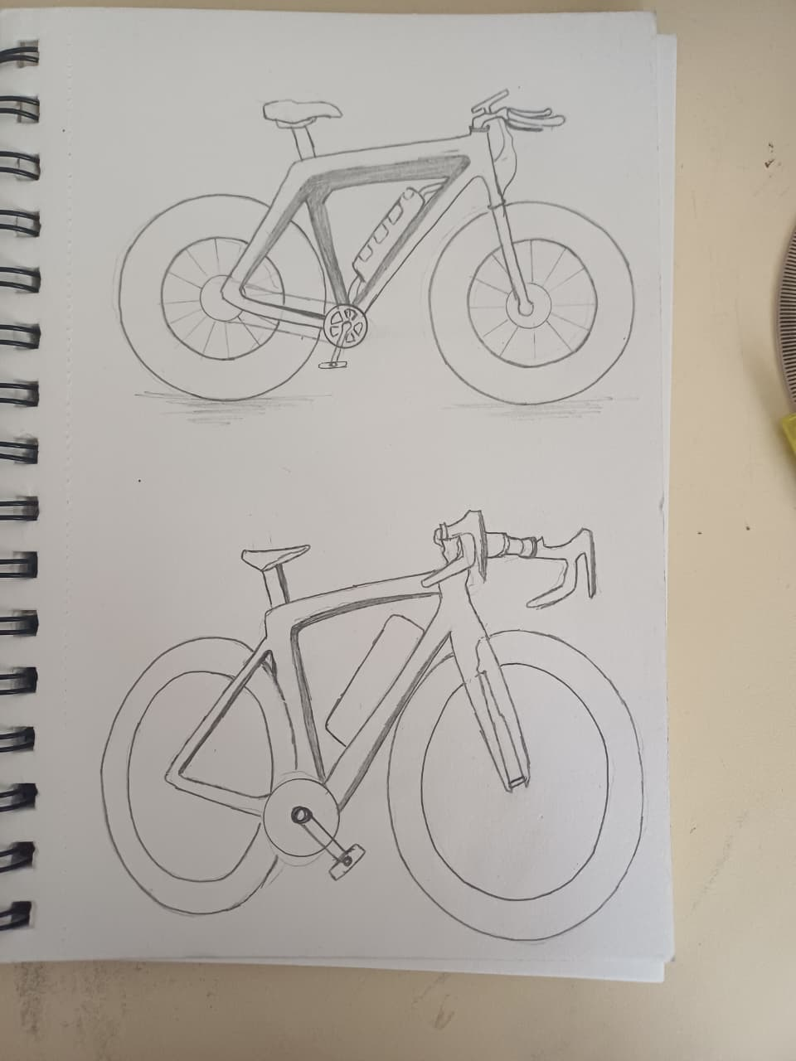
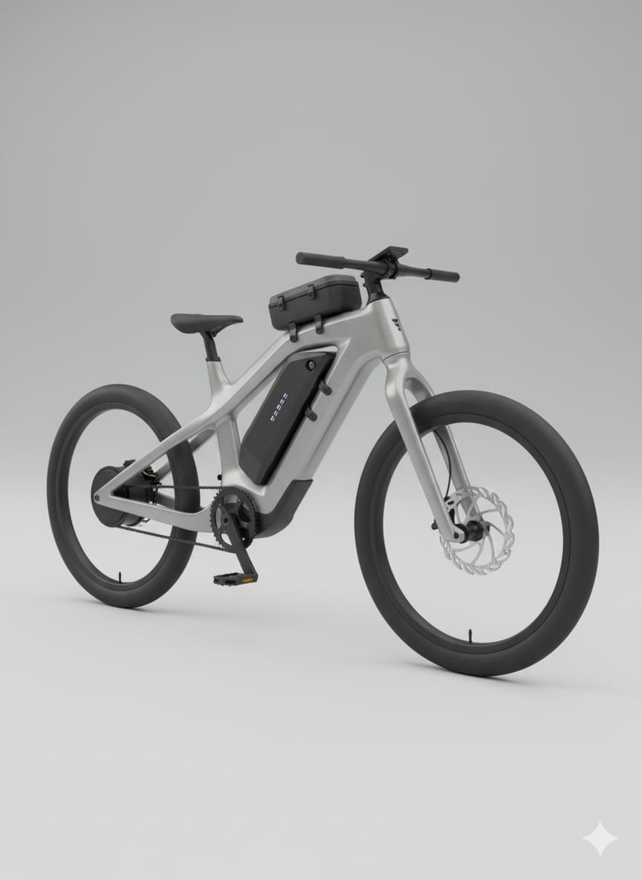
Concept 5 – EcoRide Cargo 350 C (Utility Workhorse)
User focus: Delivery workers, campus logistics, shop owners
Key Features
- Reinforced frame; load capacity up to 180 kg
- 500 W motor with regenerative braking
- Dual-battery option for longer operation
- Extended rear rack with modular cargo box
- Hydraulic brakes + puncture-resistant tyres
Rationale
Strong scores in regen (8), battery (8), and braking (8).
Pros
- Powerful torque; great for cargo applications
- Long range (100–130 km combined mode)
Cons
- Heavy (~25 kg)
- Not ideal for everyday commuting
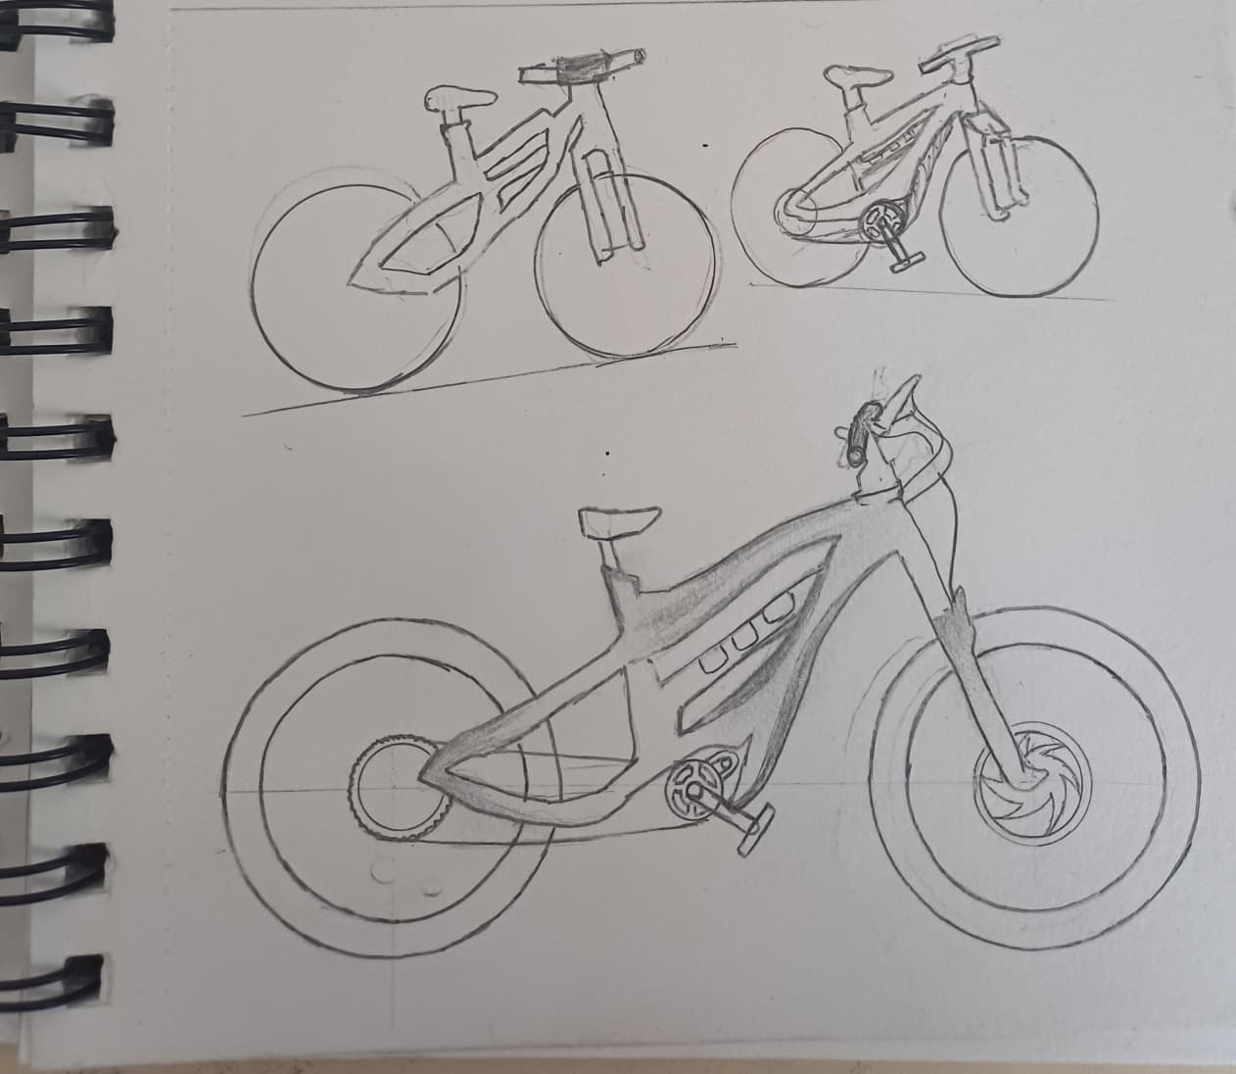
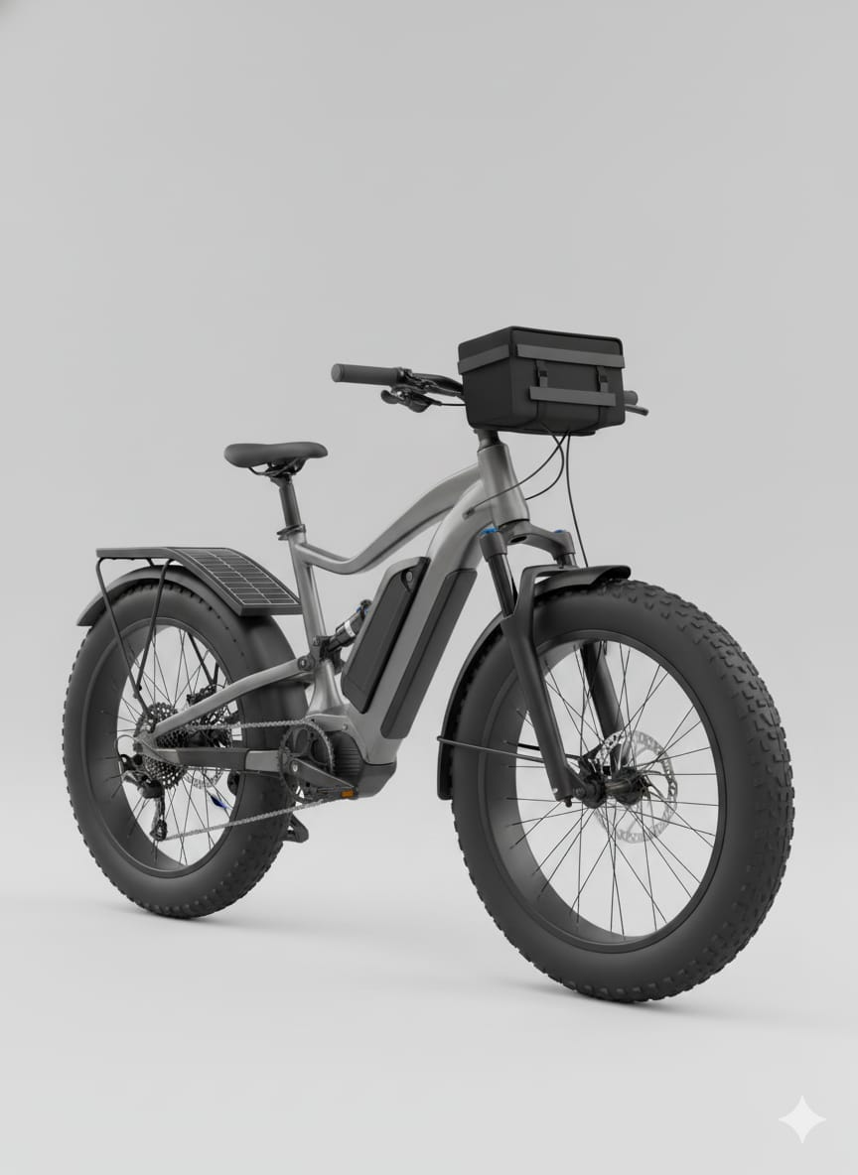
Concept 6 – EcoRide R Sport (Performance Edition)
User focus: Enthusiasts and premium buyers
Key Features
- 500 W mid-drive motor with torque + cadence sensor
- Regenerative braking, swappable battery, throttle-assist
- TFT display with app connectivity and GPS
- Streamlined carbon-composite frame
- Dual hydraulic disc brakes, sporty suspension
Rationale
High in assist (8), safety (7), and innovation; premium spec.
Pros
- High performance, 35–40 km/h top speed
- Attractive, sporty design
Cons
- Costlier (~₹1.7 L)
- Slightly heavier motor assembly
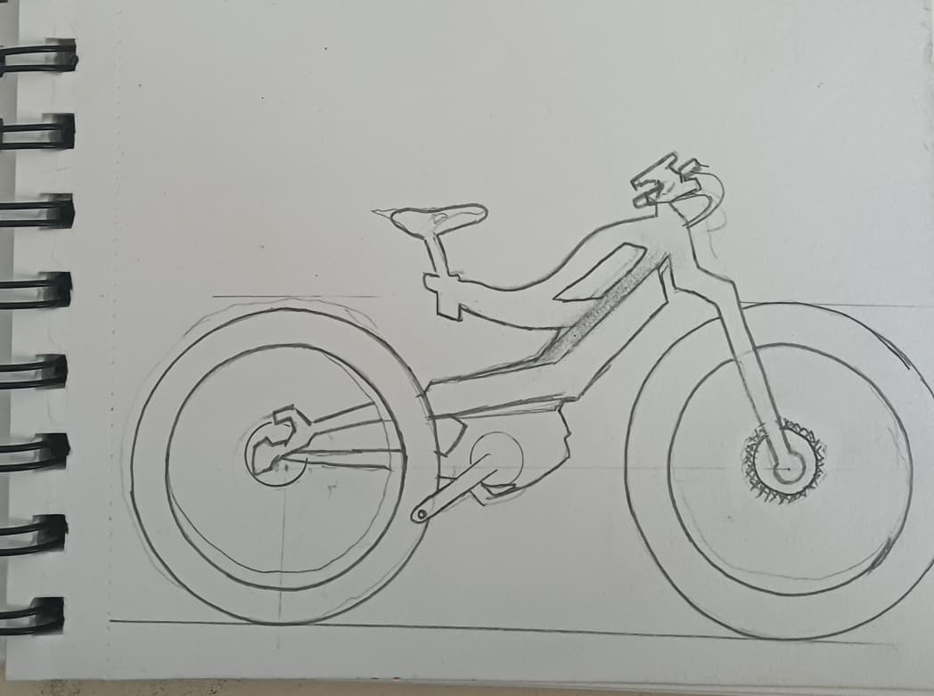
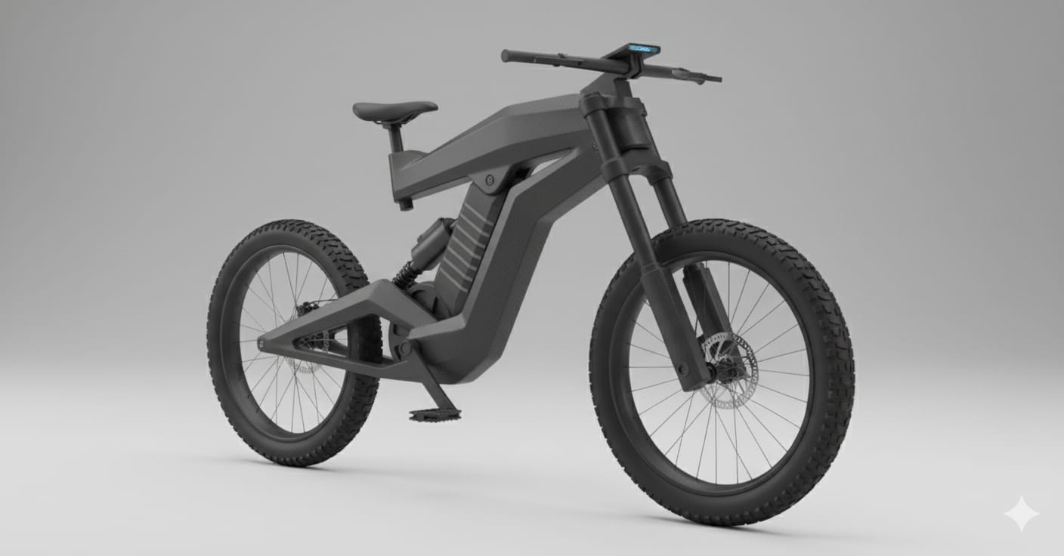
Benefits and Limitations of Each Concept
Model | Benefits | Limitation
EcoRide Lite | Lightweight  Low cost  Easy maintenance  Simple motor  Safe tyres | No regen  No solar  Short range  Few smart features
EcoRide Solar | Solar charging  Eco-friendly  Dual charging  Premium look  Sustainable | Weather dependent  Heavier  Costly  Low regeneration
EcoRide X Swap | Swappable battery  Regenerative braking  GPS tracking  High safety  Fleet-friendly | High cost  Heavy frame  Complex wiring  Needs infrastructure
EcoRide Fold | Foldable  Compact  Portable  Ergonomic  Easy storage | Lower range  Less stability  Weak brakes  High maintenance
EcoRide Cargo | Heavy-duty  High load  Dual battery  Strong brakes  Durable frame | Very heavy  Less efficient  Expensive  Bulky design
EcoRide R Sport | High power  Stylish design  Smart display  GPS + App  Fast charging | Expensive  Complex system  Niche market  Hard maintenance

Concept Improvement and Refinement
Concept 3 (Swappable) is selected as the base for final design improvement due to its modularity and broad usability.
Improvements include adopting the solar charging system (from Concept 2), enhancing frame aesthetics (from Concept 6), and introducing compact folding features (from Concept 4). The final optimized concept achieves high range, flexibility, and user comfort while remaining cost-effective.
Subsystem | Best Solution | Reason for Selection
Structural Frame | Aluminium Alloy | Light, strong, low cost
Drive & Motor | BLDC Hub Motor | Efficient, low maintenance
Battery & Power | Li-ion (18650) | High density, reliable
Control & Connectivity | MCU + LCD + App | Modern,affordable,connected
Ergonomic & Safety | HydraulicBrakes + AdjustableSeat | Safe, comfortable
Storage & Utility | Detachable FRP Box | Light, modular, weatherproof

Product Testing Suggestions for EcoRide Subsystems
1. Frame Testing – Static and dynamic load tests up to 150 kg.
2. Motor & Drive – Efficiency and regenerative braking tests over 100 cycles.
3. Battery System – Thermal and endurance tests (charge–discharge over 500 cycles).
4. Solar Module – Exposure and efficiency testing under various irradiance levels.
5. Ergonomic Assessment – Rider posture trials across height range (150–190 cm).
6. Brake & Safety – Stopping distance ≤3 m at 25 km/h; fatigue test over 1000 stops.
7. App & GPS – Real-time tracking latency and reliability test.
8. Folding and Assembly – 500-cycle fatigue test on joints and hinges.

