CASE STUDY- 4

Objective and Scope
Aesthetically refine the six EcoRide Smart Electric Cycle concepts developed in Case Study III to enhance visual appeal, user comfort, and brand identity.The design goal is to merge function and form so that each technical feature—motor, frame, battery, and storage—contributes to a visually coherent, ergonomic, and emotionally engaging product.
The refinement focuses on expressing technological function through elegant form while adhering to key aesthetic principles:
Shape, Proportion, Unity, Balance, Contrast, Line, Style, and Color:
• Shape & Contour: Replacing angular tube connections with continuous curves for a flowing frame silhouette.
• Proportion & Balance: Optimizing mass between front and rear; refined height–length ratio for stability.
• Unity & Style: Maintaining consistent design cues across the EcoRide family—headlight shape, logo band, and frame arc.
• Contrast: Matte aluminium body with gloss-accent zones on battery housing and display panel.
• Color: Functional color coding—each variant has its own visual identity (Eco-green, Cargo-black, Sport-red, etc.).
• Texture: Mixing brushed metal and matte polymer for tactile richness and durability.

Aesthetic Principle Application to Subsystems
Principle | Applied Feature | Expected Visual Outcome
Shape & Contour | Smooth S-curve spine and curved battery cover | Light, streamlined body flow
Proportion & Mass | Lower frame thicker; slim top-tube for lightness | Stable, grounded form
Unity & Style | Shared EcoRide headlight, LCD cluster, and logo band | Family identity maintained
Line & Direction | Diagonal flow from head tube to rear axle | Dynamic, forward motion
Contrast | Dual finish zones—matte body & gloss details | Depth and visual sophistication
Color & Finish | Variant-specific tones; neutral base + accent highlights | Market distinction
Texture | Matte metallic + anti-slip grip textures | Technical realism & comfort
Functional Attributes Expressed Through Aesthetics
Functional Aspect | Aesthetic Integration | Intended Design Effect
Battery Housing | Semi-flush curved enclosure with color trim | Seamless integration, reduced bulk
Motor & Drive | Metallic ring around hub motor | Emphasizes strength and performance
Solar Module | Curved film following rear rack contour | Expresses sustainability
Display & Controls | Compact LCD with recessed bezel | Organized and modern interface
Lighting | Linear LEDs on handle and rear rack | Visual rhythm and brand unity
Ergonomics | Sculpted seat & angled bars | Communicates comfort visually

Concept-Wise Aesthetic Focus (C1–C5)
Concept | Aesthetic Theme | Functional / Visual Expression
EcoRide Lite | Minimalistic urban design; silver–cyan dual tone. | Lightweight geometry, smooth frame curve; dark base shows stability.
EcoRide X Swap | Industrial precision; modular style. | Slide-out battery drawer outlined in orange; strong structural stance.
EcoRide Fold | Youthful and sleek; diagonal flow. | Hidden fold hinges, slim silhouette; lime-blue colors.
EcoRide Cargo | Power and utility aesthetics. | Extended frame with reinforced lines; black-silver scheme, matte texture.
EcoRide R Sport | Futuristic athletic form; aerodynamic unity. | Carbon-fiber style frame, red-black gloss contrast, LED speed lines.

Major Part Aesthetic Considerations (Concept Examples)
- EcoRide Lite:
Visual Theme: Simple, lightweight, and minimalistic form emphasizing clean urban mobility.
Rendering Focus: Soft frame curvature, silver–cyan color contrast, slim tyres, compact geometry.
Key Highlight: Streamlined aluminium frame with matte finish and subtle cyan highlights.
Type of Customer Focused: Students, office commuters, and first-time e-bike users seeking affordability and simplicity.

Component | Aesthetic Treatment | Visual Effect
Frame | Smooth curve top-tube | Lightweight and friendly
Handlebar | Flat ergonomic with cyan grips | Youthful appeal
Battery Cover | Silver matte with black seam | Technical neatness
Wheels | Thin spokes, dark rim | Agile character
Color Scheme | Silver–Cyan | Calm urban personality
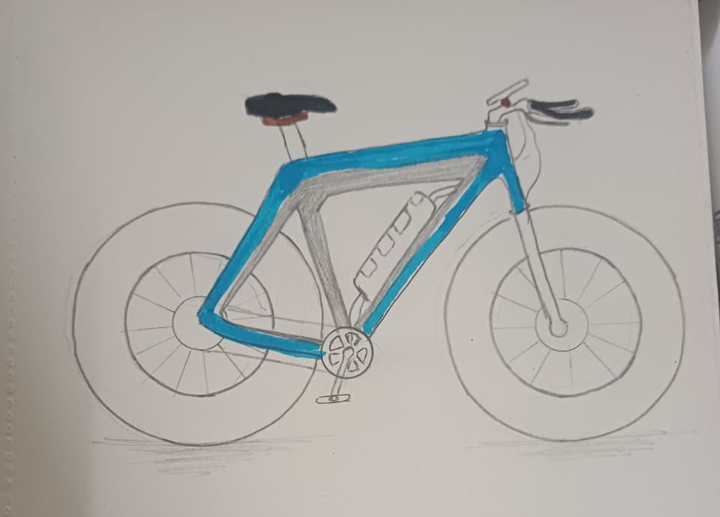
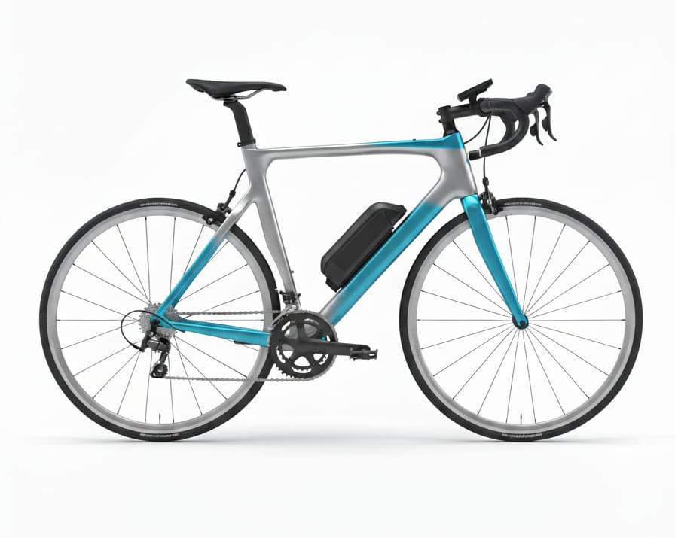
- EcoRide X Swap:
Visual Theme: Robust, industrial-tech aesthetic; modular structure with high visual weight.
Rendering Focus: Sharp orange trims on grey frame, exposed power hub motor, battery drawer highlights.
Key Highlight: Slide-out battery housing with ergonomic handle and locking mechanism accent band.
Type of Customer Focused: Delivery personnel, fleet operators, shared mobility services requiring modular reliability.

Component | Aesthetic Treatment | Visual Effect
Battery Drawer | Highlighted border line | Clear modular identity
Motor Housing | Textured metallic shell | Mechanical strength
Frame | Compact triangle proportion | Stability and power
Color Trim | Orange accent bands | Energy & motion cue
Branding | Engraved “X Swap” near downtube | High-tech feel

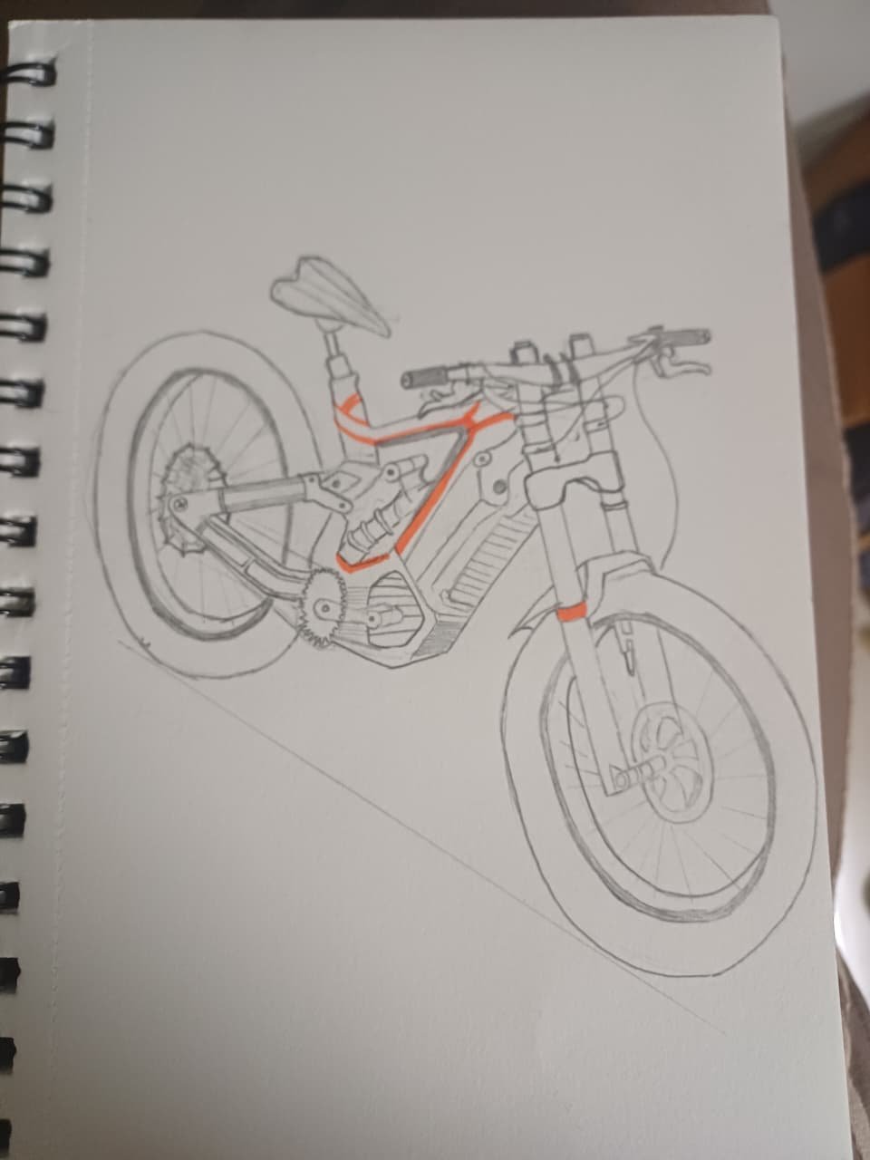
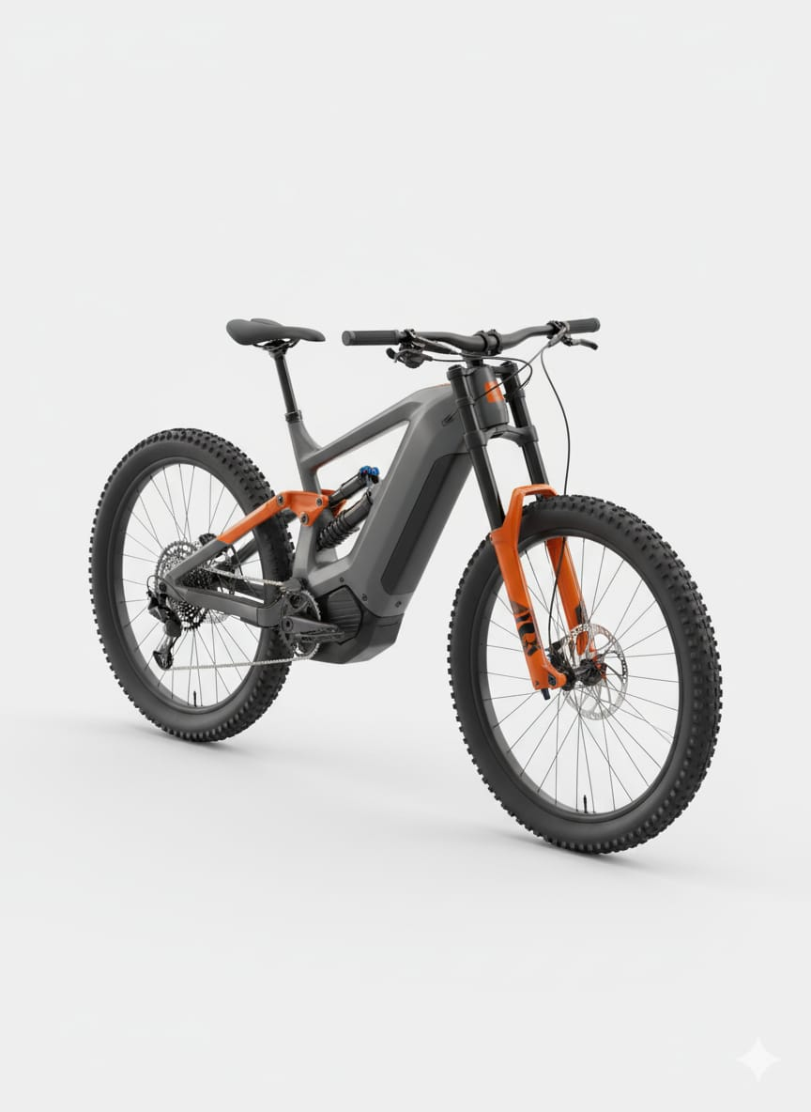
- EcoRide Fold:
Visual Theme: Urban compactness and playful minimalism; design expresses mobility and portability.
Rendering Focus: Diagonal folding line, smooth hinge joints, bright youthful colors (lime/blue).
Key Highlight: Hidden fold mechanism under continuous body curve with compact folded stance.
Type of Customer Focused: Apartment dwellers, metro commuters, and young professionals needing portable transport.

Component | Aesthetic Treatment | Visual Effect
Fold Joint | Hidden under curved housing | Seamless, integrated
Frame | Diagonal main beam | Expresses forward flow
Handlebar | Quick-release hinge with accent | Ease of folding visualized
Color | Bright pastel tones | Youthful energy
Texture | Soft-touch matte | Comfort & trendiness

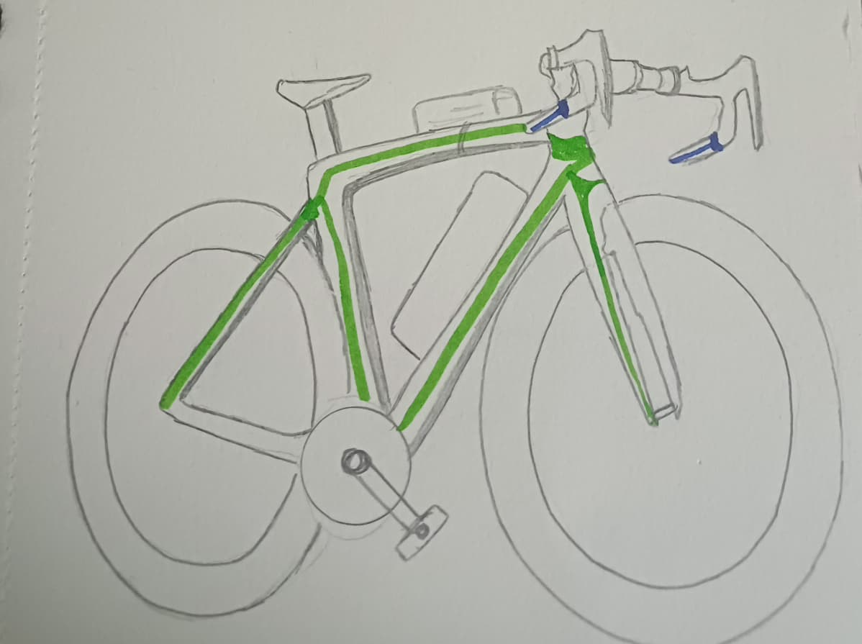

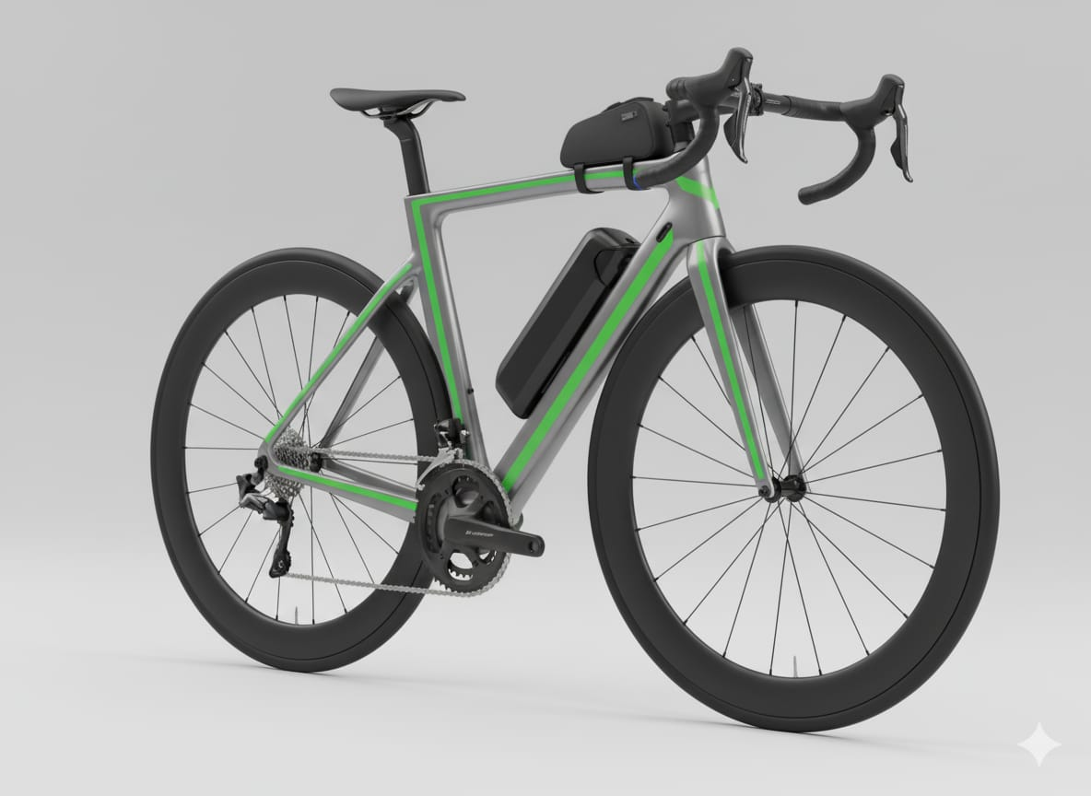
- EcoRide Cargo:
Visual Theme: Functional power; heavy-duty character with balanced proportions and stability.
Rendering Focus: Strong frame lines, extended rear section, dual-disc brakes, matte black industrial texture.
Key Highlight: Reinforced aluminium frame with detachable FRP cargo box and integrated LED tail line.
Type of Customer Focused: Small business owners, campus transport, delivery workers, and logistic operators.

Component | Aesthetic Treatment | Visual Effect
Frame | Extended curved rear beam | Strength & load confidence
Cargo Rack | Blended metal frame | Structural unity
Brakes | Exposed dual-disc calipers | Functional power
Color | Matte Black with Silver rack | Industrial durability
Finish | Anti-glare texture | Heavy-duty appeal

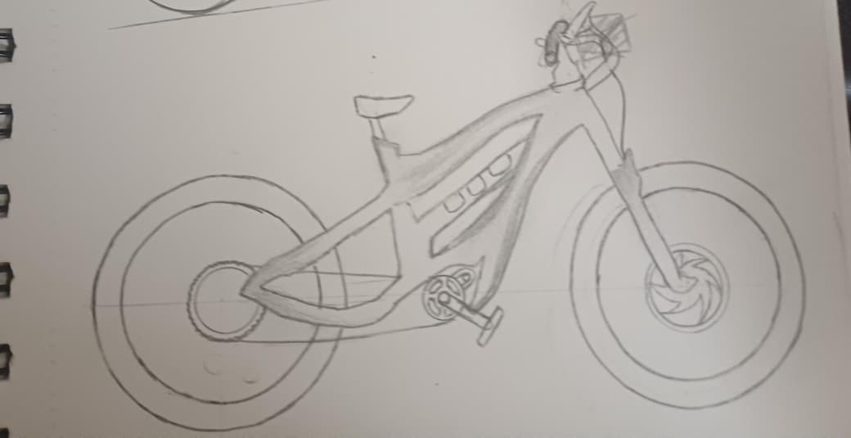
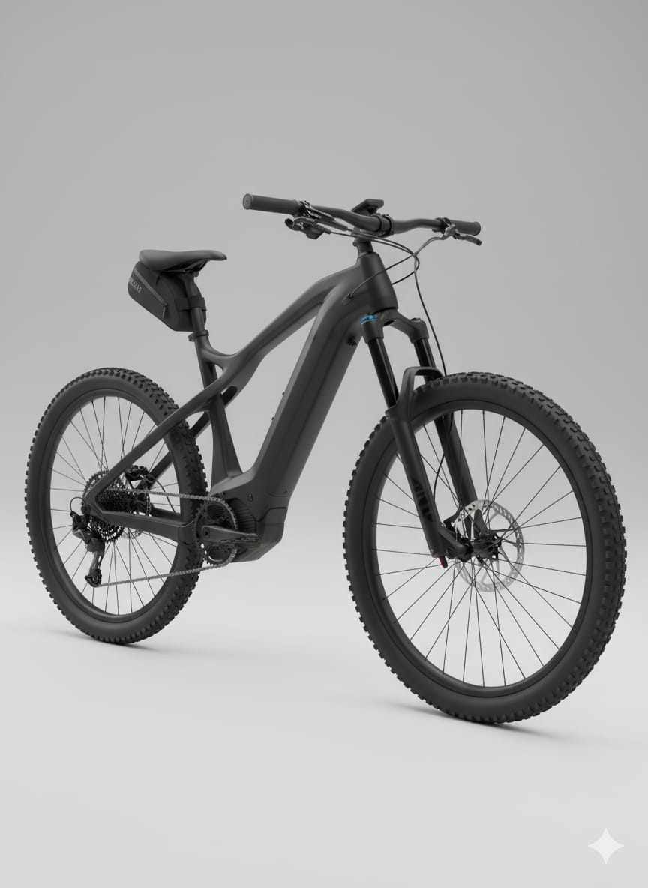

- EcoRide R Sport:
Visual Theme: Futuristic sport aesthetic with aerodynamic surfaces and racing-inspired stance.
Rendering Focus: Carbon-fiber texture, red gloss accents, LED edge strips, muscular mid-drive zone.
Key Highlight: Mid-drive BLDC motor with illuminated logo band and aggressive frame geometry.
Type of Customer Focused: Enthusiasts, fitness riders, and premium segment users valuing performance and tech styling.

Component | Aesthetic Treatment | Visual Effect
Frame | Carbon-fiber style curves | Dynamic speed expression
Motor | Mid-drive with silver hub ring | Centered visual power
Display | TFT touch in gloss housing | Premium sporty finish
Lighting | Thin LED strips on fork | Performance aura
Color Scheme | Gloss Black + Red | Aggressive, high-tech vibe

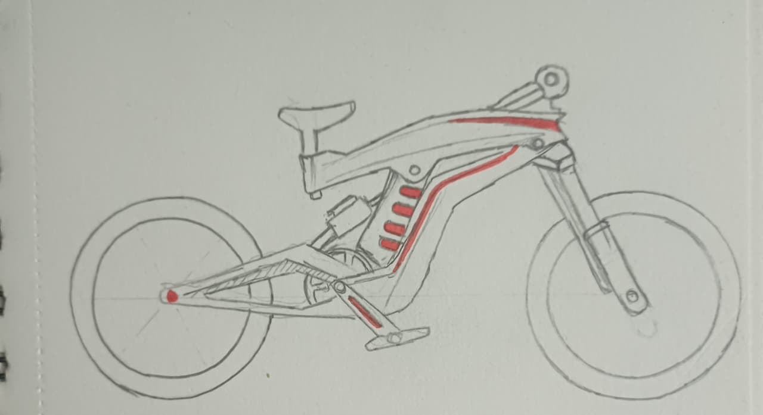

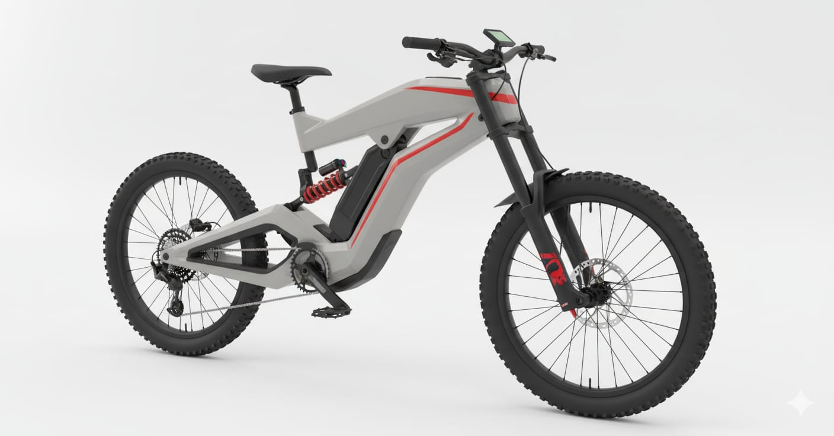

Evaluation of Refined Concepts

Parameter | Best Performing Concepts | Remarks
Unity & Style | C3, C5 | Consistent lines, dynamic character
Colour & Contrast | C2, C3, C5 | Clear identity through tone separation
Proportion & Balance | C1, C4 | Visual stability maintained
Innovation Appeal | C2, C3, C5 | Solar + swappable + performance focus
Market Attractiveness | C5>C2>C4 | R Sport gains highest visual desirability

Concept Improvement and Integration Strategy

Source Concept | Refined Feature | Final Concept (C6X)
C1 | Lightweight minimal design | Reduced visual weight
C2 | Modular swappable base | Functional flexibility
C3 | Compact geometry | Fold-portable potential
C4 | Strengthened dual-brake look | Stability and safety
C5 | Aerodynamic sport styling | High visual energy and flow

Final Hybrid Concept – EcoRide R-X Hybrid Performance Solar Edition:
Key Refinements Introduced
- Form Harmony: Unified curved spine from C1 + aerodynamic flow from C3.
- Visual Lightness: Concealed cables, compact hubs, and integrated lights.
- Material Blending: Matte carbon-polymer body with gloss trims.
- Aesthetic Energy Flow: Thin red LED strips accentuate motion.
- Proportion Re-tuning: Shorter tail geometry for balanced weight.
- Ergonomic Enhancement: Adjustable seat-handle ratio optimized for sporty posture.
- Color Philosophy:
  - Professional Sport: Graphite / Red
  - Eco Hybrid: Green / Black
  - Urban Limited: Silver / Blue
Concept Theme: Performance meets Sustainability — merging speed, technology, and eco-design in one unified aesthetic form.

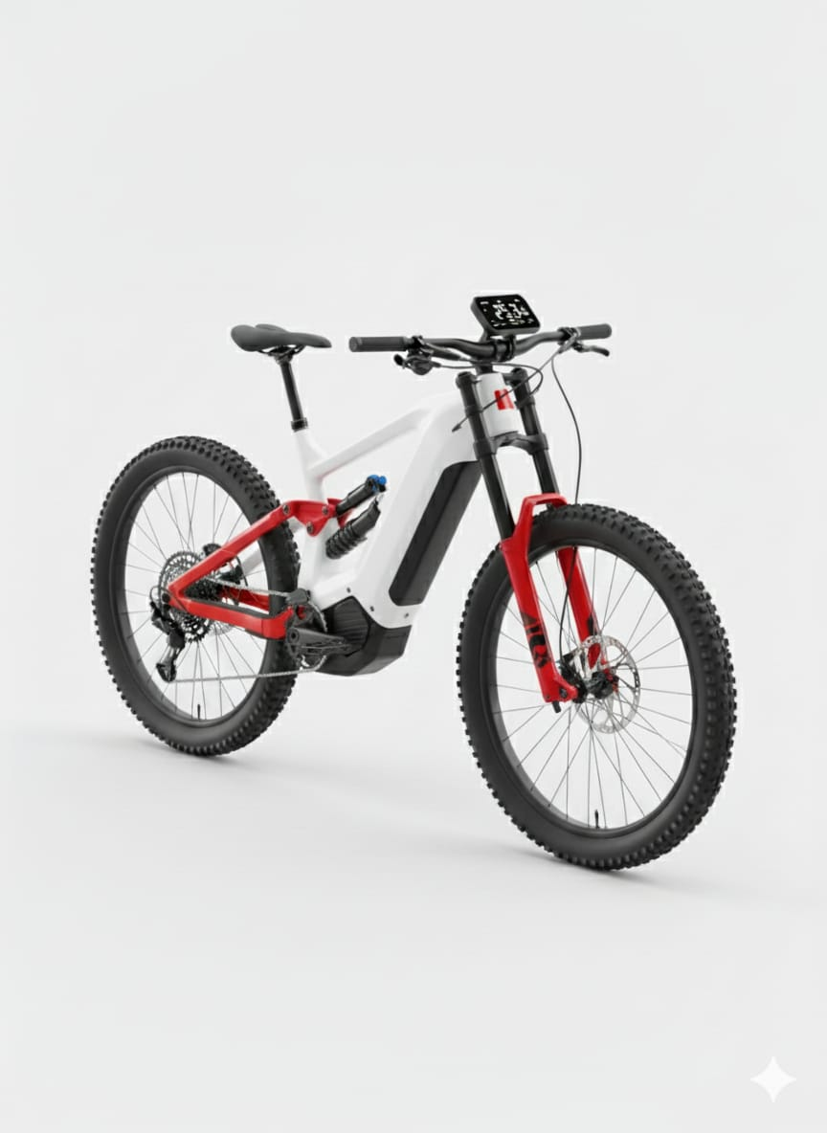

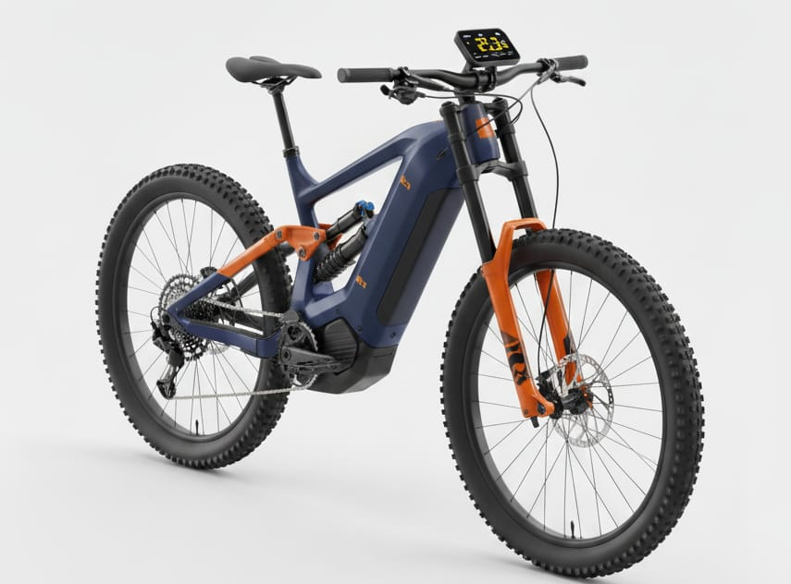
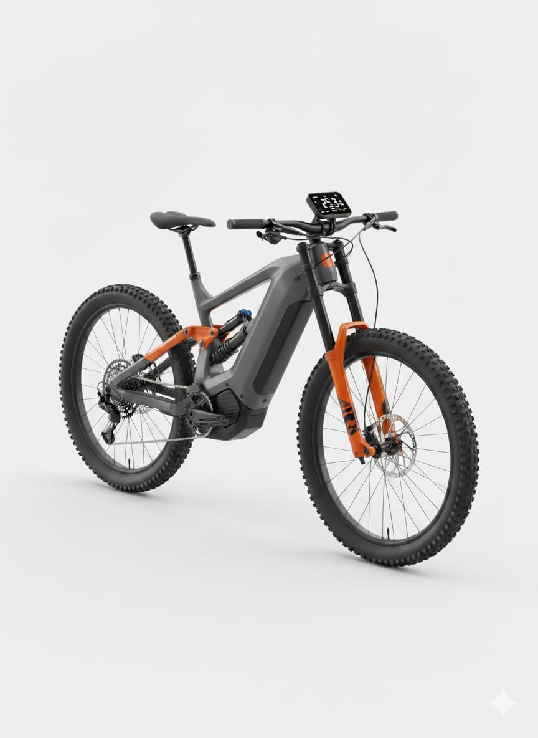

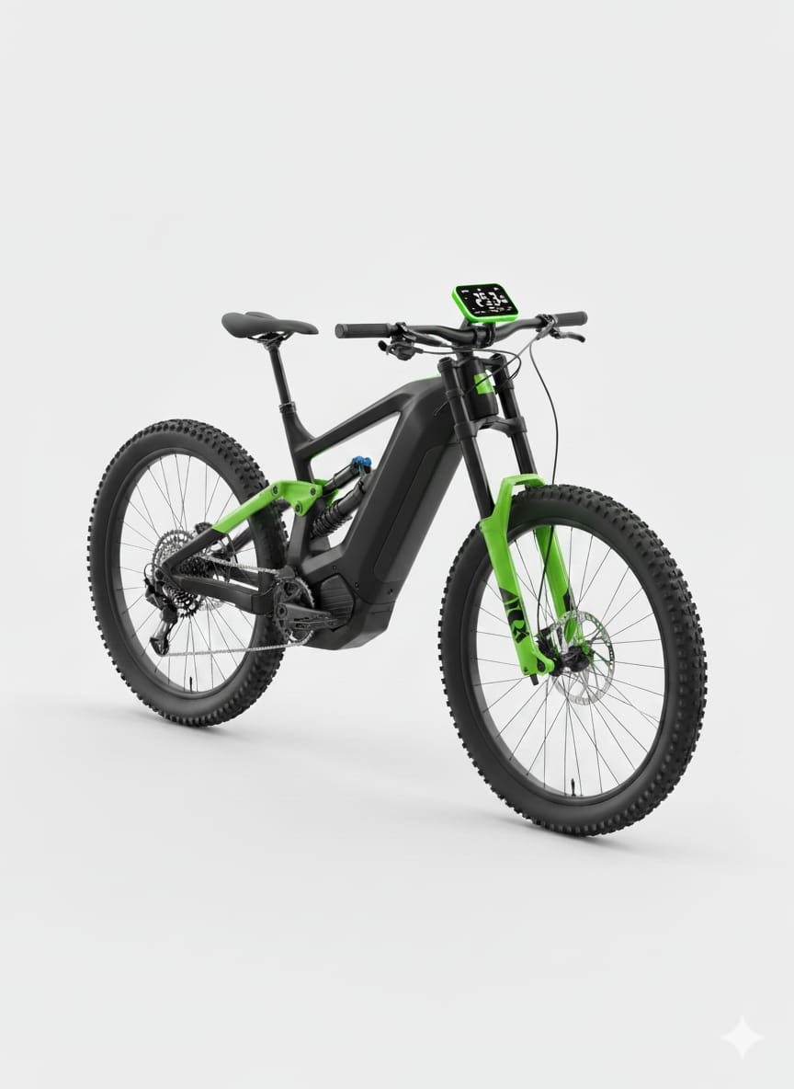

Comparative Summary of Aesthetic Focus
Design Attribute | C1 | C2 | C3 | C4 | C5
Proportion | High | Very High | High | Very High | Very High
Contrast & Color Depth | Medium | High | Medium | Medium | Very High
Form Complexity | Low | Medium-High | Medium | Medium | High
Visual Weight Balance | Excellent | Excellent | Strong | Strong | Excellent
Market Appeal | Medium | Fleet / Smart | Urban | Utility | Premium Flagship

Aesthetic Differentiation of EcoRide Variants
Aesthetic Parameter |  | X Swap 350X | Fold 350 F | Cargo 350 C | R Sport 500
  Lite 350
hape & Contour |  | Strong angular-modular shapes; exposed mechanical contour | Short, compact diagonal frame; rounded fold joints | Heavy-duty straight lines; strong geometric load-bearing shape | Aerodynamic racing curves; muscular mid-frame
  Smooth minimal curves; clean straight line frame
Proportion & Balance | Lightweight top, medium base | Bottom-heavy due to battery drawer; high visual stability | Compact height; shorter wheelbase | Heavier rear portion; long rear carrier | Performance-oriented: long front & raised tail
Unity & Style | Minimal styling unity; simple color band | Industrial tech unity; battery drawer + orange trims | Urban compact unity; hinge hidden for seamless style | Utility unity; rack, box & frame merge visually | Sport unity; carbon-fiber pattern + red LED line
Contrast | Mild contrast; matte silver + small gloss highlights | High contrast; matte graphite body + bright orange trims | Soft-touch matte surface with glossy folding joints | Matte black industrial frame + silver cargo box | Strong contrast; gloss black + red racing accents
Color Theme | Silver–Cyan (Urban) | Graphite–Orange (Tech) | Blue–Lime (Youth) | Black–Grey (Industrial) | Carbon Grey–Red (Sport
Texture Treatment | Satin frame + soft grips | Matte industrial body + textured battery housing | Soft-touch matte polymer + grip finish | Rugged matte texture for durability | Carbon-fiber texture + gloss highlights
Lighting Aesthetics | Basic LED headlight | Functional fleet-oriented LEDs | Minimal, compact LEDs | Strong rear visibility line integrated in cargo rack | Thin red performance LED lines (signature)
Brand Identity Expression | Simple, clean, budget-friendly | Industrial “X” identity; modularity highlight | Youth, metro branding with bright colors | Workhorse branding; solid and dependable | Premium flagship look; racing-inspired identity
Emotional Appeal | Friendly & minimal | Technical & powerful | Playful & portable | Strong & reliable | Aggressive & futuristic

Conclusion
The EcoRide Smart Electric Cycle aesthetic refinement integrates technical engineering with emotional design appeal.
By systematically applying mass, unity, proportion, balance, contrast, and color, the six models now communicate their unique identities while belonging to a unified brand family.
The final EcoRide R-X Hybrid Solar Edition demonstrates the fusion of performance, sustainability, and form harmony, representing the pinnacle of the EcoRide design evolution.

