DA-2
Question 1:

Code:

#include <iostream>
#include <string>
using namespace std;

class Person {
protected:
string name;
int universityID;

public:
Person(string name, int universityID) : name(name), universityID(universityID) {}

virtual void display() const {
cout << "Name: " << name << endl;
cout << "University ID: " << universityID << endl;
}
};

class Faculty : public Person {
private:
string rank;

public:
Faculty(string name, int universityID, string rank) : Person(name, universityID), rank(rank) {}

void display() const override {
Person::display();
cout << "Rank: " << rank << endl;
}
};

class UndergraduateStudent : public Person {
private:
int yearOfStudy;

public:
UndergraduateStudent(string name, int universityID, int yearOfStudy) : Person(name, universityID), yearOfStudy(yearOfStudy) {}

void display() const override {
Person::display();
cout << "Year of Study: " << yearOfStudy << endl;
}
};

class GraduateStudent : public Person {
private:
int supervisorUniversityID;

public:
GraduateStudent(string name, int universityID, int supervisorUniversityID) : Person(name, universityID), supervisorUniversityID(supervisorUniversityID) {}

void display() const override {
Person::display();
cout << "Supervisor's University ID: " << supervisorUniversityID << endl;
}
};

int main() {
Faculty faculty("John Doe", 12345, "Associate Professor");
UndergraduateStudent undergrad("Alice Smith", 54321, 2);
GraduateStudent grad("Bob Johnson", 98765, 12345);
cout << "Faculty Information:" << endl;
faculty.display();

cout << "\nUndergraduate Student Information:" << endl;
undergrad.display();

cout << "\nGraduate Student Information:" << endl;
grad.display();

return 0;
}

Output:



Question 2:

#include <iostream>
#include <string>
using namespace std;

class Book {
protected:
string title;
string author;
int year;
public:
Book(string title, string author, int year) : title(title), author(author), year(year) {}

virtual void display() {
cout << "Title: " << title << endl;
cout << "Author: " << author << endl;
cout << "Year: " << year << endl;
}
};

class Reference_Book : public Book {
private:
string topic;
public:
Reference_Book(string title, string author, int year, string topic) : Book(title, author, year), topic(topic) {}

void display() override {
cout << "Title: " << title << endl;
cout << "Author: " << author << endl;
cout << "Year: " << year << endl;
cout << "Topic: " << topic << endl;
}
};

class Magazine : public Book {
private:
string issue;
public:
Magazine(string title, string author, int year, string issue) : Book(title, author, year), issue(issue) {}

void display() override {
cout << "Title: " << title << endl;
cout << "Author: " << author << endl;
cout << "Year: " << year << endl;
cout << "Issue: " << issue << endl;
}
};

int main() {
Book book1("The Great Gatsby", "F. Scott Fitzgerald", 1925);
Reference_Book ref_book("The C++ Programming Language", "Bjarne Stroustrup", 1985, "Programming");
Magazine magazine("National Geographic", "Various", 1888, "April 2024");

cout << "Book:" << endl;
book1.display();

cout << "\nReference Book:" << endl;
ref_book.display();

cout << "\nMagazine:" << endl;
magazine.display();

return 0;
}

if(arr1[j]>arr1[j+1]){
int temp=arr1[j];
arr1[j]=arr1[j+1];
arr1[j+1]=temp;
}
}
}
printf("Array 1:\n");
for (int i=0;i<a;i++)

Output:

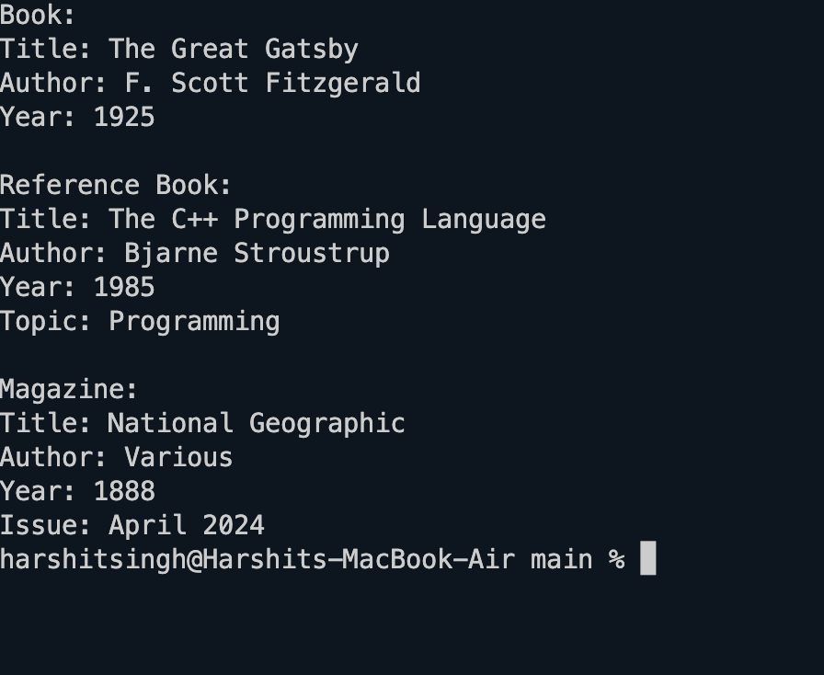

Question 3:

#include <iostream>
#include <string>
using namespace std;

class ItemType {
private:
string name;
int deposit;
int costPerDay;
public:
ItemType(string name, int deposit, int costPerDay) {
this->name = name;
this->deposit = deposit;
this->costPerDay = costPerDay;
}

// Getters
string getName() const {
return name;
}

int getDeposit() const {
return deposit;
}

int getCostPerDay() const {
return costPerDay;
}

// Setters
void setName(string name) {
this->name = name;
}

void setDeposit(int deposit) {
this->deposit = deposit;
}

void setCostPerDay(int costPerDay) {
this->costPerDay = costPerDay;
}

// Display method
void display() const {
cout << "Item Name: " << name << endl;
cout << "Deposit: $" << deposit << endl;
cout << "Cost Per Day: $" << costPerDay << endl;
}
};

int main() {
string name;
int deposit, costPerDay;

cout << "Enter item name: ";
getline(cin, name);
cout << "Enter deposit amount: ";
cin >> deposit;
cout << "Enter cost per day: ";
cin >> costPerDay;

ItemType item(name, deposit, costPerDay);

cout << "\nItem Details:" << endl;
item.display();

return 0;
}

Output:
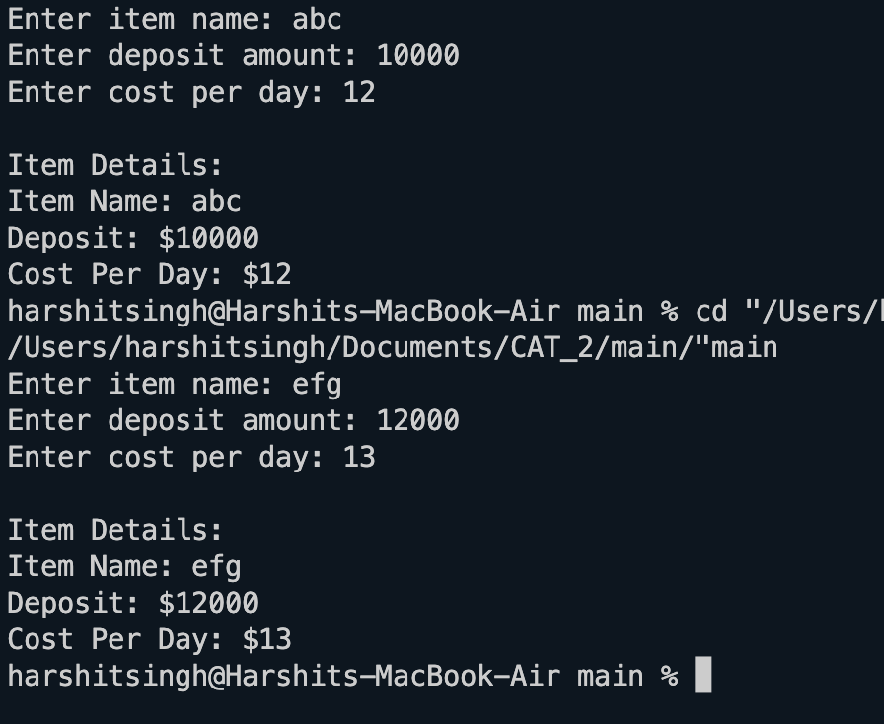

Question 4:

#include <iostream>
#include <string>
using namespace std;

class Account {
private:
int accountID;
string holderName;
double balance;

public:
// Constructor with validation
void get(){
cin >> accountID;
cin >> holderName;
cin >> balance;
}
Account(int accountID = -1, string holderName = "Unknown", double balance = 0.0) {
if (accountID >= 100 && accountID <= 999) {
this->accountID = accountID;
} else {
this->accountID = -1; // Invalid ID
}
this->holderName = holderName;
this->balance = (balance >= 0) ? balance : 0.0;
}

// Method to deposit money into the account
double credit(double amount) {
if (amount > 0) {
balance += amount;
}
return balance;
}

// Method to display account information
void display() const {
cout << "Account ID: " << accountID << endl;
cout << "Holder Name: " << holderName << endl;
cout << "Account Balance: $" << balance << endl;
}
};

int main() {
Account account;
account.get();
account.display();
double depositAmount;
cout << "\nEnter the amount: $";
cin >> depositAmount;

double newBalance = account.credit(depositAmount);

cout << "New Balance: $" << newBalance << endl;

return 0;
}

Output:

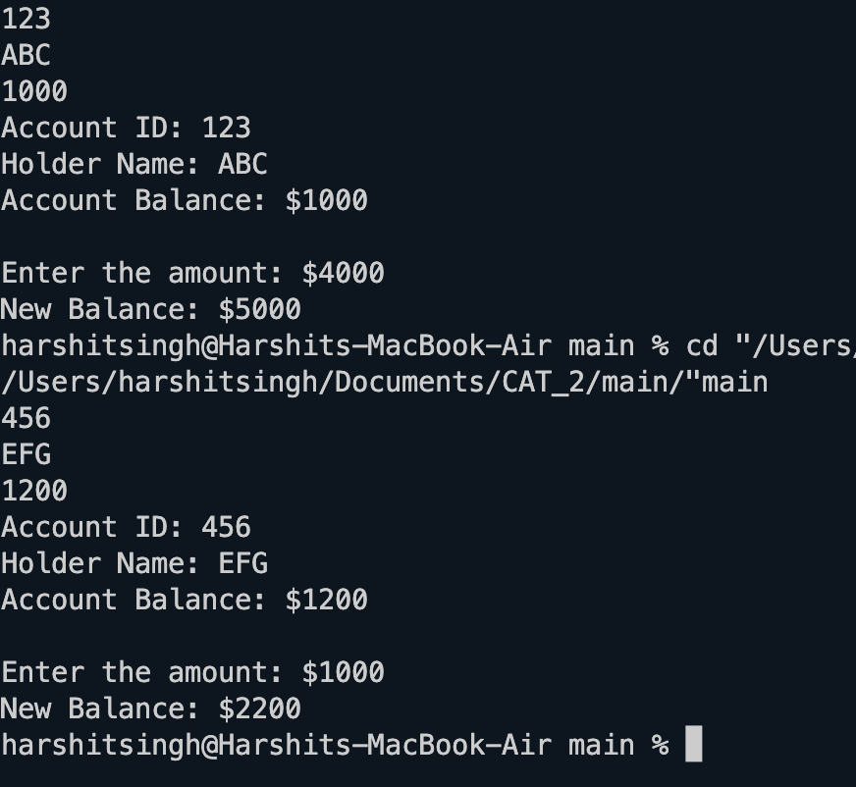

Question 5:

##include <iostream>
using namespace std;

class DummyNumberValidator {
private:
int number;
int k;

// Function to calculate the sum of digits of a number
int sumOfDigits(int num) {
int sum = 0;
while (num > 0) {
sum += num % 10;
num /= 10;
}
return sum;
}

public:
// Constructor
DummyNumberValidator(int num, int k) : number(num), k(k) {}

// Destructor
~DummyNumberValidator() {
cout << "Object destroyed." << endl;
}

// Method to check if the number is a valid dummy number
bool isValidDummyNumber() {
// Check if the number is positive
if (number <= 0) return false;

// Check if the sum of digits is divisible by 2, 3, or 5, and also divisible by k
int sum = sumOfDigits(number);
if (sum % 2 == 0 || sum % 3 == 0 || sum % 5 == 0) {
if (sum % k == 0) {
return true;
}
}
return false;
}
};

int main() {
int N, dummyNumber, k;
cout << "Enter the value of N: ";
cin >> N;
cout << "Enter the dummy number: ";
cin >> dummyNumber;
cout << "Enter the value of k: ";
cin >> k;

// Create an object of DummyNumberValidator class
DummyNumberValidator validator(dummyNumber, k);

if (validator.isValidDummyNumber()) {
cout << dummyNumber << " is a valid dummy number." << endl;
} else {
cout << dummyNumber << " is not a valid dummy number." << endl;
}

return 0;
}

Output:

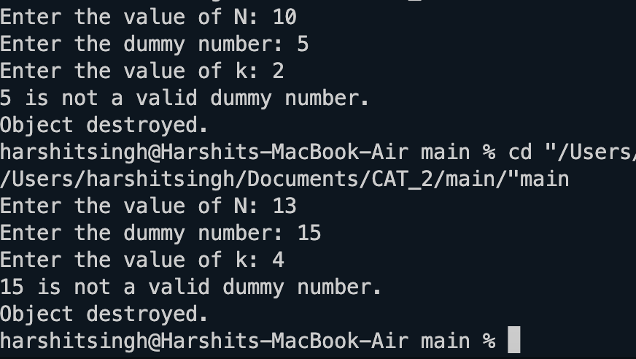

Question 6:

#include <iostream>
using namespace std;

class Account {
private:
int accountNumber;
double amount;
static double interestRate; // Static data member for interest rate

public:
// Constructor
Account(int accountNumber, double amount) {
this->accountNumber = accountNumber;
this->amount = amount;
}

void calculateAndAddInterest() {
double monthlyInterest = (amount * interestRate) / 12.0;
amount += monthlyInterest;
cout << "Monthly interest added. New balance: $" << amount << endl;
}

static void setInterestRate(double rate) {
interestRate = rate;
}
};

double Account::interestRate = 0.0;

int main() {
Account::setInterestRate(0.05);
Account account(123456, 1000.0);
account.calculateAndAddInterest();
return 0;
}

Output:



Question 7:

#include <iostream>
#include <string>
using namespace std;

class AutoInsurance {
private:
int age;
string name;
string state;
string insuranceID;
static int count; // Static data member to count the number of objects

public:

void get(){
cin >> age;
cin >> name;
cin >> state;
cin >> insuranceID;
}
// Default constructor
AutoInsurance() {
age = 0;
count++;
}

// Parameterized constructor
AutoInsurance(int age, string name, string state, string insuranceID) {
this->age = age;
this->name = name;
this->state = state;
this->insuranceID = insuranceID;
count++;
}

// Destructor
~AutoInsurance() {
cout << name << " is deleted" << endl;
}

// Function to calculate premium
void calculatePremium() {
if ((age >= 16 && age <= 80) && (state == "TN" || state == "KE")) {
int basePrice = (state == "TN") ? 500 : 1000;
int premium = basePrice + 2 * (1000 - age);
cout << "Driver " << count << ": " << premium << endl;
} else {
cout << "Driver " << count << ": Invalid input" << endl;
}
}

// Static member function to get the count of objects
static int getCount() {
return count;
}
};

// Initializing static data member
int AutoInsurance::count = 0;

int main() {

AutoInsurance driver1;
driver1.get();
AutoInsurance driver2;
driver2.get();
AutoInsurance driver3;
driver3.get();

driver1.calculatePremium();
driver2.calculatePremium();
driver3.calculatePremium();

// Displaying number of objects created
cout << "No of objects: " << AutoInsurance::getCount() << endl;

return 0;
}

Output:



