VEHICLE STEERING RESPONSE
VIRTUAL-PLATFORM PROGRAMMER GUIDE
Conversion of the verified Simulink model into a user-friendly software module
Reference model | Vehicle_Steering_Response_Organized_All_in_One_With_Legends.slx
Codex instruction file | AGENTS.md
Target module | Vehicle Steering Response page within the common virtual platform
Primary visual output | Top-down animated vehicle with trajectory and live response plots
Prepared for the ATU Virtual Laboratory Platform Project

1. Purpose of This Guide
This guide explains what the programmer and Codex are expected to build from the verified Vehicle Steering Response Simulink model. It is not a replacement for the Codex instruction file. The AGENTS.md file contains the complete implementation task, the reference TypeScript engine, acceptance tests and delivery requirements. This guide gives the human programmer a clear view of the model, the software architecture, the required interface and the final visual output.
Use: Place AGENTS.md in the root of the virtual-platform repository before starting Codex. Place the reference .slx model in a clearly named reference folder. Codex must inspect the existing platform and adapt to its current technology stack instead of creating an unrelated second application.

1.1 Conversation Reference
A shared-chat link may be added to AGENTS.md so Codex can consult the development history if necessary. The essential requirements are already embedded in AGENTS.md, so the link remains supplementary.
Shared ChatGPT conversation: https://chatgpt.com/share/6adcf7b2-4a50-83e9-8a40-829ee976507b
To complete it: open this ChatGPT conversation, select Share, copy the share link, and replace the placeholder in AGENTS.md.

1.2 What Codex Is Expected to Produce
- A reusable software simulation engine containing the converted vehicle equations.
- A user-facing virtual-platform page with editable parameters and clear validation.
- Time-response plots with titles, units and legends matching the four Simulink scope groups.
- A top-down animated vehicle that follows the calculated X-Y trajectory and rotates with heading angle.
- CSV and JSON result export.
- A named output object and an eleven-element platform signal vector for future model coupling.
- Automated validation against the verified baseline case.

2. Scientific Scope of the Converted Model
The converted module represents the same planar lateral-yaw bicycle model implemented in the Simulink file. It demonstrates how steering angle, vehicle speed, mass, yaw inertia, axle geometry and tyre cornering stiffness influence yaw rate, sideslip, lateral acceleration, tyre forces, turning radius, heading and trajectory.
Boundary: The software must not claim to simulate suspension travel, body roll, pitch, wheel hop, nonlinear tyre saturation, ABS, traction control or electronic stability control. Those functions are outside the present model.

2.1 Included Functions
- Road-wheel steering input and steering-wheel angle conversion.
- Constant longitudinal speed with minimum-speed protection.
- Vehicle sideslip and yaw-rate state calculations.
- Linear front and rear tyre slip angles and lateral forces.
- Lateral acceleration and turning radius.
- Heading angle and global X-Y trajectory.
- Eleven output signals for platform integration.

2.2 Main Assumptions
Assumption | Meaning for the User Interface
Linear bicycle model | The left and right tyres on each axle are represented by one equivalent tyre.
Linear tyre force | Lateral tyre force is proportional to slip angle; force saturation is not modelled.
Constant longitudinal speed | The selected speed remains fixed throughout one simulation.
Small-angle operating region | Results are intended for normal steering-response study, not crash or extreme-racing conditions.
Planar motion | The vehicle moves in X-Y and rotates in yaw; vertical and roll motion are excluded.
Zero initial state | Sideslip, yaw rate, heading and position start from zero.

3. Required Input Data
The interface must present each input with a unit, default value, tooltip and validation rule. Inputs should be grouped into steering scenario, operating condition, and vehicle parameters.
Parameter | Symbol | Unit | Default | Validation / Treatment
Road-wheel steering amplitude | delta | deg | 1.0 | Finite; positive or negative steering allowed
Steering application time | - | s | 1.0 | Within simulation duration
Vehicle speed | V | km/h | 60 | Non-negative; U = max(V/3.6, 0.5)
Base vehicle mass | m0 | kg | 1500 | Non-negative
Payload | mp | kg | 0 | Non-negative
Yaw moment of inertia | Iz | kg.m^2 | 2500 | Greater than zero
CG to front axle | a | m | 1.2 | Greater than zero
CG to rear axle | b | m | 1.6 | Greater than zero
Front cornering stiffness | Cf | N/rad | 80000 | Greater than zero
Rear cornering stiffness | Cr | N/rad | 80000 | Greater than zero
Steering ratio | is | - | 16 | Greater than zero
Simulation duration | - | s | 10 | Greater than zero
Numerical step | dt | s | 0.01 | Recommended 0.001 to 0.05

3.1 Internal Protections
U = max(V / 3.6, 0.5) | (1)
The vehicle speed entered in kilometres per hour is converted to metres per second. The internal speed is not allowed to fall below 0.5 m/s because the slip-angle equations divide by speed.
m = clamp(m0 + mp, 100, 50000) | (2)
Base mass and payload are added. The reference model limits total mass to the range 100-50000 kg. The interface should still warn the user when an unrealistic value is entered.

4. Converted Mathematical Logic
The programming implementation must use the same state order and equations as the Simulink model. The recommended state vector is x = [beta, r, psi, X, Y]. A fixed-step fourth-order Runge-Kutta method should update the states at each time step.

4.1 Steering and Tyre Equations
delta = delta_deg (pi / 180) | (3)
alpha_f = delta - beta - (a r / U) | (4)
alpha_r = -beta + (b r / U) | (5)
F_yf = C_f alpha_f | (6)
F_yr = C_r alpha_r | (7)
The front and rear slip angles are calculated from steering angle, sideslip angle, yaw rate, axle geometry and longitudinal speed. The linear tyre model then converts each slip angle into an equivalent axle lateral force.

4.2 Lateral and Yaw Dynamics
beta_dot = (F_yf + F_yr) / (m U) - r | (8)
r_dot = (a F_yf - b F_yr) / I_z | (9)
The first equation updates vehicle sideslip. The second equation updates yaw rate from the difference between front and rear axle yaw moments.

4.3 Heading and Trajectory
psi_dot = r | (10)
pathAngle = psi + beta | (11)
X_dot = U cos(pathAngle) | (12)
Y_dot = U sin(pathAngle) | (13)
Heading is obtained by integrating yaw rate. The direction of travel includes both vehicle heading and sideslip. Integrating the global X and Y velocities produces the trajectory used by the animated car.

4.4 Derived Outputs
Output | Programming Relationship | Unit
Yaw rate | r x 180/pi | deg/s
Sideslip angle | beta x 180/pi | deg
Lateral acceleration | (F_yf + F_yr) / m | m/s^2
Lateral acceleration | a_y / 9.81 | g
Turning radius | U / (abs(r) + 0.001) | m
Heading angle | psi x 180/pi | deg
Steering-wheel angle | delta_deg x steering ratio | deg
Position | Integrated X and Y states | m

5. Recommended Software Architecture
The software should use one physics engine as the single source of truth for the interface, exports, tests and platform signals.
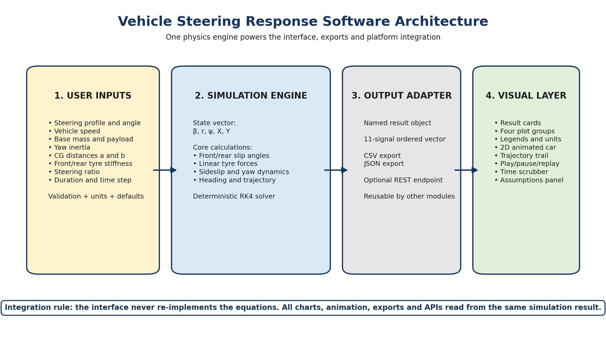
Figure 1: Recommended architecture for converting the Simulink model into an integrated software module.

6. Required User-Facing Visual Output
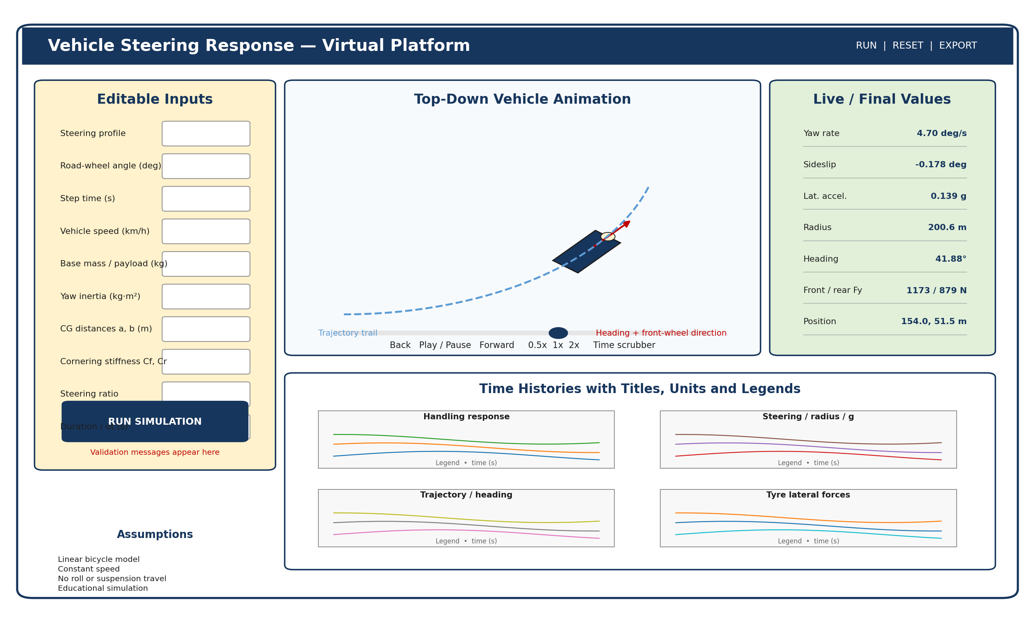
Figure 2: Functional layout concept. The programmer may follow the existing platform style, but the same information and controls must be provided.

7. Interface and Dashboard Requirements

7.1 Input Panel
The input panel must let users modify the scenario and vehicle without opening source files. Each control should carry a unit and short explanation. The page should provide Run Simulation, Reset to Defaults, Clear Results, Export CSV and Export JSON actions. Save/Load Scenario may be added when the wider platform already supports user projects.

7.2 Summary Values
The dashboard should show current or final yaw rate, sideslip angle, lateral acceleration, turning radius, heading, front and rear lateral tyre forces, steering-wheel angle, and X-Y position. These values must come from the same timestamped result array used by the plots and animation.

7.3 Plot Groups
Plot Group | Required Traces and Units
Handling Response | Yaw rate (deg/s); sideslip angle (deg); lateral acceleration (m/s^2)
Steering, Radius and g | Steering-wheel angle (deg); turning radius (m); lateral acceleration (g)
Trajectory and Heading | X position (m); Y position (m); heading angle (deg)
Tyre Lateral Forces | Front lateral force (N); rear lateral force (N)

Visual rule: Every plot requires a title, labelled axes, units, grid and visible legend. Variables with very different scales should use aligned subplots, selectable traces or separate axes instead of being compressed into one unreadable graph.

8. Animated Vehicle Requirement
A top-down vehicle animation is the most suitable graphical result because the model directly calculates X position, Y position, heading and steering angle. It is scientifically aligned with the available states and can be implemented efficiently in SVG or HTML Canvas.

8.1 Minimum Animation Features
- Vehicle body translated by X and Y position.
- Vehicle body rotated by heading angle.
- Front-wheel direction indicated by the road-wheel steering angle.
- Trajectory trail retained behind the vehicle.
- Current time, speed, yaw rate, sideslip and lateral acceleration displayed beside the animation.
- Play, pause, restart, playback-speed and time-scrubber controls.
- Auto-fit view and optional follow-camera mode.
- Static final trajectory available after playback.
Animation boundary: A 3D vehicle is optional. The baseline deliverable should remain the clear 2D top-down animation. The software must not animate suspension movement or body roll because those states do not exist in the model.

9. Platform Integration Contract
The platform must receive readable named fields and an ordered numeric vector. The ordered vector preserves compatibility with the Simulink output and any related models that expect fixed signal positions.
Index | Field | Unit
1 | yawRateDegPerS | deg/s
2 | sideslipDeg | deg
3 | lateralAccelerationMps2 | m/s^2
4 | lateralAccelerationG | g
5 | turningRadiusM | m
6 | headingDeg | deg
7 | xM | m
8 | yM | m
9 | frontLateralForceN | N
10 | rearLateralForceN | N
11 | steeringWheelAngleDeg | deg

9.1 Suggested API Shape
POST /api/vehicle-dynamics/steering-response/simulate
Request: { vehicle: {...}, scenario: {...} }
Response: { parameters, scenario, outputVectorOrder, samples, final }

If the existing platform performs simulations entirely in the browser, the same contract should be implemented as a typed function rather than a network endpoint. The result shape should remain stable so the engine can be moved to a backend later without redesigning the interface.

10. Reference Validation Case
The programmer should use the following case to confirm that the converted equations match the verified model. A fixed-step RK4 solver with dt = 0.01 s produces the values below at t = 10 s.
Input | Value
Road-wheel steering input | 1 deg step at 1 s
Vehicle speed | 60 km/h
Base mass / payload | 1500 kg / 0 kg
Yaw inertia | 2500 kg.m^2
a / b | 1.2 m / 1.6 m
Cf / Cr | 80000 / 80000 N/rad
Steering ratio | 16
Duration / time step | 10 s / 0.01 s

Output at 10 s | Expected
Yaw rate | approximately 4.7027 deg/s
Sideslip angle | approximately -0.17837 deg
Lateral acceleration | approximately 1.36797 m/s^2
Lateral acceleration | approximately 0.13945 g
Turning radius | approximately 200.615 m
Heading angle | approximately 41.876 deg
X position | approximately 153.963 m
Y position | approximately 51.465 m
Front lateral force | approximately 1172.54 N
Rear lateral force | approximately 879.41 N
Steering-wheel angle | 16 deg

Acceptance tolerance: The programmed engine should normally match within +/-1%. Position and heading may use +/-2% when a different documented high-quality numerical solver is used.

11. Programmer Completion Checklist
- ☐ The model equations are implemented directly and do not depend on MATLAB at runtime.
- ☐ Input fields have units, defaults, validation and tooltips.
- ☐ The step-steer baseline matches the reference result.
- ☐ The four plot groups have visible legends and readable scales.
- ☐ The top-down animated car follows X-Y position and heading.
- ☐ Front-wheel steering direction is visible.
- ☐ Pause, replay, playback speed and time scrubbing work.
- ☐ CSV and JSON export contain the displayed samples.
- ☐ The named output object and eleven-signal vector are exposed.
- ☐ The model limitations are visible to the user.
- ☐ The new page follows the existing platform design and navigation.
- ☐ Tests, linting and build commands pass.
- ☐ A screenshot of the full interface and visual evidence of the animation are supplied.

12. Handover to Codex
Place AGENTS.md at the repository root and start Codex from that repository. The reference Simulink file should be available under a reference or documentation folder. Codex must first inspect the platform, then implement the simulation engine, validate the baseline, integrate the page, add the plots and animation, and provide visual proof of completion.
Final requirement: The task is not complete when only a code function, plan or mock-up is produced. The required endpoint is a working and integrated virtual-platform module with the corresponding visual output.

