ENGINE–GENERATOR FUEL-TO-ELECTRIC
VIRTUAL PLATFORM IMPLEMENTATION GUIDE
Programmer Guide for Converting the Simulink Logic into a User-Friendly Virtual Laboratory Module
Modelling and Testing Engine–Generator Fuel-to-Electric Energy Conversion for Series-Based Hybrid Vehicle for Virtual-Platform Integration
Companion implementation instruction:
CODEX_BUILD_ENGINE_GENERATOR_VIRTUAL_LAB.md
October 2026

1. Purpose of This Guide
This guide explains what the Codex implementation brief is expected to produce and gives the programmer a clear technical picture of the converted module. The target is not a separate simulation package. It is one reusable engine–generator calculation module, integrated into the existing virtual laboratory and controlled through a simple interface.
The two source files are EngineGenerator_FuelToElectric_SelfContained.slx and EngineGenerator_Model_Input_Data_and_Operating_Guide.docx. The Codex task file repeats the full calculation logic so the programmer can work even when the SLX cannot be inspected directly.
Conversation context link placeholder
https://chatgpt.com/share/6adce024-70e4-83ea-bbf8-a42e812ab059
Replace this placeholder with the shared link from the present ChatGPT conversation before handing the task to Codex. The implementation brief is self-contained, so the link is supplementary rather than essential.

2. What the Converted Module Will Do
- Receive the user’s selected electrical load, demand pattern, battery SOC, generator rating, enable command and fuel lower heating value.
- Generate the same steady, gradual or pulsed demand profile used in the Simulink model.
- Apply SOC support, rating limitation, command delay and power ramping.
- Interpolate the engine-speed, BSFC and generator-efficiency maps.
- Calculate shaft power, engine torque, fuel flow, fuel chemical power, electrical output, efficiency, losses, utilization and shortfall.
- Integrate the time-series results to obtain energy and fuel totals.
- Display the system through an interactive dashboard and animated energy-flow visual.
- Export results and expose standard output signals for connection to other virtual-laboratory modules.

3. Recommended Software Architecture
The implementation should be divided into three clear layers. The calculation must exist in only one place.
Layer | Responsibility | Important rule
Numerical model core | Validation, interpolation, command delay, rate limiting, equations, integration and summary calculation. | No interface or chart dependencies. This is the single source of truth.
Platform adapter | Maps the model inputs and outputs to the existing platform, API or message bus. | Preserve the five standard root output names.
User interface | Input controls, animation, live values, charts, scenario save/load and export. | Never repeat the scientific equations in UI components.

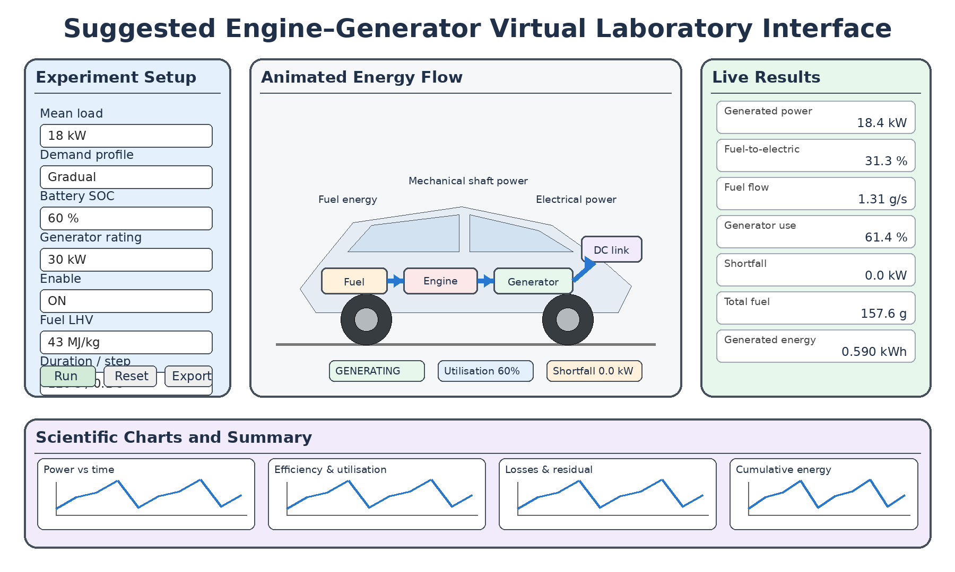
Figure 1: Recommended layout for the engine–generator virtual laboratory module.

4. Inputs and Defaults
Input | Default | Unit | Normal study range | Purpose
Mean electrical load | 18 | kW | 0–45 | Sets the average power requested from the generating set.
Demand profile | 2 | – | 1, 2 or 3 | Selects steady, gradual or pulsed demand.
Battery SOC | 60 | % | 10–95 | Creates a simple support request when SOC is below 60%.
Generator rating | 30 | kW | 10–60 | Limits continuous electrical output.
Enable command | 1 | Boolean | 0 or 1 | Turns the generator command off or on.
Fuel LHV | 43 | MJ/kg | Use traceable fuel value | Converts fuel mass flow to chemical power.
Simulation duration | 120 | s | Positive | Sets the experiment duration.
Time step | 0.1 | s | 0.01–1.0 | Sets numerical update interval.

The advanced interface should also allow the programmer or researcher to change the SOC target, SOC gain, maximum SOC support, command delay, rise/fall rates, demand limit, map limit and numerical safeguards. These controls should be collapsed by default so the main page remains easy to use.

5. Built-In Demonstration Maps
Load fraction | Generator efficiency | Engine speed (rpm) | BSFC (g/kWh)
0.00 | 0.70 | 0 | 400
0.10 | 0.76 | 1200 | 340
0.20 | 0.82 | 1400 | 300
0.35 | 0.87 | 1600 | 270
0.50 | 0.90 | 1800 | 250
0.65 | 0.92 | 2000 | 240
0.80 | 0.93 | 2200 | 235
1.00 | 0.92 | 2400 | 238
1.25 | 0.89 | 2600 | 250

The converted code must use piecewise-linear interpolation. The map values should be held in one configuration object and may later be replaced by traceable manufacturer, published or experimental data without changing the interface or model equations.

6. Calculation Sequence
Demand profile: Calculate steady, gradual or pulsed electrical demand and limit it to 0–45 kW by default.
SOC support: Calculate P_SOC = clamp[0.15(60 − SOC), 0, 6].
Generator command: Add demand and SOC support, restrict the result between zero and generator rating, then multiply by the enable command.
Dynamic response: Apply a one-second transport delay and limit command rise to 8 kW/s and fall to 12 kW/s.
Map interpolation: Calculate load fraction and interpolate generator efficiency, engine speed and BSFC.
Engine conversion: Calculate shaft power, engine torque, fuel flow, fuel power and engine efficiency.
Generator conversion: Calculate electrical power and generator efficiency subject to the selected rating.
Performance accounting: Calculate total fuel-to-electric efficiency, engine loss, generator loss, total loss, utilization, shortfall and residual.
Cumulative results: Integrate powers to kWh and fuel flow to grams.
P_demand = selected demand profile
P_SOC = clamp[gain × (SOC_target − SOC), 0, P_SOC,max]
P_cmd = rateLimit(delay(min(max(P_demand + P_SOC, 0), P_rated) × enable))
u = clamp(P_cmd / max(P_rated, epsilon), 0, 1.25)
P_shaft = P_cmd / eta_gen(u)
T_engine = 9550 × P_shaft / max(n_engine(u), 1)
fuelFlow = BSFC(u) × P_shaft / 3600
P_fuel = fuelFlow × LHV
P_gen = min(P_shaft × eta_gen(u), P_rated)
eta_f2e = P_gen / max(P_fuel, epsilon)
P_shortfall = max(P_demand − P_gen, 0)

7. Outputs Required by the Platform
Output group | Required quantities
Power | Demand, SOC support, raw command, delayed/ramped command, shaft power, generator power and shortfall.
Engine | Speed, torque, BSFC, fuel-flow rate, fuel chemical power and engine efficiency.
Generator | Efficiency, output, rating status and utilization.
Loss and balance | Engine loss, generator loss, total conversion loss and energy-balance residual.
Cumulative | Generated energy, fuel energy, loss energy, shortfall energy and total fuel used.
Integration outputs | P_gen_kW, eta_f2e_ratio, fuel_flow_gps, P_shortfall_kW and generator_utilisation_pct.

8. User-Friendly Interface Expected
- A simple experiment setup panel with units, defaults, recommended ranges and tooltips.
- Run, pause/resume where supported, reset, restore defaults, save scenario and load scenario controls.
- Live result cards for generated power, fuel-to-electric efficiency, fuel flow, utilization, shortfall, energy and fuel totals.
- Five scientific chart groups corresponding to the Simulink scopes.
- CSV and JSON export, including model version and all inputs used.
- Responsive design suitable for a typical laptop and a stacked mobile layout.
- Visible warnings when the generator rating or demand limit is active.

9. Suitable Graphical Output
Recommended primary visual: a stationary side-view vehicle silhouette containing an animated fuel tank, engine, generator and DC-link/battery connection. Animated arrows should show fuel energy, shaft power and electrical power. Arrow thickness or speed may represent power level, while component labels show operating status.
Why the car should normally remain stationary: the present model does not calculate vehicle speed, wheel torque or road motion. A moving car could suggest a result the model does not actually produce. Vehicle movement may be added later when a separate vehicle-dynamics module supplies a genuine speed signal. An illustrative moving car is acceptable only when it is clearly labelled as illustrative.
Mandatory visual proof from Codex: desktop screenshot, changed-scenario screenshot, responsive screenshot and, where the development environment supports it, a short GIF or video showing the animated flow and chart progression.

10. Baseline Reference for Confirming the Converted Logic
The programmer should run the default gradual-demand case before integrating the module. The following values provide an independent reference for the converted code.
Result | Reference value | Suggested tolerance
Generated electrical energy | 0.5896 kWh | ±1%
Fuel energy supplied | 1.8824 kWh | ±1%
Conversion loss energy | 1.2928 kWh | ±1%
Shortfall energy | 0.01538 kWh | ±3%
Total fuel used | 157.60 g | ±1%
Case fuel-to-electric efficiency | 31.32% | ±0.5 percentage point
Maximum generated power | 22.50 kW | ±0.05 kW
Average generator utilization | 58.96% | ±1 percentage point
Maximum energy residual | Approximately zero | < 1×10⁻⁹ kW where practical

11. Integration Contract
The numerical core should support a full scenario method and a step method. This allows the same logic to run a complete experiment or receive live demand and SOC values from another model.
simulate(config, maps?) -> complete time series and summary
initialize(config, maps?) -> model state
step(state, externalInput, dt) -> updated state and current output
reset(state, config) -> clean model state
At minimum, the platform adapter must preserve the following root signal names:
- P_gen_kW
- eta_f2e_ratio
- fuel_flow_gps
- P_shortfall_kW
- generator_utilisation_pct

12. How to Hand This Work to Codex
- Place the Codex implementation brief at the root of the virtual-platform repository.
- Place the SLX and the existing model guide in a documentation or reference folder, if the repository permits binary reference files.
- Replace the placeholder conversation URL in the Codex brief with the Share link from this conversation.
- Give Codex a direct instruction to implement every requirement in CODEX_BUILD_ENGINE_GENERATOR_VIRTUAL_LAB.md using the existing repository architecture.
- Require Codex to run the repository’s normal tests, compare the baseline case and provide visual proof before reporting completion.
- Review the equations, units and visual labels before merging the implementation into the main platform.

13. Programmer Acceptance Checklist
☐ One authoritative model core exists and has no UI dependencies.
☐ All six basic inputs and all advanced constants are represented with units.
☐ The three demand profiles match the specified equations.
☐ Delay, ramp limits, rating limits and map interpolation are implemented.
☐ The baseline case matches the reference values within tolerance.
☐ No NaN or infinite values appear for valid inputs.
☐ The five standard platform outputs are available.
☐ The interface provides clear charts, live values and exports.
☐ The animated visual shows fuel, shaft and electrical energy correctly.
☐ A moving car is not presented as a calculated result unless vehicle speed is supplied by another model.
☐ Screenshots and an animation or equivalent visual proof are supplied.
☐ Assumptions, map sources, version and limitations are documented.
Expected final outcome
A user can open the engine–generator module in the virtual laboratory, change operating conditions, run the model, watch the energy conversion, inspect scientific charts, export evidence and pass standard outputs to other models. The interface must explain the model rather than hide it.

