ACCRA TECHNICAL UNIVERSITY
MASTER OF TECHNOLOGY IN AUTOMOTIVE ENGINEERING

CODEX VIRTUAL-PLATFORM CONVERSION PACKAGE
PROGRAMMER IMPLEMENTATION GUIDE
Simulation of Full Parallel Hybrid under Different Torque Intensities:
Focus on Battery Energy Efficiency

Student | Lawrence Andoh
Student ID | 01250389M
Supervisor | Dr. Glenn Gyimah
Primary Codex file | AGENTS.md

Prepared as a technical handoff for integration into the common automotive virtual platform

PROGRAMMER IMPLEMENTATION GUIDE
Purpose: convert the single-file P2 Simulink model into a maintainable application module with an accurate calculation engine, web/API integration, a clear user interface, animated technical power flow, labelled charts, comparison tools and exportable results.
Important scope decision
The delivered Simulink model is the executable source of truth. Phase 1 converts its present P2 constant-torque logic exactly. Wider thesis ideas such as P3/P4 operation, regenerative braking, drive cycles, fuel maps, 2-RC electrochemistry, battery thermal dynamics and full vehicle motion are future extensions unless a later validated model is provided.

CONTENTS
1. Package and Purpose
2. Source Files and Reference Hierarchy
3. What AGENTS.md Makes Codex Do
4. Recommended Integration Architecture
5. Exact Scientific Logic to Preserve
6. API and Data Contract
7. User Interface and Visual Output
8. Animated Vehicle/Power-Flow Recommendation
9. Validation Targets and Tests
10. Programmer Handoff Procedure
11. Completion and Review Checklist

1. PACKAGE AND PURPOSE
This package has been reduced to two working documents so that neither Codex nor the programmer has to interpret a large collection of disconnected files. The first file is the technical instruction file that Codex reads. The second is this explanatory guide for the programmer and project team.
File | Primary user | Purpose
AGENTS.md | Codex and the programmer | Repository-level implementation contract. It defines the exact model logic, architecture, interface, visuals, tests, acceptance conditions and final report required from Codex.
Lawrence_Andoh_Codex_Virtual_Platform_Programmer_Guide.docx | Programmer, supervisor and platform team | Explains what Codex is expected to build, why the scientific boundary is limited, how the interface should look, and how to review the final platform.

1.1 Why AGENTS.md Is Used
AGENTS.md is intended to be placed at the root of the platform repository. Codex uses it as durable project guidance. This avoids repeatedly copying a long prompt and makes the model boundary, test values, visual requirements and definition of completion available throughout the coding task.

1.2 Expected End Product
- A pure programming-language simulation engine that reproduces the Simulink equations without requiring MATLAB at runtime.
- An API or service layer that makes the calculation engine available to the common virtual platform.
- A responsive interface where a user can change requested torque, motor speed, initial SOC, duration and approved parameters.
- An animated P2 technical power-flow view that visibly changes with clutch state and engine/motor contribution.
- Seven scope-equivalent chart groups with visible legends, units, tooltips and aligned axes.
- Low/medium/high comparison, session saving and CSV/JSON/chart export.
- Automated regression tests and browser screenshots proving that the final platform works.

2. SOURCE FILES AND REFERENCE HIERARCHY
Create a reference folder inside the platform repository and place the approved source artefacts there. The actual names may be adjusted only when the repository already has a documented convention.
repository-root/
├── AGENTS.md
├── reference/
│ ├── Lawrence_Andoh_P2_Hybrid_Torque_Intensity_Model.slx
│ ├── Lawrence_Andoh_P2_Hybrid_Model_Data_and_Testing_Guide.docx
│ └── Lawrence_Andoh_Chapters_1_to_3_Revised.pdf
└── <existing platform source folders>
Priority | Source | Use
1 | Delivered .slx model | Controls the implemented equations, signals, constants, scopes and present model boundary.
2 | Model data and testing guide | Controls parameter meanings, units, expected baseline values and interpretation.
3 | AGENTS.md | Controls the software architecture, API, interface, visualisation, testing and completion requirements.
4 | Approved thesis | Provides research context and future integration direction, but must not silently add unimplemented Phase-1 physics.
5 | Optional shared chat URL | May clarify intent, but the build must continue when the chat is unavailable.

2.1 Chat Reference
The AGENTS.md file contains the placeholder below:
CHAT_REFERENCE_URL = "PASTE_SHARED_CHATGPT_CONVERSATION_URL_HERE"
Replace it with a shared conversation URL only when one is available. It is intentionally optional. All essential logic and acceptance criteria are already contained in AGENTS.md, so Codex should never stop merely because the chat link is empty or inaccessible.

3. WHAT AGENTS.MD MAKES CODEX DO
The Codex instruction file is not simply a request to “convert Simulink to code.” It provides an implementation contract that reduces ambiguity and prevents the most common failure: a visually attractive interface powered by calculations that no longer match the model.
1. Inspect the existing virtual-platform repository before choosing technologies or creating folders.
2. Preserve the platform’s current backend, frontend, design system, authentication and deployment methods where practical.
3. Extract the P2 equations into a pure deterministic core that is independent of HTTP and interface code.
4. Expose single-run, comparison and model-information services using the existing API conventions.
5. Create an input dashboard, live/final metrics, seven scope-equivalent charts and result exports.
6. Create an animated technical view that shows the active engine, clutch, motor, battery and driveline paths.
7. Run the three baseline cases, automated tests, type checks, lint and production build.
8. Open the final application in a real browser and provide low/medium/high screenshots as evidence.
Recommended Codex kickoff prompt
Implement the P2 hybrid virtual-platform module described in AGENTS.md. First inspect the repository and the reference files, then present a concise plan. Preserve the existing platform architecture, implement the exact Phase-1 equations, run all tests, open the interface in a browser, and provide the required low/medium/high screenshots and numerical validation table.

4. RECOMMENDED INTEGRATION ARCHITECTURE
The calculation engine must remain separate from the user interface. This makes the model testable, allows the common platform to call it from different pages, and creates a controlled boundary for future battery, motor, engine and vehicle-dynamics modules.
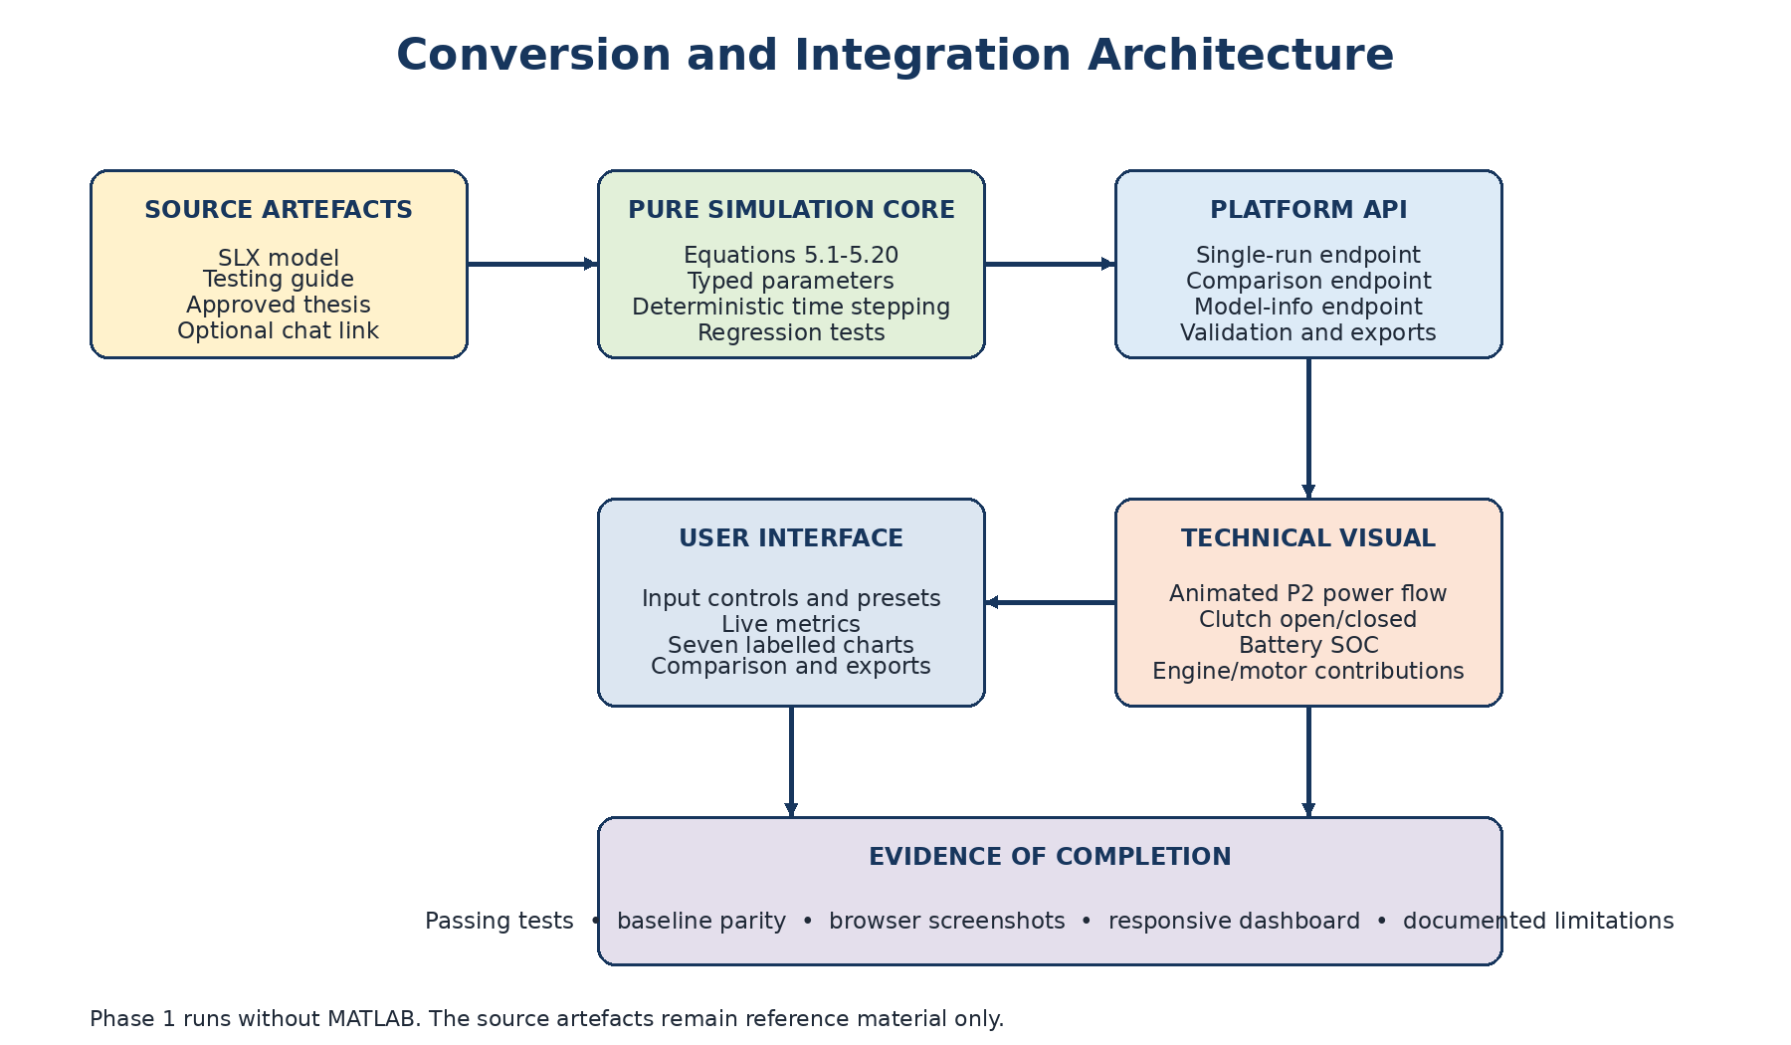
Figure 1: Conversion and integration architecture for the P2 hybrid module

4.1 Preferred Component Responsibilities
Layer | Required responsibility
Pure simulation core | Equations, time integration, limits, regime classification, parameter validation and run summary. No web-framework or UI imports.
Service/API layer | Request validation, typed responses, error handling, model information, comparison and exports.
User interface | Input controls, presets, run/reset/compare actions, metric cards, charts, technical animation and user guidance.
Evidence/test layer | Unit tests, regression tests, API tests, interface checks, build verification and captured screenshots.
Future adapters | Stable interfaces for battery limits, motor limits, engine data, wheel demand and other platform modules without altering validated Phase-1 parity.

4.2 Technology Choice
Codex is instructed to integrate with the existing platform stack. For a new prototype only, the fallback is a Python/FastAPI calculation service and a React/TypeScript interface. A technical SVG animation is preferred because it is lightweight, responsive and easier to verify than a heavy 3D scene.

5. EXACT SCIENTIFIC LOGIC TO PRESERVE
The converted application must reproduce the present Simulink model, including its simplifying assumptions. All values should be represented internally in SI units, and every parameter should have a visible name and unit.

5.1 Main Inputs and Defaults
Input | Default | Research presets/range | Purpose
Requested torque, T_req | 140 Nm | 60, 140, 240 Nm; valid 0-400 Nm | Creates the low, medium and high torque test cases.
Motor speed, n_m | 2500 rpm | Recommended 500-6000 rpm | Changes angular speed, motor power and the speed-dependent motor torque limit.
Initial SOC, SOC_0 | 0.70 | Valid 0-1; recommended 0.30-0.80 | Controls the initial energy state. SOC below 0.30 disables motor traction.
Simulation duration | 30 s | Advanced user setting | Sets the comparison period.
Time step | 0.01 s | Advanced user setting | Controls numerical integration and chart resolution.

5.2 Core Calculation Sequence
1. Classify requested torque: Low below 80 Nm, Medium from 80 to below 200 Nm, and High from 200 Nm upward.
2. Select motor share: 1.00 in Low and 0.50 in Medium/High.
3. Convert rpm to rad/s and calculate the motor torque limit as the smaller of 165 Nm and 35 kW divided by angular speed.
4. Apply the preliminary motor share and the SOC protection rule. SOC below 0.30 forces motor torque to zero.
5. Let the engine supply the remaining torque up to the 142 Nm engine limit.
6. Open the clutch only for Low operation with acceptable SOC; otherwise close it.
7. Convert requested and delivered shaft torque to wheel torque through gear ratio 1.00, final-drive ratio 3.94 and driveline efficiency 0.90.
8. Calculate motor mechanical power, battery terminal power, battery current, terminal voltage and I-squared-R loss.
9. Integrate SOC, terminal energy, loss energy, RMS current and torque RMSE over the selected duration.
10. Return all time-series signals, final metrics, active limits, warnings and the exact parameter snapshot.

5.3 Equation Summary
Equation | Implementation | Meaning
5.1 | alpha_T = 1.00 when T_req < 80 Nm; otherwise 0.50 | Initial motor torque share
5.2 | T_m,lim = min(165, 35000 / (omega_m + 0.001)) | Torque- and power-based motor limit
5.3 | T_m = clamp(alpha_T T_req, 0, T_m,lim), then T_m = 0 when SOC < 0.30 | Actual motor command
5.4 | T_e = clamp(T_req - T_m, 0, 142) | Engine command
5.5 | T_w,req = T_req i_g i_fd eta_d | Requested wheel torque
5.6 | T_w,act = (u_c T_e + T_m) i_g i_fd eta_d | Delivered wheel torque
5.7 | e_T = T_w,req - T_w,act | Torque error
5.8 | omega_m = n_m 2 pi / 60 | Motor angular speed
5.9 | P_m = T_m omega_m | Motor mechanical power
5.10 | P_b = P_m /(eta_m eta_inv) + P_aux | Battery terminal power
5.11 | I_b = [V_oc - sqrt(V_oc^2 - 4 R_int P_b)] /(2 R_int) | Battery current
5.12 | V_t = V_oc - I_b R_int | Terminal voltage
5.13-5.14 | dSOC/dt = -I_b/Q_n; Q_n = (E_nom/V_oc)3600 | SOC state
5.15 | P_loss = I_b^2 R_int | Internal loss power
5.16-5.18 | Integrate P_b and P_loss; eta_b = E_b/(E_b + E_loss) x 100 | Energy and efficiency
5.19-5.20 | RMS current and torque RMSE from cumulative squared integrals | Performance metrics

Do not silently add regenerative braking
The present model accepts propulsion torque only. The interface should reject negative requested torque in Phase 1. Regeneration, braking and negative torque require a separate validated extension.

6. API AND DATA CONTRACT
The API should follow the existing platform’s conventions. Where no convention exists, AGENTS.md defines the three endpoints below. The same calculation engine must be used by the single-run and comparison functions.
Method and route | Function
POST /api/v1/hybrid/p2/simulate | Runs one deterministic case and returns metadata, inputs, parameters, summary, warnings, active limits, scope groups and time series.
POST /api/v1/hybrid/p2/compare | Runs two or more named cases and returns aligned summaries and optional aligned time series.
GET /api/v1/hybrid/p2/model-info | Returns parameter definitions, units, ranges, equations, limitations and output group definitions for the interface.

6.1 Example Request
{
"requested_torque_nm": 140,
"motor_speed_rpm": 2500,
"initial_soc": 0.70,
"duration_s": 30,
"time_step_s": 0.01,
"parameter_overrides": {}
}

6.2 Required Result Groups
- Metadata: model ID, model version, formula version and run ID.
- Inputs and parameters: complete snapshots so the run can be repeated.
- Summary: all final torque, electrical, energy, SOC and error metrics.
- Warnings and active limits: for example motor power limit, engine saturation, low-SOC protection or protected battery discriminant.
- Time series: all twenty-three scientific signals listed in AGENTS.md.
- Scope groups: series definitions that let the interface build the seven charts without duplicating signal names.
- Compatibility export: the original 12-column HybridResults order plus time.

7. USER INTERFACE AND VISUAL OUTPUT
A successful conversion must be usable by a non-programmer. The user should not edit source code or internal model blocks to run an experiment. All approved inputs, outputs and warnings should be presented through a controlled interface.
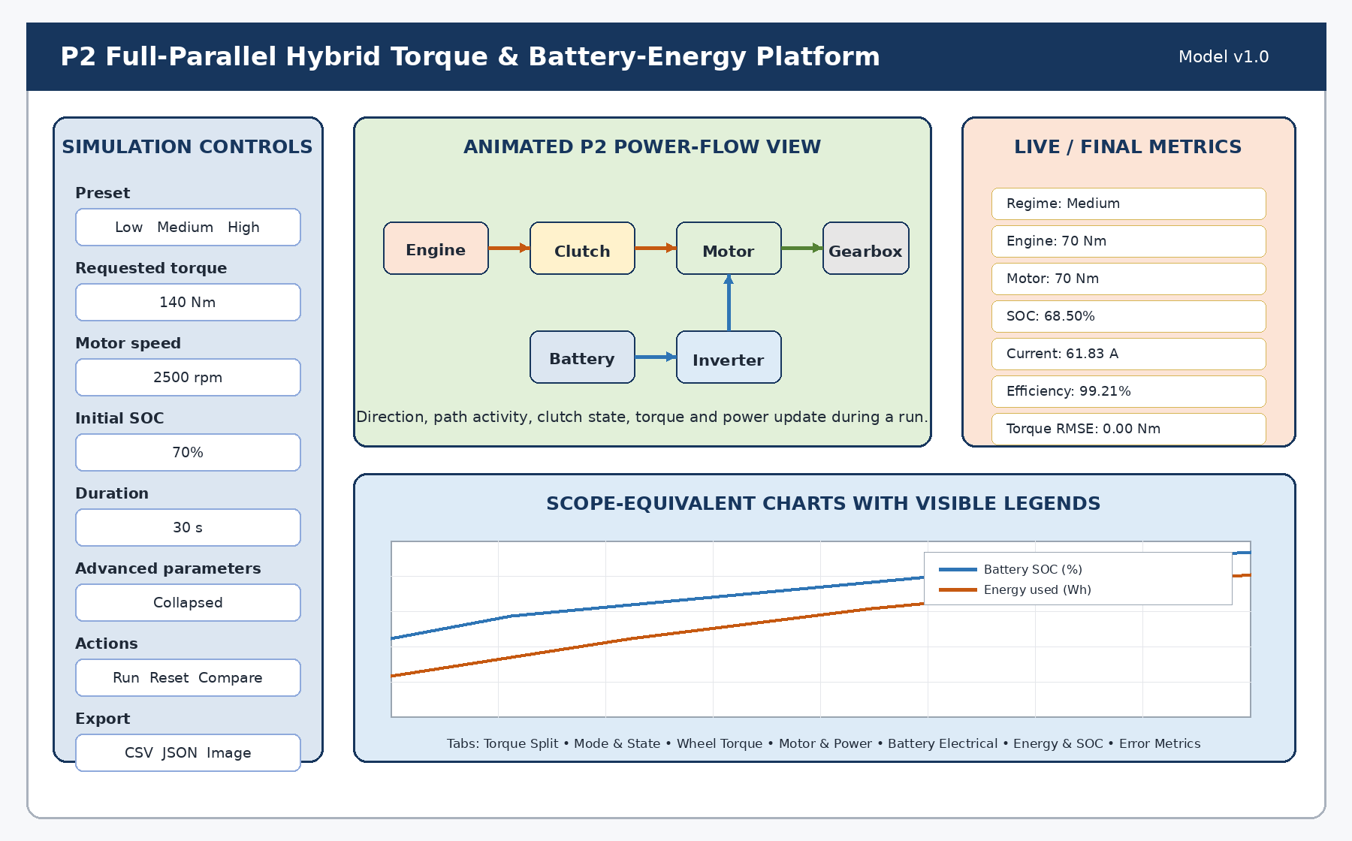
Figure 2: Recommended dashboard arrangement for the virtual platform

7.1 Minimum Interface Areas
Area | Required content
Controls | Low/Medium/High presets, torque, rpm, initial SOC, advanced parameters, Run, Reset, Compare, Save and Export.
Technical visual | Animated P2 energy and torque paths, clutch state, component activity, battery fill and live values.
Metrics | Regime, engine/motor torque, wheel-torque tracking, SOC, current, voltage, power, loss, energy, efficiency and RMSE.
Charts | Seven scope-equivalent groups with visible legends, units, axes, tooltips, zoom and reset.
Comparison | Aligned low/medium/high table, charts, relative changes, result interpretation and export.
Limitations | Visible statement that Phase 1 is a constant-torque control-oriented P2 model, not a production digital twin.

7.2 Required Scope-Equivalent Charts
Chart group | Legend entries
1. Torque Split | Requested torque; engine torque; motor torque
2. Mode and State | Motor share; clutch state; regime code; battery SOC
3. Wheel Torque Tracking | Requested wheel torque; actual wheel torque; wheel-torque error
4. Motor and Power | Motor torque; motor speed; motor mechanical power; battery terminal power
5. Battery Electrical | Battery terminal power; current; terminal voltage; internal loss power
6. Battery Energy and SOC | SOC; delta SOC; battery energy; loss energy; efficiency; RMS current
7. Torque Error Metrics | Wheel-torque error; running torque RMSE

Legend requirement
Every multi-series chart must show a visible legend. Signals with different units should be separated into aligned panels or axes rather than compressed into an unreadable scale.

8. ANIMATED VEHICLE/POWER-FLOW RECOMMENDATION
A graphical output is strongly recommended, but the most suitable Phase-1 visual is a technical power-flow animation rather than a game-like car driving along a road. The current model does not calculate vehicle distance, road speed, acceleration or gradient, so a moving car could suggest physics that have not been modelled.
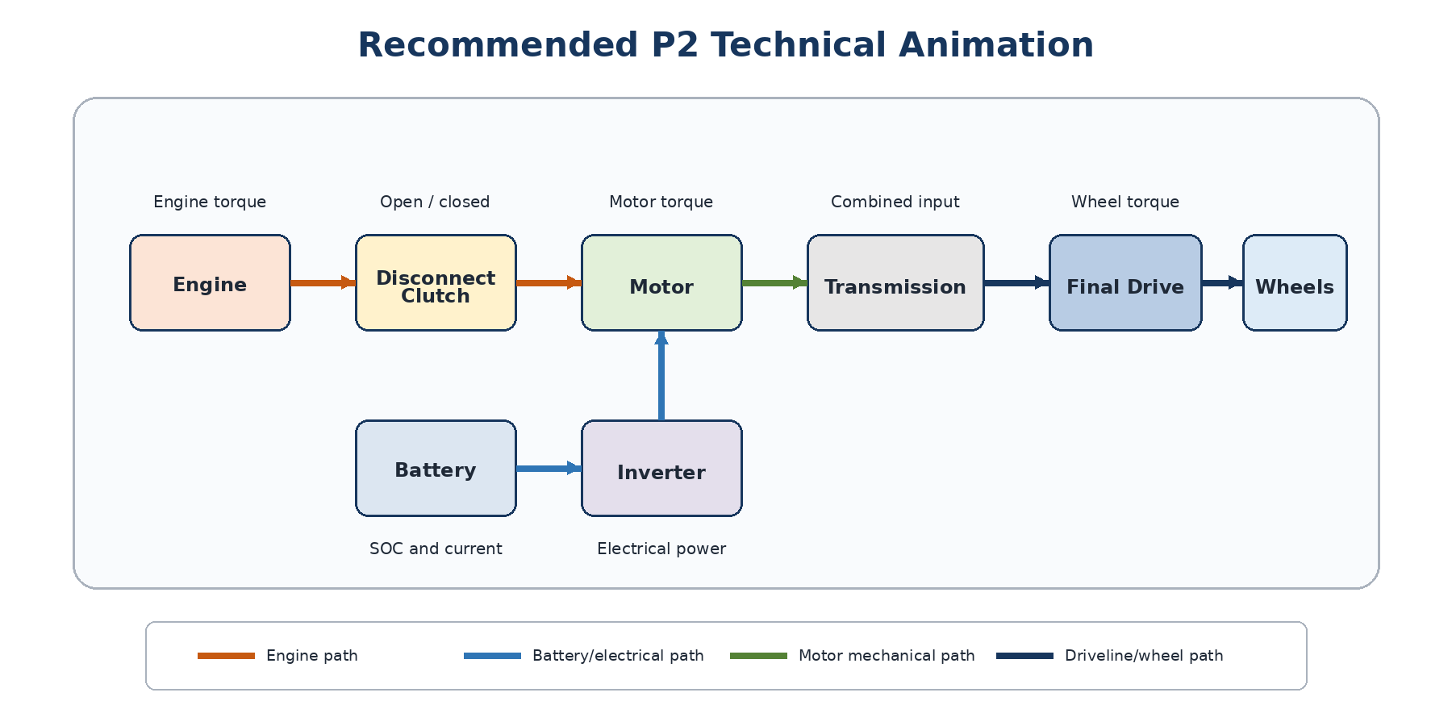
Figure 3: Recommended animated P2 technical power-flow representation

8.1 Required Animation Behaviour
- Animate directional arrows along the active engine and electrical paths.
- Show the disconnect clutch physically open or closed.
- Dim or stop the engine path during the 60 Nm low-torque case.
- Show engine and motor paths combining before the transmission in medium/high operation.
- Scale arrow thickness, movement or pulse rate using torque or power.
- Fill the battery icon according to SOC and display current, terminal voltage and power.
- Rotate or pulse motor, engine and wheel symbols only when active.
- Provide a legend for visual states and avoid relying on colour alone.

8.2 Optional Car Animation
A 2D car silhouette may contain the technical schematic, and a lightweight 3D car may be added as a later enhancement. If wheels are animated, their rotation can be estimated from motor speed, gear ratio and final-drive ratio for illustration. Do not label this as validated vehicle speed or distance unless a longitudinal vehicle model and wheel radius are explicitly added in a future version.

9. VALIDATION TARGETS AND TESTS
The programmer should judge success from numerical parity, not from visual appearance alone. The following results are the main regression targets for 30 seconds at 2500 rpm and initial SOC 0.70.
Case | T_req (Nm) | T_m (Nm) | T_e (Nm) | T_w,req (Nm) | T_w,act (Nm) | P_b (W)
Low | 60 | 60 | 0 | 212.76 | 212.76 | 18,472.50
Medium | 140 | 70 | 70 | 496.44 | 496.44 | 21,467.91
High | 240 | 120 | 120 | 851.04 | 851.04 | 36,445.00

Table 1: Expected torque and battery-power results at 30 seconds
Case | I_b (A) | V_t (V) | P_loss (W) | E_b (Wh) | E_loss (Wh) | Efficiency (%) | Delta SOC (%)
Low | 53.142 | 347.609 | 127.082 | 153.937 | 1.059 | 99.317 | 1.292
Medium | 61.828 | 347.218 | 172.024 | 178.899 | 1.434 | 99.205 | 1.503
High | 105.561 | 345.250 | 501.443 | 303.708 | 4.179 | 98.643 | 2.566

Table 2: Expected battery-energy results at 30 seconds

9.1 Mandatory Test Cases
1. Equation-level unit tests.
2. Low, Medium and High baseline regression tests within the tolerances stated in AGENTS.md.
3. Low-SOC test at requested torque 60 Nm and initial SOC 0.25: motor disabled, clutch closed and engine path active.
4. High-rpm motor power-limit test.
5. Excess-demand test that produces engine/motor saturation and non-zero torque error.
6. Negative requested-torque rejection.
7. SOC clamping and protected square-root discriminant tests.
8. API schema and error-response tests.
9. Frontend form, chart, comparison, export, responsive and accessibility tests.

9.2 Visual Evidence Required from Codex
- Screenshot of the Low case showing motor-first flow and open clutch.
- Screenshot of the Medium case showing 70 Nm engine and 70 Nm motor contribution.
- Screenshot of the High case showing 120 Nm engine and 120 Nm motor contribution.
- Screenshot or browser evidence showing the chart legends and comparison view.
- Numerical comparison table generated from the final implementation, not copied from this guide.

10. PROGRAMMER HANDOFF PROCEDURE
1. Place AGENTS.md at the Git repository root.
2. Create the reference folder and copy the approved .slx, testing guide and latest thesis document into it.
3. Replace the optional CHAT_REFERENCE_URL placeholder only when a shared conversation link is available.
4. Open Codex from the repository root so that AGENTS.md is discovered.
5. Use the kickoff prompt in Section 3 and require a plan before implementation.
6. Review the proposed integration path and ensure Codex is preserving the existing platform architecture.
7. Allow Codex to implement and run the complete test/build/browser-validation cycle.
8. Review the numerical parity table before judging the interface.
9. Review Low, Medium and High screenshots, chart legends, responsive layout and export files.
10. Reject any result that claims unimplemented P3/P4, regenerative, fuel, thermal or longitudinal vehicle functionality.

10.1 What Codex Must Report at Completion
Required report item | Reason
Stack and architecture used | Shows how the module fits into the common platform.
Files created/modified | Makes review and future maintenance practical.
Location of scientific core | Allows independent audit of equations and parameters.
API and UI routes | Allows the platform team to connect and demonstrate the module.
Run/test/build commands | Makes the result reproducible.
Test results and numerical parity table | Confirms scientific conversion rather than cosmetic implementation.
Browser screenshots | Confirms the required visual output is present.
Exports and remaining limitations | Confirms user evidence and prevents overstated capability.

11. COMPLETION AND REVIEW CHECKLIST
☐ AGENTS.md is at the repository root and remains below Codex’s normal instruction-size limit.
☐ The application runs without MATLAB or Simulink.
☐ Equations 5.1-5.20 are implemented in a pure testable module.
☐ Low, Medium and High results match the regression table.
☐ Users can change torque, rpm, SOC, duration and approved parameters without editing code.
☐ All seven chart groups are present with visible legends and units.
☐ The animated P2 power-flow visual changes correctly with regime and clutch state.
☐ Comparison, CSV/JSON export and session saving work.
☐ Low-SOC, power-limit, saturation and invalid-input cases are handled clearly.
☐ Automated tests, type checking, lint and production build pass.
☐ The interface has been inspected in a real browser at desktop and smaller-screen sizes.
☐ Codex supplies Low, Medium and High screenshots and a final implementation report.
☐ Documentation clearly separates implemented Phase 1 from future extensions.
Final review standard
The work is not complete when code is merely generated. It is complete when the platform runs, the numerical results match the converted Simulink logic, the user can operate it without editing code, and Codex provides the corresponding visual evidence requested in AGENTS.md.

End of Programmer Implementation Guide

