CHAPTER THREE
SYSTEM DESIGN, DEVELOPMENT AND IMPLEMENTATION

3.1 Introduction
This chapter explains how the proposed web-based Virtual Laboratory Management Platform is designed, developed and evaluated. The discussion is kept within those three activities so that the method remains relevant to the construction of the system. It shows how the objectives stated in Chapter One are converted into requirements, how those requirements guide the technical implementation, and how the finished functions are checked.
Reproducibility is treated as part of the method. The chapter therefore identifies the selected software stack, describes the application and database structure, explains the main role-based workflows and gives a practical procedure for rebuilding the platform on another computer. The design remains limited to the educational management boundary established earlier: the platform manages users, tasks, approved resources, practical evidence, assessment and records, while the internal engineering equations and validation of an external demonstration remain the responsibility of that specialised resource.
The work follows an iterative design-build-test cycle. A requirement is first expressed as a user action or system rule, implemented as a small functional part, checked against its expected behaviour and revised where necessary. This is consistent with design-science development, where an artefact is created in response to a defined problem and evaluated against its purpose (Peffers et al., 2007). Figure 3.1 presents the cycle used to organise the chapter and the development work.
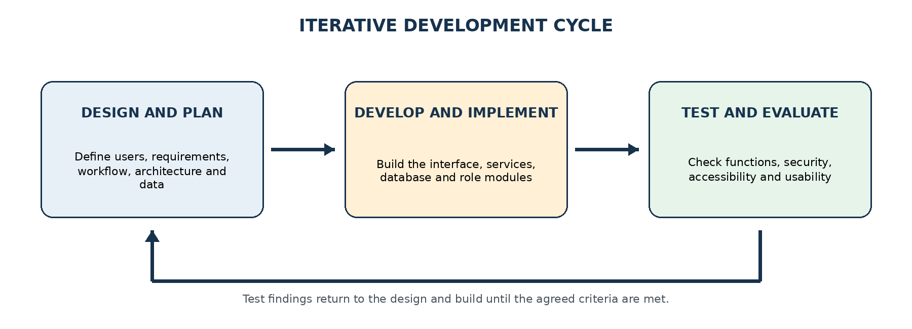
Figure 3.1: Iterative development cycle used for the platform
Source: Researcher's construct (2026)

3.2 System Design and Planning
The design stage establishes what the platform must do before attention is given to screens or code. Its starting point is the practical-learning problem identified at Accra Technical University: tasks, approved demonstrations, student outputs and assessment records can become separated when they are handled through different channels. The proposed design responds by making the practical task the central record. Users, resources, evidence, feedback and audit events are connected to that task rather than being stored as unrelated files.
Planning was carried out at two connected levels. The academic level defined the user responsibilities and the sequence from assignment creation to result release. The technical level translated that sequence into pages, services, data entities and permission rules. This separation helped to prevent a common design error in which an attractive page is built before its educational purpose is clear.

3.2.1 Requirements and Objective Traceability
The requirements were derived directly from the four specific objectives in Chapter One, the approved scope of the platform and the role descriptions already developed for the Administrator, Lecturer and Student. Each objective was translated into an observable workflow and an acceptance condition. This traceability makes it possible to show why a feature exists and how it will later be tested. Table 3.1 summarises the relationship.
Study objective | Required capability | Design response | Acceptance basis
Objective 1 | Lecturer task management | Task creation, course allocation, approved-resource selection, deadlines, required evidence and grading controls | After Administrator setup of the course offering and resource access, the Lecturer completes the create-to-release workflow independently
Objective 2 | Structured student interface | Assigned-task list, instructions, approved resource, saved work, submission, resubmission, feedback and results | Student can complete an assigned task and trace its status
Objective 3 | Database and records | Relational records for users, courses, tasks, resources, sessions, evidence, grades, feedback and audit events | A complete task-to-result record can be retrieved without broken relationships
Objective 4 | Integrated practical resources | Controlled resource catalogue, version metadata, task-resource link and return of agreed output details | Only approved resources can be opened from an assigned task and their use is recorded
Table 3.1: Traceability from study objectives to system acceptance
Functional requirements describe the actions that the system must support. Non-functional requirements describe the conditions under which those actions should be delivered. For this project, the main non-functional requirements are clear navigation, responsive display, role-based protection, five-minute inactivity control, reliable record relationships, understandable errors, recoverable accounts and a structure that can accept additional approved practical resources without rewriting the main platform. The design also requires that no public registration route create an Administrator account.
The requirements are intentionally bounded. The platform records a model or resource name, version, permitted input information, run identifier and returned output metadata when these are available. It does not claim to verify the scientific correctness of every model. It also does not replace the physical workshop, control a real vehicle or make safety-critical decisions.

3.2.2 User Roles and Main Workflow
Role separation is the main organising rule of the interface. It is applied at both the page and server levels so that hiding a menu is never treated as sufficient security. Table 3.2 states the responsibility and boundary of each role.
Role | Permitted responsibility | Control boundary
Administrator | Approve or suspend users; manage academic structure and access; register resources; reset accounts; review reports and audit records | Cannot alter a Lecturer’s academic judgement; any authorised correction follows a documented academic process and remains auditable
Lecturer | Create and publish tasks; select resources; define evidence; review submissions; grade; return feedback; release and export results | Limited to assigned courses; cannot manage system-wide accounts or platform configuration
Student | View tasks and resources; save evidence; submit or resubmit work; read feedback, notifications and released results | Cannot create or grade tasks, view another student’s evidence or change academic configuration
Table 3.2: Role responsibilities and control boundaries
The normal academic workflow begins with administrative approval and academic setup. A lecturer then creates a practical task, attaches an approved resource where one is needed, states the evidence to be submitted and publishes the task to an assigned course. The student completes the task through the same platform, and the lecturer reviews the resulting work trail before giving feedback or releasing a grade. Notifications keep the parties aware of a change, while the audit record preserves important actions. Figure 3.2 shows this sequence.
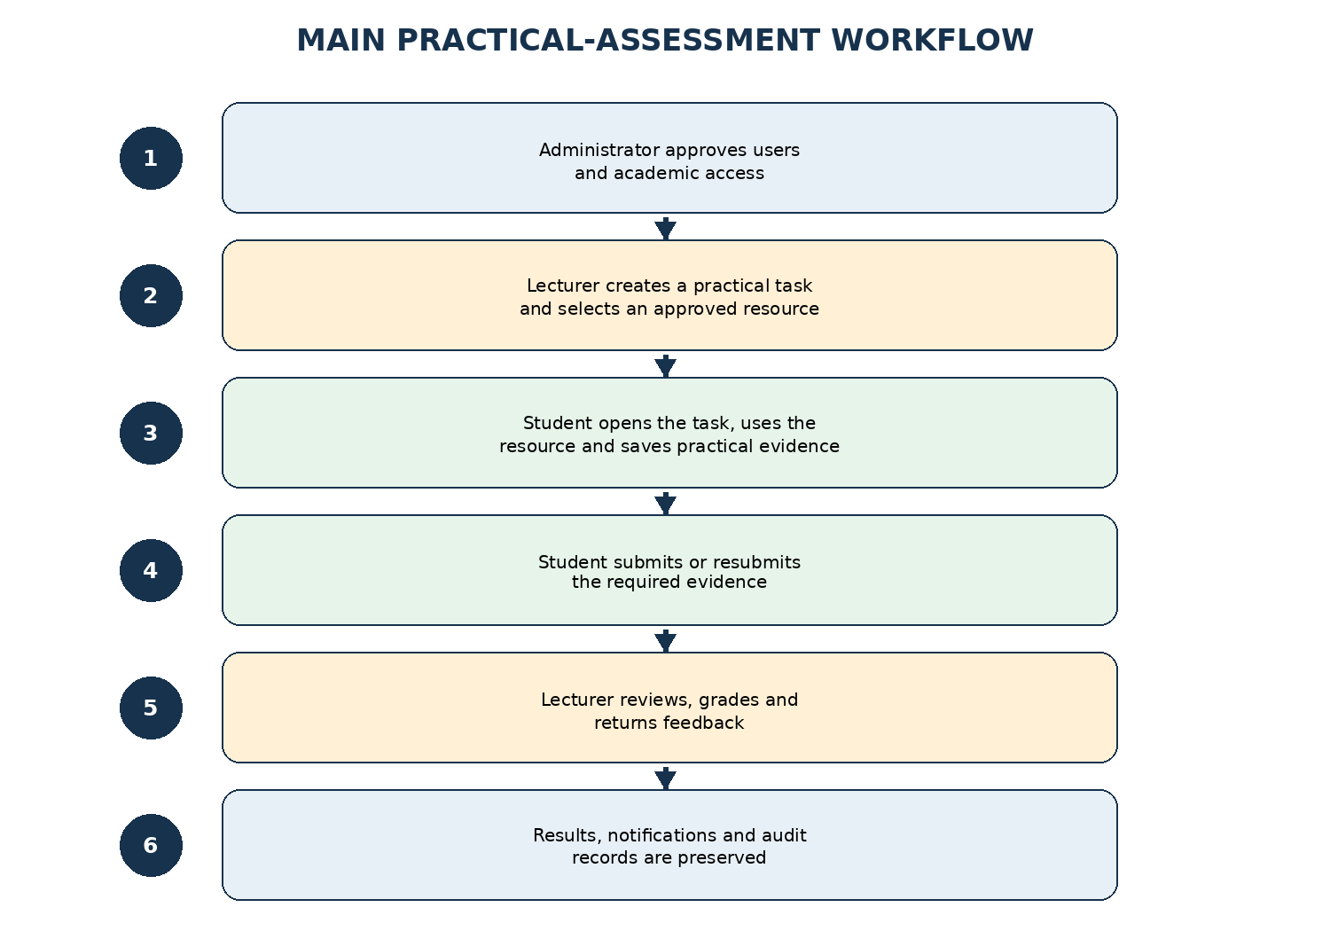
Figure 3.2: Main practical-assessment workflow
Source: Researcher's construct (2026)
Exceptions are handled without breaking the record. A lecturer may close a task, extend a deadline or permit a resubmission, but the earlier submission is retained. An Administrator may suspend an account or withdraw a resource from future use, but the historical record remains readable by authorised users. These rules protect both learning continuity and accountability.

3.2.3 System Architecture
A three-layer architecture was selected because it separates what the user sees from the rules that govern an action and from the records that must be preserved. The presentation layer contains the Welcome page and the three workspaces. It sends requests to the application layer rather than connecting directly to the database. The application and API layer validates the request, confirms the session and role, applies the academic rule and returns an appropriate response. The data and file layer stores structured records and protected evidence.
Approved practical resources remain outside the core application. They are connected through a controlled launch record that identifies the resource, version, provider, status and permitted information exchange. This boundary allows the management platform to support more than one resource without absorbing the internal mathematics of those tools. Figure 3.3 presents the relationship among the layers.
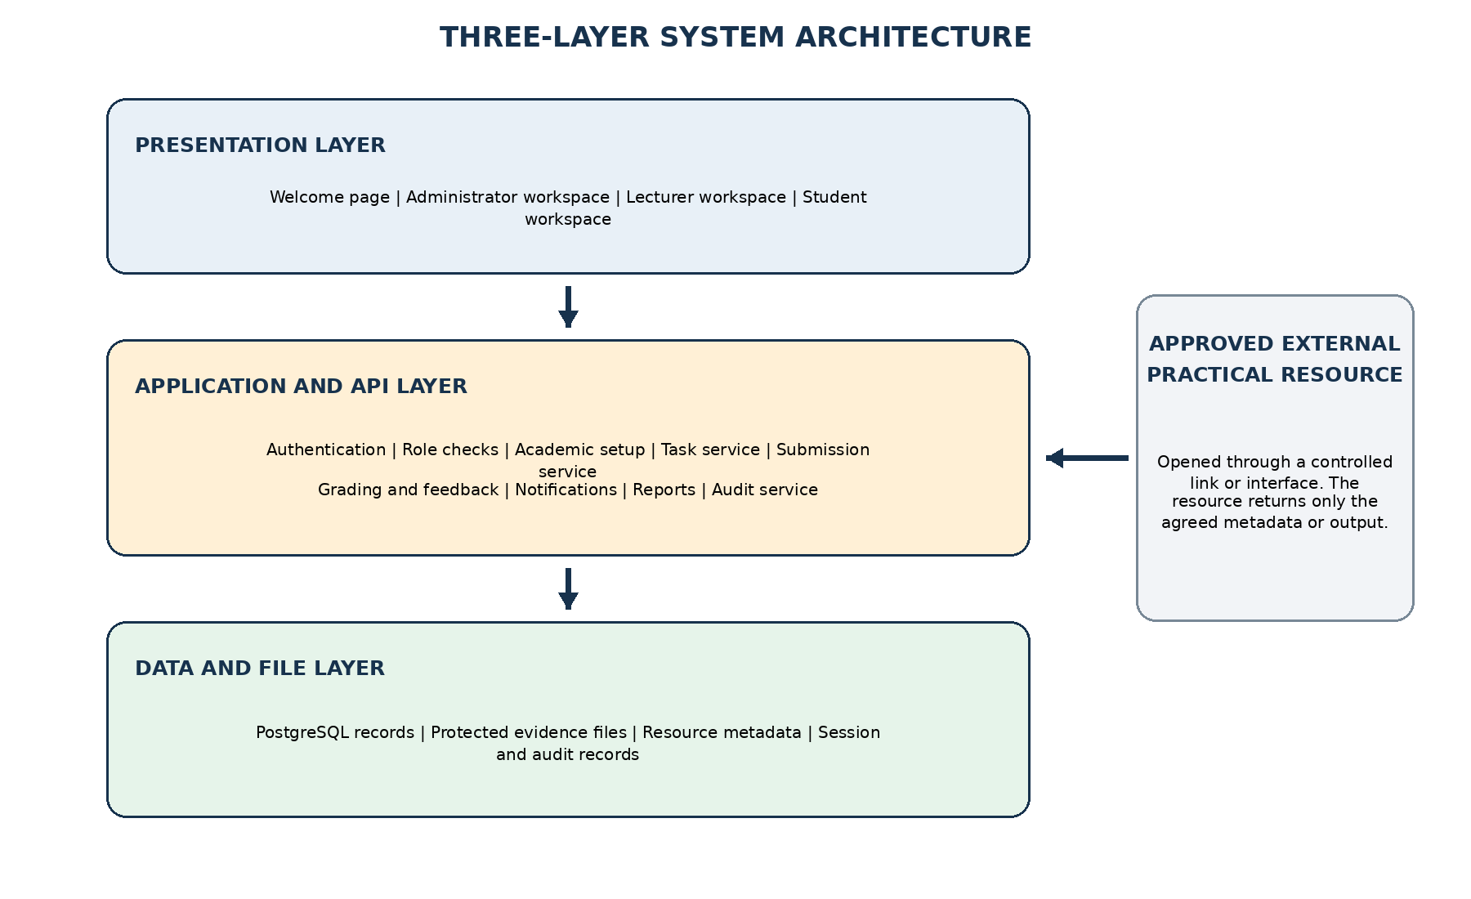
Figure 3.3: Three-layer architecture and practical-resource boundary
Source: Researcher's construct (2026)
The architecture also supports later hosting. During development, the Django application and PostgreSQL database will run locally through a documented environment. For deployment, the application service, database, protected media storage and web proxy can be placed on an institutional server or approved cloud host. The eventual hosting location may change, but the logical relationship among the layers will remain the same.

3.2.4 Database and Record Design
A relational database was selected because the platform depends on clear relationships and constraints. A submission must belong to one student and one task; a task must belong to a course offering and lecturer; a grade must refer to a valid submission; and an audit event must identify an actor and action. These rules are easier to protect when identifiers, foreign keys, uniqueness conditions and transactions are defined in the database rather than left entirely to the interface.
The logical model is arranged into six connected groups, shown in Table 3.3 and Figure 3.4. The grouping keeps academic structure separate from semester-specific access, while still allowing the system to reconstruct the complete route from a task to its evidence and final assessment.
Record group | Principal contents | Design purpose
Identity and access | roles, users, account approvals, password-reset tokens and authenticated sessions | Links each protected action to an identified user and role
Academic structure | faculties, departments, programmes, courses, course offerings, teaching assignments and enrolments | Keeps current access separate from the permanent course definition
Practical resources | resource catalogue, provider, version, status, launch address, permitted data fields and assumptions | Prevents unapproved or withdrawn resources from appearing in new tasks
Assessment tasks | task title, question, outcome, course offering, lecturer, deadline, rubric, required evidence and resource link | Makes the task the central record around which later actions are organised
Activity and evidence | practical session, run identifier, selected values, output metadata, submission, files, revisions and status | Preserves the basis of the student’s answer without treating clicks as competence
Review and oversight | grades, comments, result release, notifications, audit events and report filters | Records the academic decision and the administrative trail separately
Table 3.3: Logical database record groups
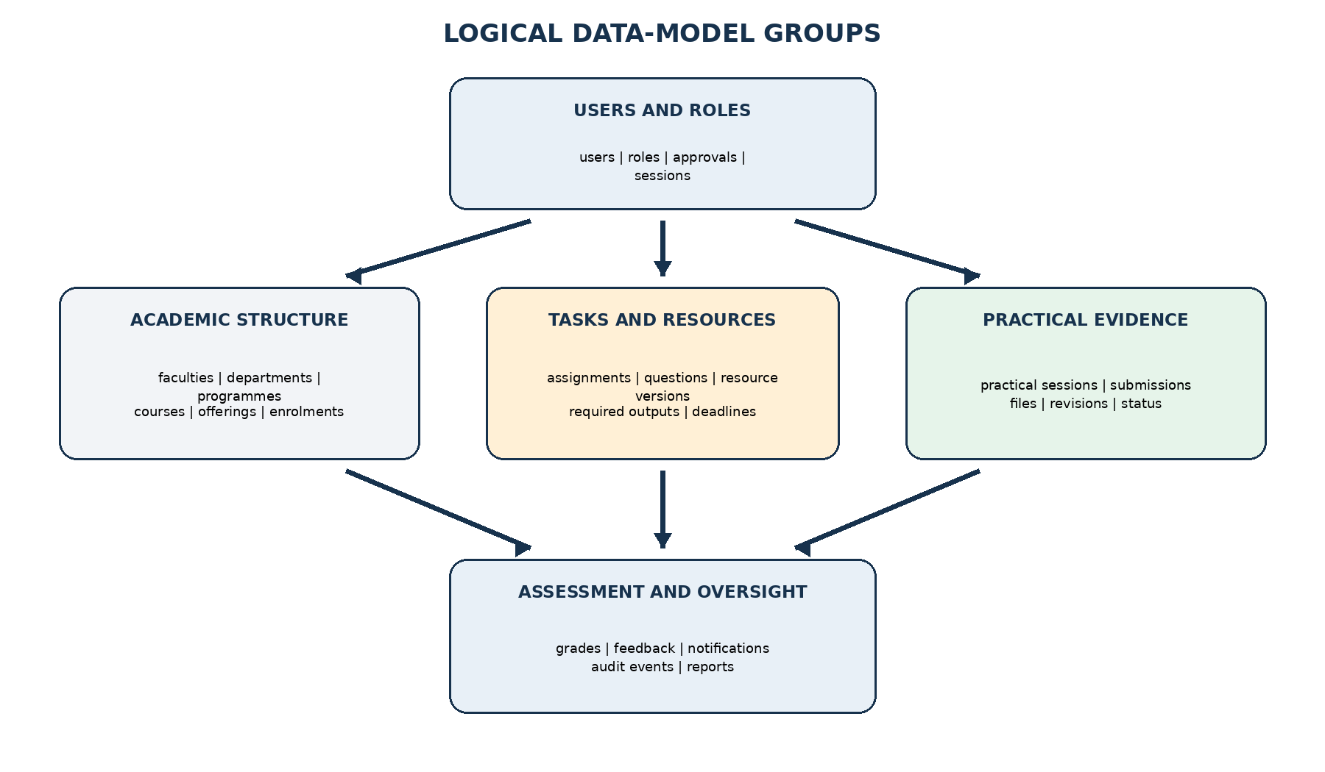
Figure 3.4: Relationships among the main data-model groups
Source: Researcher's construct (2026)
Important records are not overwritten simply because a later state exists. A resubmission creates a new revision linked to the earlier attempt; feedback remains attached to the reviewed attempt; and withdrawal of a resource changes its availability status rather than deleting its historical use. Timestamps are stored in a consistent server format, and the interface presents them in the local academic context. File content is stored outside the public web directory, while the database stores ownership, path, type, size, checksum and submission relationship.

3.2.5 Interface, Accessibility and Security Planning
The interface design follows the way each user approaches the work. The Welcome page gives direct access to registration, sign-in and General Help. After authentication, users see only the navigation needed for their role. The Administrator workspace prioritises pending approvals, academic setup, platform integration and oversight. The Lecturer workspace prioritises tasks waiting to be created or reviewed. The Student workspace prioritises open assignments, deadlines, saved work, feedback and released results.
Consistency is maintained through the orange visual identity, a scrollable left navigation panel, repeated button language and predictable page locations. Forms use visible labels rather than placeholder text alone. Keyboard focus, colour contrast, error identification and responsive layout are planned against WCAG 2.2 Level AA principles (World Wide Web Consortium, 2024). Usability is interpreted as whether specified users can complete specified tasks effectively, efficiently and satisfactorily in the intended context, following ISO 9241-11:2018.
Security is planned as a property of the complete workflow rather than a login page. The design includes approval before access, least-privilege permissions, server-side role checks, protected passwords, expiring sessions, validation of every external input, safe file handling, controlled password recovery and an audit trail. The verification criteria are drawn from the OWASP Application Security Verification Standard 5.0 and the OWASP Top 10:2025 (OWASP Foundation, 2025a, 2025b).

3.3 System Development and Implementation
After approval of the design baseline, development will translate the requirements into a working web application. A Django modular monolith will contain the server-rendered interface, application rules, integration endpoints and data-access layer within one controlled codebase, while PostgreSQL will store relational records and protected media storage will hold uploaded evidence. Development will proceed in small vertical increments. The first increment will complete registration, validation, pending status, Administrator approval, academic setup and the sign-in restriction before practical-task functions are added.
The proposed implementation basis is open source and can run on an ordinary development computer. The selected stack is shown in Table 3.4. Python 3.13 and Django 5.2 LTS will provide the application framework, server-rendered interface, authentication and permission foundation. Django templates, HTMX 2.x and Bootstrap 5.3 will support responsive interaction without requiring a separate browser application. Django REST Framework 3.16 will be limited to documented integration endpoints, while PostgreSQL 18 will preserve the relational records. Exact dependency versions will be locked in the project environment and container image tags so that a later installation does not silently use incompatible releases (Django Software Foundation, 2025a, 2025b; Django REST Framework, 2025; PostgreSQL Global Development Group, 2026).
Development area | Selected tool | Purpose in the platform
Application framework | Python 3.13 with Django 5.2 LTS | Server-rendered web application, authentication, permissions, validation and application services
Interface | HTML5, Django templates, HTMX 2.x and Bootstrap 5.3 | Responsive Administrator, Lecturer and Student workspaces with focused partial-page interaction
Integration API | Django REST Framework 3.16 | Documented endpoints only for approved-resource launch and agreed result metadata
Database | PostgreSQL 18 with Django migrations | Relational storage, constraints, transactions and indexed retrieval
File handling | Private media directory in development; S3-compatible option for deployment | Stores evidence outside the public static path while the database keeps metadata and ownership
Deployment | Docker Compose; Gunicorn and Nginx for hosted deployment | Repeatable local services and a production-ready application boundary
Source control | Git and GitHub | Version history, tagged study release and reproducible source repository
Testing | pytest, pytest-django, Playwright and axe-core | Unit, integration, end-to-end and automated accessibility checks
Design and inspection | diagrams.net and browser developer tools | Architecture diagrams, responsive inspection and browser-level diagnostics
Table 3.4: Development tools and implementation purpose

3.3.1 Source Organisation and Interface Implementation Plan
The source repository will be organised as a Django project with configuration, domain applications, templates, static assets, protected-media handling, tests and documentation separated by responsibility. Domain applications will cover accounts, academics, resources, assessments, submissions, results, notifications, reports and audit records. Database migrations and controlled starter data will be retained with the source so that the schema can be recreated in a known order. Tests will mirror the major workflows, while the documentation area will contain environment, deployment and recovery instructions.
The interface will use role-aware Django views and templates. The authenticated session will contain only the information needed to identify the user and enforce access; the server will remain the authority for every protected request. Reusable template components will be used for form fields, status labels, notification items, tables, confirmation prompts and empty states. HTMX will be applied only where partial-page interaction reduces unnecessary navigation, and every operation will retain a normal server-side fallback.
Responsive behaviour will be achieved through flexible layout rules and breakpoints rather than separate applications for wide and narrow screens. The navigation panel will remain visible on wider screens and become a controlled drawer on narrow screens. Tables containing academic records will retain essential columns and allow horizontal movement when necessary, while forms will use a single-column arrangement on small screens. Error messages will appear close to the affected field and will also be summarised at the beginning of longer forms.

3.3.2 Application Services and Database Implementation Plan
Django views and application services will handle authentication, users, academic setup, resources, tasks, practical sessions, submissions, grades, notifications, reports and audit records. Each protected request will pass through session authentication, server-side permission checks, input validation and domain rules before a state change is committed. Django REST Framework endpoints will be exposed only where an approved external resource requires a documented exchange. Multi-record operations will use database transactions so that related records either succeed together or leave no partial academic state.
Versioned Django migration files will create the database in a known sequence. Primary keys will uniquely identify records; foreign keys will prevent orphaned submissions or grades; unique constraints will prevent duplicate enrolment; and indexes will support common searches such as open tasks by course, submissions awaiting review and audit events by date. A controlled management command will create the initial academic structure where required. The bootstrap Administrator account will be created through the deployment process, never through public registration, and its temporary credential must be changed at first sign-in.
Uploaded evidence will be accepted only after the server confirms the user, task, deadline and permitted file rules. The stored file will receive a generated name, while the original name will be retained as metadata for display. Type, size and ownership will be checked before download, and the file will never be exposed through a guessable public path. A checksum may be retained to support integrity checks and duplicate detection.

3.3.3 Planned Implementation of the Role-Based Modules
The Administrator module will implement registration approval, account suspension, password-reset support, academic structure, course access, approved-resource registration, notifications, reports and the activity log. Academic setup will follow a hierarchy so that a course offering cannot be created without a course and academic period. Resource registration will record the responsible provider, version, launch method, status, permitted data exchange and any assumptions that users must see.
The Lecturer module will implement task creation and management. A Lecturer will select an assigned course, enter the practical question, state the expected output, attach a rubric or marking guide, choose an approved resource if required and define the deadline. Once published, the task will become visible to the relevant Students. The review area will group submissions by task and retain the Student’s saved session, uploaded evidence, explanations, feedback, revisions and final decision. Results may be released and exported without exposing another course’s records.
The Student module will present only tasks linked to the Student’s enrolments. The Student will be able to read the instructions, open the approved resource, save permitted session information, upload evidence and submit the response. Where resubmission is allowed, the new attempt will be created as another revision rather than replacing the first. Feedback and results will appear only when the Lecturer releases them. Notifications will draw attention to a new task, approaching deadline, returned feedback or released result.
Profile management and role-specific logout will be shared functions. The proposed five-minute inactivity rule will be enforced at the protected-session level, so activity on an unprotected page will not indefinitely keep an academic session alive. On expiry, the user will be returned to sign-in and the attempted action will not be performed silently.

3.3.4 Planned Integration of Approved Practical Resources
A practical resource will be integrated by registration rather than by copying its internal code into the management platform. The Administrator will record its name, category, owner or provider, version, description, status and launch address. The resource will then be available to a lecturer only when its status is approved. The Lecturer will link it to a task and defines which outputs are expected from the student.
For a simple resource, integration may be a controlled link that opens in a separate protected page. For a resource that supports data exchange, the platform may issue a short-lived launch identifier containing the user, task and permitted context. The returning resource will supply only the agreed result metadata, such as run identifier, model version, selected parameters, saved output name and completion time. The platform will validate this information before associating it with the student’s practical session.
This arrangement preserves the study boundary. The management platform knows enough to organise and assess the activity, but it does not claim ownership of the resource’s internal calculations. A new automotive demonstration can therefore be added without redesigning accounts, tasks, submissions or grading.

3.3.5 Security and Data-Protection Implementation Plan
Passwords will be stored only as salted hashes using Django’s password-hashing framework, with Argon2 configured as the preferred hasher. Authenticated sessions will use random server-managed identifiers in HttpOnly, Secure and SameSite cookies. Role permission will be checked for every protected view or API operation, and ownership or course membership will be checked again when a record is requested. This will prevent a user from gaining access simply by changing a page address or record identifier.
The server will validate field length, type, required values and allowed options. Database operations will use parameterised queries, while browser output will be encoded through the rendering framework. File uploads will use an allowlist of necessary formats, maximum size, generated storage name and protected download route. Login and password-recovery attempts will be rate-limited, reset tokens will expire after use, and secret values will be loaded from environment variables rather than stored in source control.
Audit events will be created for approval, suspension, task publication, resource-status change, submission, grading, result release, password-reset administration and other actions that affect academic records. Routine page views will not be treated as academic evidence. Logs will avoid storing passwords, reset secrets or unnecessary personal content. These practices follow the secure-development position that protection should be built into the development process and verified throughout it (Souppaya et al., 2022; OWASP Foundation, 2025a).

3.3.6 Reproducible Setup and Deployment Plan
Docker Compose will describe the Django application and PostgreSQL services in one configuration. It is suited to this purpose because it defines the services, network, volumes and environment needed to start the application consistently (Docker, 2026). Gunicorn and Nginx will form the hosted web boundary, while the same repository may also be run through Django’s development server for local work. The container route will be the reference procedure for reproduction.
The reproduction package will contain the source code, locked Python dependencies, Dockerfiles, Compose configuration, Django migrations, controlled starter-data commands, an environment template, test commands and README instructions. Personal credentials, uploaded student evidence and production secrets will be excluded. A clean installation will follow the steps below.
- Install Git and Docker Desktop, including Docker Compose, and confirm that both commands are available.
- Clone the tagged project repository and remain on the documented release tag used for the study.
- Copy the environment template to the local environment file, create new secret values and keep production credentials outside the repository.
- Run docker compose up --build so that the Django application and PostgreSQL services are created from the declared images and dependencies.
- Run the versioned Django migrations and controlled starter-data command, then create the bootstrap Administrator account through the documented deployment command.
- Open the local application address, normally http://localhost:8000, and confirm that the application and database health checks report a ready state.
- Run the pytest and Playwright commands and retain the generated reports before adding real users or practical resources.
- Create a separate backup volume or database dump before significant demonstration data is entered, and record any local configuration change in the README.
After the containers start, the operator will sign in with the bootstrap Administrator account, change the temporary password, confirm the academic structure and create or approve the first Lecturer and Student accounts. The same setup may remain on localhost for demonstration. Later institutional hosting will require HTTPS, a managed domain, regular database backup, monitored storage and a documented recovery procedure, but will not require a change to the logical architecture.

3.4 System Testing and Evaluation
Testing will check whether the implemented platform behaves as the approved design requires. It will proceed from small code units to the complete user workflow. Unit tests will check validation rules and permission decisions. Django integration tests will check that related records are created or rejected correctly. Playwright end-to-end tests will operate the interface as an Administrator, Lecturer or Student. Manual evaluation will then examine clarity, accessibility and usability in tasks that automated tests cannot judge completely.
Testing will be performed on a clean local deployment created from the same reproduction instructions. Test data will use fictional users and non-sensitive files. Each case will record the requirement, starting state, actions, expected result, observed result, evidence and correction where necessary. Actual outcomes and screenshots will be presented in Chapter Four; the present chapter defines the procedure and acceptance basis.

3.4.1 Functional and Integration Testing
The functional test path follows the complete academic sequence rather than checking pages in isolation. Approval must affect sign-in; academic allocation must affect which tasks a user can see; a resource must be approved before a lecturer can select it; a submission must remain connected to its session evidence; and result release must trigger the correct notification. Table 3.5 presents the principal cases.
Test area | Test path | Expected behaviour | Evidence
Account access | Register lecturer/student -> pending -> administrator approval -> sign in | Unapproved account is blocked; approved account enters only its assigned workspace | API response, page state and audit event
Lecturer workflow | Create task -> attach approved resource -> publish | Task is visible only to enrolled students in the selected course offering | Task record and student dashboard
Student workflow | Open task -> use resource -> save -> submit -> resubmit | Each attempt is linked to the same task and earlier evidence remains traceable | Session, submission and revision records
Assessment | Review -> comment -> grade -> release | Student sees feedback and result only after release; lecturer decision is preserved | Grade, feedback and notification records
Authorisation | Attempt direct access to another role’s route or record | Server returns a denial and no protected data is exposed | HTTP status and security log
Session control | Remain inactive for five minutes and then attempt a protected action | Session expires and the user must authenticate again | Session record and redirected page
Input/file safety | Submit invalid fields, unsafe names, blocked file types and oversized files | Input is rejected with a clear message and no unsafe file is stored | Validation response and upload directory check
Accessibility | Keyboard navigation, labels, focus, contrast and automated WCAG checks | Core workflows are operable without a mouse and critical WCAG 2.2 AA errors are absent | Manual checklist and axe-core report
Compatibility | Repeat core workflow in current Chrome, Edge and Firefox at wide and narrow screen widths | No broken navigation, clipped controls or loss of required function | Screenshots and test log
Table 3.5: Core functional, security and compatibility test matrix
A case passes only when the visible response, server response and stored record agree. For example, a task is not considered successfully published merely because a confirmation message appears; the database record must have the published state, the enrolled student must see it and an unrelated student must not. Where a failure is found, the defect is recorded, corrected and the original and related cases are repeated.

3.4.2 Security, Accessibility, Performance and Compatibility Checks
Security checks focus on broken access control, unsafe input, weak session handling, file exposure and insecure configuration because these are direct risks to the proposed platform. Tests attempt protected routes with no session, the wrong role and the correct role but wrong record ownership. Invalid identifiers, unexpected fields and malicious-looking input are sent directly to the API. The application is also checked for exposed secrets, detailed server errors and public access to stored evidence. The OWASP ASVS 5.0 checklist is used to record the applicable controls.
Accessibility is checked through keyboard-only completion of core tasks, visible focus, form labels, error announcements, heading order, colour contrast and automated axe-core scans. Automated results are treated as screening evidence rather than proof of full accessibility, consistent with WCAG 2.2’s use of both testable criteria and human evaluation (World Wide Web Consortium, 2024). Current Chrome, Edge and Firefox are used for compatibility checks, and wide-screen and narrow-screen layouts are inspected for clipping or loss of function.
Performance is evaluated at the prototype scale. The browser records the time needed to load the dashboard and open the main lists, while the server records API response time for sign-in, task retrieval, submission and grading. A small concurrent-load check is used to identify obvious bottlenecks. The purpose is not to claim university-wide capacity from a localhost test; it is to establish a baseline and identify queries, files or pages that require optimisation before wider deployment.

3.4.3 Usability Evaluation
Usability evaluation uses representative tasks for the three intended roles. An Administrator approves an account and registers an academic or resource item. A Lecturer creates and publishes a practical task, reviews a submission and releases feedback. A Student finds the task, uses the approved resource, saves evidence and submits it. The evaluator records completion, errors, requests for assistance and brief observations about unclear language or navigation.
After the task session, participants complete the ten-item System Usability Scale. SUS is brief enough for a prototype and provides a common score for perceived usability (Brooke, 1996). For odd-numbered items, one is subtracted from the response; for even-numbered items, the response is subtracted from five; the sum is multiplied by 2.5 to obtain a score from 0 to 100. The score is interpreted together with task evidence and comments rather than treated as proof that every feature works.
The evaluation should include representatives of the intended user groups available for the study. Their number, background, consent procedure and completed results are reported with the findings in Chapter Four once testing is conducted. This keeps the present chapter focused on the evaluation method and prevents estimated figures from being presented as completed work.

3.4.4 Acceptance and Record of Corrections
The platform is accepted within the initial study scope when all four objectives have at least one completed end-to-end test, critical access-control tests pass, no unresolved defect prevents the core task-to-result workflow, and the main interfaces can be operated across the selected browsers and screen sizes. Accessibility or usability findings that do not block the workflow are still recorded and prioritised for correction; acceptance does not mean that the platform has reached its final institutional form.
A simple traceability record links each requirement to its design component, implementation module, test case and final result. This allows a reader or later developer to reproduce not only the application but also the reasoning by which it was judged. Corrections are committed through source control with a short description and the affected test is repeated. The final release is tagged so that the code, database migration level and reported Chapter Four results refer to the same system version.

3.5 Chapter Summary
This chapter has presented a focused method for the design, proposed development and evaluation of the web-based Virtual Laboratory Management Platform. The design begins with the approved objectives and assigns clear responsibilities to the Administrator, Lecturer and Student. A three-layer logical architecture separates the interface, application rules and records, while approved practical resources remain connected but technically independent. The relational data model preserves the route from academic setup and task publication through practical evidence, feedback and result release.
Development will use a reproducible Django 5.2 LTS and PostgreSQL 18 modular-monolith stack supported by Git, locked dependencies and Docker Compose. The planned implementation covers role-based workspaces, protected resource integration, structured evidence, assessment, notifications, session control and audit records. The reproduction procedure identifies the files and steps required to rebuild the system without relying on the original development computer.
Testing will follow the same objectives and workflows. This chapter defines the functional, integration, security, accessibility, compatibility, performance and usability checks. Chapter Four will present only the interfaces actually implemented, measured results, test evidence and recorded corrections.
CHAPTER THREE REFERENCES
Brooke, J. (1996). SUS: A ‘quick and dirty’ usability scale. In P. W. Jordan, B. Thomas, B. A. Weerdmeester, & I. L. McClelland (Eds.), Usability evaluation in industry (pp. 189–194). Taylor & Francis.
Django REST Framework. (2025). Version 3.16 announcement. https://www.django-rest-framework.org/community/3.16-announcement/
Django Software Foundation. (2025a). Django 5.2 release notes. https://docs.djangoproject.com/en/5.2/releases/5.2/
Django Software Foundation. (2025b). Using the Django authentication system. https://docs.djangoproject.com/en/5.2/topics/auth/default/
Docker. (2026). Docker Compose. https://docs.docker.com/compose/
International Organization for Standardization. (2018). ISO 9241-11:2018: Ergonomics of human-system interaction—Part 11: Usability: Definitions and concepts. ISO.
OWASP Foundation. (2025a). OWASP Application Security Verification Standard 5.0.0. https://owasp.org/www-project-application-security-verification-standard/
OWASP Foundation. (2025b). OWASP Top 10:2025. https://owasp.org/Top10/2025/
Peffers, K., Tuunanen, T., Rothenberger, M. A., & Chatterjee, S. (2007). A design science research methodology for information systems research. Journal of Management Information Systems, 24(3), 45–77. https://doi.org/10.2753/MIS0742-1222240302
PostgreSQL Global Development Group. (2026). PostgreSQL versioning policy. https://www.postgresql.org/support/versioning/
Souppaya, M., Scarfone, K., & Dodson, D. (2022). Secure Software Development Framework (SSDF) version 1.1: Recommendations for mitigating the risk of software vulnerabilities (NIST Special Publication 800-218). National Institute of Standards and Technology. https://doi.org/10.6028/NIST.SP.800-218
World Wide Web Consortium. (2024). Web Content Accessibility Guidelines (WCAG) 2.2. https://www.w3.org/TR/WCAG22/

