SERIES-PARALLEL HYBRID
VIRTUAL-PLATFORM PROGRAMMER HANDOVER
Codex Build Instructions, Integration Contract and Visual-Output Specification
Based on the approved all-in-one Simulink model
Series_Parallel_Hybrid_All_In_One_Fixed.slx
Prepared for virtual-platform implementation
October 2026

1. Purpose of This Handover
This handover converts the approved Simulink concept into a clear software-development brief. The main file, AGENTS.md, is written specifically for OpenAI Codex. It tells Codex how to inspect the existing virtual-platform repository, port the deterministic state-machine and plant logic, integrate the converted code, build the user interface, verify numerical equivalence and produce visual proof of the finished module.
The second purpose is to help the human programmer understand what Codex is expected to build and how the result should be judged. The programmer should not accept a visually attractive dashboard unless its numerical logic matches the approved model.

2. Files Supplied
File | Primary user | Purpose
AGENTS.md | Codex and programmer | Repository-root instruction file containing the complete conversion, integration, testing and visual-output specification.
Programmer handover guide (this document) | Programmer, supervisor and project team | Explains how to use the Codex file, the expected architecture, interface, animation, outputs and acceptance process.

The existing Simulink model and operating guide remain reference inputs. They are not duplicated inside this handover because the aim is to avoid unnecessary files.

3. Why the Main File Is Named AGENTS.md
Codex reads an AGENTS.md file from the project hierarchy before it begins work. Placing the supplied file in the root of the virtual-platform repository makes the engineering requirements persistent across Codex sessions. This is more reliable than pasting a long prompt repeatedly.
Official Codex guidance: Custom instructions with AGENTS.md
The supplied AGENTS.md is kept below the normal 32 KiB project-instruction limit. When the repository already contains large global or parent instructions and Codex reports truncation, increase project_doc_max_bytes in the Codex configuration or explicitly ask Codex to read the file before implementation.

4. How to Use the Two Files
- Create or open the repository that contains the existing virtual platform.
- Place AGENTS.md in the repository root. Replace any older project-level file only after merging useful existing instructions.
- Create a reference folder and place the existing Simulink model and operating guide there, using the exact filenames stated in AGENTS.md.
- Generate a ChatGPT shared-conversation link and replace PASTE_SHARED_CHAT_LINK_HERE in AGENTS.md. The link is optional context; the local sources remain authoritative.
- Start a new Codex session from the repository root and ask it to summarize the instructions and propose an implementation plan before changing code.
- Allow Codex to inspect the repository, then review its chosen integration point and stack. It should reuse the platform framework rather than create a separate application.
- Require Codex to run the repository’s build, lint, type-check and test commands and to provide the visual evidence specified in the instruction file.
Suggested first Codex request:
Read AGENTS.md and the files under reference/. Inspect the repository without changing code. Then report: (1) the current technology stack, (2) the best integration point, (3) the proposed simulation-core language, (4) the UI route/component location, (5) the test strategy, and (6) any conflict between the repository and the specification.

5. Chat-Link Placeholder
Only the user can create a stable shared link to this conversation. The AGENTS.md file therefore contains the placeholder below:
CHAT_CONTEXT_URL = https://chatgpt.com/share/6ade3ade-ff30-83e8-b621-146139a5f84b
Open the conversation in ChatGPT, use the Share function, copy the generated link and replace the placeholder. Codex must continue from the local model specification when the shared link is unavailable, so the project is not dependent on an external conversation.

6. Recommended Software Architecture
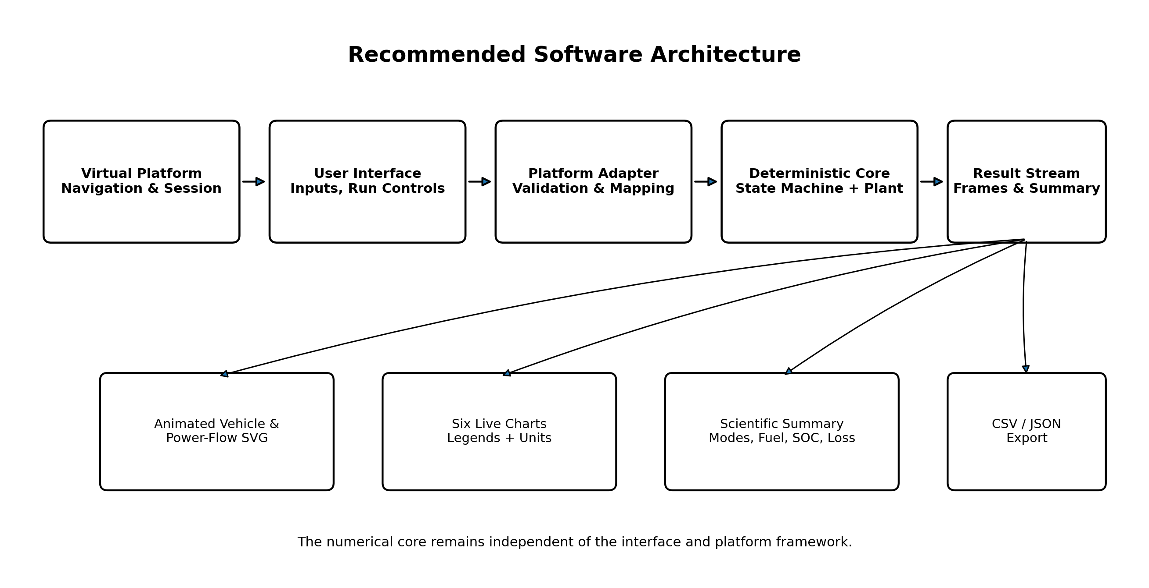
Figure 1. Recommended platform architecture
The numerical core must remain independent from the interface. This separation allows the same logic to run in a browser worker, server process or future external service without rewriting the equations. The platform adapter handles repository-specific APIs and state management, while the interface focuses on user controls, animation and presentation.

7. What the Converted Logic Must Preserve
- All six operational states: electric-only, series, mechanical-drive, combined-drive, engine-charging and regenerative operation, together with ready and limited states.
- Mode and reason codes, minimum dwell time, transition timer and immediate braking priority.
- The exact battery-power sign convention: positive is discharge and negative is charging.
- The approved road-load, driver, component-power, fuel, SOC, loss and vehicle-motion relationships.
- The four built-in scenarios and the intentional low-SOC verification stimulus in Scenario 1.
- The six Scope-equivalent data groups and visible legends.
- Unmet-power reporting instead of silently forcing the demanded result.
- Deterministic results for the same inputs and time step.

8. Main Input Contract
Group | Field | Default | Unit / range
User | Scenario code | 1 | 1 to 4
User | Initial SOC | 0.60 | 0.30 to 0.80
User | Demand scale | 1.00 | recommended 0.50 to 1.50
User | Road grade | 0 | percent; recommended -10 to +10
User | Manual wheel power | 25 | kW; -80 to +120
Vehicle | Mass | 1500 | kg; minimum 500
Vehicle | Drag coefficient | 0.29 | dimensionless
Vehicle | Frontal area | 2.20 | m²
Vehicle | Rolling resistance | 0.012 | dimensionless
Vehicle | Wheel radius | 0.31 | m
Powertrain | Battery capacity | 2.0 | kWh
Powertrain | Engine maximum | 75 | kW
Powertrain | MG1 maximum | 55 | kW
Powertrain | MG2 maximum | 60 | kW
Powertrain | Low-SOC threshold | 0.45 | fraction
Powertrain | High-SOC threshold | 0.65 | fraction

9. Main Output Contract
Output group | Required values
Motion | Time, target speed, actual speed, distance and speed error.
Wheel demand | Requested, delivered and unmet wheel power.
Components | Engine shaft, MG1 DC, MG2 mechanical, battery and wheel power.
Control | Mode code and label, reason code and label, transition status and clutch command.
Energy | SOC, fuel rate, fuel used and recovered energy.
Losses | Path efficiency, mechanical loss, electrical loss and overall efficiency.
Summary | Mode distribution, transitions, final SOC, total fuel, total regeneration, tracking metrics and configuration metadata.

10. User-Interface Expectation
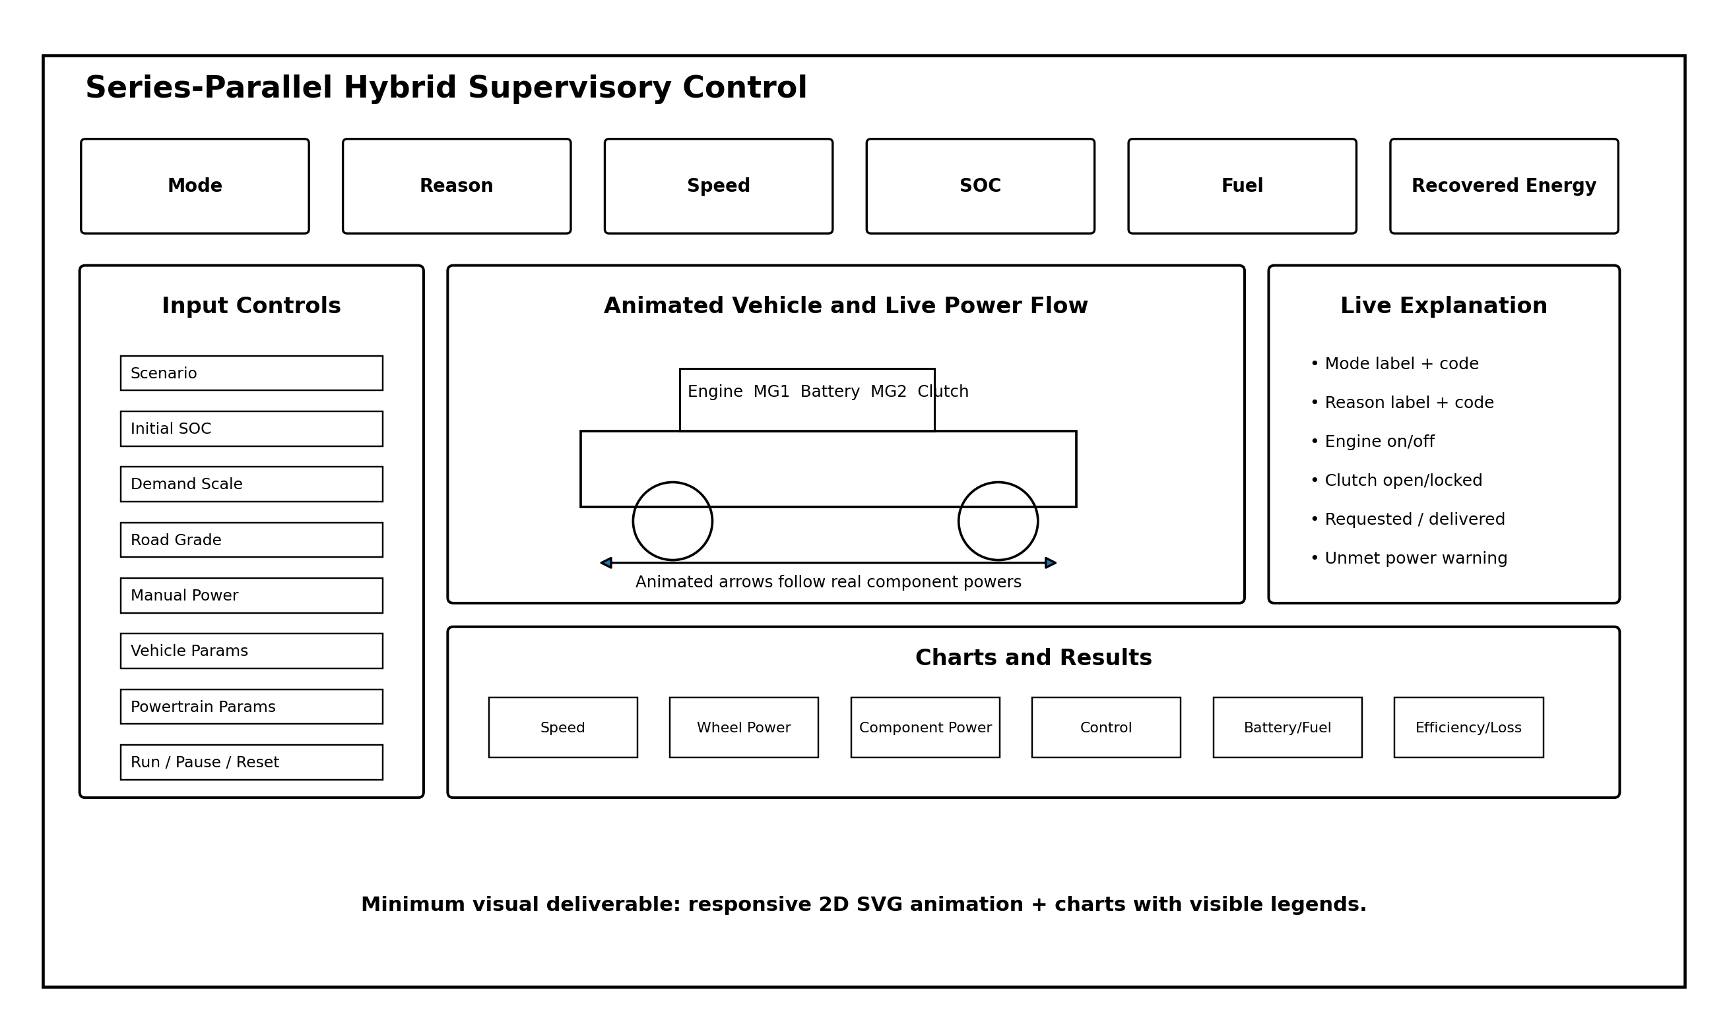
Figure 2. Recommended dashboard arrangement
The interface should open as one understandable workspace. The user should not need to navigate through internal code to change parameters or understand results. Advanced parameters may be placed inside collapsible sections, but scenario, SOC, demand, grade and run controls should remain obvious.

11. Animated Car and Power-Flow Recommendation
A graphical result is recommended and is included as a requirement in AGENTS.md because the academic contribution is transparent operating-mode control. The most useful visual is not a decorative 3D car. It is a data-driven 2D SVG vehicle or drivetrain diagram that explains where power is moving at each moment.
Visual element | Required behaviour
Vehicle wheels | Rotate in proportion to actual vehicle speed.
Road | Tilts according to selected road gradient.
Engine | Shows active/inactive state and current shaft power.
Battery | Shows SOC and distinguishes discharge from charge.
MG1 and MG2 | Show generating or motoring direction and power.
Clutch | Clearly opens or locks according to the control command.
Power arrows | Animate in the correct direction and vary in intensity with power magnitude.
Braking | Shows regenerative flow from wheels to battery and a braking indication.
Mode explanation | Displays readable mode and reason text, not only numeric codes.

A full 3D vehicle is optional. It should be considered only when the existing platform already uses a suitable 3D library and the added work will not delay numerical verification. The baseline requirement is a clear, responsive 2D SVG animation driven by real simulation outputs.

12. Required Charts and Legends
Chart | Legend traces
Vehicle Speed | Target Speed (km/h); Actual Speed (km/h).
Wheel Power | Requested Wheel Power (kW); Delivered Wheel Power (kW); Unmet Power (kW).
Component Power | Engine Shaft; MG1 DC; MG2 Mechanical; Battery +discharge/-charge; Wheel Power, all in kW.
Control State | Mode Code; Reason Code; Transition Active; Clutch Command.
Battery and Fuel | SOC (%); Fuel Rate (g/s); Fuel Used (L); Recovered Energy (kWh).
Efficiency and Loss | Path Efficiency (%); Mechanical Loss (kW); Electrical Loss (kW); Overall Energy Efficiency (%).

Every chart must show its legend and units. When traces use incompatible units, the programmer should use separated panels or carefully labelled secondary axes rather than forcing all signals onto one unreadable scale.

13. Verification Standard
The software port must be tested against the approved model rather than judged by appearance. AGENTS.md contains formula checks and a golden mode sequence. The most important baseline acceptance values are summarized below.
Check | Expected baseline
Time step | 0.1 s
Run duration | 30 s
Level-road rolling resistance | approximately 176.58 N with default mass and Crr
+5% grade force | approximately 734.83 N with default mass
Scenario 1 modes | Ready, electric-only, series, combined-drive, mechanical-drive, regenerative and engine-charging
Approximate final speed | 69.60 km/h
Approximate final SOC | 0.60279
Approximate fuel used | 0.07706 L
Approximate recovered energy | 0.08269 kWh

Small floating-point differences are acceptable. Changes of several simulation steps in the mode sequence or material differences in final energy values require investigation. Tests must not be weakened merely to make an incorrect port pass.

14. Suitable Final Visual Output Demanded from Codex
The programming task must not end with source code alone. Codex is instructed to produce visual evidence showing that the module has been integrated and that the animation and charts are connected to real model data.
- A desktop dashboard screenshot during mechanical-drive or combined-drive operation.
- A regenerative-braking screenshot showing reverse energy flow to the battery.
- A results-screen screenshot with chart legends visible.
- A narrow or mobile screenshot proving responsive layout.
- A short GIF, MP4 or equivalent interactive preview showing at least three operating modes. When recording is impossible, provide the working preview route and reproducible capture instructions.
The visual proof should be stored in project documentation or attached to the Codex task result. Values must come from the simulation and must not be manually fabricated for screenshots.

15. Programmer Review Checklist
☐ Codex reused the existing platform stack and did not create an unrelated second application.
☐ The numerical core is independent from UI components.
☐ Inputs, units, ranges and sign conventions match the model.
☐ All operating modes, codes, transition rules and component limits are present.
☐ Golden numerical and mode-sequence tests pass.
☐ The animation is driven by live outputs.
☐ All six chart groups show visible legends and units.
☐ Scenario 1 is clearly labelled as a verification run.
☐ Unmet power and limit conditions are visible.
☐ CSV and JSON export work.
☐ Responsive and accessibility checks pass.
☐ Build, lint, type-check and tests pass.
☐ Codex supplied screenshots or an interactive preview and documented remaining limitations.

16. Final Scope Boundary
The platform module may provide a polished interface and animated explanation, but the underlying engineering model remains control-oriented and manufacturer-neutral. It does not include detailed combustion, semiconductor switching, battery ageing, thermal networks, clutch hydraulics, wheel-slip control or real-vehicle safety functions. These boundaries must remain visible in the interface documentation.
The resulting software is an educational and research demonstration of supervisory selection, transition, power allocation, SOC movement and energy-path losses. Any future use on physical hardware would require a separate design, validation, safety and testing programme.

17. Expected Programmer Outcome
After following this handover, the programmer should receive an integrated virtual-platform module rather than an isolated calculation script. A user will be able to choose a scenario, change parameters, run the hybrid model, watch the car and power paths respond, identify the selected mode and reason, inspect all scientific outputs, compare losses and export a reproducible result.

