Lab 1 – Ronald Dole

Step 1 – Defining the purpose of the application

Purpose – To find the area of carpet necessary to cover a floor, based on the length and width of the room.

Input – Length of room and width of room in feet, labeled L and W respectively.

Process – Multiply L and W together.

Output – The area of carpet necessary in square feet, labeled as A.

Step 2 – Visualizing the application

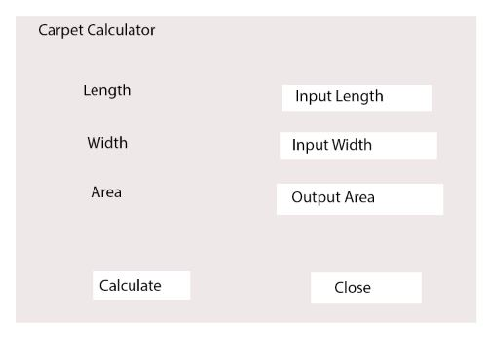

Steps 3 + 4 – Listing Controls and Text

Form

-Carpet Calculator

Labels

-Length

-Width

-Area

-Output Area (lblArea)

TextBox

-Input Length (txtRoomLength)

-Input Width (txtRoomWidth)

Buttons

-Calculate (btnCalc)

-Close (btnClose)

Step 5 – Creating event handlers

btnCalc – When clicked, multiplies the numbers in txtRoomLength and txtRoomWidth, returning the value to lblArea.

btnClose – Terminate the application.

Step 6 – Creating a Flow Chart

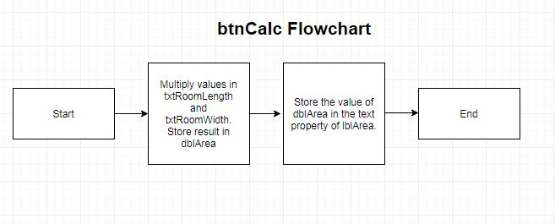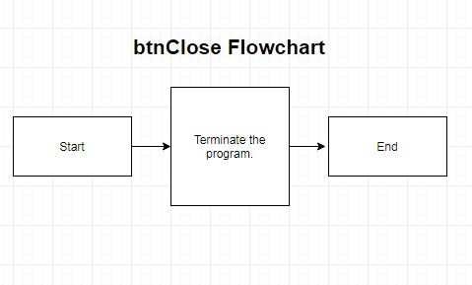

Part 2 – Screenshot of Visual Studio Open

