|  |  |
| --- | --- |
| Name : Christian Job C. Trio | Section : BSIT 3C |
| Assignment No : 2 | Submission Date : Mar. 22, 2024 |
| Assignment Title: Rock Paper Scissors | |

**Code :**

**HTML FILE**

<!DOCTYPE html>

<html>

<head>

<title>Rock Paper Scissors</title></head>

<body>

<h1>Rock - Paper - Scissors</h1>

<div class="butdiv"><button onclick="rotateOnClick(this, 'rock')" id="rockButton"><span class="emoji">&#9994;</span></button>

<button onclick="rotateOnClick(this, 'paper')" id="paperButton"><span class="emoji">&#128400;</span></button>

<button onclick="rotateOnClick(this, 'scissors')" id="scissorsButton"><span class="emoji">&#9996;</span></button></div><br>

<span class="player"><span style="text-shadow: 0 0 10px rgba(27, 253, 156, 0.4), 0 0 9px rgba(27, 253, 156, 0.1);">PLAYER:</span><span id="play"></span><br>

<span class="com">COMPUTER:<span id="computer"></span></span><br>

<h2 id="result"></h2>

<div style="background-color:#212121; margin:0;"><a href="rps.html"><button id="playAgainButton" style="display:none; text-decoration:none; --green: #1BFD9C; font-size: 15px; padding: 0.7em 2.7em; letter-spacing: 0.06em; position: relative; font-family: inherit;

border-radius: 0.6em; overflow: hidden; transition: all 0.3s; line-height: 1.4em; border: 2px solid var(--green); background: linear-gradient(to right, rgba(27, 253, 156, 0.1) 1%, transparent 40%,transparent 60% , rgba(27, 253, 156, 0.1) 100%); color: var(--green); box-shadow: inset 0 0 10px rgba(27, 253, 156, 0.4), 0 0 9px 3px rgba(27, 253, 156, 0.1); ">Play Again</button></a></div>

**JS FILE**

<script>

function rotateOnClick(button, choice) {

button.classList.add('rotate');

setTimeout(function() {

evaluateResult(choice);

disableButtons();

document.getElementById('playAgainButton').style.display = 'block';

}, 700);

}

function evaluateResult(playerChoice) {

var choices = ['rock', 'paper', 'scissors'];

var computerChoice = choices[Math.floor(Math.random() * choices.length)];

var resultDiv = document.getElementById('result');

var resultText;

document.getElementById('play').innerText=playerChoice;

document.getElementById('computer').innerText=computerChoice;

if (playerChoice === computerChoice) {

resultText = "IT'S A TIE";

} else if (

(playerChoice === 'rock' && computerChoice === 'scissors') ||

(playerChoice === 'paper' && computerChoice === 'rock') ||

(playerChoice === 'scissors' && computerChoice === 'paper')

) {

resultText = "YOU WIN";

} else {

resultText = "YOU LOSE";

}

resultDiv.innerText = resultText;

}

function disableButtons() {

document.getElementById('rockButton').disabled = true;

document.getElementById('paperButton').disabled = true;

document.getElementById('scissorsButton').disabled = true;

}

function playAgain() {

document.getElementById('rockButton').disabled = false;

document.getElementById('paperButton').disabled = false;

document.getElementById('scissorsButton').disabled = false;

document.getElementById('playAgainButton').style.display = 'none';

document.getElementById('result').innerText = '';

}

</script>

**CSS FILE**

<style>

body {

background:#212121;

text-align: center;

}

input {

width: 200px;

height: 200px;

border-radius: 50%;

}

.butdiv button {

margin-right:10px;

margin-left:10px;

width: 200px;

height: 200px;

border-radius: 50%;

transition: transform 0.5s;

border-color:#212121;

background:linear-gradient(to bottom right, #305170, #6DFC6B);

}

.emoji {

font-size: 100px;

}

.player {

font-size: 20px;

font-weight: 600;

color:white;

}

.com {

color: red;

}

.rotate {

animation: rotateButton 0.7s linear;

}

@keyframes rotateButton {

0% {

transform: rotate(0deg);

}

25% {

transform: rotate(100deg);

}

70% {

transform: rotate(100deg);

}

100% {

transform: rotate(0deg);

}

}

button{

margin:auto;

}

#play{

text-transform:uppercase;

}

#computer{

text-transform:uppercase;

}

a{

text-decoration:none;

}

h1,h2{

text-shadow: 0 0 10px rgba(27, 253, 156, 0.4), 0 0 9px rgba(27, 253, 156, 0.1);

color:white;

}

</style>

**SCREENSHOT**

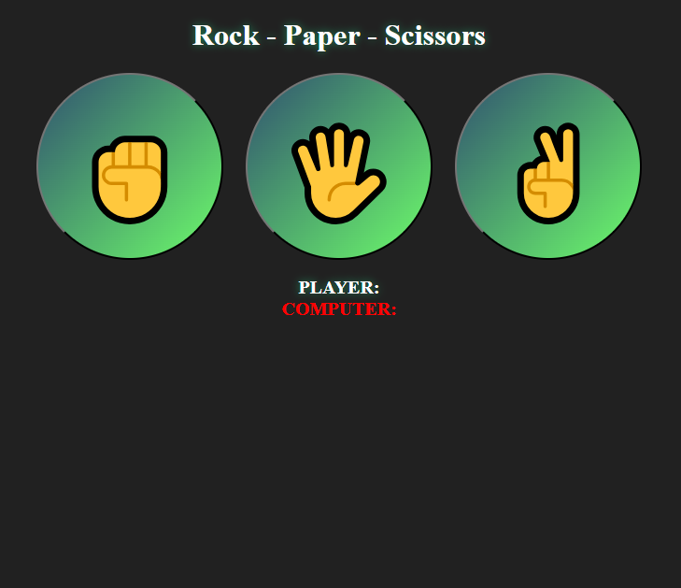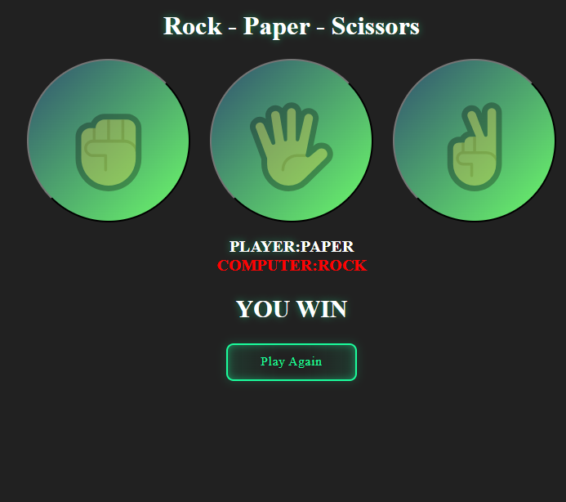

**Dictionary:**

*// List keywords, tags, or methods that are new to you and explain how they are used in the code.*

*transform - rotates element into different angles*

*setTimeout - executes code after a certain time has passed*

*Math.floor - rounds down number*

*Math.random - random number generator*

*add - adds class name to an element*