|  |  |
| --- | --- |
| Name : Christian Job C. Trio | Section : BSIT 3C |
| Assignment No : 3 | Submission Date : April 6, 2024 |
| Assignment Title: Number Guessing Game | |

**Code :**

**HTML FILE**

<html>

<head>

<title>Number Guessing Game</title>

</head>

<body>

<h1>Please input a number between 1-10</h1><br>

<input type="text" id="userInput" class="input"></input>

<button onclick="checkNumber()"><span>Submit</span></button>

<div id="message"></div>

</body>

</html>

<body>

<h1>Please input a number between 1-10</h1><br>

<input type="text" id="userInput" class="input"></input>

<button id="submitButton" onclick="checkNumber()"><span>Submit</span></button>

<div id="message"></div>

<div id="playAgain" style="display: none;">

<button onclick="restartGame()"><span>Play Again</span></button>

**</div>**

</body>

</html>

**CSS FILE**

<style>

h1{

text-shadow: 0 0 10px rgba(27, 253, 156, 0.4), 0 0 9px rgba(27, 253, 156, 0.1);

color:white;

}

body{

text-align:center;

background:#212121;

}

button {

background: #fff;

border: none;

padding: 10px 20px;

display: inline-block;

font-size: 15px;

font-weight: 600;

width: 120px;

text-transform: uppercase;

cursor: pointer;

transform: skew(-21deg);

}

span {

display: inline-block;

transform: skew(21deg);

}

button::before {

content: '';

position: absolute;

top: 0;

bottom: 0;

right: 100%;

left: 0;

background: rgb(20, 20, 20);

opacity: 0;

z-index: -1;

transition: all 0.5s;

}

button:hover {

color: #fff;

}

button:hover::before {

left: 0;

right: 0;

opacity: 1;

}

.input {

border: 2px solid #e8e8e8;

padding: 15px;

border-radius: 10px;

background-color: #212121;

font-size: small;

font-weight: bold;

text-align: center;

margin-right:10px;

color:white;

}

.input:focus {

outline-color: white;

background-color: #212121;

color: #e8e8e8;

box-shadow: 5px 5px #888888;

}

div{

color:white;

}

</style>

**JS FILE**

<script>

var attempts = 0;

var inputField = document.getElementById("userInput");

var submitButton = document.getElementById("submitButton");

var randomNumber = Math.floor(Math.random() * 10) + 1;

function checkNumber() {

var userInput = inputField.value;

var messageBox = document.getElementById("message");

var playAgainButton = document.getElementById("playAgain");

if (userInput === "" || isNaN(userInput)) {

messageBox.innerHTML = "Invalid input: Please input a number between 1 - 10";

} else {

var number = parseInt(userInput);

attempts++;

if (number < 1 || number > 10) {

messageBox.innerHTML = "Invalid input: Please input a number between 1 - 10";

} else if (number === randomNumber) {

messageBox.innerHTML = "Congratulations! You've won in " + attempts + " attempts.";

playAgainButton.style.display = "block";

inputField.disabled = true;

submitButton.disabled = true;

} else if (number < randomNumber) {

messageBox.innerHTML = "Your number is lower, try again with a higher number.";

} else {

messageBox.innerHTML = "Your number is high, try again with a lower number.";

}

}

}

function restartGame() {

inputField.value = "";

document.getElementById("message").innerHTML = "";

document.getElementById("playAgain").style.display = "none";

inputField.disabled = false;

submitButton.disabled = false;

attempts = 0;

randomNumber = Math.floor(Math.random() * 10) + 1;

}

</script>

**SCREENSHOT**

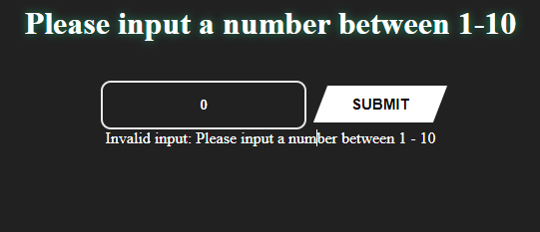

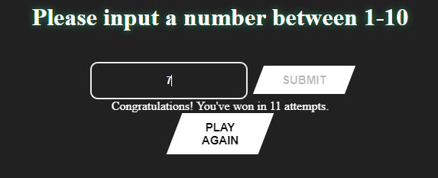

**Dictionary:**

**transform:skew() = skews an element to a certain angle**

**transition = changes values of element based on duration**

**isNaN = checks if value is Not-A-Number**

**parseInt = converts string to integer**

**::focus = select element that currently has focus**