|  |  |
| --- | --- |
| Name : Christian Job C. Trio | Section : BSIT 3C |
| Assignment No : 1 | Submission Date : March. 15, 2025 |
| Assignment Title: Calculator | |

**Code :**

**HTML FILE**

<html>

<head><title>Calculator</title></head>

<link href='https://fonts.googleapis.com/css?family=Inter' rel='stylesheet'>

<body>

<div class="background">

<div class="top">

<div class="block"></div>

<div class="textblock1"><span class="small"></span></div>

<div class="textblock2"><span class="large"></span></div>

</div>

<div class="bottom">

<div class="horizontal"></div>

<div class="horizontal2">

<div class="circlered"><img src="del.png"></div>

<div class="circlered"><span>C</span></div>

<div class="circleblue"><span>%</span></div>

<div class="circleblue"><span>+</span></div>

</div>

<div class="horizontal3">

<div class="circlegreen"><span>7</span></div>

<div class="circlegreen"><span>8</span></div>

<div class="circlegreen" style="margin-left:5.6px;

margin-right:5.6px;"><span>9</span></div>

<div class="circleblue"><span>-</span></div>

</div>

<div class="horizontal4">

<div class="circlegreen"><span>4</span></div>

<div class="circlegreen"><span>5</span></div>

<div class="circlegreen" style="margin-left:5.6px;

margin-right:5.6px;"><span>6</span></div>

<div class="circleblue"><span>/</span></div>

</div>

<div class="horizontal4">

<div class="circlegreen"><span>1</span></div></button>

<div class="circlegreen"><span>2</span></div>

<div class="circlegreen" style="margin-left:5.6px;

margin-right:5.6px;"><span>3</span></div>

<div class="circleblue"><span style="font-size:17px;">x</span></div>

</div>

<div class="horizontal4">

<div class="circlegreen"><span>0</span></div>

<div class="circlegreen"><span>00</span></div>

<div class="circlegreen" style="margin-left:5.6px;

margin-right:5.6px;"><span>.</span></div>

<div class="circleblue"><span>=</span></div>

</div>

</div>

</div>

</body>

</html>

**JS FILE**

<script>

        document.addEventListener('DOMContentLoaded', function () {

            let inputText = '';

            //event listener kada div

            document.querySelectorAll('.circlegreen, .circleblue').forEach(button => {

                button.addEventListener('click', function () {

                    const buttonText = button.textContent.trim();

                    //symbol function

                    if (['+', '-', '*', '/', '%'].includes(buttonText)) {

                        //function para hindi madoble yung symbol

                        if (inputText !== '' && ['+', '-', '*', '/', '%'].includes(inputText.slice(-1))) {

                            inputText = inputText.slice(0, -1) + buttonText;

                        } else {

                            inputText += buttonText;

                        }

                    } else if (buttonText === '=') {

                        //replace x sa asterisk

                        inputText = inputText.replace(/x/g, '*');

                        //calculation

                        let result;

                        try {

                            result = eval(inputText);

                            document.querySelector('.small').textContent = inputText + '=' + result;

                        } catch (error) {

                            result = 'Error';

                        }

                        //clear large after equals

                        document.querySelector('.large').textContent = result;

                        inputText = '';

                    } else {

                        //limit 10 characters

                        if (inputText.length < 11) {

                            inputText += buttonText;

                        }

                    }

                    //update para lumabas yung pinindot

                    document.querySelector('.large').textContent = inputText;

                });

            });

            //backspace function

            document.querySelector('.circlered').addEventListener('click', function () {

                if (inputText.length > 0) {

                    inputText = inputText.slice(0, -1);

                    document.querySelector('.large').textContent = inputText;

                }

            });

            //C function

            document.querySelector('.circlered span').addEventListener('click', function () {

                inputText = '';

                document.querySelector('.large').textContent = inputText;

                document.querySelector('.small').textContent = inputText;

            });

        });

    </script>

**CSS FILE**

<style>

.background

{

margin-top:119px;

margin-left:103px;

margin-right:100px;

width:266px;

height:431px;

background-color:#262626;

border-radius:5px;

}

.top{

height:96px;

width:100%;

background-color:#333333;

border-top-left-radius:5px;

border-top-right-radius:5px;

}

.bottom{

height:335px;

width:100%;

background-color:#262626;

border-bottom-left-radius: 10px;

border-bottom-right-radius: 10px;

}

.horizontal{

height:39px;

width:266px;

}

.horizontal2{

height:53px;

width:266px;

display:flex;

flex-direction:row;

justify-content:center;

}

.circlered{

margin-left:5.4px;

margin-right:5.4px;

width:50px;

height:50px;

border-radius:50%;

background: linear-gradient(to bottom, #DB3045, #66688A);

box-shadow: 0 4px 0 0 rgba(0, 0, 0, 1);

}

.circleblue{

margin-left:5.6px;

margin-right:5.6px;

width:50px;

height:50px;

border-radius:50%;

background: linear-gradient(to bottom, #3038DB, #66688A);

box-shadow: 0 4px 0 0 rgba(0, 0, 0, 1);

}

img{

margin-top:10px;

margin-left:8px;

width:30px;

height:30px;

user-select:none;

pointer-events: none;

overflow:hidden;

}

.bottom span{

display: flex;

  align-items: center;

  justify-content: center;

  height: 100%;

  color:#FFFFFF;

  font-weight:700;

  font-family:Inter;

  font-size:20px;

}

.horizontal3{

height:53px;

width:266px;

display:flex;

flex-direction:row;

justify-content:center;

margin-top:3px;

}

.horizontal4{

height:53px;

width:266px;

display:flex;

flex-direction:row;

justify-content:center;

margin-top:4px;

}

.circlegreen{

margin-left:5.4px;

margin-right:5.4px;

width:50px;

height:50px;

border-radius:50%;

background: linear-gradient(to bottom, #1C7B59, #3498E1);

box-shadow: 0 4px 0 0 rgba(0, 0, 0, 1);

}

.block{

width:266px;

height:26px;

}

.textblock1{

width:266px;

height:25px;

display: flex;

align-items: center;

justify-content: flex-end;

text-align: right;

}

.small

{

font-family:Inter;

font-size:15px;

font-weight:700;

color:#838383;

margin-right:22.5px;

}

.textblock2{

width:266px;

height:37px;

text-align: right;

}

.large

{

font-family:Inter;

font-size:30px;

font-weight:700;

color:#FFFFFF;

margin-right:22.5px;

height:100%;

}

button {

            margin: 0;

            padding: 0;

            border: none;

            background: none;

            font: inherit;

            color: inherit;

            cursor: pointer;

            outline: none;

        }

span{

user-select:none;

}

</style>

**SCREENSHOT**

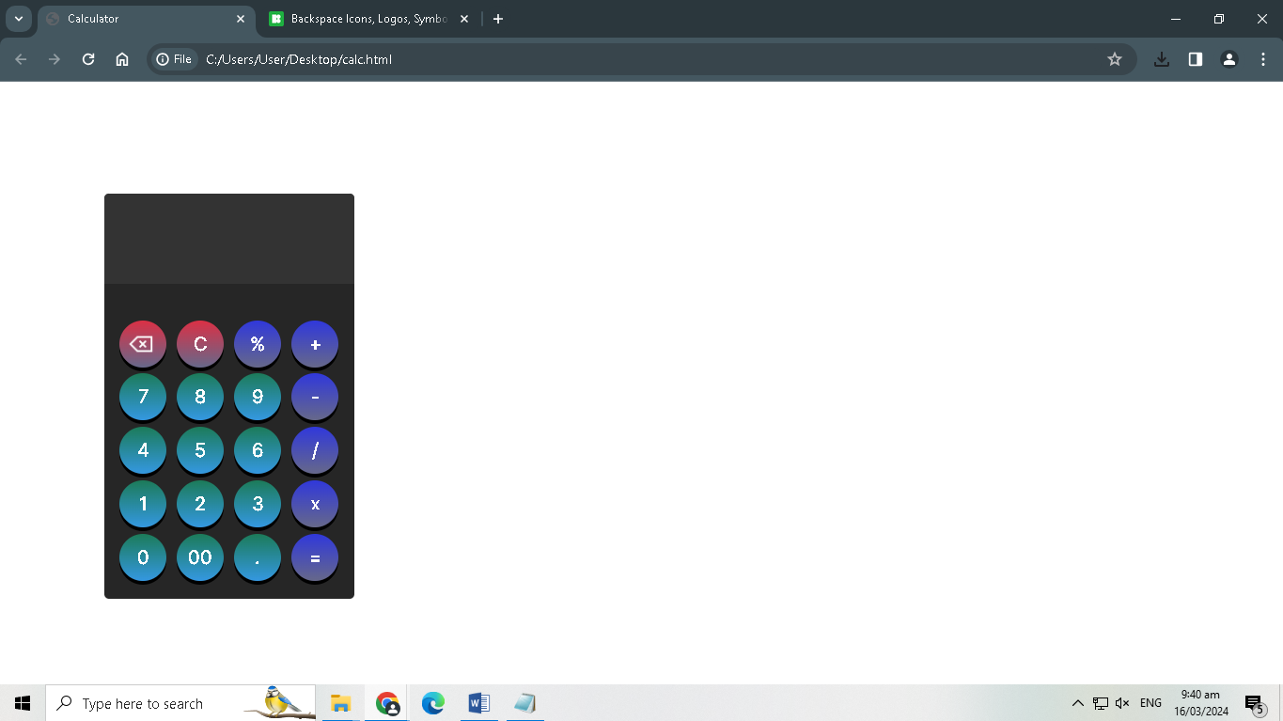

**Dictionary:**

addEventListener - when an event happens, the function inside will be executed

querySelectorAll - returns elements based on the selector of CSS, for example: classes or ids

trim - removes spaces

eval - evaluates text for arithmetic operations

slice - removes last character in the string