## Chapter 1. INTRODUCTION

**SCOPE OF PROJECT**

**Project Description:** The project is to develop an online blood donation website.

Our target audience for now is all Engineering and Medical college students of Mumbai.Youth being the major population, we hope to expand our idea to the entire nation and save lives.

**IMPORTANCE**

In today’s world many humans are dying due to non-availability of blood and blood loss. Our organization will try to reduce the deaths that occur due to non-availability of blood and provide blood to government and private hospitals for free of cost ensuring the safety of patients and proper usage of blood.

**PROBLEM DEFINATION**

Lack of blood for patients has caused a major issue! Due to non-availability of blood at the right time many lives are lost. In order to resolve that we have come forth **Nirmay**.

**Problem we identified**

Lack of awareness among young population for blood donation. Blood donation is a major concern to the society as donated blood is lifesaving for individuals who need it. Blood is scarce. There is a shortage to active blood donors to meet the need of increased blood demand.

How we providing solution with your website or How it is helpful to any population:

1. It connects population of young college students and blood donation camps making the blood easily available.
2. This website will be college level and there will be a database which will hold student’s blood donation records.
3. Our most important priority is to ensure a safe blood supply, available at all times of need.

**Chapter 2. USER REQUIREMENTS**

End user: Population of every age group who requires blood, college students and faculty who wish to see profile of other faculty and students.

In order for better understanding of the user requirement of the project we had an interview with Mr. Goku who is also an engineering student (Mumbai University). We asked him few questions based on which we found out our User Requirement.

1. Do you think blood donation awareness among the young generation is important?

Goku: Yes, it is really important because blood is scarce and not available when needed and considering the fact that youth has healthy blood and the population of young people above the age of 20 is good, awareness is must.

1. Do you support and use such websites? What are your thoughts on such websites. Goku: I didn’t used any such websites in the past but I would be glad to help out society in any way possible. Support to such websites is must and it’s a great initiative taken by you guys.
2. What do you expect from a website like this (user interface and what things should be included)?

Goku: Since this website mainly focuses on college students and faculty it would be good to have details of the faculty and students. The user interface must be clean, simple and not fancy. The website must speak for itself.

1. Would you recommend this website to your friends and family?

Goku: Yes, definitely it’s a great opportunity to give something to the society and an amazing initiative. Will recommend it to everyone.

**Chapter 3. DESIGN AND IMPLEMENTATION**

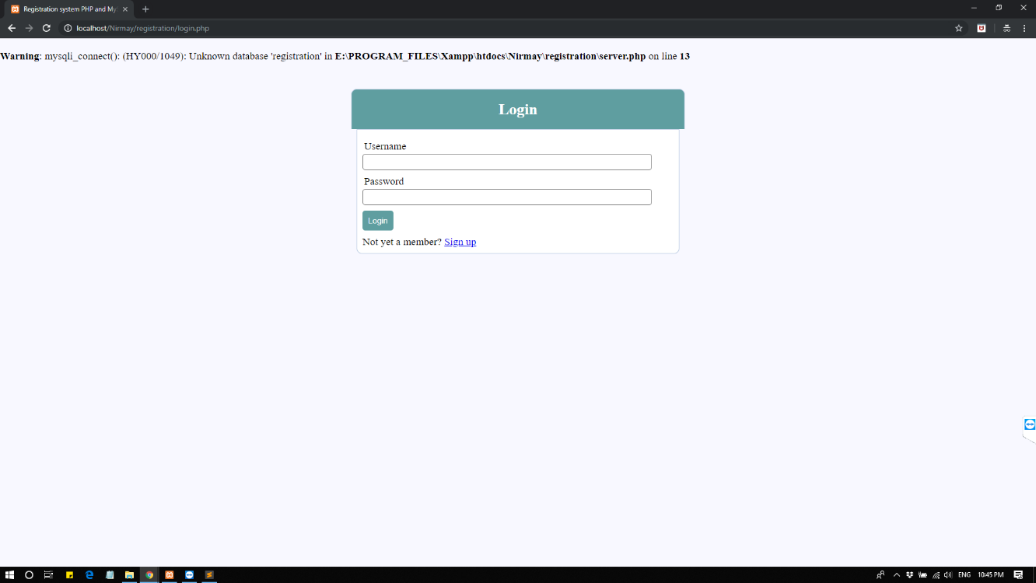

Figure 3.1

This is the login page where users can login if they have already registered themselves over the register site provided by Nirmay.

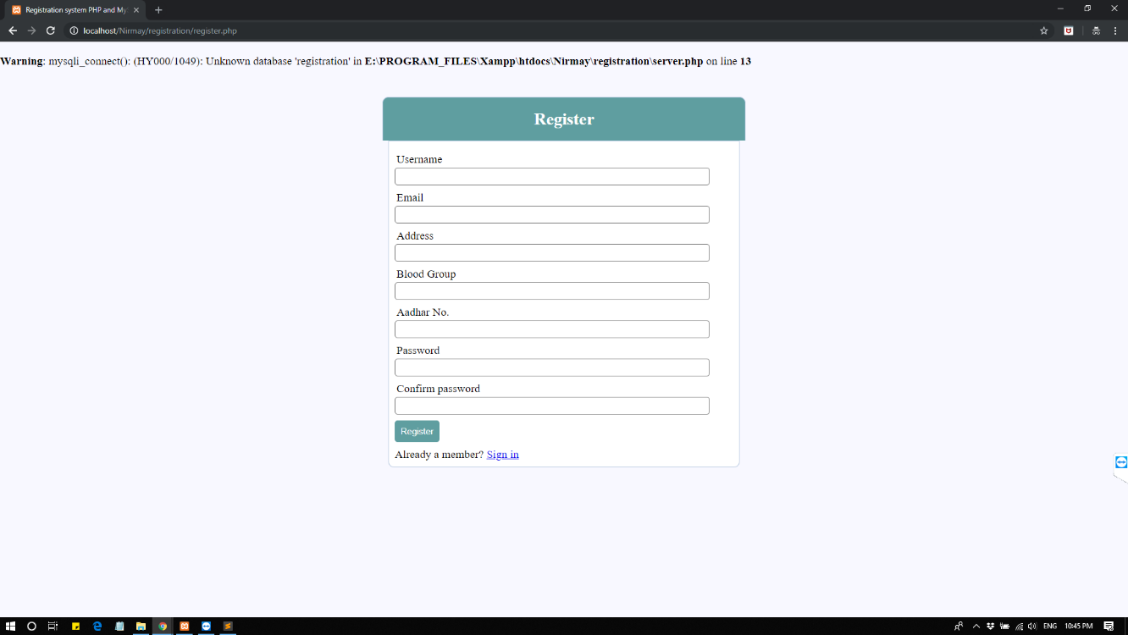

Figure 3.2

In the register page you can register with the fields provided in it!

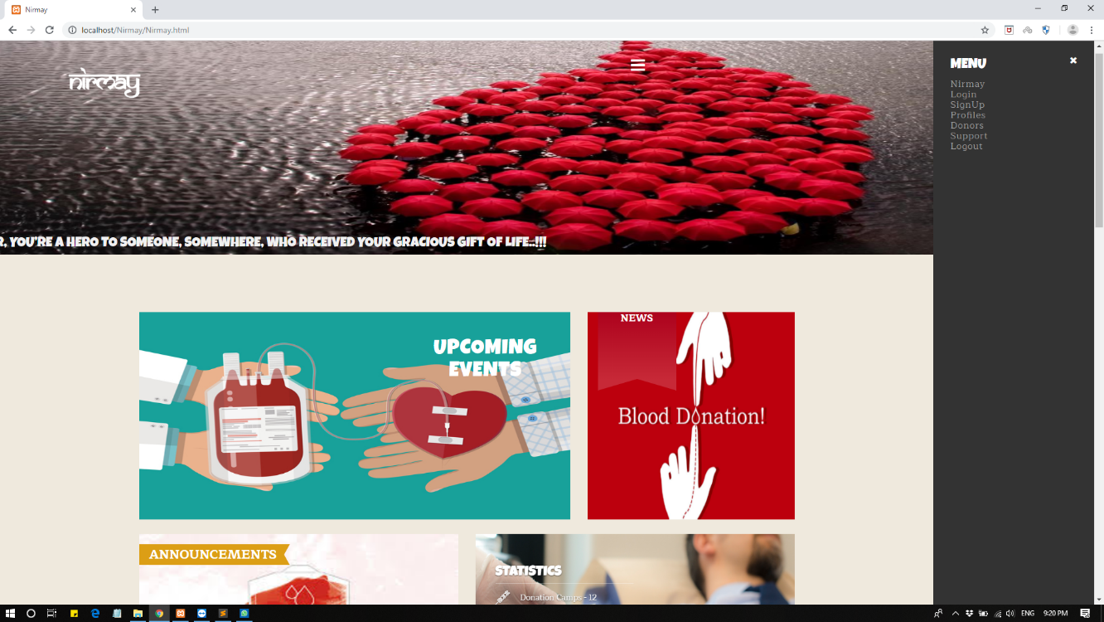

Figure 3.3

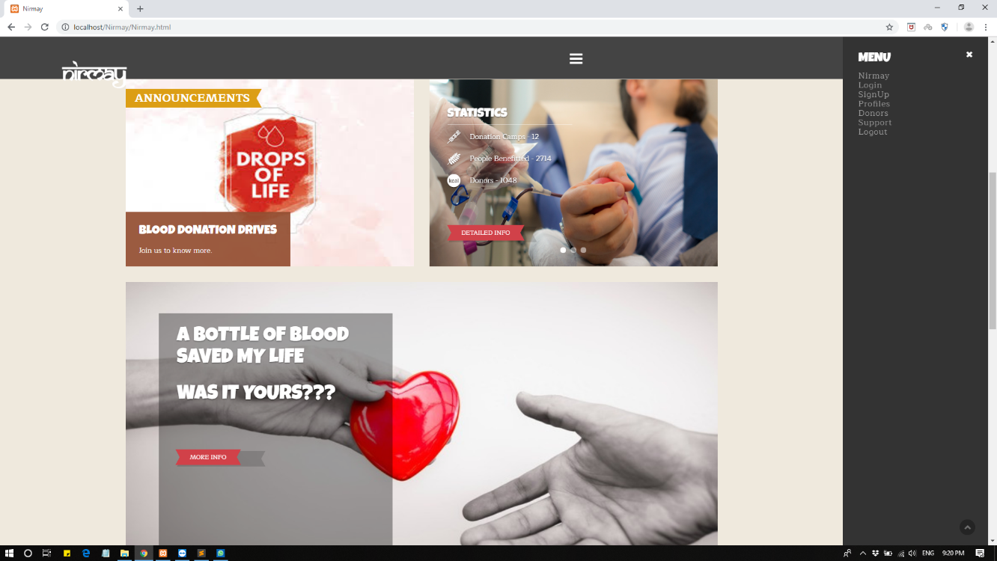

Figure 3.4

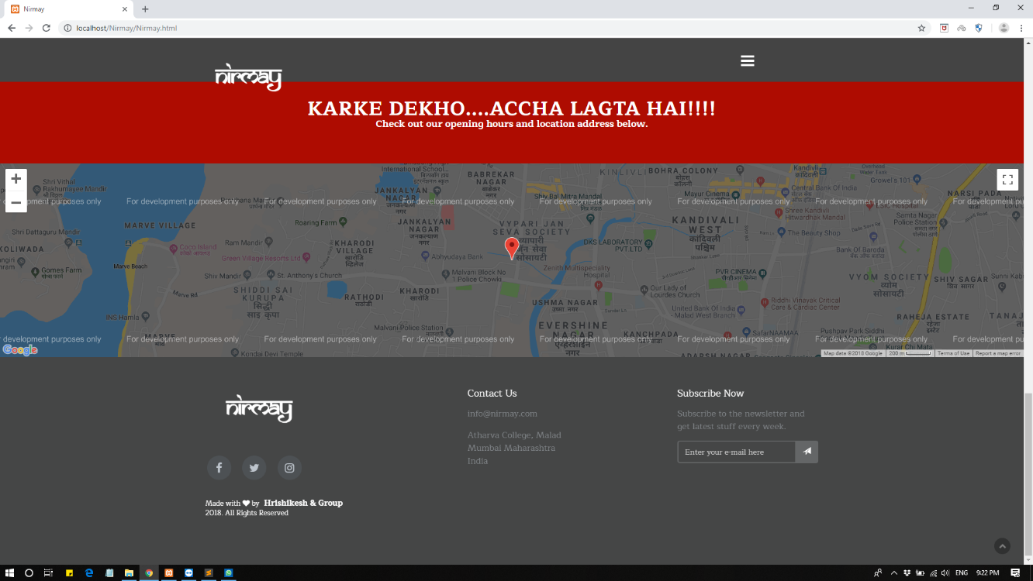

Figure 3.5

This is our homepage where we have different sections which you can see in the above figures**.**

The different sections are as follows.

1. Nirmay: This will redirect to the home page.
2. Login: If the user is already registered then he/she can log in into his profile.
3. Signup: If the person is a new user then he has to register himself first.
4. Profile: Here one can check his own profile.
5. Donors: Here the user can search the donors according to their blood groups. We have used a card system here.
6. Support: Here you can contact us directly if you have any issues.
7. Logout: if you want to end your session you can logout.
8. News: Here you can check the news of latest events and donations.

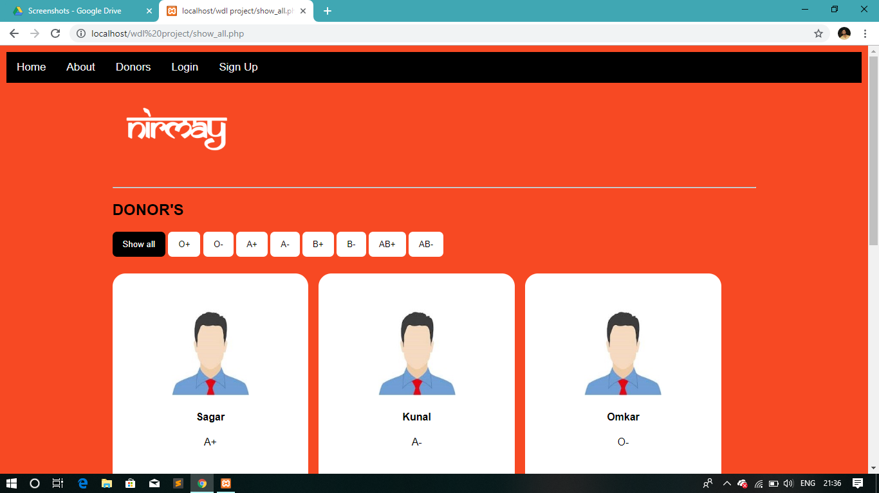

Figure3. 6

This is the blood donors page where you can find the donors according to their blood group. Here their contact number will be displayed so if anyone wants blood they can contact here.

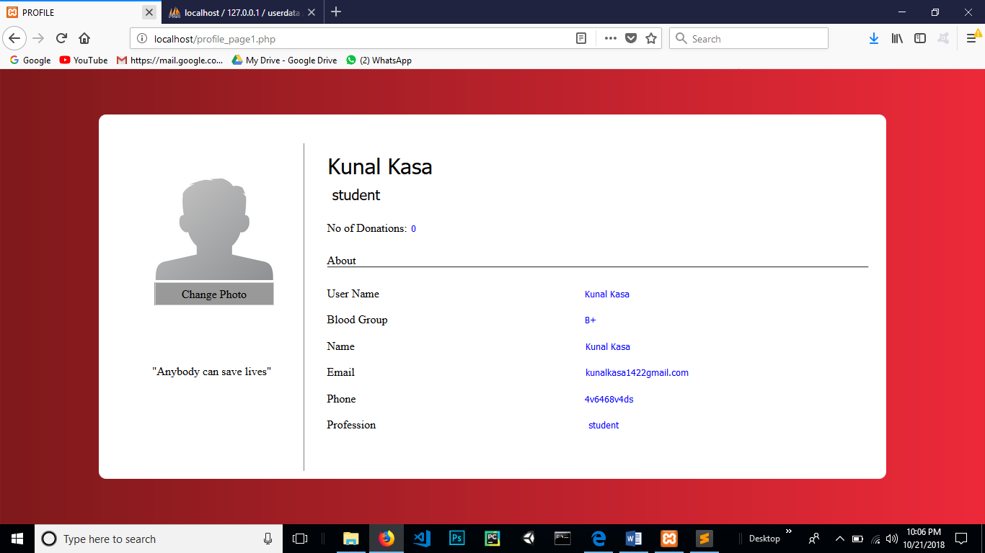

Figure 3.7

This is the profile page, here you can see your own details that you have entered at the time of registration.

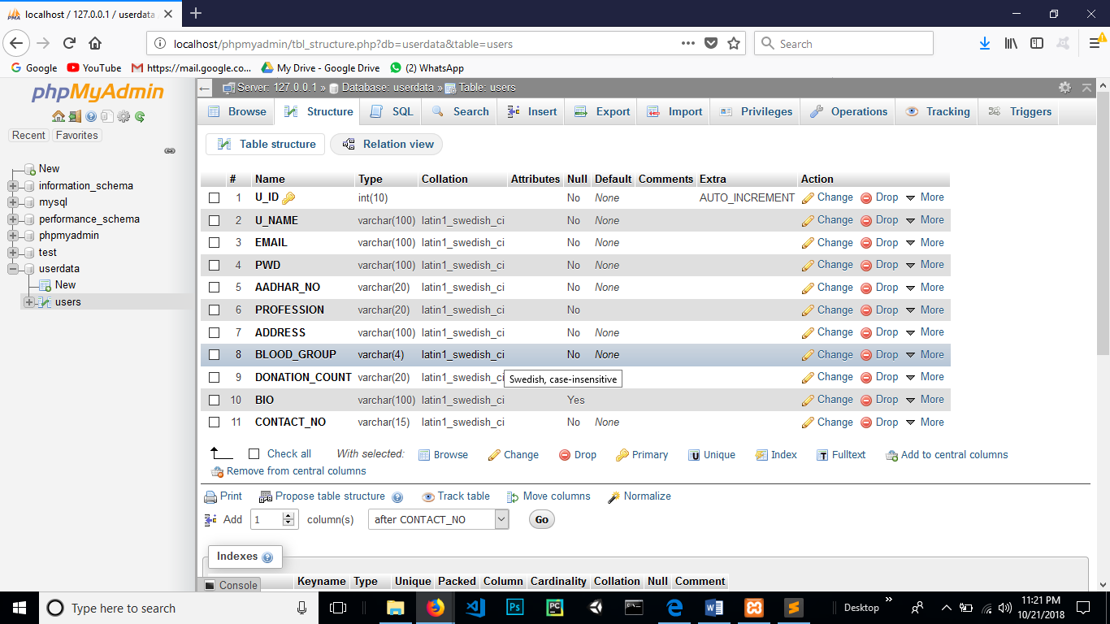

Figure 3.8

This is the database structure containing the table which stores the information of users which have registered to Nirmay.

The fields are:

1. U_ID
2. U_NAME
3. EMAIL
4. PWD
5. AADHAR_NO
6. PROFESSION
7. ADDRESS
8. BLOOD_GROUP
9. DONATION_COUNT
10. CONATCT_NO

## Chapter 4. CONCLUSION

* Users should be able to use the website from any Web browser supporting HTML 3.2 (or later) and cookies.
* Visitors new to the site should be able to login by themselves. Users will be differentiated by unique user identifiers.
* Site visitors should be able to search the database using relevant keywords to identify the person who has the same interest as theirs.
* Users should be able to update their profile.

1.http://www.lifeshare.org/

2.http://www.shareblood.in/

3.https://www.ncbi.nlm.nih.gov/pmc/**articles**/PMC3708194/

4. <https://www.omicsonline.org/articles-blood-donation.php>

5.http://www.who.int/