Contents

EXECUTIVE SUMMARY 1

Introduction 2

CAMPAIGN OVERVIEW 3

DIGITAL SITUATIONAL ANALYSIS 4

Strengths of the eagles 4

Opportunity 4

Weakness 4

threats 4

gaps in social media 4

TARGET AUDIENCE 5

Demographic variables 5

Psychographics variables 5

CAMPAIGN PURPOSE & OBJECTIVES 5

Campaign Purpose 5

Specific (What do you want to accomplish) 5

Measurable (how will you measure progress) 5

Achievable 6

Relevant 6

Time 6

CAMPAIGN MESSAGE 6

MARKETING BUDGET 6

Proposed Budget for the campaign 6

SOCIAL MEDIA MARKETING STRATEGY: CHANNELS, TIMELINE AND COSTS 7

CREATIVE EXECUTIONS AND CONTENT CREATION 8

CAMPAIGN ANALYTICS: MONITORING, TRACKING AND REPORTING 8

CONCLUSION 8

REFERENCE LIST 10

APPENDICES 11

# EXECUTIVE SUMMARY

February 2020 marks the start of an exciting period for the West Coast Eagles Football Club, the 2020 AFLW season will see the inclusion of a West Coast Eagles team for the first time since its inception in 2017. The West Coast Eagles are seeking to ensure that their first season is a success, which means the sale of memberships is essential. This campaign proposal has been designed to ensure that the AFLW promotional campaign reaches its uppermost goals. The West Coast Eagles are excited to expand their media campaign around the build-up to their first season in the WAFL.

Women’s sport is on the rise around the world, proven with the success of the FIFA Women’s Football World Cup which was estimated to have recorded one billion viewers for the first time. In Australia the Women’s Football League has been expanding constantly since its inception:

* 2017’s first season consisted of eight (8) teams
* 2019 saw the inclusion of a further two (2) teams taking the total to ten (10)
* 2020 is the biggest planned expansion by adding another four (4) teams, including the West Coast Eagles, taking the league total to fourteen (14)

As you can understand, this latest expansion is a great opportunity for the West Coast Eagles to target a new range of fans. Most of their target audience as it stands would mostly be men, the added channel of women’s football opens a new avenue of support.

Statistics from the Australian Football Leagues 2019 season show that 111.4 million people tuned in over the course of the season, this accounts for all viewers across both Foxtel and Channel 7. This coupled with the West Coast Eagles boasting around 80,000 members, provides the perfect audience for this campaign, these are the people that must be targeted at attracted over to the AFLW.

During the 2018 season of AFLW, viewership figures dropped quite substantially. We believe that this is due to a lack of promotion on the part of the AFL. In 2017, they were heavily promoting the inaugural season of the AFLW; then moving forward into the second season there was a missed opportunity to capitalise, that is where our campaign becomes essential. With the grand expansion happening prior to the 2020 season, we have been presented with the perfect opportunity to draw viewers from our personal fan base and redirect their attention to a new variety of the sport they hold dear.

We strongly believe that our campaign will succeed in promoting aside to the AFLW that the fans have not yet seen. By launching the West Coast Eagles side into the league, we have access to a previously untapped 80,000 fans, these are the people that will be targeted and introduced to a new format of the Australian Football League, a format which both supports and promotes women in sport. If this campaign is successful, we believe we can provide the West Coast Eagles Women’s team with unrivalled support for their opening campaign in 2020.

# Introduction

The purpose of this report is to outline a social media campaign plan that can be put into action by the West Coast Eagles Football Club. In 2020 the West Coast Eagles will be fielding a team in the third season of the AFLW. As anticipation begins to grow for the season, it is important for the club to capitalise on the hype and media attention all in order to build the sale of membership prior to the season’s commencement.

This campaign will centre around building the hype of the upcoming season, the season begins in early February as it is a precursor to the men’s AFL season which allows for the entire West Coast Eagles fan base to be a target audience. These people will be excited for the new season to begin but will still be in that crucial waiting phase, this will allow for the AFLW to be sold as a way to fill the void.

As social media is a continually growing industry in today’s society, it is our most important avenue of communication with the fans and our target audiences. It is through these mediums that our campaign will be focusing the promotion of the West Coast Eagles inaugural entrance to the women’s Australian football league. Most of our target audience will be highly active on social platforms, so this makes it the easiest way to interact with the club’s followers.

The team will begin their pre-season training in November of 2019, this adds a new element of promotion that can be heavily exploited to build anticipation for the upcoming season. This will form a cornerstone of this promotional campaign. Fans are passionate about their sporting club and are receptive to any output, based on this a small peek behind the curtain will be well received. Using this pre-season training as promotional material on social platforms will build excitement for a new brand of the club they love.

As you step through this report, we hope you will become increasingly aware of the power of a social media campaign and especially the merits of the campaign we are putting forward for your consideration. This entire campaign has been designed to build excitement for the Women’s Australian Football League ahead of the debut of the first West Coast Eagles team to compete in this growing league.

# CAMPAIGN OVERVIEW

This campaign identifies that the AFLW has not and will not achieve the heights of a sport that has been at the forefront of Australian culture for 122 years. The point of this campaign is not to help the WAFL reach the same level as the AFL, we are in essence looking to ensure that the West Coast Eagles have the highest levels of fan support throughout the 2020 season.

The West Coast Eagles currently boast membership numbers of 80,000 fans, as of yet these fans have not had any firsthand experience of the AFLW competition. Up until the season launch in 2020 the only West Australian team in the competition has been the Fremantle Dockers (who joined the competition in its inaugural season) and it is understood that no Eagles fan would turncoat to support a Fremantle subsidiary. It is because of this contributing factor that it has become so important to commit 100% to promote the West Coast Eagles AFLW team.

In today’s society, our main point of promotion has to be social media platforms. The West Coast Eagles already have a large following boasting:

* 319, 000 Facebook Likes
* 188, 000 Instagram Followers
* 83, 900 Twitter Followers
* 13, 700 YouTube Subscribers

(Data correct as of 18/10/2019)

This provides us with a ready-made target audience for the campaign. These people who are already affiliated with the sporting club will be the most receptive to more content and output from their favourite channels.

We will be increasing membership sales prior to the commencement of the season by ensuring the AFLW is at the forefront of people’s minds. This will be done through constant integrated promotions across all of the West Coast Eagles social platforms. Through these channels, we can provide player content (photos, videos, etc.) and behind the scenes footage featuring the training of the new team in the lead to their debut season. This content will both be engaging for those who are already a fan of the sporting club (perhaps looking for a new avenue to channel their support) and will generate a level of ‘buzz’ and anticipation around the league that may not have been felt since the opening season of the AFLW.

It is also to the advantage of this campaign, that the AFLW season happens prior to the commencement of the men’s league. This ensures we have an uninterrupted window within which to promote AFLW, the teams begin training in early November meaning a campaign launched then would not be met with competition from the promotional material of the main AFL season. This advantage can also be channelled into another use; with supporters of the West Coast Eagles (and AFL in general) eagerly awaiting the return of the much-beloved sport, there is an opportunity to supply them with another form of support. The AFLW can benefit from being promoted as a way to begin your club support earlier in the year than has previously been possible.

The purpose of this campaign is to ensure that the West Coast Eagles women’s team has a strong supporter base from the outset of the season, it is our belief that given a chance the West Coast Eagles team can become the most supported team in the national league.

# DIGITAL SITUATIONAL ANALYSIS

## Strengths of the eagles

In 2018, the West Coast Eagles had a total of 290,000 followers on Facebook, 73,000 on twitter, 109,000 on Instagram and 6,000 on YouTube, this means that, among AFL teams, the eagles have the seventh-largest following with a total of 479,000 total followers (Morson, 2018). The eagles main rival in the AFL is the Fremantle dockers who are one of the two Western Australian AFL teams. Fremantle has 76,000 fewer followers on Facebook then the eagles at a total of 214,000, on twitter the difference is only 2,000 as the dockers have 72,000 followers (Morson, 2018). Compared to the eagles, Fremantle has a much smaller following on social media with a total of 375,000 total followers which places them 13th out of the 18 total teams (Morson, 2018). In terms of influencers, ABC news Australia on twitter is an important potential influencer for the eagles, they have 1.5 million followers and have a 92% influence score, Appendix reference B,( (social studio, 2019). Another key influencer is Nine news Australia page on twitter, they have about 500,000 followers and an influence score of 92%, The influencers can be found in the appendix reference B, (social studio, 2019).

## Opportunity

The eagles should start focusing on marketing via video and photo sharing platforms like Instagram, YouTube and Facebook. The Eagles already have a large following on Instagram and Facebook this could be used to engage with their audience more. A key point for the club would be that the eagles are the most supported team in Western Australia with 90,000 members compared to 50,000 for Fremantle (Wildie, 2019), this gives the eagles an advantage in terms of marketing and getting support within the state. The eagles also get a large amount of activity on blogging sites like [www.bigfooty.com](http://www.bigfooty.com/), in the appendix reference c, (social studio, 2019), this shows that there is a need for the eagles to engage these blog sites more, in order to create excitement and engagement.

## Weakness

A weakness for the club is that the sentiment on social media towards the club seems to be falling and is currently at 57% positive  compared to 78%  positive for the main rival Fremantle,this can be found in the appendix reference D, (social studio, 2019), this is having a negative impact on the club and could lead to a loss of memberships next year. The negative news seems to be due to the ASADA drugs scandal.

## threats

more negative trends like more drug scandals could lead to the club losing members.  The club is overly reliant on one form of media type which is forum posting and (social studio, 2019).

## gaps in social media

A gap in the social media activity of the is that its main media type of blog/forum posting which makes up about 93% of the total, the club should focus more on YouTube and Instagram as these forms of social media can be more direct engage then forums that are not linked with the club. The YouTube activity sits at 0.4% of their total this is compared to 4.7% for Fremantle and 13.1% for Collingwood football club (In the appendix reference E) (social studio, 2019).

# TARGET AUDIENCE

## Demographic variables

In order to target the audience for the campaign that is 2020 AFLW Member Acquisition & Brand Campaign, West Coast Eagles will be targeting the customers based on demographical variables. The demographical variables are divided into certain factors like age, gender, education, occupation and income. However, the club will target the individuals between the age group of 18 to 40 years. It will focus upon females’ individuals as would be more interested in woman's football, but the overall goal is to market the event as a family-friendly, all gender event. This target audience will belong to different working professionals as well as college students from upper-middle-class income group. The target audience persona can be found in the appendix of the document, this shows that for the campaign the focus will be based on eagles fans, people that live in Western Australia or just members of the public that seek to show support to the new AFLW team.

## Psychographics variables

In the case of psychographic segmentation, the target audience for the campaign will be divided into lifestyle and personality. The target audience between the age group of 18-40 years may present their psychographic profiles. By considering lifestyle factors, the club will target the audience who prefers urban living and embody more interest in sporting events. On the other hand, the club will target individuals who openly communicate their views.

# CAMPAIGN PURPOSE & OBJECTIVES

## Campaign Purpose

In 2020 the west coast eagles will field its first-ever AFLW team, thus the club plans on creating a media plan that will promote and build up hype during the preseason in November. The overall purpose of the social media campaign is to create excitement and media hype ahead of the west coast eagles debut in the AFLW starting in 2020, the club plans are to use the build-up and excitement surrounding the start upcoming AFLW season in order to promote the sale of AFLW membership. The club hopes that their AFLW team can garner a large following, the club plans on using social media services such as blogs, twitter and video sharing applications like YouTube and engage with their audience and encourage the fans to support the new team.

## Specific (What do you want to accomplish)

The objective of the campaign is the build-up hype for the upcoming AFLW season in order to increase awareness and support for the west coast eagles AFLW team. About 35% of the eagle’s overall fan base is female, thus there should be a targeted drive to get increased female support for the AFLW team while also promoting the campaign as a family-friendly event for all genders. The team hopes that the built-up hype and excitement for the AFLW will result in an increase in ticket/membership sales from the club website. The club will use live streaming, highlight videos, promo videos and other social media marketing techniques to increase the hype and awareness of the AFLW team. This tactic is already used by other major sports teams to build up the momentum before match day.

## Measurable (how will you measure progress)

The media campaign is set to go for at least 2 months from November 2019 to December 2019. The club hopes that by the end of the month-long campaign the total amount of memberships to the AFLW sold would have increased and AFLW team would have an exciting fanbase

## Achievable

1 month might not be long enough for the goals to be fully archived but the recent success of the AFLW in 2018-2019 shows that there is a demand for AFLW teams and there is a fanbase for the league (sporting news, 2018). In 2018, 41,975 fans turned out to the Optus Stadium in Perth to watch the Fremantle AFLW team vs. Collingwood (sporting news, 2018), as eagles are one of two AFLW teams in Western Australia they have access to the Western Australian market.

## Relevant

In 2018, 41,975 fans turned out to the Optus Stadium in Perth to watch the Fremantle AFLW team vs. Collingwood (sporting news, 2018), as eagles are one of two AFLW teams in Western Australia they have access to the Western Australian market. At the first-come of the AFL in 2017, the game between Collingwood and Carlton had to be moved to a bigger stadium due to a higher than expected level of interest in the match (AFL.com, 2017). This shows that there is a real interest in woman’s professional football.

## Time

The project is expected to run from November to December 2019, this is meant to lead up to the opening of the 2020 season.

# CAMPAIGN MESSAGE

West coast eagles are an AFL team that is soon starting a female team to compete in the AFLW national competition (West Coast Eagles 2019). As a result of the above, the key message that the campaign is going to show the audience of AFL is that anybody can be fans of the West Coast Eagles regardless of the gender of the fan. The core audience for this campaign is as mentioned earlier adult ages female fans and as a result, it is important that the campaign message resonates with that core audience.

The key message is that regardless of gender there is still a club that anyone is welcome to join. For the message to be effective it must be relevant to the content in the campaign and be linked to the social media channels chosen to reinforce that core message. The message will encourage support to the core values that the core audience is interested in and reinforce the campaign to generate awareness to the event itself that the campaign is hoping to draw attention towards.

The message needs to be about inclusion so that the club is encouraging the support of the community that the campaign itself is targeted towards. Due to the payment required to join the membership, it can be assumed that the core audience would need sufficient money to join the AFLW membership but everyone can still be interested in following the team which can lead to creating awareness towards the AFLW membership for those interested (West Coast Eagles 2019)

The campaign message will encourage those with views that align to the values that the message portrays to support the message in different ways and one of those direct ways is to join the AFLW membership or share the message to others which creates attention that can also lead to more memberships.

# MARKETING BUDGET

## Proposed Budget for the campaign

A marketing budget is regarded as a marketing plan that presents the cost of the services or products offered by the firms. It is defined as the estimated amount of cost that is needed to promote services or goods. Generally, it is a significant part of the marketing process and marketing plan. However, West Coast Eagles will develop a marketing plan that will include a marketing budget for the campaign. The marketing budget for the campaign will include all of the costs that are expected to pay for advertising in different social media channels. This will involve search engine optimization, ongoing maintenance, website development along with printed materials. The club is expected to pay 4% to 10% for its marketing budget in different social media channels.

However, to promote the campaign among the target audience, the club will make efficient use of various social media channels like Google, Instagram, YouTube and Facebook. It will post relevant contents and images regarding the campaign in these social media channels to reach to its target audience Moreover, the marketing budget of Google will be estimated to be $3,000 for three months as it is going to use search engine optimization to post the content. Furthermore, the marketing budget of Instagram will be $1,000 for two months that will help in viewing and listening to the contents. While the marketing budget of YouTube will be approximately $1,000 for one month and Facebook, it will be $2,000 for two months for posting different ads related to the campaign. As a result, the total estimated marketing budget for the campaign that will be spent on different marketing channels will be $16,000.

While creating a marketing budget is it important for the firms to consider internal marketing performance records, marketing audits, and competitor analysis along with market and industry research. Moreover, the marketing budget proposed above related to the utilization of social media channels will be developed by considering these factors. The club will make use of the percentage method for estimating the budget. However, West Coast Eagle's will set its marketing budget as per the percentage of profit and sales. It can be said that the club will spend 5% of their total revenue on the marketing campaign to maintain its existing position within the market.

# SOCIAL MEDIA MARKETING STRATEGY: CHANNELS, TIMELINE AND COSTS

February 2020 is an essential day for the West Coast Eagles. The West Coast Eagles need to get some followers before and find ways to make them members. Marketing campaigns can help West Coast Eagles achieve their goals. Advertising on social media is a viable approach. Marketers can consider popular social media such as Facebook， Twitter，Instagram to promote the West Coast Eagle is a viable method. Advertising on social media for casual sports fans will have a subtle effect. In general, they are interested in sports and sometimes put some money into their hobbies. But this usually lasts only a short time. It is difficult to convert them to members of the West Coast Eagles in a short period, but it is essential to attract them to buy tickets to watch the game.

This is to make some of them become members of the West Coast Eagles and continue to choose to purchase tickets in the future. Here we will use Facebook as an example to analyze in detail how to attract more followers to the West Coast Eagles and find ways to turn them into members. According to (Cowling, 2019), Facebook is Australia's hottest social media, with more than 10 million people using it in January 2019. This Facebook promotion will get good results. This not only attracts the attention of leisure sports enthusiasts but also reminds the fans of the West Coast Eagles about its latest news. However, if the marketer wants to get the best marketing results, relevant marketing materials must be released sometime before the start of the event.

Although Facebook is a suitable social media, we should still confirm the need to issue marketing channels in early November 2019. At the same time, marketers should also consider how to convert followers into members of the West Coast Eagles. After that, let's confirm how to market at the end of November 2019. For example, how to write an advertising copy. After that, marketers should review as soon as possible whether their manuscript offends some people or is inaccurate. Once you've completed these steps, you'll be able to post these ads on social media. Although Facebook is a social media with a broad audience, it is not easy to display advertisements on it. If you post an ad on your page, you don't have to pay any money. But how to advertise it is a problem that needs to be solved. One solution is to work with Facebook. However, the high price is worth noting. Facebook has two ways to calculate ads: cost-per-click (CPC) and cost-per-thousand-impressions (CPM) ("How much it costs to advertise on Facebook | Facebook Ads Help Centre," n.d.). Facebook has two ways to calculate ads: cost-per-click (CPC) and cost-per-thousand-impressions (CPM). The cost per click is about $0.30, and the cost per thousand impressions is around $8. If the West Coast Eagles want to get better publicity, much advertising is essential. We decided to post 100,000 ads on Facebook. In other words, the cost of promoting the West Coast Eagle on Facebook is about $30,000.

## CREATIVE EXECUTIONS AND CONTENT CREATION

In order to create an effective social media marketing campaign, it is first required to identify the core audience. As discussed earlier the core audience for this campaign are adult females. Once the core audience is found the next step in creating a successful social media marketing campaign is to make sure that the core audience is listening to the campaign message through the channels that they are most likely to use. According to (Corry, K. Duncan, M. Itallie,A. Vandelanotte,C. 2018) one of the most successful channels to share a campaign over a period of time to generate awareness about a sports-related website is Facebook.

The two most effective channels to use for this campaign would be the websites Facebook and Twitter because they are among the most used websites that allow posting of content such as images and videos that can boost awareness of AFLW memberships (Owens, B. 2017). The selection of channel is important to the campaign because if chosen well it can allow the maximum potential number of viewers to the campaign and make sure it is relevant to those watching.

The two main aspects to the campaign that would be most effective using the chosen channels would be videos blogs or posts relevant to the AFLW club. The videos that should be shown on Facebook or twitter are videos that highlight any information about the team playing for AFLW to get excitement generated about the possibility of supporting AFLW by joining the club.

The videos or posts can be used in both twitter and Facebook which makes it easier to sync the two channels together to get one strong campaign that resonates well with the core audience. The videos that are used for the campaign should highlight the AFLW team to generate attention to AFLW which will generate social media attention. The video that would generate a large amount of attention towards the AFLW membership would be one that highlights the team itself and highlight the players of the team. One way of doing this is by creating videos that introduce some of the main players in the team.

The other way of sharing the campaign is through different posts that can be on twitter and Facebook that highlights the membership itself and shows how they can support the team through that membership. The videos that highlight players and the blogs that show how the audience can support the team would create attention towards the AFLW which would create enthusiasm towards the membership of the AFLW.

Please see the appendix for a mock-up of the Facebook and twitter pages

# CAMPAIGN ANALYTICS: MONITORING, TRACKING AND REPORTING

Advertising does not represent the end of marketing efforts. Marketers track follow-up on advertising. Here, marketers should know how to use Google Analytics properly. First, marketers need to set up a smart goal on Google Analytics. This goal must be clear and achievable. For example, one month after the ad is placed, we will add 15 followers per day to attract them to the West Coast Eagles. Once the marketer has established the goal, he will start to use Google Analytics to get conclusions and analyze it.

Marketers should also pay attention to viewers' comments on advertising. Social media monitoring is a way of detecting social media users' comments about a social account (Jaume, n.d.). Tracking keywords or hashtags is one way to implement social media monitoring. I think the following keywords and hashtags are worth noting: West Coast Eagles, WA, Sports, Interest, and Football. The West Coast Eagle is the most important keyword, and the target of our promotion is the West Coast Eagle. This is why he is the most important keyword. Keyword WA should also attract the attention of marketers. The West Coast Eagle is a club located in Perth. We should focus on feedback from local sports enthusiasts. Because compared to foreigners, locals have a more significant advantage when participating in activities related to the West Coast Eagles. They don't have to travel long distances to watch the game. At the same time, sports, interest, and football are also one of the points that need attention.

# CONCLUSION

Feb**r**uary 2020 marks the start of a new AFLW campaign, the league will be expanding from ten (10) competing teams to fourteen (14) one of these being a team from the West Coast Eagles. This campaign has been designed to push women’s AFL to the forefront of the public’s mind and increase viewership. Social media has been identified as the most effective channel to reach and influence a specific target audience (being mostly family orientated females). Output across the multiple social media channels is essential in ensuring engagement and in turn attract people to this new avenue of sport. It is our hope that implementing this social media campaign in the lead up to the West Coast Eagle debut in the AFLW will increase mem**be**rship and aw**are**ness of the sport. If this campaign is effective, the West Coast Eagles Women**'**s team will have the highest engagement of any team in the league.

# REFERENCE LIST

1. AFL. (2018). *AFL 2018 Annual Report* [Ebook] (p. 49). Retrieved from <https://indd.adobe.com/view/29e884e9-3cd6-4d38-b840-2b7335822220>
2. Corry, K. Duncan, M. Itallie,A. Vandelanotte,C (2018) Effectiveness of a social media marketing campaign to increase awareness and membership of a physical activity website <https://www-sciencedirect-com.ezproxy.ecu.edu.au/science/article/pii/S1440244018308284>
3. Lassey, J. (2019). 2019 AFL season by the TV rating numbers. Retrieved 18 October 2019, from https://tvblackbox.com.au/sports/2019/9/30/2019-afl-season-by-the-tv-ratings-numbers?rq=2019%20afl%20season%20by%20the%20numbers
4. West coast eagles (2019) Its time to try something new <https://www.westcoasteagles.com.au/eagles-media/video/eagle-stories>
5. Owens, B (2017) Social Media is here. Like it or Not <https://journals-sagepub-com.ezproxy.ecu.edu.au/doi/full/10.1177/0363546516683654>
6. Cowling, D. (2019). Social Media Statistics Australia – January 2019. Retrieved 15 October 2019, from <https://www.socialmedianews.com.au/social-media-statistics-australia-january-2019/>
7. How much it costs to advertise on Facebook | Facebook Ads Help Centre. Retrieved 15 October 2019, from <https://www.facebook.com/business/help/201828586525529?ref=fbb_budgeting>
8. AFL.com. (2017). *Pies-Blues AFLW opener moved to Ikon Park*. Retrieved from AFL.com: <https://www.afl.com.au/news/2017-01-23/piesblues-aflw-opener-moved-to-ikon-park>
9. Barysevich, A. (2019). *5 Data-Backed Social Media Trends for 2019 [Infographic]*. Retrieved from <https://www.socialmediatoday.com>: <https://www.socialmediatoday.com/news/5-data-backed-social-media-trends-for-2019-infographic/556312/>
10. eagles, W. c. (2019). *west coast eagles analytics*. Retrieved from Blackboard: <https://blackboard.ecu.edu.au/bbcswebdav/pid-6747423-dt-content-rid-9472156_1/courses/MKT2805.2019.2.ONCAMPUS_OFFCAMPUS/WCE%20Google%20Analytics.pdf>
11. Morson, S. (2018). *Which club has the most social media fans?* Retrieved from <https://www.zerohanger.com>: <https://www.zerohanger.com/club-social-media-fans-17505/>
12. social studio. (2019). *social studio*. Retrieved from West Coast Eagles analysis: <https://socialstudio.radian6.com/analyze/w/9069faba-dffd-40d2-9d9b-22f8d6711fee#dashboards/1932533>
13. sporting news. (2018). *AFLW: Fremantle and Collingwood record historic attendance in Perth*. Retrieved from <https://www.sportingnews.com>: <https://www.sportingnews.com/au/afl/news/aflw-record-attendance-fremantle-collingwood-optus-stadium-perth/11exjlzjc98qa1dc82yk7uh682>
14. Wildie, T. (2019). *Fremantle Dockers' membership drifts after an AFL season marked by frustrating losses*. Retrieved from <https://www.abc.net.au>: <https://www.abc.net.au/news/2019-08-12/fremantle-dockers-membership-drifts-after-frustrating-season/11404134>
15. Watkins, B., & Lee, J. W. (2016). Communicating brand identity on social media: A case study of the use of Instagram and Twitter for collegiate athletic branding. *International Journal of Sport Communication*, *9*(4), 476-498.

# APPENDICES

|  |  |  |
| --- | --- | --- |
| **PERSONA DEVELOPMENT TEMPLATE** | | |
| **Name** | **Job Title/Role** | **Experience/ Education** |
| Target audience | Employed or unemployed | Education: Any  Experience: Any |
| **Photo/ Sketch** | **Key Demographic Details** | **Personality & Behavioural Characteristics** |
|  | Age: 18+  Gender: females but preferably any gender  Religion: Any  Education level: Any  Income level: Any  Marital Status: Any | They are a creative person who likes to explore things. they like to work with others. They are helpful in nature and confident in executing things systematically. |
| **Attitude towards technology** | **Attitude towards your brand (West Coast Eagles)** | **Lifestyle** |
| ◼ Great – it’s easy to use and saves me time 🞏 I like it but it often falls short 🞏 I don’t like it but I have to use it | They are fans of the eagles or they want to support the new AFLW team and be involved. | Depending upon the lifestyle factors they like to live a creative and modern life. |
| **Which social media platforms does this person use?** | **Which digital devices does this person use?** | **Which are their preferred social media channels or platforms?** |
| YouTube  AFL blogs  Facebook  LinkedIn | Mobile  Laptop | YouTube  Facebook  Twttier |

**---- persona, Reference A --------**

------influencers, **Reference B--------**

**------eagles’ activities, Reference C----------**

----- Sentiment, Reference D--------

**---Collingwood football club YouTube activities, reference E-----**

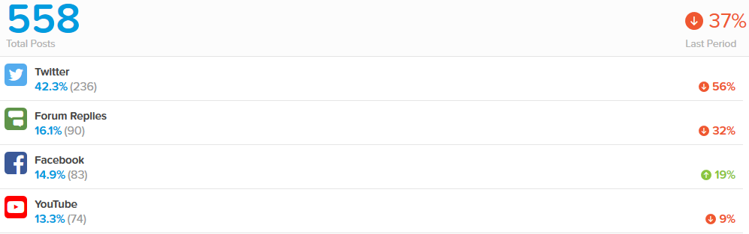

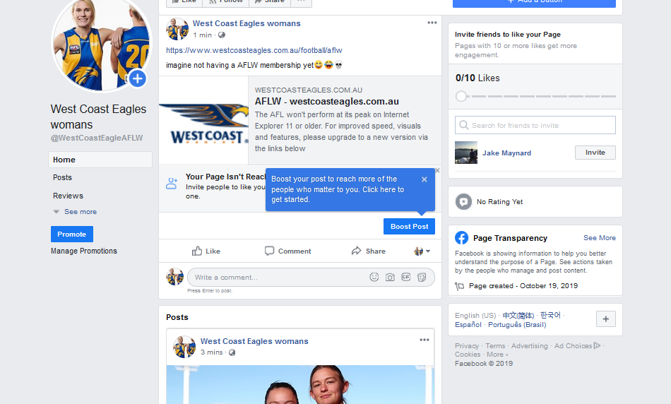**--Fremantle football club activities, reference E---**

**Reference F, AFLW Facebook page.**

<https://www.facebook.com/WestCoastEagleAFLW>

**Reference F, twitter mock-up**

<https://twitter.com/AflwWest>

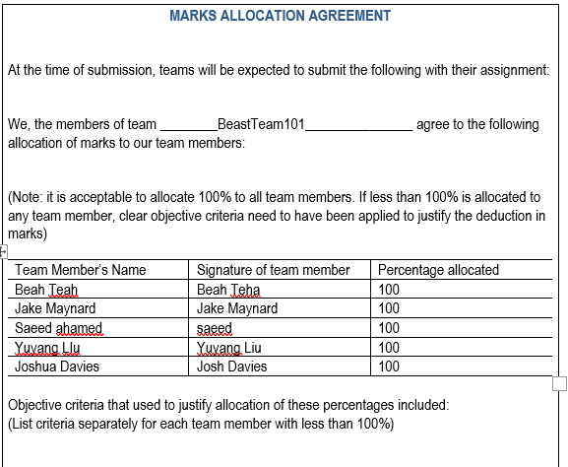

**-Team Contract—**