v: 1.1.17

Alex Wolfe

alex.thor.wolfe@gmail.com

**Tardy Kiosk**

Tardy Kiosk provides a simple check-in kiosk for late students that will automatically mark a student tardy in PowerSchool, as well as optionally printing out a tardy slip designed for thermal printers. Upon entering their student number, the kiosk will determine if a student is tardy and based upon the settings you have entered for the school, mark them with the appropriate attendance code.

Features:

-Quick check-in using only a student number, either through keyboard or barcode scanner.

-Adjustable settings per school.

-Two options for tardy codes, based on attendance code and minutes late.

-Enters meeting attendance code automatically into the student’s attendance screen, including comment, if any

-Optional configurable tardy slip designed for Thermal Receipt printers

-Tardy code settings per Kiosk that allows user to temporarily override school settings

-Kiosk History, searchable list of all students checked in through Tardy Kiosk.

**Tardy Kiosk versions**

* 10/24/2022 – v1.1.17: Added an option to disable the comment from displaying on the tardy slip.
* 10/20/2022 – v1.1.16: Fixed the false positive “Failed to record Attendance, Please try again” error when submitting a tardy for a multi-period, single attendance taken section.
* 09/29/2022 – v1.1.15: The minutes late settings now accepts negative numbers and can record a tardy before a class has started.
* 09/19/2022 – v1.1.14: Fixed error caused by new comment tag update.
* 09/14/2022 – v1.1.13: Kiosk History will now only fetch the last years worth of Kiosk entries. Comment entry now supports 3 tags, {checkindate} {checkintime} {checkindatetime}. If placed in the comment field the Kiosk will input insert the check-in date/time.
* 09/12/2022 – v1.1.12: Added setting to indicate which period to place attendance in. Used for Daily Attendance Bridge.
* 09/12/2022 – v1.1.11: Previous update caused comment box on Tardy Entry to be ignored, fixed.
* 08/10/2022 – v1.1.10: Attendance codes will default to the next year if school is currently between years.
* 03/22/2022 – v1.1.9: Non-numerical IDs are accepted now, new setting to disable comment box.
* 12/09/2021 – v1.1.8: Bug fixes (Double checking entry date, Tardy History resets to page one when searching)
* 09/22/2021 – v1.1.7: Bug fixes (Form clearing, Bugged “Failed to record Attendance” warning)
* 09/14/2021 – v1.1.6: Changed how the current section is detected
* 08/24/2021 – v1.1.5: Printing window now hidden and less obtrusive.
* 08/24/2021 – v1.1.4: “Undefined” no longer shows on slip when comment is empty.
* 08/24/2021 – v1.1.3: Prompt “Print Tardy Slip” button works correctly.
* 07/14/2021 – v1.1.2: ID Type added. Student entry can be done via Lunch ID or State Student Number now
* 06/25/2021 – v1.1.1: Temp Settings display correct username
* 06/22/2021 – v1.1.0: Public release
* 2020-2021 – v1.0.0→v1.0.5: Internal district use and testing.

## Installation:

**Installing Tardy Kiosk**  
Tardy Kiosk consists of two plugins. The extension plugin, which sets up the database structure, and the main plugin with the application itself.

1. Unzip the download that contains both the plugin files.
2. Navigate to the Plugin Management Dashboard (System Setup > System Settings > Plugin Management Configuration
3. Click the Install button
4. Click the Browse... button and select the TardyKioskExtensions.zip from download you unzipped in step 1.
5. Check the box to enable the plugin
6. Click the Install button
7. Click the Browse... button and select the TardyKioskFull.zip from download you unzipped in step 1.
8. Check the box to enable the plugin
9. Tardy Kiosk should now be available at Applications→Tardy Kiosk on the main screen.

**In order for the Kiosk to function correctly, the user logged into PowerSchool to access the Kiosk must have full access to the student’s Enter Meeting Attendance page.**

**Warning: The Tardy Kiosk is not designed to be unattended by staff. Please make sure students are using the Kiosk appropriately.**

## Printer:

The Tardy Kiosk has the ability to print a tardy slip to any printer that has been configured for your current operating system. While the Tardy Kiosk can print to traditional printers, the tardy slip was designed to be printed on 80MM thermal receipt paper. Any receipt printer that has driver support for your OS should work, but testing has only been done under an Epson TM-T88V.

## Kiosk Mode:

In order for the Tardy Kiosk to print without printer prompts/unneeded UI, you must enable your browser’s Kiosk Mode/Kiosk Printing. Unfortunately this is outside the scope of these instructions since it can vary on OS/browser, but [an online search](https://www.google.com/search?q=kiosk+mode+browsers) should find you the information you need. Generally it requires you to make a shortcut to your browser application with additional settings added. For example, using Google Chrome on MacOS the shortcut file might look like this:

/Applications/Google\ Chrome.app/Contents/MacOS/Google\ Chrome --kiosk-printing https://powerschool.example.edu/admin &

Which tells Chrome to launch in Kiosk mode and to go to the admin home page of our Powerschool application.

## Tardy Entry:

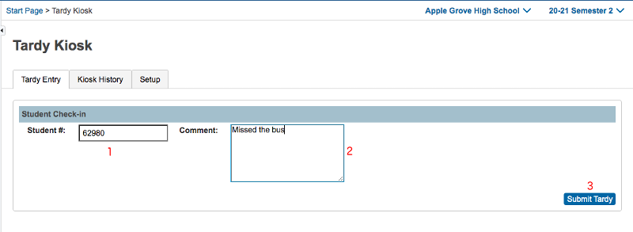

1. **Student #** – Student number you wish to check-in. Uses the [Students]Student_Number field. Accepts keyboard or barcode scanner entry.
2. **Comment** – Attendance comment that will be used for the attendance record. (optional)
3. **Submit Tardy** – Submits the tardy to be recorded for student’s attendance record. Click or hit “Enter” on the keyboard to submit tardy.

## Kiosk History :

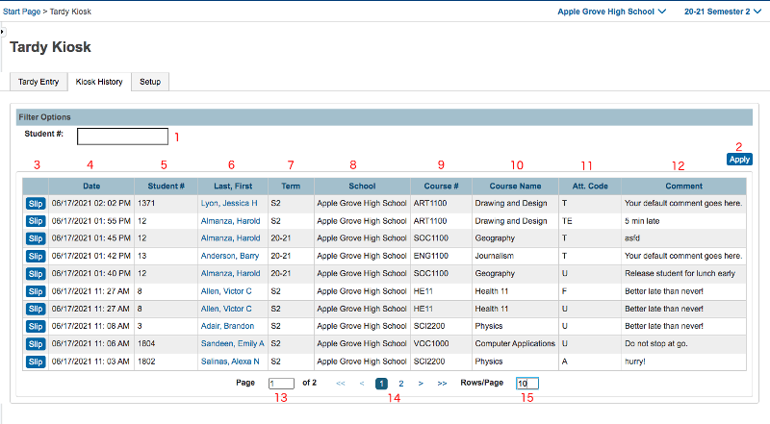

1. **Student #** - Search through Kiosk History for a particular student using their Student Number.
2. **Apply**  - Filters the Kiosk history by the Student Number you input in 1.
3. **Historic Tardy Slip –** Print a copy of a tardy slip from a previous check-in.
4. **Date –** Date/Time when student was checked in.
5. **Student #** - Student # of the student was was checked in.
6. **Last,First –** Student’s Name**,** click to navigate to student’s Attendance screen.
7. **Term –** The term that the course is taken in.
8. **School** – The school where the tardy took place
9. **Course #** - The course number of the course the student was tardy to.
10. **Course Name** – The course name of the course the student was tardy to.
11. **Att Code** – The attendance code that was used for the tardy check-in.
12. **Comment** – The attendance comment for the attendance record.
13. **Page Number Box** – Enter the page you wish to go to in the table.
14. **Pagination Controls** – Navigates through the pages of historic tardies.
15. **Rows/Page** – The amount of rows you wish to see per page, the lower the number the more pages there will be.

## Setup:

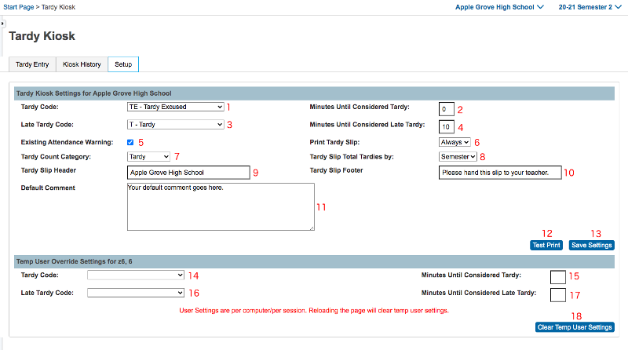

**ID Type (not shown) –** Select the ID type that will be used to lookup student. This will only be used for tardy entry, Student Number will be used for all other identification in the plugin.

1. **Tardy Code** – Attendance code used if student is later than the minutes in box 2.
2. **Minutes Until Considered Tardy** – Initial threshold until student is considered tardy. If positive, a student will be considered late if they’re over that amount of time. If negative, a student will be considered tardy if they’re not in class that many minutes prior. Uses Attendance code in box 1.
3. **Late Tardy Code** – Attendance code used if student is later than the minutes in box 4. (optional)
4. **Minutes Until Considered Late Tardy** – Secondary threshold until is considered tardy. If positive, a student will be considered late if they’re over that amount. If negative a student will be considered tardy if they’re not in class that many minutes prior. Must be greater than “Minutes Until Considered Tardy” setting. Uses Attendance code in box 3.(optional)
5. **Existing Attendance Warning** – Prompts user that attendance has already been entered for the late class. Prompts user if you want to overwrite.
6. **Print Tardy Slip –** Toggle to print tardy slip upon check-in.
7. **Tardy Count Category** – Which Attendance Code Category to use to calculate total amount of tardies on tardy slip.
8. **Tardy Slip Total Tardies by** – What term type to use to count total tardies. Uses the current term of whatever type you use.
9. **Tardy Slip Header** – Text displayed at the top of the tardy slip.(optional)
10. **Tardy Slip Footer** – Text displayed at the bottom of the tardy slip.(optional)
11. **Default Comment –** Comment used when recording meeting attendance. Overwritten by comment on “Tardy Entry” screen.(optional)
12. **Test Print**  - Sample tardy slip used to test printer connection.
13. **Save Settings**  - Saves Tardy Kiosk settings for the current school.
14. **Temp Use Tardy Code** – Temp override code used if you need to use another code besides the school’s default tardy kiosk settings. Used to enter exceptions to normal tardies, such as late bus etc. Uses minutes entered in box 15.(optional)
15. **Temp Minutes Until Considered Tardy** – Temp override minutes for code in box 14.(optional)
16. **Temp Use Late Tardy Code** – Temp override late code used if you need to use another code besides the school’s default tardy kiosk settings. Used to enter exceptions to normal tardies, such as late bus etc. Uses minutes entered in box 17.(optional)
17. **Temp Minutes Until Considered Late Tardy** – Temp override minutes for code in box 16.(optional)
18. **Clear Temp User Settings**  - Quick way to clear temp settings when no longer needed.
19. **Daily Attendance Period Override (not shown)** – Attendance will be placed In this period instead of the section that student is currently tardy for. Used for schools with Daily Attendance bridge.