LAURELSHIELD
Customer Portal Help Guide
A detailed, illustrated, screen-by-screen reference for every section
of your Laurelshield customer portal

Table of Contents

Introduction
This guide documents every screen in the Laurelshield customer portal in the order you will normally use them: from getting oriented on Overview, through defining scope and connecting evidence, to issuing and sharing your Cyber Risk Passport, and finally the transparency screens (Appeals and Audit Trail) that let you contest a decision or see exactly who has looked at your data. Each chapter follows the same structure: what the screen is for, what you will see on it, step-by-step instructions for using it, and one or more callout boxes for warnings, key points, or practical tips.
KEY POINT
This guide covers the Customer Portal only, the role used by your organization's own security or IT leadership. Laurelshield Assurance Operations staff, brokers, and carriers see different portals with different screens, not covered here.

A companion Textbook and Workbook go deeper on the underlying cyber insurance concepts (Evidence Confidence Levels, canonical controls, the Laurelshield Suite product family) and provide hands-on exercises. This guide is deliberately procedural: it tells you what to click and what to expect, with less theory.

CHAPTER 1

1. Overview
Your assurance cockpit: a single-glance summary of where your organization stands right now, across every registered assurance boundary (scope).

What You'll See
- Quick Actions: one-click tiles to every other section of the portal.
- Active assurance boundary selector. If you manage more than one scope (for example, separate legal entities or regions), switch between them here. Every number on this page reflects whichever scope is currently selected.
- Assurance Summary: live counts of Verified, Conditional, Material Gap, and Evidence Expired controls, Open Remediation items, and Passports Issued.
- Resources: a table of your scopes and issued passports. Click any row to jump straight to it.
- A reminder of the 12-stage assurance lifecycle at the bottom of the page.

Step by Step
- If you manage more than one scope, use the dropdown to pick which one you are reviewing.
- Scan the Assurance Summary card row first. Material Gaps and Evidence Expired are the two numbers that need your attention before anything else.
- Click a Quick Actions tile, or a row in Resources, to jump directly into that part of the workflow.

On Screen
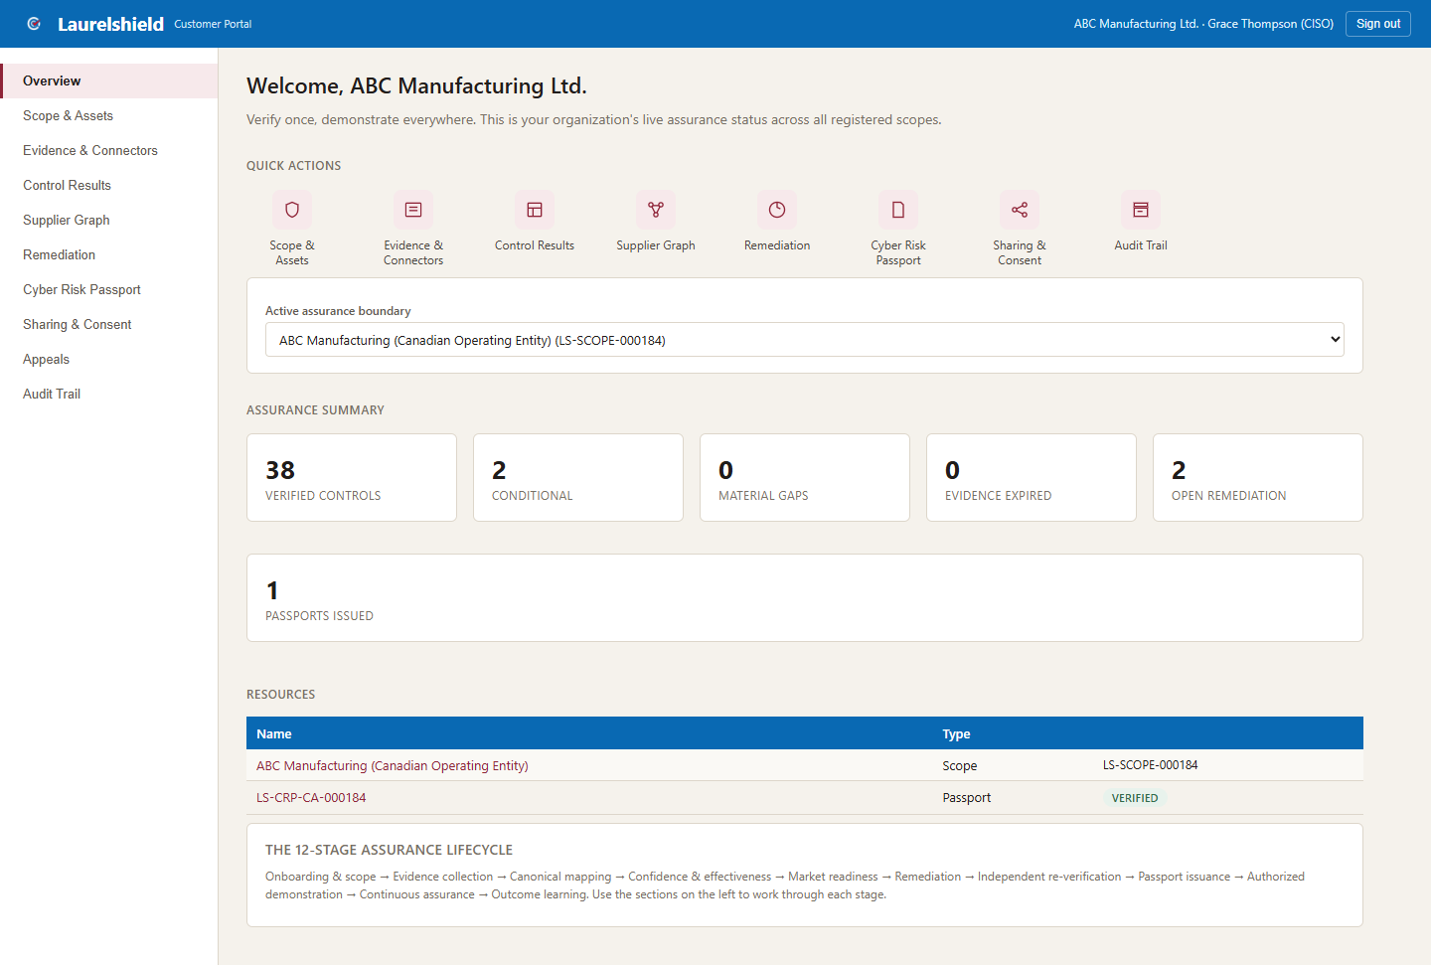
Figure 1.1: The Overview screen, shown here for a fully verified demo tenant (ABC Manufacturing Ltd.).
TIP
Make Overview your starting point every time you log in. It is designed so a busy CISO can tell in ten seconds whether anything needs attention today.

CHAPTER 2

2. Scope & Assets
Defines the assurance boundary: exactly which legal entity, network, cloud tenant, and applications are being assessed. No evidence gets collected against anything until it exists here.

What You'll See
- Your registered scope(s), each with a status badge (draft or approved) and a version number.
- The assets registered inside each scope: type (network, endpoint, cloud subscription, application, data store), name, criticality, environment, and data classification.
- A form to register a new assurance boundary.

Step by Step
- Click "Register New Assurance Boundary." Give it a name that identifies the legal entity and jurisdiction, for example "ABC Manufacturing (Canadian Operating Entity)." This exact name is what later appears on your Cyber Risk Passport.
- Describe what is inside it: networks, applications, cloud tenants, and sites in scope.
- Register your key assets underneath it. At minimum, register your most critical applications and cloud subscriptions.
- Click "Approve Scope" once your asset list is materially complete. Evidence can technically be added to a draft scope, but most downstream workflows assume an approved one.

On Screen
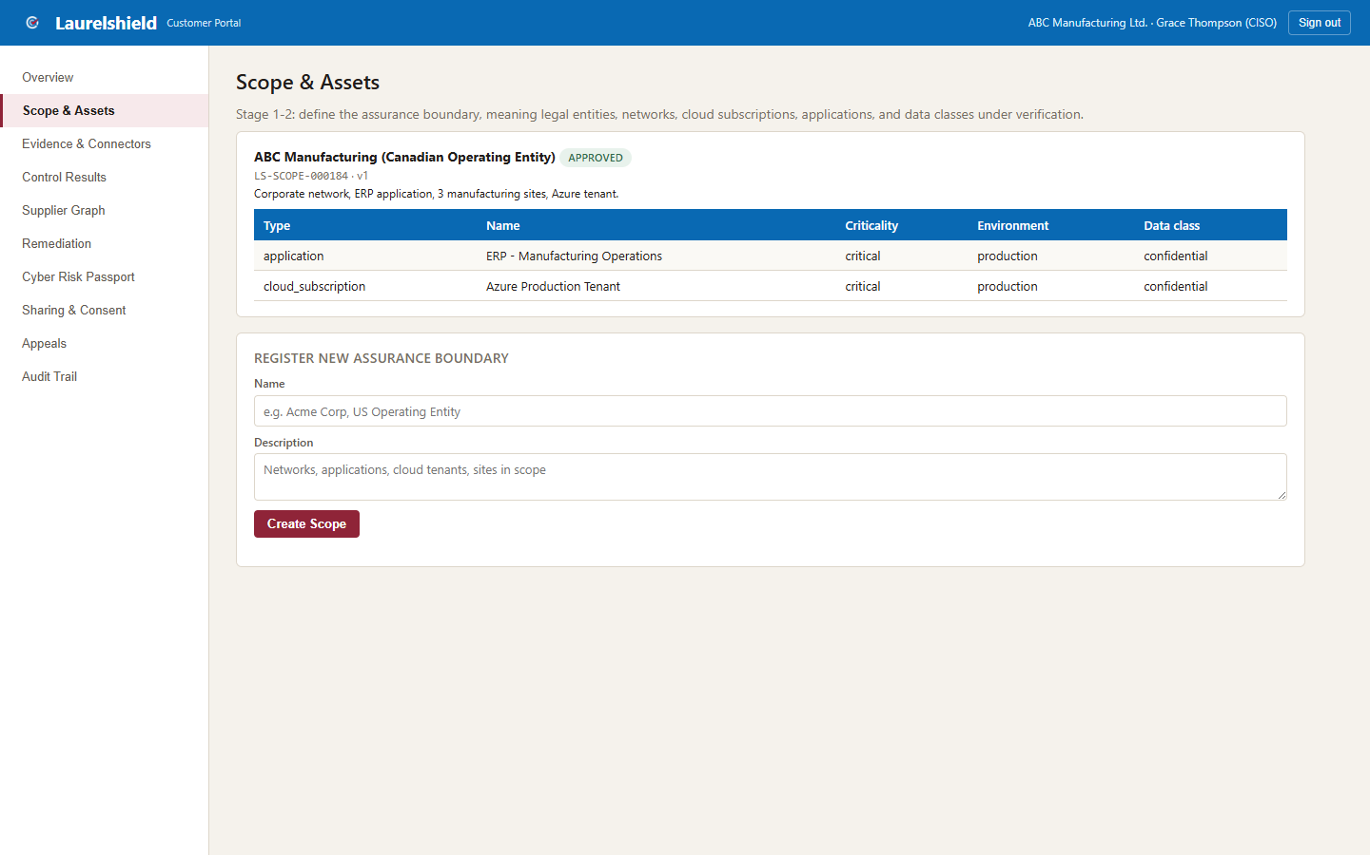
Figure 2.1: The Scope & Assets screen, shown here for a fully verified demo tenant (ABC Manufacturing Ltd.).
COMPLIANCE WARNING
A scope left in draft with an incomplete asset list will make your Control Results and Passport look less complete than your real environment. Keep the asset list current as your environment changes; this is not a one-time setup step.

TIP
One scope per legal entity or operating region is the usual pattern. If your organization has genuinely separate business units with different security postures, register each as its own scope rather than blending them into one.

CHAPTER 3

3. Evidence & Connectors
This is how Laurelshield actually learns about your environment: connectors, operational tests, and manual documentation, each carrying source, timestamp, and hash-based chain of custody.

What You'll See
- Connected Evidence Sources: up to seven connector types (Identity Provider, Endpoint Detection & Response, Backup & Recovery, External Attack Surface Scanner, Email Security & DNS, Cloud Platform, SIEM/Log Management), each showing connection status, last sync time, and whether it is running in Simulated or Live mode.
- Operational Tests: buttons to run a restore test or an incident response tabletop exercise, the only way to reach ECL-4 evidence, proof a control actually works, not just that it is configured.
- Manual/Document Evidence: for governance and data-security controls that have no live connector.

Step by Step
- Click "+ Add a Connector" and choose the type that matches a real system in your environment.
- Choose Simulated for an instant demo, or Live if you want real evidence. Today only the Identity Provider connector supports Live mode, via a Microsoft Graph (Entra ID) app registration. You will need a Tenant ID, Client ID, and Client Secret from your Azure AD administrator, with Policy.Read.All, Directory.Read.All, RoleManagement.Read.Directory, and AuditLog.Read.All permissions, admin-consented.
- For a Live connector, click "Test Connection" first to confirm the credentials work before running a full sync.
- Click "Sync Now." This is what actually pulls evidence and updates Control Results; adding a connector alone does nothing until you sync it.
- For controls with no connector, use Manual/Document Evidence: pick the control, describe the evidence (for example, a board-approved policy document), and submit. This creates ECL-1 evidence that sits pending until an assessor reviews it; it does not become a verified claim automatically.

On Screen
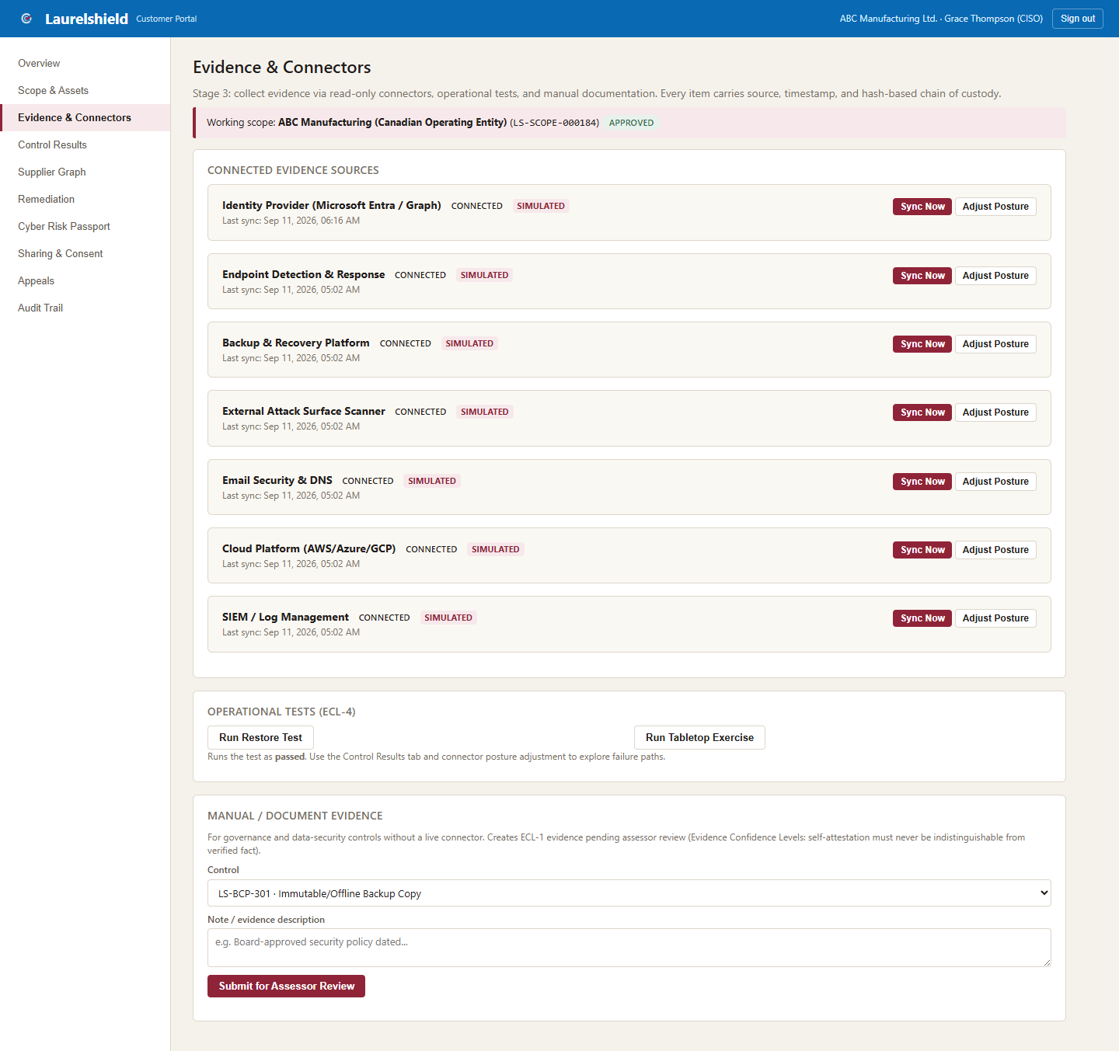
Figure 3.1: The Evidence & Connectors screen, shown here for a fully verified demo tenant (ABC Manufacturing Ltd.).
COMPLIANCE WARNING
Adjusting a simulated connector's posture does not take effect until you click Sync Now again. Nothing updates silently; this is deliberate so every change to your evidence has an explicit, logged trigger.

TIP
Sync your connectors on a regular cadence, not just once. Evidence has a freshness window per control, and a control that goes too long without a refresh will show as expired even if nothing about your actual environment changed.

CHAPTER 4

4. Supplier Graph
Your extended attack surface: the third parties you depend on that could cause a loss even if every one of your own controls is perfect.

What You'll See
- Registered suppliers with a criticality badge (critical, high, medium, low), the service they provide, and which canonical controls that relationship affects.
- A form to add a new supplier and link it to one or more controls.

Step by Step
- Click Add Supplier for each meaningful third party: cloud hosting, managed IT/MSP, payment processing, email security, and any vendor with access to in-scope systems or data.
- Fill in service, business process supported, data touched, region, contract owner, recovery dependency, and alternative provider if one exists.
- Select every canonical control this supplier relationship affects. For example, a cloud hosting provider typically touches your Cloud domain controls and your backup controls.
- Set criticality honestly. "Critical" plus "no alternative provider" is exactly the combination that matters most.

On Screen
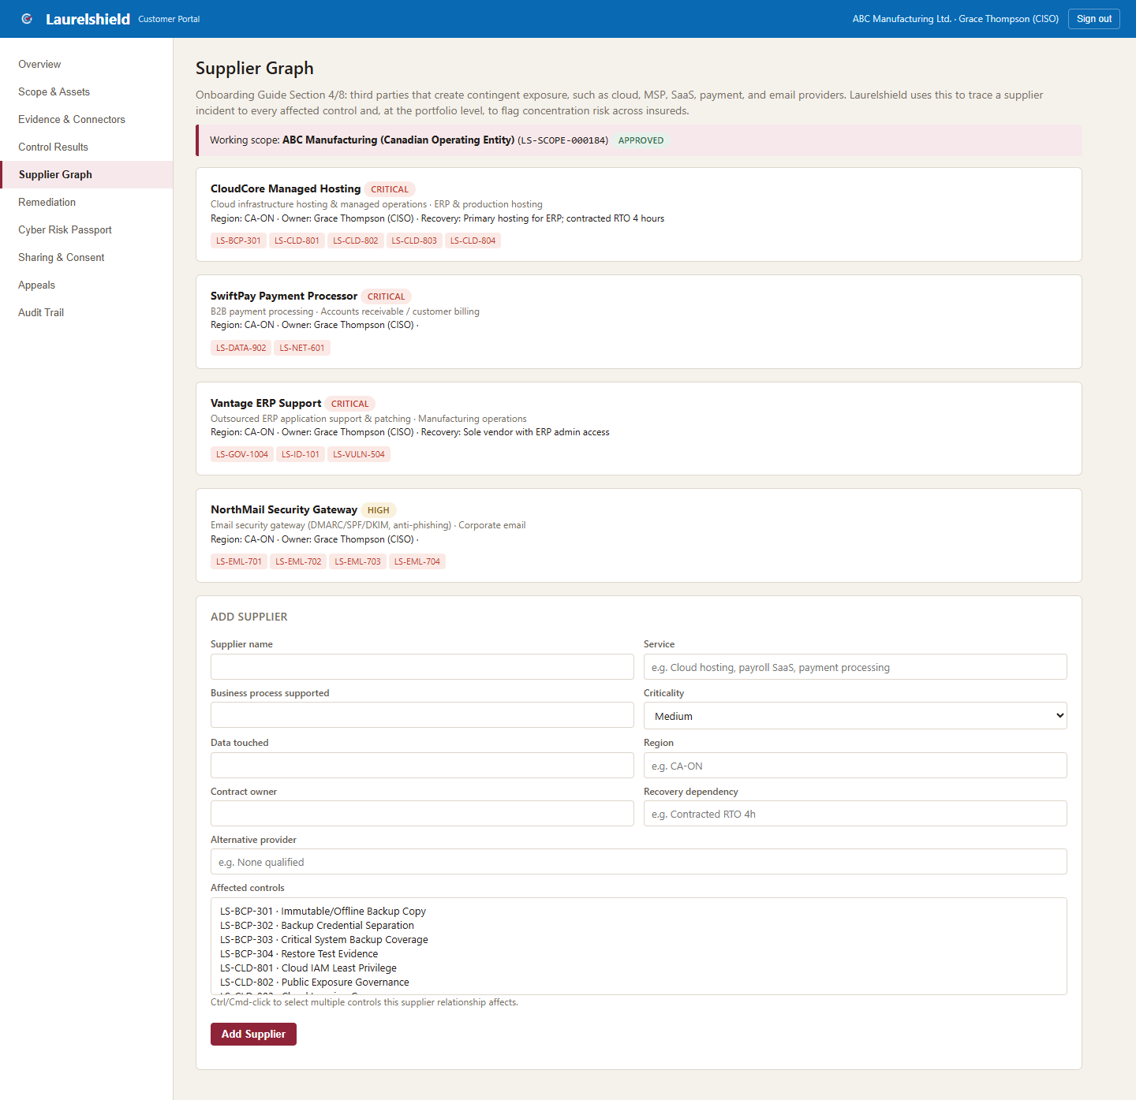
Figure 4.1: The Supplier Graph screen, shown here for a fully verified demo tenant (ABC Manufacturing Ltd.).
KEY POINT
At the portfolio level, Laurelshield flags concentration risk: a supplier that serves multiple insureds at once, meaning a single incident at that supplier becomes a multi-policy loss event. This is genuinely useful information for your carrier, not just paperwork. Keeping this list accurate and current is one of the highest-leverage things you can do in the portal.

TIP
Revisit this list whenever you change vendors or renew a major contract. A stale supplier graph understates your real dependency risk.

CHAPTER 5

5. Remediation
Tracks and closes findings the right way, with a structural rule that the person who fixes something is never the person who signs off that it is fixed.

What You'll See
- A table of open findings: control, finding description, owner, due date, and status (open, reverification pending, closed, overdue).

Step by Step
- Work the finding with whoever owns that control area in your organization.
- Click "Mark Remediated" once the fix is in place. This does not close the finding; it queues it for independent re-verification.
- An Assurance Operations reviewer, someone independent of the fix, confirms closure. Only then does the item move to Closed.

On Screen
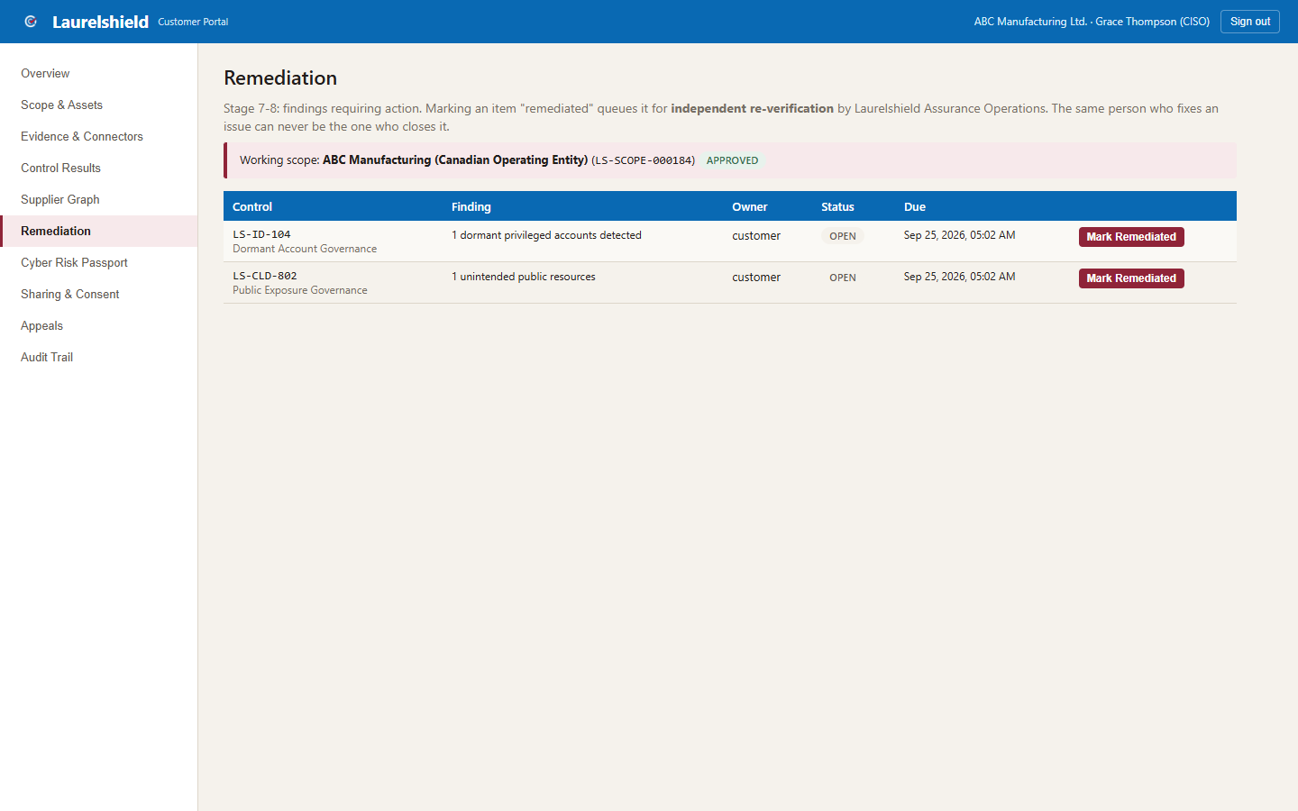
Figure 5.1: The Remediation screen, shown here for a fully verified demo tenant (ABC Manufacturing Ltd.).
KEY POINT
This separation of duties is enforced by the platform, not just a policy on paper. It exists because self-graded remediation is exactly the kind of gap a claims investigator looks for after a breach: "you said you fixed it, who confirmed that?"

TIP
Do not wait until a renewal deadline to start working your remediation queue. The independent confirmation step takes real turnaround time on Laurelshield's side; build in a buffer.

CHAPTER 6

6. Cyber Risk Passport
Your signed, portable, revocable credential: the thing you actually hand to a broker or carrier instead of re-answering their questionnaire from scratch.

What You'll See
- Your passport code (for example LS-CRP-CA-000184), issue date, overall status (verified or conditional), a signature-verified confirmation line, and the full table of every canonical control with its status, ECL, and coverage percentage.
- An "Issue New Passport" button and, on an existing passport, a "Revoke" button.

Step by Step
- Once you are satisfied with your control coverage on Overview and Control Results, click "Issue New Passport for Current Scope."
- Check the status. Verified means no material gaps; Conditional means some controls need attention but nothing severe enough to withhold the passport.
- Review the "Signature verified" line; this confirms the passport has not been tampered with since issuance.
- Use Sharing & Consent to actually give a partner access to it.

On Screen
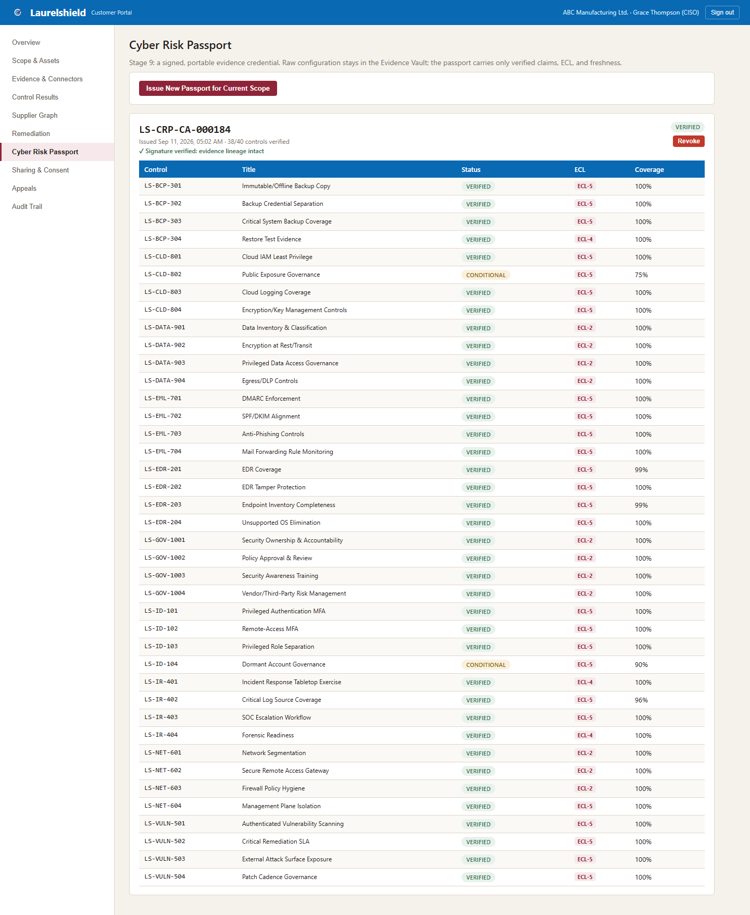
Figure 6.1: The Cyber Risk Passport screen, shown here for a fully verified demo tenant (ABC Manufacturing Ltd.).
COMPLIANCE WARNING
Revocation is permanent in this build; there is no undo. Only revoke a passport you genuinely want to withdraw, then issue a fresh one when ready.

TIP
A passport is a snapshot in time, not a subscription. If your controls change materially after issuance, especially anything moving toward Material Gap, issue a new passport rather than letting a stakeholder keep relying on a stale one.

CHAPTER 7

7. Sharing & Consent
You decide who can see your passport, for what purpose, and for how long. Nothing is visible to a broker or carrier until you explicitly grant it.

What You'll See
- Your active sharing grants: recipient, purpose, and expiry date.
- A form to grant new access, and a Revoke action on any existing grant.

Step by Step
- Pick a broker or carrier partner from the list.
- Set a purpose, for example "renewal placement support" or "pre-bind underwriting review," and an expiry window.
- Click "Share." The partner can now view a translated version of your passport for as long as the grant is active.
- Click "Revoke" on any grant at any time to end access early.

On Screen
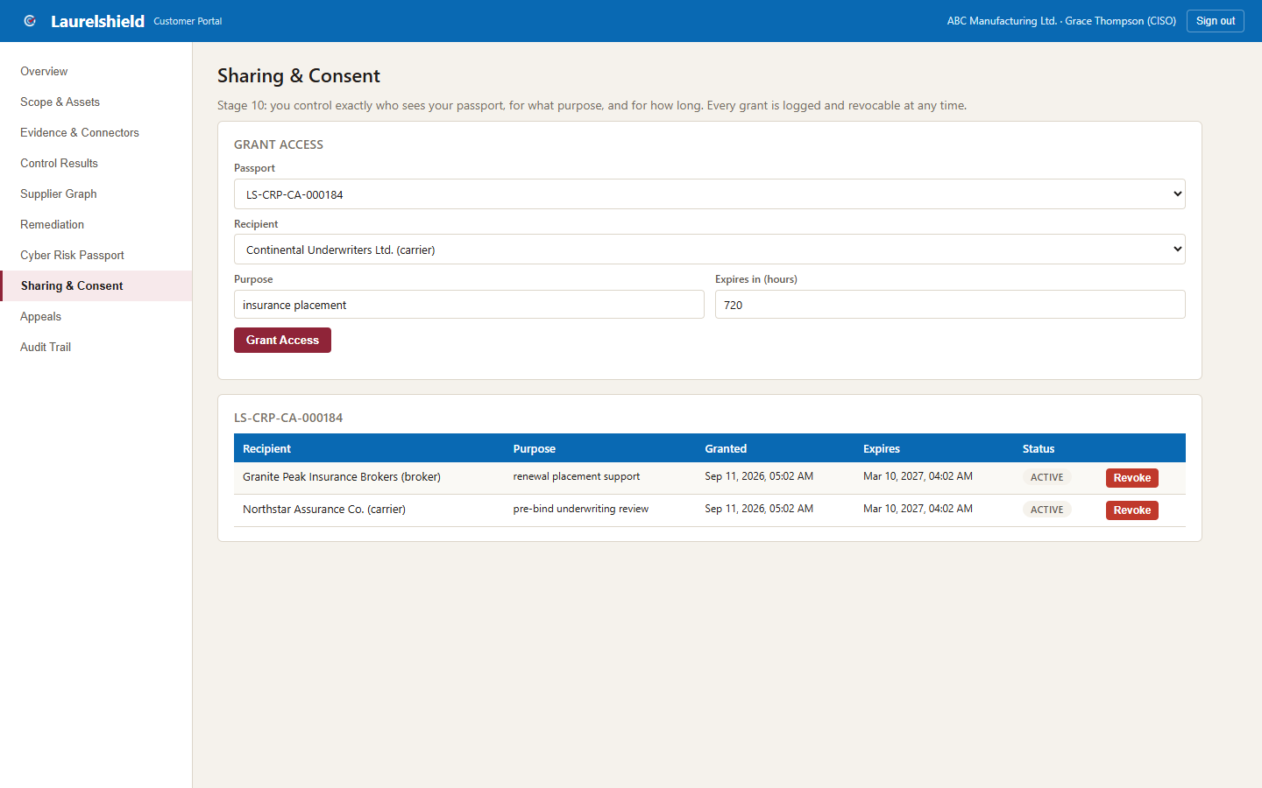
Figure 7.1: The Sharing & Consent screen, shown here for a fully verified demo tenant (ABC Manufacturing Ltd.).
KEY POINT
A carrier never sees your raw canonical results. Laurelshield translates your verified controls into that carrier's own proprietary question wording and thresholds, a confidential mapping layer that is never exposed to you, other carriers, or brokers. You only ever see the resulting readiness classification; the underlying weighting is the carrier's and Laurelshield's trade secret. This is by design; it keeps the process fair to every insured being compared.

TIP
Every time a partner actually opens your shared passport, it is logged. Check Audit Trail if you want to know whether they have actually looked yet, not just whether you sent the invite.

CHAPTER 8

8. Appeals
Your right to contest a verification decision you believe is wrong.

What You'll See
- Any appeals you have filed and their status: open, under review, upheld, or overturned.
- A form to file a new appeal.

Step by Step
- Click File an Appeal.
- If the appeal relates to a specific verification, reference it.
- Explain your reason clearly and specifically: which control, what evidence you believe was misread or overlooked, and why.
- An Assurance Operations Decision Officer, independent of the original verification, reviews and either upholds or overturns the finding.

On Screen
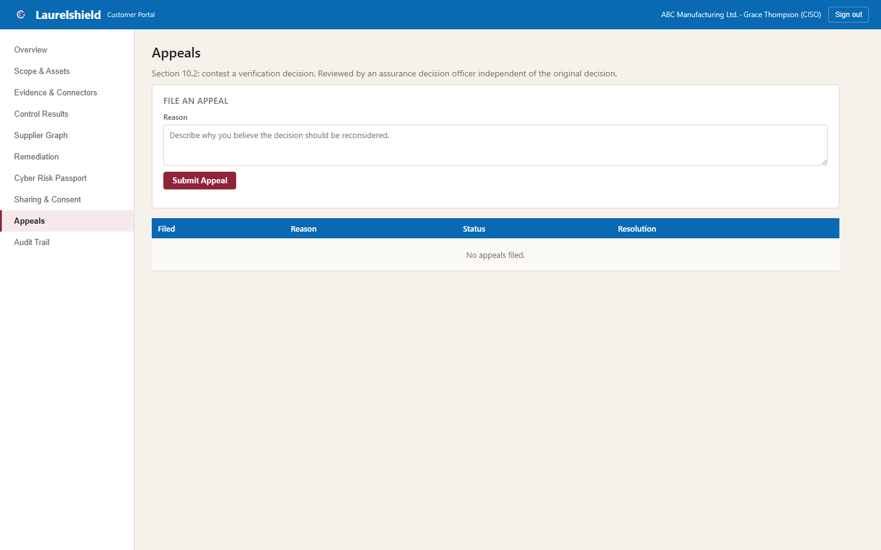
Figure 8.1: The Appeals screen, shown here for a fully verified demo tenant (ABC Manufacturing Ltd.).
TIP
Vague appeals take longer to resolve than specific ones. "I disagree with the finding on LS-ID-104" resolves faster than "this seems wrong."

CHAPTER 9

9. Audit Trail
Radical transparency: a record of every action touching your organization's data, including every time a broker or carrier partner actually accessed something you shared with them.

What You'll See
- A chronological table: when, who (or which system process), what action, and what resource it touched.

Step by Step
- Use this whenever you need to answer "did anyone outside our organization look at this, and when."
- Cross-reference with Sharing & Consent if a partner's access seems unexpected: confirm the grant that authorized it is still one you intended to have active.

On Screen
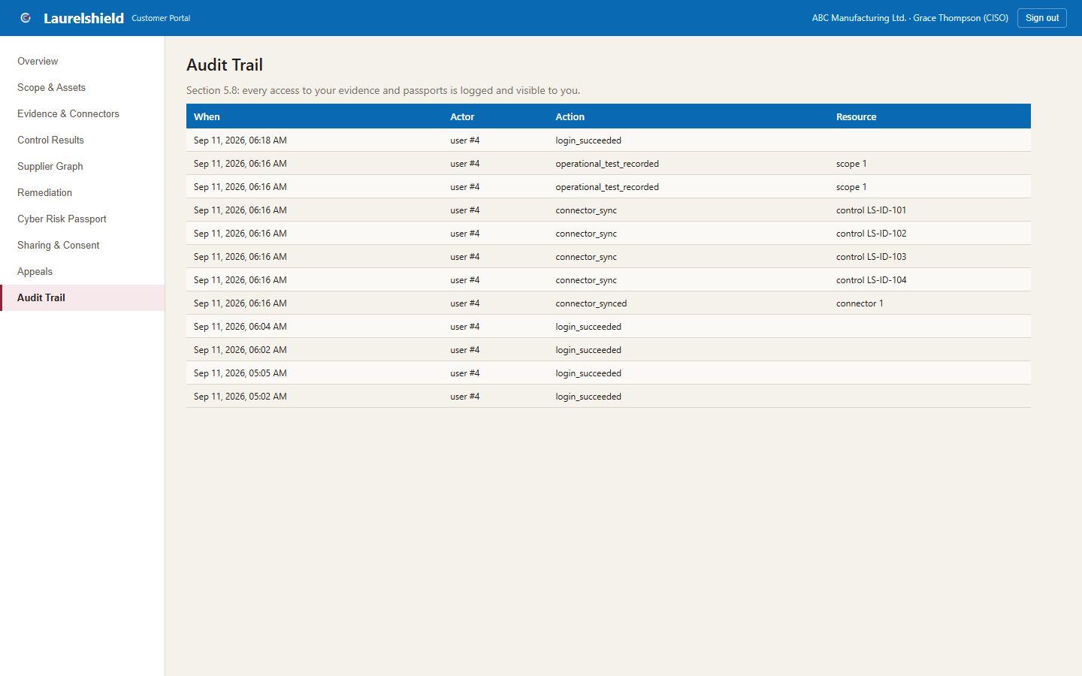
Figure 9.1: The Audit Trail screen, shown here for a fully verified demo tenant (ABC Manufacturing Ltd.).
TIP
This is not a marketing claim; it is a genuine log. If a broker or carrier tells you they reviewed your evidence before a decision, this is where you can confirm it actually happened, and when.

Getting Further Help
If something in the portal does not match this guide, confirm you are looking at the right screen for your role, screens differ between the customer, broker, carrier, and Assurance Operations portals, and check with your Laurelshield administrator whether your environment has been updated since this guide was produced.
BEFORE YOU CONTACT SUPPORT
☐ Confirm you are signed in as a customer_admin user, not a broker, carrier, or Assurance Operations account.
☐ Confirm the active assurance boundary selected on Overview is the one you expect.
☐ For a Live connector issue, check the exact error text; it usually comes directly from Microsoft, not Laurelshield.
☐ For anything else, contact your Laurelshield administrator or Assurance Operations contact.

